BRACT’s
Vishwakarma Institute of Technology, Pune
Practical Implementation Sheet
Department: CSE-AI Semester: 5 Academic Year: 2026-27
Division: C Batch: 3 Practical No: 9
Roll no: 68 PRN No: 12415154 Name of Student: Kalpesh Patil
Subject Name : Deep Learning

Problem Statement : Perform image classification using a pre-trained Vision Transformer (ViT) model and compare its performance with a Convolutional Neural Network (CNN) model using the Oxford-IIIT Pet dataset.

Algorithm :
- The required libraries, including PyTorch, torchvision, NumPy, Matplotlib, and scikit-learn, are imported.
- The Oxford-IIIT Pet dataset containing images of 37 cat and dog breeds is loaded.
- The images are resized to 224 × 224 pixels, converted into tensors, and normalized using ImageNet statistics.
- Balanced training, validation, and testing subsets are created with 20, 5, and 5 images per class, respectively.
- The ImageNet-pretrained ResNet50 CNN and ViT-B/16 Vision Transformer models are loaded.
- The pretrained parameters are frozen, and the original classification heads are replaced with new layers for 37 output classes.
- The new classification heads are trained for two epochs using the Adam optimizer and cross-entropy loss.
- Both models are evaluated using accuracy, macro precision, macro recall, macro F1-score, and test loss.
- Performance comparison graphs, training and validation accuracy curves, and confusion matrices are generated.
- Finally, the performance and training time of both models are compared, and conclusions are drawn from the results.

Code :
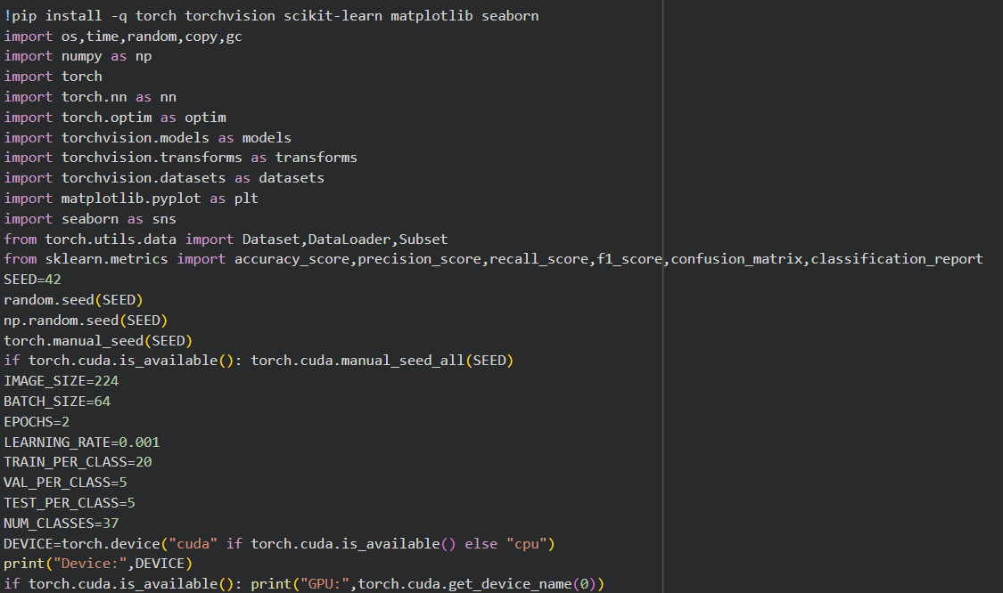
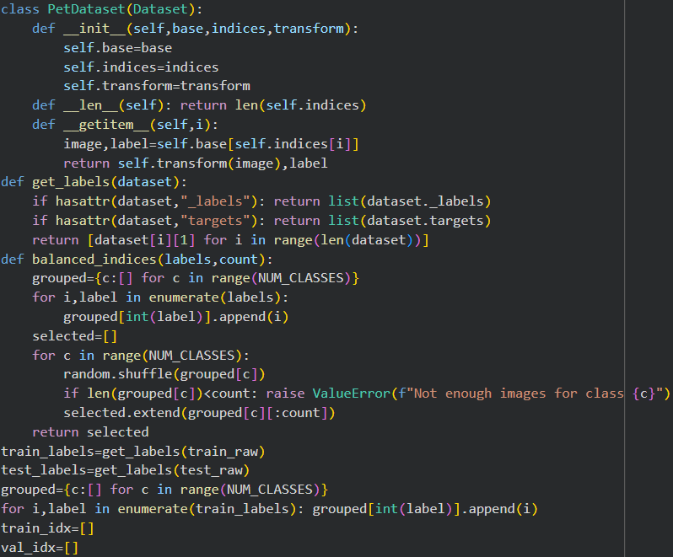
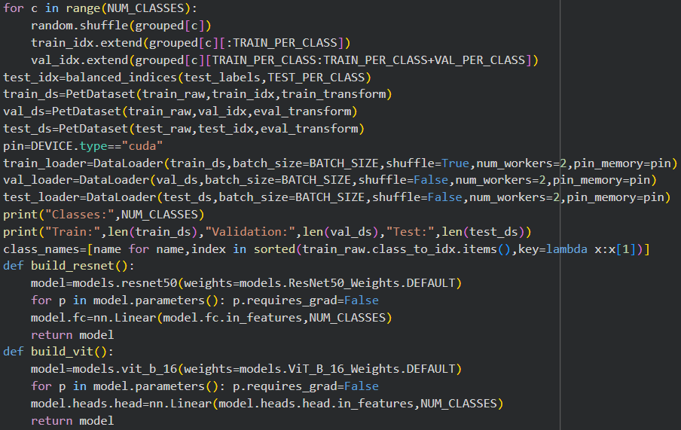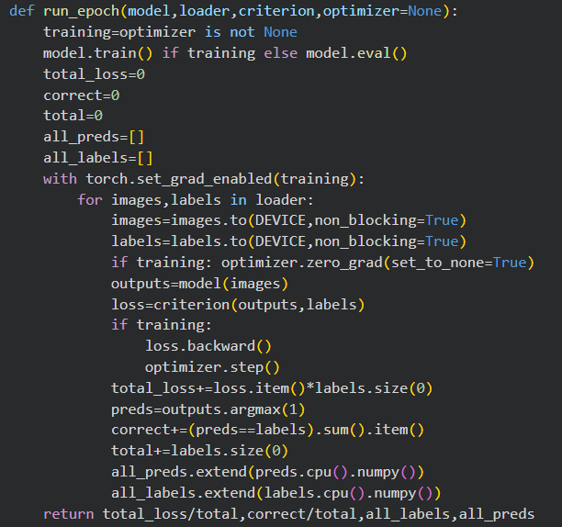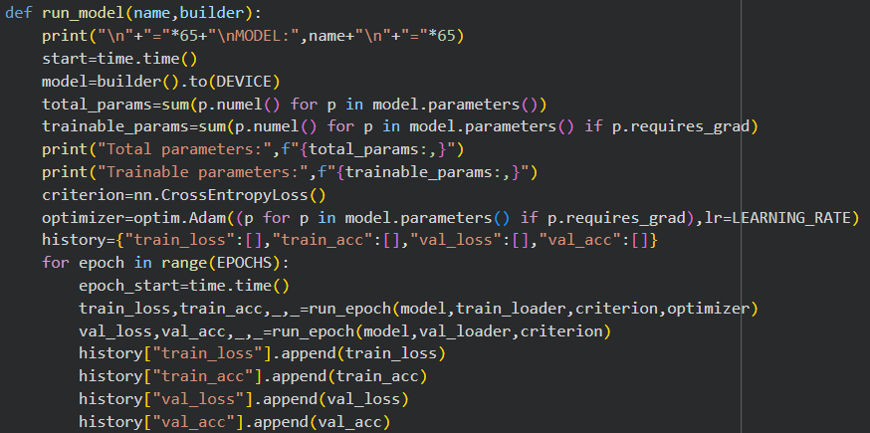
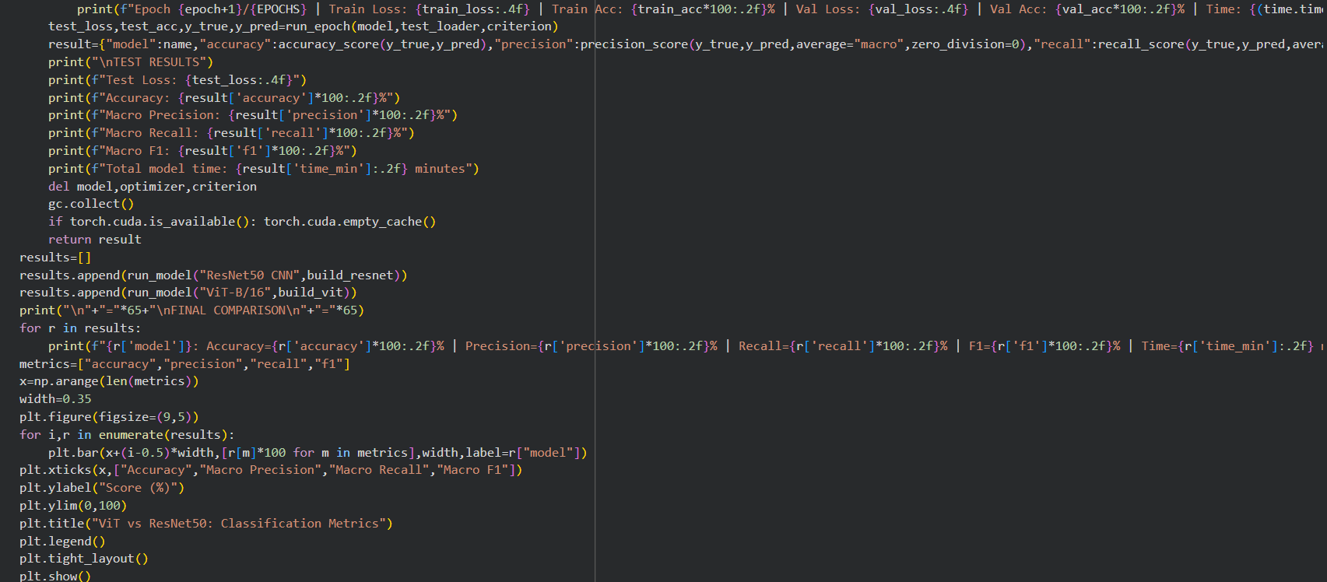
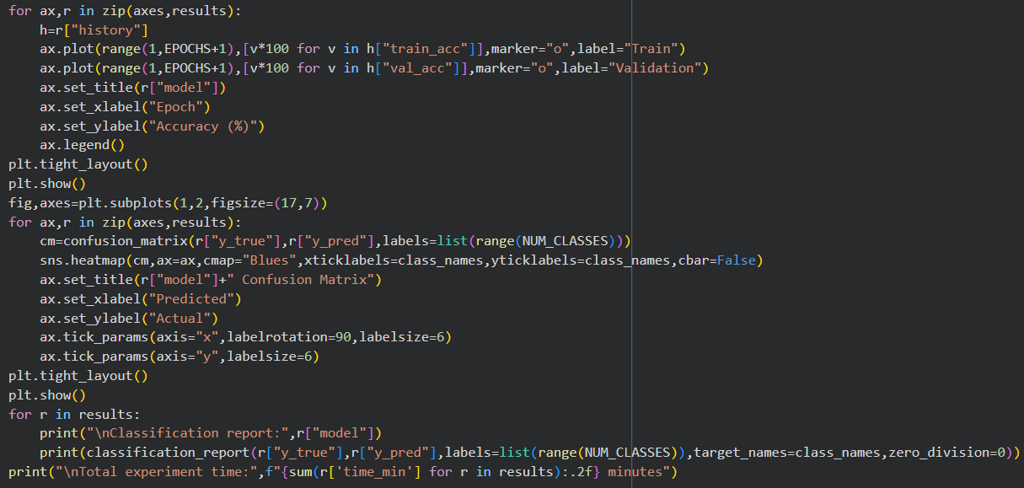

Output :


