BRACT’s
Vishwakarma Institute of Technology, Pune
Practical Implementation Sheet
Department: CSE-AI Semester: 5 Academic Year: 2026-27
Division: C Batch: 3 Practical No: 5
Roll no: 68 PRN No: 12415154 Name of Student: Kalpesh Patil
Subject Name : Deep Learning

Problem Statement: Implement and compare RNN, LSTM, and GRU models for sequence classification, and analyze their performance using appropriate evaluation metrics.
Algorithm:
- Start by importing the required libraries for TensorFlow/Keras, NumPy, Pandas, Matplotlib, Seaborn, and Scikit-learn.
- Set random seeds to make the experiment reproducible and define the common hyperparameters such as vocabulary size, maximum sequence length, embedding dimension, recurrent units, number of epochs, batch size, and learning rate.
- Load the IMDB movie-review dataset directly using Keras and represent each review as a sequence of integer word IDs.
- Preprocess the sequences by padding or truncating them to a fixed maximum length so that all inputs have the same shape.
- Create a model consisting of an Embedding layer, a recurrent layer, a Dropout layer, a Dense layer with ReLU activation, and a Sigmoid output layer.
- Construct three different models by using SimpleRNN, LSTM, and GRU as the recurrent layer while keeping the remaining architecture and hyperparameters the same.
- Compile all three models using the Adam optimizer, binary cross-entropy loss, and accuracy as the training metric.
- Train the RNN, LSTM, and GRU models using the same training and validation data and the same hyperparameters to ensure a fair comparison.
- Evaluate each trained model on the test dataset and calculate accuracy, precision, recall, F1-score, and test loss.
- Calculate the number of trainable parameters and measure the training time for each model.
- Generate training and validation accuracy and loss graphs to analyze convergence and possible overfitting.
- Generate comparison visualizations for the evaluation metrics, test loss, parameter count, and training time.
- Generate confusion matrices and ROC curves with AUC values to further evaluate the classification performance of each model.
- Display detailed classification reports and sample predictions for the three models.
- Finally, compare the results of RNN, LSTM, and GRU and analyze how their different recurrent architectures affect sequence classification performance.

Code:
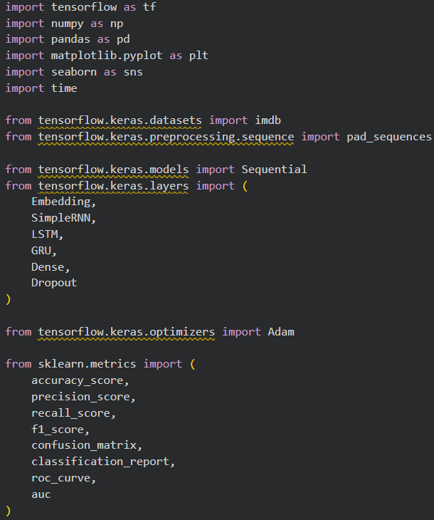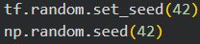
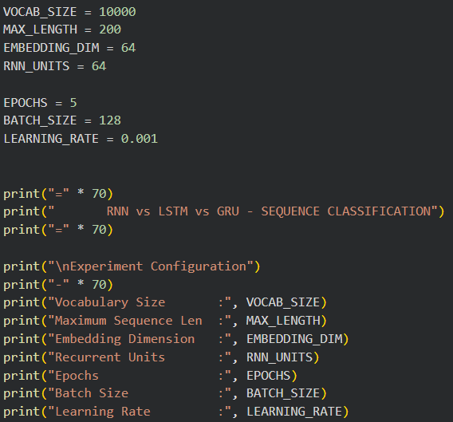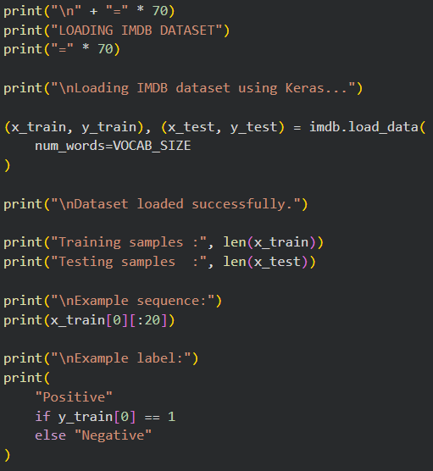
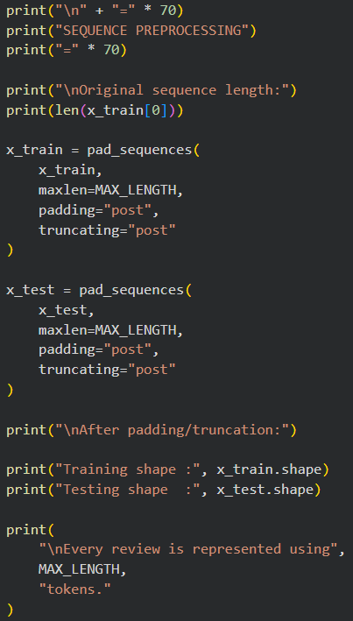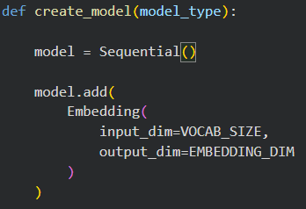
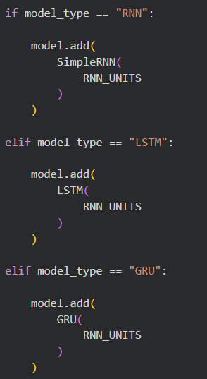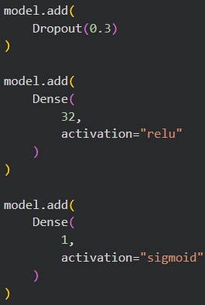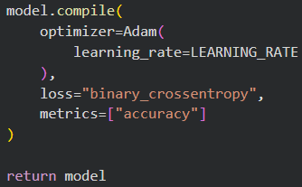
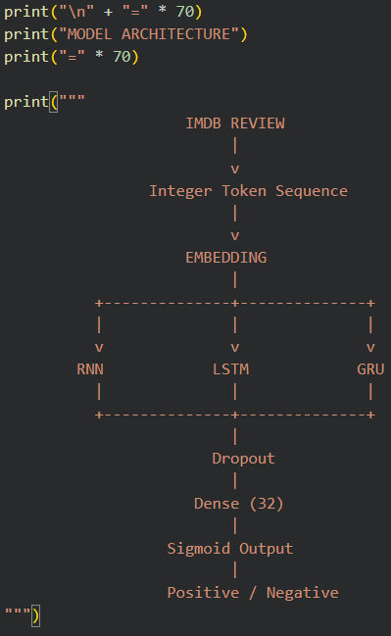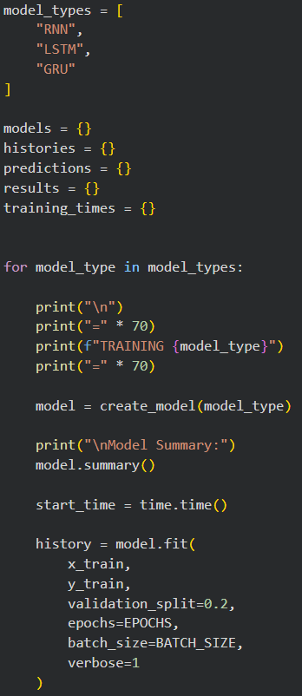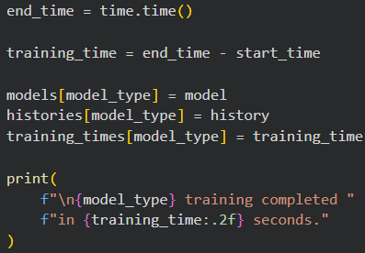
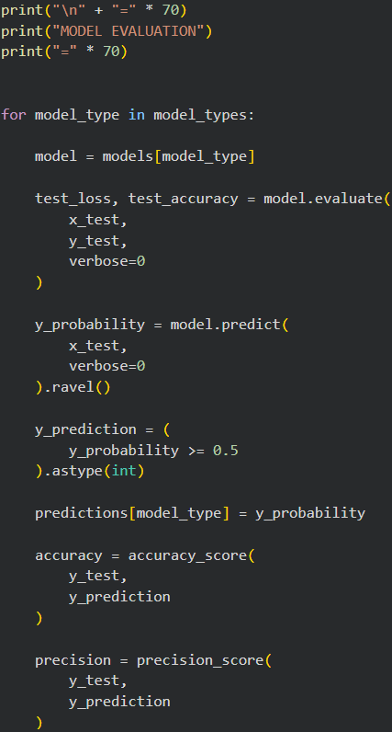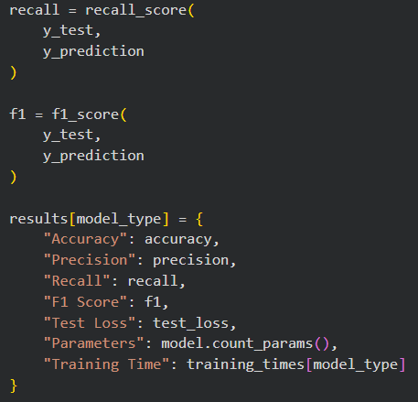
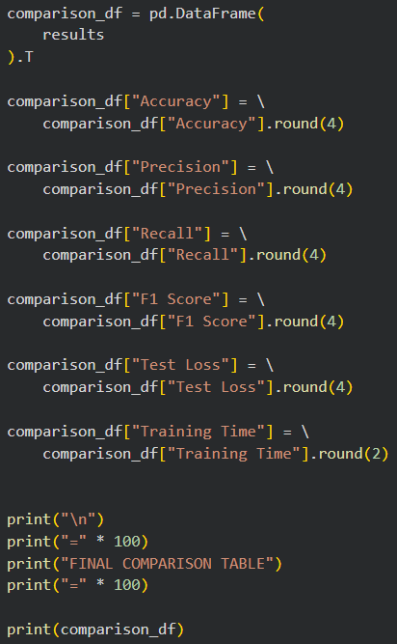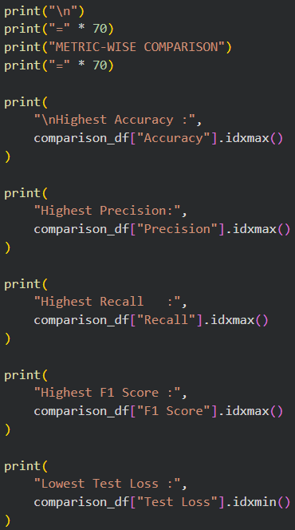
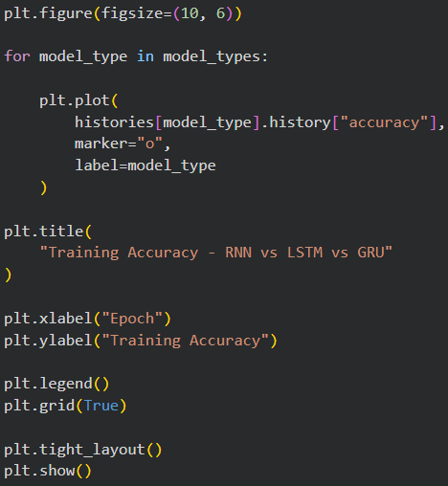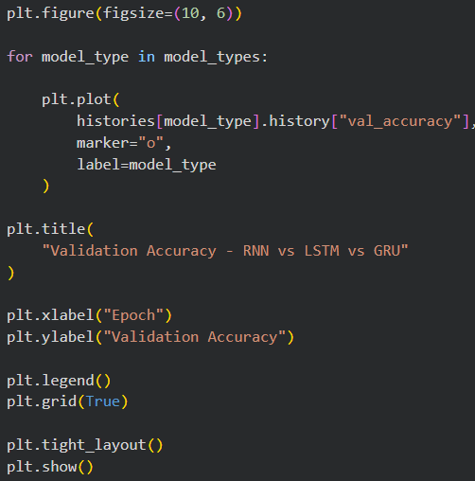
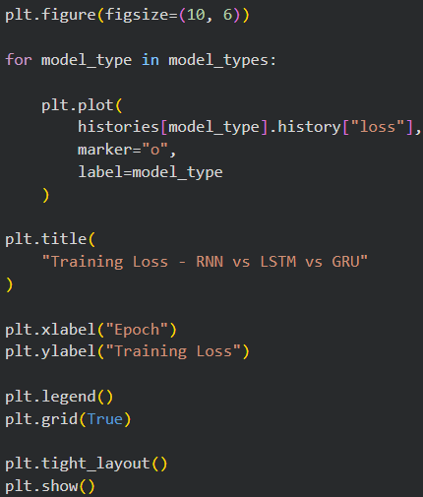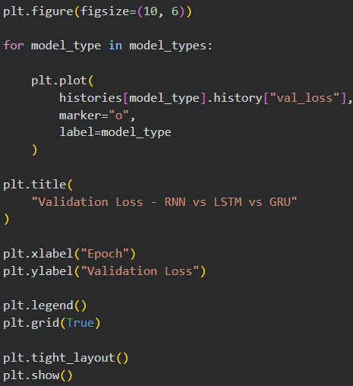
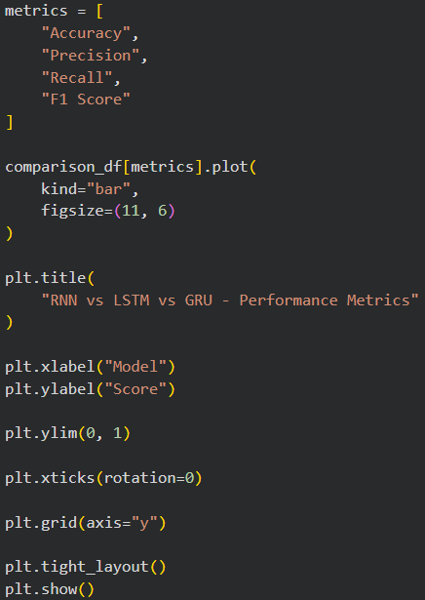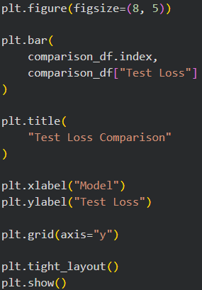
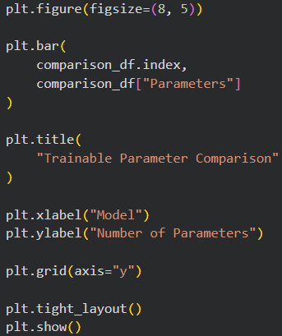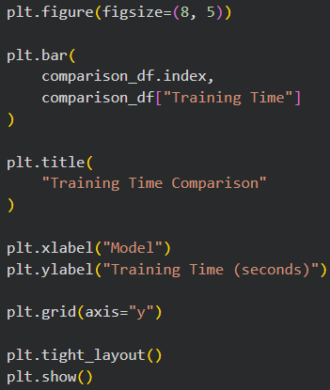
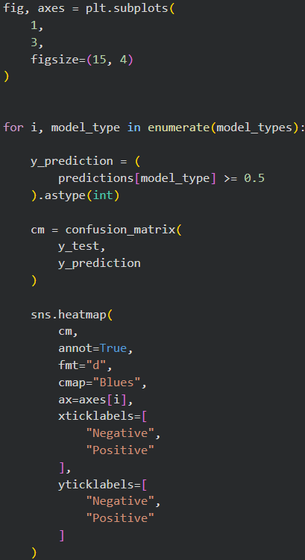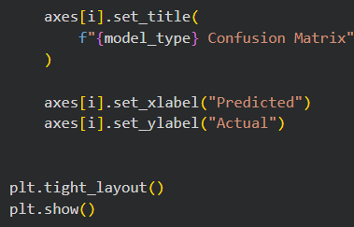
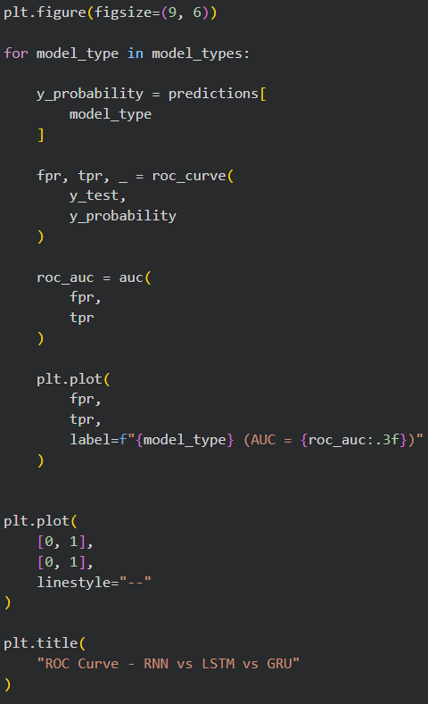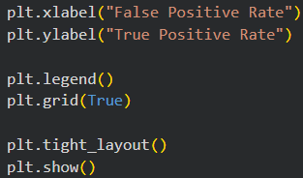
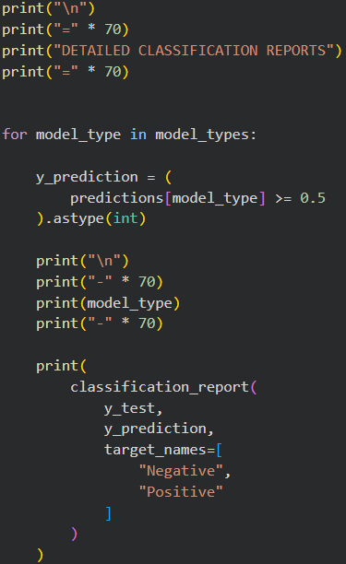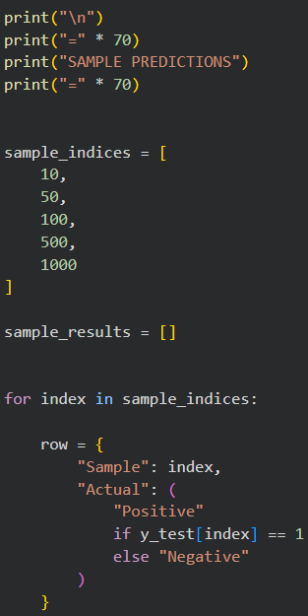
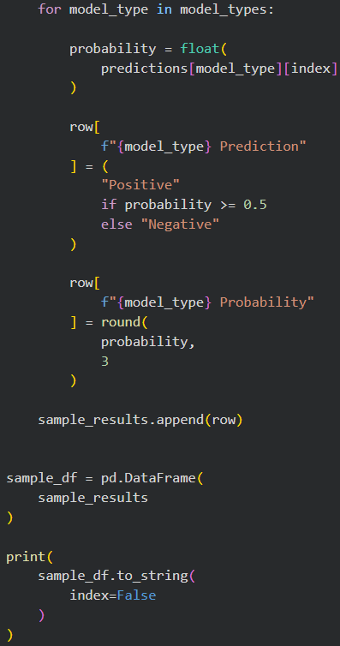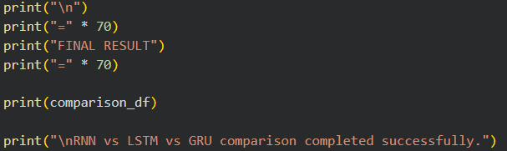

Output:
