EE 779: Computing Assignment 2

Linear Prediction Analysis

Kalpesh Patil (130040019)

# Problem A: Synthesized vowel

Vowel /a/ (formants: 730, 1090, 2440 Hz; bandwidths: 50 Hz) at two fundamental frequencies (120 Hz, 300 Hz) was produced. Levinson recursion was implemented for LP analysis. Following diagram shows Levinson algorithm outline.

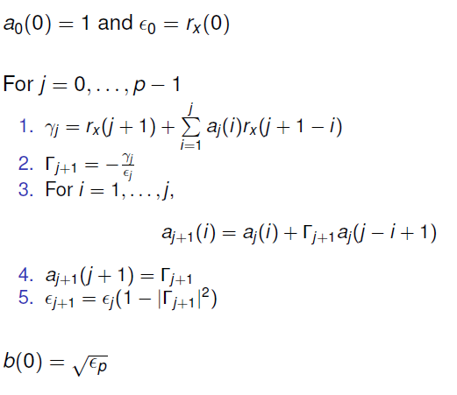 (src: EE 779 lcture slides)

### Code

clear all

*//Function to calculate filter response using difference equation*

function [**y**]=time_response(**x**, **num**, **den**)

n_samples = length(**x**);

**y** = zeros(n_samples,1)

*//numerator is constant (all pole filter)*

**y**(1) = **num**(1)\***x**(1)

k = **num**(1)

*//response by taking coefficients for denominator*

for ii =2:n_samples

temp = k\***x**(ii)

for jj = 1:min(ii-1,length(**den**)-1)

temp = temp - **den**(jj+1)\***y**(ii - jj)

end

**y**(ii) = temp

end

endfunction

*//function to find discrete coefficients of cascade of multiple filters*

function [**num**, **den**]=find_cascade_filter(**F_list**, **B_list**, **Fs**)

**num** = 1

**den** = [1]

for iter = 1:length(**F_list**)

F = **F_list**(iter)

B = **B_list**(iter)

*//finding poles for current iteration*

r = exp(-B*%pi/**Fs**)

theta = 2*%pi*F/**Fs**

*//current filter*

num_curr = 1

den_curr = [1 -2*r*cos(theta) r^2]

*//multiplication of polynomials can be computed using their*

*//convolution. Numerator is constant(1). Hence only*

*//denominator needs to be multiplied*

**den** = conv(**den**,den_curr)

end

endfunction

*//produce vowel /a/ for given F0*

function **a**=produce_vowel(**F0**)

vowel_formant_list = [730, 1090, 2440]; *//F1,F2,F3 for vowell a*

Fs = 8000

t_duration = 0.5

*//numerator of filter assumed to be 1*

k = 1

*//specifying input signal*

n_samples = t_duration*Fs + 1

n_fft = n_samples*10;

x = zeros(n_samples,1);

*//impulse train generation*

for i = 2:t_duration\***F0**

x(floor((i-1)*Fs/**F0**))= 1

end

*//Create delta input for finding impulse response*

delta_n = zeros(n_samples,1)

delta_n(1) = 1

F_list = vowel_formant_list

*//Bandwidth is constant for all formants*

B_list = [50,50,50]

*//find output of cascade filter*

[num,den] = find_cascade_filter(F_list,B_list,Fs)

h = time_response(delta_n,num,den)

y = time_response(x,num,den)

**a** = y

*//plot responses and save sound files*

*// plot_frequency_response(y,n_fft,F0,Fs)*

*// plot_y(y,F0,Fs)*

endfunction

*//produce vowels*

Fs = 8000

F0_list = [120, 300]

for iii = 1:length(F0_list)

*//window signal near centre*

window_time = 30

F0 = F0_list(iii)

x = produce_vowel(F0)'

N = window_time*Fs/1000 + 1

n_fft = 10*N

*//applying hamming window*

x_init = (length(x)+1)/2 - (N-1)/2

win_hamming = window('hm', N);

y = x(x_init: x_init + N - 1).*win_hamming;

*//finding autocorrelation*

r = zeros(length(y),1)

for ki=0:length(x)

for ni=ki:L-1

r(ki+1)=r(ki+1)+y(ni+1)*y(ni-ki+1);

end

end

delta_n = zeros(N,1)

delta_n(1) = 1

h_total = []

*//Levinson Durbin recursion*

p_max = 10

e_vec = [r(1)]

i = 1

k = r(2)/e_vec(1)

a_vec = [1,k]

e_vec = [e_vec,(1-(k)^2)*e_vec(1)]

for i = 2:p_max

k = r(i+1)

for j = 1:i-1

k = k - a_vec(j+1)*r(i-j+1)

end

k = k/e_vec(i)

a_vec_old = a_vec

a_new = k

for j = 1:i-1

a_vec(j+1) = a_vec_old(j+1)-k*a_vec_old(i-j+1)

end

a_vec = [a_vec , a_new]

e_vec(i+1) = (1-k^2)*e_vec(i)

*//Plotting LP approximation overlapping with the original spectrum*

if (modulo(i,2)==0)

fig = scf()

h_padded = zeros(n_fft,1)

h_padded(1:length(y)) = y'

H = fftshift(fft(h_padded))

H_mag = abs(H(n_fft/2 +1:n_fft))

freq_array = linspace(0,Fs/2,n_fft/2)

plot(freq_array,20*log(H_mag))

if(h_total == [])

h_total = H_mag

end

ax = gca()

original_frequencies = [730, 1090, 2440]

temp_d = (n_fft*original_frequencies)/Fs

temp_d2 = zeros(length(freq_array),1)

temp_d2(floor(temp_d)+1) = max(ax.y_ticks.locations)

plot(freq_array,temp_d2,'k-.')

num = sqrt(e_vec(i+1))

den = -a_vec(2:length(a_vec))

den = [1,den]

[h,w] = frmag(num,den,n_fft)

[h2,w2] = frmag(num,den,n_fft/2)

h_total = [h_total,h2']

plot(w*Fs,20*log(abs(h)),'red')

plot_title = strcat(['LP approximation of vowel a for F0 = ',string(F0),' p = ',string(i)])

xtitle(plot_title,'Frequency (Hz)','Magnitude in dB')

xs2jpg(gcf(), strcat(['../plots/Q1/',plot_title,'.jpg']));

end

end

*//plotting all LP together*

fig = scf()

plot2d(w2,20*log(h_total),[1:(p_max/2+1)])

plot_title = strcat(['All lp plots together for F0 ',string(F0)])

xtitle(plot_title,'Frequency (Hz)','Magnitude in dB')

legends(['original','p = 2','p = 4','p = 6','p = 8','p = 10'],[1:(p_max/2+1)],opt = 3)

xs2jpg(gcf(), strcat(['../plots/Q1/',plot_title,'.jpg']));

end

xdel(winsid())

### Results & Discussion

1. For lower values of p all the poles of the filter (formant frequencies) are not captured in the LP approximation
2. Actual vowel sound has 6th order transfer function (3 formants -> 6th order). As we can observe from the combined plot of all p’s together, for p >= 6, LP approximation was successful in capturing the formant frequencies.
3. For higher values of p, LP approximation tries to envelope the signal more aggressively which results in deviation from ideal LP output for F0 = 300 Hz
4. LP approximation is better for pitch frequency of 120 Hz than that of 300 Hz.

All plots together for different p’s for F0 = 120 Hz

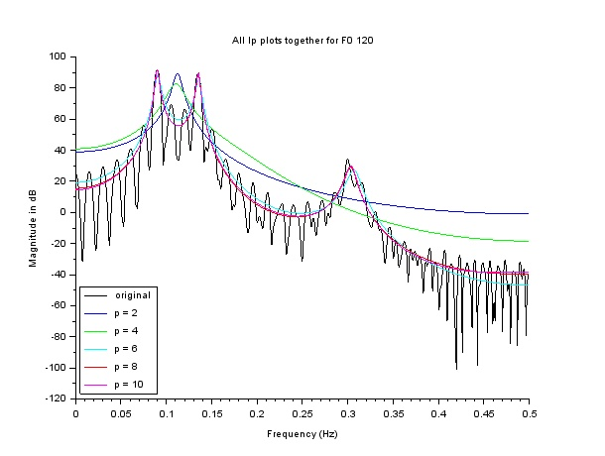

NOTE: Vertical lines depicting required discrete frequencies are shown in the individual plots for each p to avoid clutter in common plot

Plots for F0 = 120 Hz with different values of p

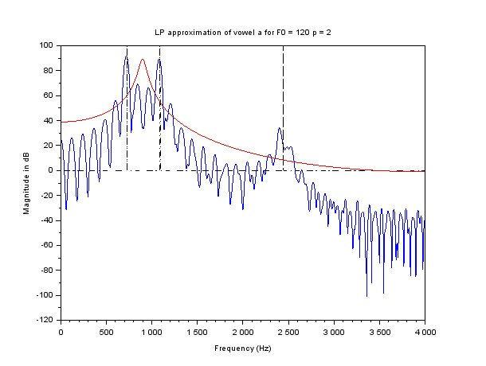

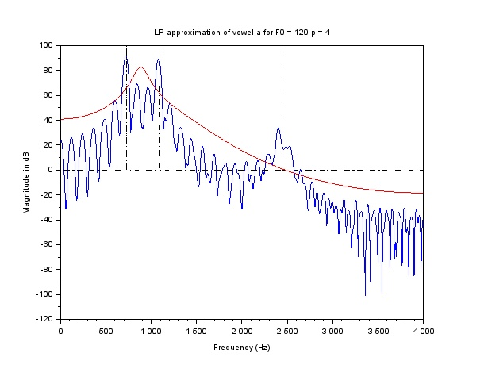

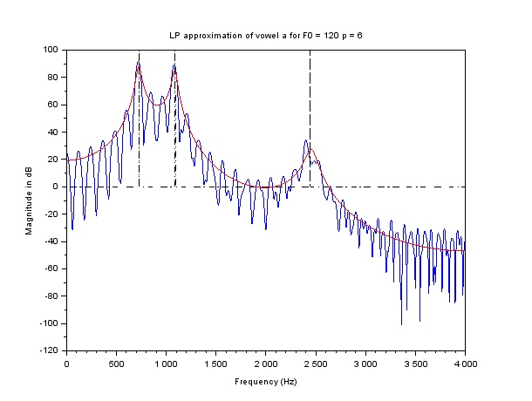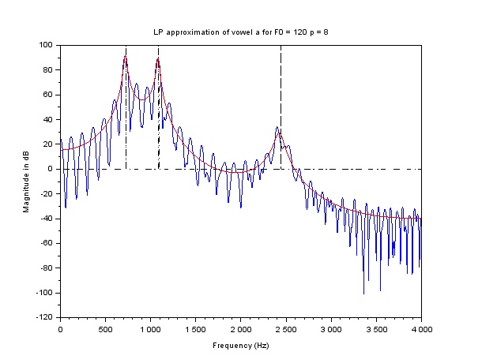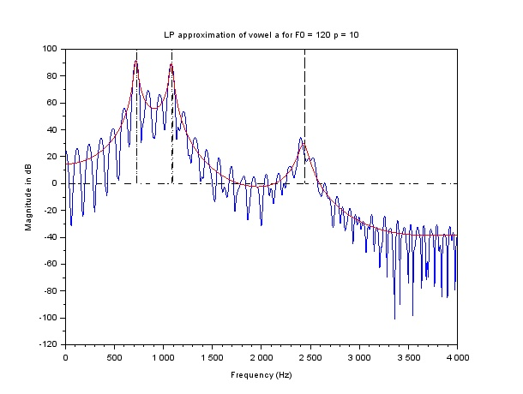

All plots together for different p’s for F0 = 120 Hz

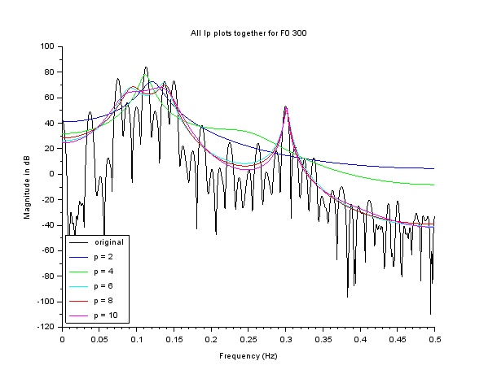

Plots for F0 = 300 Hz with different values of p

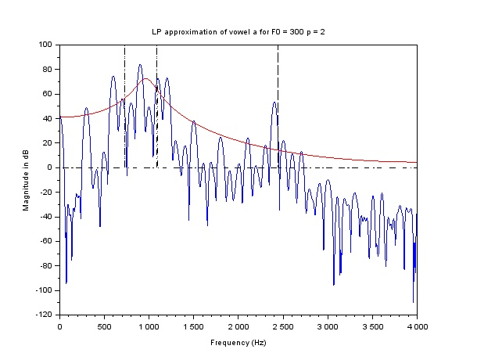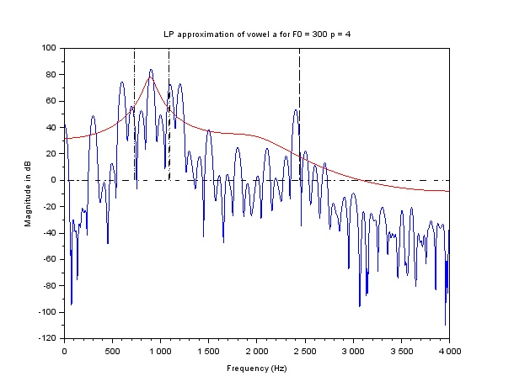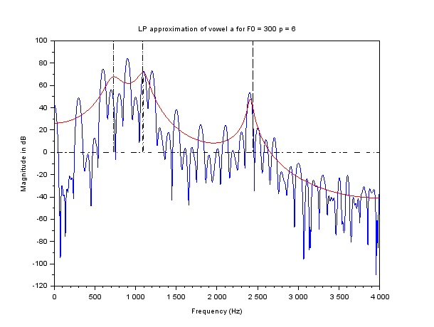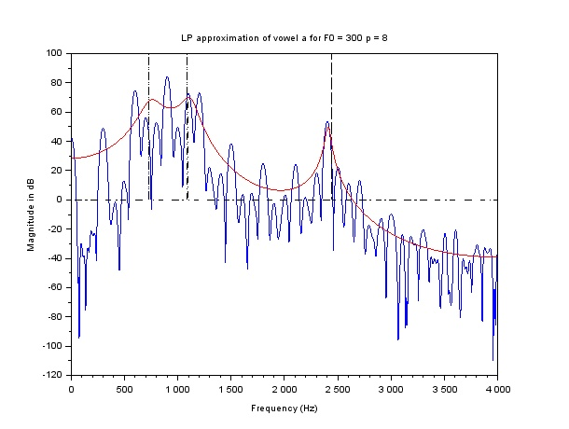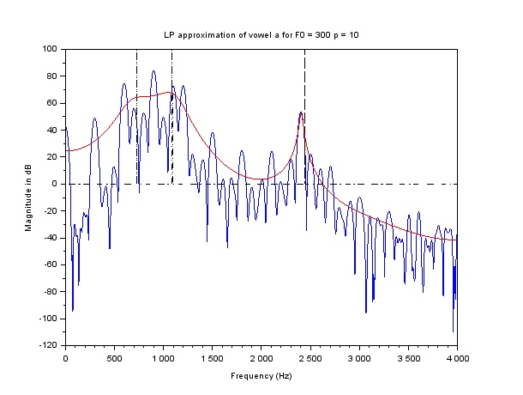

# Problem B: Natural Speech

## Q1. Pre-emphasis

Following function implements pre-emphasis filter using difference equation. Note that pre-emphasis has been done only for the voiced sounds (/a/, /n/ and /i/). Unvoiced sounds (/s/) doesn’t require pre-emphasis to be done

### Code

*//pre_emphasis filter*

function **y**=pre_emphasis_filter(**x**, **alpha**)

**y** = zeros(length(**x**))

**y**(1) = **x**(1)

for i = 2:length(**x**)

**y**(i) = **x**(i)-**alpha**\***x**(i-1)

end

endfunction

### Results & Discussion

Pre-emphasis is done compensate for the spectral roll off. Higher frequencies are boosted and lower frequencies are suppressed (high pass filter) due pre-emphasis. This phenomenon can be observed in the following graphs. Note that /s/ is an unvoiced sound and hence it is not passed through pre-emphasis filter.

/a/ before and after pre-emphasis

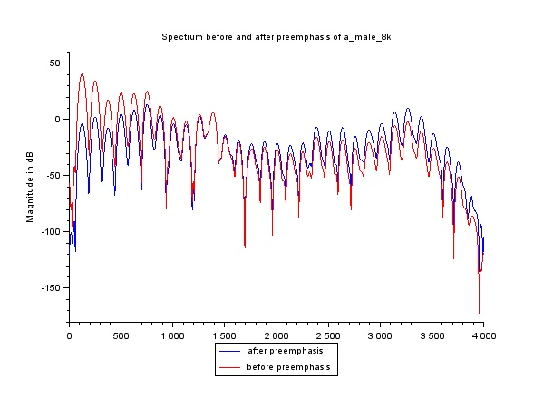

/i/ before and after pre-emphasis

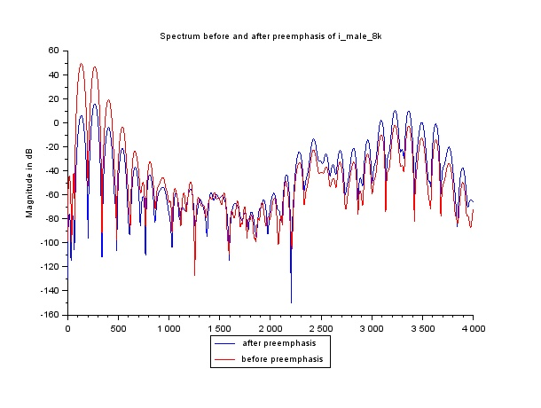

/n/ before and after pre-emphasis

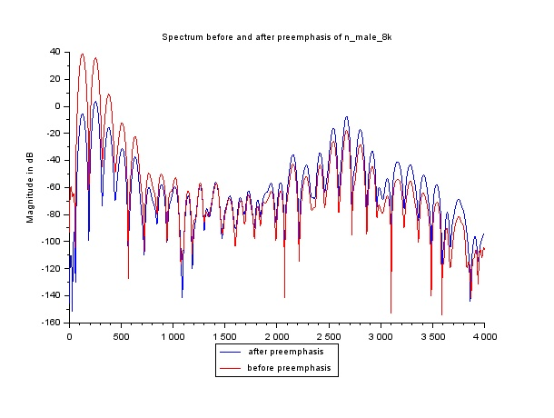

## Q2. LP analysis using Levinson method

Using the Levinson algorithm described in Problem A, LP analysis was performed on windowed pre-emphasized input signal

Code for Q1, Q2 and Q3 is at the end.

## Results & Discussion

1. Pole zero plots

Pole zero plots are plotted for given values of p. It can be noted that all poles and zeros of the LP filter obtained using autocorrelation model are inside unit circle. This is expected since autocorrelation method indeed produces a stable-causal system unlike covariance (covariance method can produce poles at any location).

Pole zero plots for /a/ for different values of p = 6 and p = 10

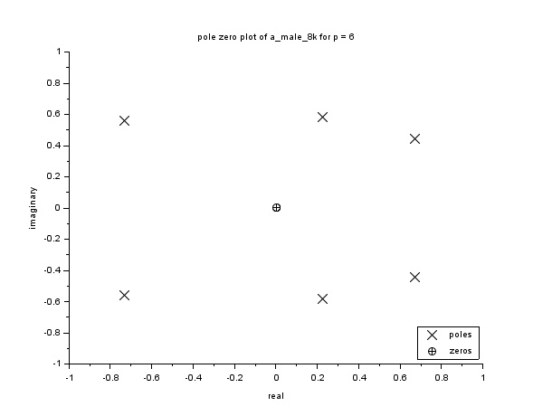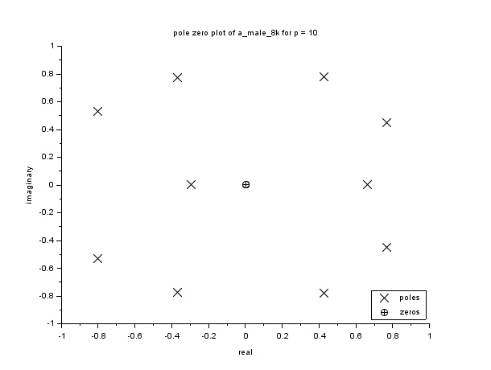

Poles zero plot for /i/ for p = 6 and p = 10

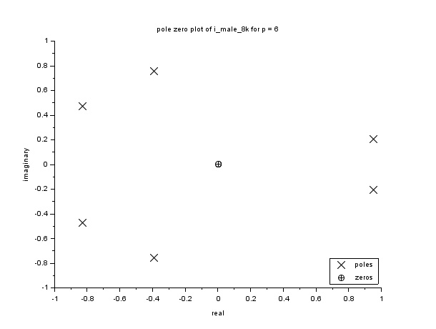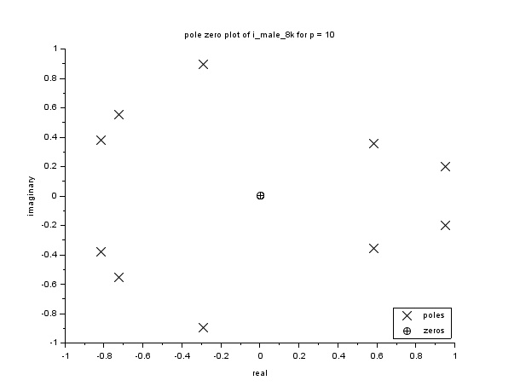

Pole zero plot for /n/ for p = 6 and p = 10

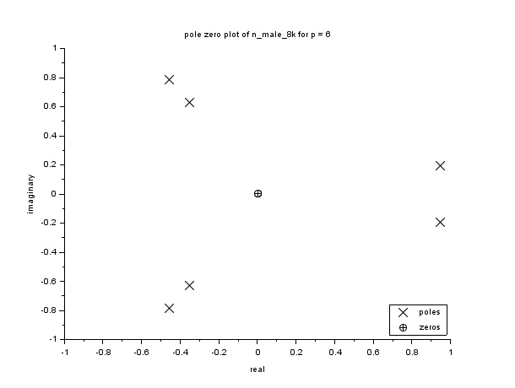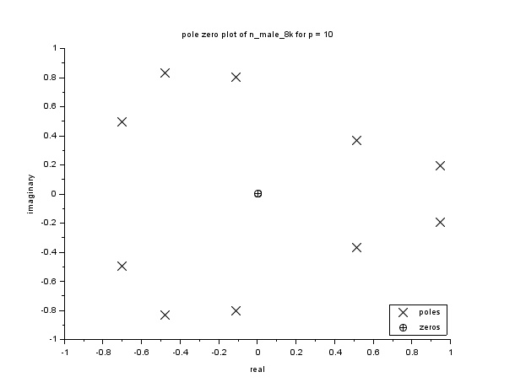

Pole zero plot for /s/ for p = 6 and p = 10

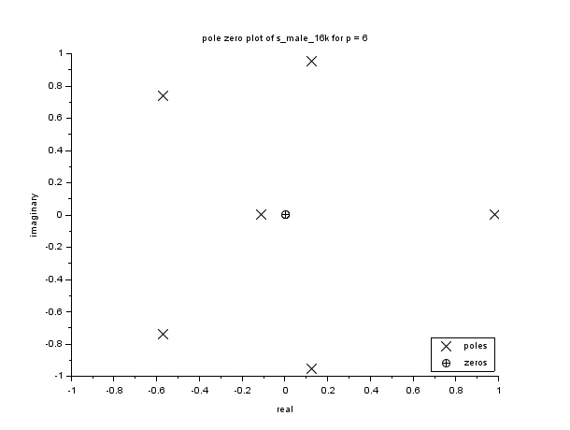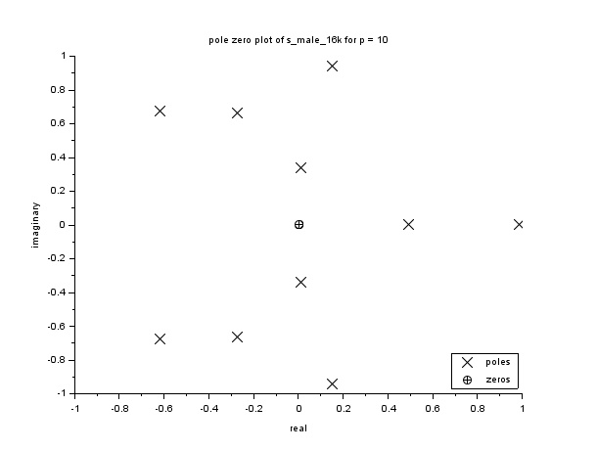

1. LPC spectrum

In general it can be observed that lower values of p are not able to capture all the poles while higher values of p try to envelope the signal more aggressively. Also the error due to approximation is more at the valleys in the spectrum than peaks. Vowels like /a/ and /i/ are inherently all pole transfer functions, hence they can be modelled pretty well using LP. For nasal sound /n/ higher order LP is required since it contains zeros as well. Fricatives (/s/) also require higher order LP.

Combined LP spectrum for all p’s for /a/

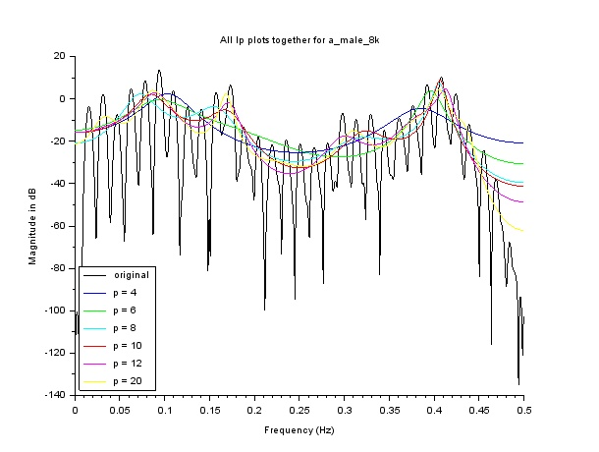

LPC magnitude spectrum for /a/ for different values of p

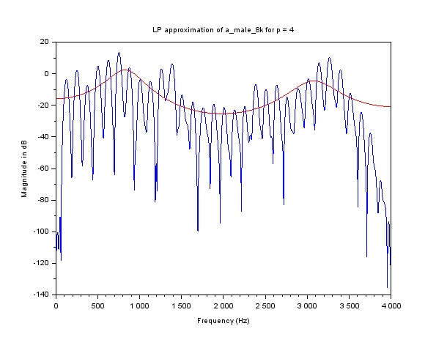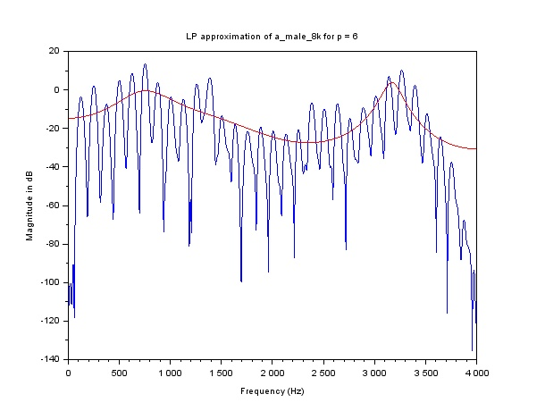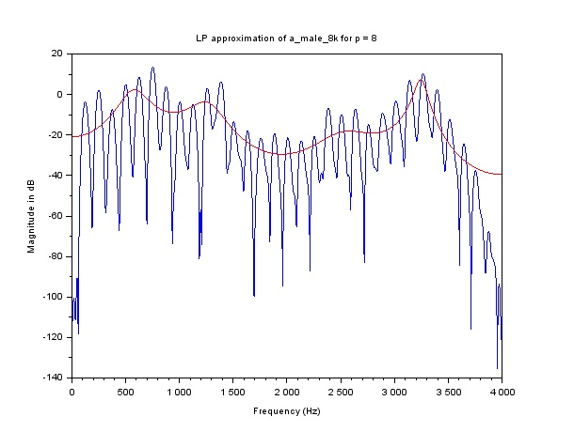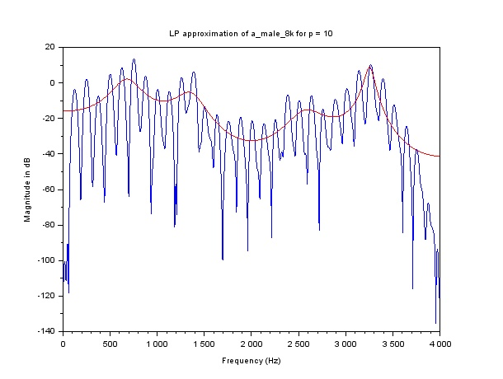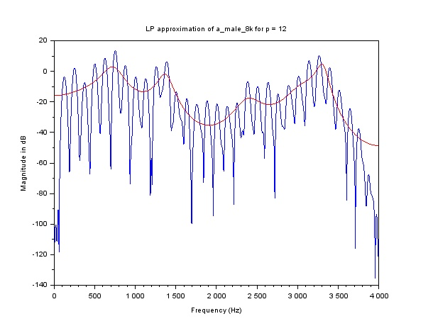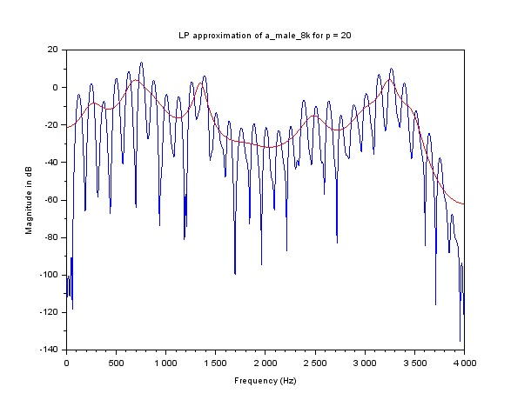

Combined LP spectrum for all p’s for /i/

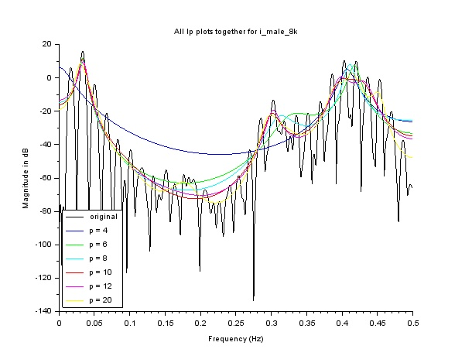

LPC magnitude spectrum for /i/ for different values of p

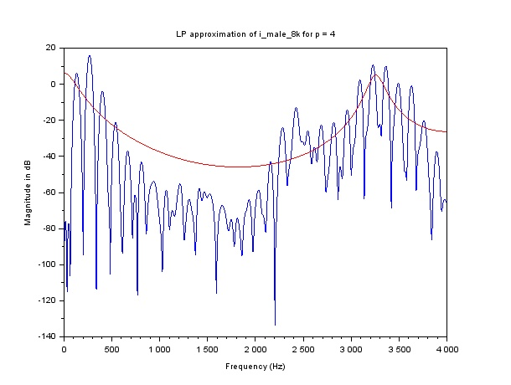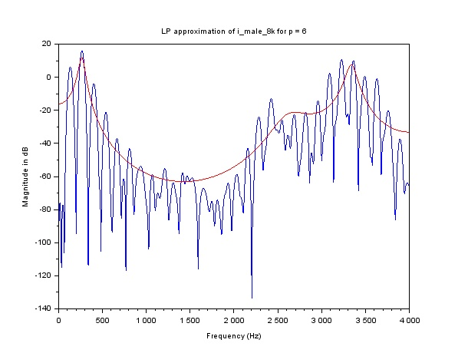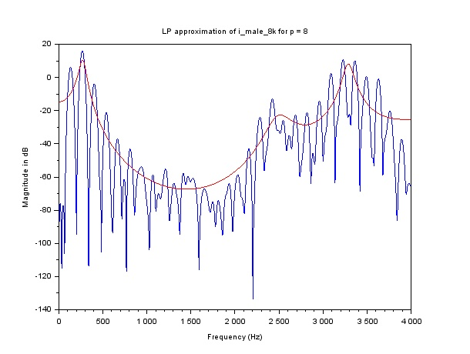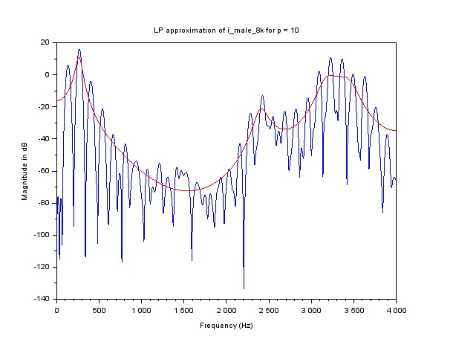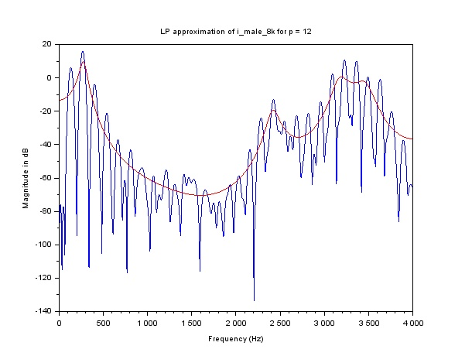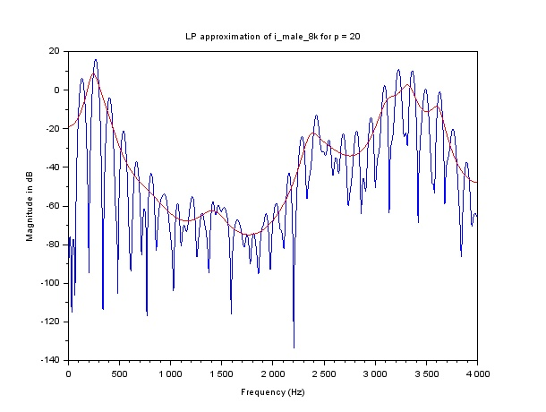

LPC magnitude spectrum for /i/ for different values of p

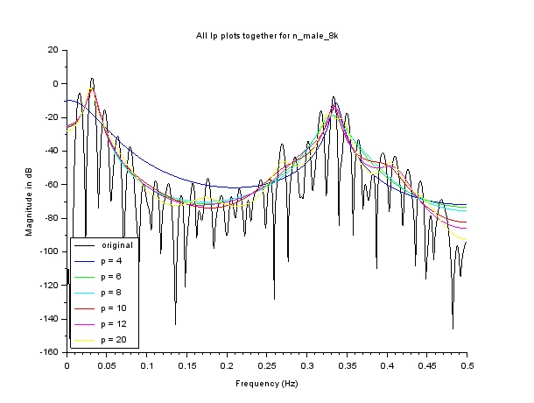

LPC spectrum for /n/ for different values of p

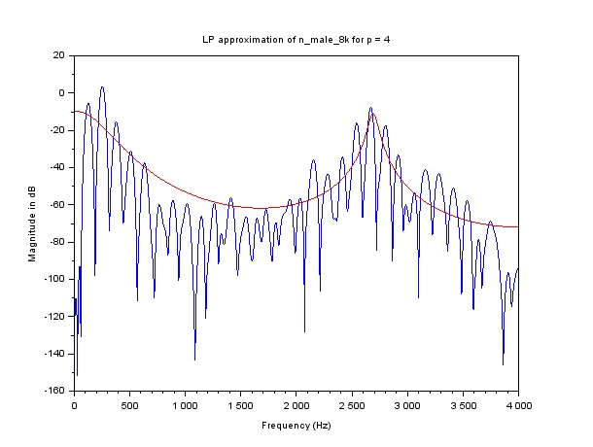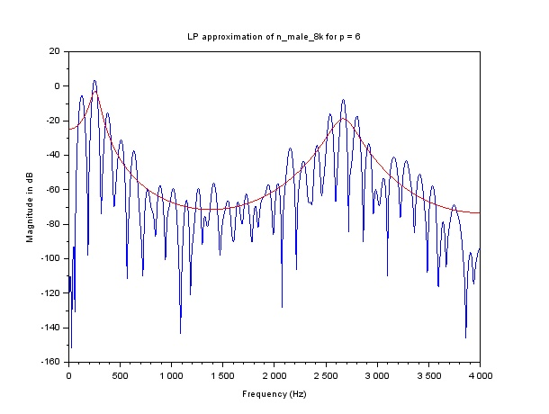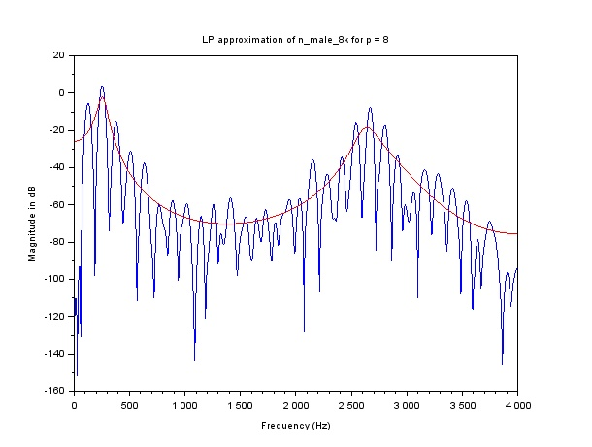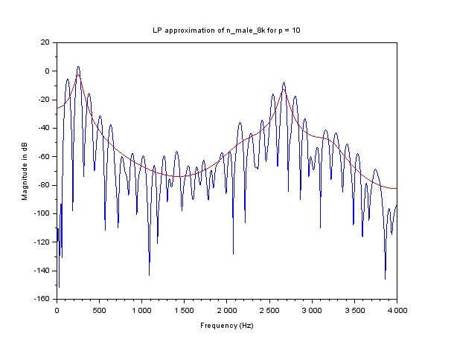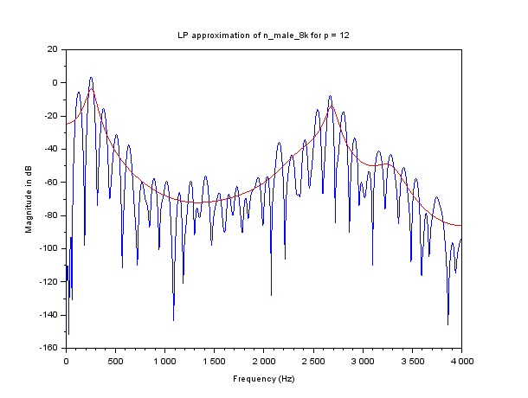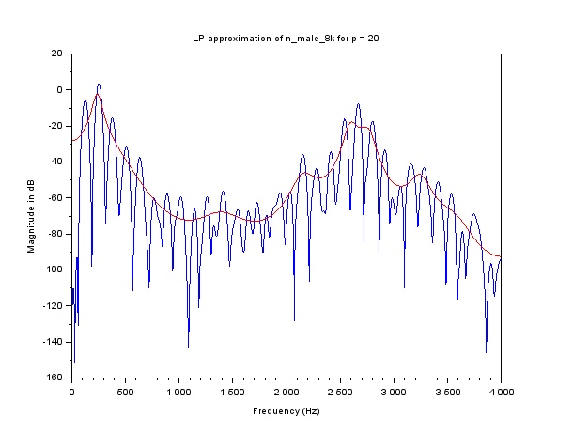

LPC magnitude spectrum for /s/ for different values of p

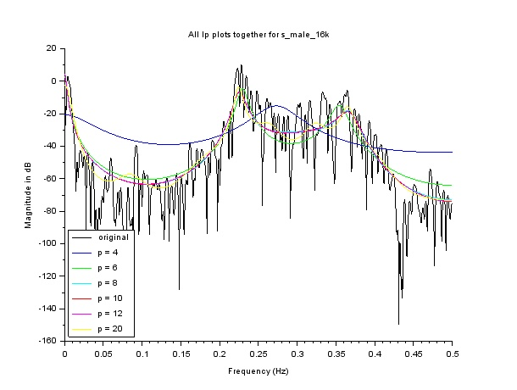

LPC spectrum for /s/ for different values of p

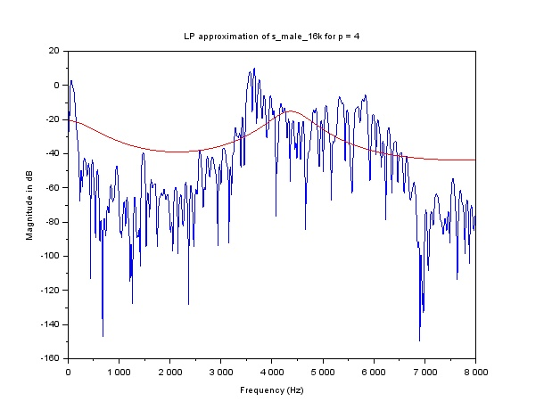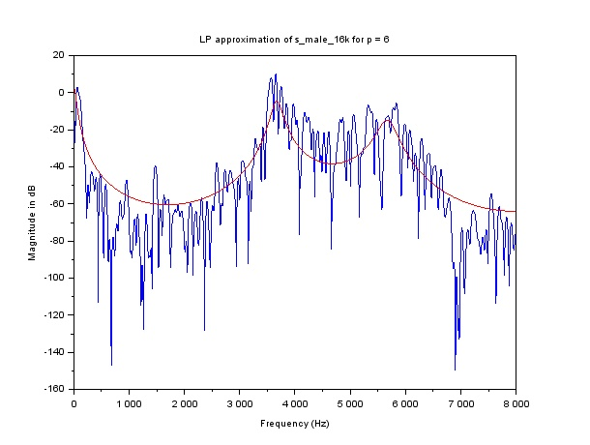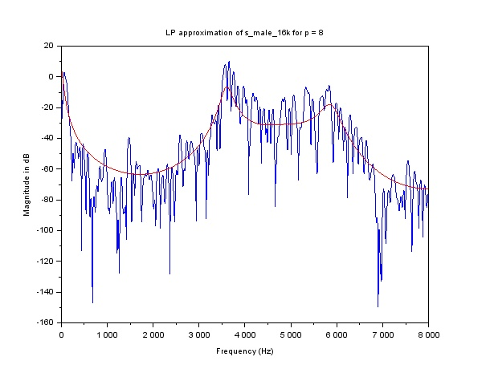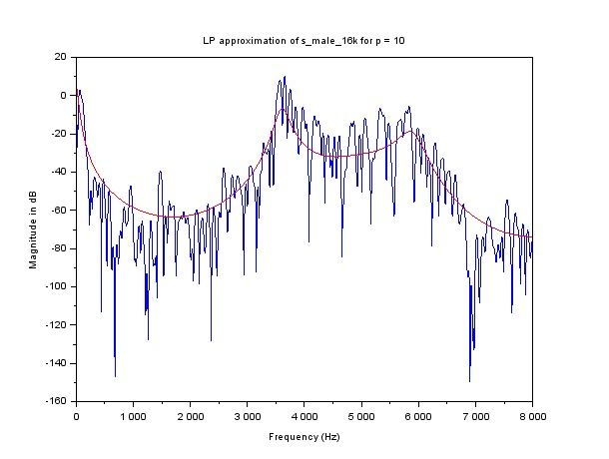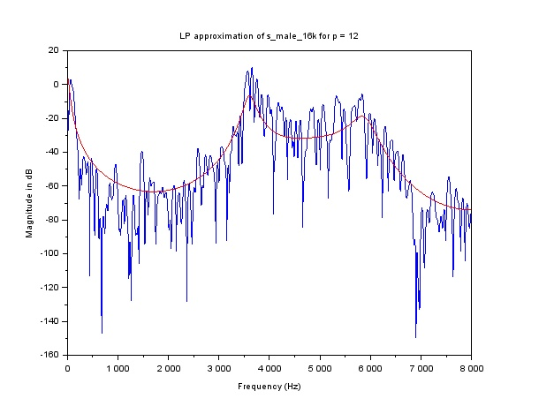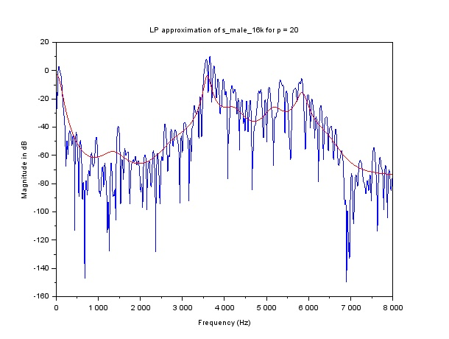

1. Error vs p

Error signal energy is plotted for given sounds. As p increases, error signal energy decreases. This is expected as a result of Levinson recursion. Note that absolute value of error energy is more for /a/, /i/ compared to /s/ and /n/, because vowels generally tend to have higher energy (abs(x[n]) is large -> acf(x[n]) will have larger values -> error will be more)

Error vs p plot for /a/

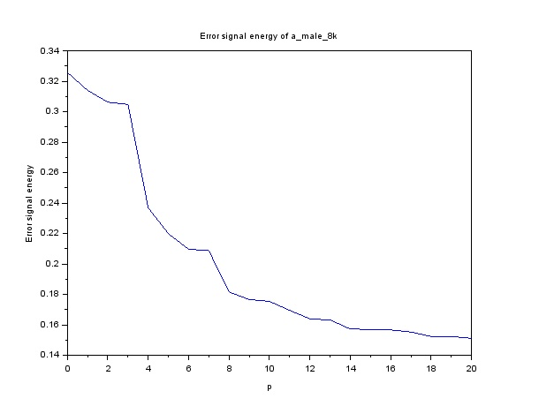

Error vs p plot for /i/

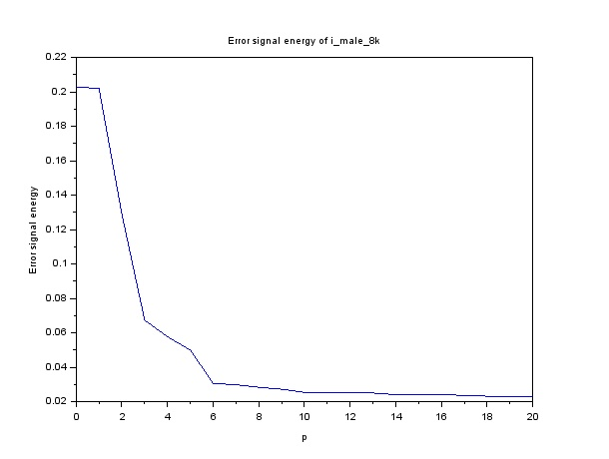

Error vs p plot for /n/

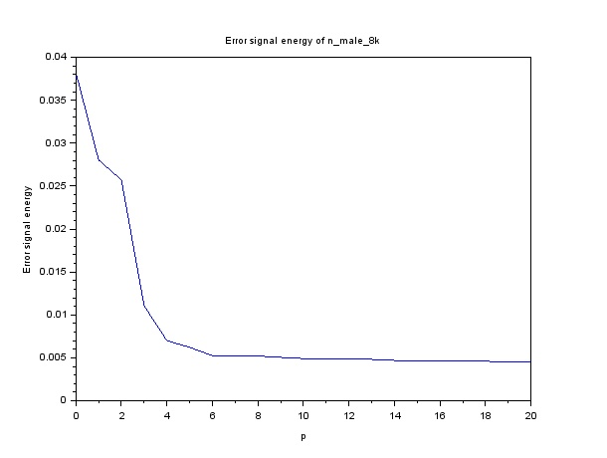

Erros vs p for /s/

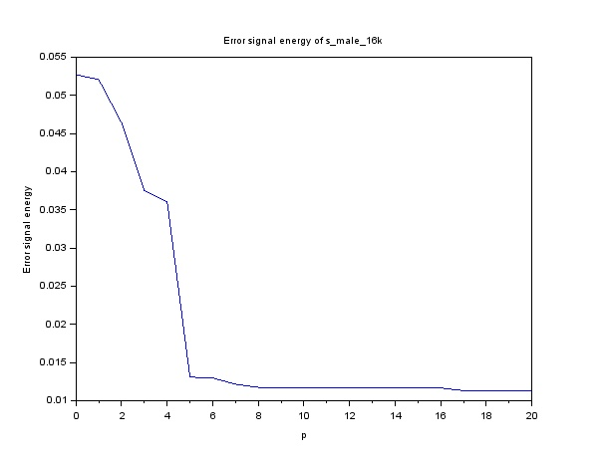

## Q2. Inverse Filtering

Following function implements inverse filter using linear difference equation.

### Code

*//inverse filter*

function **y**=inverse_filter(**x**, **num**, **den**)

**y** = zeros(length(**x**),1)

for i = 1:length(**x**)

for j = 1:min(length(**den**),i)

**y**(i) = **y**(i) + **den**(j)\***x**(i-j+1)

end

**y**(i) = **y**(i)/**num**

end

endfunction

### Results & Discussion

Residual signal is computed as the output of the corresponding inverse filter for /a/ and /s/. This residual signal approximates the source excitation signal. For voiced sound (/a/) source excitation is impulse train. Source excitation is white noise for unvoiced sound (/s/). This can be seen from the plots of residual signals. The pitch of the voiced sound (/a/) can be estimated using autocorrelation function of the residual signal. We compute the distance between successive peaks in the autocorrelation function of residual signal of /a/. The distance between the peaks was found to be 64. Therefore pitch frequency is 8000/64 = **125 Hz** which corresponds to pitch period of **8 ms.**

We observe that magnitude spectrum of residual /a/ contains harmonics (due to voiced nature). Such harmonics are not observed in case of /s/

Residual signal for /a/

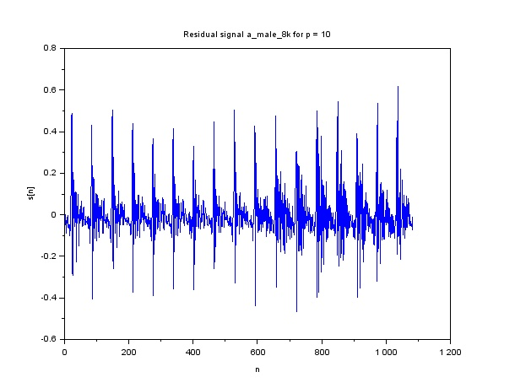

Residual signal for /s/

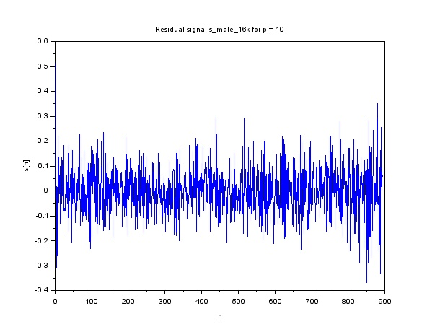

ACF of residual signal for /a/

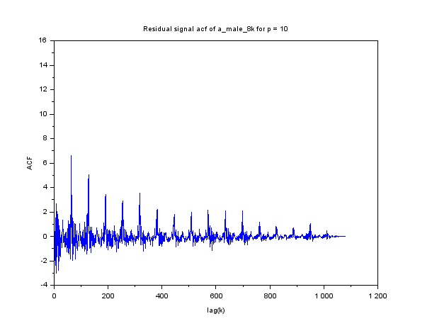

ACF of residual signal zoomed (for pitch estimation)

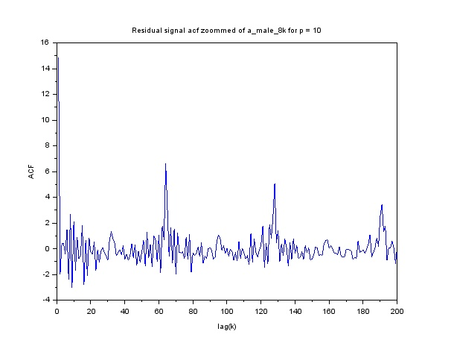

Magnitude spectrum of residual signal of /a/

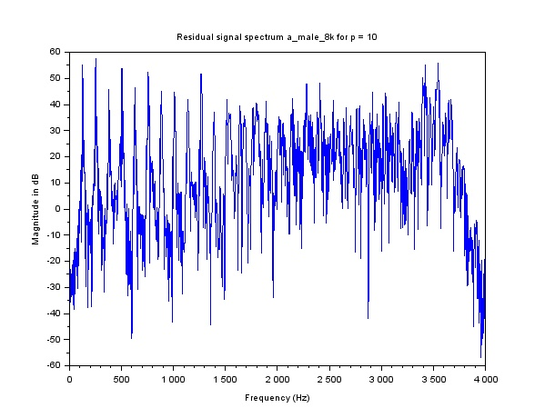

Magnitude spectrum of residual signal of /s/

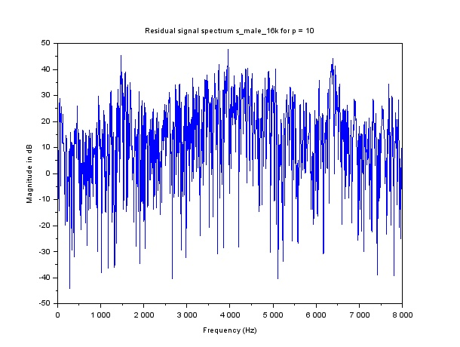

### Entire Code for Problem B

clear all

*//function to read previously generated wavefiles*

function **y**=read_file(**wavefile**)

**y** = loadwave(strcat(['../wav_files/Q2/',**wavefile**]));

endfunction

*//pre_emphasis filter*

function **y**=pre_emphasis_filter(**x**, **alpha**)

**y** = zeros(length(**x**))

**y**(1) = **x**(1)

for i = 2:length(**x**)

**y**(i) = **x**(i)-**alpha**\***x**(i-1)

end

endfunction

*//de_emphasis filter*

function **y**=de_emphasis_filter(**x**, **alpha**)

**y** = zeros(length(**x**))

**y**(1) = **alpha**\***x**(1)

for i = 2:length(**x**)

**y**(i) = **y**(i-1) + **alpha**\***x**(i)

end

endfunction

*//inverse filter*

function **y**=inverse_filter(**x**, **num**, **den**)

**y** = zeros(length(**x**),1)

for i = 1:length(**x**)

for j = 1:min(length(**den**),i)

**y**(i) = **y**(i) + **den**(j)\***x**(i-j+1)

end

**y**(i) = **y**(i)/**num**

end

endfunction

*//find windowed fft*

function [**X_mag**]=find_windowed_FFT(**x**, **window_type**, **N**, **n_fft**)

*//we can put this window anywhere on the signal. We will put it*

*//at the centre*

x_init = (length(**x**)+1)/2 - (**N**-1)/2

select **window_type**

case 'hamming' then

win_hamming = window('hm', **N**);

windowed_x = **x**(x_init: x_init + **N** - 1).*win_hamming;

case 'rect' then

windowed_x = **x**(x_init: x_init + **N** - 1)

end

*//zero padding*

pad = zeros(1,ceil((**n_fft** - **N**)/2));

padded_x = [pad windowed_x pad]

*//finding fft*

freq_x = fftshift(fft(padded_x))

**X_mag** = abs(freq_x(**n_fft**/2 +1:**n_fft**))

endfunction

*//1. Compute and plot the narrowband spectrum using a Hamming window*

*// of duration = 30ms before and after pre-emphasis.*

files_list = ["a_male_8k","i_male_8k","n_male_8k","s_male_16k"]

Fs_list = [8000,8000,8000,16000]

for i = 1:length(Fs_list)

x = read_file(files_list(i))

window_time = 30

Fs = Fs_list(i)

N = window_time*Fs/1000 + 1

n_fft = 10*N

[X_mag] = find_windowed_FFT (x,'hamming',N,n_fft)

freq_array = linspace(0,Fs/2,n_fft/2)

fig = scf()

x_preemph = pre_emphasis_filter(x,0.95)

[X_preemph_mag] = find_windowed_FFT (x_preemph','hamming',N,n_fft)

plot2d(freq_array,[20*log(X_preemph_mag)',20*log(X_mag)'],[2,5])

plot_title = strcat(['Spectrum before and after preemphasis of ',files_list(i)])

xtitle(plot_title,'Frequency (Hz)','Magnitude in dB')

legends(['after preemphasis','before preemphasis'],[2,5],opt = 6)

xs2jpg(gcf(), strcat(['../plots/Q2/',plot_title,'.jpg']));

end

*//2. Using a 30 ms Hamming window centered in the segment of the*

*// waveform preemphasised for the voiced sounds)*

do_emphasis_list = [1,1,1,0]

p_list = [4,6,8,10,12,20]

pole_zero_list = [6,10]

do_inverse_filtering = [1,0,0,1]

for iii = 1:length(Fs_list)

Fs = Fs_list(iii)

x = read_file(files_list(iii))'

if(do_emphasis_list(iii)==1)

x = pre_emphasis_filter(x,0.95)

end

x = x'

window_time = 30

N = window_time*Fs/1000 + 1

n_fft = 10*N

x_init = (length(x)+1)/2 - (N-1)/2

win_hamming = window('hm', N);

y = x(x_init: x_init + N - 1).*win_hamming;

r = zeros(length(y),1)

for ki=0:length(x)

for ni=ki:L-1

r(ki+1)=r(ki+1)+y(ni+1)*y(ni-ki+1);

end

end

delta_n = zeros(N,1)

delta_n(1) = 1

h_total = []

*//LP recursion*

p_max = 20

e_vec = [r(1)]

i = 1

k = r(2)/e_vec(1)

a_vec = [1,k]

e_vec = [e_vec,(1-(k)^2)*e_vec(1)]

for i = 2:p_max

k = r(i+1)

for j = 1:i-1

k = k - a_vec(j+1)*r(i-j+1)

end

k = k/e_vec(i)

a_vec_old = a_vec

a_new = k

for j = 1:i-1

a_vec(j+1) = a_vec_old(j+1)-k*a_vec_old(i-j+1)

end

a_vec = [a_vec , a_new]

e_vec(i+1) = (1-k^2)*e_vec(i)

*//overlapping LP approximation plot on windowed fft*

if (find(i==p_list) ~= [])

fig = scf()

h_padded = zeros(n_fft,1)

h_padded(1:length(y)) = y'

H = fftshift(fft(h_padded))

H_mag = abs(H(n_fft/2 +1:n_fft))

if(h_total == [])

h_total = [h_total,H_mag]

end

freq_array = linspace(0,Fs/2,n_fft/2)

plot(freq_array,20*log(H_mag))

num = sqrt(e_vec(i+1))

den = -a_vec(2:length(a_vec))

den = [1,den]

[h,w] = frmag(num,den,n_fft)

[h2,w2] = frmag(num,den,n_fft/2)

h_total = [h_total,h2']

plot(w*Fs,20*log(abs(h)),'red')

plot_title = strcat(['LP approximation of ',files_list(iii),' for p = ',string(i)])

xtitle(plot_title,'Frequency (Hz)','Magnitude in dB')

xs2jpg(gcf(), strcat(['../plots/Q2/',plot_title,'.jpg']));

end

*//plotting pole zero plots*

if(find(i == pole_zero_list)~=[])

fig = scf()

den = -a_vec(2:length(a_vec))

den = [1,den]

poles = roots(den)

plot2d([real(poles),zeros(length(poles),1)],[imag(poles),zeros(length(poles),1)],[-2,-3])

legends(['poles','zeros'],[-2,-3],opt = 'lr')

plot_title = strcat(['pole zero plot of ',files_list(iii),' for p = ',string(i)])

xtitle(plot_title,'Frequency (Hz)','Magnitude in dB')

ax=get("current_axes")

ax.data_bounds = [-1,-1;1,1]

xs2jpg(gcf(), strcat(['../plots/Q2/',plot_title,'.jpg']));

end

*//inverse filtering*

if((do_inverse_filtering(iii)) & (i == 10))

den = -a_vec(2:length(a_vec))

den = [1,den]

num = sqrt(e_vec(i+1))

residual_signal = inverse_filter(x,num,den)

fig = scf()

plot(residual_signal)

plot_title = strcat(['Residual signal ',files_list(iii),' for p = ',string(i)])

xtitle(plot_title,'n','s[n]')

xs2jpg(gcf(), strcat(['../plots/Q2/',plot_title,'.jpg']))

fig = scf()

h_padded = zeros(n_fft,1)

h_padded(1:length(residual_signal)) = residual_signal

H = fftshift(fft(h_padded))

H_mag = abs(H(n_fft/2 +1:n_fft))

freq_array = linspace(0,Fs/2,n_fft/2)

plot(freq_array,20*log(H_mag))

plot_title = strcat(['Residual signal spectrum ',files_list(iii),' for p = ',string(i)])

xtitle(plot_title,'Frequency (Hz)','Magnitude in dB')

xs2jpg(gcf(), strcat(['../plots/Q2/',plot_title,'.jpg']));

*//3. finding pitch period for voiced signals using ACF of residual signal*

*// and plotting magnitude spectrum of residual signal*

if(do_emphasis_list(iii)==1)

temp_res = length(residual_signal)*xcorr(residual_signal,["biased"])

acf_residual = temp_res(length(residual_signal):length(temp_res))

fig = scf()

plot(acf_residual)

plot_title = strcat(['Residual signal acf of ',files_list(iii),' for p = ',string(i)])

xtitle(plot_title,'lag(k)','ACF')

xs2jpg(gcf(), strcat(['../plots/Q2/',plot_title,'.jpg']));

*//63.5 is period*

acf_zoomed = acf_residual(1:200)

fig = scf()

plot(acf_zoomed)

plot_title = strcat(['Residual signal acf zoommed of ',files_list(iii),' for p = ',string(i)])

xtitle(plot_title,'lag(k)','ACF')

xs2jpg(gcf(), strcat(['../plots/Q2/',plot_title,'.jpg']));

pitch_period = Fs_list(iii)*63.5

end

end

end

*//plotting error vs p graph*

fig = scf()

plot([0:p_max],e_vec)

plot_title = strcat(['Error signal energy of ',files_list(iii)])

xtitle(plot_title,'p','Error signal energy')

xs2jpg(gcf(), strcat(['../plots/Q2/',plot_title,'.jpg']));

*//plotting all LP together*

fig = scf()

plot2d(w2,20*log(h_total),[1:(length(p_list)+1)])

plot_title = strcat(['All lp plots together for ',files_list(iii)])

xtitle(plot_title,'Frequency (Hz)','Magnitude in dB')

legends(['original','p = 4','p = 6','p = 8','p = 10','p = 12','p = 20'],[1:(length(p_list)+1)],opt = 3)

xs2jpg(gcf(), strcat(['../plots/Q2/',plot_title,'.jpg']));

end

xdel(winsid())