## **TITLE:** COVID-19 Detection and Classification

**TEAM MEMBERS:** NITIN BISHT, 21MM61R08

## NEMANTH KUMAR, 21MM61R09

**OBJECTIVE:** Automated detection and classification of COVID-19 based on supervised machine learning of chest X-ray images and its comparison with Deep Neural Network Models

**Classes:**

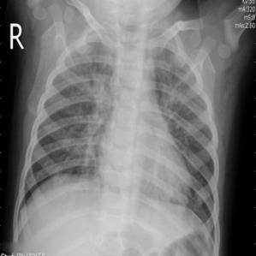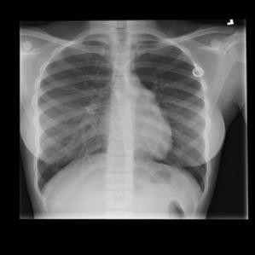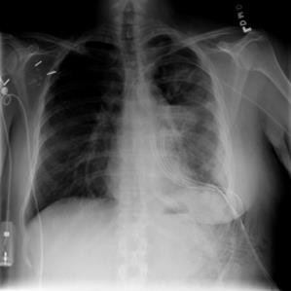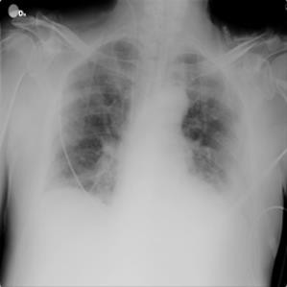

COVID

LUNG OPACITY

VIRAL PNEUMONIA

NORMAL

# Dataset to be used:

COVID-19 RADIOGRAPHY DATABASE

<https://drive.google.com/u/0/uc?id=1ZMgUQkwNqvMrZ8QaQmSbiDqXOWAewwou&export=download>

[The data has been modified by performing Data Augmentation(it didn’t help much though)]

# CONTRIBUTIONS

# Nitin Bisht: Supervised Learning Methods

# Nemanth Kumar : Deep Learning Methods

**NITIN BISHT:**

1. Performing Image Preprocessing Steps on the X-Ray Images i.e., Noise Removal, Thresholding of the images and finally applying morphological operations on the image
2. Segmentation of the images to find Region of Interest (ROI).
3. Creating a function that takes a sequence of images as an input, performs preprocessing steps, performs segmentation by creating appropriate mask and returns the images with the region of interest.
4. Extracting first order histogram and second order GLCM features and creating a csv file using it.
5. Creating a classification method (KNN/SVM/Random Forest) to classify the X-Ray images
6. Creating performance evaluation metrics to compare the models and predict the best model available.

**NEMANTH KUMAR:**

Used the Deep learning approach for the same problem. Followed following steps:

1. Collecting the dataset from the dataset mentioned.
2. categorizing it based on different classes
3. designing the model
4. splitting the data into train, test, and validation.
5. Data augmentation of the train images.

F) Training the model with two optimizers (Adam, SGD).

G) Plotting the model accuracy and the loss

H) Plotting the confusion matrix

**OUTPUT AFTER PREPROCESSING IMAGES AND .csv AFTER FEATURE EXTRACTION:**

<https://drive.google.com/drive/folders/1EuBGpBF6HN3ob3Y65SkAJDAWSvzHEXDw?usp=sharing>

**SAMPLES AFTER PREPROCESSING**

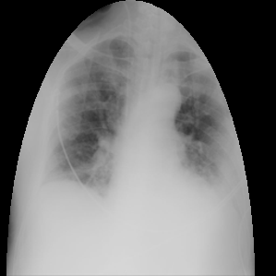

Fig a) Normal b) Pneumonia c) Lung Opacity d) COVID

**RESULTS AFTER SUPERVISED LEARNING**

|  |  |  |  |
| --- | --- | --- | --- |
|  | Random Forest | KNN | KNN |
| ACCURACY | 0.71 | 0.54 | 0.59 |
| F1 Score | 0.69 | 0.52 | 0.56 |

|  |  |  |  |
| --- | --- | --- | --- |
|  | Random Forest | KNN | SVM |
| Unprocessed Dataset | 0.73 | 0.55 | 0.53 |
| Processed Dataset | 0.71 | 0.52 | 0.54 |

Table 1 : Comparing both the models

Table 2: Comparing models with processed and unprocessed dataset

**RESULTS FOR UNSUPERVISED LEARNING**

|  |  |  |
| --- | --- | --- |
|  | Accuracy | F1 score |
| SGD Optimizer | 0.76 | 0.76 |
| Adam Optimizer | 0.84 | 0.84 |

|  |  |  |
| --- | --- | --- |
|  | Stochastic Gradient Descent | Adam Optimizer |
| Unprocessed Dataset | 0.84 | 0.84 |
| Processed Dataset | 0.76 | 0.74 |

Table 1 : Comparing both the model by changing optimizers

Table 2: Comparing optimizers with processed and unprocessed dataset

**LINK OF CODE**

**SUPERVISED LEARNING**

[**https://colab.research.google.com/drive/1um2jLkg7XOd8ba57Bw7so9o0Rshz1lIE?usp=sharing**](https://colab.research.google.com/drive/1um2jLkg7XOd8ba57Bw7so9o0Rshz1lIE?usp=sharing)

**DEEP LEARNING**

[**https://colab.research.google.com/drive/1Jta76iiJwmqgdWVuYr2p3nByHaxTnF9t?usp=sharing**](https://colab.research.google.com/drive/1Jta76iiJwmqgdWVuYr2p3nByHaxTnF9t?usp=sharing)

[**https://colab.research.google.com/drive/1bn1nD5ddotfzz61BHwxzNIz38V_0bAAv?usp=sharing**](https://colab.research.google.com/drive/1bn1nD5ddotfzz61BHwxzNIz38V_0bAAv?usp=sharing)

**CONCLUSION**

The deep learning model is giving significantly better result compared to Supervised learning techniques. However, ensemble methods like SVM+ Random forests can be tried which might improve supervised model further.