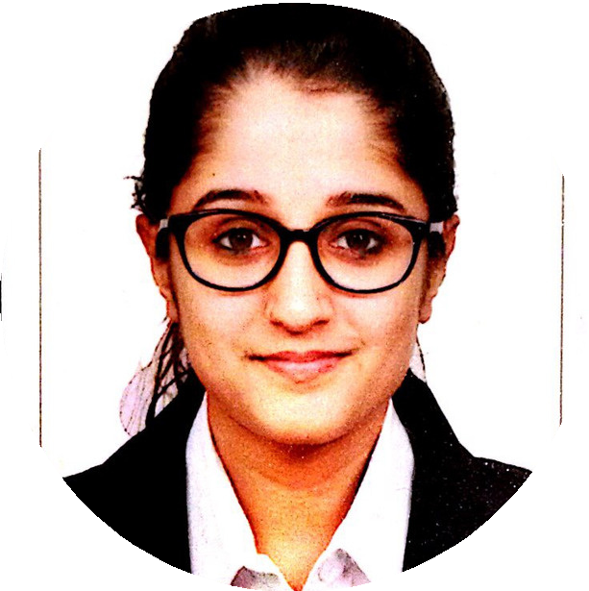

Delhi NCR, India [kanupriyaswami@gmail.com](mailto:kanupriyaswami@gmail.com)

+91-7757859888

linkedin.com/in/kanupriyaswami

**S K I L L S & E X P E R T I S E**

Java

Spring / Spring boot frameworks Hibernate

AWS

Microservices

Software Architecture & Design MySQL

MongoDB

Database Architecture Agile

Web services

**T O O L S**

Idea Intellij AWS

SQL Server Postman / Soap UI Confluence

Jira

**I N T E R E S T S**

-Hackathons

-Volunteering

KANUPRIYA SWAMI

**S E N I O R S O F T W A R E E N G I N E E R**

Senior software engineer with 5 years of experience in analysis, design, development, testing and implementation of various web services and applications. Experienced with all stages of the development cycle for dynamic web projects. Solutions are based on Java and AWS stack including MySQL while leveraging spring and spring boot frameworks.

# W O R K E X P E R I E N C E

**Senior Software Engineer**

Pitney Bowes | 2016 - Present

Proficiency in Java and latest frameworks like spring boot, hibernate, hystrix, etc.

Hands on experience with multiple AWS services such as Lambda, EC2, Kubernetes, S3, ECS, Route53, etc.

Amongst the first respondents in case of any malfunctioning on production environments or client-integration issues.

Building high volume micro-services used in catering to eCommerce products for clients such as USPS, eBay, PayPal, etc.

Tuning of existing complex modules to accommodate higher volume ramp-ups in tandem with development of new components.

Active involvement in requirement gathering by coordinating with onsite teams.

Cohesive worker having strong analytical, problem solving and interpersonal skills.

# P E R S O N A L P R O J E C T S

eCommerce Start-up (2019)

Strategized the business model by gaining a holistic perspective of the recently booming ecommerce startups.

Evaluated ecommerce technology stack and platforms to meet the business plan.

Spear-headed procurement of goods online via third party sales venues such as eProlo and Oberlo.

Performed extensive market research for thriving products in the western online markets.

Devised an efficient advertisement model based on the online channels Facebook and Google Ads

# E D U C A T I O N

**Bachelor Of Technology, Computer Science**

Symbiosis Institute Of Technology, Pune | 2012-2016 3.1/4.0 GPA

# A C H I E V E M E N T S

**Sprint Leadership Program | 2019**

Mentorship program for selected few employees on pan India level for overall enhancement of technical and leadership skills.

# Think Thursday Presentation | 2019

Demonstration of architecture and design process of a complex module on global company level

# Multiple in house awards

Received for outstanding achievements in a given quarter