To,

Sunny Jain

We are delighted that you have decided to work on this type of great startup project. We will be proud to work on this project. Thank you for giving us such an opportunity. Your Work Flow Diagrams of the project as your Request has been attached follow. If You found Any problem in this diagrams you can tell. We Are Waiting for Your reply……….

Thank you,

Kalpit Akhawat

9727331128

* **Company Registration**

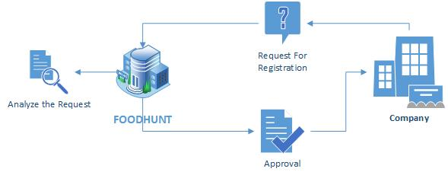

* **Ministore Application**

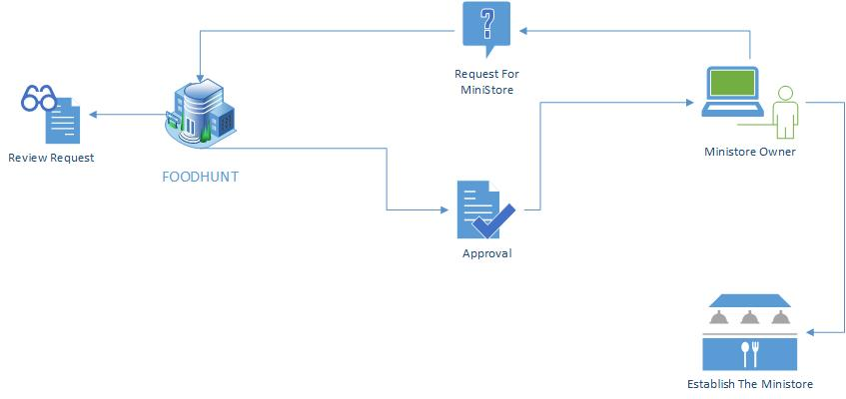

* **Distribution Channel**

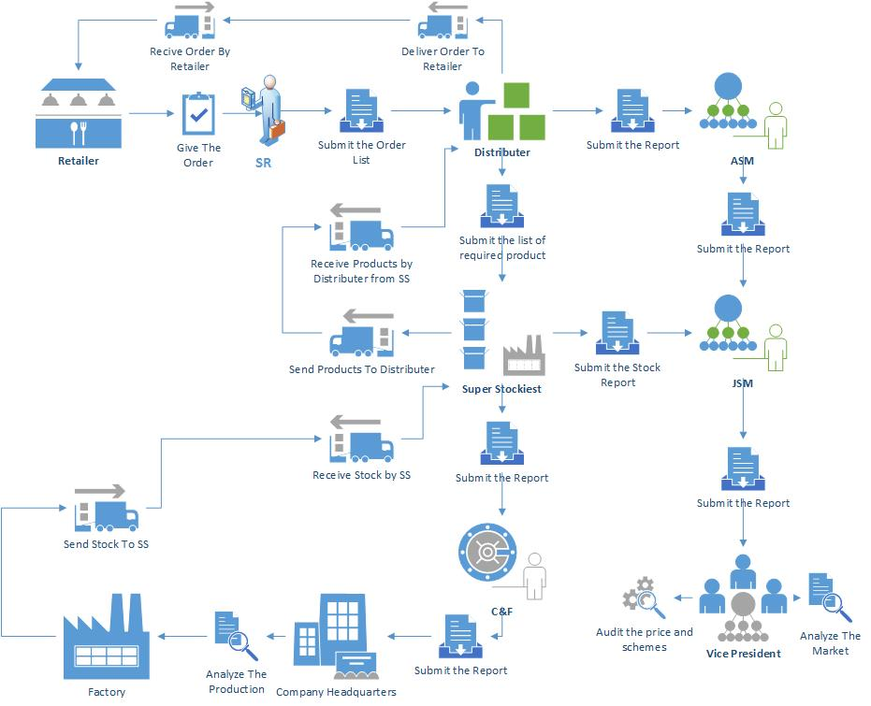

* **E-Commerce**

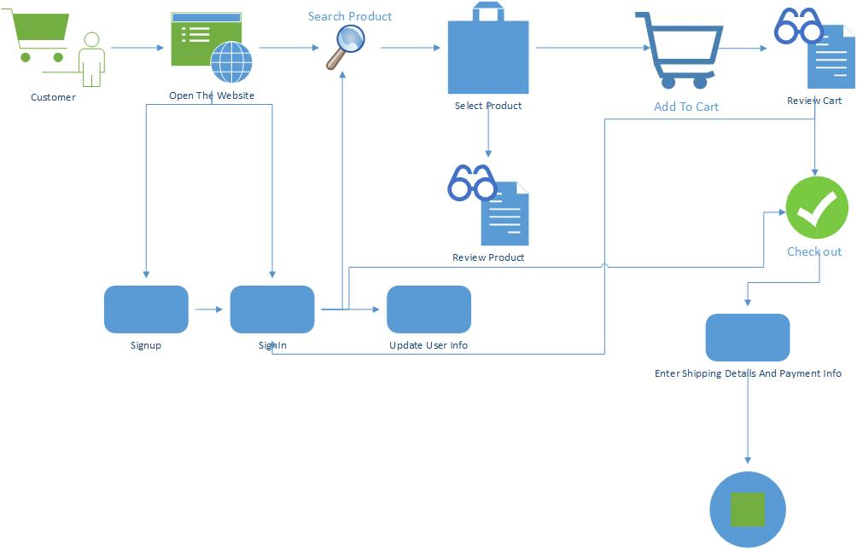

* **Shipping Channel in E-Commerce**

