**HELPING AN ART ENTHUSIAT**

**BACKGROUND**

You are in New York and this is your first time here. You have been visiting many different states of USA. You are an Art Enthusiast who is following a certain artist of America and have been visiting Art Museums of different cities which ultimately led you here in New York.

**PROBLEM**

Since you are in New York as a tourist and are visiting many famous places, you have heard that there are many Art Museums who showcase paintings of your favorite artist. The main problems here are that do not know which Art Museum showcase the work of your favorite artist and this is your first time in New York so you do not know about locations around.

**SOLUTION**

Using Foursquare API you can collect data of Art Museums in New York City and using the tips,photos and details and can collect all the necessary data of the closet art museum showcasing your favorite artist, you can see the ratings that place have and other necessary information. So as of now, we can pinpoint all the Art Museums in New York.

**METHODOLOGY**

There are certain things we need before we can implement what we want. We need to create a Foursquare API ID and an app in it. The Client ID and Client Secret would be used as to show the user who is searching and according to the account we have, we will be given extra information of the locality we are searching.

So having Client ID and Client Secret with us, we move forward.

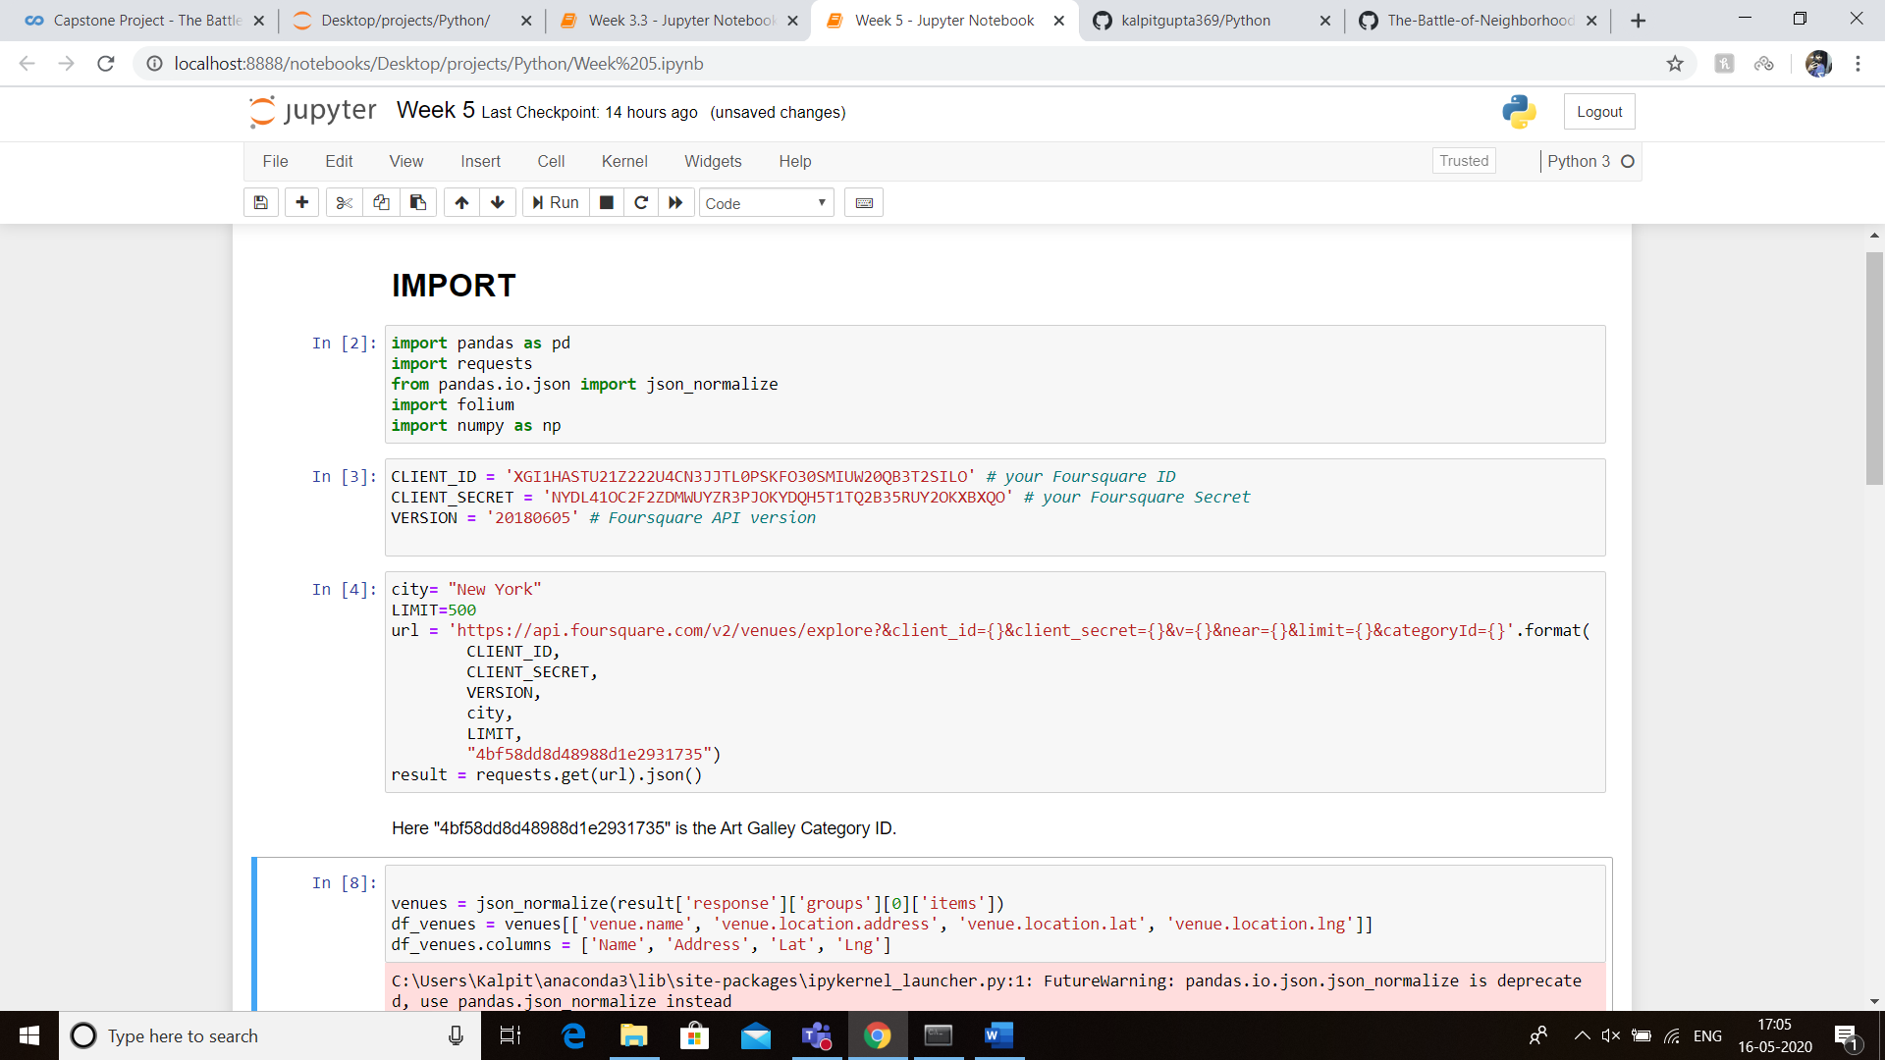

It is safe to assume that the location is already set to New York, since we are in New York. We are to shortlist neighborhoods that have art galleries.

Here to search of a particular type of location, we will use a category ID for that type of location.

For example, to find Art Gallery, we use

“4bf58dd8d48988d1e2931735” as the Category ID since it is represents Art Galleries.

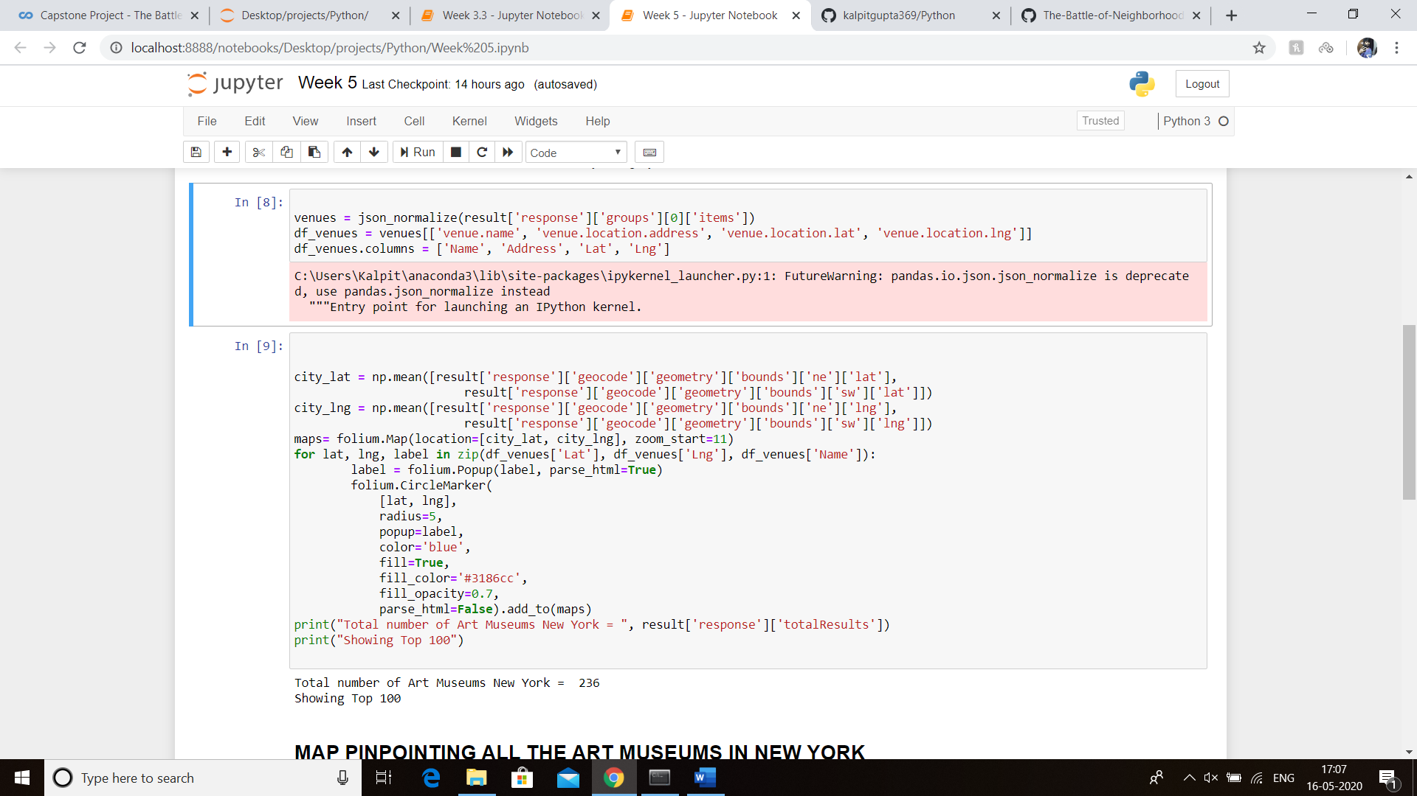

We have Client ID and Client Secret with us, we have already have New York City saved as the current location and also know what is the Category ID for Art Museums in New York.

As we can see, there are 236 Art Galleries in New York. So it is safe to assume that we have tons of options to visit and can explore new Artists for the sake of being an art enthusiast!

**CONCLUSION**

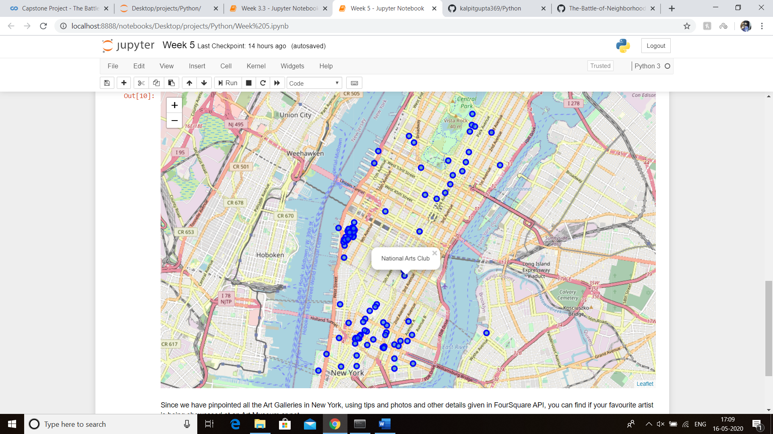

There are a total of 236 Art Galleries displayed. To check ratings and to see extra details of the venue we need not worry since Foursquare API does it for you, though free account does not have maximum benefits. Personally it would be advisable to visit the 23rd and 24th street since it is densely filled with Art Galleries and we would have a lot of options without travelling much.

THANK YOU FOR YOUR TIME!