V. Results
[Draft – Results section only. Section number, reference numbers and cross-references to the Methods/Experiments sections are placeholders to be aligned with the full manuscript.]
This section reports the performance of the two proposed model families, GraphMPNN for the acid and base dissociation constants (pKa) and the multi-factor mechanistic network (MFMN) family for human intravenous clearance (CL), steady-state volume of distribution (VDss) and fraction unbound in plasma (Fu), on the official held-out test split of each endpoint. Every model was trained on the official training split only, with ten random seeds (42–51); the reported prediction for each compound is the arithmetic mean of the ten seed predictions (hereafter, the 10-seed ensemble). Variability is reported in two complementary forms: (i) the mean ± sample standard deviation (SD) of the metric over the ten individually trained seeds, which quantifies training stochasticity, and (ii) a 95% confidence interval (CI) of the ensemble metric obtained by a nonparametric bootstrap over test compounds (B = 10 000 resamples with replacement, percentile interval), which quantifies uncertainty due to the finite test set. Pairwise comparisons between models use a paired bootstrap in which both models are evaluated on the same resampled compounds; a difference is reported as resolved when the 95% CI of the paired difference excludes zero.
pKa endpoints are evaluated in pKa units using the coefficient of determination (R²), mean absolute error (MAE), root mean squared error (RMSE) and the fraction of compounds predicted within one pKa unit (W1). CL, VDss and Fu are modeled in log₁₀ space; for these endpoints we report R², MAE and RMSE in log₁₀ units, the geometric mean fold error, GMFE = 10^(mean |log₁₀ ŷ − log₁₀ y|), and the fraction of compounds predicted within two-fold of the observed value (W2F). Lower is better for MAE, RMSE and GMFE; higher is better for R², W1 and W2F.

A. Performance of the Proposed Models
Tables I and II report the 10-seed ensemble performance of the proposed models, and Fig. 1 shows the corresponding parity plots. On pKa, GraphMPNN achieves an ensemble R² of 0.969 (95% CI 0.956–0.979) and an MAE of 0.424 pKa units on the acidic test set (n = 776), and an R² of 0.948 (0.934–0.959) with an MAE of 0.416 on the basic test set (n = 815). 91.0% and 89.9% of acidic and basic test compounds, respectively, are predicted within one pKa unit.
For the pharmacokinetic endpoints, the MFMN models reach an ensemble GMFE of 2.018 (95% CI 1.841–2.222) for CL, 1.764 (1.643–1.904) for VDss and 2.086 (1.980–2.203) for Fu, with W2F of 0.605, 0.684 and 0.613, respectively. The CL and VDss test sets each contain 177 compounds and the Fu test set 633 compounds; the CIs for CL and VDss are correspondingly wider (e.g., CL R² 0.366–0.602).
Across all five endpoints, the 10-seed ensemble outperforms the average individual seed on every metric. For example, CL R² is 0.497 for the ensemble versus 0.441 ± 0.020 for individual seeds, and pKa (acidic) MAE is 0.424 versus 0.484 ± 0.020. The seed-to-seed SD of R² is at most 0.029 across endpoints, with the largest values for VDss and CL.
Table I
Test-set performance of GraphMPNN on pKa (10-seed ensemble)
Endpoint | Metric | Ensemble [95% CI] | Seed mean ± SD
pKa (acidic) (n = 776) | R² | 0.969 [0.956, 0.979] | 0.963 ± 0.002
 | MAE | 0.424 [0.383, 0.471] | 0.484 ± 0.020
 | RMSE | 0.757 [0.622, 0.899] | 0.820 ± 0.025
 | W1 | 0.910 [0.889, 0.929] | 0.887 ± 0.010
pKa (basic) (n = 815) | R² | 0.948 [0.934, 0.959] | 0.937 ± 0.003
 | MAE | 0.416 [0.381, 0.452] | 0.472 ± 0.010
 | RMSE | 0.670 [0.591, 0.756] | 0.736 ± 0.016
 | W1 | 0.899 [0.879, 0.919] | 0.885 ± 0.009
Ensemble: mean prediction of 10 seeds; CI: compound-level bootstrap, B = 10 000. Seed mean ± SD over the 10 individually trained seeds. MAE and RMSE in pKa units; W1: fraction within 1 pKa unit.

Table II
Test-set performance of the MFMN models on CL, VDss and Fu (10-seed ensemble)
Endpoint – model | Metric | Ensemble [95% CI] | Seed mean ± SD
CL – MFMN-DynGate (n = 177) | R² | 0.497 [0.366, 0.602] | 0.441 ± 0.020
 | MAE | 0.305 [0.265, 0.347] | 0.324 ± 0.007
 | RMSE | 0.412 [0.357, 0.468] | 0.435 ± 0.008
 | GMFE | 2.018 [1.841, 2.222] | 2.109 ± 0.036
 | W2F | 0.605 [0.531, 0.678] | 0.579 ± 0.018
VDss – MFMN-InteractAux (n = 177) | R² | 0.648 [0.547, 0.730] | 0.609 ± 0.029
 | MAE | 0.247 [0.216, 0.280] | 0.259 ± 0.012
 | RMSE | 0.328 [0.284, 0.371] | 0.345 ± 0.013
 | GMFE | 1.764 [1.643, 1.904] | 1.814 ± 0.048
 | W2F | 0.684 [0.616, 0.751] | 0.670 ± 0.028
Fu – MFMN-DynGate + LW (n = 633) | R² | 0.712 [0.671, 0.749] | 0.681 ± 0.009
 | MAE | 0.319 [0.297, 0.343] | 0.337 ± 0.006
 | RMSE | 0.435 [0.403, 0.468] | 0.458 ± 0.006
 | GMFE | 2.086 [1.980, 2.203] | 2.173 ± 0.028
 | W2F | 0.613 [0.573, 0.649] | 0.588 ± 0.015
MAE and RMSE in log10 units; GMFE: geometric mean fold error; W2F: fraction within two-fold. LW: 1.25× training-loss weight for compounds with fu < 0.006. CI and seed statistics as in Table I.

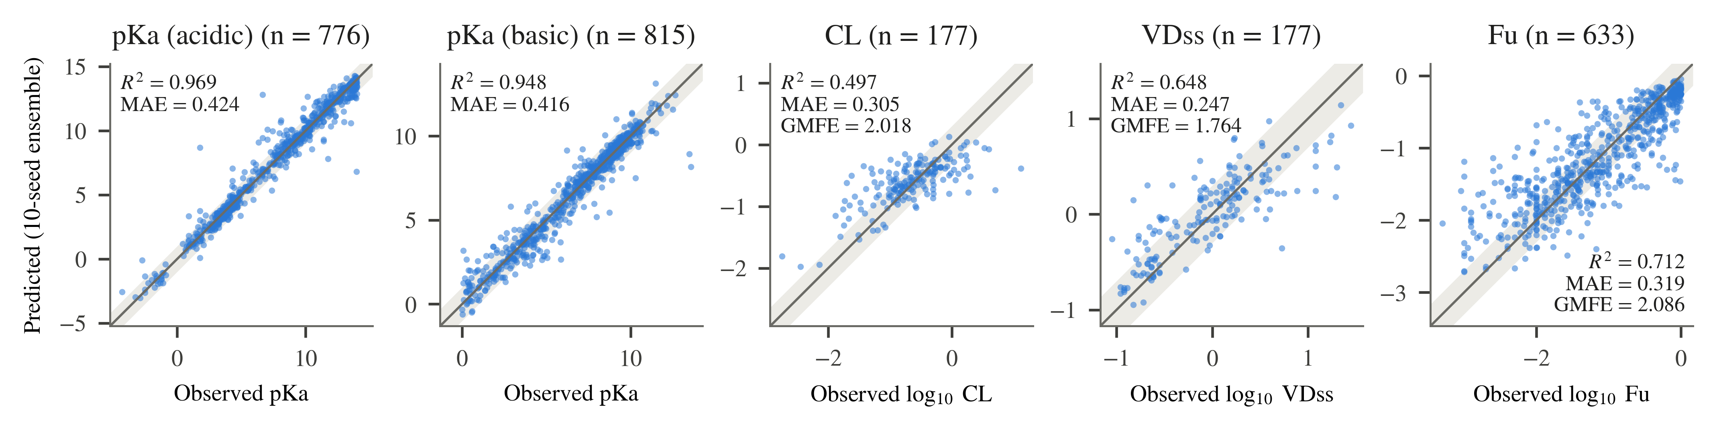
Fig. 1. Predicted versus observed values on the official test sets for the proposed models (10-seed ensemble). The solid line is the identity; the shaded band marks ±1 pKa unit (pKa) or two-fold error (CL, VDss, Fu). Inset metrics are ensemble values from Tables I and II.

B. Comparison With the Published Benchmark
Table III compares the 10-seed ensemble with the published benchmark values on the same official test splits: Jia et al. [REF: Jia et al., J. Med. Chem., 2025, 68(7), 7737–7750] for CL, VDss and Fu, and [NEEDS: citation for the pKa benchmark] for pKa. The benchmark reports point estimates only, so a paired test against it is not possible; instead, we report whether the published value lies inside the bootstrap 95% CI of the ensemble metric. Fig. 2 shows the relative differences.
The ensemble improves on the published value in 16 of the 21 metric–endpoint pairs for which a benchmark value is available. On both pKa endpoints, all three metrics improve and the published value lies outside the ensemble CI: MAE decreases from 0.61 to 0.424 (acidic) and from 0.67 to 0.416 (basic). For VDss, all five metrics improve (GMFE 1.764 vs. 1.88; W2F 0.684 vs. 0.62); of these, only the MAE improvement places the published value outside the ensemble CI.
For CL, the ensemble improves on R², MAE and RMSE (R² 0.497 vs. 0.48) but trails on GMFE (2.018 vs. 2.00) and W2F (0.605 vs. 0.64). For Fu, the ensemble improves on R² (0.712 vs. 0.69) and W2F (0.613 vs. 0.60) and trails on MAE, RMSE and GMFE (2.086 vs. 2.01). For all ten CL and Fu metrics, the published value lies inside the ensemble 95% CI.
The comparison depends on whether the ensemble or an individual model is considered. Using the seed-mean metric instead of the ensemble, the proposed models still improve on all pKa and VDss benchmark values, but on 0 of 5 CL metrics and 0 of 5 Fu metrics (e.g., CL seed-mean R² 0.441 vs. 0.48; Fu seed-mean R² 0.681 vs. 0.69).
Table III
Comparison of the 10-seed ensemble with the published benchmark (official test splits)
Endpoint | Metric | Published | Ensemble [95% CI] | Δ (ens. − pub.) | Pub. in CI | Seed mean
pKa (acidic) | R² | 0.94 | 0.969 [0.956, 0.979] | +0.029 | no | 0.963
 | MAE | 0.61 | 0.424 [0.383, 0.471] | −0.186 | no | 0.484
 | RMSE | 1.05 | 0.757 [0.622, 0.899] | −0.293 | no | 0.820
pKa (basic) | R² | 0.91 | 0.948 [0.934, 0.959] | +0.038 | no | 0.937
 | MAE | 0.67 | 0.416 [0.381, 0.452] | −0.254 | no | 0.472
 | RMSE | 0.98 | 0.670 [0.591, 0.756] | −0.310 | no | 0.736
CL | R² | 0.48 | 0.497 [0.366, 0.602] | +0.017 | yes | 0.441
 | MAE | 0.31 | 0.305 [0.265, 0.347] | −0.005 | yes | 0.324
 | RMSE | 0.42 | 0.412 [0.357, 0.468] | −0.008 | yes | 0.435
 | GMFE | 2.00 | 2.018 [1.841, 2.222] | +0.018 | yes | 2.109
 | W2F | 0.64 | 0.605 [0.531, 0.678] | −0.035 | yes | 0.579
VDss | R² | 0.60 | 0.648 [0.547, 0.730] | +0.048 | yes | 0.609
 | MAE | 0.28 | 0.247 [0.216, 0.280] | −0.033 | no | 0.259
 | RMSE | 0.35 | 0.328 [0.284, 0.371] | −0.022 | yes | 0.345
 | GMFE | 1.88 | 1.764 [1.643, 1.904] | −0.116 | yes | 1.814
 | W2F | 0.62 | 0.684 [0.616, 0.751] | +0.064 | yes | 0.670
Fu | R² | 0.69 | 0.712 [0.671, 0.749] | +0.022 | yes | 0.681
 | MAE | 0.30 | 0.319 [0.297, 0.343] | +0.019 | yes | 0.337
 | RMSE | 0.41 | 0.435 [0.403, 0.468] | +0.025 | yes | 0.458
 | GMFE | 2.01 | 2.086 [1.980, 2.203] | +0.076 | yes | 2.173
 | W2F | 0.60 | 0.613 [0.573, 0.649] | +0.013 | yes | 0.588
Bold marks the better value of Published vs. Ensemble. Published values: CL/VDss/Fu from Jia et al. [REF]; pKa from [NEEDS: citation]. No published W1/GMFE/W2F values are used for pKa. Published values were transcribed from the source; re-verify before submission.

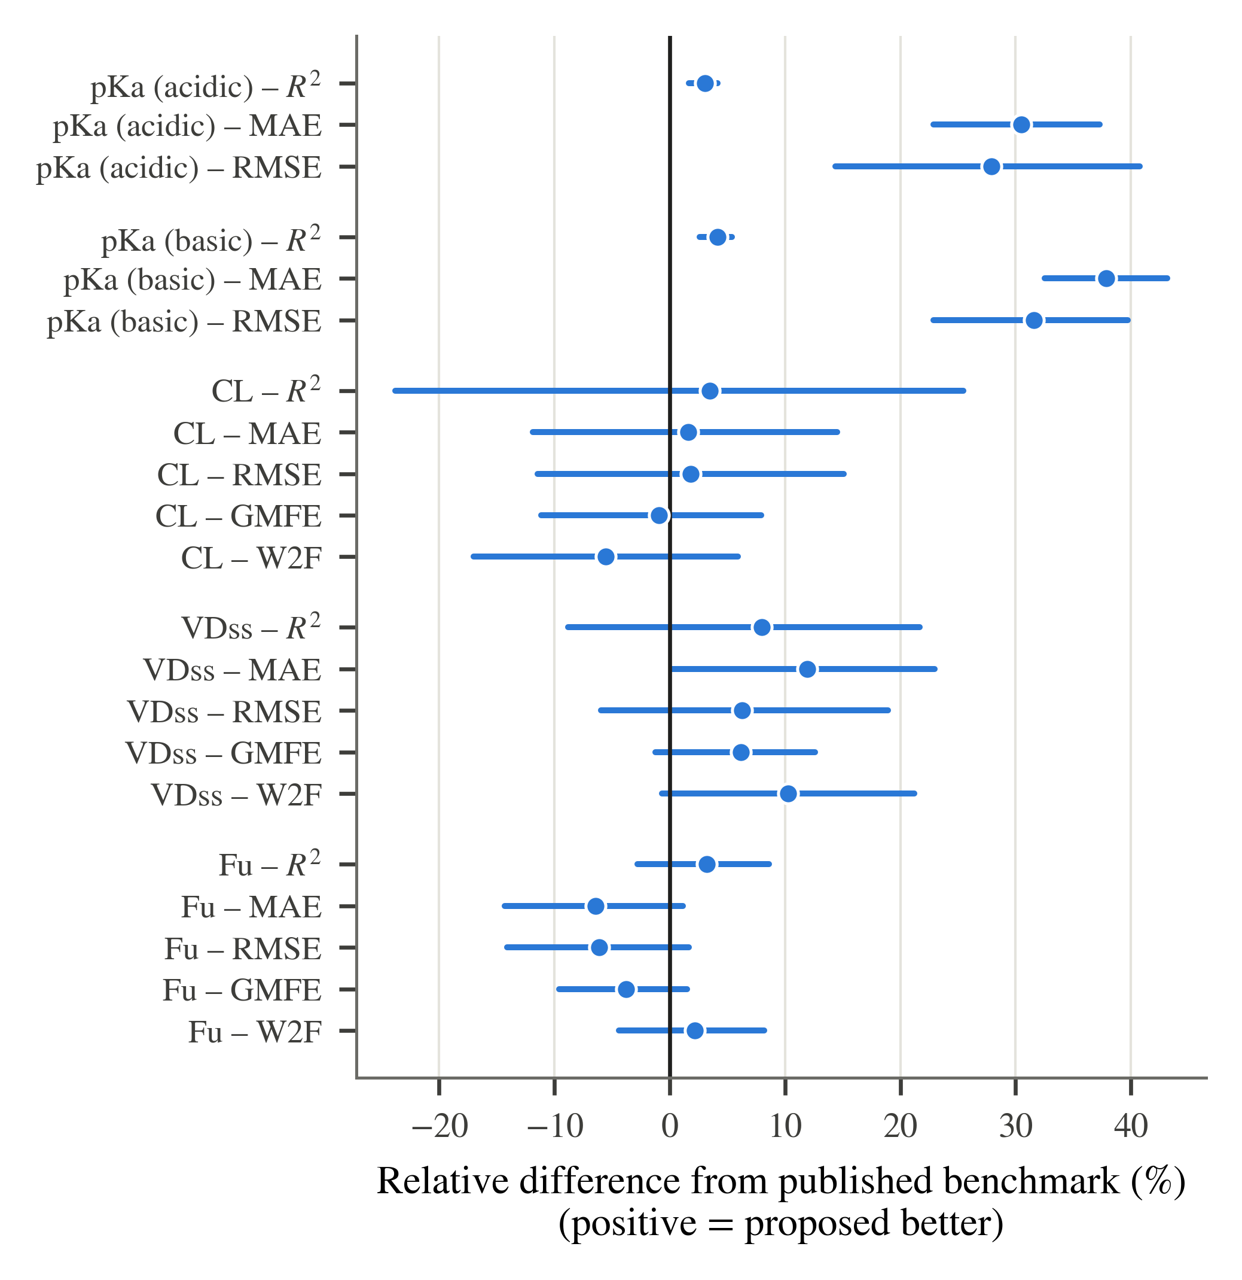
Fig. 2. Relative difference between the 10-seed ensemble and the published benchmark for each endpoint and metric, oriented so that positive values favor the proposed model. Dots: ensemble; bars: bootstrap 95% CI of the ensemble metric expressed relative to the published value. The vertical line marks parity with the benchmark.

C. Comparison With Untuned Classical Baselines
Table IV compares the proposed models with three classical regressors trained on the same training split and evaluated on the same test compounds in the same order: Random Forest (RF), XGBoost (XGB) and support vector regression (SVM), each with library-default hyperparameters (no tuning). RF was trained with seeds 42–51 and is reported as a 10-seed ensemble. With default settings, XGB uses no row or column subsampling, so all ten seeds produced identical predictions and its ensemble equals a single fit; SVM is deterministic and was fit once. Fig. 3 summarizes the headline error metric per endpoint.
On both pKa endpoints and on Fu, the proposed model has the better value on every metric against every baseline, and every paired-difference CI excludes zero. The strongest pKa baseline by MAE is RF on the acidic set (0.699 vs. 0.424 for GraphMPNN) and XGB on the basic set (0.701 vs. 0.416). On Fu, the strongest baseline is SVM (GMFE 2.284 vs. 2.086; R² 0.663 vs. 0.712).
On VDss, the proposed model has the better point estimate on every metric against all three baselines; the paired CIs exclude zero against XGB and SVM on all metrics, but include zero against RF on all metrics (GMFE 1.764 vs. 1.848, paired-difference CI [-0.212, 0.041]). On CL, the proposed model is better than XGB on all metrics with CIs excluding zero, but is not resolved from RF or SVM on any metric. RF has the better point estimate on CL for MAE (0.303 vs. 0.305), GMFE (2.010 vs. 2.018) and W2F (0.638 vs. 0.605), and SVM has the better point estimate for W2F (0.627).
Table IV
Proposed models versus untuned classical baselines (official test splits)
Endpoint / model | Metric values (metric names given in each endpoint row)
pKa (acidic) (n = 776) | R² | MAE | RMSE | W1
GraphMPNN | 0.969 | 0.424 | 0.757 | 0.910
Random Forest | 0.927† | 0.699† | 1.158† | 0.777†
XGBoost | 0.919† | 0.743† | 1.221† | 0.781†
SVM | 0.770† | 1.475† | 2.057† | 0.499†
pKa (basic) (n = 815) | R² | MAE | RMSE | W1
GraphMPNN | 0.948 | 0.416 | 0.670 | 0.899
Random Forest | 0.862† | 0.758† | 1.089† | 0.746†
XGBoost | 0.881† | 0.701† | 1.012† | 0.756†
SVM | 0.723† | 1.067† | 1.546† | 0.634†
CL (n = 177) | R² | MAE | GMFE | W2F
MFMN-DynGate | 0.497 | 0.305 | 2.018 | 0.605
Random Forest | 0.484 | 0.303 | 2.010 | 0.638
XGBoost | 0.374† | 0.355† | 2.266† | 0.497†
SVM | 0.485 | 0.310 | 2.042 | 0.627
VDss (n = 177) | R² | MAE | GMFE | W2F
MFMN-InteractAux | 0.648 | 0.247 | 1.764 | 0.684
Random Forest | 0.609 | 0.267 | 1.848 | 0.661
XGBoost | 0.485† | 0.307† | 2.026† | 0.588†
SVM | 0.542† | 0.283† | 1.919† | 0.610†
Fu (n = 633) | R² | MAE | GMFE | W2F
MFMN-DynGate + LW | 0.712 | 0.319 | 2.086 | 0.613
Random Forest | 0.630† | 0.379† | 2.391† | 0.488†
XGBoost | 0.643† | 0.365† | 2.316† | 0.531†
SVM | 0.663† | 0.359† | 2.284† | 0.534†
Metric names are given in each italic endpoint row (pKa: R², MAE, RMSE, W1; CL/VDss/Fu: R², MAE, GMFE, W2F). Proposed and RF: 10-seed ensembles; XGB: seed-invariant (single fit); SVM: single deterministic fit. Bold: best value per endpoint and metric. †: paired-bootstrap 95% CI of the difference (proposed − baseline) excludes zero in favor of the proposed model; no mark: CI includes zero. No baseline was resolved as better than the proposed model (‡ unused). Full metric set and difference CIs: supplementary table [NEEDS: supplementary reference].

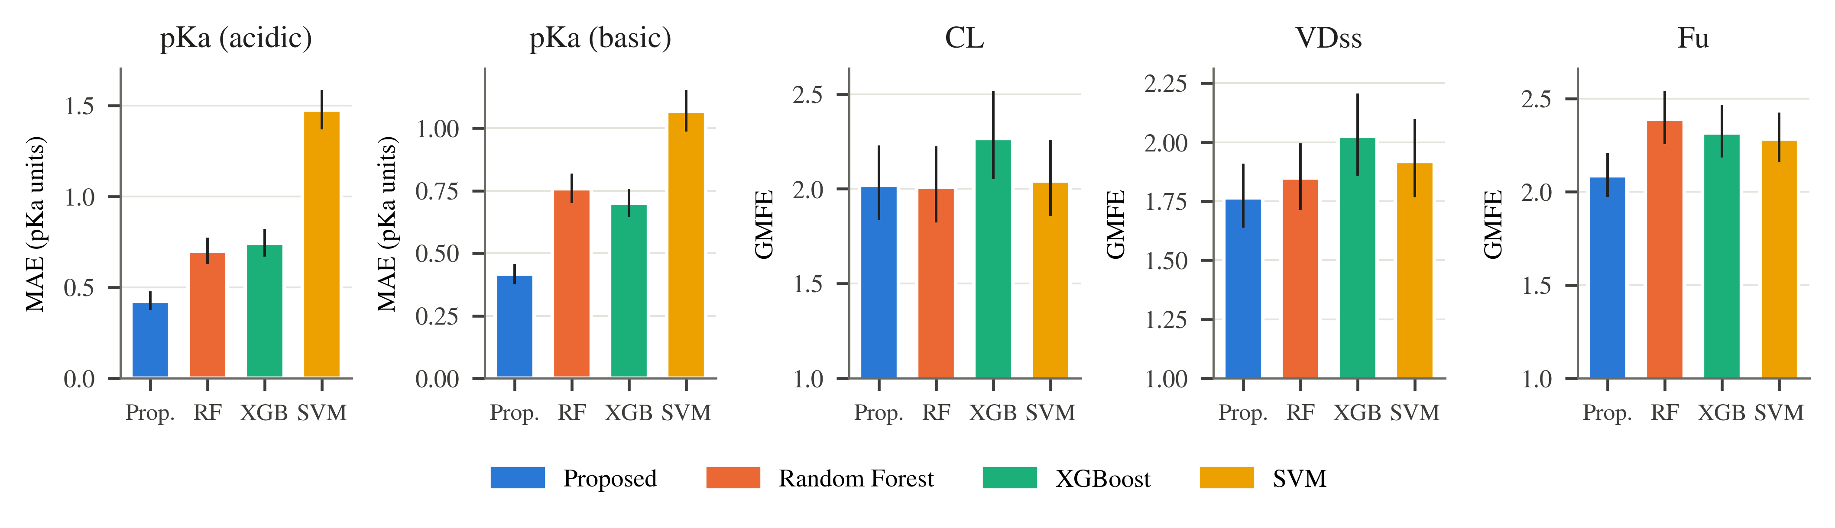
Fig. 3. Headline error metric of the proposed models and the untuned baselines on each official test set (MAE in pKa units for pKa; GMFE for CL, VDss and Fu; lower is better). Error bars: bootstrap 95% CI of each model's metric (B = 10 000). Proposed: GraphMPNN (pKa) or MFMN variant (CL, VDss, Fu).

D. Ablation Study
Table V reports a 10-seed ablation of the MFMN family on CL and VDss, retrained under the same protocol and test split as the final models. For each endpoint, the final model is compared with the base MFMN (no auxiliary supervision and no dynamic gating) and with the alternative MFMN variant that differs only in the gating mechanism (MFMN-InteractAux for CL; MFMN-DynGate for VDss). Fig. 4 shows the per-seed GMFE distributions.
On CL, the final MFMN-DynGate model has the best ensemble value on R², MAE, RMSE and GMFE (GMFE 2.018 vs. 2.036 for MFMN-InteractAux and 2.057 for the base MFMN) and ties MFMN-InteractAux on W2F (0.605). None of these differences is resolved by the paired bootstrap; all paired-difference CIs include zero. Across seeds, the SD of R² decreases from 0.076 (base) to 0.036 (InteractAux) and 0.020 (DynGate).
On VDss, the final MFMN-InteractAux model improves on the base MFMN on R², MAE, RMSE and GMFE with paired CIs excluding zero (GMFE 1.764 vs. 1.872; difference CI [-0.174, -0.047]); the W2F difference is not resolved. MFMN-InteractAux and MFMN-DynGate are not resolved on any metric (GMFE 1.764 vs. 1.771); MFMN-DynGate has the higher ensemble W2F (0.695 vs. 0.684) and a lower seed-to-seed SD of R² (0.009 vs. 0.029).
Table V
Ablation of the MFMN family on CL and VDss (10 seeds, official test splits)
Endpoint | Variant | R² | MAE | GMFE | W2F
CL | MFMN (base) | 0.468 (0.364 ± 0.076) | 0.313 (0.348 ± 0.022) | 2.057 (2.230 ± 0.114) | 0.571 (0.561 ± 0.034)
 | MFMN-InteractAux | 0.490 (0.426 ± 0.036) | 0.309 (0.329 ± 0.013) | 2.036 (2.135 ± 0.065) | 0.605 (0.591 ± 0.023)
 | MFMN-DynGate (final) | 0.497 (0.441 ± 0.020) | 0.305 (0.324 ± 0.007) | 2.018 (2.109 ± 0.036) | 0.605 (0.579 ± 0.018)
VDss | MFMN (base) | 0.571† (0.528 ± 0.029) | 0.272† (0.287 ± 0.009) | 1.872† (1.935 ± 0.040) | 0.655 (0.632 ± 0.022)
 | MFMN-DynGate | 0.647 (0.609 ± 0.009) | 0.248 (0.260 ± 0.004) | 1.771 (1.821 ± 0.017) | 0.695 (0.680 ± 0.010)
 | MFMN-InteractAux (final) | 0.648 (0.609 ± 0.029) | 0.247 (0.259 ± 0.012) | 1.764 (1.814 ± 0.048) | 0.684 (0.670 ± 0.028)
Entries: 10-seed ensemble (seed mean ± SD). Bold: best ensemble value per endpoint and metric (ties both bold). †: paired-bootstrap 95% CI of the difference (final − variant) excludes zero in favor of the final model; no mark: CI includes zero; no variant was resolved as better than the final model. The final-model rows are the retrained finals of Table II; the ablation variants were compared against the same test rows.

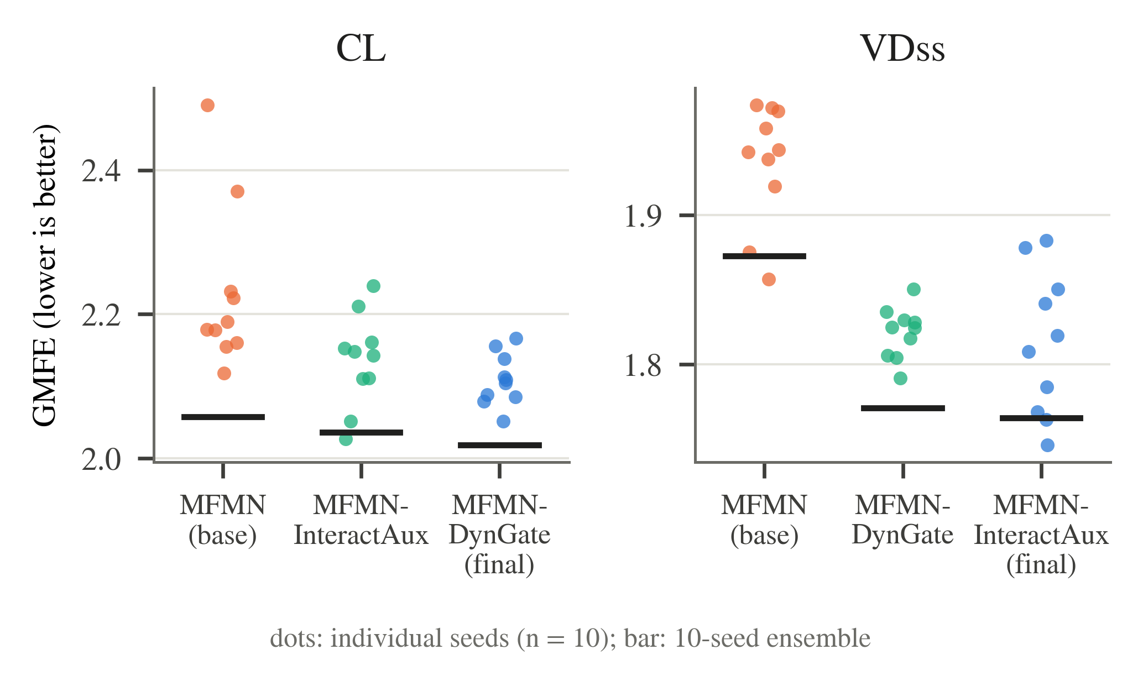
Fig. 4. Per-seed test GMFE (dots, n = 10 per variant) and 10-seed ensemble GMFE (horizontal bar) for the MFMN ablation on CL and VDss. Lower is better.
Ablation of GraphMPNN (pKa) and of the Fu recipe is not yet complete. Table VI is a placeholder for the 10-seed GraphMPNN ablation, in which the xTB-derived features, the edge gating and the ionizable-site readout are removed one at a time; these runs are in progress.
[PENDING: 10-seed GraphMPNN ablation (no xTB features, no edge gating, no site readout) for pKa (acidic) and pKa (basic). Note for authors: the code that produced the original single-seed ablation rows is not in the project; the variants were reconstructed and should be verified before these results are reported.]
[NEEDS: Fu ablation. The 10-seed Fu ablation (unweighted MFMN-DynGate; untuned base MFMN) did not pass the seed-42 reproduction check against the stored single-seed results and was not run. Either report the Fu ablation from a re-established protocol or state its absence in Limitations.]
Table VI
Ablation of GraphMPNN on pKa (10 seeds) — placeholder
Endpoint | Variant | R² | MAE | RMSE
pKa (acidic) | GraphMPNN (final) | 0.969 (0.963 ± 0.002) | 0.424 (0.484 ± 0.020) | 0.757 (0.820 ± 0.025)
 | w/o xTB features | PENDING | PENDING | PENDING
 | w/o edge gating | PENDING | PENDING | PENDING
 | w/o site readout | PENDING | PENDING | PENDING
pKa (basic) | GraphMPNN (final) | 0.948 (0.937 ± 0.003) | 0.416 (0.472 ± 0.010) | 0.670 (0.736 ± 0.016)
 | w/o xTB features | PENDING | PENDING | PENDING
 | w/o edge gating | PENDING | PENDING | PENDING
 | w/o site readout | PENDING | PENDING | PENDING
Final-model rows from Table I. Variant rows to be filled when the 10-seed runs complete.

