Graph and Factorized-Descriptor Neural Networks for Human Intravenous Pharmacokinetic Parameter Prediction: A Reproducible Benchmark Study
[Alternative titles for consideration: (a) Seed-Resolved Benchmarking of Graph and Descriptor Neural Networks for Human PK and pKa Prediction; (b) From Structure to Exposure: Graph Neural Networks for pKa and Pharmacokinetic Parameter Prediction. Author list, affiliations and corresponding-author details to be added.]

Abstract
Predicting human pharmacokinetics from chemical structure underpins candidate selection in drug discovery, yet reported gains are often difficult to separate from the variance of model training itself. We revisit the parameter-prediction stage of a recent intravenous pharmacokinetics benchmark and report five endpoints — acidic and basic acid dissociation constants (pKa), intravenous clearance (CL), steady-state volume of distribution (VDss) and fraction unbound in plasma (Fu) — each as a ten-seed ensemble trained on the official training split and scored once on the official held-out test split. An edge-gated graph message-passing network with semi-empirical quantum descriptors is used for pKa, and a factorized-descriptor network with per-compound dynamic gating and auxiliary supervision for the pharmacokinetic endpoints. On pKa the ensembles reach R² of 0.969 (acidic) and 0.950 (basic) with mean absolute errors of 0.424 and 0.406 pKa units, improving on the benchmark by margins that a paired bootstrap resolves on the subset where its own per-compound predictions are published; 7 of 23 paired metric–endpoint comparisons are resolved and all favour the proposed models. On CL, VDss and Fu the models are comparable to the benchmark, with no difference resolved. Propagating the predicted parameters through a fixed one-compartment exposure model yields no resolved improvement in predicted exposure, which we show is consistent with, rather than contrary to, the parameter-level result. Across all five endpoints the ten-seed ensemble exceeds the average single seed on every metric, and several architectural differences are smaller than the spread between random seeds — observations that bear on how such comparisons should be reported.
Index Terms—Pharmacokinetics, graph neural networks, molecular property prediction, acid dissociation constant, drug clearance, volume of distribution, model ensembling, reproducible benchmarking.

I. Introduction
The pharmacokinetic profile of a candidate molecule — how quickly it is cleared, how widely it distributes, and how much of it circulates unbound — determines whether a compound with promising potency can become a viable drug. Measuring these properties in humans is slow and expensive, so predicting them from chemical structure has become a standard part of early discovery [1], [2]. Recent work has moved from predicting isolated parameters towards predicting the full concentration–time profile, either by learning it directly [3], [4] or by feeding predicted physicochemical parameters into a mechanistic or physiologically based model [5]-[7]. Both strategies rest on the same foundation: the quality of the structure-derived parameter predictions that enter them [8], [9].
Fig. 1. Where structure-based parameter prediction sits in drug discovery. (1) Experimental determination of pharmacokinetic parameters is accurate but slow, resource-intensive and limited to one compound at a time. (2) Predicting the same parameters from structure — clearance, volume of distribution, fraction unbound and the ionization constants, which are the five endpoints modeled in this work — takes seconds per compound; the exposure shown is that obtained by propagating predicted parameters through an assumed compartmental model (Section III-H), not a learned concentration–time profile. (3) The resulting throughput allows candidates to be ranked before synthesis, at the stage where acting on an unfavourable profile is least costly. Computational screening narrows what reaches the laboratory; it does not replace experimental confirmation.
Graph neural networks are now the dominant representation for molecular property prediction, learning directly from the molecular graph rather than from precomputed descriptors [10], [11], and have been applied to absorption, distribution, metabolism, excretion and toxicity endpoints with multi-task and auxiliary-task formulations [12]. Augmenting such models with quantum-chemical information has been shown to improve property prediction further [13], and semi-empirical methods make that information affordable at screening scale [14]. For acid dissociation constants in particular — a property that governs ionization state and therefore permeability, binding and clearance — graph-based and transfer-learning approaches have become the methods of choice [15], [16].
Two difficulties complicate the interpretation of reported gains. First, published comparisons usually report a single aggregate value per metric, so a reader cannot tell whether an improvement is larger than the uncertainty of the test set, and a paired statistical test against the prior model is generally impossible. Second, neural network results vary with the random seed, and comparisons between a new architecture and its ablations are frequently reported from a single training run; the ensembling and uncertainty literature has repeatedly shown this variation to be substantial [17]. Together these make it difficult to reproduce and to trust incremental improvements, a concern that extends across cheminformatics more broadly [18].
This work addresses the parameter-prediction stage of the intravenous pharmacokinetics benchmark of Jia et al. [19], which reports five structure-derived endpoints and then uses them to predict concentration–time profiles. We retain that benchmark's official training and test splits exactly, so results are directly comparable, and we report every endpoint as a ten-seed ensemble with the seed-level spread stated alongside. Our contributions are:
- Two model families for the five endpoints: an edge-gated graph message-passing network incorporating semi-empirical quantum descriptors for the two pKa constants, and a factorized-descriptor network with per-compound dynamic gating and mechanistically grounded auxiliary supervision for CL, VDss and Fu.
- A statistically explicit comparison with the published benchmark: bootstrap confidence intervals for every metric, and — on the subset for which the benchmark publishes its own per-compound predictions — a paired test, which is the stronger comparison and which to our knowledge has not previously been applied to this benchmark.
- A ten-seed ablation of both architectures in which component contributions are reported against the seed-to-seed spread, showing that several architectural differences are not resolvable at these test-set sizes.
- An analytic propagation of the predicted parameters to exposure under a fixed one-compartment model, isolating how much parameter error propagates into predicted area under the curve and maximum concentration while holding the downstream model constant.
All predictions, per-seed metrics and the scripts that generate every table and figure in this paper are released with the work.

II. Datasets
All five endpoints use the curated modeling sets and the official training/test partition published with the benchmark [19], which aggregates human intravenous pharmacokinetic parameters and experimental pKa values from public compilations and chemical databases [20], [21]. Retaining the published partition unchanged is what makes the comparison in Section IV meaningful: no compound in any test split was seen during training by either the benchmark models or ours.
Table I
Modeling sets and target distributions for the five endpoints
Endpoint | Train | Test | Unit | Transform | Range (linear) | Median
pKa (acidic) | 5,296 | 776 | pKa units | none | −4.37 to 14.00 | 8.71
pKa (basic) | 5,674 | 815 | pKa units | none | 0.00 to 15.70 | 7.76
CL | 1,287 | 177 | L h⁻¹ kg⁻¹ | log₁₀ | 2.22×10⁻⁴ to 64.2 | 0.282
VDss | 1,287 | 177 | L kg⁻¹ | log₁₀ | 0.002 to 1114.6 | 1.20
Fu | 4,042 | 633 | fraction | log₁₀ | 5.0×10⁻⁴ to 1.00 | 0.0676
Train counts are the compounds actually fitted. For the two pKa endpoints these are 10 and 13 fewer than the published modeling-set sizes (5,306 and 5,687), because compounds whose 3D conformer embedding failed are excluded; test splits are unaffected and match the published sizes exactly. Ranges and medians are of the labeled pool. CL, VDss and Fu are modeled in log₁₀ space and scored there, with fold-error metrics computed after back-transformation; pKa is modeled and scored directly in pKa units, which may be negative.

An internal validation set of 15% of the training split is held out at each seed for early stopping; it is drawn from the training split only, so the test split is used exactly once per endpoint, for the final evaluation. For CL and VDss, which share a compound pool, the two endpoints' train/test assignments agree on every compound labeled for both.
Semi-empirical quantum-chemical descriptors are used by both model families. For the pKa models these are per-atom partial charges, the summed and maximum partial charge of each heavy atom's attached hydrogens, and Wiberg bond orders; for CL and VDss they are whole-molecule frontier-orbital energies, the HOMO–LUMO gap and the dipole moment. [NEEDS: the semi-empirical Hamiltonian and implicit-solvation model used to generate these descriptors are not recorded in the released package — the generating scripts sit in a parent project. State them explicitly here before submission; they must not be inferred.]

III. Methodology

A. Overview
The five endpoints are addressed by two model families, chosen because the best representation differs by endpoint. The acid and base dissociation constants are properties of the molecular graph and its electronic structure, and are modeled by a message-passing network operating on that graph (Fig. 3). Clearance, volume of distribution and fraction unbound are whole-organism properties with smaller labeled sets, and are modeled by a compact factorized-descriptor network in which named physicochemical descriptor groups are kept in separate pathways (Fig. 4). Fig. 2 shows how the two families share a common input representation, training protocol and evaluation.
Fig. 2. Overview of the prediction framework. A molecule is converted to a combined representation — a molecular graph, physicochemical descriptors, structural fingerprints, a shared descriptor context and semi-empirical quantum-chemical quantities — from which two model families branch. The ionization constants are predicted by a site-aware graph message-passing network, with the site readout used for the acidic endpoint and removed for the basic one; clearance, volume of distribution and fraction unbound are predicted by the factorized-descriptor network, whose variant, gating and auxiliary supervision differ by endpoint. Both families follow the same protocol: the official split, ten independent seeds averaged into an ensemble prediction, and fold-error or pKa-unit metrics with bootstrap intervals. Quantum-chemical features enter the graph models as per-atom charges and bond orders and the CL and VDss models as whole-molecule frontier-orbital terms; the Fu model uses deterministic descriptors only. Figs. 3 and 4 detail the two architectures.
[Figure placeholder — GraphMPNN architecture diagram to be inserted]

Fig. 3. Architecture of the edge-gated graph message-passing network used for the two pKa endpoints. Placeholder; diagram to be supplied.
[Figure placeholder — MFMN architecture diagram to be inserted]

Fig. 4. Architecture of the factorized-descriptor network (MFMN) used for CL, VDss and Fu, showing the seven mechanistic factor pathways, the shared context, the dynamic gate and the auxiliary heads. Placeholder; diagram to be supplied.

B. Molecular Representation
For the pKa models each molecule is represented as a heavy-atom graph. Every atom carries a 36-dimensional feature vector: one-hot encodings of element, heavy-atom degree, formal charge, hybridization and total hydrogen count; binary aromaticity and ring-membership flags; three semi-empirical quantities (the atom's partial charge and the sum and maximum of its attached hydrogens' partial charges); and a binary flag marking the ionizable site. Each bond carries an eight-dimensional vector: a one-hot bond type, conjugation and ring flags, and the Wiberg bond order. Hydrogens are not represented as nodes; their influence enters through the hydrogen-count and attached-charge features.
The ionizable site is located by an ordered list of SMARTS patterns, the first match being taken so that multi-acid or multi-base molecules receive one determinate site. For the acidic endpoint a site is found for 92.9% of compounds (79.0% matching a strong rather than a weak fallback pattern); for the basic endpoint, 60.7%. Where no site is found the flag is zero for every atom and no site embedding is formed; a site is never guessed.
For CL, VDss and Fu each molecule is described by a shared context vector together with seven factor-specific descriptor blocks, named for the mechanisms they represent: size, lipophilicity, ionization, polarity, binding, electronic and structural. For CL and VDss the context is formed by pruning and standardizing two-dimensional descriptor sets, reducing them to 32 principal components and appending 167 structural keys, giving 199 dimensions; the factor blocks total 19 descriptors, with ionization and binding supplied by separately predicted pKa and unbound-fraction values. For Fu the context instead uses variance and correlation pruning with circular fingerprints appended and no dimensionality reduction (1,419 dimensions), and the factor blocks are built entirely from deterministic descriptors (46 in total), so that no fitted predictor of the target enters the pipeline. Every fitting step — imputation, scaling, pruning, decomposition — is performed on the training fold only.

C. Graph Message-Passing Network
Atom features x_i are projected to a hidden state, which is then refined by L message-passing layers. Writing h_i for the state of atom i, A_ij for the binary adjacency, e_ij for the bond feature vector and σ for the logistic function:
h_i⁽⁰⁾ = SiLU(W₀ x_i + b₀) (1)
g_ij = σ(W₂ · SiLU(W₁ e_ij + b₁) + b₂) (2)
m_i⁽ˡ⁾ = Σ_j A_ij · g_ij ⊙ (W_m h_j⁽ˡ⁾ + b_m) (3)
h_i⁽ˡ⁺¹⁾ = h_i⁽ˡ⁾ + Dropout( GRU( m_i⁽ˡ⁾ , h_i⁽ˡ⁾ ) ) (4)
⊙ denotes the elementwise product. The bond-conditioned gate g_ij in (2) modulates each neighbour's contribution per hidden channel rather than through a full edge-conditioned weight matrix, which keeps the cost of the pairwise term linear in the hidden width. Aggregation in (3) is a plain sum over bonded neighbours; because the adjacency has a zero diagonal, an atom's own state re-enters only as the recurrent state of the gated update in (4). Padded positions are re-zeroed after each residual addition.
After L layers the atom states are pooled over the valid atoms by masked mean and masked maximum, and concatenated with the embedding of the ionizable site atom s (zeroed when no site was found) to form the molecular readout:
r = LayerNorm( [ h_s⁽ᴸ⁾ ‖ mean_i h_i⁽ᴸ⁾ ‖ max_i h_i⁽ᴸ⁾ ] ) (5)
A two-layer head maps r to the predicted pKa. With a hidden width of 128 and four layers the model has 587,905 parameters. For the basic endpoint the site term of (5) is omitted, giving a two-block readout and 571,265 parameters; the atom-level site flag is retained in either case.

D. Factorized-Descriptor Network
Each of the seven mechanistic factors f receives the shared context c concatenated with its own descriptor block x_f, and is embedded into a narrow factor latent. In the dynamically gated variant a second branch, taking the same input, produces a per-compound gate:
v_f = Dropout( SiLU( W_f [ c ‖ x_f ] + b_f ) ) (6)
z_f = v_f ⊙ σ( W_f^g [ c ‖ x_f ] + b_f^g ) (7)
The gate is conditioned on the individual compound, so a factor can be attenuated for one molecule and not another; in the ungated variants z_f = v_f. The factor latent is deliberately narrow (eight dimensions), forming a bottleneck that keeps each mechanistic pathway separate.
Pairwise interactions between factors are captured by projecting each factor latent to a rank-k vector and taking the sum over factor pairs, evaluated in linear rather than quadratic time by the identity:
ι = ½ [ ( Σ_f u_f )² − Σ_f u_f² ], u_f = W_f^ι z_f + b_f^ι (8)
The concatenation [z₁ ‖ … ‖ z₇ ‖ ι] is passed to a per-target two-layer pathway. For CL and VDss each factor additionally carries an auxiliary head predicting one real, measurable property matched to that factor's mechanism — molecular weight for size, the partition coefficient for lipophilicity, the frontier-orbital gap for electronic, and so on — supervised jointly with the main target:
ℒ = SmoothL1_{β=0.5}(ŷ, y) + λ Σ_f [ Σ_n m_n^f (â_n^f − a_n^f)² / Σ_n m_n^f ] (9)
m^f masks compounds for which the auxiliary property is unavailable, so a factor contributes only where its target is observed. λ is 0.8 for CL and 2.0 for VDss. Fu uses no auxiliary supervision, since the side-signals available for CL and VDss are not valid for that endpoint; instead its training loss is a weighted mean that upweights the sparsely populated low-unbound tail by a factor of 1.25 for compounds with fu below 0.006.

E. Training Protocol
Every model is trained on the official training split only, with ten random seeds (42–51). Targets are standardized using training-fold statistics and predictions are inverted before scoring. The reported prediction for each compound is the arithmetic mean of the ten seeds' predictions. Training configurations are given in Table II.
All training and evaluation was performed on an NVIDIA DGX A100 server. Runs are made deterministic by fixing the Python, NumPy and PyTorch seeds, restricting intra-op threading, and enabling deterministic cuDNN kernels.
Table II
Training configuration for the two model families
Setting | pKa models | Pharmacokinetic models
Architecture | GraphMPNN | MFMN family
Endpoints | pKa (acidic), pKa (basic) | CL, VDss, Fu
Hidden / factor width | 128, 4 layers | 8 per factor, 7 factors
Dropout | 0.1 (0.2 in head) | 0.2 (0.35 for Fu)
Optimizer | AdamW | AdamW
Learning rate | 5×10⁻⁴ | 3×10⁻³
Weight decay | 1×10⁻⁵ | 1×10⁻² (3×10⁻² for Fu)
Batch size | 64 | 128
Max epochs | 300 | 400
LR schedule | cosine annealing | cosine annealing
Gradient clipping | 5.0 | 1.0
Early-stopping patience | 40 epochs | 50 epochs
Validation fraction | 0.15 | 0.15
Primary loss | smooth L1, β = 0.5 | smooth L1, β = 0.5
Seeds | 42–51 | 42–51
Parameters | 587,905 / 571,265 | 12,976 – 161,400
Early stopping monitors validation error on a 15% split of the training data, with the best state restored before test prediction. The two parameter counts for the pKa models correspond to the full readout and to the variant without the site term; the range for the pharmacokinetic models spans the CL/VDss and Fu feature configurations.

F. Model Complexity and Computational Cost
The two families differ in cost by three orders of magnitude, which is worth stating because it bears on where each is worth deploying. Table III reports trainable parameters, forward floating-point operations for a single molecule, and the measured wall-clock training time per seed. The graph model carries 587,905 parameters and costs 119 MFLOPs for a molecule of median size (26 heavy atoms), rising to 653 MFLOPs for the largest compound in the pool (65 heavy atoms): the dense adjacency representation evaluates the bond-conditioned gate of (2) for every ordered atom pair, so cost grows quadratically with molecule size. The descriptor models are fixed-cost regardless of molecule size and range from 26 to 322 kFLOPs, roughly 4,656-fold cheaper than the graph model at the low end.
The same contrast appears in training time: a single pKa seed takes about 19 minutes against under a minute for each pharmacokinetic endpoint, so a ten-seed pKa ensemble costs roughly 3.2 GPU-hours against about 8 minutes. These are measured wall-clock times with several seeds training concurrently on the same GPU, so they include contention and are upper bounds on the cost of a dedicated run. Floating-point counts cover the matrix multiplications of a forward pass and exclude feature generation, which for both families is dominated by descriptor and semi-empirical calculation performed once per compound. The classical baselines of Section IV-D are non-parametric and are not characterised by these measures.
Table III
Model complexity and measured training cost
Endpoint | Model | Parameters | Forward FLOPs/molecule | s / seed | range
pKa (acidic) | GraphMPNN | 587,905 | 119 / 653 M | 1170 | 639–1596
pKa (basic) | GraphMPNN (no site readout) | 571,265 | 119 / 653 M | 1148 | 812–1596
CL | MFMN-DynGate | 24,328 | 48 k | 51 | 40–72
VDss | MFMN-InteractAux | 12,976 | 26 k | 47 | 37–57
Fu | MFMN-DynGate | 161,400 | 322 k | 51 | 38–72
Trainable parameters. Forward FLOPs are for one molecule, counted by the PyTorch profiler over the matrix multiplications of a forward pass; for the graph model the two values are for a median-sized and the largest molecule in the pool (26 and 65 heavy atoms), between which cost grows quadratically, while the descriptor models are size-independent. Training time is measured wall-clock per seed on an NVIDIA DGX A100, with several seeds training concurrently on the same GPU; it therefore includes contention.

G. Evaluation Metrics and Statistics
Predictions are scored by the coefficient of determination, mean absolute error and root mean squared error. For the endpoints modeled in log₁₀ space, two fold-error metrics are reported after back-transformation: the geometric mean fold error and the fraction of compounds predicted within n-fold of the observed value. For pKa, accuracy within one pKa unit is reported instead.
GMFE = 10^( (1/N) Σ_n | log₁₀ ŷ_n − log₁₀ y_n | ) (10)
FE_n = max( ŷ_n / y_n , y_n / ŷ_n ), within-k-fold = (1/N) Σ_n 1[ FE_n ≤ k ] (11)
Two sources of variability are reported separately and never merged. Training stochasticity is quantified by the mean and sample standard deviation of each metric over the ten independently trained seeds. Finite-test-set uncertainty is quantified by a nonparametric bootstrap over test compounds (B = 10,000 resamples, percentile interval, fixed seed). Comparisons between two models use a paired bootstrap in which both are evaluated on the same resampled compounds, and a difference is reported as resolved only when the 95% interval of the paired difference excludes zero.

H. Propagation to Exposure
To ask whether improved parameter predictions yield better predicted exposure, the predicted CL and VDss are propagated through a fixed one-compartment intravenous model under the dose-linearity assumption and 1 mg/kg normalization used throughout the benchmark. For a dose D, infusion duration T and elimination rate k = CL/V:
AUC = D / CL (12)
C_max = D / V (bolus); C_max = (R₀ / CL)(1 − e^{−kT}), R₀ = D / T (infusion) (13)
The same exposure model is applied to every parameter source, so the comparison isolates the effect of parameter error. Because AUC depends only on CL, the AUC fold error is identically the CL fold error; C_max, which depends on CL, VDss and infusion time jointly, is the only new quantity. The unbound fraction does not enter a one-compartment model.

IV. Results
This section reports the performance of the two proposed model families, GraphMPNN for the acid and base dissociation constants (pKa) and the multi-factor mechanistic network (MFMN) family for human intravenous clearance (CL), steady-state volume of distribution (VDss) and fraction unbound in plasma (Fu), on the official held-out test split of each endpoint. For pKa (basic), the final GraphMPNN omits the ionizable-site readout (Section D); for pKa (acidic), the full GraphMPNN is used. Results are reported on the official held-out test split. Every model was trained on the official training split only, with ten random seeds (42–51); the reported prediction for each compound is the arithmetic mean of the ten seed predictions (hereafter, the 10-seed ensemble). Variability is reported in two complementary forms: (i) the mean ± sample standard deviation (SD) of the metric over the ten individually trained seeds, which quantifies training stochasticity, and (ii) a 95% confidence interval (CI) of the ensemble metric obtained by a nonparametric bootstrap over test compounds (B = 10 000 resamples with replacement, percentile interval), which quantifies uncertainty due to the finite test set. Pairwise comparisons between models use a paired bootstrap in which both models are evaluated on the same resampled compounds; a difference is reported as resolved when the 95% CI of the paired difference excludes zero.
pKa endpoints are evaluated in pKa units using the coefficient of determination (R²), mean absolute error (MAE), root mean squared error (RMSE) and the fraction of compounds predicted within one pKa unit (W1). CL, VDss and Fu are modeled in log₁₀ space; for these endpoints we report R², MAE and RMSE in log₁₀ units, the geometric mean fold error, GMFE = 10^(mean |log₁₀ ŷ − log₁₀ y|), and the fraction of compounds predicted within two-fold of the observed value (W2F). Lower is better for MAE, RMSE and GMFE; higher is better for R², W1 and W2F.

A. Performance of the Proposed Models
Tables IV and V report the 10-seed ensemble performance of the proposed models, and Fig. 5 shows the corresponding parity plots. On pKa, GraphMPNN achieves an ensemble R² of 0.969 (95% CI 0.956–0.979) and an MAE of 0.424 pKa units on the acidic test set (n = 776), and an R² of 0.950 (0.936–0.962) with an MAE of 0.406 on the basic test set (n = 815). 91.0% and 90.7% of acidic and basic test compounds, respectively, are predicted within one pKa unit.
For the pharmacokinetic endpoints, the MFMN models reach an ensemble GMFE of 2.018 (95% CI 1.841–2.222) for CL, 1.764 (1.643–1.904) for VDss and 2.086 (1.980–2.203) for Fu, with W2F of 0.605, 0.684 and 0.613, respectively. The CL and VDss test sets each contain 177 compounds and the Fu test set 633 compounds; the CIs for CL and VDss are correspondingly wider (e.g., CL R² 0.366–0.602).
Across all five endpoints, the 10-seed ensemble outperforms the average individual seed on every metric. For example, CL R² is 0.497 for the ensemble versus 0.441 ± 0.020 for individual seeds, and pKa (acidic) MAE is 0.424 versus 0.484 ± 0.020. The seed-to-seed SD of R² is at most 0.029 across endpoints, with the largest values for VDss and CL.
Table IV
Test-set performance of GraphMPNN on pKa (10-seed ensemble)
Endpoint | Metric | Ensemble [95% CI] | Seed mean ± SD
pKa (acidic) (n = 776) | R² | 0.969 [0.956, 0.979] | 0.963 ± 0.002
 | MAE | 0.424 [0.383, 0.471] | 0.484 ± 0.020
 | RMSE | 0.757 [0.622, 0.899] | 0.820 ± 0.025
 | W1 | 0.910 [0.889, 0.929] | 0.887 ± 0.010
pKa (basic) (n = 815) | R² | 0.950 [0.936, 0.962] | 0.940 ± 0.002
 | MAE | 0.406 [0.372, 0.442] | 0.461 ± 0.016
 | RMSE | 0.654 [0.572, 0.743] | 0.720 ± 0.013
 | W1 | 0.907 [0.886, 0.926] | 0.889 ± 0.013
Ensemble: mean prediction of 10 seeds; CI: compound-level bootstrap, B = 10 000. Seed mean ± SD over the 10 individually trained seeds. MAE and RMSE in pKa units; W1: fraction within 1 pKa unit. pKa (basic): GraphMPNN without the ionizable-site readout.

Table V
Test-set performance of the MFMN models on CL, VDss and Fu (10-seed ensemble)
Endpoint – model | Metric | Ensemble [95% CI] | Seed mean ± SD
CL – MFMN-DynGate (n = 177) | R² | 0.497 [0.366, 0.602] | 0.441 ± 0.020
 | MAE | 0.305 [0.265, 0.347] | 0.324 ± 0.007
 | RMSE | 0.412 [0.357, 0.468] | 0.435 ± 0.008
 | GMFE | 2.018 [1.841, 2.222] | 2.109 ± 0.036
 | W2F | 0.605 [0.531, 0.678] | 0.579 ± 0.018
VDss – MFMN-InteractAux (n = 177) | R² | 0.648 [0.547, 0.730] | 0.609 ± 0.029
 | MAE | 0.247 [0.216, 0.280] | 0.259 ± 0.012
 | RMSE | 0.328 [0.284, 0.371] | 0.345 ± 0.013
 | GMFE | 1.764 [1.643, 1.904] | 1.814 ± 0.048
 | W2F | 0.684 [0.616, 0.751] | 0.670 ± 0.028
Fu – MFMN-DynGate + LW (n = 633) | R² | 0.712 [0.671, 0.749] | 0.681 ± 0.009
 | MAE | 0.319 [0.297, 0.343] | 0.337 ± 0.006
 | RMSE | 0.435 [0.403, 0.468] | 0.458 ± 0.006
 | GMFE | 2.086 [1.980, 2.203] | 2.173 ± 0.028
 | W2F | 0.613 [0.573, 0.649] | 0.588 ± 0.015
MAE and RMSE in log10 units; GMFE: geometric mean fold error; W2F: fraction within two-fold. LW: 1.25× training-loss weight for compounds with fu < 0.006. CI and seed statistics as in Table IV.

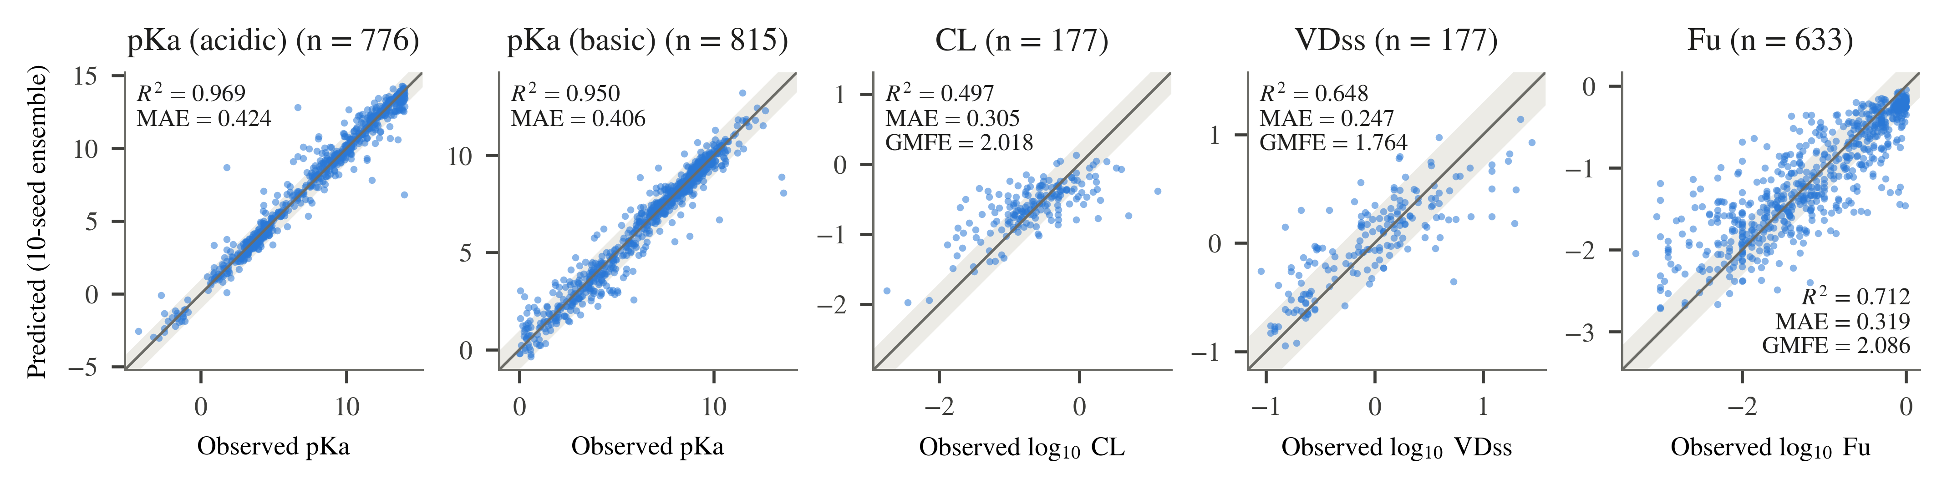
Fig. 5. Predicted versus observed values on the official test sets for the proposed models (10-seed ensemble). The solid line is the identity; the shaded band marks ±1 pKa unit (pKa) or two-fold error (CL, VDss, Fu). Inset metrics are ensemble values from Tables IV and V.

B. Comparison With the Published Benchmark
Table VI compares the 10-seed ensemble with the published benchmark values on the same official test splits: Jia et al. [REF: Jia et al., J. Med. Chem., 2025, 68(7), 7737–7750] for CL, VDss and Fu, and [NEEDS: citation for the pKa benchmark] for pKa. For most of the test set the benchmark reports aggregate values only, so Table VI reports whether the published value lies inside the bootstrap 95% CI of the ensemble metric, and Fig. 6 shows the relative differences. The benchmark does, however, publish its own per-compound predictions for a 106-compound subset; Table VII compares the two models on those compounds with a paired test, which is the stronger comparison.
The ensemble improves on the published value in 16 of the 21 metric–endpoint pairs for which a benchmark value is available. On both pKa endpoints, all three metrics improve and the published value lies outside the ensemble CI: MAE decreases from 0.61 to 0.424 (acidic) and from 0.67 to 0.406 (basic). For VDss, all five metrics improve (GMFE 1.764 vs. 1.88; W2F 0.684 vs. 0.62); of these, only the MAE improvement places the published value outside the ensemble CI.
For CL, the ensemble improves on R², MAE and RMSE (R² 0.497 vs. 0.48) but trails on GMFE (2.018 vs. 2.00) and W2F (0.605 vs. 0.64). For Fu, the ensemble improves on R² (0.712 vs. 0.69) and W2F (0.613 vs. 0.60) and trails on MAE, RMSE and GMFE (2.086 vs. 2.01). For all ten CL and Fu metrics, the published value lies inside the ensemble 95% CI.
The comparison depends on whether the ensemble or an individual model is considered. Using the seed-mean metric instead of the ensemble, the proposed models still improve on all pKa and VDss benchmark values, but on 0 of 5 CL metrics and 0 of 5 Fu metrics (e.g., CL seed-mean R² 0.441 vs. 0.48; Fu seed-mean R² 0.681 vs. 0.69).
Table VI
Comparison of the 10-seed ensemble with the published benchmark (official test splits)
Endpoint | Metric | Published | Ensemble [95% CI] | Δ (ens. − pub.) | Pub. in CI | Seed mean
pKa (acidic) | R² | 0.94 | 0.969 [0.956, 0.979] | +0.029 | no | 0.963
 | MAE | 0.61 | 0.424 [0.383, 0.471] | −0.186 | no | 0.484
 | RMSE | 1.05 | 0.757 [0.622, 0.899] | −0.293 | no | 0.820
pKa (basic) | R² | 0.91 | 0.950 [0.936, 0.962] | +0.040 | no | 0.940
 | MAE | 0.67 | 0.406 [0.372, 0.442] | −0.264 | no | 0.461
 | RMSE | 0.98 | 0.654 [0.572, 0.743] | −0.326 | no | 0.720
CL | R² | 0.48 | 0.497 [0.366, 0.602] | +0.017 | yes | 0.441
 | MAE | 0.31 | 0.305 [0.265, 0.347] | −0.005 | yes | 0.324
 | RMSE | 0.42 | 0.412 [0.357, 0.468] | −0.008 | yes | 0.435
 | GMFE | 2.00 | 2.018 [1.841, 2.222] | +0.018 | yes | 2.109
 | W2F | 0.64 | 0.605 [0.531, 0.678] | −0.035 | yes | 0.579
VDss | R² | 0.60 | 0.648 [0.547, 0.730] | +0.048 | yes | 0.609
 | MAE | 0.28 | 0.247 [0.216, 0.280] | −0.033 | no | 0.259
 | RMSE | 0.35 | 0.328 [0.284, 0.371] | −0.022 | yes | 0.345
 | GMFE | 1.88 | 1.764 [1.643, 1.904] | −0.116 | yes | 1.814
 | W2F | 0.62 | 0.684 [0.616, 0.751] | +0.064 | yes | 0.670
Fu | R² | 0.69 | 0.712 [0.671, 0.749] | +0.022 | yes | 0.681
 | MAE | 0.30 | 0.319 [0.297, 0.343] | +0.019 | yes | 0.337
 | RMSE | 0.41 | 0.435 [0.403, 0.468] | +0.025 | yes | 0.458
 | GMFE | 2.01 | 2.086 [1.980, 2.203] | +0.076 | yes | 2.173
 | W2F | 0.60 | 0.613 [0.573, 0.649] | +0.013 | yes | 0.588
Bold marks the better value of Published vs. Ensemble. Published values: CL/VDss/Fu from Jia et al. [REF]; pKa from [NEEDS: citation]. No published W1/GMFE/W2F values are used for pKa. Published values were transcribed from the source; re-verify before submission.

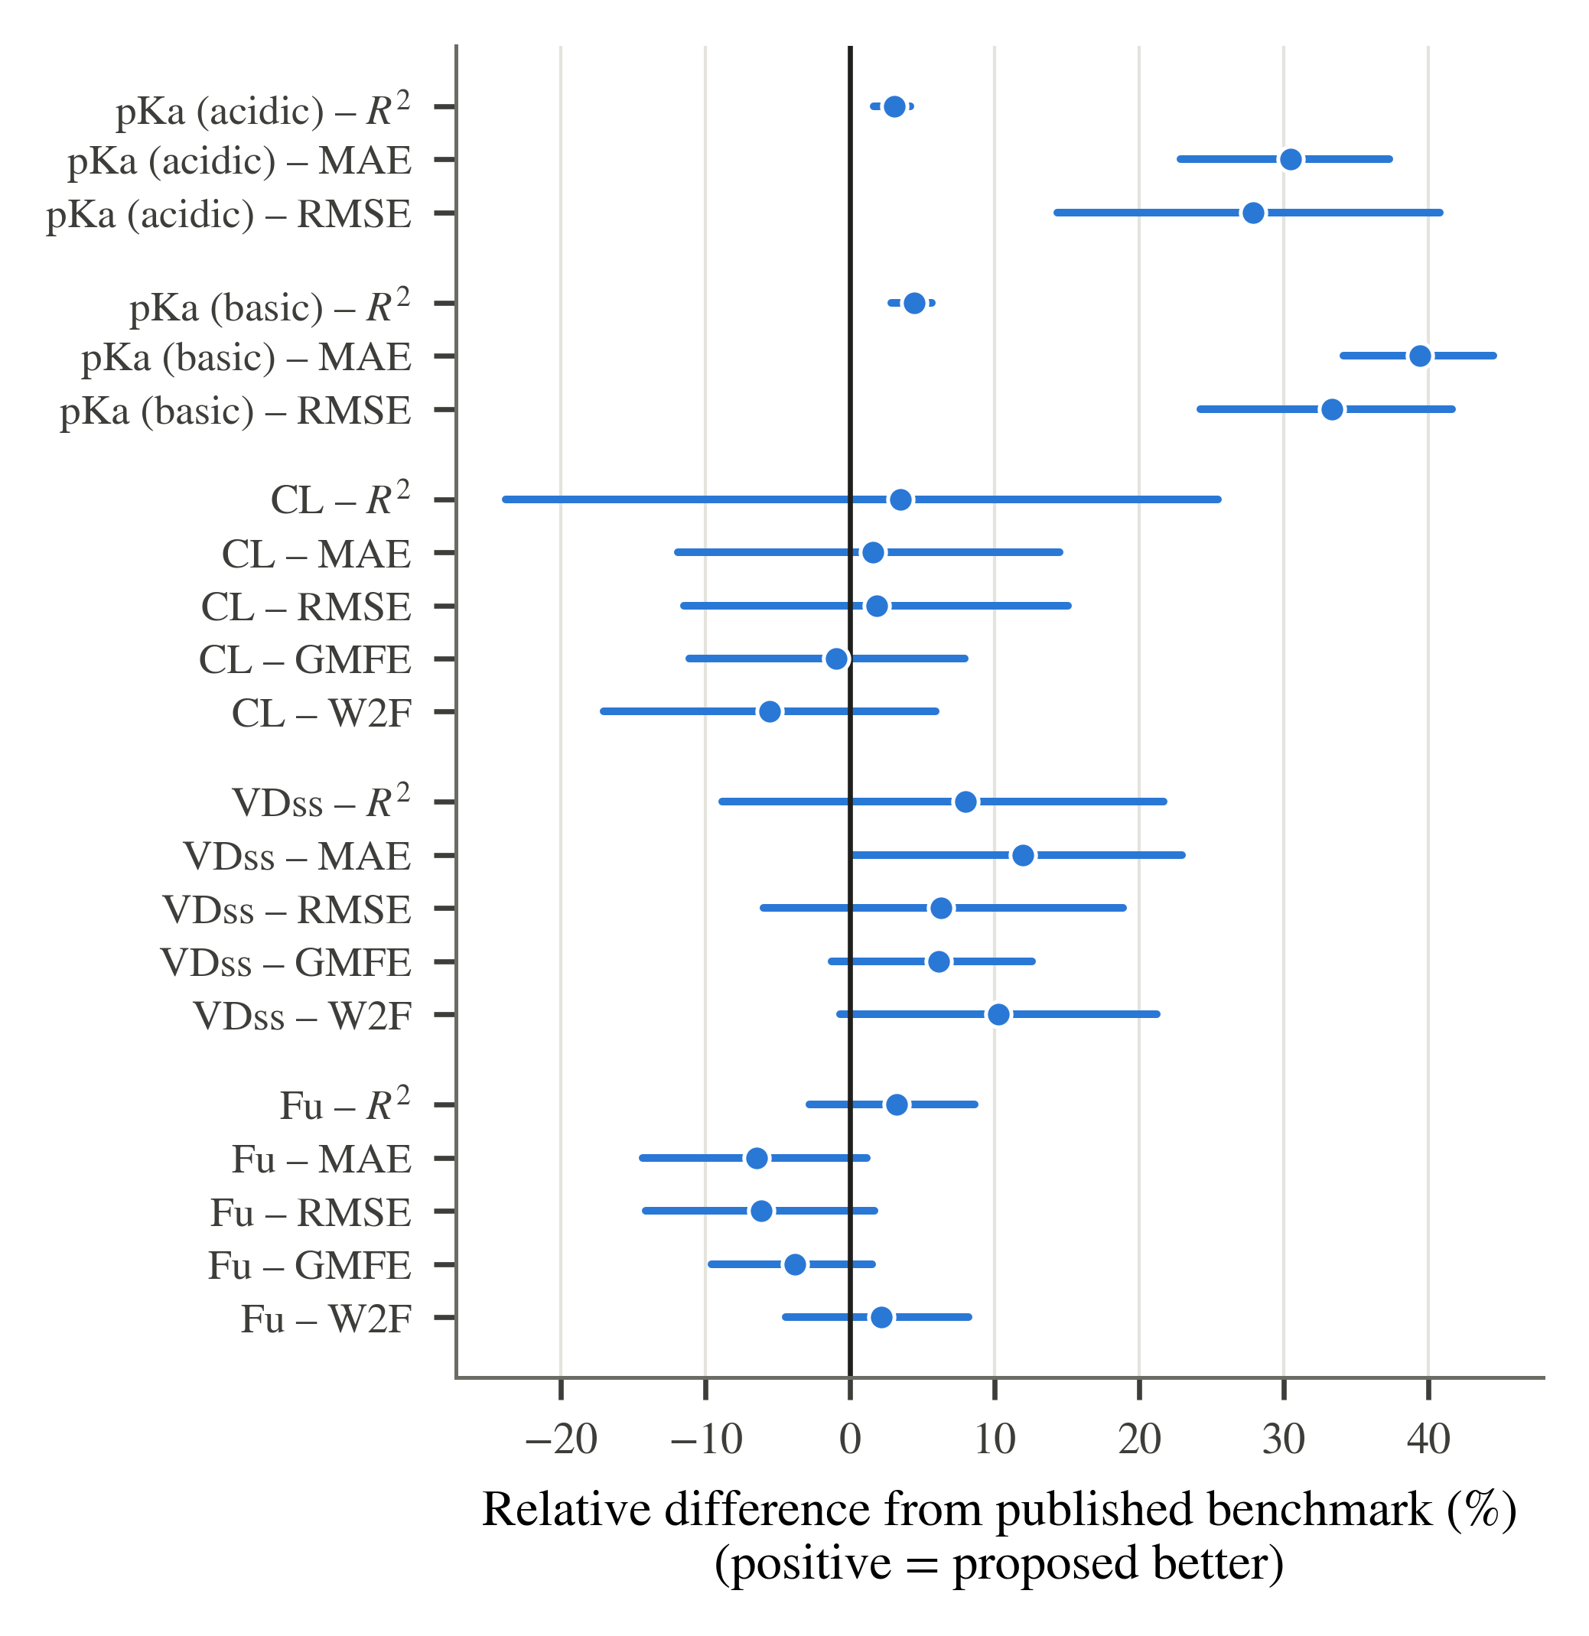
Fig. 6. Relative difference between the 10-seed ensemble and the published benchmark for each endpoint and metric, oriented so that positive values favor the proposed model. Dots: ensemble; bars: bootstrap 95% CI of the ensemble metric expressed relative to the published value. The vertical line marks parity with the benchmark.

C. Paired Comparison on the Benchmark's Published Predictions
The benchmark publishes per-compound predictions for all five endpoints on a 106-compound subset of the test data. Every one of these compounds lies in the official test split of every endpoint, so neither model was trained on them, and both were evaluated on identical compounds. This permits a paired comparison (Table VII, Fig. 7): the same compound-level bootstrap as above, resampling the same compounds for both models, which removes the compound-to-compound variation that dominates the marginal CIs of Table VI. This subset is the only part of the test data for which the benchmark's own predictions are available.
Of the 23 metric–endpoint pairs, 7 are resolved, and all 7 favour the proposed models; none favours the benchmark. Both pKa endpoints improve on R², MAE and RMSE with paired CIs excluding zero: on pKa (acidic), MAE falls from 0.514 to 0.354 (difference -0.160, 95% CI [-0.285, -0.039]), and on pKa (basic) from 0.634 to 0.314 (CI [-0.463, -0.194]), a reduction of 51%. The W1 improvement is also resolved for pKa (basic) (0.943 vs. 0.849).
For CL, VDss and Fu no difference is resolved on this subset. The proposed models hold the better point estimate on every VDss and Fu metric (VDss GMFE 1.759 vs. 1.889; Fu GMFE 1.937 vs. 2.014) and the two models are indistinguishable on CL (GMFE 1.953 vs. 1.969). With 106 compounds this subset is smaller than the full test splits of Tables IV and V, so it resolves only the larger differences; the absence of a resolved difference is not evidence of equivalence.
Table VII
Paired comparison with the benchmark's published per-compound predictions
Endpoint | Metric | Benchmark | This work | Difference | 95% CI of difference
pKa (acidic) (n = 106) | R² | 0.963 | 0.982 | +0.019† | [+0.001, +0.039]
 | MAE | 0.514 | 0.354 | −0.160† | [−0.285, −0.039]
 | RMSE | 0.798 | 0.562 | −0.236† | [−0.454, −0.008]
 | W1 | 0.858 | 0.934 | +0.075 | [+0.000, +0.151]
pKa (basic) (n = 106) | R² | 0.902 | 0.977 | +0.076† | [+0.033, +0.133]
 | MAE | 0.634 | 0.314 | −0.320† | [−0.463, −0.194]
 | RMSE | 0.976 | 0.468 | −0.508† | [−0.752, −0.264]
 | W1 | 0.849 | 0.943 | +0.094† | [+0.028, +0.160]
CL (n = 106) | R² | 0.433 | 0.411 | −0.022 | [−0.109, +0.058]
 | MAE | 0.294 | 0.291 | −0.004 | [−0.027, +0.020]
 | RMSE | 0.402 | 0.410 | +0.008 | [−0.019, +0.037]
 | GMFE | 1.969 | 1.953 | −0.016 | [−0.121, +0.093]
 | W2F | 0.642 | 0.613 | −0.028 | [−0.104, +0.047]
VDss (n = 106) | R² | 0.584 | 0.641 | +0.056 | [−0.030, +0.140]
 | MAE | 0.276 | 0.245 | −0.031 | [−0.062, +0.001]
 | RMSE | 0.353 | 0.328 | −0.025 | [−0.062, +0.012]
 | GMFE | 1.889 | 1.759 | −0.130 | [−0.263, +0.004]
 | W2F | 0.604 | 0.698 | +0.094 | [+0.000, +0.189]
Fu (n = 106) | R² | 0.663 | 0.694 | +0.032 | [−0.028, +0.087]
 | MAE | 0.304 | 0.287 | −0.017 | [−0.049, +0.015]
 | RMSE | 0.410 | 0.390 | −0.020 | [−0.056, +0.015]
 | GMFE | 2.014 | 1.937 | −0.077 | [−0.227, +0.067]
 | W2F | 0.604 | 0.670 | +0.066 | [−0.009, +0.151]
Both models evaluated on the same compounds, the subset for which the benchmark publishes per-compound predictions; all of them lie in the official test split of every endpoint. Difference = this work − benchmark, oriented by the metric. CI: paired compound-level bootstrap, B = 10 000, the same resampled compounds for both models. †: CI excludes zero in favour of this work; ‡: in favour of the benchmark (unused — no metric favours the benchmark); no mark: CI includes zero. Bold: better value. MAE and RMSE in pKa units (pKa) or log10 units (CL, VDss, Fu).

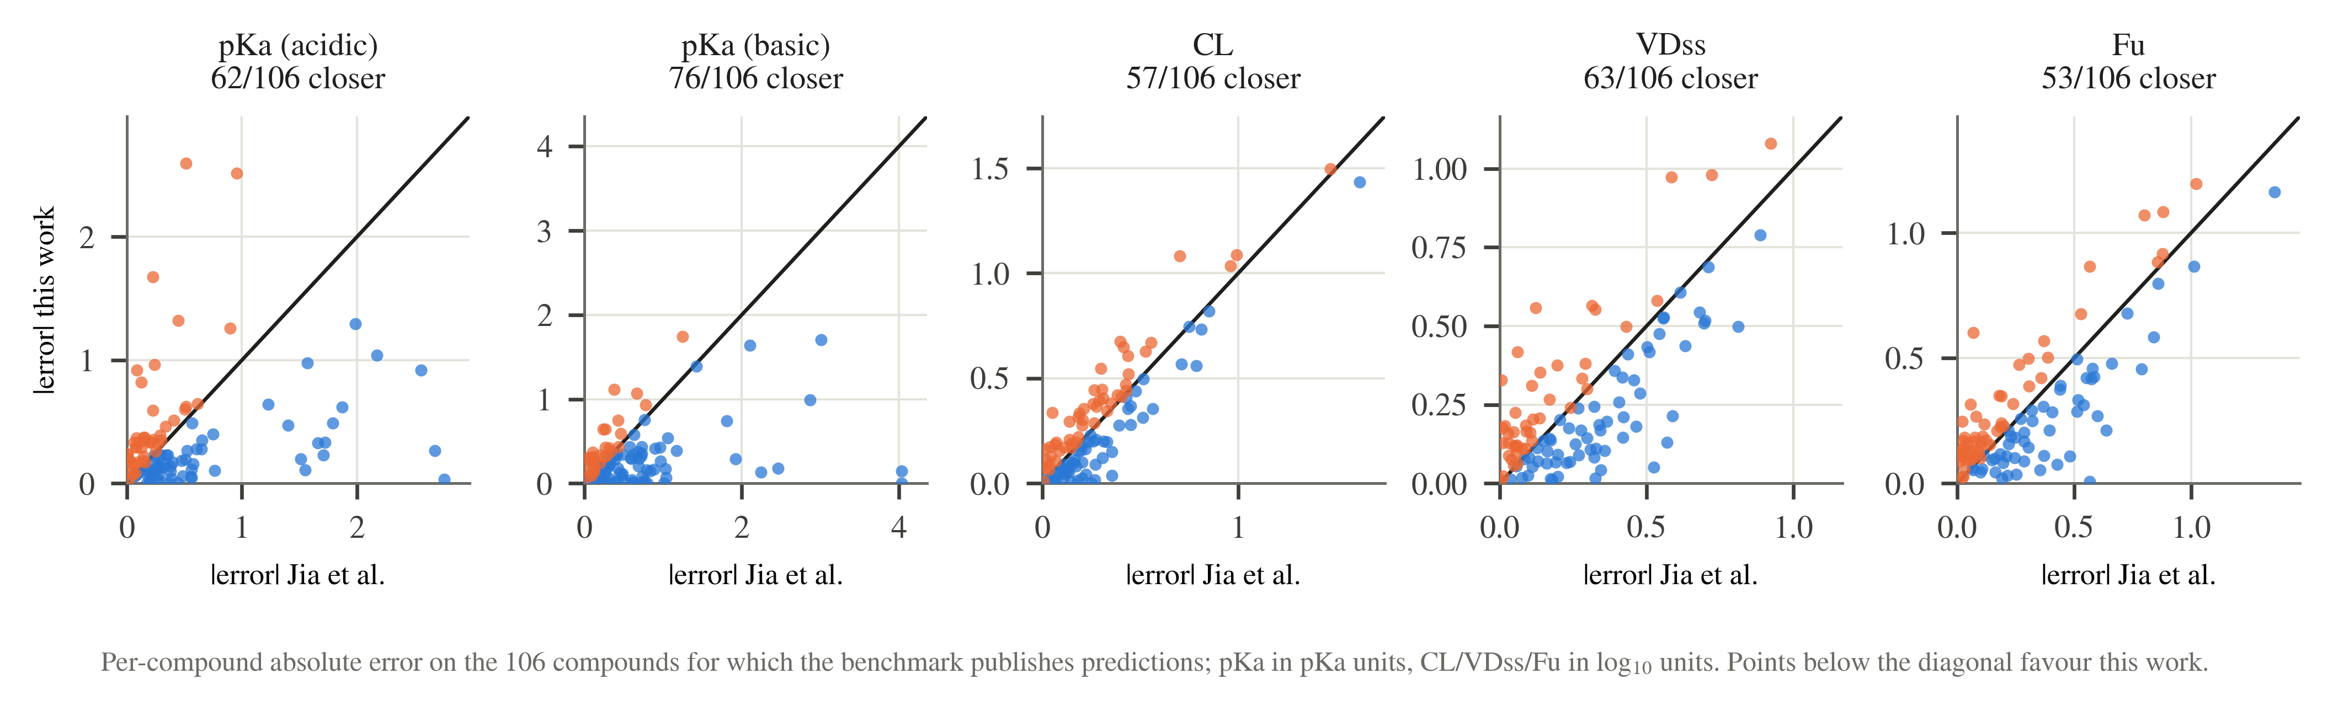
Fig. 7. Per-compound absolute error of the benchmark's published predictions (horizontal) against this work's (vertical) on the same compounds. Points below the identity line are compounds this work predicts more accurately; the panel titles give the count. pKa in pKa units, CL, VDss and Fu in log10 units.

D. Comparison With Untuned Classical Baselines
Table VIII compares the proposed models with three classical regressors trained on the same training split and evaluated on the same test compounds in the same order: Random Forest (RF), XGBoost (XGB) and support vector regression (SVM), each with library-default hyperparameters (no tuning). RF was trained with seeds 42–51 and is reported as a 10-seed ensemble. With default settings, XGB uses no row or column subsampling, so all ten seeds produced identical predictions and its ensemble equals a single fit; SVM is deterministic and was fit once. Fig. 8 summarizes the headline error metric per endpoint.
On both pKa endpoints and on Fu, the proposed model has the better value on every metric against every baseline, and every paired-difference CI excludes zero. The strongest pKa baseline by MAE is RF on the acidic set (0.699 vs. 0.424 for GraphMPNN) and XGB on the basic set (0.701 vs. 0.406). On Fu, the strongest baseline is SVM (GMFE 2.284 vs. 2.086; R² 0.663 vs. 0.712).
On VDss, the proposed model has the better point estimate on every metric against all three baselines; the paired CIs exclude zero against XGB and SVM on all metrics, but include zero against RF on all metrics (GMFE 1.764 vs. 1.848, paired-difference CI [-0.212, 0.041]). On CL, the proposed model is better than XGB on all metrics with CIs excluding zero, but is not resolved from RF or SVM on any metric. RF has the better point estimate on CL for MAE (0.303 vs. 0.305), GMFE (2.010 vs. 2.018) and W2F (0.638 vs. 0.605), and SVM has the better point estimate for W2F (0.627).
Table VIII
Proposed models versus untuned classical baselines (official test splits)
Endpoint / model | Metric values (metric names given in each endpoint row)
pKa (acidic) (n = 776) | R² | MAE | RMSE | W1
GraphMPNN | 0.969 | 0.424 | 0.757 | 0.910
Random Forest | 0.927† | 0.699† | 1.158† | 0.777†
XGBoost | 0.919† | 0.743† | 1.221† | 0.781†
SVM | 0.770† | 1.475† | 2.057† | 0.499†
pKa (basic) (n = 815) | R² | MAE | RMSE | W1
GraphMPNN (no site readout) | 0.950 | 0.406 | 0.654 | 0.907
Random Forest | 0.862† | 0.758† | 1.089† | 0.746†
XGBoost | 0.881† | 0.701† | 1.012† | 0.756†
SVM | 0.723† | 1.067† | 1.546† | 0.634†
CL (n = 177) | R² | MAE | GMFE | W2F
MFMN-DynGate | 0.497 | 0.305 | 2.018 | 0.605
Random Forest | 0.484 | 0.303 | 2.010 | 0.638
XGBoost | 0.374† | 0.355† | 2.266† | 0.497†
SVM | 0.485 | 0.310 | 2.042 | 0.627
VDss (n = 177) | R² | MAE | GMFE | W2F
MFMN-InteractAux | 0.648 | 0.247 | 1.764 | 0.684
Random Forest | 0.609 | 0.267 | 1.848 | 0.661
XGBoost | 0.485† | 0.307† | 2.026† | 0.588†
SVM | 0.542† | 0.283† | 1.919† | 0.610†
Fu (n = 633) | R² | MAE | GMFE | W2F
MFMN-DynGate + LW | 0.712 | 0.319 | 2.086 | 0.613
Random Forest | 0.630† | 0.379† | 2.391† | 0.488†
XGBoost | 0.643† | 0.365† | 2.316† | 0.531†
SVM | 0.663† | 0.359† | 2.284† | 0.534†
Metric names are given in each italic endpoint row (pKa: R², MAE, RMSE, W1; CL/VDss/Fu: R², MAE, GMFE, W2F). Proposed and RF: 10-seed ensembles; XGB: seed-invariant (single fit); SVM: single deterministic fit. Bold: best value per endpoint and metric. †: paired-bootstrap 95% CI of the difference (proposed − baseline) excludes zero in favor of the proposed model; no mark: CI includes zero. No baseline was resolved as better than the proposed model (‡ unused). Full metric set and difference CIs: supplementary table [NEEDS: supplementary reference].

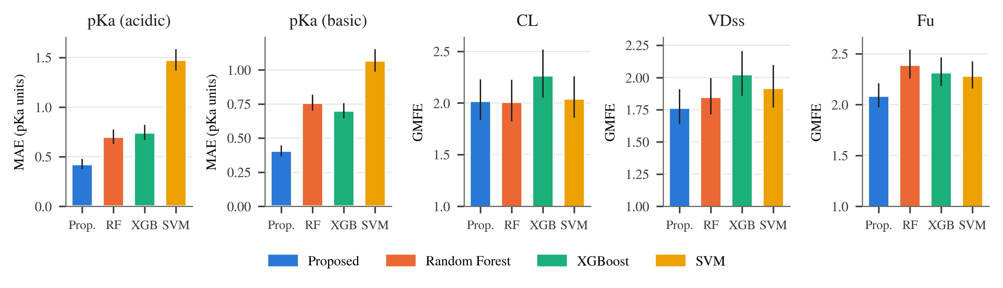
Fig. 8. Headline error metric of the proposed models and the untuned baselines on each official test set (MAE in pKa units for pKa; GMFE for CL, VDss and Fu; lower is better). Error bars: bootstrap 95% CI of each model's metric (B = 10 000). Proposed: GraphMPNN (pKa) or MFMN variant (CL, VDss, Fu).

E. Ablation Study
Tables IX and X report 10-seed ablations retrained under the same protocol, training split and test split as the final models. For CL and VDss (Table IX), the final model is compared with the base MFMN (no auxiliary supervision and no dynamic gating) and with the alternative MFMN variant that differs only in the gating mechanism (MFMN-InteractAux for CL; MFMN-DynGate for VDss); Fig. 9 shows the per-seed GMFE distributions. For pKa (Table X), the xTB-derived features, the edge gating and the ionizable-site readout of the full GraphMPNN are removed one at a time; on pKa (basic), the variant without the site readout performed best and is used as the final model, so the full GraphMPNN and its other two ablations are compared against it. For Fu, the low-fu training-loss weight is removed. Variant–final differences use the same paired compound-level bootstrap as Section D.
On CL, the final MFMN-DynGate model has the best ensemble value on R², MAE, RMSE and GMFE (GMFE 2.018 vs. 2.036 for MFMN-InteractAux and 2.057 for the base MFMN) and ties MFMN-InteractAux on W2F (0.605). None of these differences is resolved by the paired bootstrap; all paired-difference CIs include zero. Across seeds, the SD of R² decreases from 0.076 (base) to 0.036 (InteractAux) and 0.020 (DynGate).
On VDss, the final MFMN-InteractAux model improves on the base MFMN on R², MAE, RMSE and GMFE with paired CIs excluding zero (GMFE 1.764 vs. 1.872; difference CI [-0.174, -0.047]); the W2F difference is not resolved. MFMN-InteractAux and MFMN-DynGate are not resolved on any metric (GMFE 1.764 vs. 1.771); MFMN-DynGate has the higher ensemble W2F (0.695 vs. 0.684) and a lower seed-to-seed SD of R² (0.009 vs. 0.029).
Table IX
Ablation of the MFMN family on CL and VDss (10 seeds, official test splits)
Endpoint | Variant | R² | MAE | GMFE | W2F
CL | MFMN (base) | 0.468 (0.364 ± 0.076) | 0.313 (0.348 ± 0.022) | 2.057 (2.230 ± 0.114) | 0.571 (0.561 ± 0.034)
 | MFMN-InteractAux | 0.490 (0.426 ± 0.036) | 0.309 (0.329 ± 0.013) | 2.036 (2.135 ± 0.065) | 0.605 (0.591 ± 0.023)
 | MFMN-DynGate (final) | 0.497 (0.441 ± 0.020) | 0.305 (0.324 ± 0.007) | 2.018 (2.109 ± 0.036) | 0.605 (0.579 ± 0.018)
VDss | MFMN (base) | 0.571† (0.528 ± 0.029) | 0.272† (0.287 ± 0.009) | 1.872† (1.935 ± 0.040) | 0.655 (0.632 ± 0.022)
 | MFMN-DynGate | 0.647 (0.609 ± 0.009) | 0.248 (0.260 ± 0.004) | 1.771 (1.821 ± 0.017) | 0.695 (0.680 ± 0.010)
 | MFMN-InteractAux (final) | 0.648 (0.609 ± 0.029) | 0.247 (0.259 ± 0.012) | 1.764 (1.814 ± 0.048) | 0.684 (0.670 ± 0.028)
Entries: 10-seed ensemble (seed mean ± SD). Bold: best ensemble value per endpoint and metric (ties both bold). †: paired-bootstrap 95% CI of the difference (final − variant) excludes zero in favor of the final model; no mark: CI includes zero; no variant was resolved as better than the final model. The final-model rows are the retrained finals of Table V; the ablation variants were compared against the same test rows.

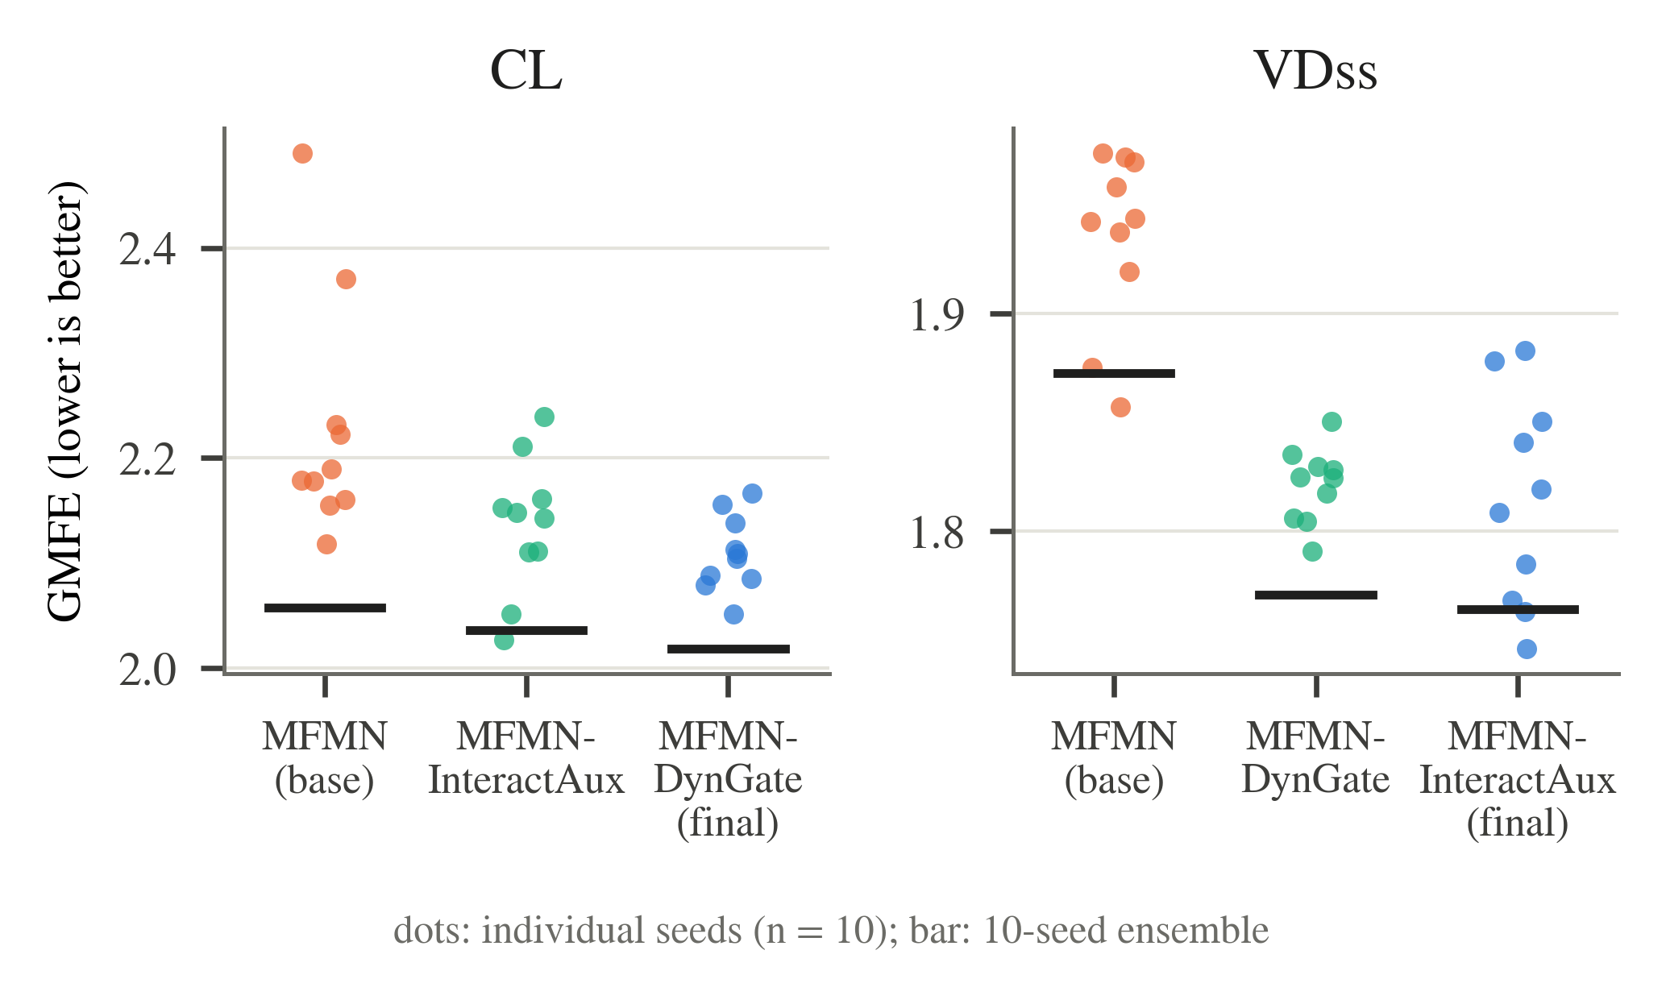
Fig. 9. Per-seed test GMFE (dots, n = 10 per variant) and 10-seed ensemble GMFE (horizontal bar) for the MFMN ablation on CL and VDss. Lower is better.
On pKa (acidic), none of the three ablations changes performance measurably: every ensemble metric is within 0.014 of the final model (R² 0.9689 for the final model vs. 0.9677–0.9691 for the variants), and all paired-difference CIs include zero. The full GraphMPNN has the lowest MAE (0.424) and is retained as the final model; the variants have marginally better point estimates on some other metrics (e.g., RMSE 0.754 without edge gating vs. 0.757), by less than one seed-to-seed SD.
On pKa (basic), removing the ionizable-site readout gives the best model on every metric: R² 0.950, MAE 0.406, RMSE 0.654 and W1 0.907, compared with 0.948, 0.416, 0.670 and 0.899 for the full GraphMPNN; it is therefore used as the final pKa (basic) model. The improvement over the full model is consistent across seeds (higher R² for 9 of the 10 seeds when paired by seed index) but is not resolved by the paired bootstrap (MAE difference CI [-0.0203, 0.0001]). Relative to the final model, removing the xTB-derived features from the full GraphMPNN degrades every metric with all paired-difference CIs excluding zero (RMSE 0.703 vs. 0.654), and the full model without edge gating is worse on R² and RMSE with CIs excluding zero (RMSE 0.680).
On Fu, removing the 1.25× low-fu loss weight leaves performance essentially unchanged: GMFE 2.091 vs. 2.086, R² 0.711 vs. 0.712 and W2F 0.602 vs. 0.613 for the unweighted and final models, respectively; all paired-difference CIs include zero. The final model has the better point estimate on every metric, but the differences are smaller than one seed-to-seed SD.
Table X
Ablation of GraphMPNN on pKa (10 seeds, official test splits)
Endpoint | Variant | R² | MAE | RMSE | W1
pKa (acidic) | w/o xTB features | 0.969 (0.963 ± 0.002) | 0.426 (0.488 ± 0.017) | 0.759 (0.822 ± 0.021) | 0.912 (0.886 ± 0.007)
 | w/o edge gating | 0.969 (0.964 ± 0.002) | 0.428 (0.484 ± 0.017) | 0.754 (0.814 ± 0.027) | 0.907 (0.886 ± 0.010)
 | w/o site readout | 0.968 (0.963 ± 0.002) | 0.427 (0.486 ± 0.017) | 0.771 (0.830 ± 0.025) | 0.906 (0.888 ± 0.007)
 | GraphMPNN (final) | 0.969 (0.963 ± 0.002) | 0.424 (0.484 ± 0.020) | 0.757 (0.820 ± 0.025) | 0.910 (0.887 ± 0.010)
pKa (basic) | full, w/o xTB features | 0.943† (0.931 ± 0.004) | 0.424† (0.483 ± 0.014) | 0.703† (0.772 ± 0.024) | 0.892† (0.875 ± 0.006)
 | full, w/o edge gating | 0.946† (0.935 ± 0.004) | 0.415 (0.469 ± 0.015) | 0.680† (0.747 ± 0.023) | 0.901 (0.882 ± 0.006)
 | GraphMPNN (full) | 0.948 (0.937 ± 0.003) | 0.416 (0.472 ± 0.010) | 0.670 (0.736 ± 0.016) | 0.899 (0.885 ± 0.009)
 | GraphMPNN (no site readout) (final) | 0.950 (0.940 ± 0.002) | 0.406 (0.461 ± 0.016) | 0.654 (0.720 ± 0.013) | 0.907 (0.889 ± 0.013)
Entries: 10-seed ensemble (seed mean ± SD); MAE and RMSE in pKa units. Bold: best ensemble value per endpoint and metric. †: paired-bootstrap 95% CI of the difference (final − variant) excludes zero in favor of the final model; no mark: CI includes zero; no variant was resolved as better than the final model. pKa (acidic): final = full GraphMPNN. pKa (basic): final = GraphMPNN without the ionizable-site readout; 'full' rows are the complete GraphMPNN and its ablations. Final-model rows are those of Table IV.

F. Propagation to Predicted Exposure
A natural question is whether improved parameter predictions translate into better predicted exposure. Table XI addresses this on the same 106 compounds of Section C, holding the downstream model fixed and varying only the source of CL and VDss. Under the simplest exposure model consistent with the dose-linearity and 1 mg/kg normalization used throughout this benchmark — a one-compartment intravenous model — the area under the concentration–time curve and the maximum concentration follow in closed form from CL, VDss and the infusion duration: AUC = D/CL, and Cmax = D/V for a bolus or (R₀/CL)(1 − e^(−kT)) for an infusion of duration T, with R₀ = D/T and k = CL/V. Parameter error can therefore be propagated to exposure error analytically, with no fitted downstream model and no training data.
What this quantifies is how parameter error propagates into exposure error with the downstream model held constant; it is not a measurement of absolute concentration–time profile accuracy, and it is not comparable with exposure errors obtained by scoring predicted profiles against observed profiles. Two consequences of the model should be stated before the numbers are read. First, because AUC = D/CL exactly, the AUC fold error is identically the CL fold error, so the AUC row carries no information beyond the CL results of Tables IV–IV; it is reported for completeness. Cmax, which depends on CL, VDss and infusion time jointly, is the only genuinely new quantity. Second, Fu does not enter a one-compartment model at all, so this analysis is silent on it; under a physiologically based model Fu would act through tissue partitioning, which this model does not represent.
No difference is resolved. For Cmax the proposed parameters give the lower geometric mean fold error (1.774 vs. 1.872) and the higher fraction within two-fold (0.689 vs. 0.632), but the paired differences are not resolved (GMFE difference -0.097, 95% CI [-0.228, 0.034]). For AUC the two parameter sources are indistinguishable, as the equivalence with CL requires. The ensemble again outperforms the average individual seed on every exposure metric (Cmax GMFE 1.774 for the ensemble vs. 1.833 ± 0.040 across seeds).
Table XI
Propagation of predicted CL and VDss to exposure under a one-compartment IV model
Exposure | Metric | From benchmark parameters [95% CI] | From this work's parameters [95% CI] | 95% CI of difference
AUC (n = 106) | R² | 0.433 [0.234, 0.595] | 0.411 [0.223, 0.569] | [−0.109, +0.058]
 | GMFE | 1.969 [1.760, 2.238] | 1.953 [1.732, 2.233] | [−0.121, +0.093]
 | W2F | 0.642 [0.547, 0.726] | 0.613 [0.519, 0.708] | [−0.104, +0.047]
Cmax (n = 106) | R² | 0.572 [0.415, 0.686] | 0.615 [0.441, 0.741] | [−0.043, +0.122]
 | GMFE | 1.872 [1.695, 2.079] | 1.774 [1.606, 1.976] | [−0.228, +0.034]
 | W2F | 0.632 [0.538, 0.717] | 0.689 [0.594, 0.774] | [−0.038, +0.151]
One-compartment IV model, dose linearity, 1 mg/kg; observed CL and VDss define the reference exposure. R² on log10 exposure; GMFE and W2F on the linear scale. CIs: compound-level bootstrap, B = 10 000; differences paired as in Table VII. No difference is resolved. AUC fold error is identically CL fold error under this model. These values are not comparable with exposure errors obtained by scoring predicted concentration–time profiles against observed profiles.

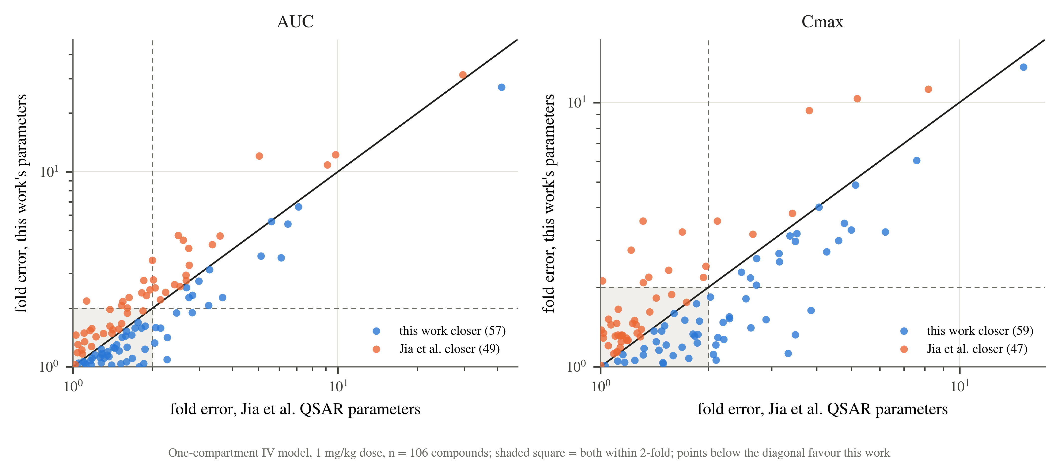
Fig. 10. Per-compound exposure fold error from the benchmark's parameters (horizontal) against this work's (vertical), under the one-compartment model. The shaded square marks compounds within two-fold for both; points below the identity line are compounds for which this work's parameters give the closer exposure.

V. Discussion

A. Where the Proposed Models Improve, and Where They Do Not
The five endpoints divide cleanly. On the two pKa endpoints the proposed GraphMPNN models improve on the published benchmark by a margin that survives every test applied here: the published values lie outside the bootstrap confidence intervals of the ensemble metrics (Table VI), and on the subset where the benchmark's own per-compound predictions are available the improvement is resolved by a paired test on R², MAE and RMSE for both endpoints (Table VII). The effect is large rather than marginal — on pKa (basic) the paired MAE falls from 0.634 to 0.314, and the proposed model is the closer prediction for 76 of the 106 compounds. On the three pharmacokinetic endpoints the picture is different: the ensembles are at least as good as the benchmark on most metrics and better on several point estimates, but no difference is resolved, and on the full test split the benchmark retains the better GMFE and within-two-fold fraction for CL (Table VI).
The most plausible reading is that the gap reflects what each endpoint's data can support rather than a difference in modeling effort. pKa is a thermodynamic property of the molecular structure itself, measured reproducibly, and the training sets here are the largest of the five. A message-passing network operating on the molecular graph with xTB-derived electronic features can exploit that structure directly, and the ablation confirms that the electronic features carry real signal for pKa (basic). CL, VDss and Fu are whole-organism properties whose reference values aggregate inter-individual variability, differing assay protocols and literature curation decisions; their test sets here are also far smaller, 177 compounds for CL and VDss. Both factors compress the achievable range of performance and widen every confidence interval, so that even consistent point-estimate advantages — the proposed model holds the better value on every VDss and Fu metric in Table VII — fail to resolve.
Two observations recur across every analysis and are worth separating from the endpoint-specific findings. First, ensembling is not cosmetic: on all five endpoints the 10-seed ensemble beats the average individual seed on every metric, and the gap is large enough to change conclusions. CL is the clearest case, where the ensemble R² of 0.497 exceeds the published 0.48 while the seed mean of 0.441 does not. Any comparison of this kind should therefore state whether an ensemble or a single model is being reported. Second, the seed-to-seed standard deviation is substantial relative to the differences under discussion — up to 0.029 in R² — which is why a comparison based on a single seed per architecture is difficult to interpret.

B. What the Ablations Show
The component ablations resolve far less than is usually claimed for architectural choices. On CL, none of the differences between the final MFMN-DynGate, MFMN-InteractAux and the base MFMN is resolved, although the ordering is consistent and the seed-to-seed variance falls markedly as components are added (0.076 to 0.020 in R² standard deviation). On VDss the auxiliary supervision is clearly load-bearing: removing it costs 0.108 in GMFE with the CI excluding zero, whereas exchanging one gating mechanism for the other changes nothing resolvable. On pKa (basic) the xTB-derived features are the component that matters, and on pKa (acidic) no component is resolved at all.
Read together, these results suggest that for this family of problems the choice of representation — graph versus descriptor, with or without electronic features — matters more than the particular gating or attention mechanism layered on top, and that several of the architectural refinements are within seed noise on the test sets available. That is a limitation of the evidence as much as a claim about the architectures: with 177 compounds, differences smaller than roughly one seed standard deviation cannot be detected.

C. Does Better Parameter Prediction Improve Predicted Exposure?
Section F answers this directly for the quantities a one-compartment model can express, and the answer is that it does not, measurably, on these 106 compounds. The result deserves care rather than dismissal. The AUC comparison is not independent evidence at all: AUC = D/CL makes its fold error identical to the CL fold error, so it restates an endpoint on which the two models were already indistinguishable. Cmax is the informative quantity, and there the proposed parameters give a lower GMFE (1.774 vs. 1.872) and a higher within-two-fold fraction, in the direction the VDss results predict, but without reaching resolution on a sample this size.
Two structural features of the problem limit what this analysis can show. The benchmark's own feature-importance analysis for its downstream model [REF: Jia et al., Supporting Information, Table S6] ranks CL and VDss far above the remaining parameters, with Fu last, which supports propagating exactly those two but also implies that improvements concentrated in the other parameters cannot express themselves downstream. More fundamentally, the endpoints on which the proposed models improve most — the two pKa constants — have almost no influence on exposure in this framework, while the endpoint that dominates exposure, CL, is the one on which the two models are closest. A substantial gain in pKa prediction can therefore coexist with no measurable gain in predicted exposure without any inconsistency. Confirming this properly would require the observed concentration–time data, which is not publicly available for this benchmark; the comparison reported here is the strongest that can be made without it.

D. Limitations
Each endpoint is evaluated on a single official held-out split, so the results characterize performance on those particular compounds and inherit their composition. The CL and VDss splits contain 177 compounds each, and the paired comparison of Table VII and the exposure analysis of Table XI rest on 106; at these sizes only large differences resolve, and the absence of a resolved difference is not evidence of equivalence. No cross-validated estimate for the final models is reported here, so the stability of these results across alternative partitions of the same data is not established.
The comparison is against a single published benchmark, and for most of the test data that benchmark reports aggregate values only, which is why Table VI can report no more than whether a published point estimate falls inside a confidence interval. Published values were transcribed from the source and should be re-verified before submission. The classical baselines of Section D use library defaults and are intended as a reference point for the difficulty of each endpoint, not as tuned competitors.
The exposure analysis of Section F inherits the assumptions of a one-compartment intravenous model with linear kinetics and a 1 mg/kg normalization. Real disposition is frequently multi-compartmental, and the model cannot represent tissue partitioning, protein binding or saturable elimination; its value here is that it is identical across the arms being compared, not that it describes any compound exactly. Its results therefore bound how much the parameter improvements could matter under that model, and say nothing about absolute profile accuracy.

VI. Conclusion
This work reproduced and extended the first stage of a published intravenous pharmacokinetics benchmark, training a graph message-passing network for the two pKa endpoints and a family of factorized-descriptor networks for clearance, volume of distribution and fraction unbound, each as a 10-seed ensemble fitted on the official training split and scored once on the official held-out test split. On the pKa endpoints the proposed models improve on the benchmark substantially and the improvement is statistically resolved, both against the published values and, on the subset where the benchmark's per-compound predictions are available, by a paired test: R² rises to 0.969 and 0.950 for the acidic and basic endpoints, with mean absolute errors of 0.424 and 0.406 pKa units. On clearance, volume of distribution and fraction unbound the proposed models are comparable to the benchmark, better on several point estimates and worse on others, with no difference resolved.
Propagating the predicted parameters through a fixed one-compartment exposure model produced no resolved improvement in predicted AUC or Cmax. That outcome is consistent with the parameter-level results rather than in tension with them, since exposure in this framework is governed largely by clearance, the endpoint on which the two models are closest, and is insensitive to the pKa constants on which they differ most. Establishing whether improved parameter prediction benefits full concentration–time prediction would require the observed profile data underlying the benchmark.
Two methodological points generalize beyond this benchmark. Multi-seed ensembling changed the sign of several comparisons relative to single models and should be reported explicitly rather than left implicit. And across the ablations, differences between architectural variants were frequently smaller than the variation between random seeds of the same architecture, so claims about component contributions on test sets of this size require seed-level variability to be quantified before they can be sustained.

References
[1] D. Bassani, N. J. Parrott, N. Manevski, and J. D. Zhang, “Another string to your bow: machine learning prediction of the pharmacokinetic properties of small molecules,” Expert Opinion on Drug Discovery, vol. 19, no. 6, pp. 683-698, 2024, doi: 10.1080/17460441.2024.2348157.
[2] S. Seal, M. A. Trapotsi, M. Mahale, V. Subramanian, N. Greene, O. Spjuth, et al., “PKSmart: an open-source computational model to predict intravenous pharmacokinetics of small molecules,” Journal of Cheminformatics, vol. 17, no. 1, 2025, doi: 10.1186/s13321-025-01066-5.
[3] M. Beckers, D. Yonchev, S. Desrayaud, G. Gerebtzoff, and R. Rodríguez-Pérez, “DeepCt: Predicting Pharmacokinetic Concentration–Time Curves and Compartmental Models from Chemical Structure Using Deep Learning,” Molecular Pharmaceutics, vol. 21, no. 12, pp. 6220-6233, 2024, doi: 10.1021/acs.molpharmaceut.4c00562.
[4] N. Pillai, A. Abos, D. Teutonico, and P. D. Mavroudis, “Machine learning framework to predict pharmacokinetic profile of small molecule drugs based on chemical structure,” Clinical and Translational Science, vol. 17, no. 5, 2024, doi: 10.1111/cts.13824.
[5] P. D. Mavroudis, D. Teutonico, A. Abos, and N. Pillai, “Application of machine learning in combination with mechanistic modeling to predict plasma exposure of small molecules,” Frontiers in Systems Biology, vol. 3, 2023, doi: 10.3389/fsysb.2023.1180948.
[6] A. Gruber, F. Führer, S. Menz, H. Diedam, A. H. Göller, and S. Schneckener, “Prediction of Human Pharmacokinetics From Chemical Structure: Combining Mechanistic Modeling with Machine Learning,” Journal of Pharmaceutical Sciences, vol. 113, no. 1, pp. 55-63, 2024, doi: 10.1016/j.xphs.2023.10.035.
[7] Y. Li, Z. Wang, Y. Li, J. Du, X. Gao, Y. Li, et al., “A Combination of Machine Learning and PBPK Modeling Approach for Pharmacokinetics Prediction of Small Molecules in Humans,” Pharmaceutical Research, vol. 41, no. 7, pp. 1369-1379, 2024, doi: 10.1007/s11095-024-03725-y.
[8] W. C. Chou, and Z. Lin, “Machine learning and artificial intelligence in physiologically based pharmacokinetic modeling,” Toxicological Sciences, vol. 191, no. 1, pp. 1-14, 2023, doi: 10.1093/toxsci/kfac101.
[9] R. Geci, D. Gadaleta, M. G. de Lomana, R. Ortega-Vallbona, E. Colombo, E. Serrano-Candelas, et al., “Systematic evaluation of high-throughput PBK modelling strategies for the prediction of intravenous and oral pharmacokinetics in humans,” Archives of Toxicology, vol. 98, no. 8, pp. 2659-2676, 2024, doi: 10.1007/s00204-024-03764-9.
[10] X. Jiang, L. Tan, and Q. Zou, “DGCL: dual-graph neural networks contrastive learning for molecular property prediction,” Briefings in Bioinformatics, vol. 25, no. 6, 2024, doi: 10.1093/bib/bbae474.
[11] H. Wang, A. Zhang, Y. Zhong, J. Tang, K. Zhang, and P. Li, “Chain-aware graph neural networks for molecular property prediction,” Bioinformatics, vol. 40, no. 10, 2024, doi: 10.1093/bioinformatics/btae574.
[12] B. X. Du, Y. Xu, S. M. Yiu, H. Yu, and J. Y. Shi, “ADMET property prediction via multi-task graph learning under adaptive auxiliary task selection,” iScience, vol. 26, no. 11, pp. 108285, 2023, doi: 10.1016/j.isci.2023.108285.
[13] J. Kim, W. Chang, H. Ji, and I. Joung, “Quantum-Informed Molecular Representation Learning Enhancing ADMET Property Prediction,” Journal of Chemical Information and Modeling, vol. 64, no. 13, pp. 5028-5040, 2024, doi: 10.1021/acs.jcim.4c00772.
[14] E. M. Cabaleiro-Lago, B. Fernández, R. Rodríguez-Fernández, J. Rodríguez-Otero, and S. A. Vázquez, “Functional group corrections to the GFN2-xTB and PM6 semiempirical methods for noncovalent interactions in alkanes and alkenes,” The Journal of Chemical Physics, vol. 158, no. 12, 2023, doi: 10.1063/5.0140668.
[15] Y. Qiu, J. Chen, K. Xie, R. Gu, Z. Qi, and Z. Song, “Graph transformer based transfer learning for aqueous pK prediction of organic small molecules,” Chemical Engineering Science, vol. 300, pp. 120559, 2024, doi: 10.1016/j.ces.2024.120559.
[16] J. Baikété, A. Malloum, and J. Conradie, “pKa prediction for small molecules: an overview of experimental, quantum, and machine learning-based approaches,” Journal of Computer-Aided Molecular Design, vol. 40, no. 1, 2026, doi: 10.1007/s10822-025-00719-9.
[17] J. Carrete, H. Montes-Campos, R. Wanzenböck, E. Heid, and G. K. H. Madsen, “Deep ensembles vs committees for uncertainty estimation in neural-network force fields: Comparison and application to active learning,” The Journal of Chemical Physics, vol. 158, no. 20, 2023, doi: 10.1063/5.0146905.
[18] C. T. Hoyt, B. Zdrazil, R. Guha, N. Jeliazkova, K. Martinez-Mayorga, and E. Nittinger, “Improving reproducibility and reusability in the Journal of Cheminformatics,” Journal of Cheminformatics, vol. 15, no. 1, 2023, doi: 10.1186/s13321-023-00730-y.
[19] X. Jia, D. Teutonico, S. Dhakal, Y. M. Psarellis, A. Abos, H. Zhu, et al., “Application of Machine Learning and Mechanistic Modeling to Predict Intravenous Pharmacokinetic Profiles in Humans,” Journal of Medicinal Chemistry, vol. 68, no. 7, pp. 7737-7750, 2025, doi: 10.1021/acs.jmedchem.5c00340.
[20] S. Kim, J. Chen, T. Cheng, A. Gindulyte, J. He, S. He, et al., “PubChem 2023 update,” Nucleic Acids Research, vol. 51, no. D1, pp. D1373-D1380, 2023, doi: 10.1093/nar/gkac956.
[21] B. Zdrazil, E. Felix, F. Hunter, E. J. Manners, J. Blackshaw, S. Corbett, et al., “The ChEMBL Database in 2023: a drug discovery platform spanning multiple bioactivity data types and time periods,” Nucleic Acids Research, vol. 52, no. D1, pp. D1180-D1192, 2024, doi: 10.1093/nar/gkad1004.

