Creating a Lambda Function Triggered by S3 in AWS

**STEP 1: Sign in to AWS Management Console**

1. Click on the **Open Console** button, and you will get redirected to AWS Console in a new browser tab.  
2. On the AWS sign-in page,  
Leave the Account ID as default. Never edit/remove the 12 digit Account ID present in the AWS Console. Otherwise, you cannot proceed with the lab.  
3. Now copy your **Username** and **Password** in the Lab Console to the **IAM Username and Password** in AWS Console and click on the **Sign in** button.  
4. Once Signed in to the AWS Management Console, Make the default AWS Region as **US East (N. Virginia) us-east-1.**

**STEP 2: Create an S3 Bucket**

1. In this task, we are going to create an S3 bucket by providing the required configurations such as name, region, and ACLs.  
2. Navigate to the **Services** menu at the top. Click on **S3** in the **Storage** section.  
3. On the S3 dashboard, click on **Create bucket**button.  
4. Bucket name: Enter ***any name***  
 Note: S3 bucket names are globally unique, choose a name that is available.

5. Region: Select **US East (N. Virginia) us-east-1**  
6. Object ownership: Select **ACLs disabled (recommended)** option

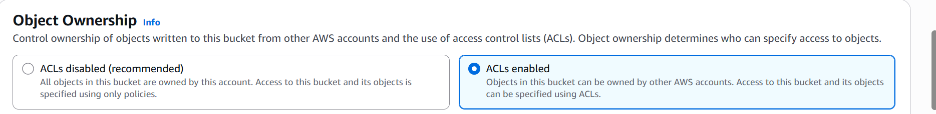

7. Uncheck block all public access box and check the acknowledge box

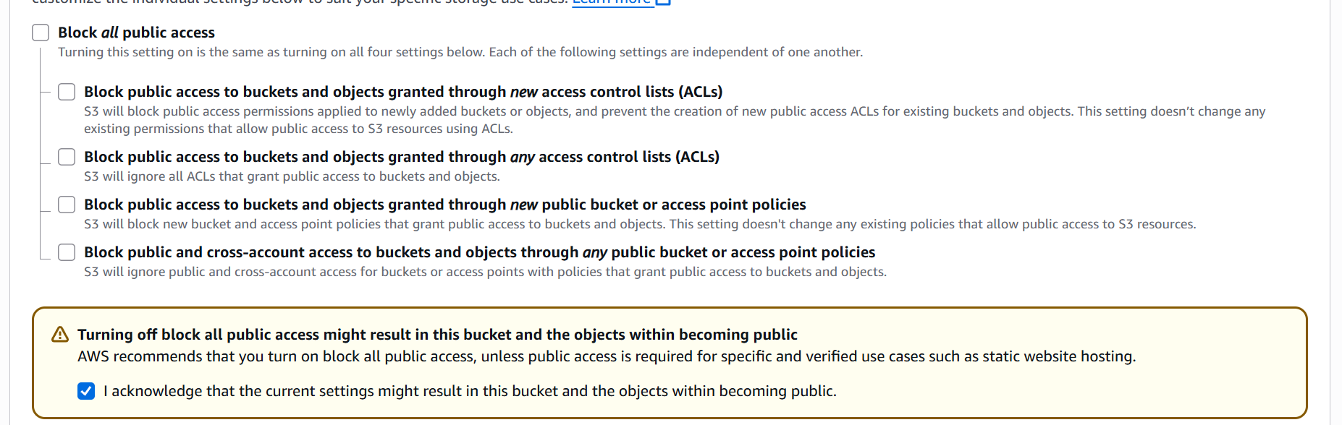

8. Click on the **Create bucket** button

**STEP 3: Create a Lambda Function**

1. Go to the AWS Lambda console.   
2. Click "**Create function**".   
3. Choose "**Author from scratch**".  
4. Enter a function name (e.g., demofunction).  
  
5. Select a **runtime** (e.g., Python 3.x or Node.js).

6. For permissions, choose "Create a new role with basic Lambda permissions".  
7. Click "Create function".

**STEP 4: Add S3 Trigger**

1. In the **Function overview** section, click "**Add trigger**".

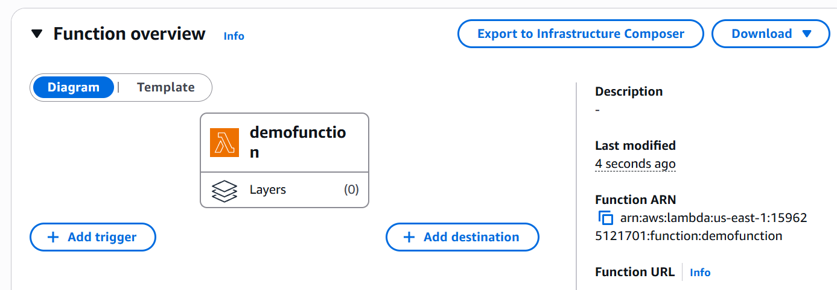

1. **Select "S3" as the trigger source**.

1. Choose the **previously created S3 bucket**.

4. Set the event type to “All object create event”.

1. Click "Add".

**STEP 5: Add Code to Lambda Function**

Example (Python):

import json

def lambda_handler(event, context):

    # TODO implement

    return {

        'statusCode': 200,

        'body': json.dumps('Hello from Lambda!')

    }

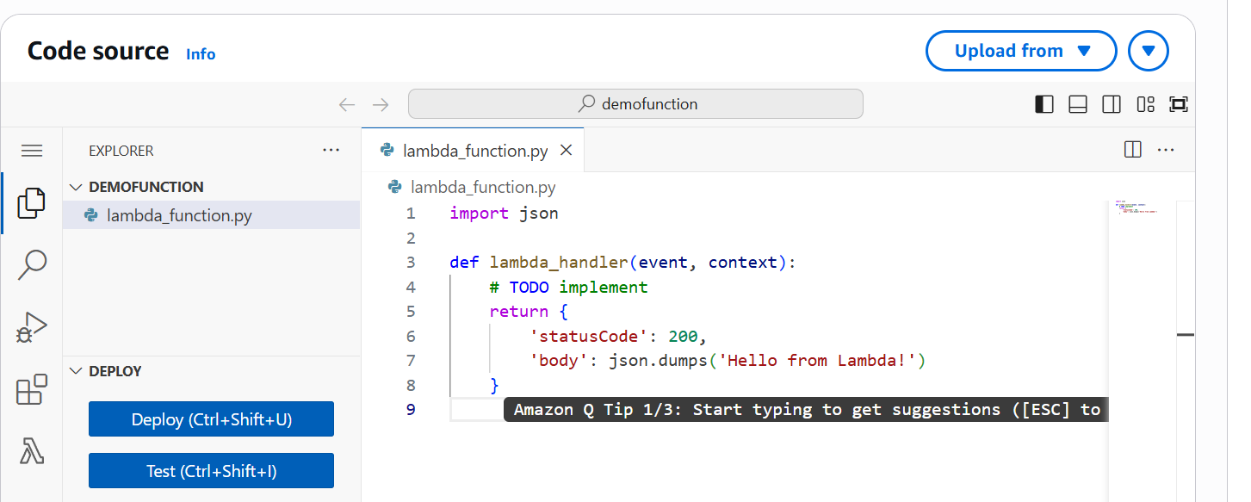

**Click "Deploy"** after updating the function code

**STEP 6: Test the Setup**

Upload a file to the S3 bucket.

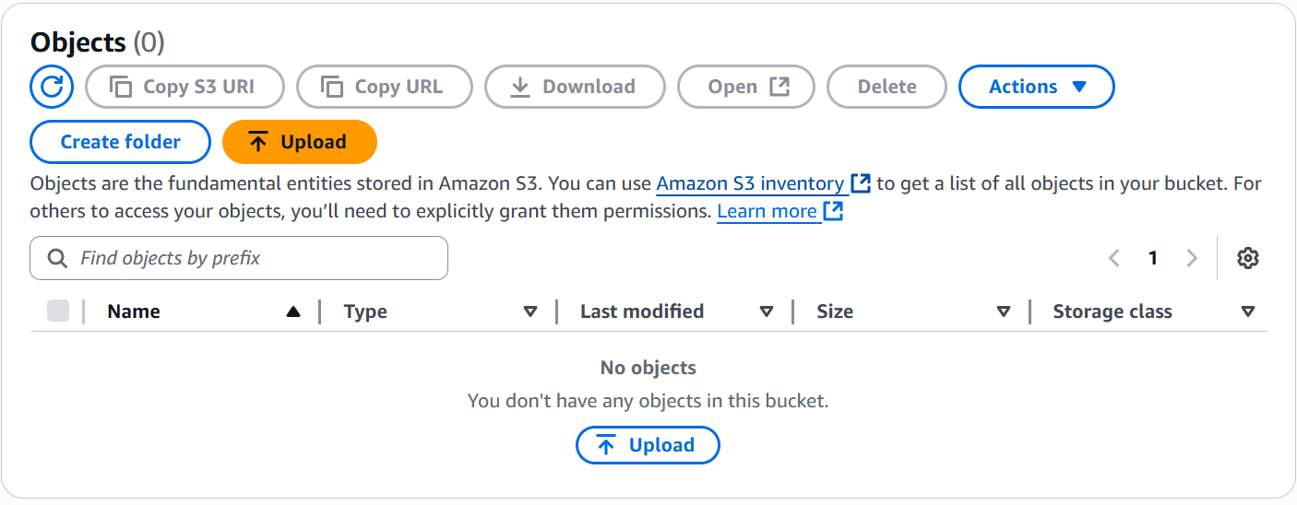

**Method 1.** (A) Go to the Lambda function’s "Monitor" tab and open CloudWatch Logs.

(B) Check the logs to verify if the function was triggered.

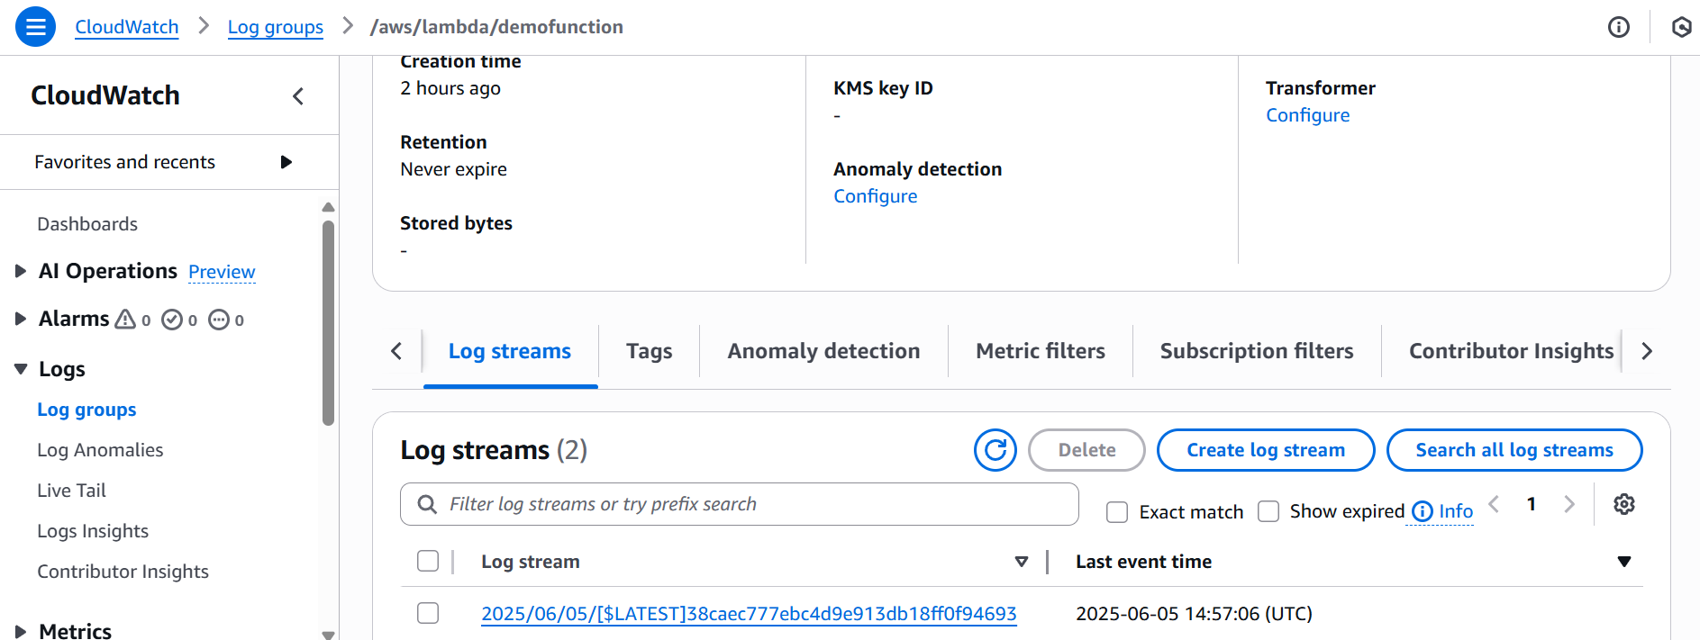

**Method 2:** Use Amazon CloudWatch Metrics

In CloudWatch > Metrics, navigate to: Lambda > By Function Name

Select your function to see the number of invocations and errors.

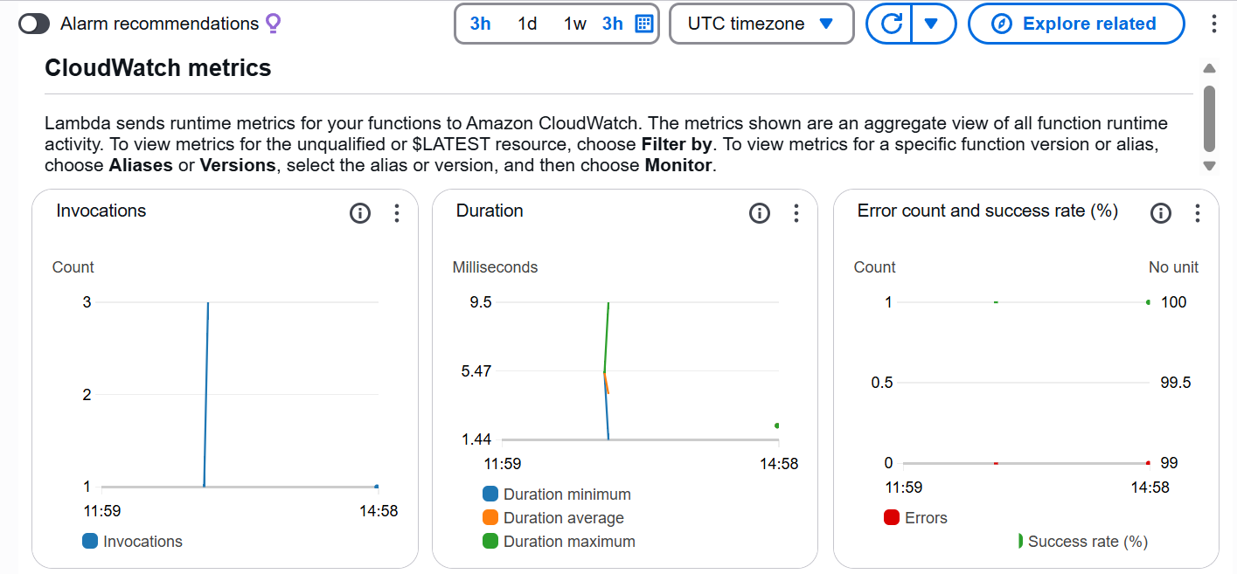

[Note on Permissions]

1. If access issues occur, go to the IAM console.

2. Locate the Lambda execution role and attach the "AmazonS3ReadOnlyAccess" policy or a custom policy with appropriate S3 permissions.