**PIZZA SALES SQL QUERIES**

1. **KPI’s**
2. **Total Revenue:** The sum of the total price of all pizza orders.

SELECT sum(total_price) as Total_Revenue FROM `pizza-sales-01.pizza.pizza-sales`;

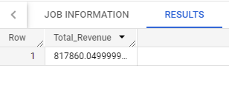

1. **Average Order Value:** The average amount spent per order, calculated by dividing the total revenue by the total number of orders.

SELECT sum(total_price)/count(distinct order_id) as Average_Order_Value FROM `pizza-sales-01.pizza.pizza_sales` ;

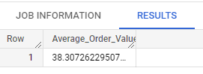

1. **Total Pizza Sold**: The sum of the quantities of all pizzas sold.

SELECT sum(quantity) as Total_Pizza_Sold FROM `pizza-sales-01.pizza.pizza_sales` ;

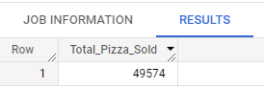

1. **Total Orders:** The total number of orders placed.

SELECT count(distinct order_id) as Total_Orders FROM `pizza-sales-01.pizza.pizza_sales` ;

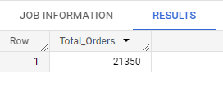

1. **Average Pizzas Per Order:** The average number of pizzas sold per order, calculated by dividing the total number of pizzas sold by the total number of orders.

SELECT sum(quantity) / count(distinct order_id) as Average_Pizzas_Per_Order FROM `pizza-sales-01.pizza.pizza_sales` ;

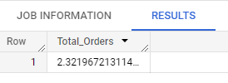

**B. Stats**

1. **Daily Trends for Total Orders:** Daily trend of total orders over a specific time period by identifying any patterns or fluctuations in order volumes on a daily basis.

SELECT extract(dayofweek from order_date ) as Order_Day , count(distinct order_id) as Total_Orders FROM `pizza-sales-01.pizza.pizza_sales` group by extract(dayofweek from order_date);

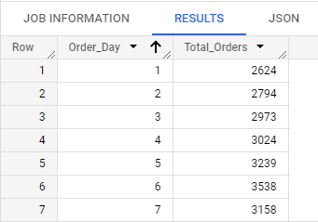

1. **Monthly Trends for Total Orders:** Illustrates the hourly trend of total orders throughout the day. This chart will allow us to identify peak hours or periods of high order activity.

SELECT extract(month from order_date ) as Order_Month , count(distinct order_id) as Total_Orders FROM `pizza-sales-01.pizza.pizza_sales` group by extract(month from order_date);

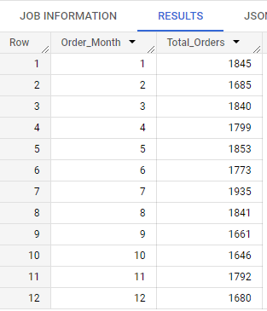

1. **Percentage of Sales by Pizza Category:** Distribution of sales across different pizza categories. the popularity of various pizza categories and their contribution to overall sales.

SELECT pizza_category,sum(total_price) as Total_Sales, sum(total_price)*100 / (select sum(total_price)FROM `pizza-sales-01.pizza.pizza_sales`) as Percentage_Sales FROM `pizza-sales-01.pizza.pizza_sales` group by pizza_category;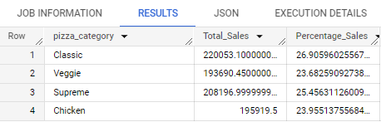

1. **Percentage Sales By Pizza Size:** The percentage of sales attributed to different pizza sizes help us understand customer preferences for pizza sizes and their impact on sales.

SELECT pizza_size,sum(total_price) as Total_Sales, sum(total_price)*100 / (select sum(total_price)FROM `pizza-sales-01.pizza.pizza_sales`) as Total_Sales FROM `pizza-sales-01.pizza.pizza_sales` group by pizza_size;

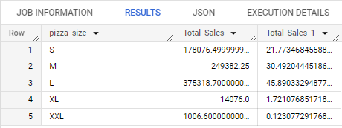

1. **Total Pizzas Sold by Pizza Category:** Presents the total number of pizzas sold for each pizza category. This will allow us to compare the sales performance of different pizza categories.

SELECT pizza_category, count( quantity) as Total_Sales FROM `pizza-sales-01.pizza.pizza_sales` group by pizza_category;

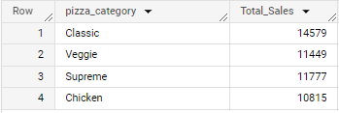

1. **Top 5 Best Sellers by Revenue: T**he top 5 best-selling pizzas based on the Revenue. This will help us identify the most popular pizza options.

SELECT pizza_name, sum(total_price) as Total_Revenue FROM `pizza-sales-01.pizza.pizza_sales` group by pizza_name order by Total_Revenue desc Limit 5 ;

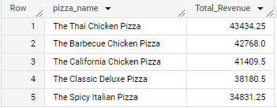

1. **Top 5 Best Sellers by Total Quantity:** The top 5 best-selling pizzas based on the Total Quantity. This will help us identify the most popular pizza options.

SELECT pizza_name, sum(quantity) as Total_Sales FROM `pizza-sales-01.pizza.pizza_sales` group by pizza_name order by Total_Sales desc Limit 5;

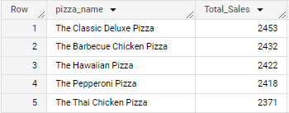

1. **Top 5 Best Sellers by Total Orders:** The top 5 best-selling pizzas based on the Total Orders. This will help us identify the most popular pizza options.

SELECT pizza_name, count(distinct order_id) as Total_Orders FROM `pizza-sales-01.pizza.pizza_sales` group by pizza_name order by Total_Orders desc Limit 5;

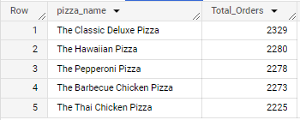

1. **Bottom 5 Best Sellers by Revenue:** The bottom 5 worst-selling pizzas based on the Revenue. This will help us identify the underperforming or less popular pizza options.

SELECT pizza_name, sum(total_price) as Total_Revenue FROM `pizza-sales-01.pizza.pizza_sales` group by pizza_name order by Total_Revenue limit 5 ;

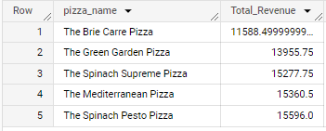

1. **Bottom 5 Best Sellers by Total Quantity**: The bottom 5 worst-selling pizzas based on the Total Quantity. This will help us identify the underperforming or less popular pizza options.

SELECT pizza_name, sum(quantity) as Total_Sales FROM `pizza-sales-01.pizza.pizza_sales` group by pizza_name order by Total_Sales Limit 5;

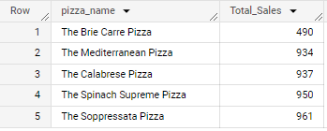

1. **Bottom 5 Best Sellers by Total Orders:** The bottom 5 worst-selling pizzas based on the Total Orders. This will help us identify the underperforming or less popular pizza options.

SELECT pizza_name, count(distinct order_id) as Total_Orders FROM `pizza-sales-01.pizza.pizza_sales` group by pizza_name order by Total_Orders Limit 5;

