BELLABEAT
Smart Device Data Analysis
How Fitness-Tracker Usage Trends Can Shape Bellabeat's Marketing Strategy
Prepared for: Urška Sršen & Sando Mur, Bellabeat Executive Team
Prepared by: Marketing Analytics Team | Data source: FitBit Fitness Tracker Data (Kaggle, CC0)
August 2026

1. Ask — Business Task
Bellabeat's cofounder Urška Sršen wants to understand how consumers use non-Bellabeat smart devices, then apply those insights to guide marketing strategy for one Bellabeat product. This analysis explores usage patterns across activity, sleep, heart rate, and weight-tracking data to surface trends that Bellabeat can act on.

Guiding Questions
- What are some trends in smart device usage?
- How could these trends apply to Bellabeat customers?
- How could these trends help influence Bellabeat's marketing strategy?

Stakeholders
- Urška Sršen — Cofounder & Chief Creative Officer
- Sando Mur — Cofounder & Mathematician, Executive Team
- Bellabeat Marketing Analytics Team

Product in Focus
Recommendations are framed primarily around the Bellabeat Leaf (activity, sleep, stress tracker) and Time (wellness watch), since the source data covers activity, sleep, and heart rate — the closest match to what these two products track.

2. Prepare — Data Sources
Data comes from the FitBit Fitness Tracker Data set (Kaggle, made available through Mobius, CC0: Public Domain). Thirty-plus Fitbit users consented to share personal tracker data, including activity, heart rate, sleep, and weight logs, generated between March 12 and May 12, 2016.
File | Rows | Unique Users | Date Range | Grain
dailyActivity_merged.csv | 1,397 | 35 | Mar 12 – May 12, 2016 (62 days) | 1 row per user per day
sleepDay_merged.csv | 413 | 24 | Apr 12 – May 12, 2016 | 1 row per user per sleep session
heartrate_seconds_merged.csv | 1,048,575 | 13 | Mar 29 – Apr 12, 2016 | 1 row per 5-second reading
weightLogInfo_merged.csv | 100 | 13 | Mar 30 – May 9, 2016 | 1 row per manual/auto weigh-in

Credibility Assessment (ROCCC)
This data has real limitations for Bellabeat's use case:
Not Reliable/Representative — a self-selected sample of only ~35 users, all from one 2016 Fitbit study, with no demographic breakdown (age, gender, location). Bellabeat's core audience is women, but sex isn't recorded here. Not Current — collected in 2016; wearable habits and devices have changed since. Citable/Original — sourced via Mobius from consenting Fitbit users and distributed as public domain, so licensing is not a concern, but third-party (not first-party Bellabeat) data.

Known Data Issues Found During Review
- Sample sizes shrink across files: 35 users logged activity, but only 24 logged sleep and just 13 logged weight or heart rate — weight and heart-rate findings should be read as directional, not representative.
- 9 daily-activity rows had 0 steps and 0 calories, suggesting the tracker wasn't worn — excluded from analysis.
- 3 exact duplicate rows in sleepDay_merged.csv — removed.
- 96 of 100 weight-log rows are missing body-fat %; that field was dropped from analysis.
- 64 of 100 weight entries were logged manually vs. 36 automatically — manual logging is a compliance risk (see recommendations).

3. Process — Cleaning & Preparation
Data was processed in Python (pandas) for its scale — the heart-rate file alone contains over 1 million rows, which is impractical to clean reliably by hand in a spreadsheet.

Cleaning Steps
- Converted all date/time fields to proper datetime types and derived a Weekday field from ActivityDate.
- Removed 9 "device not worn" rows (0 steps AND 0 calories) from daily activity.
- Removed 3 duplicate rows from sleepDay_merged.csv.
- Inner-joined daily activity with sleep on Id + date to study the activity–sleep relationship (421 matched user-days across 24 users).
- Aggregated heart-rate seconds data to hourly averages per hour-of-day to study daily heart-rate rhythm.
- Categorized users by average daily steps (Sedentary <5,000 / Lightly Active 5,000–7,499 / Fairly Active 7,500–9,999 / Very Active 10,000+), per CDC step-based activity bands.
- Calculated each user's logging frequency (days logged ÷ 62-day study window) to gauge device engagement.

4. Analyze & Share — Key Findings
35  unique users (activity) | 68.7%  of the day spent sedentary | 44%  of nights under 7 hrs sleep | 31 / 35  users log <90% of days

4.1 Most users are moderately active, not sedentary by choice
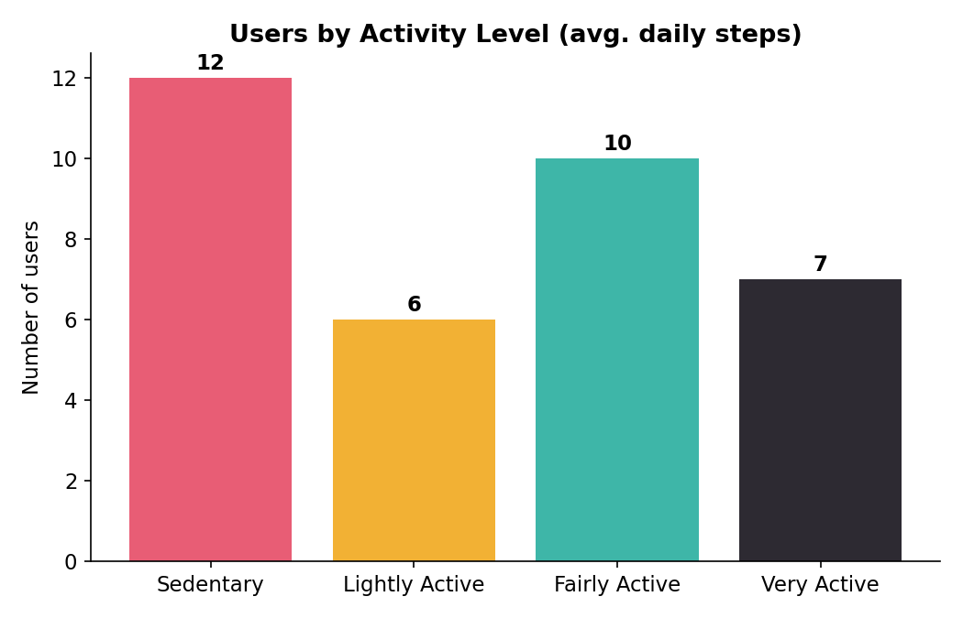
Users grouped by average daily step count.
Based on average daily steps, 17 of 35 users (about half) qualify as Fairly Active or Very Active, and 12 are Sedentary. This tells Bellabeat that its audience isn't uniformly low-activity — there's a real segment already motivated to move, plus a meaningful sedentary group that likely needs gentler, habit-building prompts rather than performance-athlete messaging.

4.2 Sedentary time dominates the day — even for active users
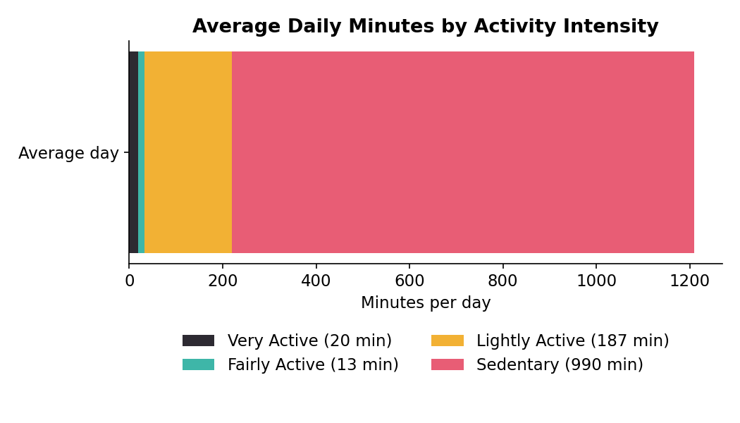
Average daily minutes by activity intensity, across all users and days.
On an average day, users spend about 990 minutes (nearly 69% of all logged time) sedentary, versus just 20 minutes Very Active and 13 minutes Fairly Active. Even people who hit high step counts still accumulate large stretches of sitting — the two aren't mutually exclusive. This is the single biggest opportunity area: nudging people to break up sitting time, not just chase step totals.

4.3 Steps and activity intensity drive calories more than movement volume alone
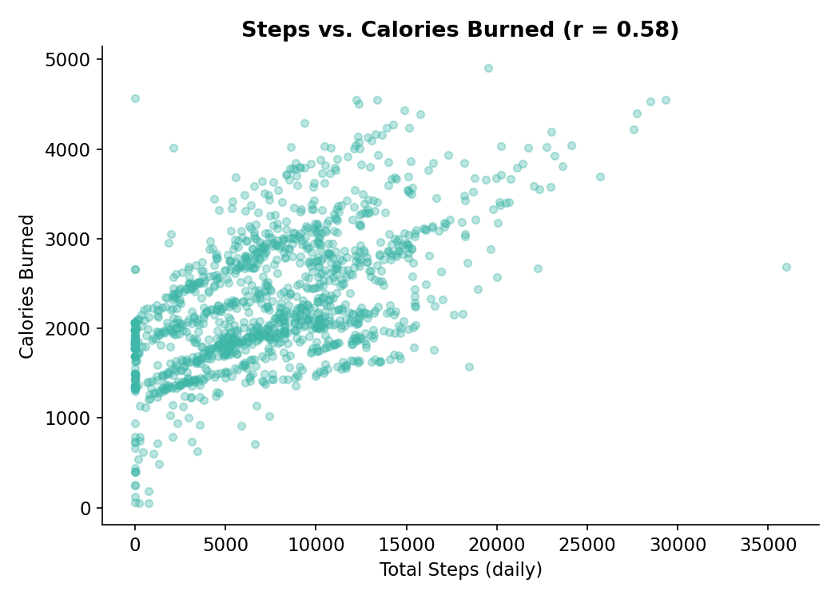
Each point is one user-day. Correlation with calories: steps r = 0.58, very-active minutes r = 0.59, sedentary minutes r = -0.04.
Total steps and very-active minutes both correlate moderately with calories burned, while sedentary minutes show almost no relationship. Practically: encouraging even short bursts of higher-intensity movement (a brisk walk, stairs) likely moves the needle on calorie goals more than simply logging more sedentary "awake" time.

4.4 More sedentary time is associated with less sleep
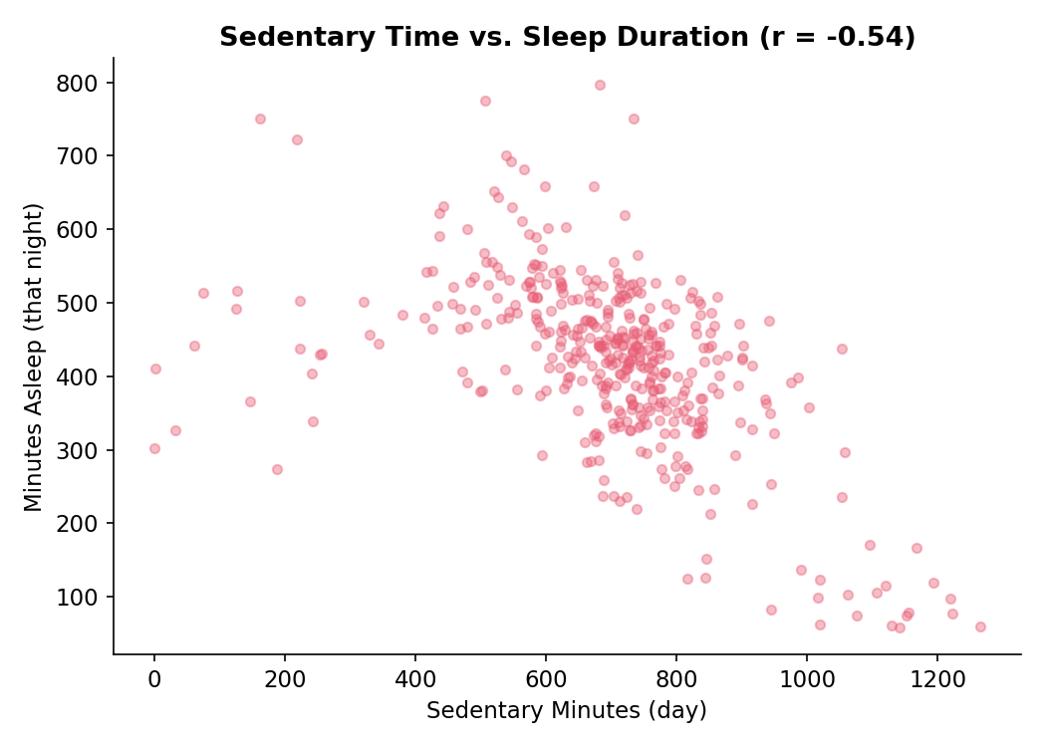
Matched user-days with both activity and sleep logged (n = 421, 24 users).
Sedentary minutes and that night's sleep duration are negatively correlated (r = -0.54) — days with more sitting tend to be followed by shorter sleep. Very-active minutes showed almost no relationship with sleep (r = -0.09) once sedentary time is accounted for, suggesting it's prolonged inactivity, not lack of exercise, that most tracks with poorer sleep in this data. This is a natural bridge between Bellabeat's activity and sleep tracking — a "move more during the day" nudge could be framed as a sleep-quality tool, not just a fitness one.

4.5 Sleep is inconsistent, and users lose real time "awake in bed"
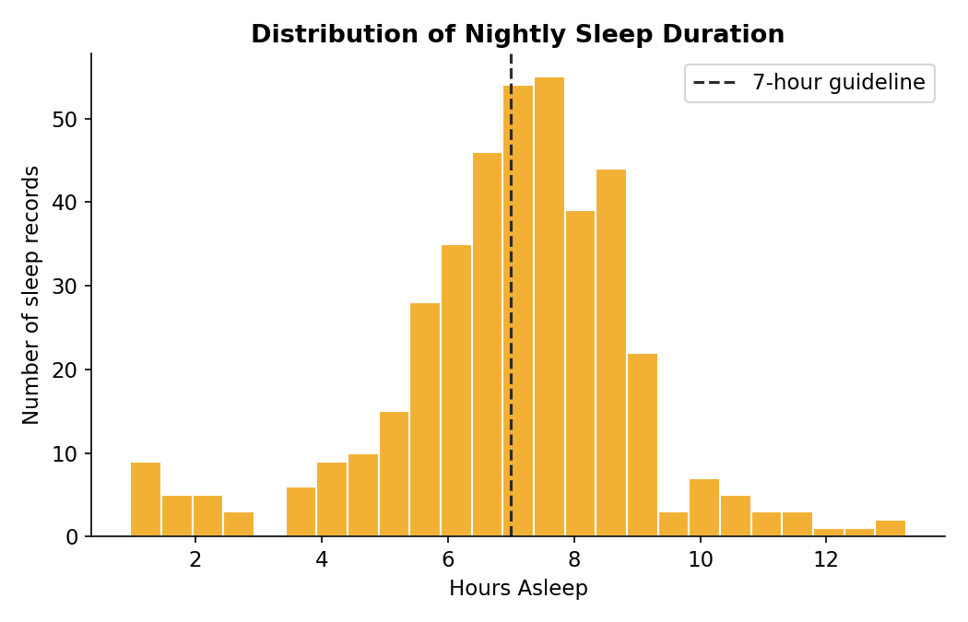
Distribution of nightly sleep duration across 410 logged sleep sessions.
Users average 419 minutes (about 7.0 hours) asleep per night, but 44% of nights fall short of the 7-hour general guideline, and the average person spends about 39 minutes awake in bed before/after sleeping (458 minutes in bed vs. 419 asleep). Sleep quality — not just duration — looks like an underused hook: coaching on wind-down routines and consistent bed/wake times could differentiate Bellabeat from step-counting-only competitors.

4.6 Weekday patterns: activity dips midweek and on Sunday
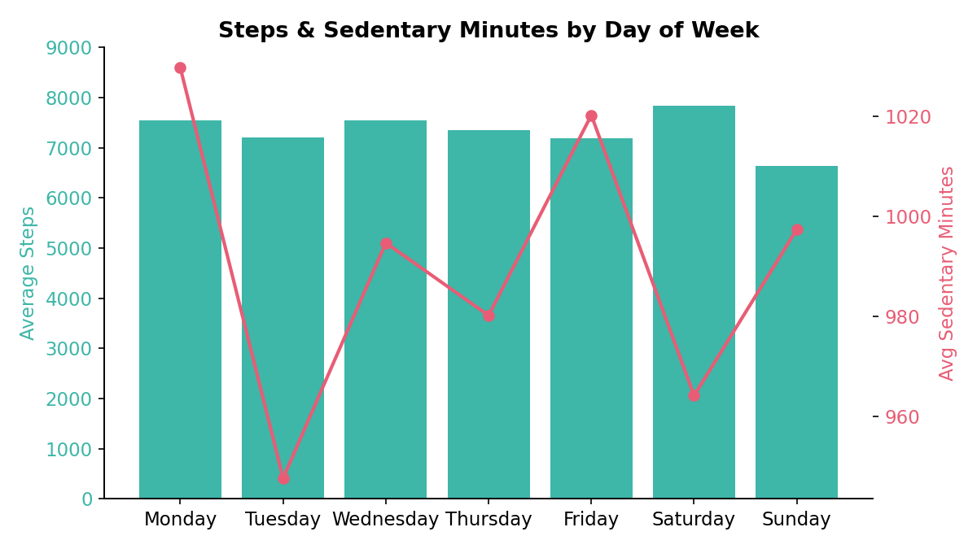
Average steps (bars) and average sedentary minutes (line) by day of week.
Saturday shows the highest average steps (~7,830) and Sunday the lowest (~6,640) alongside relatively high sedentary time — a classic "active Saturday, recovery/rest Sunday" pattern. Weekday sedentary minutes stay consistently high (947–1,030 min), reflecting desk-bound routines. This argues for day-of-week-aware notifications: movement reminders timed for weekday afternoons, and lighter, recovery-toned messaging on Sundays.

4.7 Heart rate rises sharply through the day and peaks in early evening
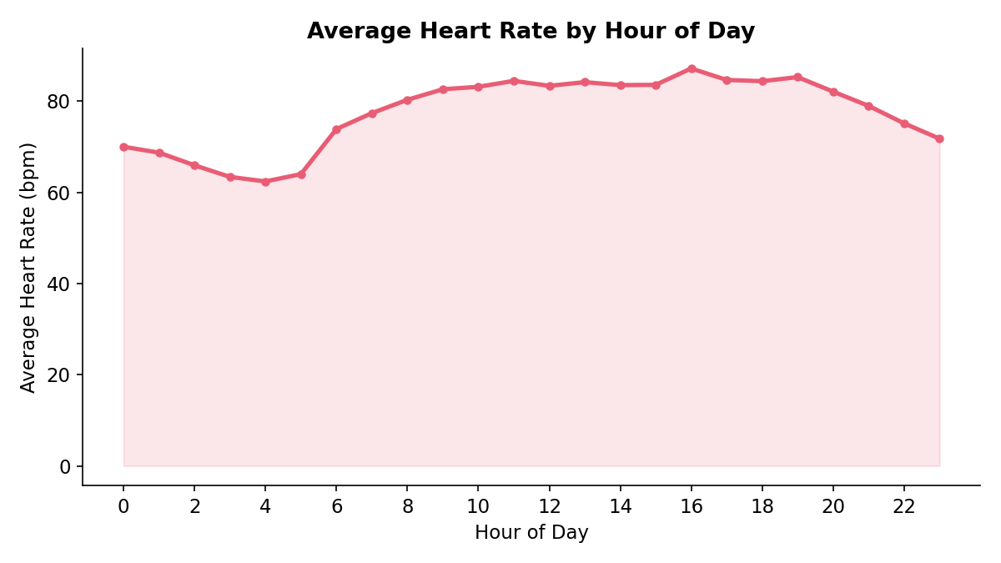
Average heart rate by hour of day, aggregated across ~1M readings from 13 users.
Resting heart rate is lowest overnight (roughly 60–65 bpm in the early hours) and climbs through the day, peaking in the early evening — consistent with commute/exercise/dinner-hour activity — before tapering off toward bedtime. A wellness watch like Bellabeat Time could use this rhythm to time its stress or activity nudges for when users are naturally most active, rather than at fixed clock times.

4.8 Engagement drops off — most users don't log every day
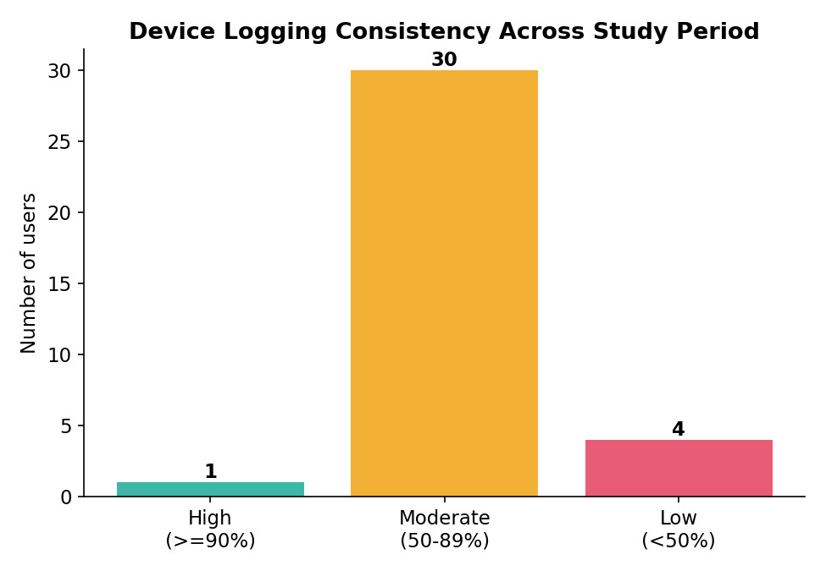
Device logging consistency over the 62-day study window.
Only 1 of 35 users logged activity on 90%+ of study days; 30 logged moderately (50–89% of days), and 4 logged on fewer than half the days. Combined with the sharp drop-off from 35 activity users to just 13 for weight and heart rate, this points to a broader retention challenge: people start tracking enthusiastically, then taper off. For Bellabeat, sustained engagement — not just initial adoption — is where a subscription membership model can add the most value.

5. Act — Recommendations for Bellabeat Marketing
Three high-level, data-backed recommendations, framed for the Bellabeat Leaf and Time products:

1. Sell "sitting less," not just "stepping more"
Sedentary time dominates the day (68.7% of logged time) and is the strongest lifestyle factor linked to shorter sleep in this data. Marketing and in-app messaging should lead with hourly "stand and stretch" nudges and frame reduced sitting as a sleep and energy benefit, not only a fitness metric — a differentiated angle versus step-count-first competitors.

2. Position sleep quality, not just sleep tracking, as a core Bellabeat value
With 44% of nights under 7 hours and ~39 minutes nightly spent awake in bed, there's a clear opportunity for the Bellabeat app and membership program to offer wind-down coaching, bedtime consistency streaks, and heart-rate-informed "ready for bed" alerts timed to each user's own daily heart-rate rhythm — turning passive tracking into an active sleep-improvement product.

3. Design specifically for re-engagement, and market membership around it
Logging drops off over time — most users track moderately, not daily, and far fewer keep logging weight or wearing a heart-rate-capable device long-term. Bellabeat should invest in weekly personalized recap notifications, day-of-week-aware reminders (e.g., lighter tone on Sundays, movement prompts midweek), and use the Bellabeat membership program's personalized guidance as the retention lever — the thing that keeps users logging past the first few weeks, which this data suggests is exactly where engagement fades.

Limitations to Flag Alongside Any Recommendation
- Small, dated (2016), non-representative sample with no gender data — validate directionally against Bellabeat's own first-party user data before finalizing campaigns.
- Weight and heart-rate conclusions rest on only 13 users each and should be treated as hypotheses to test, not settled facts.
- Consider pairing this analysis with a current, larger dataset (e.g., anonymized Bellabeat app usage) to validate these trends before scaling any campaign.

