VITAL SECURITY PLC
INTERNAL WORKFORCE & PAYROLL MANAGEMENT PLATFORM | SYSTEM DESIGN DOCUMENT

SYSTEM DESIGN DOCUMENT
Human Resources, Attendance & Payroll Module — Requirements, Access Control and Workflow Specification

Solution
Internal Workforce & Payroll Management Platform, built as the first module of a broader company ERP
Delivery Model
Internal design, build, testing and phased rollout by Control Room
CONFIDENTIAL — INTERNAL USE ONLY

Table of Contents
Table of Contents 2
1. Executive Summary 4
1.1 Objectives 4
1.2 Expected Benefits 4
2. Scope and Design Principles 5
2.1 In-Scope Solution 5
2.2 Explicitly Out of Scope 5
2.3 Design Principles 5
3. Proposed Solution Architecture 6
3.1 Logical Architecture 6
3.2 Recommended Application Components 7
4. Organization, Sites and User Hierarchy 7
Functional Feature Set 7
Operational Workflow 7
Business Rules and Validation 8
5. Attendance and Guard Relief-Chain Management 8
Functional Feature Set 8
Operational Workflow 9
Business Rules and Validation 10
6. Payroll Management 10
Functional Feature Set 10
Operational Workflow 10
Business Rules and Validation 11
7. Roles, Responsibilities and Access Governance 11
8. Reporting and Executive Dashboards 12
Functional Feature Set 12
Operational Workflow 12
Business Rules and Validation 13
9. Administration, Configuration and Governance 13
Functional Feature Set 13
Operational Workflow 13
Business Rules and Validation 13
10. Security, Access Control and Auditability 13
Functional Feature Set 13
Operational Workflow 14
Business Rules and Validation 14
Security and Data Protection Control Matrix 14
11. Data Model and Information Architecture 14
12. Cross-Functional Example Scenario 15
12.1 Example: Onboarding to First Paid Shift 15
13. Testing and Acceptance Criteria 15
14. Implementation Risks and Mitigation 16
15. Success Metrics and Post-Rollout Measurement 16
16. Assumptions, Dependencies and Decisions Required 17
16.1 Assumptions 17
16.2 Decisions Required 17
17. Final Proposed Scope and Acceptance Statement 17
17.1 Current Scope (Delivered) 17
17.2 Planned Expansion 18
18. Document Sign-Off 18
Appendix A. Glossary 19

1. Executive Summary
Vital Security PLC operates a workforce of field-deployed security guards and office staff across multiple client sites. This document specifies the Internal Workforce & Payroll Management Platform: a system that makes attendance, scheduling and payroll accurate, auditable, and resistant to manipulation, while remaining simple enough for guards to use in the field and administrators to operate day to day.
The platform is designed as the first module of a broader internal Enterprise Resource Planning (ERP) system for Vital Security PLC, built on a shared core layer so that future modules — Finance, Inventory, Fleet, and others — extend the same foundation rather than being rebuilt from scratch.

1.1 Objectives
- Create one controlled source of truth for employee records, site assignments, attendance and payroll.
- Prevent unauthorized manipulation of guard working hours through a system-enforced relief-chain handover, not manual trust.
- Separate duties across roles so no single person can complete a sensitive process — onboarding or payroll — alone.
- Give Operations and head office visibility into site coverage and attendance exceptions without blocking legitimate operational flexibility.
- Support two genuinely different payroll models — hourly/rate-based for guards, salaried for staff — under one disciplined approval workflow.
- Maintain a full, tamper-evident audit trail of every material action across the system.
- Provide a foundation that additional company modules can be built on without re-architecting what already works.

1.2 Expected Benefits
Area | Expected Improvement | Example at Vital Security
Payroll integrity | Hours cannot be altered without a verifiable system record | A guard's clock-in is rejected unless a specific predecessor has genuinely clocked out
Accountability | Every sensitive action traceable to one person | Payroll approvals, overrides and record edits are all attributed and timestamped
Operational visibility | Head office sees coverage gaps as they happen | An understaffed site raises an alert rather than being discovered after the fact
Segregation of duties | No single role can complete a sensitive process alone | Onboarding spans HR and Operations; payroll spans preparer, checker and approver
Guard usability | Field staff can check in quickly with minimal friction | Guards select a predecessor and clock in from a simple mobile-first screen
Foundation for growth | Future modules reuse the same core instead of starting over | Finance can later be built on the same users, audit log and event system

2. Scope and Design Principles
This section defines what the platform covers today, what is explicitly excluded, and the principles that shaped every design decision described later in this document.

2.1 In-Scope Solution
Feature | Detailed Requirement | Business Value | Priority
Organization & Users | Company/site/user hierarchy, role-based access, onboarding workflow | Correct ownership and accountability | Must
Attendance & Relief-Chain | Clock-in/out, predecessor verification, 48-hour rule, exceptions, coverage alerts | Prevents unauthorized hour manipulation | Must
Payroll Management | Dual guard/staff pipelines, rate entry, multi-step approval, state history | Disciplined, auditable pay processing | Must
Reporting & Dashboards | Live module cards, coverage and payroll status visibility | Fast operational and leadership visibility | Must
Administration | RBAC, permission registry, organizational configuration | Controlled platform operation | Must
Security & Audit | Server-enforced permissions, full audit log, event system | Enterprise-grade governance | Must
Future ERP Modules | Finance, Inventory, Sales/CRM, Procurement, Fleet, Project Management | Shared foundation for company growth | Should

2.2 Explicitly Out of Scope
- Recruitment, candidate management, and formal performance/appraisal management — planned for a later phase, not part of the current build.
- GPS/location verification at clock-in — identified as the next priority enhancement, not yet implemented.
- Financial ERP functions such as general ledger, accounts payable/receivable, or budgeting — reserved for a future Finance module.
- Inventory, fleet, procurement, and other planned ERP modules — represented only as placeholders in the current system.
- Any autonomous or AI-driven decision-making — all approvals, overrides, and payroll actions require a specific accountable human.

2.3 Design Principles
1. No single person completes a sensitive process alone — onboarding and payroll are both deliberately split across roles.
2. Verify, don't trust — the relief-chain and server-side timestamps replace informal manual attendance records with system-enforced proof.
3. Alert, don't obstruct — coverage and staffing anomalies are surfaced for human judgment rather than automatically blocked, since operations sometimes need legitimate flexibility.
4. Mobile-first for the field — guard-facing check-in and relief screens must be fast and simple to use on a phone.
5. Auditability by design — every meaningful change is attributable to a specific user and timestamp, system-wide.
6. Build once, reuse everywhere — shared core services (users, organizations, audit, events) support this module and every future one.

3. Proposed Solution Architecture
The platform follows a modular architecture: a shared core layer providing identity, organization structure, audit, and event handling, with the Human Resources & Payroll module as the first business module built on top of it. Future modules will attach to the same core rather than duplicating it.
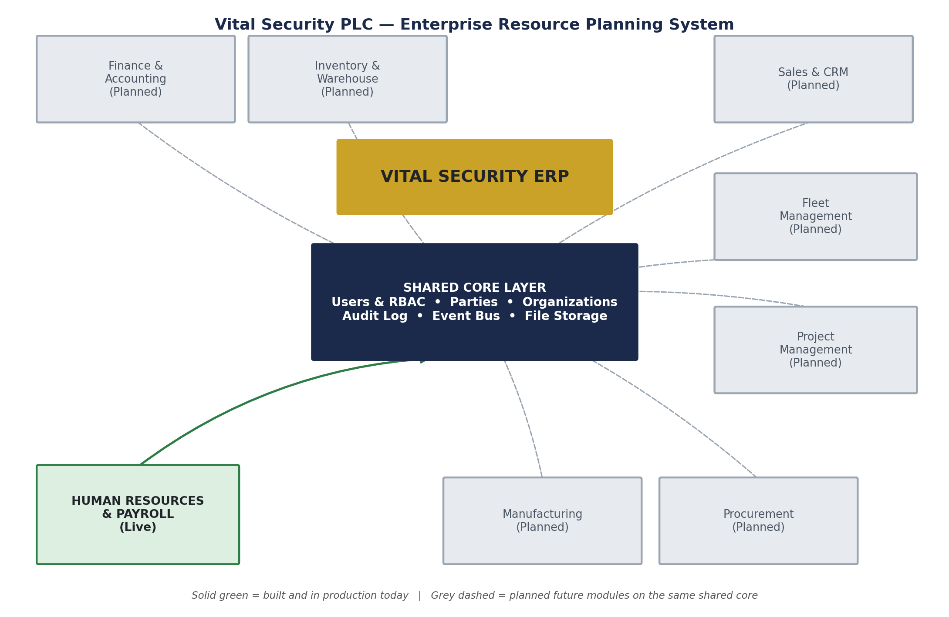
Figure 1 — Shared core layer with the Human Resources & Payroll module live today, and future modules planned on the same foundation.

3.1 Logical Architecture
Layer | Main Components | Relevance | Design Notes
Presentation | Admin workspace, guard mobile view, dashboards | One interface family, role-specific complexity | Consistent shared component library
Application | User/RBAC service, attendance & relief-chain engine, payroll engine, notification/event service, audit service | Encodes governance and workflow rules | Modular services, clear responsibilities
Data | Organization, users, sites, attendance, payroll, audit log | Stores the full auditable management history | Structured, relational, indexed for scope-based queries

3.2 Recommended Application Components
Component | Responsibility | Key Controls
Authentication & Session | Login and session handling for all users | Credentials issued only through controlled account creation
Authorization (RBAC) | Role and scope-based access filtering | Server-enforced on every request, not just hidden in the interface
Attendance & Relief-Chain Service | Clock-in/out lifecycle and predecessor verification | 48-hour rule, exception handling, coverage alerting
Payroll Service | Guard and staff payroll lifecycle | Multi-step approval, segregation of duties, full state history
Notification & Event Service | Cross-module event handling | Enables future modules to react without tight coupling
Audit Service | Who/what/when history | Immutable, exportable, system-wide

Architecture constraint
The platform is the system of record for attendance and payroll governance — not a replacement for future specialized systems. It should consume verified data and provide management context: who, what, status, and accountability.

4. Organization, Sites and User Hierarchy
Establishes the structural foundation for managing employees, sites, and access from company level down to the individual guard or staff member.

Functional Feature Set
Feature | Detailed Requirement | Business Value | Priority
User accounts | Login credentials created independently of employee records | Controlled identity issuance | Must
Employee records | Personal, job, and guard-specific details linked to a user account | Reliable accountability | Must
Site assignment | Places an employee on a specific site's roster | Correct deployment tracking | Must
Role-based access | Admin, HR, Operations, Finance, Guard with scoped visibility | Least privilege | Must
Site capacity configuration | Expected simultaneous guard headcount per site | Basis for coverage alerting | Should

Operational Workflow
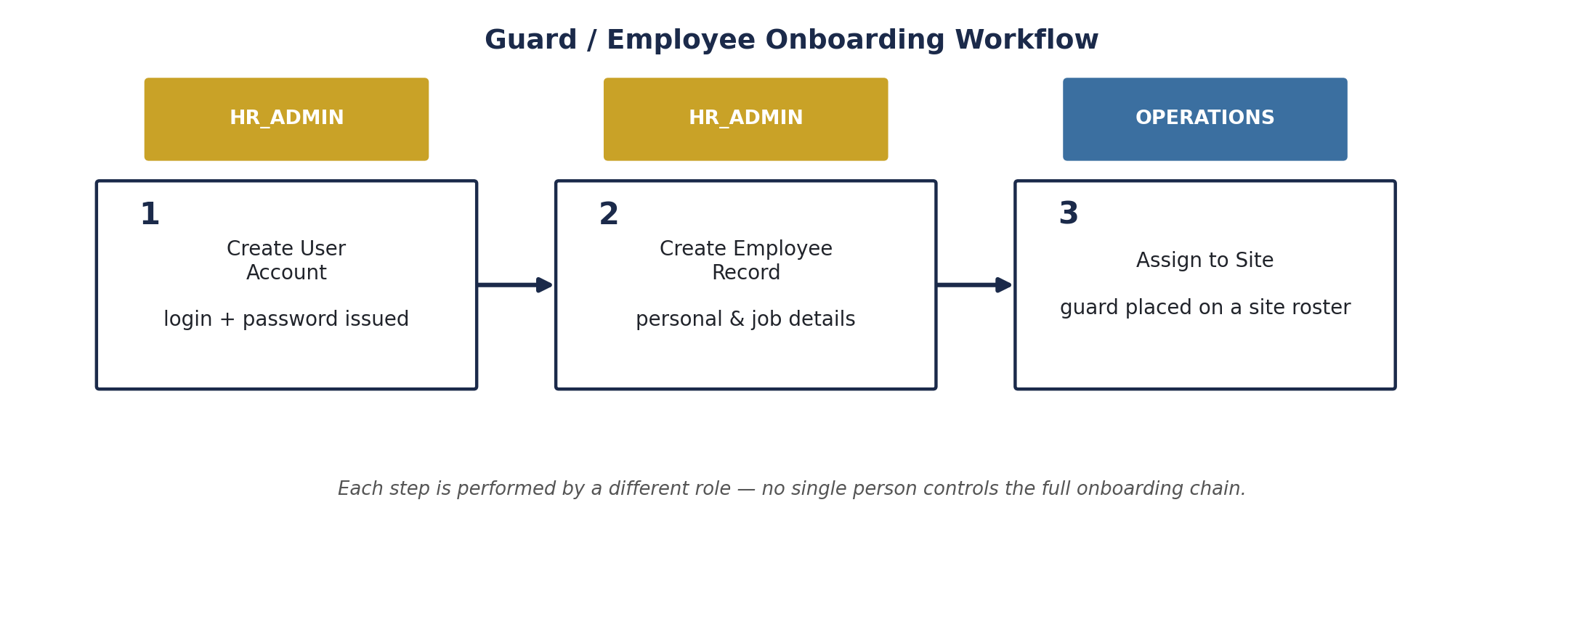
Figure 2 — Onboarding workflow: three steps, three different roles.
7. Admin creates a user account (login credentials) before any other record exists for the person.
8. HR creates the employee record, linked to that user account, capturing personal and job details.
9. Operations assigns the employee to a specific site, separately from identity creation.
10. Test access confirms only the intended scope is visible to the new account.
11. The employee is activated and appears in relevant site rosters and reports.

Business Rules and Validation
- Identity creation (HR) and deployment (Operations) are always performed by different roles.
- A user account must exist before an employee record can be created.
- An employee must have a valid site assignment before appearing on attendance rosters.
- Every create, update, and delete action on users, employees, and site assignments is written to the audit log.

5. Attendance and Guard Relief-Chain Management
The core control of this platform. Prior to this system, guard hours were recorded manually, allowing hours to be added or extended without head office's knowledge. This section replaces manual trust with a system-enforced handover between guards.

Functional Feature Set
Feature | Detailed Requirement | Business Value | Priority
Relief-chain clock-in | Clock-in requires selecting the specific on-duty guard being relieved | Structurally prevents unverified hours | Must
Predecessor verification | System blocks clock-in unless the selected predecessor has already clocked out | Closes the core fraud gap | Must
48-hour rule | Guard cannot restart a shift at a site within 48 hours of their own last one | Legal rest compliance, closes proxy-relief pattern | Must
No-predecessor handling | Null predecessor allowed only when nobody is currently on duty at the site | Covers first-ever shifts and normal daily gaps | Must
Exception/override path | Operations-only override for a missed clock-out, with mandatory reason | Keeps correction authority with a supervisory role | Must
Coverage alerting | Alert when on-duty headcount drops below a site's expected level | Visibility without blocking legitimate flexibility | Should
Server-side timestamps | All clock times stamped on arrival at the server, never from a guard's device | Prevents client-side time manipulation | Must

Operational Workflow
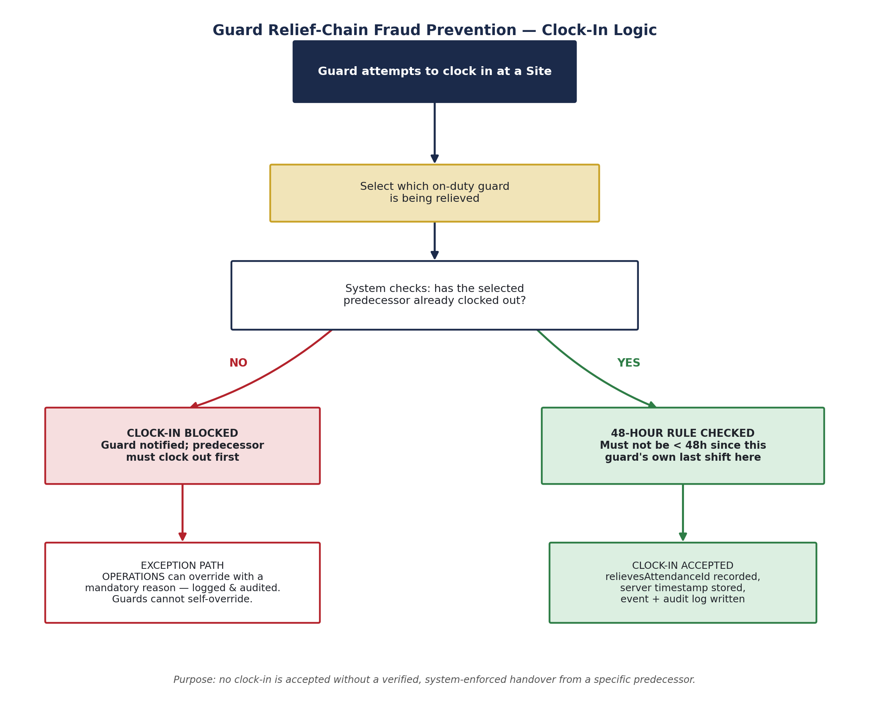
Figure 3 — Clock-in logic: no shift begins without a verified handover.
12. Guard attempts to clock in at a site.
13. If any guard is currently on duty, the incoming guard selects which one they are relieving.
14. The system verifies the selected predecessor has already clocked out; if not, the clock-in is blocked.
15. If nobody is currently on duty at the site — whether it is the site's first-ever shift or simply a normal gap between shifts — the clock-in proceeds without a predecessor.
16. The system checks the 48-hour rule against the guard's own attendance history at that site.
17. A successful clock-in is recorded with a server timestamp, the predecessor reference where applicable, and an audit log entry.
18. If a predecessor genuinely forgot to clock out, Operations resolves it through the override path with a mandatory reason — never the guards themselves.
19. Coverage is recalculated after every clock-in and clock-out, and an alert is raised if a site falls below its expected headcount.

Business Rules and Validation
- A guard cannot clock in claiming to relieve a predecessor who has not actually clocked out.
- A guard cannot restart a shift at the same site within 48 hours of their own previous shift there.
- Only Operations-level accounts or above may override a missed clock-out, and every override requires a written reason.
- Coverage alerts are informational only — the system does not block guards from clocking in beyond a site's expected headcount, since genuine operational needs (emergencies, handover overlap, training) can require temporary extra coverage.
- Every clock-in, clock-out, edit, and override is written to the audit log with the acting user and timestamp.

6. Payroll Management
Guards and office staff are paid under genuinely different logic — hourly/rate-based for guards, salaried for staff — so the platform runs two parallel payroll pipelines rather than forcing both into a single generic process.

Functional Feature Set
Feature | Detailed Requirement | Business Value | Priority
Guard payroll pipeline | Rate entry, hour-based calculation, multi-step review | Accurate variable-hour pay | Must
Staff payroll pipeline | Fixed-salary calculation, matching review rigor | Consistent salaried pay | Must
Segregated approval stages | Distinct preparer, checker, and approver stages before payment | No single role can complete the cycle alone | Must
Returned status | Any review stage can send a record back for correction | Error correction without breaking the audit trail | Must
Full state history | Every payroll record retains its complete stage history | Traceability and dispute resolution | Must
Endpoint-level permissions | Every payroll action individually permission-gated | No action possible outside an authorized role | Must

Operational Workflow
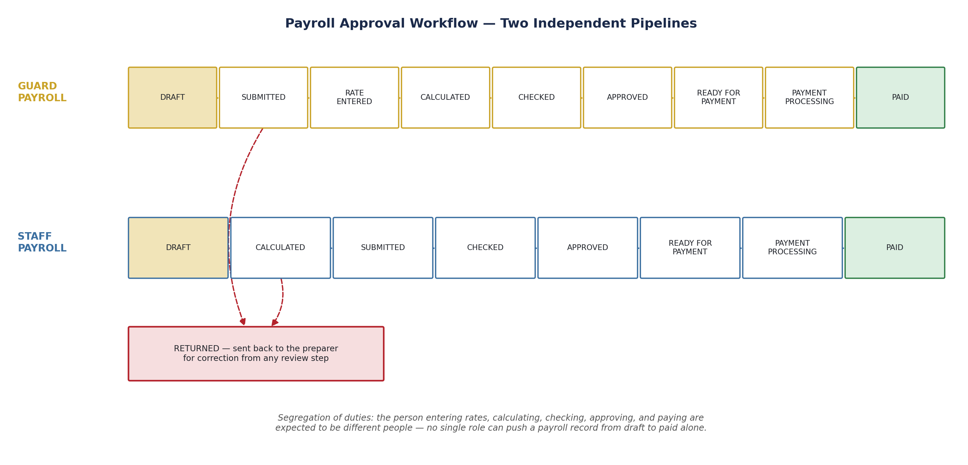
Figure 4 — Payroll approval workflow: two independent pipelines, each requiring independent review.
20. A payroll run is generated for the relevant guard or staff population and cycle.
21. For guards, rates are entered against recorded hours before calculation; staff salaries calculate directly.
22. The record is submitted, then independently checked by a different user.
23. An approver signs off before the record becomes eligible for payment.
24. Payment is processed and the record is marked paid, with the full stage history retained.
25. A record found incorrect at any review stage is returned to the preparer rather than silently corrected.

Business Rules and Validation
- No single role may move a payroll record from draft to paid without it passing through independent review.
- Every payroll action — generate, enter rates, calculate, submit, check, approve, return, pay — requires its own specific permission.
- A returned record must go back through the full review chain again; a correction does not skip stages.
- Every state transition, and the user who performed it, is retained permanently in the record's history.

7. Roles, Responsibilities and Access Governance
Access is controlled by role, deliberately structured so that no single person can carry out an entire sensitive process alone. This is the foundation the onboarding and payroll workflows above are both built on.
Role | Represents | Responsibility | Key Decisions
SUPER_ADMIN | Company owner / senior oversight | Read-only visibility across the system; oversight is intentionally kept separate from execution. | Escalation authority, not action authority
ADMIN | System administrator | Creates user accounts and employee records; manages employee data. | Give role
OPERATIONS | Site and workforce operations | Assigns guards to sites, resolves attendance exceptions, monitors coverage. | Deployment and exception handling
FINANCE_OFFICER | Payroll and finance processing | Runs the payroll lifecycle end-to-end — the most operationally powerful role, and the most heavily audited. | Payroll execution
GUARD | Field security guard | Views and manages only their own shift, hours, sites, and payroll. | Self-service only, no administrative access

8. Reporting and Executive Dashboards
Gives Operations and head office a concise, decision-ready view of workforce and payroll status without requiring them to dig through individual records.

Functional Feature Set
Feature | Detailed Requirement | Business Value | Priority
Live module dashboard | Central navigation showing active and planned modules | Fast orientation, honest scope | Must
HR summary card | Live employee, attendance, and payroll status at a glance | Fast operational visibility | Must
Coverage visibility | Sites currently below expected headcount surfaced clearly | Early operational awareness | Should
Payroll status visibility | Records grouped by current workflow stage | Clear view of what needs review or approval | Should

Operational Workflow
26. Dashboard refreshes from the latest attendance and payroll activity.
27. Operations and leadership review current coverage and payroll status.
28. Any at-risk item — an understaffed site or a stalled payroll record — is visible without a separate report request.

Business Rules and Validation
- Dashboard cards only describe functionality that is actually implemented — no card advertises a feature that does not yet exist.
- Planned future modules are shown clearly as not-yet-available rather than omitted or presented as functional.

9. Administration, Configuration and Governance
Gives administrators control over roles, permissions, and organizational structure without requiring changes to the underlying system.

Functional Feature Set
Feature | Detailed Requirement | Business Value | Priority
RBAC administration | Create and manage roles, permissions, and scope | Security and least privilege | Must
Modular permission registry | Each module registers its own permissions independently | Avoids a single unmanageable permission file as the system grows | Must
Site configuration | Expected headcount and organizational hierarchy per site | Accurate coverage alerting | Should
Employee code generation | Race-safe, atomic sequence per organization | Guarantees unique employee IDs under concurrent registration | Must

Operational Workflow
29. Administrator configures organizational structure, roles, and site parameters.
30. New modules register their required permissions at startup rather than requiring manual central edits.
31. Administrator monitors audit activity and usage on an ongoing basis.

Business Rules and Validation
- Every permission is scoped to the specific action it governs — broad, catch-all permissions are avoided in favor of narrow, purpose-specific ones.
- Employee ID generation uses an atomic counter, preventing duplicate IDs even under simultaneous registrations.

10. Security, Access Control and Auditability
Protects management and payroll information and provides a complete, tamper-evident history of changes.

Functional Feature Set
Feature | Detailed Requirement | Business Value | Priority
Server-enforced RBAC | Every request independently checked against the acting user's permissions | Cannot be bypassed via the interface | Must
Full audit log | Records who changed what and when, across every module | Traceability and investigation capability | Must
Event system | Internal event bus for cross-module reactions | Enables future modules without tight coupling | Should
Atomic multi-record operations | Guard registration writes linked records as a single atomic operation | Prevents half-created records on failure | Must

Operational Workflow
32. User identity is authenticated and their role/scope determined.
33. Every request is independently checked against the required permission before any action executes.
34. Material changes are validated, written, and logged to the audit trail.
35. Administrators can export audit history for review at any time.

Business Rules and Validation
- Access control is enforced at the server on every request — not only hidden or disabled in the interface.
- No material create, update, delete, or override action occurs without a corresponding audit log entry.

Security and Data Protection Control Matrix
Control | Implementation Approach | Verification Method
Authorization | Role and scope-based access checks on every request | Access denial testing
Audit trail | Exportable, immutable who/what/when log | Audit export review
Data integrity | Atomic multi-record writes; race-safe ID generation | Concurrent-operation testing
Segregation of duties | Distinct preparer/checker/approver roles for payroll and onboarding | Workflow review
Timestamp integrity | All attendance timestamps recorded server-side on receipt | Client-manipulation testing

11. Data Model and Information Architecture
Provides a clean structure connecting organization, users, sites, attendance, and payroll — designed to support current operations and future ERP modules without redesign.
Entity | Key Attributes | Purpose
Organization | Company hierarchy, employee code sequence configuration | Structural foundation
User | Login identity, role, status | Access control
Employee | Personal and job details, linked to a user and (optionally) an organizational Party record | HR record of truth
Site | Location, expected headcount | Coverage and deployment basis
Attendance Record | Clock-in/out, predecessor reference, server timestamp | Relief-chain enforcement and history
Payroll Record | Guard or staff pay cycle, current stage, full state history | Payroll governance
Audit Log | Entity, action, actor, timestamp | System-wide traceability

12. Cross-Functional Example Scenario
The platform becomes most valuable when its controls work together across roles in an ordinary operational day, not just in isolated features.

12.1 Example: Onboarding to First Paid Shift
- HR_ADMIN creates a user account and employee record for a new guard.
- OPERATIONS assigns the guard to a specific site, separately from HR's identity-creation step.
- The guard clocks in for their first shift; since nobody is currently on duty at that site, the clock-in proceeds without a predecessor and is logged accordingly.
- At shift end, the guard clocks out; the next guard due on-site later clocks in by selecting this guard as the one being relieved.
- At the end of the payroll cycle, FINANCE_OFFICER enters the guard's rate, calculates pay from recorded hours, and the record proceeds through check and approval before payment.
- Every step above — account creation, site assignment, both clock-ins, and every payroll stage — is independently attributable in the audit log.

13. Testing and Acceptance Criteria
The platform is accepted against tested behavior, not visual demonstration alone. The following core scenarios represent the minimum acceptance bar for the current scope.
36. Create a user account, then an employee record, then a site assignment, confirming each step requires the correct role.
37. Clock in a guard at a site with no one currently on duty and confirm the shift is accepted without a predecessor.
38. Attempt to clock in a guard claiming to relieve a predecessor who has not clocked out, and confirm the system blocks it.
39. Confirm the 48-hour rule blocks a guard from returning to the same site too soon after their own last shift.
40. Confirm only Operations-level accounts can execute the missed-clock-out override, and that guard-level accounts cannot.
41. Run a full guard payroll cycle from rate entry through calculation, check, approval, and payment.
42. Run a full staff payroll cycle and confirm the different calculation logic applies correctly.
43. Confirm a returned payroll record must pass through the full review chain again, not just the point it was returned from.
44. Confirm coverage alerts fire when a site drops below its expected headcount, without blocking additional clock-ins.
45. Confirm every action above produces a corresponding, correctly attributed audit log entry.

14. Implementation Risks and Mitigation
Risk | Potential Impact | Mitigation | Owner
Guards attempting to bypass the relief-chain informally | Reintroduces the original fraud gap | Clock-in is only accepted through the enforced predecessor check; there is no manual override path available to guards | Operations
Coverage alerts ignored due to alert fatigue | Real understaffing goes unnoticed | Keep alerting scoped to genuine deviations from expected headcount, not noisy or constant | Operations
Payroll stage skipped under time pressure | Breaks segregation of duties | Every stage transition is permission-gated at the server; skipping is not possible regardless of urgency | Finance
Permission scope creep over time | Roles gradually accumulate unnecessary access | Modular, narrowly-scoped permission registry reviewed as new modules are added | Admin
Incomplete adoption of shared UI components in new work | Inconsistent look and feel as the system grows | Component library use is a standing requirement for all new and redesigned pages | Admin

15. Success Metrics and Post-Rollout Measurement
Metric | Baseline | Target | Measurement Method
Unauthorized hour disputes | Historical manual-record disputes | Zero incidents traced to a bypassed relief-chain | Audit log review
Payroll rework rate | Baseline during initial rollout | Decreasing returned-record rate over successive cycles | Payroll stage history
Coverage alert response time | Baseline during initial rollout | Understaffed sites addressed same-day | Coverage alert to resolution tracking
Onboarding completion accuracy | Baseline during initial rollout | Zero employees active without a completed onboarding chain | Audit log review
Component library adoption | 0% at present | 100% of new/redesigned pages using the shared library | Code review

Success definition
The platform is successful when Operations and head office trust it as the single source of truth for attendance and payroll — not merely when the software is deployed.

16. Assumptions, Dependencies and Decisions Required

16.1 Assumptions
- Every site is continuously staffed with a rotating guard population; there is always a designated successor for an ongoing post.
- Guards are interchangeable within a site — any on-duty guard can be relieved by any other, rather than fixed named positions.
- Production deployment will run on infrastructure supporting real atomic transactions (a replica-set-based database), not a standalone instance.

16.2 Decisions Required
Decision | Why It Matters | Target Decision Point
Location verification approach | Determines the design of the planned GPS/geofencing enhancement | Before next development phase
Recruitment & Performance module scope | Determines whether these remain roadmap items or move into active development | Next planning cycle
UI component library retrofit | Determines whether existing pages are eventually brought in line with new ones | Ongoing, revisit periodically

17. Final Proposed Scope and Acceptance Statement
This document defines the Vital Security PLC Internal Workforce & Payroll Management Platform covering organization and user management, attendance with relief-chain fraud prevention, dual-pipeline payroll, reporting, administration, and security/audit — built as the first module of a broader internal ERP.

17.1 Current Scope (Delivered)
- Organization, user, and site management with segregated onboarding
- Guard relief-chain attendance system with 48-hour rule and Operations-only exception handling
- Coverage alerting (alert-only, non-blocking)
- Dual guard/staff payroll pipelines with full segregation-of-duties approval workflow
- Role-based access control enforced server-side, with a modular per-module permission registry
- System-wide audit log and internal event system
- Live HR dashboard module with honest, accurate placeholders for planned future modules

17.2 Planned Expansion
- GPS/location verification at clock-in and clock-out
- Recruitment and Performance Management modules
- Finance & Accounting module, building on existing payroll period and rate data
- Remaining planned ERP modules: Inventory, Sales/CRM, Procurement, Project Management, Fleet Management

Acceptance principle
The platform should be accepted against tested behavior — functional acceptance scenarios, security/access verification, and audit trail completeness — not visual demonstration alone.

18. Document Sign-Off
This document is submitted for review and feedback. Comments, questions, or additional requirements will be incorporated into the next revision.

Role | Name / Signature | Date
Prepared by | Control Room | Date

