VITAL SECURITY PLC
INTERNAL WORKFORCE & PAYROLL MANAGEMENT PLATFORM |
WORKFLOW AND ROLE STRUCTURE



WORKFLOW AND ROLE STRUCTURE
End-to-End Process: Account Creation, Registration, Attendance Handover, and Payroll Approval
CONFIDENTIAL — INTERNAL USE ONLY

Table of Contents
Table of Contents 2
1. Purpose of This Update 3
2. Roles and Responsibilities 3
3. Account Creation and Employee Registration 4
Functional Feature Set 4
Operational Workflow 4
Business Rules and Validation 4
4. Site Assignment and Attendance Monitoring 5
Functional Feature Set 5
Operational Workflow 5
Business Rules and Validation 5
5. Guard Reliever Handover 6
Functional Feature Set 6
Operational Workflow 6
Business Rules and Validation 7
6. Finance Review and Head Approval 8
Functional Feature Set 8
Operational Workflow 8
Business Rules and Validation 8
7. Consolidated Risk-to-Control Mapping 9
8. Open Items for Next Revision 9
9. Document Sign-Off 10

1. Purpose of This Update
This document captures a refined role structure and end-to-end workflow for the Internal Workforce & Payroll Management Platform. It supersedes the account-creation and attendance-handover sections of the v1.0 System Design Document while leaving the underlying payroll approval discipline and audit principles unchanged.
- A dedicated System Admin role now handles all account creation, separate from HR, Operations, and Finance.
- The guard attendance handover is reversed: the outgoing guard declares their reliever at clock-out, rather than the incoming guard claiming a predecessor at clock-in.
- A Head role is introduced as the final payroll approver, distinct from the read-only oversight role described previously.

2. Roles and Responsibilities
Role | Represents | Responsibility
System Admin | Technical access control | Creates login accounts for every role — HR, Operations, Finance, Head, and Guard. Does not perform HR, operational, or financial actions.
HR | People and pay-terms administration | Registers employees (staff and guards) and enters payroll-relevant contract details — salary and transport allowance for staff, rate and transport allowance for guards. Manages attendance at the period level: locking past periods and producing reports. Does not edit individual attendance records.
Operations | Site deployment and oversight | Assigns guards to sites and monitors their working hours. Reports work-hour anomalies to HR rather than editing attendance data directly.
Finance | Payroll processing | Views HR's registration and contract data, processes payroll, checks salary calculations, and can edit entries before sending the record to the Head for approval.
Head | Final payroll approval | Reviews and approves payroll after Finance's checks, authorizing payment. Distinct from a read-only oversight role — this is an active approval step.
Guard | Field security personnel | Uses their own account to clock in and out, declaring their reliever at clock-out. Views their own work-hour history. No administrative access.

Naming note
“Head” is used as a placeholder for the final payroll approver — confirm the intended title (e.g. General Manager, Head of Finance, Director) before this is reflected in system role labels.

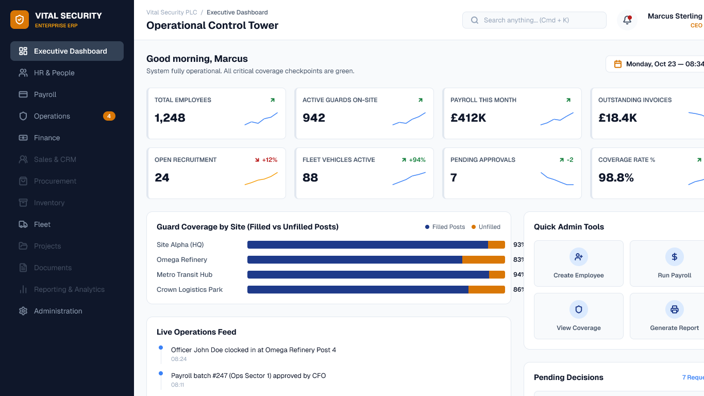

3. Account Creation and Employee Registration

Functional Feature Set
Feature | Detailed Requirement | Business Value | Priority
Account creation | System Admin issues login credentials for HR, Operations, Finance, Head, and Guard users | Centralizes access issuance under one accountable role | Must
Employee registration | HR registers both office staff and guards as employees | Single source of truth for personnel records | Must
Payroll contract entry | HR enters salary and transport allowance for staff; rate and transport allowance for guards | Captures pay terms at the source, ready for Finance review | Must

Operational Workflow
1. System Admin creates a login account for the new user, regardless of their eventual role.
2. HR registers the employee record — staff or guard — linked to that account.
3. HR enters the payroll-relevant contract details for that employee.
4. The registration and contract data become visible to Finance for later payroll processing.

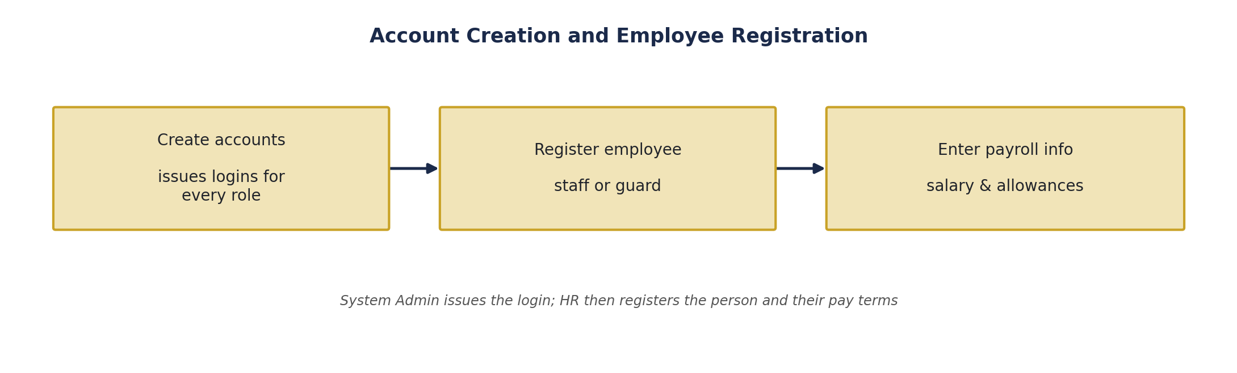
Figure 1 — Account creation and employee registration.
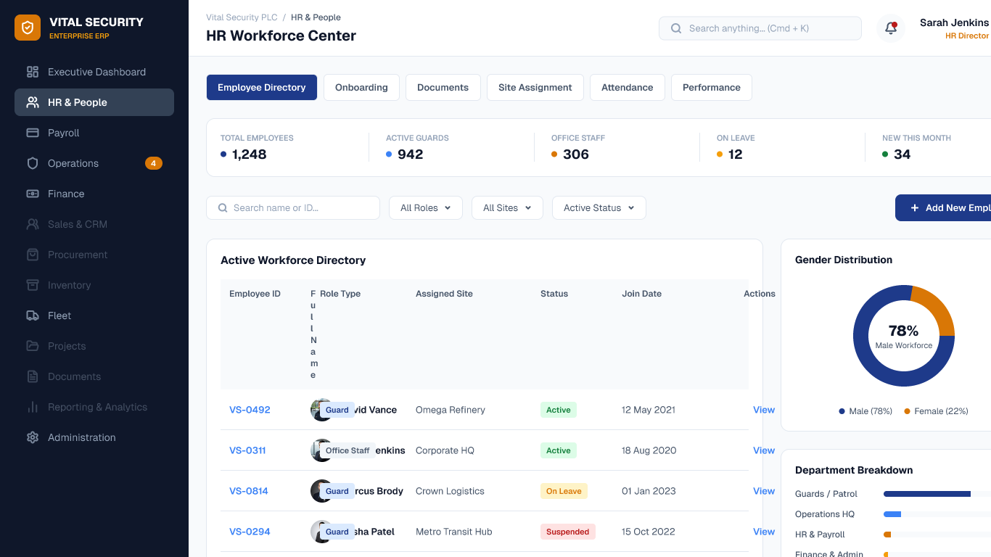

Business Rules and Validation
- Only System Admin can create login accounts; no other role can self-provision access.
- HR's contract entries (salary, rate, allowances) do not require a second sign-off before saving — Finance reviews them later during payroll processing, not at entry time.
- Every account creation, employee registration, and contract entry is written to the audit log.

4. Site Assignment and Attendance Monitoring

Functional Feature Set
Feature | Detailed Requirement | Business Value | Priority
Site assignment | Operations places a registered guard on a site's roster | Correct deployment tracking | Must
Hours monitoring | Operations views guard working hours on an ongoing basis | Early visibility into coverage and irregularities | Must
Anomaly reporting | Operations reports work-hour errors to HR rather than editing them | Keeps attendance data changes within an audited path | Must

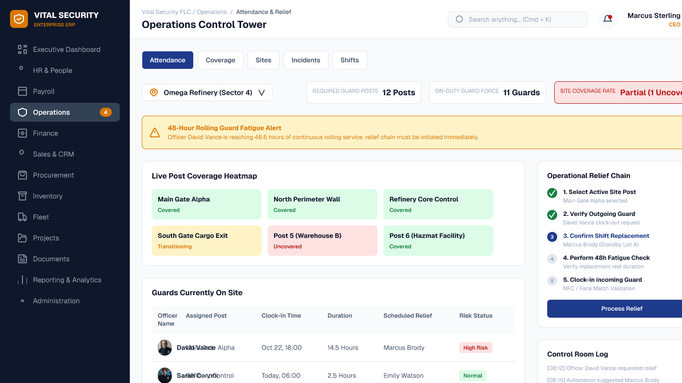
5. Operations assigns a registered guard to a specific site.
6. Operations monitors that guard's working hours on an ongoing basis.
7. If a work-hour discrepancy appears, Operations reports it to HR rather than editing the record.

Business Rules and Validation
- Operations can view but not directly edit attendance records — this preserves the integrity of the guard-recorded handover data described in Section 5.
- Anomaly reports are logged and routed to HR, keeping a visible trail of who raised the concern and when.

5. Guard Reliever Handover
This is the core attendance-integrity control. Rather than the incoming guard claiming who they are relieving, the outgoing guard declares their reliever by ID at the moment they clock out. The system only accepts a clock-in from that specific declared guard.

Functional Feature Set
Feature | Detailed Requirement | Business Value | Priority
Reliever declaration | At clock-out, the guard identifies their reliever by ID or name lookup | The person leaving — not the person arriving — asserts the handover | Must
Declaration matching | Clock-in is only accepted from the specific guard declared by the outgoing guard | Prevents an incoming guard from fabricating a predecessor claim | Must
First-shift handling | A site's first-ever shift has no prior declaration to check and proceeds directly | Covers legitimate cases with no predecessor to reference | Must
Own attendance history | Guards can view their own clock-in/out history at any time | Transparency for the guard's own record | Should

Operational Workflow
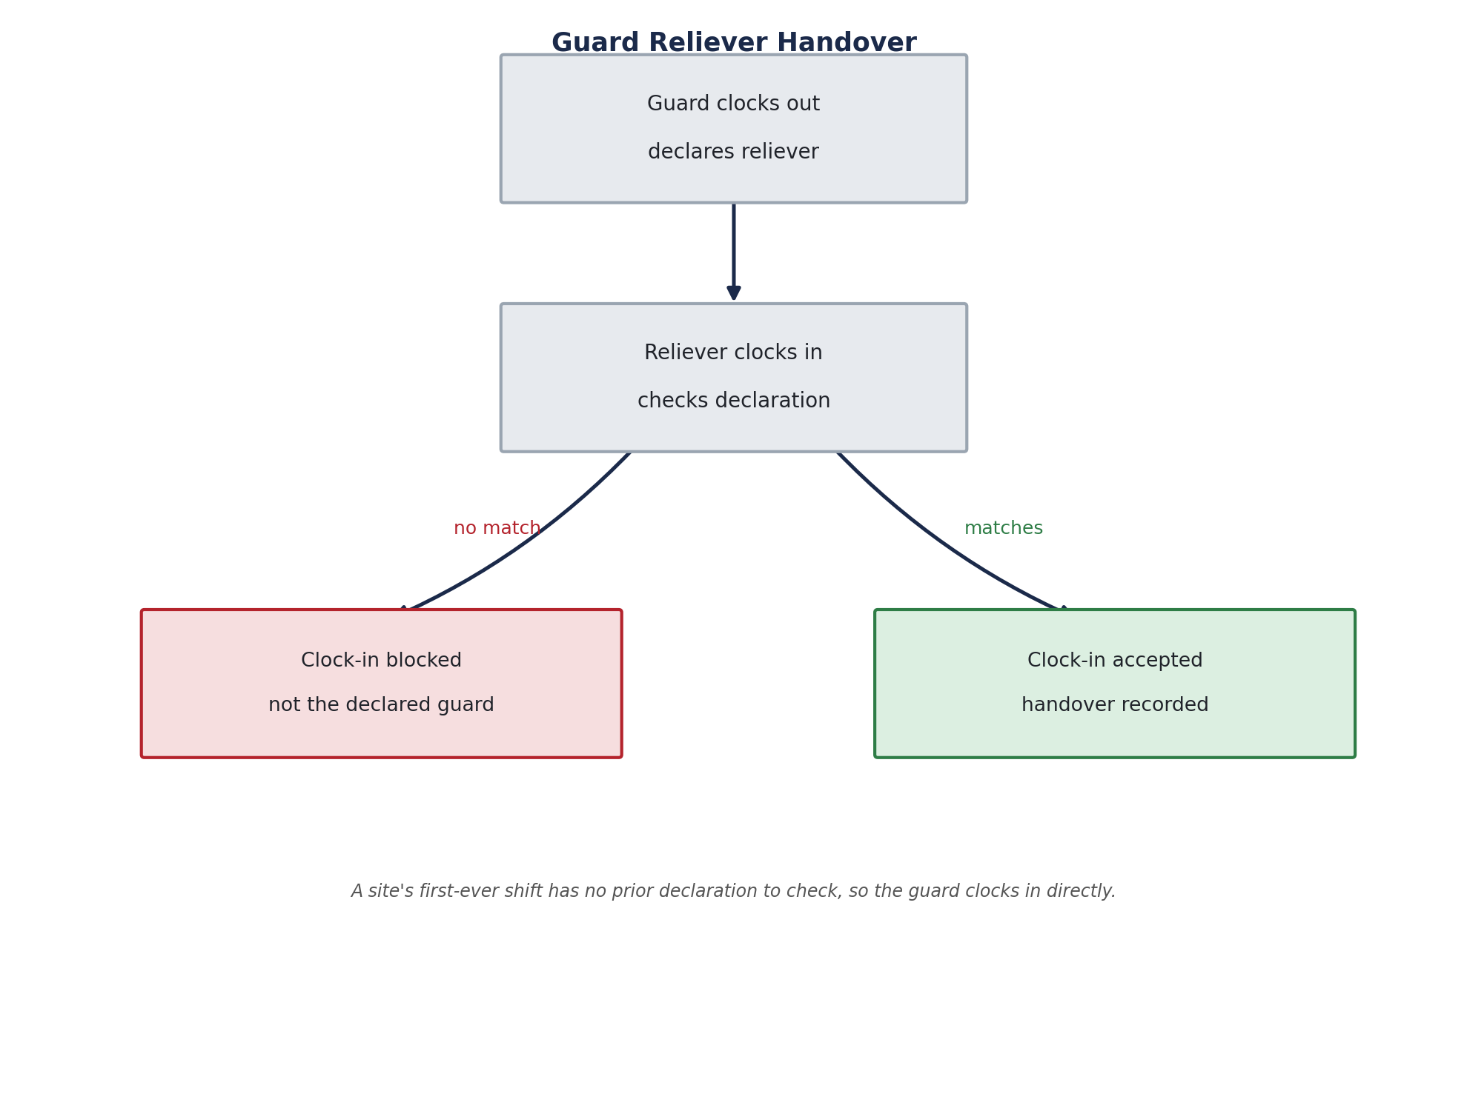

Figure 3 — Guard reliever handover: the outgoing guard's declaration gates the incoming guard's clock-in.
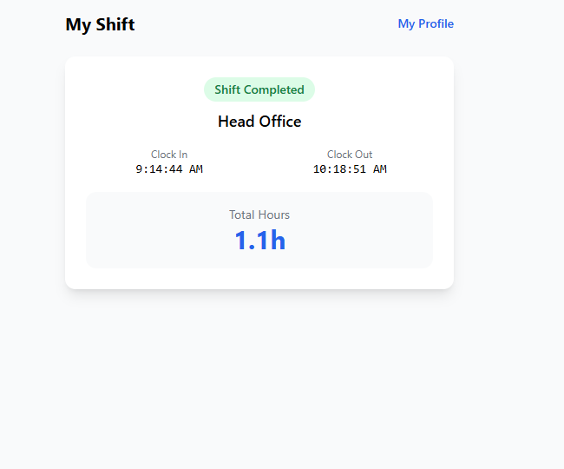
8. An on-duty guard clocks out and declares, by ID or name lookup, which guard is relieving them.
9. When that named guard attempts to clock in, the system checks their identity against the declaration.
10. A match is accepted and recorded; a guard who is not the declared reliever is blocked from clocking in.
11. A site's first-ever shift, with no predecessor to declare a reliever, proceeds without this check.

Business Rules and Validation
- The reliever declaration should reference a valid, registered guard via lookup — not free-text entry — to prevent typos or impersonation from silently breaking the chain.
- A guard cannot self-declare as their own reliever.
- Every clock-in and clock-out, and the declaration linking them, is written to the audit log with a server-side timestamp.
- Exception handling for a reliever who never arrives is an open item for the next revision of this workflow.

6. Finance Review and Head Approval

Functional Feature Set
Feature | Detailed Requirement | Business Value | Priority
Payroll review | Finance views registration and contract data and checks salary calculations | Independent verification before payment | Must
Correction handling | Finance can edit payroll entries if an error is found | Errors are fixed before approval, not after payment | Must
Final approval | The Head reviews and approves before payment is authorized | A second, independent sign-off on money movement | Must
Payment processing | Payment is issued only after Head approval | No payment occurs without an approved record | Must

Operational Workflow
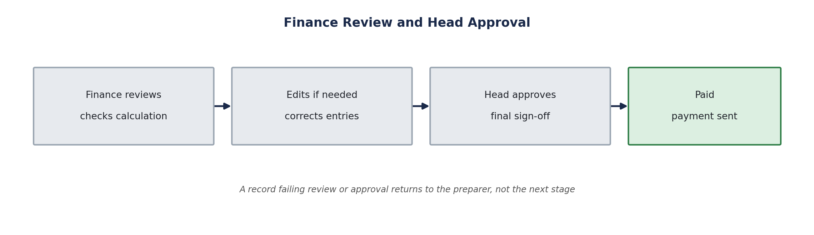
Figure 4 — Finance review and Head approval.
12. Finance reviews the registration, contract, and attendance data compiled for the payroll period.
13. Finance checks the salary or rate-based calculation and edits any entry found to be incorrect.
14. The record is sent to the Head for review and approval.
15. On approval, payment is processed and the record is marked paid.
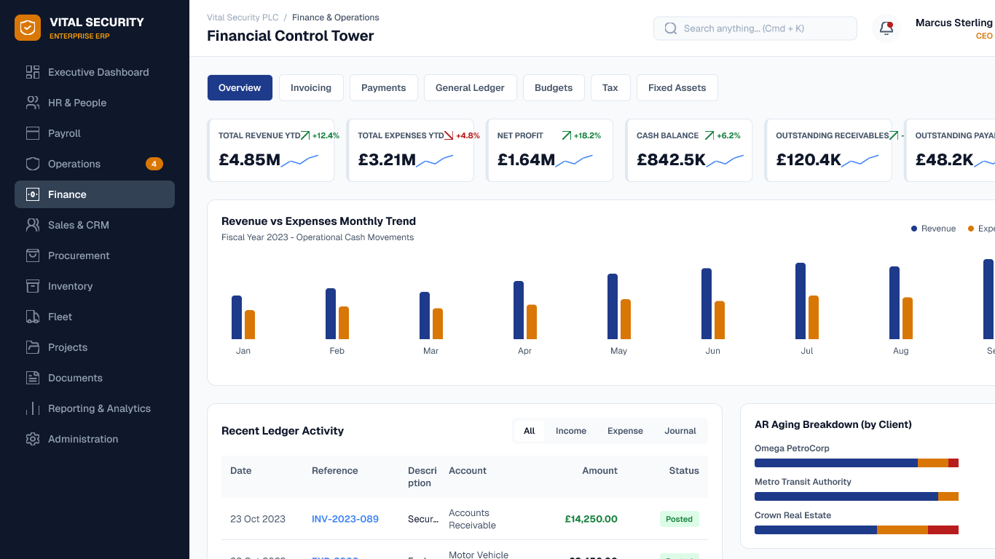

Business Rules and Validation
- Finance's edits do not require a separate sign-off before submission to the Head — the Head's approval is the control point for the whole record.
- Payment cannot be processed without a recorded Head approval.
- Every review, edit, and approval action is attributed to a specific user and written to the audit log.

7. Consolidated Risk-to-Control Mapping
Risk | Control
Unauthorized account creation | Only System Admin can create logins; no self-provisioning by any other role
Unregistered or unverified pay terms | HR enters contract data at registration; Finance independently checks it before approval
Attendance manipulated after the fact | Operations and HR can view and lock/report on attendance but cannot directly edit guard clock records
Incoming guard falsely claiming a predecessor | The outgoing guard's declaration — not the incoming guard's claim — is what the system checks
Payroll paid without independent review | Finance reviews and can correct; the Head must separately approve before payment is possible

