<https://kontent.ai/platform/>

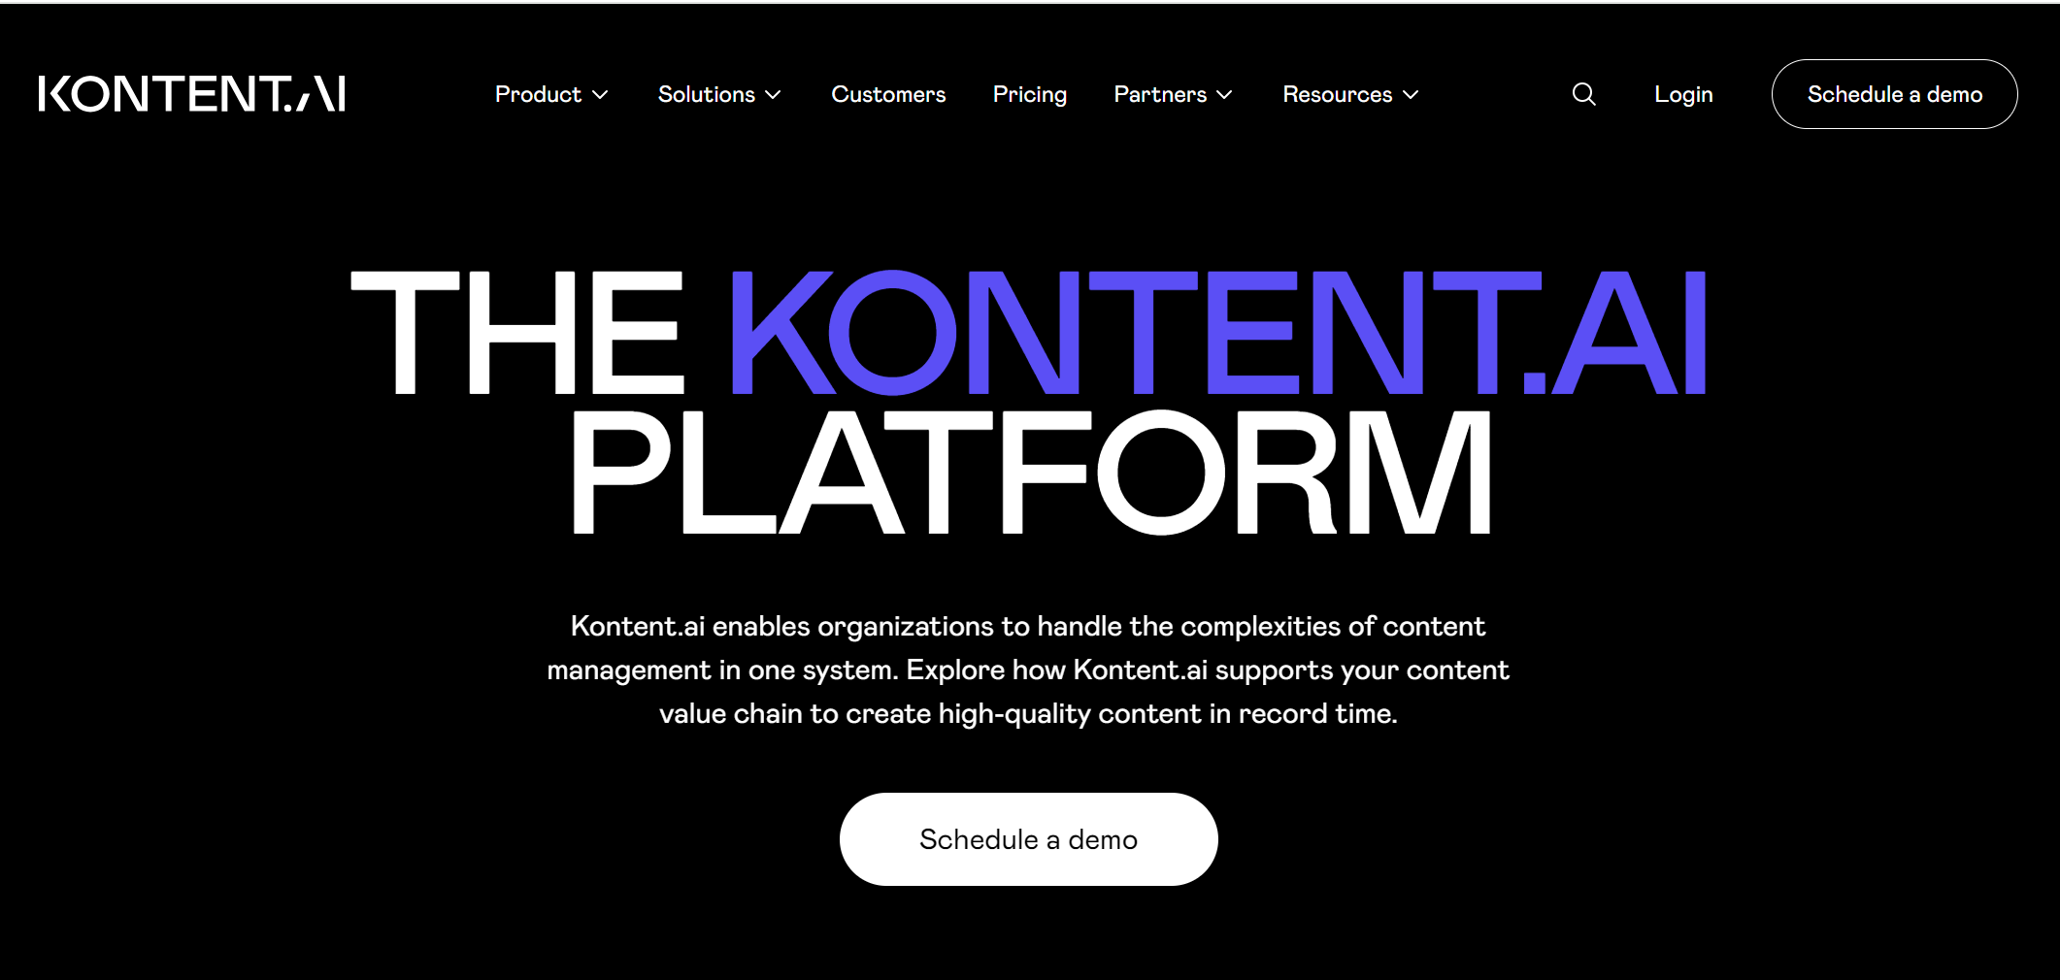

What is Kontent.AI

Kontent.ai is a **headless content management system (CMS)** that enables organizations to manage their content in a modular and flexible manner. Formerly known as Kentico Kontent, this platform allows teams to create, plan, and publish content across multiple channels from a single repository, often referred to as a "content bucket" .

Key Features of Kontent.ai

* **Headless Architecture**: As a headless CMS, Kontent.ai separates content management from content presentation. This means that users can manage content independently of how it is displayed, allowing for seamless integration with various front-end technologies and channels such as websites, mobile apps, chatbots, and voice assistants

**Content Modeling**: Kontent.ai employs a **top-down content modeling** approach, allowing users to define high-level structures before building components.

**Localization and Scalability**: Kontent.ai provides robust localization features, making it suitable for global businesses.

Kontent.ai's **API-first architecture** simplifies content integration in several significant ways, enhancing both flexibility and efficiency for developers and organizations.

Seamless Access to Content

* **Content as a Service (CaaS)**: Kontent.ai treats content as a service, allowing developers to access content through well-defined APIs. This means that content can be easily retrieved and utilized across various platforms—websites, mobile applications, IoT devices—without being tied to a specific front-end technology
* **RESTful APIs**: The platform provides robust RESTful APIs that enable developers to programmatically manage and deliver content. These APIs are designed for high performance and scalability, facilitating efficient data retrieval and integration into applications

Enhanced Flexibility and Scalability

* **Decoupled Architecture**: By separating the content management backend from the presentation layer, Kontent.ai allows organizations to scale their content operations independently. This decoupling means that changes in one area (like the frontend) do not necessitate changes in the other (the backend), making it easier to adapt to evolving business needs
* **Multi-channel Support**: Developers can use Kontent.ai's APIs to deliver consistent content across multiple channels. This multi-channel capability ensures that users receive a uniform experience regardless of the platform they are using, which is crucial for maintaining brand consistency .

Automation and Real-Time Updates

* **Webhooks**: Kontent.ai supports webhooks that notify external systems of content changes in real-time. This feature allows for automation in workflows, such as updating caches or notifying third-party services when new content is published. Such automation reduces manual intervention and ensures that all platforms are synchronized with the latest content
* **Custom Elements**: The ability to add custom elements within Kontent.ai allows developers to integrate external services directly into the CMS interface. For example, integrating e-commerce functionalities or asset management tools can streamline workflows for content creators and enhance the overall user experience

.

Improved Developer Experience

* **Framework Compatibility**: Kontent.ai provides SDKs and sample applications compatible with popular frameworks like React, Angular, and Vue.js. This compatibility allows developers to leverage their existing skills, reducing the learning curve and accelerating development processes
* **Comprehensive Documentation**: Well-documented APIs facilitate easier integration efforts by providing clear guidelines on how to interact with the system. This documentation helps developers quickly understand how to implement features without extensive trial-and-error