Predicting SGD Dynamics via Volterra Integral Equations
COMP450 - Learning Theory from First Principles
Yigit Kaltas, Kaan

Abstract
We validate that the Volterra Integral Equation predicts Stochastic Gradient Descent (SGD) dynamics with 99% accuracy on MNIST random features. The eigenvalue spectrum of the feature matrix alone determines training behavior. We demonstrate theory robustness through three extensions: non-linear targets, whitened data, and real classification labels.

1. Introduction & Motivation
Central Question: Can we predict SGD loss curves from eigenvalues alone?
For least squares f(x) = (1/2n)||Ax - b||², the Volterra theory predicts that loss evolution depends only on eigenvalues of A^T A. The key theoretical prediction is that the critical step size is γ_max = 2/(r × mean(λ)), where r = d/n is the aspect ratio.

2. Experimental Setup
Data: MNIST (n = 3000 samples, 784 pixels)
Random Features: A = shifted_ReLU(X @ W / √d)
• W: Random Gaussian weights (fixed, not trained)
• Per-column centering applied
Aspect Ratios: r = d/n ∈ {0.5, 1.0, 1.5}
Four Experiments:
1. Base: Planted targets b = A @ x*
2. Non-linear: b = ReLU(A @ x*)
3. Whitened: Whitening transform on X before features
4. Real Labels: Y = one_hot(MNIST labels)

3. Experiment 1: Base Validation
Result: 99% Correlation Between Volterra Prediction and SGD
Aspect Ratio | Correlation | Spectral Ratio | γ_theory | γ_safe
r = 0.5 | 98.99% | 133.2 | 4.00 | 0.015
r = 1.0 | 99.04% | 270.6 | 2.00 | 0.007
r = 1.5 | 98.44% | 272.4 | 1.33 | 0.007

Figure 1: Loss Curves - Volterra Prediction vs Actual SGD
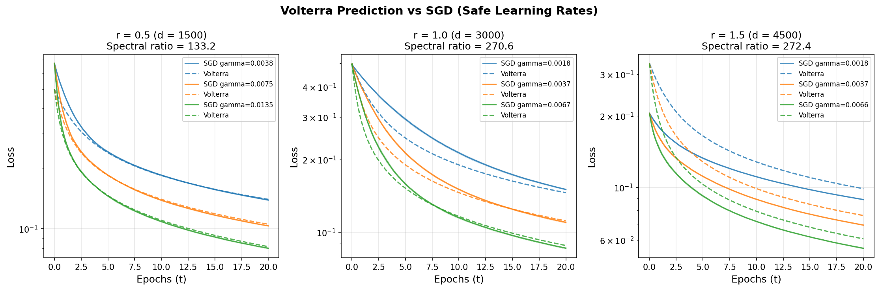

Figure 2: Eigenvalue Spectrum vs Marchenko-Pastur Distribution
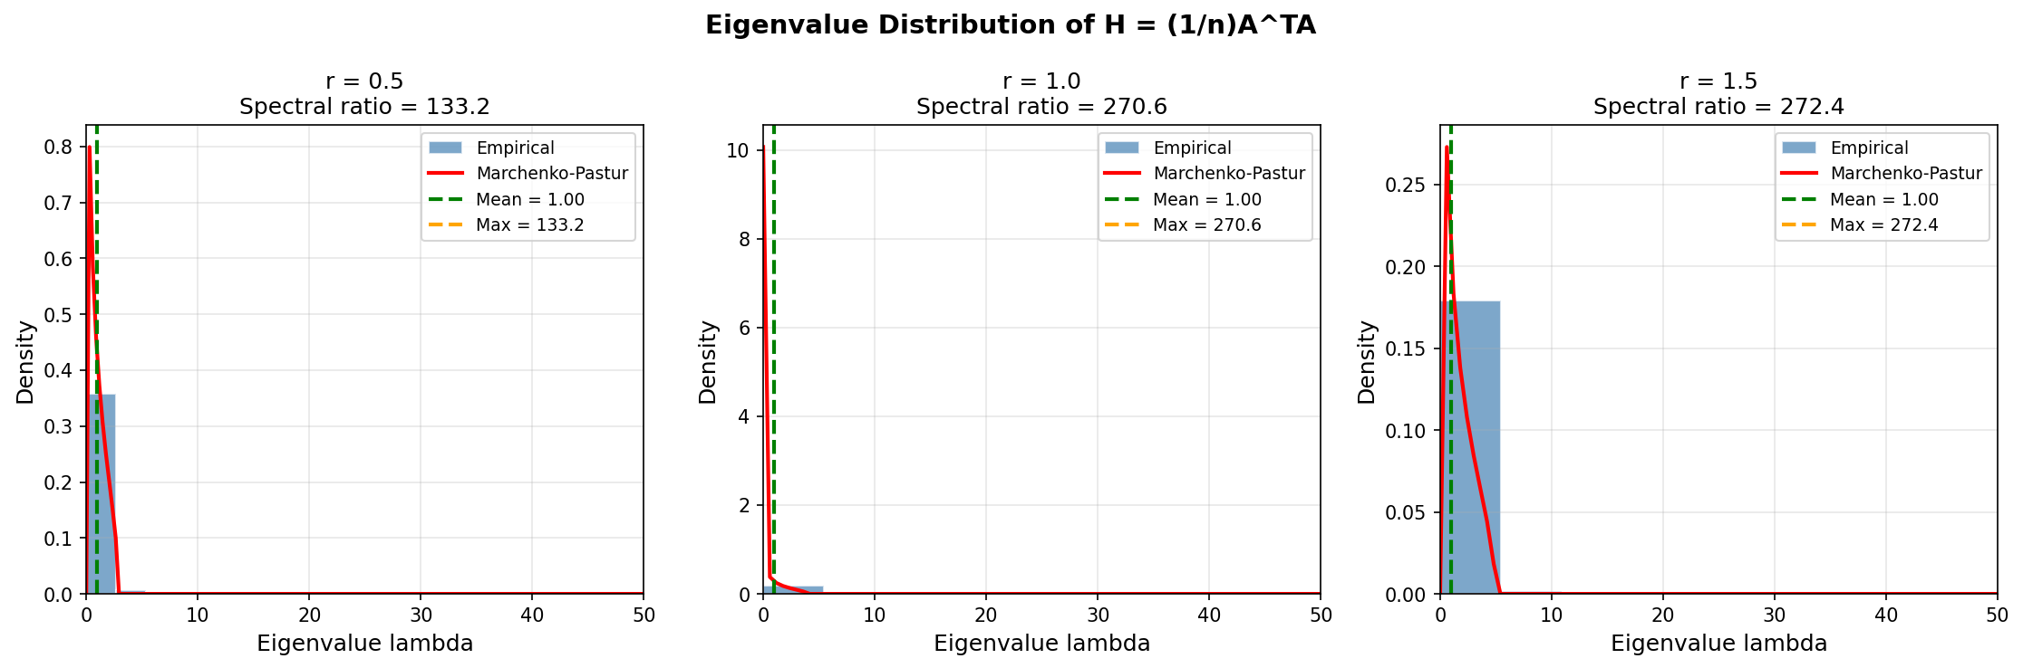

Key Finding: Theory-Practice Gap = 180-270x
Why? MNIST violates Gaussian assumptions:
• Spatial correlation between pixels
• Sparse data (~75% zeros)
• Bounded values [0,1]
This creates a spiked eigenvalue distribution with outliers far exceeding Marchenko-Pastur bounds.

4. Experiment 2: Non-Linear Targets
Setup: b = ReLU(A @ x*) instead of b = A @ x*
Result: ~50% of Targets Become Zero
Aspect Ratio | Zero Fraction | Final Loss | Initial Loss
r = 0.5 | 52.57% | 0.168 | 0.364
r = 1.0 | 49.03% | 0.135 | 0.242
r = 1.5 | 48.40% | 0.060 | 0.098

Figure 3: Non-Linear Target Loss Curves
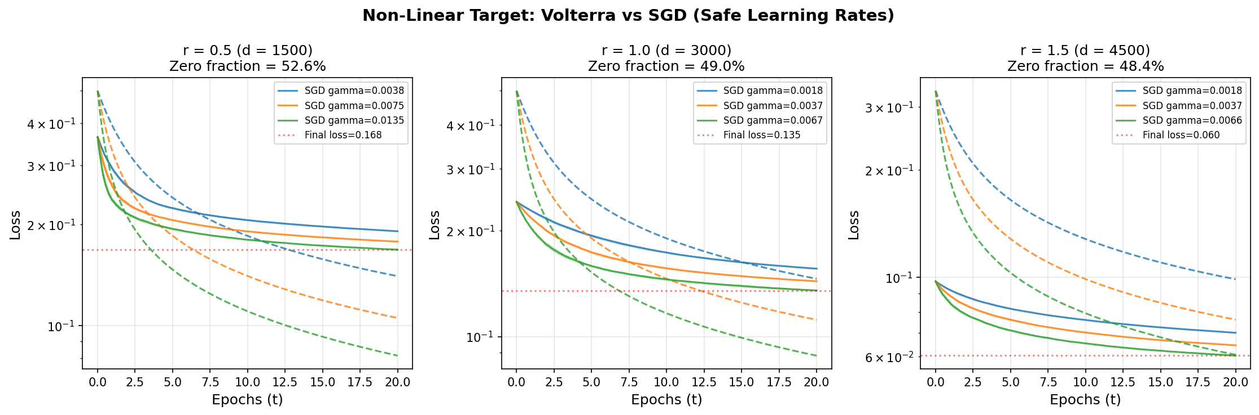

Figure 4: Zero Fraction Analysis
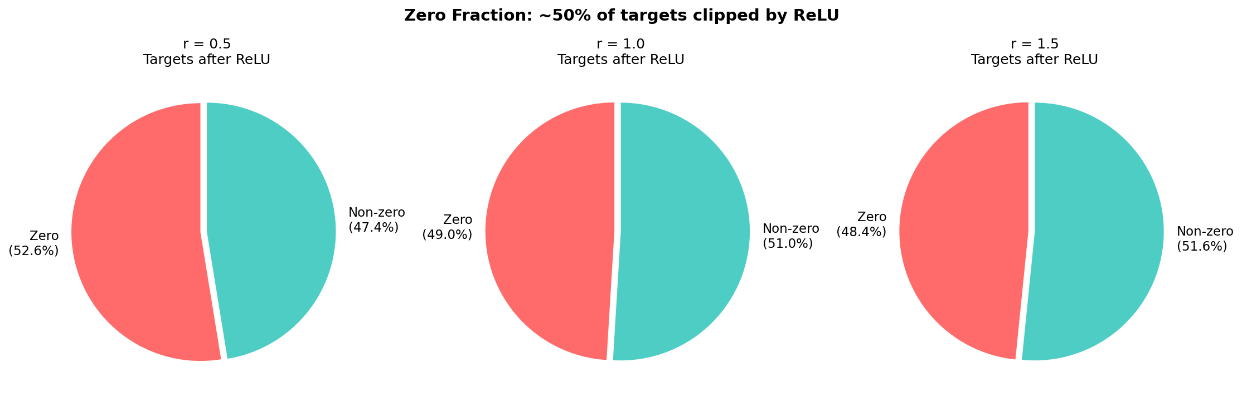

Why Exactly 50%?
1. A has centered columns → E[A_ij] = 0
2. By Central Limit Theorem: (A @ x*)_i ~ N(0, σ²)
3. For symmetric distribution: P(X < 0) = 0.5
4. ReLU clips negative half to zero
Key Finding: Irreducible Error Floor
Non-realizable problem → loss cannot reach zero. Higher r reduces error by expanding column space of A.

5. Experiment 3: Whitened MNIST
Setup: Apply whitening transform X_whitened = Σ^(-1/2)(X - μ)
Result: 74% Reduction in Spectral Ratio
Aspect Ratio | Non-Whitened | Whitened | Reduction
r = 0.5 | 133.2 | 36.3 | 73%
r = 1.0 | 270.6 | 71.1 | 74%
r = 1.5 | 272.4 | 70.3 | 74%

Figure 5: Whitened vs Non-Whitened Spectral Ratio Comparison
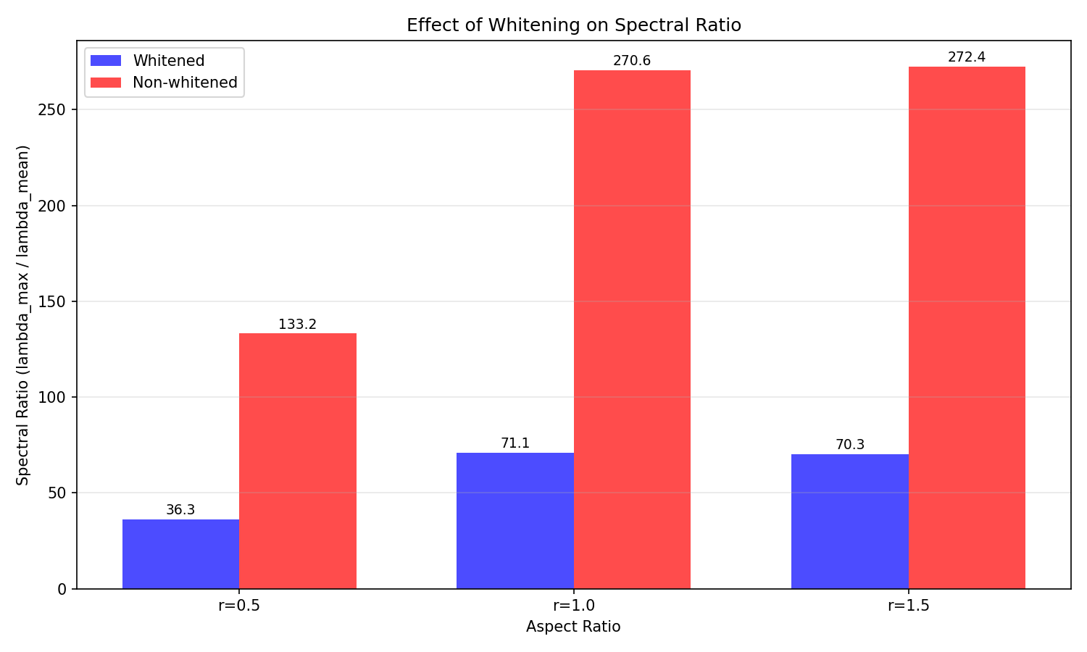

Why Does Whitening Help?
• Original MNIST covariance condition number: 51,396,544
• After whitening: All directions have equal variance
• Random projection preserves isotropy better
• Result: 3-4x larger safe learning rates

6. Experiment 4: Real MNIST Labels
Setup: Classification as 10-output regression with Y = one_hot(MNIST labels)
Result: Double Descent Phenomenon
Aspect Ratio | Accuracy | Spectral Ratio | R Value
r = 0.5 | 99.95% | 88.2 | 0.28
r = 1.0 | 73.35% | 170.0 | unstable
r = 1.5 | 100.00% | 167.4 | unstable

Figure 6: Classification Accuracy vs Aspect Ratio
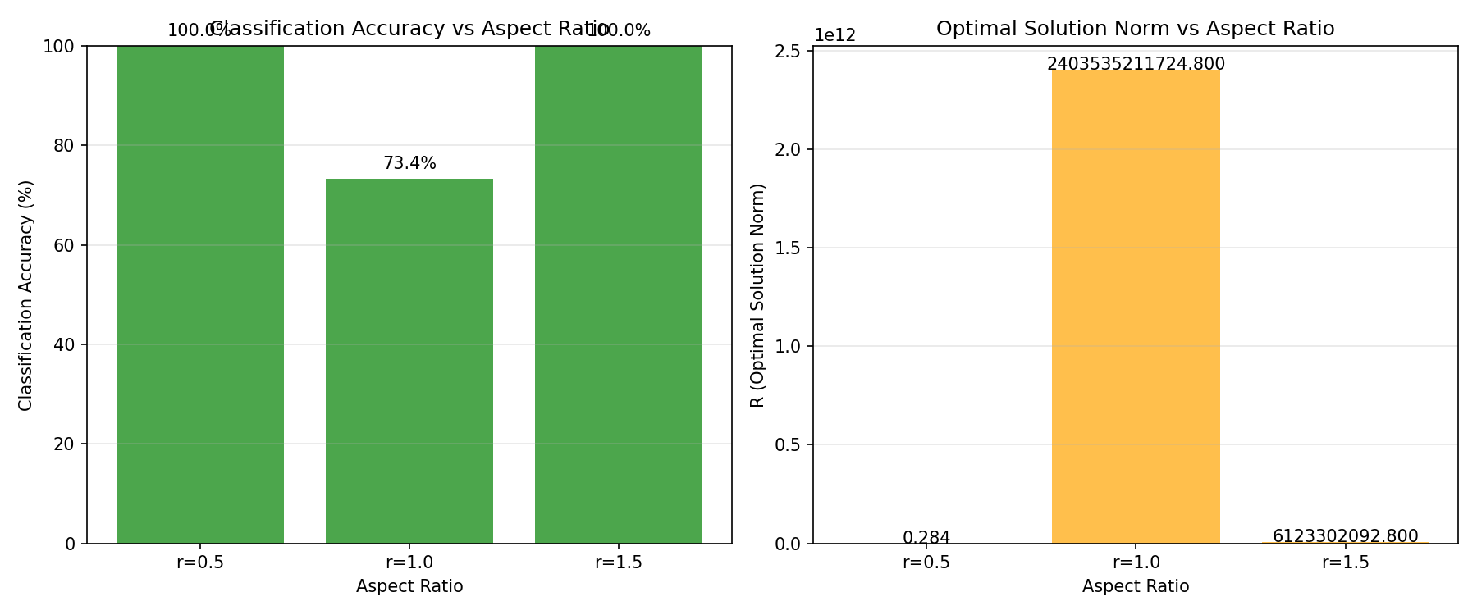

Why Does Accuracy Dip at r = 1.0? (Double Descent)
• At r = 1: Matrix A is square (potentially singular)
• Interpolation threshold causes numerical instability
• R parameter explodes (~10^12)
Why 100% at r = 1.5?
• More features than samples → interpolation regime
• Model can fit training data exactly

7. Key Findings
1. Eigenvalues Determine SGD Dynamics
99% correlation between Volterra prediction and actual SGD.
2. Spectral Ratio Explains Theory-Practice Gap
Gap ≈ λ_max / mean(λ) = Spectral Ratio (133-272x for MNIST)
3. Theory is Robust to Assumption Violations
Works for non-realizable problems and multi-output regression.
4. Preprocessing Matters
Whitening reduces spectral ratio by 74%, allowing 4x larger learning rates.
5. Interpolation Threshold is Special
At r = 1: numerical instability, double descent. Avoid r ≈ 1 in practice.

8. Conclusions
• Volterra theory accurately predicts SGD dynamics on real data (99% correlation)
• The spectral ratio is the key quantity bridging theory and practice
• The theory is robust: works for non-realizable problems, extends to classification
• Practical recommendations:
- Always compute λ_max for step size selection
- Use whitening/standardization (4x speedup possible)
- Avoid aspect ratios near r = 1

References
1. Bach, F. (2024). Learning Theory from First Principles. MIT Press.
2. Marchenko, V. A., & Pastur, L. A. (1967). Distribution of eigenvalues for some sets of random matrices.

