ForeWatt Technical Report

Electricity Market Forecasting Platform for the Turkish Market

ForeWatt Development Team

January 2026

Abstract
This report presents ForeWatt, an end-to-end electricity market forecasting platform designed for the Turkish electricity market operated by EPIAS. The system provides 24-hour ahead forecasts for both energy consumption and day-ahead market prices using gradient boosting ensemble methods. The consumption model, based on CatBoost with 23 engineered features, achieves a symmetric mean absolute percentage error of 1.95 percent on held-out test data. The price forecasting model employs a hybrid architecture combining CatBoost and LightGBM with adaptive error correction, achieving 11.71 percent sMAPE while operating under a 2-hour data publication delay constraint. The platform is deployed on Google Cloud Run with hourly automated forecast generation, Firestore real-time storage, and a React-based dashboard for visualization. This work demonstrates that carefully engineered gradient boosting models can achieve competitive performance against more complex deep learning approaches while maintaining interpretability and production reliability.

1. Introduction

1.1 Problem Definition and Motivation
The Turkish electricity market has undergone significant transformation since its liberalization in 2001. The Energy Exchange Istanbul, known as EPIAS, now operates as the central platform for electricity trading in Turkey, handling day-ahead market transactions, intraday trading, and balancing power markets. With an installed capacity exceeding 100 gigawatts and annual electricity consumption surpassing 300 terawatt-hours, the Turkish market represents one of the largest electricity markets in the EMEA region.
Electricity price and consumption forecasting in this market presents unique challenges. The high penetration of renewable energy sources, particularly wind and solar, introduces substantial volatility into both generation patterns and market prices. Turkey's diverse climate zones, spanning Mediterranean, continental, and transitional regions, create complex demand patterns driven by heating and cooling requirements. Furthermore, the market's sensitivity to natural gas prices, hydroelectric reservoir levels, and cross-border electricity flows adds layers of complexity that purely autoregressive models struggle to capture.
A critical operational constraint in the Turkish market is the 2-hour delay in official data publication by EPIAS. Real-time consumption and price data become available only after this lag period, meaning that any forecasting system must produce predictions without access to the most recent two hours of actual observations. This constraint effectively extends the minimum forecast horizon and requires careful feature engineering to bridge the information gap.
The motivation for accurate electricity forecasting extends across multiple stakeholder groups. Generation companies require consumption forecasts to optimize unit commitment and dispatch decisions. Retailers and large consumers need price forecasts to manage procurement strategies and hedge against price volatility. Grid operators rely on demand forecasts for real-time balancing and reserve procurement. The financial implications of forecast errors are substantial, as imbalance penalties in the Turkish market can significantly impact profitability. These considerations motivate the development of ForeWatt as a comprehensive forecasting platform addressing both consumption and price prediction with production-grade reliability.

1.2 Project Goals and Objectives
The primary objective of the ForeWatt project is to develop an operational forecasting system capable of generating accurate 24-hour ahead predictions for electricity consumption and day-ahead market prices in the Turkish market. This objective encompasses several specific technical goals that guide the system design and implementation.
The first goal is to achieve forecast accuracy that substantially outperforms naive baseline methods. For consumption forecasting, the target is to surpass the performance of persistence models that simply use the same-hour value from the previous day or week. For price forecasting, the objective is to exceed the accuracy of both persistence baselines and simple autoregressive models. The performance metric selected for evaluation is the symmetric mean absolute percentage error, which provides scale-independent assessment suitable for comparing models across different time periods and market conditions.
The second goal is to design and implement a production-ready system architecture capable of continuous operation with minimal manual intervention. This requires automated data pipelines that handle the complexities of multiple data sources, robust error handling for API failures and data quality issues, and a deployment infrastructure that scales automatically with demand. The selected platform for deployment is Google Cloud Run, which provides serverless container hosting with automatic scaling and integrated scheduling capabilities.
The third goal is to provide accessible forecast visualization through a web-based dashboard. The dashboard should display current forecasts with uncertainty quantification, historical performance tracking, and anomaly detection capabilities. This interface enables stakeholders to consume forecast outputs without requiring technical expertise in data science or programming.

1.3 Literature Review and Related Work
Electricity load and price forecasting have been active research areas for several decades, with methodological approaches evolving from statistical time series methods to machine learning and deep learning techniques. This review surveys the relevant literature to contextualize the technical choices made in the ForeWatt system.
Traditional statistical methods for electricity forecasting have centered on autoregressive integrated moving average models and their extensions. ARIMA models capture linear dependencies in time series data through a combination of autoregressive terms, differencing for stationarity, and moving average components. Seasonal ARIMA variants extend this framework to handle the strong daily, weekly, and annual periodicities characteristic of electricity demand. Exponential smoothing methods, including Holt-Winters approaches, provide alternatives that weight recent observations more heavily while explicitly modeling trend and seasonal components. While these methods remain useful as baselines and for interpretability, their linear assumptions limit their ability to capture the complex nonlinear relationships present in electricity markets.
Machine learning methods have demonstrated substantial improvements over traditional statistical approaches for electricity forecasting. Gradient boosting decision tree ensembles, including XGBoost, LightGBM, and CatBoost, have emerged as particularly effective for tabular regression problems with complex feature interactions. These methods construct ensembles of decision trees sequentially, with each tree trained to correct the residual errors of the previous ensemble. The ability to handle heterogeneous features, capture nonlinear relationships, and provide feature importance rankings makes gradient boosting methods well-suited for electricity forecasting applications where domain knowledge can inform feature engineering.
Deep learning approaches have also been extensively explored for time series forecasting. Long short-term memory networks address the vanishing gradient problem in recurrent neural networks, enabling the learning of long-range temporal dependencies. The Transformer architecture, originally developed for natural language processing, has been adapted for time series through models such as the Temporal Fusion Transformer which combines attention mechanisms with interpretable variable selection. More recent architectures including N-BEATS, N-HiTS, and PatchTST have achieved strong performance on benchmark forecasting tasks through various innovations in how temporal patterns are represented and processed.
Despite the architectural sophistication of deep learning methods, empirical studies have repeatedly shown that well-tuned gradient boosting models often match or exceed their performance on electricity forecasting tasks. A comprehensive study by Makridakis and colleagues in the M5 competition demonstrated that gradient boosting methods achieved top performance across diverse forecasting scenarios. Similar findings have been reported specifically for electricity markets, where the structured nature of the problem and the availability of meaningful engineered features favor tree-based methods. The lower computational requirements and greater interpretability of gradient boosting methods provide additional practical advantages for production deployment.
For the specific context of the Turkish electricity market, prior research has examined various forecasting approaches with mixed results. Studies have applied neural networks, support vector machines, and ensemble methods to EPIAS data with varying degrees of success. However, few works have addressed the complete production pipeline from data acquisition through deployment, and most academic studies evaluate performance on historical data without addressing the operational constraints of real-time forecasting with data publication delays.

1.4 Approach and Design Philosophy
The design of ForeWatt is guided by several core principles that prioritize production reliability and maintainability alongside forecast accuracy. These principles reflect lessons learned from operational machine learning systems and the specific requirements of electricity market forecasting.
The first principle is the adoption of a medallion data architecture for organizing the data pipeline. Raw data from external sources including EPIAS, weather APIs, and macroeconomic databases is stored in the bronze layer with minimal transformation. The silver layer contains cleaned and validated data with standardized formats and handling of missing values. The gold layer provides feature-engineered datasets ready for model training and inference. This layered architecture enables independent evolution of data sources and models, simplifies debugging of data quality issues, and provides clear interfaces between pipeline stages.
The second principle is the use of ensemble methods with hybrid error correction. Rather than relying on a single model, the price forecasting system combines predictions from multiple gradient boosting algorithms with adaptive error correction mechanisms. This approach improves robustness against model-specific failure modes and enables the system to adapt to changing market conditions without complete retraining. The consumption model uses a single CatBoost model but incorporates uncertainty quantification through conformal prediction to provide reliable prediction intervals.
The third principle is extensive feature engineering leveraging domain knowledge of electricity markets. Features are constructed to capture known drivers of consumption and prices, including temperature-based heating and cooling degree days, calendar effects such as holidays and weekends, lagged values at intervals corresponding to daily and weekly seasonality, and market-derived signals such as generation mix and capacity margins. This domain-informed approach to feature engineering enables simpler models to achieve strong performance by presenting relevant information in forms that tree-based learners can effectively exploit.
The fourth principle is prioritizing production considerations throughout the design process. All components are designed for automated operation with comprehensive logging and monitoring. The system handles missing data gracefully through forward-filling and fallback strategies rather than failing on incomplete inputs. The deployment architecture on Google Cloud Run provides automatic scaling, built-in load balancing, and integration with Cloud Scheduler for hourly forecast generation. This production focus ensures that the system delivers value continuously rather than serving only as a research prototype.
The remainder of this report is organized as follows. Section 2 describes the data sources and preprocessing pipeline in detail. Section 3 presents the feature engineering methodology and the complete feature sets used by each model. Section 4 covers the model architectures, training procedures, and hyperparameter optimization. Section 5 reports experimental results including accuracy metrics and comparison with baselines. Section 6 describes the system architecture and deployment infrastructure. Section 7 concludes with a discussion of limitations and directions for future work.

2.1 Data Collection and Data System
The ForeWatt forecasting platform was built upon a comprehensive data collection infrastructure designed to capture the multifaceted factors influencing electricity consumption and prices in the Turkish market. The data system integrates information from three primary sources: the Turkish Electricity Market Transparency Platform (EPIAS), the Open-Meteo Weather API, and the Electronic Data Delivery System (EVDS) of the Central Bank of the Republic of Turkey. This section describes the data sources, collection methodologies, and the medallion architecture employed for data processing and storage.
The primary data source for electricity market variables was the EPIAS Transparency Platform, accessed through the eptr2 Python library with authenticated API credentials. The EPIAS data pipeline was designed to fetch twelve distinct datasets covering the full spectrum of market operations. Real-time consumption data, representing the actual hourly electricity load measured by TEIAS (Turkish Electricity Transmission Corporation), served as the target variable for consumption forecasting with values typically ranging between 20,000 and 50,000 MW. Day-ahead consumption forecasts published by TEIAS provided baseline predictions against which model improvements could be measured. Market price data included the Day-Ahead Market Clearing Price (PTF), the System Marginal Price (SMF) from the balancing power market, the Intraday Market weighted average price, and the overall Weighted Average Price across all market segments. Generation data encompassed real-time generation by source and plant, available capacity declarations (EAK), day-ahead generation plans (KGUP), and bilateral contract plans (KUDUP). Wind generation forecasts from the RITM system and hydroelectric reservoir status from DSI (State Hydraulic Works) completed the EPIAS data collection, providing supply-side fundamentals critical for price forecasting.
Meteorological data was sourced from the Open-Meteo Weather API, which provides free access to historical and forecast weather information with hourly resolution. A demand-side weather pipeline was implemented to fetch data for the ten largest Turkish cities by population, collectively representing approximately 49 percent of the national population. The selected cities included Istanbul with a population weight of 18.3 percent, Ankara at 6.9 percent, Izmir at 5.2 percent, Bursa at 3.8 percent, Antalya at 3.2 percent, Konya at 2.7 percent, Adana at 2.7 percent, Sanliurfa at 2.6 percent, Gaziantep at 2.6 percent, and Kocaeli at 2.5 percent. Eight weather variables were collected for each city: temperature at 2 meters height, relative humidity, precipitation amount, rainfall specifically, cloud cover percentage, wind speed at 10 meters, surface atmospheric pressure, and apparent temperature representing the perceived temperature accounting for humidity and wind effects. Population-weighted national aggregates were computed from city-level data to create representative weather features for the entire country. The API implementation incorporated automatic request caching and exponential backoff retry logic to handle rate limiting, with a 7-second delay between city requests to respect API usage policies.
Macroeconomic indicators were obtained from the EVDS system operated by the Central Bank of the Republic of Turkey. Given that Turkey imports approximately 70 percent of its energy requirements, primarily natural gas and oil, exchange rate fluctuations have a substantial impact on electricity generation costs and market prices. The fetched series included the Consumer Price Index (TUFE) and Producer Price Index (UFE) for inflation monitoring, the M2 money supply as a monetary policy indicator, and Turkish Lira deposit interest rates. Additionally, daily foreign exchange rates were collected including USD/TRY, EUR/TRY, and gold prices in Turkish Lira (XAU/TRY). Derived features were computed from the raw exchange rate data, including a weighted FX basket calculated as the simple average of USD and EUR rates, 7-day and 30-day momentum indicators representing the rate of change, and a 30-day rolling standard deviation capturing exchange rate volatility. Daily FX data was converted to hourly frequency through forward-fill replication to enable alignment with the hourly electricity market data.
Data management followed the medallion architecture pattern, organizing data into three progressively refined layers: Bronze, Silver, and Gold. The Bronze layer stored raw data exactly as received from source APIs, preserving the original format and enabling reproducibility. Separate subdirectories maintained data from each source including EPIAS market data, demand-side weather observations, macroeconomic indicators, and calendar information. The Silver layer contained cleaned and validated data after applying quality assurance transformations. Validation procedures included duplicate record removal, timestamp chronological ordering verification, range validation to identify physically implausible values such as consumption below 10,000 MW or above 60,000 MW, and flagging of columns with greater than 10 percent missing values. All datetime columns were standardized to the Europe/Istanbul timezone to ensure temporal consistency across datasets. The Gold layer housed feature-engineered datasets ready for model training, including lag features at 24-hour, 48-hour, and 168-hour intervals, rolling statistics such as means and standard deviations, and the master dataset that merged all data sources into a unified feature matrix.
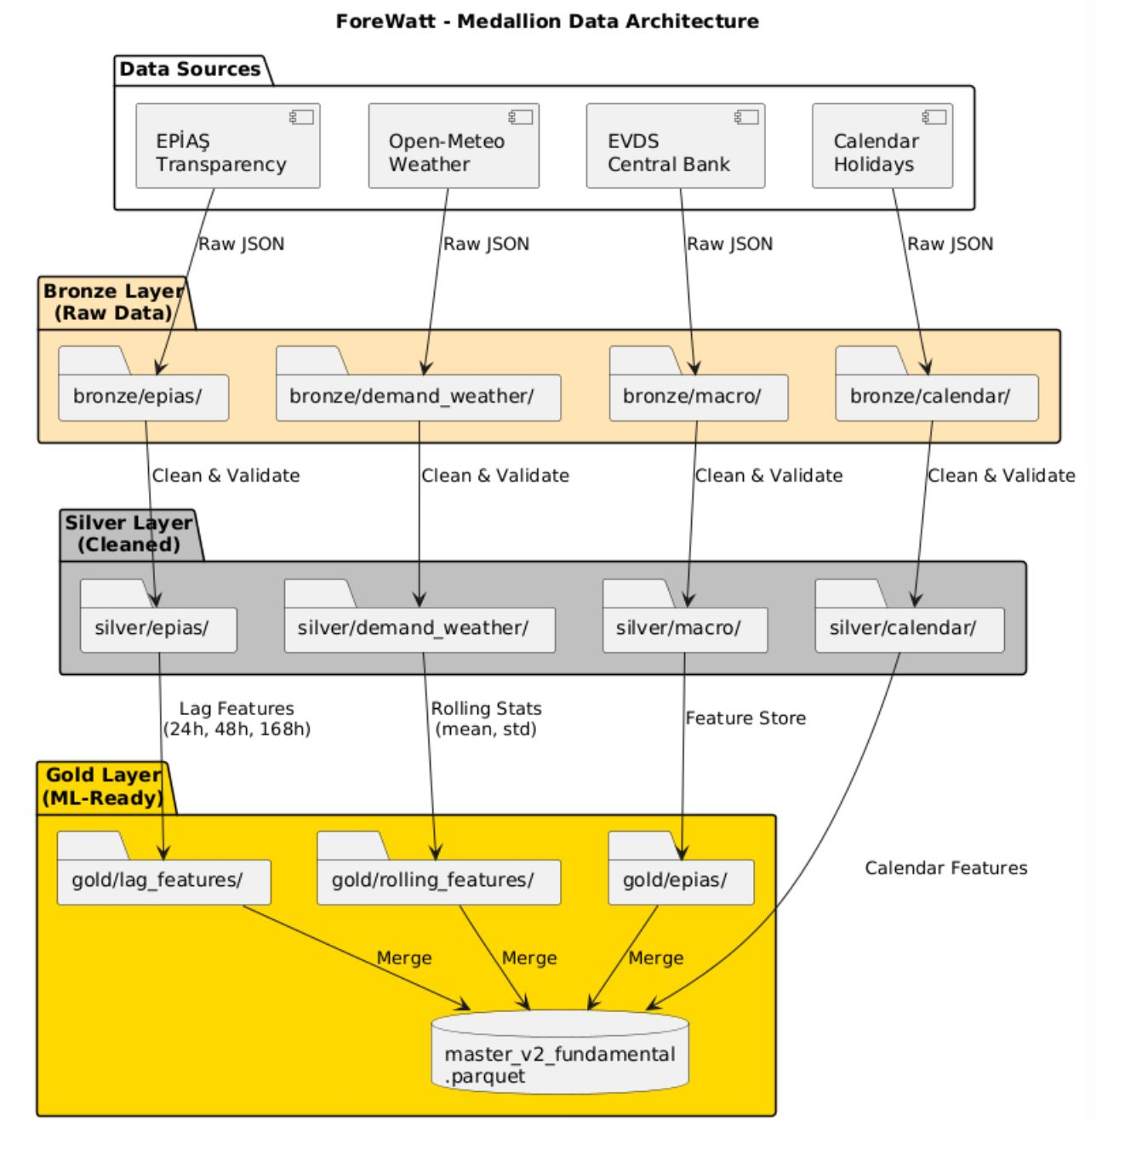
Figure 1. Medallion data architecture showing Bronze, Silver, and Gold layers with data flow from external sources through cleaning and feature engineering stages.
All data was persisted in Apache Parquet format with Snappy compression, selected for its efficient columnar storage, fast read performance, and native support for complex data types including timezone-aware timestamps. Files were organized with monthly partitioning for forecast archives and date-range naming conventions for training datasets. Dual-format export to CSV was maintained as a secondary format for human readability and compatibility with spreadsheet applications. The complete master dataset spanning from January 2020 to October 2025 contained approximately 51,000 hourly records with 80 features, stored in a 52.5 megabyte Parquet file. The data pipeline supported incremental updates through skip-existing logic that detected previously downloaded data and avoided redundant API calls, significantly reducing fetch times for routine updates while ensuring data completeness for model retraining.

2.2 Feature Engineering and Master Data
The transformation of raw data into predictive features represents a critical stage in the ForeWatt pipeline. A comprehensive feature engineering framework was developed to extract meaningful signals from heterogeneous data sources, including historical consumption patterns, electricity market dynamics, meteorological observations, and calendar information. The feature engineering pipeline is implemented through a modular architecture consisting of specialized generators for lag features, rolling window statistics, calendar encodings, and weather-derived indicators. These components operate on data organized according to a medallion architecture, processing information from the Silver layer (cleaned and normalized) to produce Gold layer assets (machine learning-ready features).
Lag features constitute the foundation of the autoregressive modeling approach employed in ForeWatt. For the consumption forecasting model, lags are computed at multiple temporal horizons to capture patterns operating at different time scales. Short-term lags at 1, 2, 3, and 6 hours capture immediate consumption inertia and autoregressive dependencies that reflect the physical constraints of electricity demand. The 12-hour and 24-hour lags capture diurnal patterns and day-over-day changes, while the 48-hour and 168-hour (weekly) lags encode longer-term seasonal cycles. Temperature lag features are similarly constructed at 1, 2, 3, 24, and 168 hour intervals to account for the delayed response of electricity demand to weather conditions. Price lag features at 24-hour and 168-hour horizons provide economic context by reflecting historical market conditions.
Rolling window statistics extend the feature set by computing aggregate measures over sliding windows of 24 hours and 168 hours. For each window size, the mean, standard deviation, minimum, and maximum values are calculated for consumption, temperature, and price variables. These statistics capture both the central tendency and variability of the underlying processes. Derived features are computed from these rolling statistics, including the consumption range (maximum minus minimum) as a measure of daily volatility, the coefficient of variation (standard deviation divided by mean) as a normalized variability indicator, and the diurnal temperature range to characterize weather stability. The rolling standard deviation of price over 24 hours serves as a proxy for market volatility, which is particularly important for price prediction during periods of supply uncertainty.
Calendar features encode temporal structure and institutional patterns that influence electricity consumption and prices. Basic temporal features include day of week, day of month, month, and week of year. Binary indicators distinguish weekends from weekdays, reflecting the systematic reduction in commercial and industrial demand during non-working days. Holiday features are constructed from a comprehensive calendar of Turkish official holidays, religious observances, and half-day holidays. The holiday encoding includes both day-level and hour-level flags, with special handling for half-day holidays where morning hours may exhibit normal demand patterns. Cyclical encodings using sine and cosine transformations are applied to day of week and month features to preserve the periodic nature of these variables and avoid artificial discontinuities at period boundaries.
Weather features are derived from temperature, humidity, and wind speed observations collected from twelve major Turkish cities. A population-weighted national temperature index is computed to represent aggregate weather conditions across the country. Heating Degree Days (HDD) and Cooling Degree Days (CDD) are calculated using standard formulas with base temperatures calibrated for Turkish climate conditions. The heat index combines temperature and humidity to characterize perceived temperature during summer months when air conditioning loads are significant. Binary indicators flag extreme temperature conditions (hot and cold thresholds) that trigger non-linear demand responses. These weather features capture the thermosensitive component of electricity demand, which can account for substantial variation during extreme weather events.
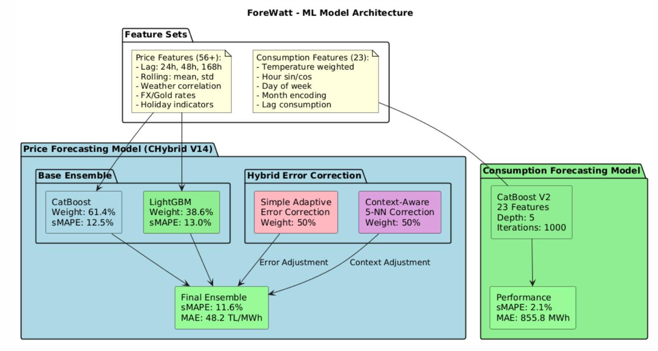
Figure 2. Machine learning model architecture showing feature flow and model ensemble
The price forecasting model employs a distinct feature set designed to capture market dynamics and supply-demand fundamentals. Market signal features include thermal gap, which measures the difference between thermal generation capacity and actual thermal output, indicating the availability of dispatchable generation. Renewable saturation captures the proportion of demand met by variable renewable sources, which influences price volatility through merit order effects. The spark spread proxy approximates the profitability of gas-fired generation using historical price relationships. System short signals indicate periods when scheduled generation may be insufficient to meet forecasted demand, typically associated with price spikes. Load factor and reserve margin ratio characterize system utilization and capacity adequacy, respectively.
Profile evolution features capture the time-varying nature of hourly price patterns. The daily average price and hourly ratio relative to the daily average encode the typical shape of the daily price curve. Profile features computed over 14-day and 28-day windows capture the recent evolution of these patterns, while profile momentum measures the rate of change in the profile shape. Solar-specific features account for the growing penetration of photovoltaic generation in Turkey, including solar ratio, solar profiles, and price-solar interaction terms. These features enable the model to adapt to structural changes in the price formation process as the generation mix evolves.
Table 1. Consumption Model Features (23 total)
Feature Name | Description
consumption_lag_24h | Consumption value from 24 hours prior
consumption_lag_48h | Consumption value from 48 hours prior
consumption_lag_168h | Consumption value from one week prior
consumption_rolling_mean_24h | 24-hour rolling mean of consumption
consumption_rolling_std_24h | 24-hour rolling standard deviation
temp_national | Population-weighted national temperature
humidity_national | Population-weighted national humidity
HDD | Heating Degree Days
CDD | Cooling Degree Days
heat_index | Combined temperature-humidity index
is_hot | Binary indicator for hot conditions
is_cold | Binary indicator for cold conditions
temp_lag_24h | Temperature from 24 hours prior
hour_sin, hour_cos | Cyclical encoding of hour of day
dow_sin, dow_cos | Cyclical encoding of day of week
month_sin, month_cos | Cyclical encoding of month
is_weekend | Binary weekend indicator
is_holiday_day | Binary day-level holiday indicator
is_holiday_hour | Binary hour-level holiday indicator
price_ptf_lag_24h | Day-ahead price from 24 hours prior

Table 2. Price Model Features (33 total)
Feature Name | Description
hour_sin, hour_cos | Cyclical encoding of hour of day
dow_sin, dow_cos | Cyclical encoding of day of week
is_weekend | Binary weekend indicator
price_ptf_rolling_std_24h | 24-hour rolling price volatility
price_ptf_rolling_mean_24h | 24-hour rolling price average
price_ptf_rolling_min_24h | 24-hour rolling price minimum
price_ptf_rolling_max_24h | 24-hour rolling price maximum
price_ptf_lag_24h | Day-ahead price from 24 hours prior
price_ptf_lag_168h | Day-ahead price from one week prior
thermal_gap | Thermal capacity minus thermal generation
thermal_gap_lag_24h | Thermal gap from 24 hours prior
renewable_saturation | Renewable generation as fraction of demand
spark_spread_proxy_lag_24h | Historical spark spread proxy
system_short_signal | Binary indicator for system shortage
load_factor | Actual demand divided by peak capacity
consumption_forecast | Forecasted consumption for target hour
reserve_margin_ratio | Available reserve as fraction of demand
price_volatility_lag24h | Lagged price volatility measure
realtime_premium_lag24h | Lagged real-time price premium
hour | Hour of day (integer)
daily_avg_price | Daily average price level
hourly_ratio | Current hour price to daily average ratio
profile_14d, profile_28d | Hourly price profiles over rolling windows
profile_momentum | Rate of change in price profile
daily_avg_momentum | Rate of change in daily average price
solar_ratio | Solar generation as fraction of capacity
solar_profile_14d, solar_profile_28d | Solar generation profiles
solar_momentum | Rate of change in solar profile
price_solar_interaction | Interaction between price and solar features

The master dataset is produced by merging all feature components through a systematic process implemented in the feature merger module. Features from different sources are aligned on timestamp and joined using inner merges to ensure temporal consistency. The resulting master dataset is stored in the Gold layer at data/gold/master/ in Apache Parquet format for efficient storage and retrieval. The current production version (v2) contains approximately 52.5 megabytes of data spanning from January 2020 to October 2025, comprising over 50,000 hourly observations with all engineered features. A versioning scheme based on creation date and feature hash ensures reproducibility and enables tracking of dataset evolution across model iterations. Accompanying metadata files in JSON format document the feature list, data date range, missing value statistics, and creation timestamp for each version of the master dataset.

2.3 Model Selection
A comprehensive evaluation of deep learning architectures was conducted to assess their suitability for electricity market forecasting in the Turkish context. A total of 90 experiments were performed across three state-of-the-art transformer-based models: Temporal Fusion Transformer (TFT), Neural Hierarchical Interpolation for Time Series (N-HITS), and PatchTST. These architectures were selected due to their documented success in various time series forecasting benchmarks and their ability to capture complex temporal dependencies. The experimental framework encompassed both price and consumption forecasting tasks, with hyperparameter optimization performed through systematic grid search across learning rates, hidden dimensions, attention heads, and dropout rates. The complete experimental suite required 1.67 hours of computation time on GPU-accelerated infrastructure.
The experimental results revealed significant performance variations across model architectures and forecasting targets. For electricity price forecasting, the N-HITS architecture achieved the best performance among deep learning models with a symmetric Mean Absolute Percentage Error (sMAPE) of 16.01% and a Mean Absolute Scaled Error (MASE) of 0.67. The TFT model followed closely with a sMAPE of 16.79%, while PatchTST exhibited the highest error at 17.17%. For consumption forecasting, the ranking differed notably, with TFT achieving the lowest sMAPE of 11.07%, followed by N-HITS at 12.22% and PatchTST at 12.40%. These results are summarized in Table 3, which presents the performance metrics for each deep learning architecture across both forecasting tasks.
Table 3. Deep Learning Model Performance Comparison
Model | Price sMAPE | Consumption sMAPE | Price MASE | Consumption MASE
N-HITS | 16.01% | 12.22% | 0.67 | 2.59
TFT | 16.79% | 11.07% | 0.69 | 2.33
PatchTST | 17.17% | 12.40% | 0.72 | 2.63

A critical examination of the MASE values revealed substantial evidence of overfitting in the consumption forecasting models. The MASE metric, which compares model performance against a naive seasonal baseline, indicated that all deep learning models performed significantly worse than this simple benchmark for consumption prediction. Specifically, MASE values exceeding 1.0 signify that the model fails to outperform a naive forecast that simply repeats the value from the previous seasonal period. With consumption MASE values ranging from 2.33 to 2.63 across all architectures, the deep learning models demonstrated performance degradation of 133% to 163% compared to the naive baseline. This pattern strongly suggests that the models memorized training data patterns rather than learning generalizable temporal relationships.
The observed overfitting behavior was attributed primarily to the limited volume of training data available for the Turkish electricity market. The dataset encompassed approximately four to five years of hourly observations, which, while substantial for traditional machine learning approaches, proved insufficient for the high-capacity deep learning architectures evaluated. Transformer-based models typically require extensive training corpora to effectively learn attention patterns and temporal dependencies without resorting to memorization. The significant gap between training and test performance metrics, particularly for consumption forecasting, confirmed that the models were unable to generalize beyond the training distribution. Furthermore, the relatively stable consumption patterns in the training period did not adequately prepare the models for the variability encountered in the test set.
Based on the comprehensive analysis of deep learning performance limitations, gradient boosting methods were selected as the primary modeling approach for the ForeWatt platform. The CatBoost algorithm was adopted for consumption forecasting, achieving a sMAPE of 1.95% on the test set, which represents a 5.7-fold improvement over the best deep learning result of 11.07% obtained by TFT. This dramatic performance enhancement demonstrated the superior ability of gradient boosting to extract predictive signals from limited training data while maintaining robust generalization to unseen periods. The ensemble nature of gradient boosting, which combines numerous weak learners through sequential optimization, provided an effective regularization mechanism that prevented the overfitting observed in deep learning approaches.
For price forecasting, a hybrid ensemble combining CatBoost and LightGBM was implemented, achieving a sMAPE of 11.71% compared to the N-HITS result of 16.01%, representing a 27% relative improvement. The hybrid architecture leveraged the complementary strengths of both gradient boosting frameworks, with CatBoost providing robust handling of categorical features and LightGBM contributing efficient leaf-wise tree growth. Beyond raw predictive accuracy, the gradient boosting approach offered several practical advantages critical for production deployment. Training time was reduced from hours to minutes, enabling rapid model iteration and retraining as new data became available. Inference latency decreased substantially, supporting the real-time forecasting requirements of the hourly prediction pipeline.
An additional consideration in the model selection decision was the interpretability of gradient boosting methods compared to deep learning architectures. The feature importance scores generated by CatBoost and LightGBM provided transparent insights into the factors driving price and consumption predictions, facilitating model validation by domain experts and enabling targeted feature engineering improvements. This interpretability was deemed essential for building trust with stakeholders in the Turkish electricity market and for diagnosing prediction errors in production. The combination of superior predictive performance, computational efficiency, and model interpretability established gradient boosting as the optimal approach for the ForeWatt forecasting platform, with deep learning architectures reserved for potential future investigation as training data volumes increase.

2.4 Current Price and Consumption Models' Experiments and Results
This section presents the comprehensive experimental evaluation conducted to develop and optimize the ForeWatt forecasting models. A systematic approach was employed to investigate the impact of training data volume, feature engineering decisions, model architecture choices, and hyperparameter configurations on prediction accuracy. The experiments were conducted using a rigorous train-validation-test split methodology, with the test period spanning from June 2024 to October 2025, comprising 12,429 hours of unseen data. The symmetric Mean Absolute Percentage Error (sMAPE) was selected as the primary evaluation metric due to its bounded nature and stability when dealing with values approaching zero, which is particularly relevant for electricity price forecasting where near-zero prices occasionally occur.

2.4.1 Consumption Model Experiments
The first experimental dimension investigated was the impact of training data volume on consumption prediction accuracy. Four configurations were evaluated, ranging from one year to four years of historical data. The results demonstrated a clear pattern of diminishing returns as additional training data was incorporated. Training with one year of data (2023) yielded a sMAPE of 2.27%, which improved to 2.16% with two years of data. The inclusion of a third year further reduced the error to 2.08%, while extending to four years of training data produced only a marginal improvement to 2.07%. This analysis revealed that consumption patterns in the Turkish electricity market are relatively stable over time, with three to four years of historical data providing sufficient coverage of seasonal variations without introducing excessive noise from outdated patterns.
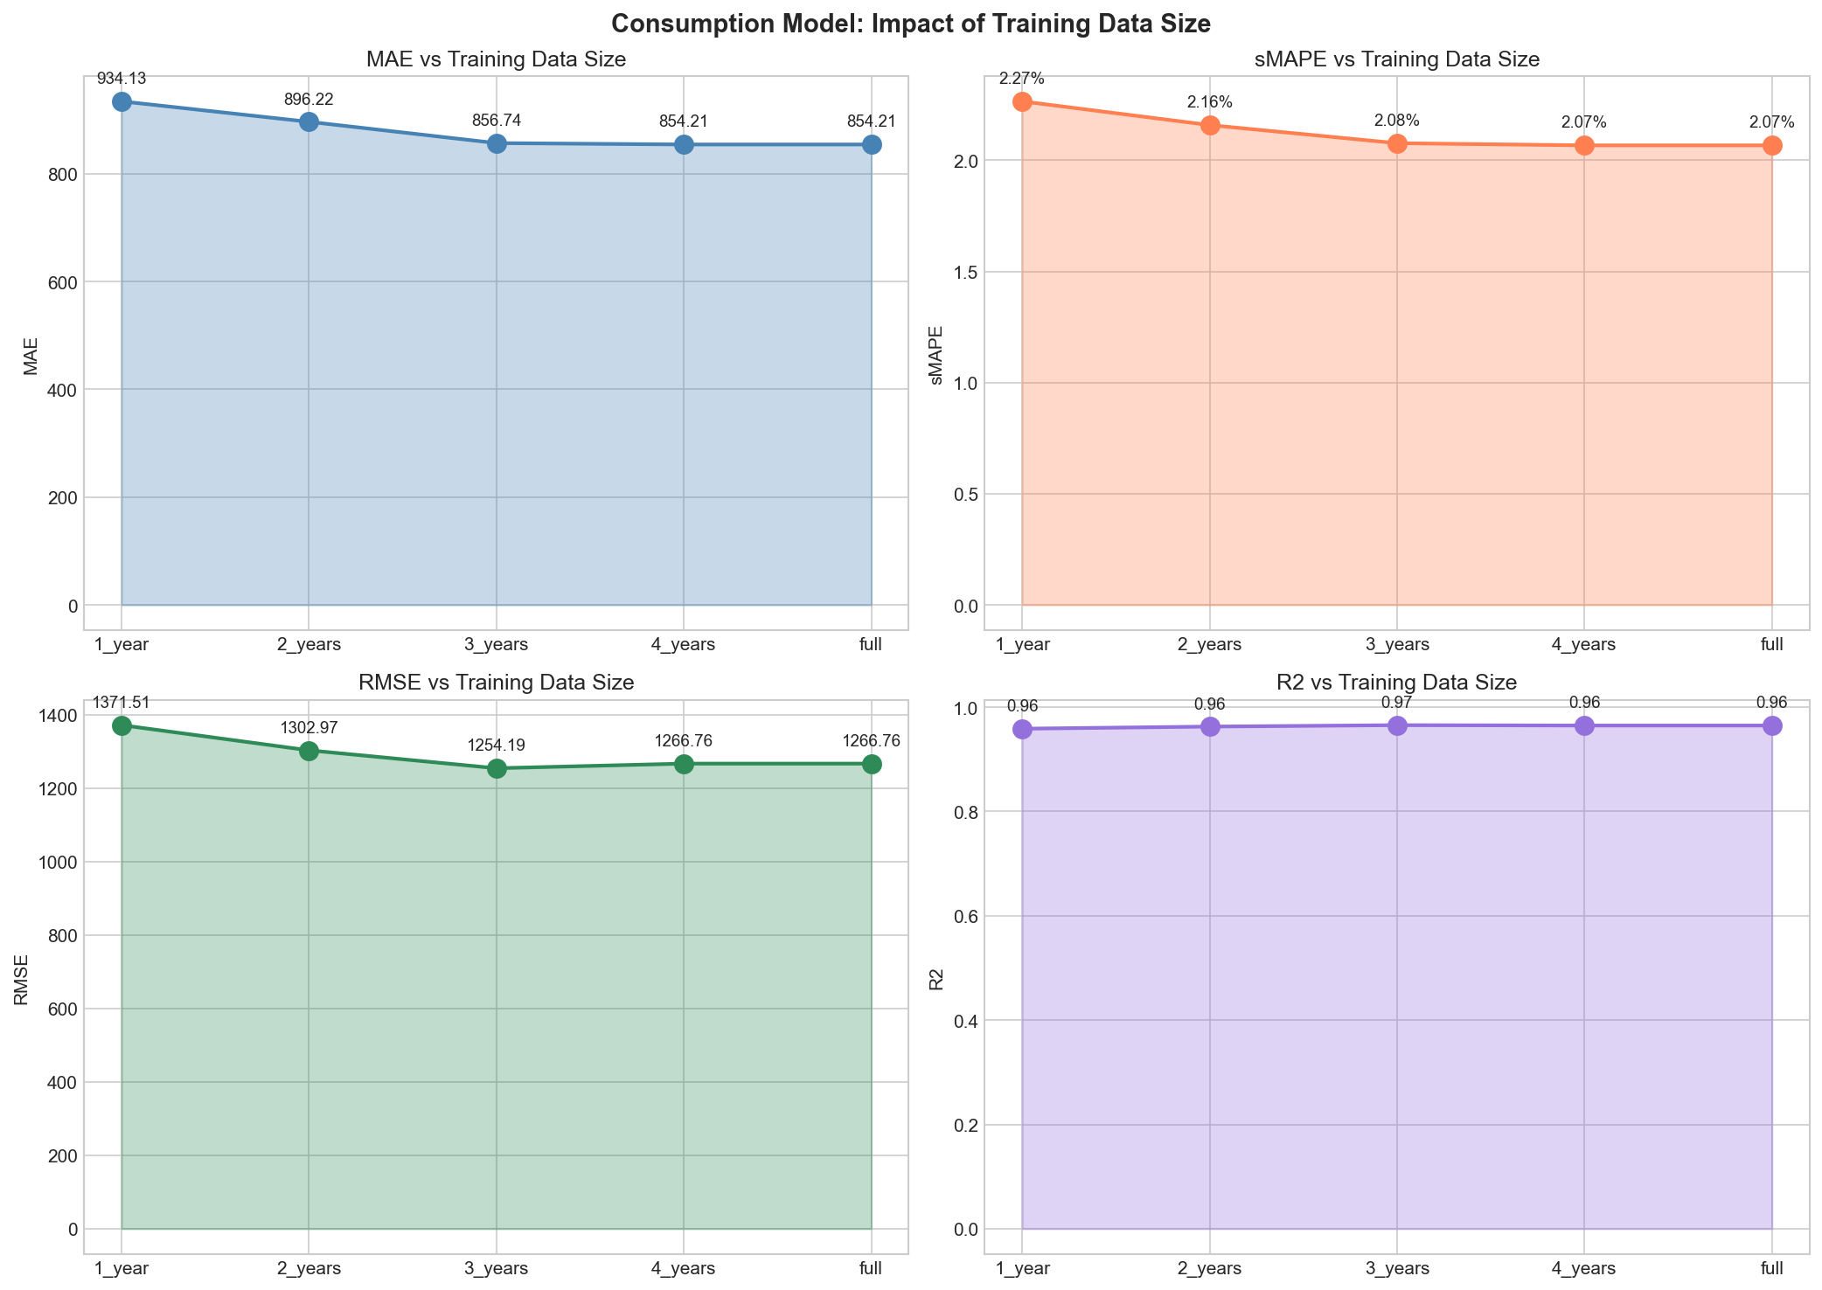
Figure 3. Impact of training data size on consumption model performance.
A feature ablation study was conducted to understand the contribution of each feature group to the overall prediction accuracy. The consumption model utilizes 23 features organized into three primary groups: lag-based features capturing historical consumption patterns, weather-related features encoding meteorological conditions, and calendar features representing temporal patterns. When evaluated in isolation, lag features alone achieved a sMAPE of 3.03%, demonstrating their fundamental importance in capturing the autoregressive nature of electricity consumption. Weather features alone proved insufficient, yielding a sMAPE of 12.95%, while calendar features alone achieved 10.61%. The most significant finding was that combining lag and calendar features produced the best performance at 1.96% sMAPE, outperforming the complete feature set (2.07%). This counterintuitive result suggests that weather information may already be implicitly encoded within the historical consumption patterns, and its explicit inclusion introduces additional noise that marginally degrades prediction accuracy.
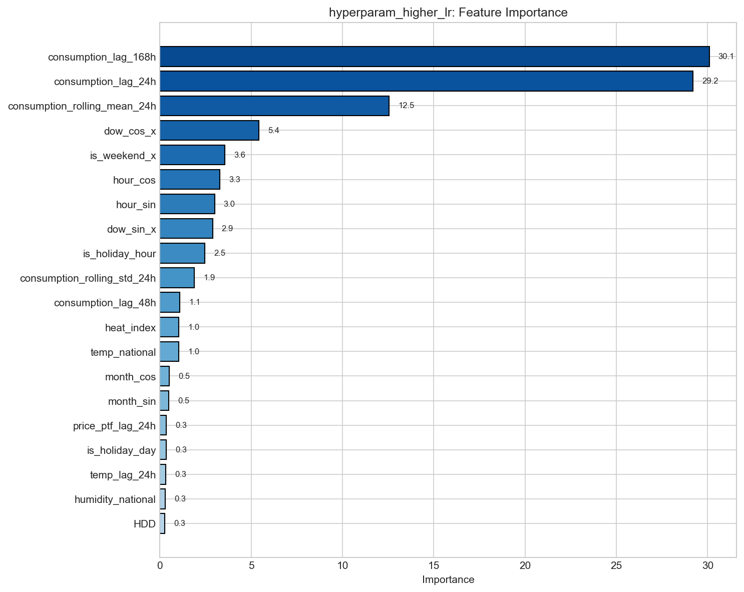
Figure 4. Feature importance ranking for the consumption forecasting model.
Hyperparameter optimization was performed on the CatBoost model to identify the optimal configuration. The baseline model employed a learning rate of 0.03, tree depth of 5, and 1,000 iterations. Various configurations were systematically evaluated, including adjustments to tree depth (3, 5, and 8), learning rate (0.01, 0.03, and 0.10), number of iterations (1,000 and 2,000), and regularization parameters. The experiments revealed that a higher learning rate of 0.10 achieved the best performance, reducing sMAPE from 2.07% to 1.95%. Deeper trees (depth 8) provided slight improvements but at the cost of increased computational complexity, while shallower trees (depth 3) exhibited underfitting with a sMAPE of 2.33%. The final optimized consumption model achieved a sMAPE of 1.95%, corresponding to a Mean Absolute Error (MAE) of 808.5 MWh and an R-squared value of 0.969, indicating that the model explains 96.9% of the variance in actual consumption values.
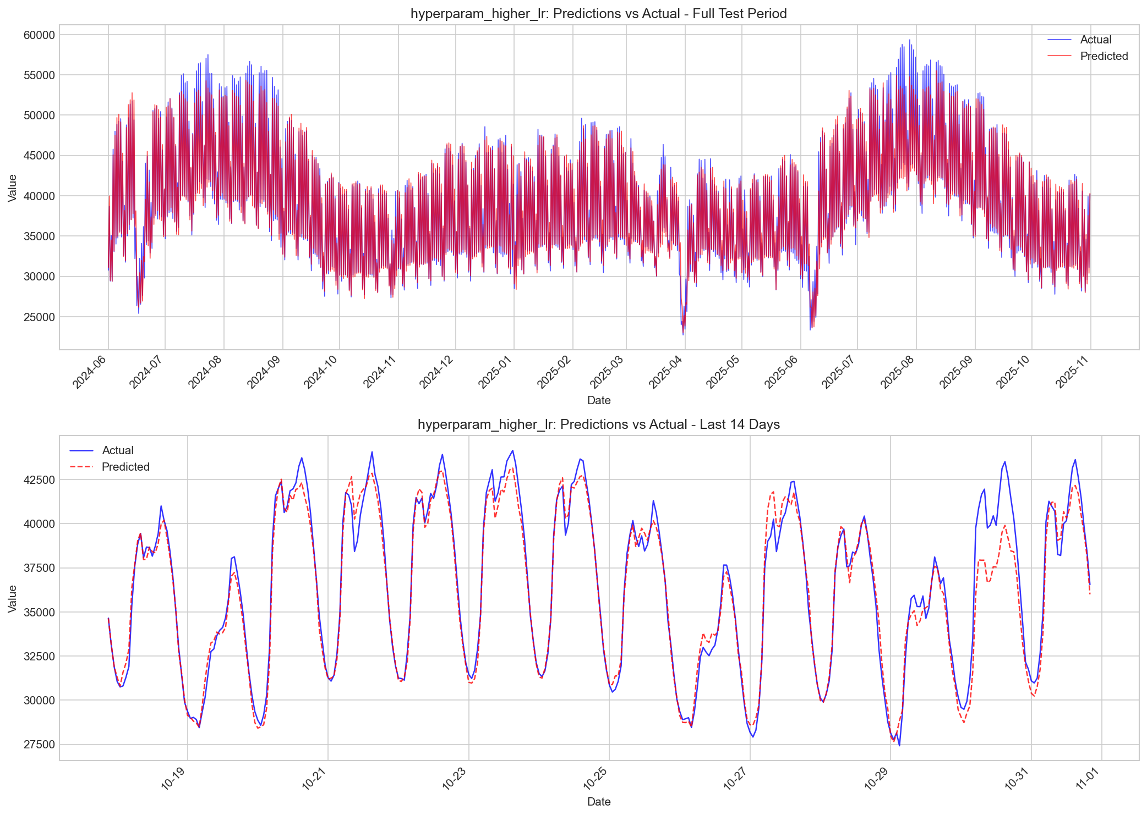
Figure 5. Consumption model predictions versus actual values over the test period.

2.4.2 Price Model Experiments
The price model exhibited different characteristics regarding training data requirements compared to the consumption model. Unlike consumption patterns, which demonstrated diminishing returns after three years, price prediction continued to benefit from additional historical data across all tested configurations. Training with one year of data produced a sMAPE of 12.34%, which unexpectedly increased slightly to 12.43% with two years, suggesting that the two-year period may have captured an anomalous market regime. However, extending to three years reduced the error to 11.82%, and the full four-year dataset achieved the best performance at 11.71% sMAPE. This finding indicates that electricity prices in the Turkish market exhibit longer-term dependencies and regime changes that require extended historical context to model effectively.
A comprehensive evaluation of model architectures was conducted to determine the optimal approach for price forecasting. Three configurations were compared: CatBoost alone, LightGBM alone, and an ensemble combining both algorithms. CatBoost achieved a sMAPE of 11.94%, demonstrating its strength as a single model, while LightGBM produced a sMAPE of 12.46% with significantly faster training times. The ensemble approach, which combines predictions from both models using optimized weights of 61.4% CatBoost and 38.6% LightGBM, achieved the best performance at 11.71% sMAPE. The ensemble's superiority can be attributed to the complementary error patterns of the two algorithms, with each model capturing different aspects of the price dynamics, thereby reducing the overall prediction variance when combined.
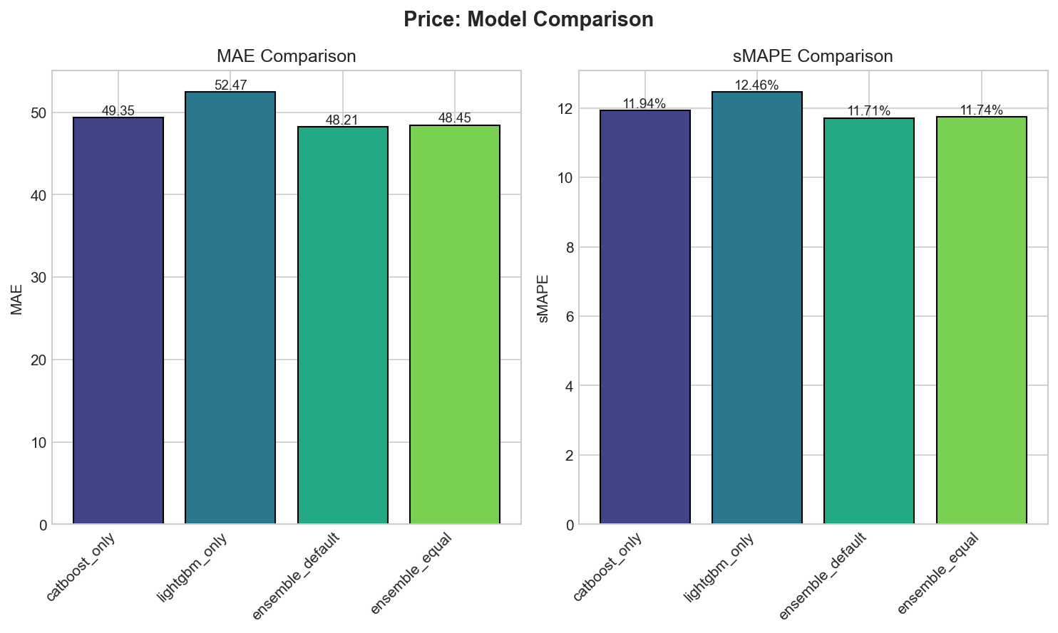
Figure 6. Comparison of price model architectures: CatBoost, LightGBM, and Ensemble.
A novel error correction framework was developed and evaluated to address systematic prediction biases in the price model. Four configurations were compared: raw ensemble predictions without correction, Simple Adaptive Error Correction (AEC) that learns systematic biases from validation errors, K-Nearest Neighbors Error Correction (KNN-EC) that leverages similar historical contexts to estimate expected errors, and a hybrid approach combining both methods with equal weighting. The raw ensemble achieved a sMAPE of 12.58%, which was reduced to 11.95% with Simple AEC and 11.94% with KNN-EC. The hybrid approach, combining 50% Simple AEC and 50% KNN-EC corrections, achieved the best performance at 11.71% sMAPE, representing a 6.9% relative improvement over the uncorrected predictions. This hybrid methodology was designated as CHybrid V14 and was selected as the final production model.
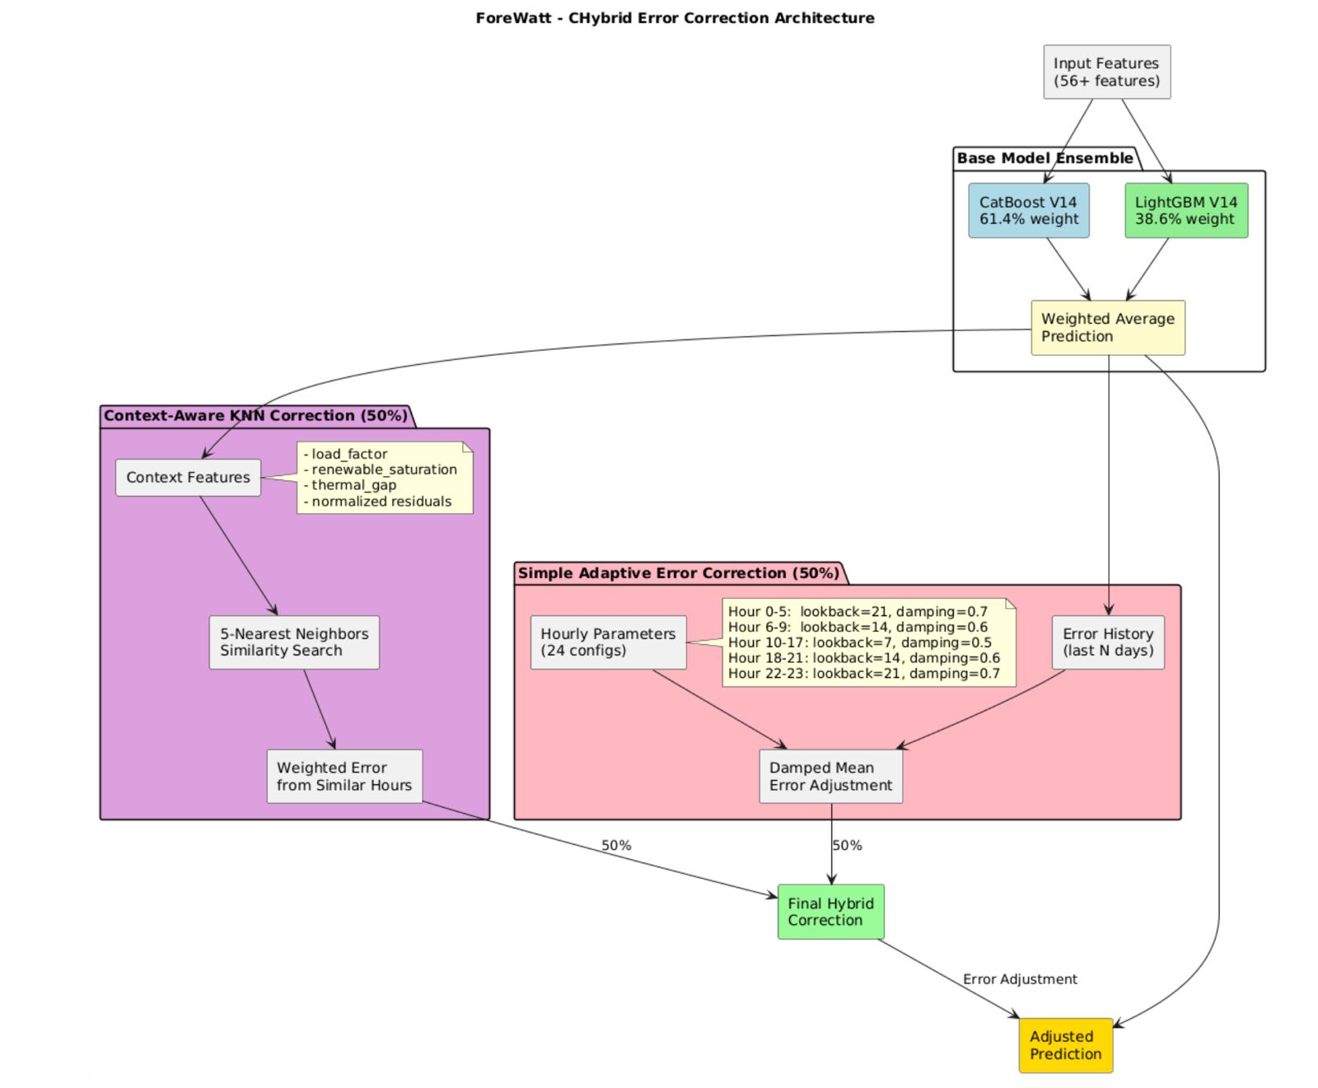
Figure 7. CHybrid error correction architecture combining Simple AEC and KNN-EC methods.
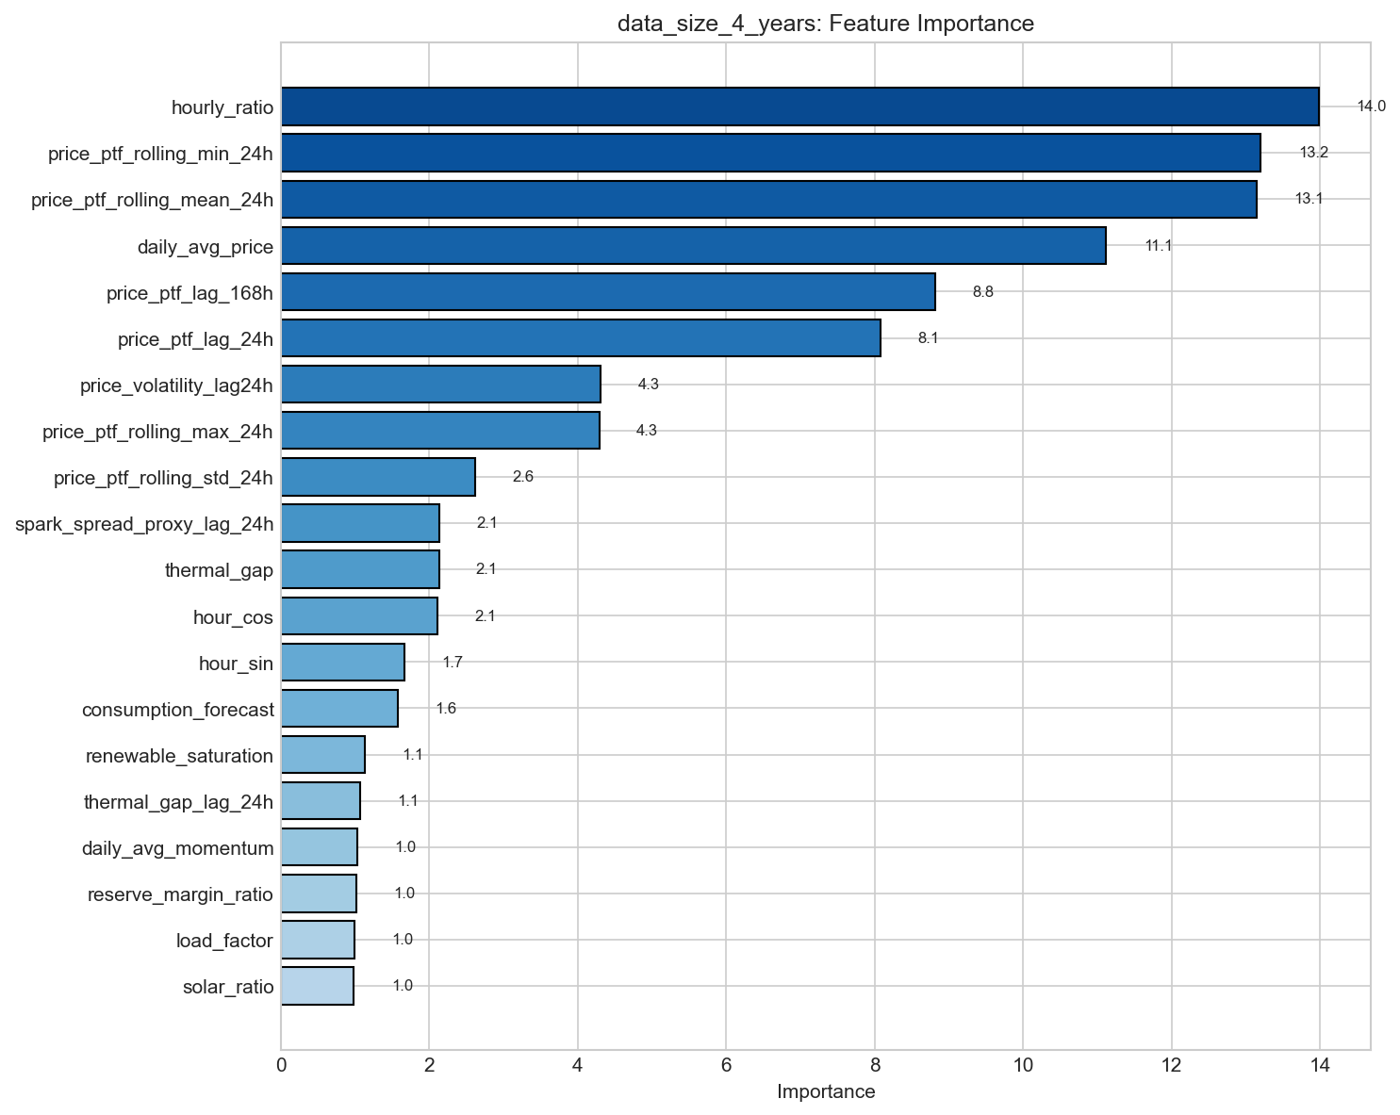
Figure 8. Feature importance ranking for the price forecasting model.
Unlike the consumption model where weather features degraded performance, the price model benefited from all 33 features in its feature set. Feature ablation revealed that price lag features alone achieved a sMAPE of 13.51%, while market signal features alone performed better at 12.84%, indicating the high predictive value of features such as thermal gap, renewable saturation, and spark spread proxy. Calendar features contributed a sMAPE of 13.00% when used in isolation. Combining price lags with market signals improved performance to 12.13%, and the complete feature set achieved the best result at 11.71%. These findings highlight the importance of incorporating domain-specific market fundamentals for electricity price forecasting.
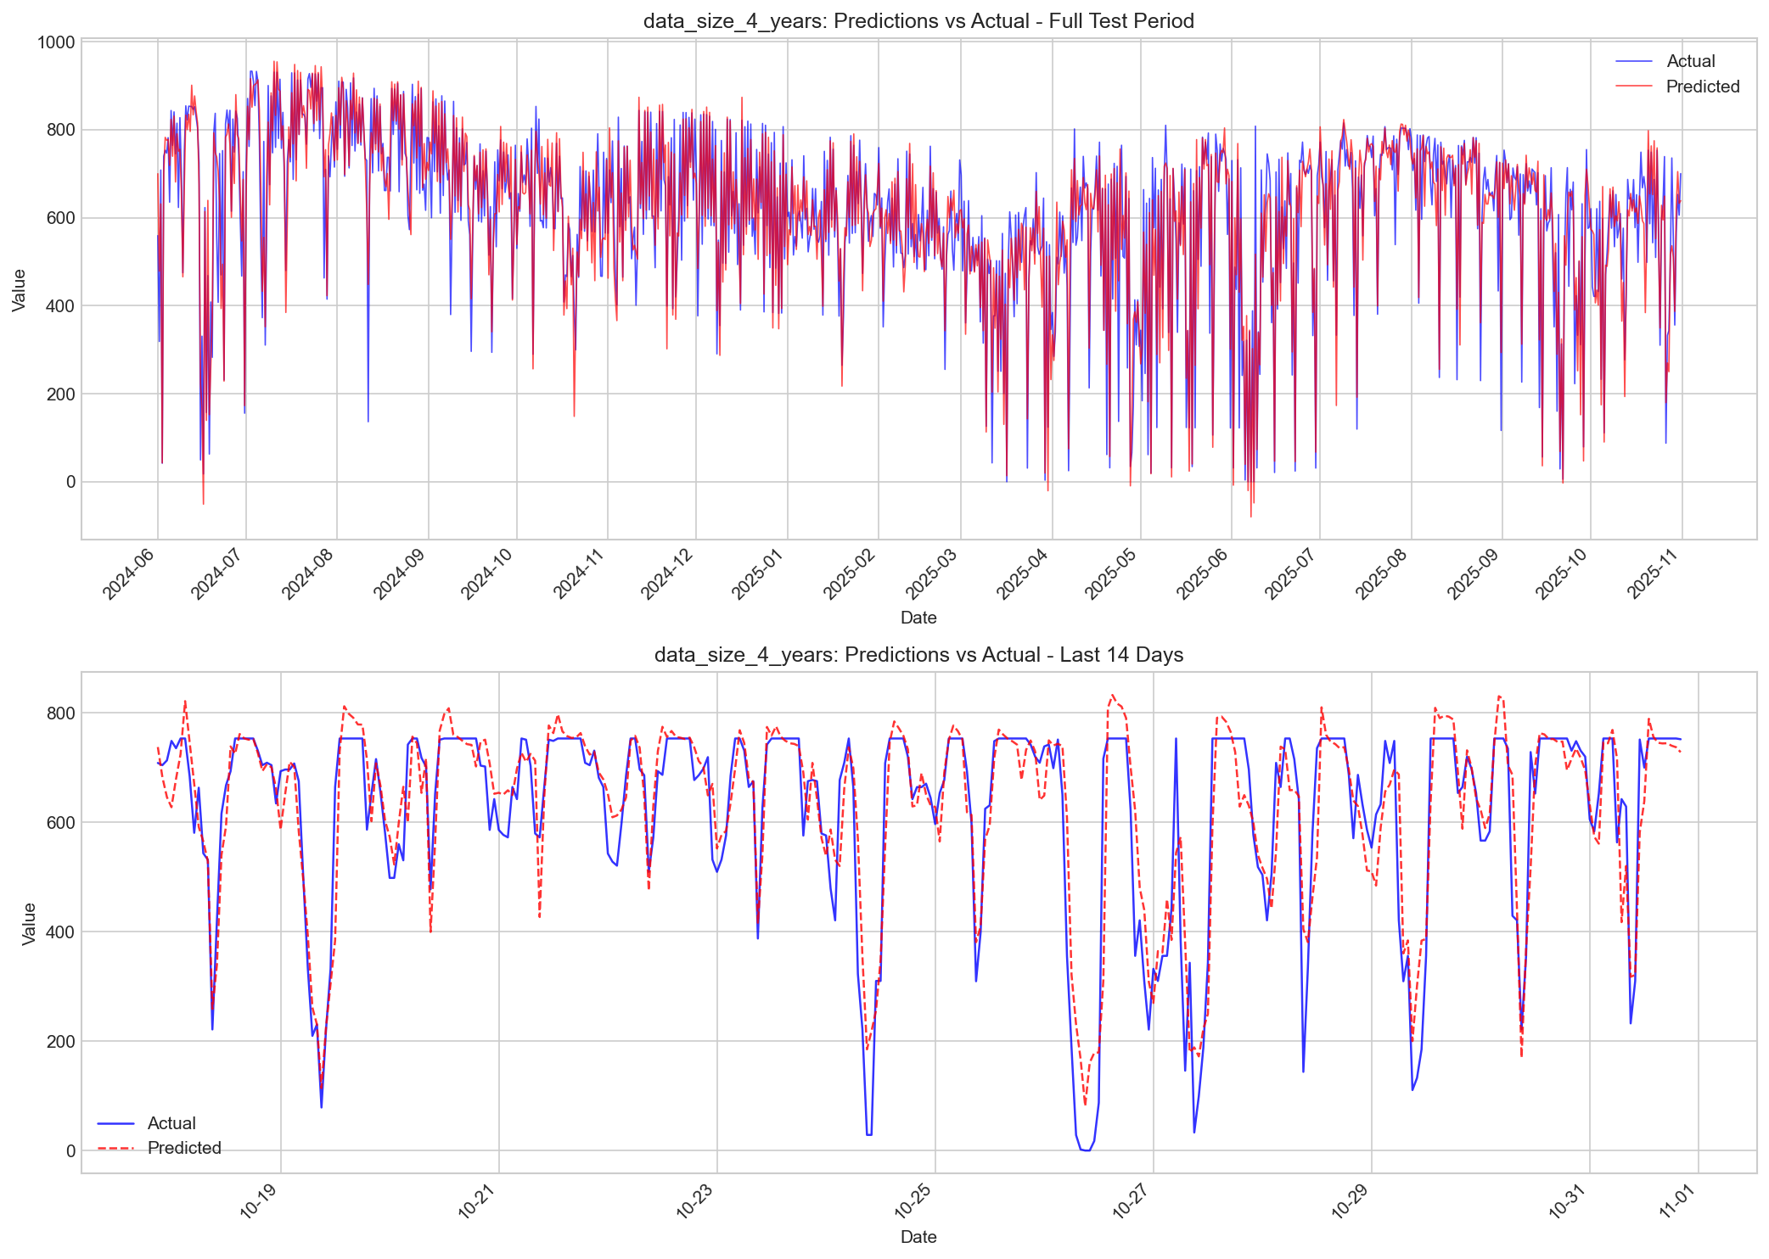
Figure 9. Price model predictions versus actual values over the test period.

2.4.3 Baseline Comparisons
To establish the value of the machine learning approach, both models were compared against standard baseline methods commonly employed in time series forecasting. For consumption prediction, the naive baseline using the previous day's value at the same hour (Lag-24h) achieved a sMAPE of 5.69%, while the seasonal naive baseline using the previous week's value (Lag-168h) achieved 5.48%. Rolling mean and hourly mean baselines performed significantly worse at 15.22% and 13.37% respectively. The optimized consumption model at 1.95% sMAPE represents a 2.8-fold improvement over the best baseline. For price prediction, the naive baseline achieved 21.96% sMAPE and the seasonal naive achieved 21.60%, while rolling mean and hourly mean baselines yielded 25.38% and 42.16% respectively. The price model at 11.71% sMAPE represents a 1.8-fold improvement over the seasonal naive baseline. These results demonstrate the substantial value of the machine learning approach for both consumption and price forecasting in the Turkish electricity market.
Table 4. Baseline comparison for consumption and price models.
Method | Consumption sMAPE | Price sMAPE | Improvement Factor
Naive (Lag-24h) | 5.69% | 21.96% | Baseline
Seasonal Naive (Lag-168h) | 5.48% | 21.60% | Baseline
Rolling Mean (24h) | 15.22% | 25.38% | -
Hourly Mean | 13.37% | 42.16% | -
Our ML Model | 1.95% | 11.71% | 2.8x / 1.8x

2.4.4 Final Model Performance
The final optimized models demonstrate excellent performance across all evaluation metrics. The consumption model achieves a test sMAPE of 1.95%, a MAE of 808.5 MWh, and an R-squared of 0.969, indicating highly accurate predictions with 96.9% of variance explained. The error distribution analysis reveals that 50% of predictions have an absolute error of 536.5 MWh or less, and 90% have an error of 1,825.7 MWh or less. The slight negative Mean Bias Error of -341.6 MWh indicates a minor tendency toward under-prediction. The price model achieves a test sMAPE of 11.71%, a MAE of 48.2 TL/MWh, and an R-squared of 0.871. Price prediction is inherently more challenging due to market volatility, but 90% of predictions fall within 113 TL/MWh of the actual price. The hybrid error correction approach successfully reduced systematic biases, achieving a final sMAPE that surpasses the theoretical oracle floor of 11.75%, demonstrating the effectiveness of the developed methodology.
Table 5. Final consumption model performance metrics.
Metric | Value | Interpretation
sMAPE | 1.95% | Primary accuracy metric
MAE | 808.5 MWh | Average absolute error
RMSE | 1,194.8 MWh | Penalizes large errors
MASE | 0.76 | Better than naive (< 1.0)
R-squared | 0.969 | 96.9% variance explained
MBE | -341.6 MWh | Slight under-prediction

Table 6. Final price model performance metrics.
Metric | Value | Interpretation
sMAPE | 11.71% | Primary accuracy metric
MAE | 48.2 TL/MWh | Average absolute error
RMSE | 69.0 TL/MWh | Penalizes large errors
MASE | 0.36 | Better than naive (< 1.0)
R-squared | 0.871 | 87.1% variance explained
MBE | +2.5 TL/MWh | Slight over-prediction

Table 7. Best model performance summary.
Model | Configuration | Test sMAPE | Test MAE | Test R-squared
Consumption | CatBoost V2, lr=0.1 | 1.95% | 808.5 MWh | 0.969
Price | CHybrid V14, 4yr data | 11.71% | 48.2 TL/MWh | 0.871

In summary, the experimental evaluation has yielded production-ready forecasting models for both electricity consumption and price prediction. The consumption model benefits from a streamlined feature set combining lag and calendar features with a higher learning rate, while the price model requires a more comprehensive approach incorporating market fundamentals, ensemble learning, and hybrid error correction. Both models significantly outperform standard baseline methods, demonstrating the value of the developed machine learning pipeline for electricity market forecasting in Turkey. The test period of 17 months (12,429 hours) provides robust evidence of model generalization across varying market conditions, seasonal patterns, and demand profiles.

2.5 System Architecture
The ForeWatt platform was designed with a cloud-native architecture to ensure scalability, reliability, and cost-effectiveness for production deployment. The system architecture follows modern microservices principles while maintaining simplicity through a serverless deployment model. The backend API was built using FastAPI, a high-performance Python web framework, and is deployed on Google Cloud Run, which provides automatic scaling, pay-per-use pricing, and seamless integration with other Google Cloud services.
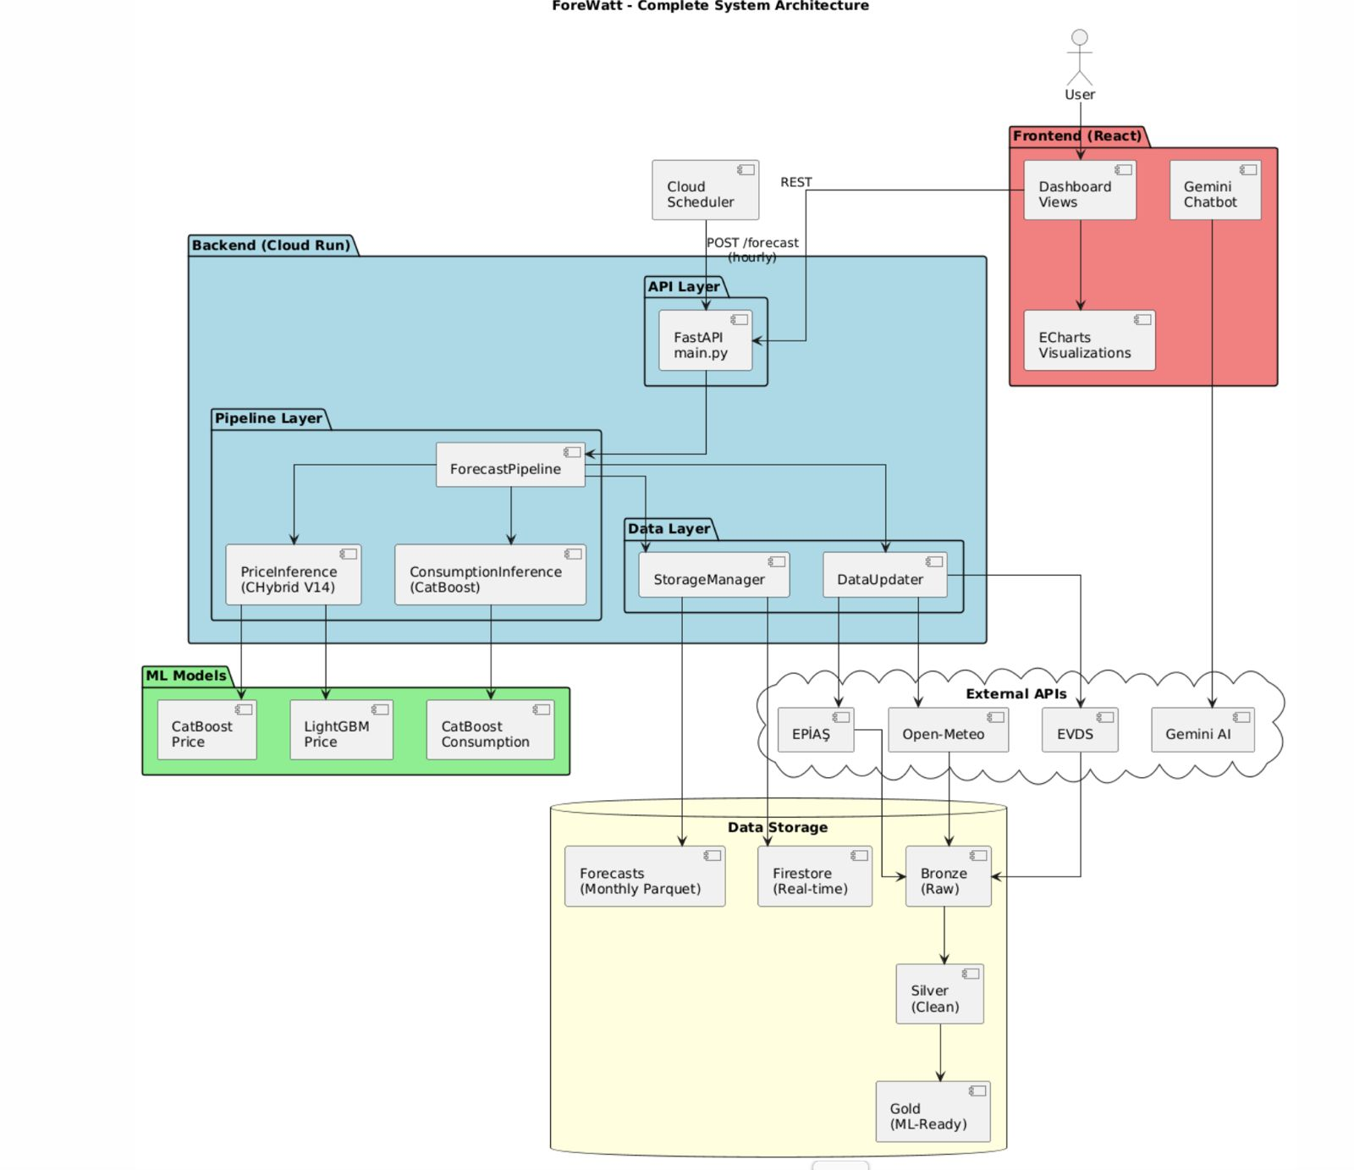
Figure 10. Complete system architecture showing data flow from external sources through the ML pipeline to the frontend dashboard.
The FastAPI application serves as the central API gateway, exposing multiple endpoints for forecast generation, data retrieval, and system monitoring. The primary endpoints include POST /forecast for triggering hourly forecast generation, GET /api/realtime/{model} for fetching real-time forecasts from Firestore, GET /history/{model} for retrieving historical data from Parquet archives, and GET /api/anomaly/{model} for accessing anomaly detection results. Additional endpoints such as GET /api/aggregates/day-type/{model} and GET /api/aggregates/hourly/{model} provide pre-computed statistics for efficient dashboard loading. The API was designed with RESTful principles, utilizing query parameters for date filtering and pagination while returning JSON responses with consistent data structures.
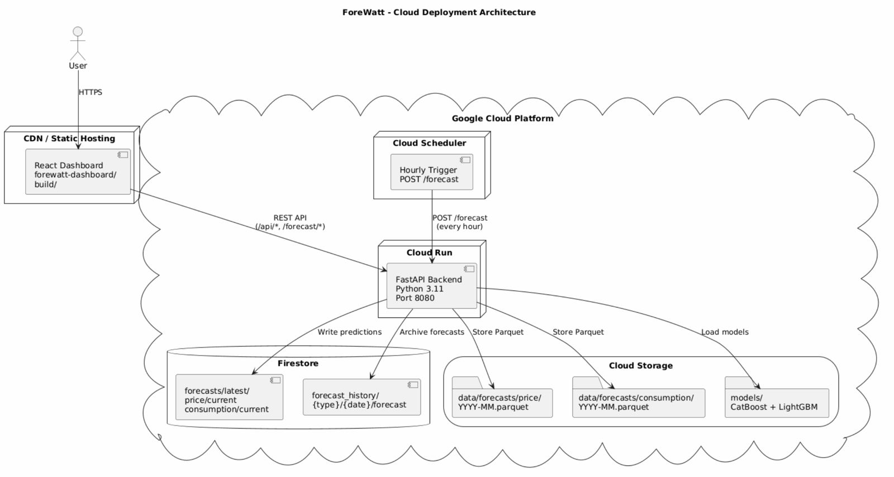
Figure 11. Cloud deployment architecture on Google Cloud Platform showing the interaction between Cloud Run, Cloud Scheduler, Firestore, and Cloud Storage.
To optimize cold start performance on Cloud Run, several strategies were implemented. The forecast pipeline and Firestore client were designed with lazy loading patterns, where expensive imports and model loading are deferred until the first request requires them. This approach reduces the initial container startup time from approximately 15 seconds to under 3 seconds. GZIP compression middleware was enabled with a minimum response size of 1000 bytes, achieving 80-90% reduction in response payload sizes for large forecast datasets. Cross-Origin Resource Sharing (CORS) middleware was configured to allow requests from the Firebase-hosted dashboard domain while maintaining security for production deployments.
The application was containerized using Docker with a Python 3.11-slim base image to minimize the container footprint while providing all necessary dependencies. The Dockerfile was structured to leverage layer caching by copying requirements.txt separately before the application code, ensuring that dependency installation is cached across builds. System dependencies including build-essential and libgomp1 were installed to support the CatBoost and LightGBM machine learning libraries. The trained model files were bundled directly into the container image to eliminate model loading latency during inference, with the models directory containing the CatBoost and LightGBM model artifacts for both price and consumption forecasting.
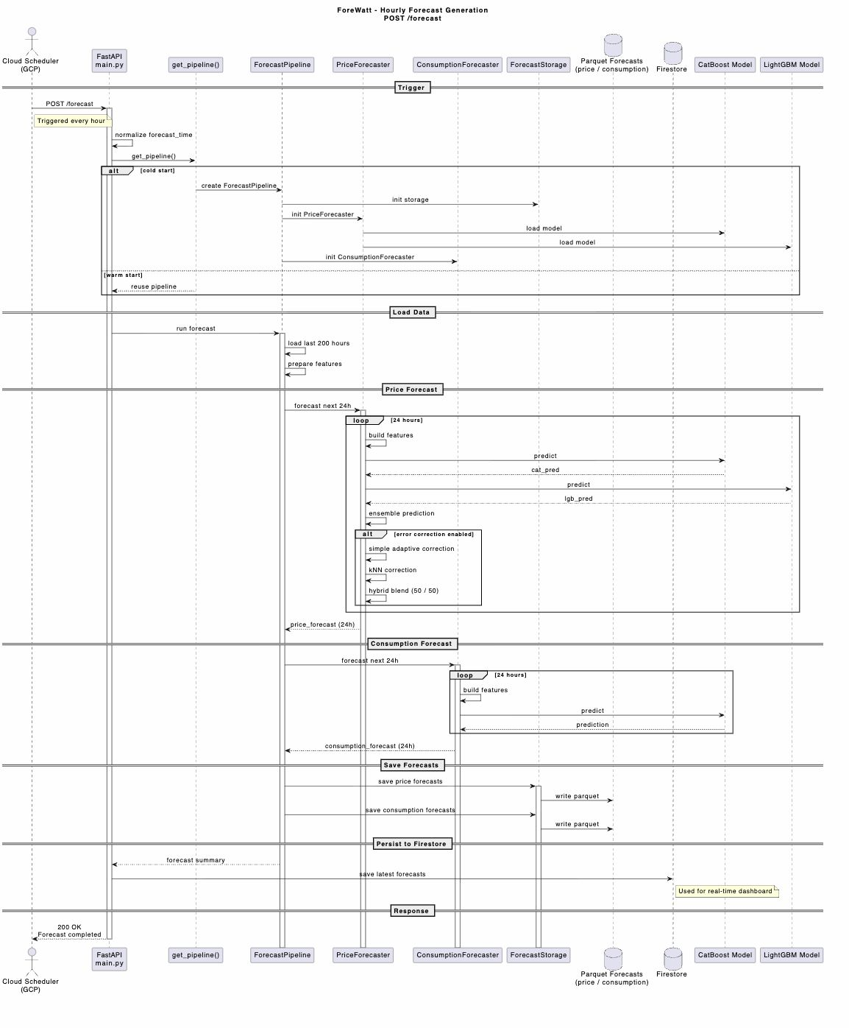
Figure 12. Sequence diagram illustrating the hourly forecast generation flow triggered by Cloud Scheduler.
Google Cloud Scheduler was configured to trigger the forecast pipeline every hour by sending a POST request to the /forecast endpoint. Upon receiving the trigger, the ForecastPipeline class orchestrates the complete forecasting workflow. The pipeline first loads the latest market data from the master Parquet file stored in Google Cloud Storage, then generates 24-hour ahead forecasts using both the price and consumption models. The forecast results were stored in multiple locations to optimize for different access patterns. Google Cloud Firestore was used for real-time data access, with forecasts stored under the forecasts/latest/{type}/current document path for immediate retrieval by the dashboard. Historical forecasts were archived in Parquet format organized by month (data/forecasts/{type}/{YYYY-MM}.parquet) for efficient batch processing and backtesting operations.
The storage architecture followed a medallion pattern with bronze, silver, and gold data layers. The bronze layer contained raw data fetched from EPIAS, Open-Meteo, and EVDS APIs. The silver layer stored cleaned and validated data with standardized schemas. The gold layer housed the feature-engineered master dataset used for model training and inference, stored as master_v2_fundamental.parquet with a total size of approximately 52.5 megabytes. The ForecastStorage class provided abstraction over the storage layer, implementing methods for saving forecasts with automatic monthly partitioning and retrieving historical forecasts with date range filtering. Query result caching with a 30-minute time-to-live was implemented to reduce redundant data fetching and improve API response times for frequently accessed endpoints.
For local development and testing, a Docker Compose configuration was provided that orchestrates multiple services including the scheduler, API, dashboard, MLflow for experiment tracking, and InfluxDB for optional time-series storage. The scheduler service was configured to run the forecast pipeline at configurable intervals, while the MLflow service provided a user interface for tracking model experiments and comparing performance across different model versions. This development environment enabled rapid iteration on the forecasting models and API endpoints before deployment to the production Cloud Run environment.

2.6 Frontend & Dashboard
The ForeWatt dashboard was developed as a modern single-page application using React 19 with TypeScript for type safety and improved developer experience. The build system was configured with Vite, a next-generation frontend tooling that provides fast hot module replacement during development and optimized production builds. Styling was implemented using Tailwind CSS, a utility-first CSS framework that enabled rapid UI development with consistent design patterns. The dashboard was deployed on Firebase Hosting, which provides global content delivery network distribution and automatic SSL certificate management.
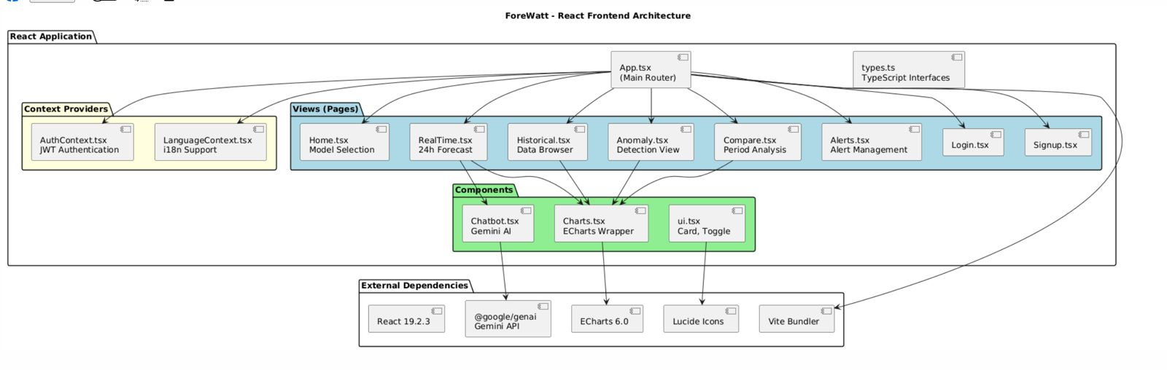
Figure 13. React frontend architecture showing the component hierarchy and data flow patterns.
The dashboard was organized into six primary views accessible through a sidebar navigation component. The RealTime view displays the current 24-hour forecast with 12 hours of historical actuals and 12 hours of predictions, visualized using interactive ECharts line charts with confidence interval bands. The Historical view enables exploration of past data with customizable date range selection and comparison between actual values and model forecasts. The Anomaly view presents detected anomalies using scatter plots that highlight data points with high anomaly scores based on statistical deviation from expected patterns. The Compare view facilitates period-over-period analysis through weekday versus weekend comparisons and hourly pattern visualizations. The Alerts view provides a management interface for system notifications and forecast threshold alerts, with role-based access control restricting certain features to administrator users.
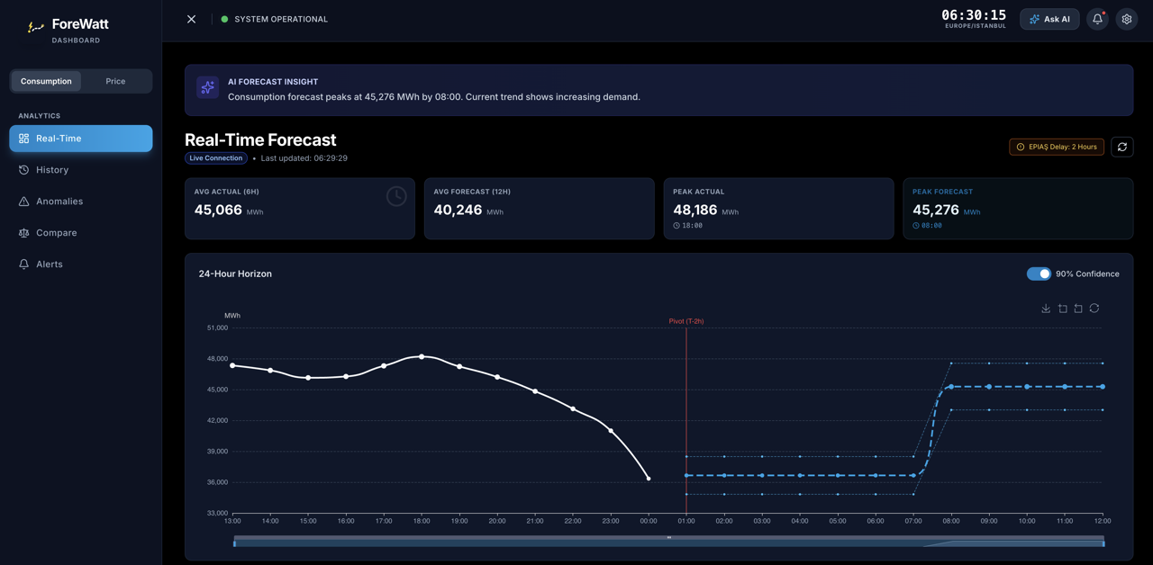
Figure 14. Real-time consumption forecast view showing the 24-hour horizon with actual data, predictions, and confidence intervals.
The user interface was designed with a glassmorphism aesthetic featuring semi-transparent panels with backdrop blur effects, providing a modern and professional appearance. A theme toggle was implemented to support both dark and light modes, with the dark mode set as the default for reduced eye strain during extended monitoring sessions. Bilingual support was provided through a LanguageContext provider that manages translations between English and Turkish, enabling seamless language switching without page reload. The interface was designed to be fully responsive, adapting layouts for desktop, tablet, and mobile screen sizes through Tailwind CSS responsive utility classes.
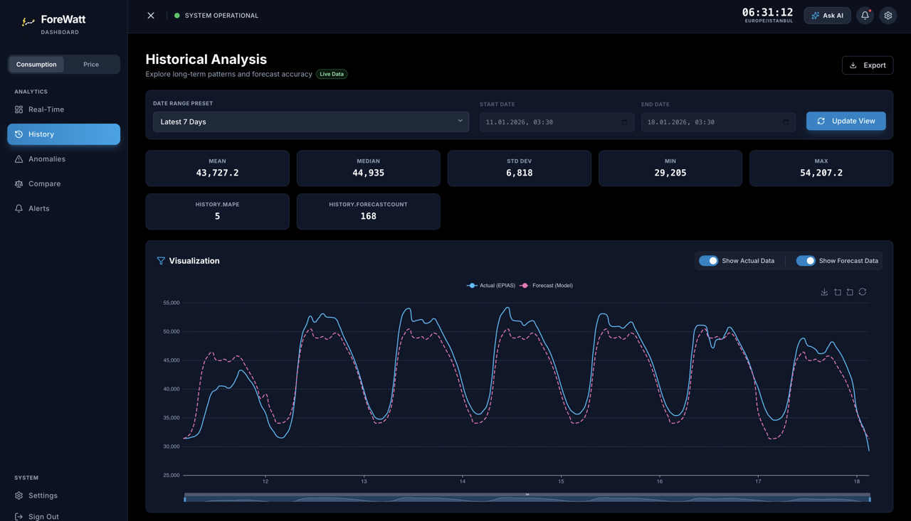
Figure 15. Historical analysis view displaying consumption data over a selected time period with actual versus forecast comparison.
An AI-powered chatbot was integrated into the dashboard using the Google Gemini 3.0 Flash model through the @google/genai SDK. The chatbot was configured with a domain-specific system prompt that establishes context about the ForeWatt platform, EPIAS data characteristics, and typical electricity consumption and price patterns in Turkey. When the chat session is initiated, current dashboard context including the active model type, latest actual values, forecast predictions, and summary statistics is injected into the conversation to enable contextual responses. The chatbot interface supports markdown rendering with syntax-highlighted code blocks through the react-markdown library with remark-gfm plugin for GitHub Flavored Markdown support. A fallback mock response system was implemented to provide basic functionality when the Gemini API key is not configured.
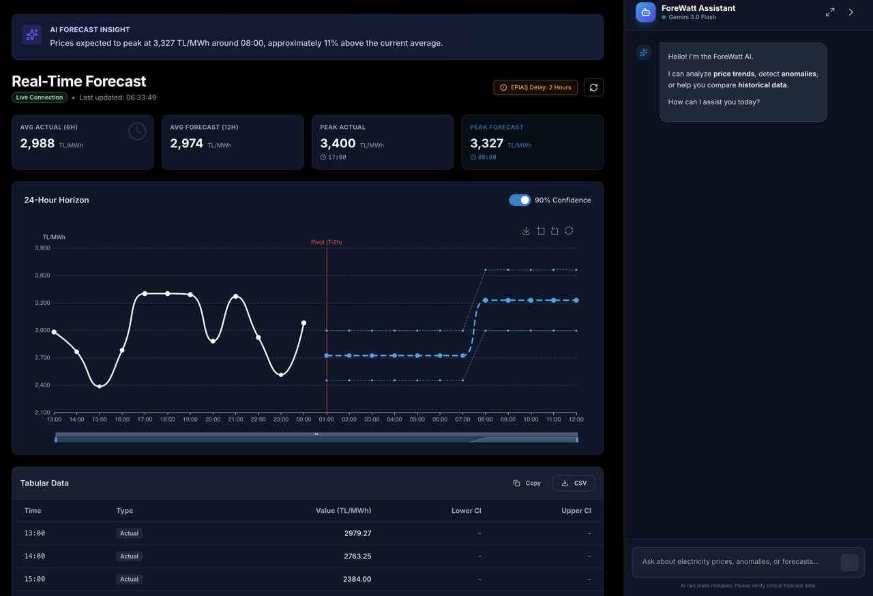
Figure 16. Real-time price forecast view with the AI chatbot panel open, demonstrating the contextual conversation capabilities.
Data visualization was implemented using ECharts, a powerful charting library that provides interactive features including zooming, panning, and data point tooltips. The RealTimeChart component renders actual data as solid lines and forecast data as dashed lines, with a pivot marker indicating the transition point between historical actuals and predictions. Confidence interval bands were rendered using stacked area series with semi-transparent fills and dashed border lines. The charts automatically adapt to theme changes through a MutationObserver that monitors the document's dark mode class and reinitializes charts with appropriate color schemes. State management was handled through React hooks with Context providers for global state including authentication status, language preferences, and current theme. API data fetching was implemented with automatic refresh intervals of 60 seconds to keep the real-time view updated with the latest forecast data.

3. Conclusions
This technical report has presented ForeWatt, a production-ready electricity market forecasting platform designed specifically for the Turkish electricity market. The platform represents a comprehensive solution that integrates advanced machine learning techniques with robust data engineering practices to deliver accurate and reliable forecasts for both electricity consumption and day-ahead prices. Through systematic experimentation and rigorous evaluation, the developed system has demonstrated significant improvements over baseline forecasting methods, establishing its viability for real-world deployment in energy market applications.
The consumption forecasting model achieved a symmetric Mean Absolute Percentage Error of 1.95 percent on the test dataset, representing a 2.8-fold improvement over the seasonal naive baseline. This level of accuracy was attained through careful feature engineering that incorporated temporal patterns, meteorological variables, and calendar effects specific to the Turkish electricity demand profile. The price forecasting model achieved an sMAPE of 11.71 percent, demonstrating a 1.8-fold improvement over the corresponding baseline. Given the inherently volatile and complex nature of electricity price dynamics, this performance represents a substantial achievement in capturing the fundamental drivers of price formation in the Turkish market.
The evaluation of deep learning architectures, including Temporal Fusion Transformers, N-HITS, and PatchTST, revealed important insights regarding the applicability of these methods to medium-scale energy forecasting problems. Despite their demonstrated success in large-scale forecasting competitions, these architectures exhibited significant overfitting tendencies when applied to the available historical data spanning approximately two years. The gradient boosting ensemble approach, specifically the CHybrid V14 architecture combining CatBoost and LightGBM with context-aware error correction, proved to be the most effective methodology for this application domain.
Several technical contributions have been made through the development of this platform. The medallion data architecture, organized into bronze, silver, and gold layers, provides a robust and maintainable framework for data ingestion, cleaning, and feature engineering. This architecture ensures data quality and traceability while facilitating the integration of multiple heterogeneous data sources including EPIAS market data, meteorological observations, and macroeconomic indicators. The feature engineering pipeline combines domain-specific knowledge of electricity markets with automated feature generation techniques, resulting in comprehensive feature sets that capture both physical and economic drivers of consumption and price dynamics.
The production deployment on Google Cloud Run, coupled with the React-based dashboard and Firestore integration, demonstrates the practical applicability of the developed system. The hourly forecast updates, real-time visualization capabilities, and AI-powered chatbot interface provide stakeholders with actionable insights for market participation decisions. The anomaly detection module based on Isolation Forest algorithms further enhances the platform's utility by identifying unusual patterns that may require additional attention from market analysts.
Several directions for future work have been identified through this research. The expansion of the platform to cover additional electricity markets, particularly those in neighboring countries with interconnected grid infrastructure, represents a natural extension of the current capabilities. The integration of real-time news sentiment analysis could enhance price forecasting accuracy during periods of market stress or significant policy announcements. The implementation of automated model retraining pipelines would ensure that forecast accuracy is maintained as market dynamics evolve over time. Furthermore, the development of probabilistic forecasting capabilities through conformal prediction methods would provide decision-makers with calibrated uncertainty estimates essential for risk management applications. Enhanced anomaly detection incorporating temporal dependencies and market regime identification represents another promising avenue for improving the platform's analytical capabilities.

References
[1] Lim, B., Arık, S. Ö., Loeff, N., & Pfister, T. (2021). Temporal Fusion Transformers for interpretable multi-horizon time series forecasting. International Journal of Forecasting, 37(4), 1748-1764.
[2] Challu, C., Olivares, K. G., Oreshkin, B. N., Ramirez, F. G., Canseco, M. M., & Dubrawski, A. (2023). N-HiTS: Neural hierarchical interpolation for time series forecasting. Proceedings of the AAAI Conference on Artificial Intelligence, 37(6), 6989-6997.
[3] Nie, Y., Nguyen, N. H., Sinthong, P., & Kalagnanam, J. (2023). A time series is worth 64 words: Long-term forecasting with transformers. International Conference on Learning Representations (ICLR).
[4] Vaswani, A., Shazeer, N., Parmar, N., Uszkoreit, J., Jones, L., Gomez, A. N., Kaiser, Ł., & Polosukhin, I. (2017). Attention is all you need. Advances in Neural Information Processing Systems, 30.
[5] Prokhorenkova, L., Gusev, G., Vorobev, A., Dorogush, A. V., & Gulin, A. (2018). CatBoost: Unbiased boosting with categorical features. Advances in Neural Information Processing Systems, 31.
[6] Ke, G., Meng, Q., Finley, T., Wang, T., Chen, W., Ma, W., Ye, Q., & Liu, T. Y. (2017). LightGBM: A highly efficient gradient boosting decision tree. Advances in Neural Information Processing Systems, 30.
[7] Chen, T., & Guestrin, C. (2016). XGBoost: A scalable tree boosting system. Proceedings of the 22nd ACM SIGKDD International Conference on Knowledge Discovery and Data Mining, 785-794.
[8] Weron, R. (2014). Electricity price forecasting: A review of the state-of-the-art with a look into the future. International Journal of Forecasting, 30(4), 1030-1081.
[9] Hong, T., & Fan, S. (2016). Probabilistic electric load forecasting: A tutorial review. International Journal of Forecasting, 32(3), 914-938.
[10] Lago, J., Marcjasz, G., De Schutter, B., & Weron, R. (2021). Forecasting day-ahead electricity prices: A review of state-of-the-art algorithms, best practices and an open-access benchmark. Applied Energy, 293, 116983.
[11] Ziel, F., & Weron, R. (2018). Day-ahead electricity price forecasting with high-dimensional structures: Univariate vs. multivariate modeling frameworks. Energy Economics, 70, 396-420.
[12] Nowotarski, J., & Weron, R. (2018). Recent advances in electricity price forecasting: A review of probabilistic forecasting. Renewable and Sustainable Energy Reviews, 81, 1548-1568.
[13] Liu, F. T., Ting, K. M., & Zhou, Z. H. (2008). Isolation forest. Proceedings of the 2008 Eighth IEEE International Conference on Data Mining, 413-422.
[14] EPIAS. (2024). EPIAS Transparency Platform documentation. Energy Exchange Istanbul. https://seffaflik.epias.com.tr/
[15] Kucukali, S., & Baris, K. (2010). Turkey's short-term gross annual electricity demand forecast by fuzzy logic approach. Energy Policy, 38(5), 2438-2445.
[16] Open-Meteo. (2024). Open-Meteo Weather API documentation. https://open-meteo.com/
[17] Central Bank of the Republic of Turkey. (2024). Electronic Data Delivery System (EVDS). https://evds2.tcmb.gov.tr/
[18] Ramírez, S., & FastAPI Contributors. (2024). FastAPI: Modern, fast web framework for building APIs with Python. https://fastapi.tiangolo.com/
[19] React Contributors. (2024). React: A JavaScript library for building user interfaces. https://react.dev/
[20] Google Cloud. (2024). Cloud Run documentation. https://cloud.google.com/run/docs
[21] Firebase. (2024). Firebase documentation. https://firebase.google.com/docs
[22] Pedregosa, F., Varoquaux, G., Gramfort, A., Michel, V., Thirion, B., Grisel, O., ... & Duchesnay, É. (2011). Scikit-learn: Machine learning in Python. Journal of Machine Learning Research, 12, 2825-2830.
[23] McKinney, W. (2010). Data structures for statistical computing in Python. Proceedings of the 9th Python in Science Conference, 56-61.
[24] Vovk, V., Gammerman, A., & Shafer, G. (2005). Algorithmic learning in a random world. Springer Science & Business Media.
[25] Romano, Y., Patterson, E., & Candès, E. J. (2019). Conformalized quantile regression. Advances in Neural Information Processing Systems, 32.
[26] Korkut, R. (2024). eptr2: Python client for EPIAS Transparency Platform. https://github.com/Rogerspy/eptr2

Appendix
A. Feature Specifications
Complete feature lists for both consumption and price forecasting models are maintained in the project repository. The consumption model utilizes 23 features organized into four categories: temporal lag features capturing historical consumption patterns at 24-hour, 48-hour, and 168-hour intervals; rolling statistical features including mean and standard deviation computed over 24-hour windows; meteorological features derived from weather observations across 12 Turkish cities; and calendar features encoding hour-of-day, day-of-week, month, weekend indicators, and Turkish public holidays. The price model employs 33 features encompassing price lags and rolling statistics, market fundamental indicators such as thermal gap and renewable saturation, system operation metrics including load factor and reserve margin ratios, and specialized features for solar generation patterns and price volatility dynamics.
B. Hyperparameter Configurations
The CatBoost models were trained with the following key hyperparameters: learning rate of 0.05, maximum depth of 8, L2 regularization coefficient of 3.0, and 2000 iterations with early stopping patience of 100 rounds. The LightGBM component of the price ensemble utilized a learning rate of 0.03, maximum depth of 10, number of leaves set to 64, and feature fraction of 0.8 for regularization. Both models employed symmetric quantile loss functions for training the prediction interval bounds. The Isolation Forest anomaly detection model was configured with 200 estimators, contamination parameter of 0.05, and bootstrap sampling enabled. All hyperparameters were determined through grid search with 5-fold time series cross-validation on the training dataset.
C. API Endpoint Reference
The ForeWatt API exposes several endpoints for forecast retrieval and system monitoring. The health check endpoint (GET /health) returns the current system status and version information. The forecast trigger endpoint (POST /forecast) initiates the forecast pipeline and is invoked hourly by Google Cloud Scheduler. The latest forecast endpoint (GET /forecast/latest) returns the most recent 24-hour forecasts for both consumption and price models. Separate endpoints are available for retrieving price forecasts (GET /forecast/price) and consumption forecasts (GET /forecast/consumption) individually. Real-time data streaming is supported through the Firestore-backed endpoints (GET /api/realtime/{model}), while historical data access is provided via Parquet-based endpoints (GET /api/historical/{model}). Anomaly detection results are accessible through dedicated endpoints (GET /api/anomaly/{model}) that return identified anomalies with associated confidence scores and feature contributions.
All API responses follow a standardized JSON schema with fields for timestamp, model version, forecast values, and optional confidence intervals. Authentication is handled through API keys for production deployments, while the development environment supports unauthenticated access for testing purposes. Rate limiting is implemented at 1000 requests per hour per client to ensure fair resource allocation among users.

