2.1 Data Collection and Data System
The ForeWatt forecasting platform was built upon a comprehensive data collection infrastructure designed to capture the multifaceted factors influencing electricity consumption and prices in the Turkish market. The data system integrates information from three primary sources: the Turkish Electricity Market Transparency Platform (EPIAS), the Open-Meteo Weather API, and the Electronic Data Delivery System (EVDS) of the Central Bank of the Republic of Turkey. This section describes the data sources, collection methodologies, and the medallion architecture employed for data processing and storage.
The primary data source for electricity market variables was the EPIAS Transparency Platform, accessed through the eptr2 Python library with authenticated API credentials. The EPIAS data pipeline was designed to fetch twelve distinct datasets covering the full spectrum of market operations. Real-time consumption data, representing the actual hourly electricity load measured by TEIAS (Turkish Electricity Transmission Corporation), served as the target variable for consumption forecasting with values typically ranging between 20,000 and 50,000 MW. Day-ahead consumption forecasts published by TEIAS provided baseline predictions against which model improvements could be measured. Market price data included the Day-Ahead Market Clearing Price (PTF), the System Marginal Price (SMF) from the balancing power market, the Intraday Market weighted average price, and the overall Weighted Average Price across all market segments. Generation data encompassed real-time generation by source and plant, available capacity declarations (EAK), day-ahead generation plans (KGUP), and bilateral contract plans (KUDUP). Wind generation forecasts from the RITM system and hydroelectric reservoir status from DSI (State Hydraulic Works) completed the EPIAS data collection, providing supply-side fundamentals critical for price forecasting.
Meteorological data was sourced from the Open-Meteo Weather API, which provides free access to historical and forecast weather information with hourly resolution. A demand-side weather pipeline was implemented to fetch data for the ten largest Turkish cities by population, collectively representing approximately 49 percent of the national population. The selected cities included Istanbul with a population weight of 18.3 percent, Ankara at 6.9 percent, Izmir at 5.2 percent, Bursa at 3.8 percent, Antalya at 3.2 percent, Konya at 2.7 percent, Adana at 2.7 percent, Sanliurfa at 2.6 percent, Gaziantep at 2.6 percent, and Kocaeli at 2.5 percent. Eight weather variables were collected for each city: temperature at 2 meters height, relative humidity, precipitation amount, rainfall specifically, cloud cover percentage, wind speed at 10 meters, surface atmospheric pressure, and apparent temperature representing the perceived temperature accounting for humidity and wind effects. Population-weighted national aggregates were computed from city-level data to create representative weather features for the entire country. The API implementation incorporated automatic request caching and exponential backoff retry logic to handle rate limiting, with a 7-second delay between city requests to respect API usage policies.
Macroeconomic indicators were obtained from the EVDS system operated by the Central Bank of the Republic of Turkey. Given that Turkey imports approximately 70 percent of its energy requirements, primarily natural gas and oil, exchange rate fluctuations have a substantial impact on electricity generation costs and market prices. The fetched series included the Consumer Price Index (TUFE) and Producer Price Index (UFE) for inflation monitoring, the M2 money supply as a monetary policy indicator, and Turkish Lira deposit interest rates. Additionally, daily foreign exchange rates were collected including USD/TRY, EUR/TRY, and gold prices in Turkish Lira (XAU/TRY). Derived features were computed from the raw exchange rate data, including a weighted FX basket calculated as the simple average of USD and EUR rates, 7-day and 30-day momentum indicators representing the rate of change, and a 30-day rolling standard deviation capturing exchange rate volatility. Daily FX data was converted to hourly frequency through forward-fill replication to enable alignment with the hourly electricity market data.
Data management followed the medallion architecture pattern, organizing data into three progressively refined layers: Bronze, Silver, and Gold. The Bronze layer stored raw data exactly as received from source APIs, preserving the original format and enabling reproducibility. Separate subdirectories maintained data from each source including EPIAS market data, demand-side weather observations, macroeconomic indicators, and calendar information. The Silver layer contained cleaned and validated data after applying quality assurance transformations. Validation procedures included duplicate record removal, timestamp chronological ordering verification, range validation to identify physically implausible values such as consumption below 10,000 MW or above 60,000 MW, and flagging of columns with greater than 10 percent missing values. All datetime columns were standardized to the Europe/Istanbul timezone to ensure temporal consistency across datasets. The Gold layer housed feature-engineered datasets ready for model training, including lag features at 24-hour, 48-hour, and 168-hour intervals, rolling statistics such as means and standard deviations, and the master dataset that merged all data sources into a unified feature matrix.
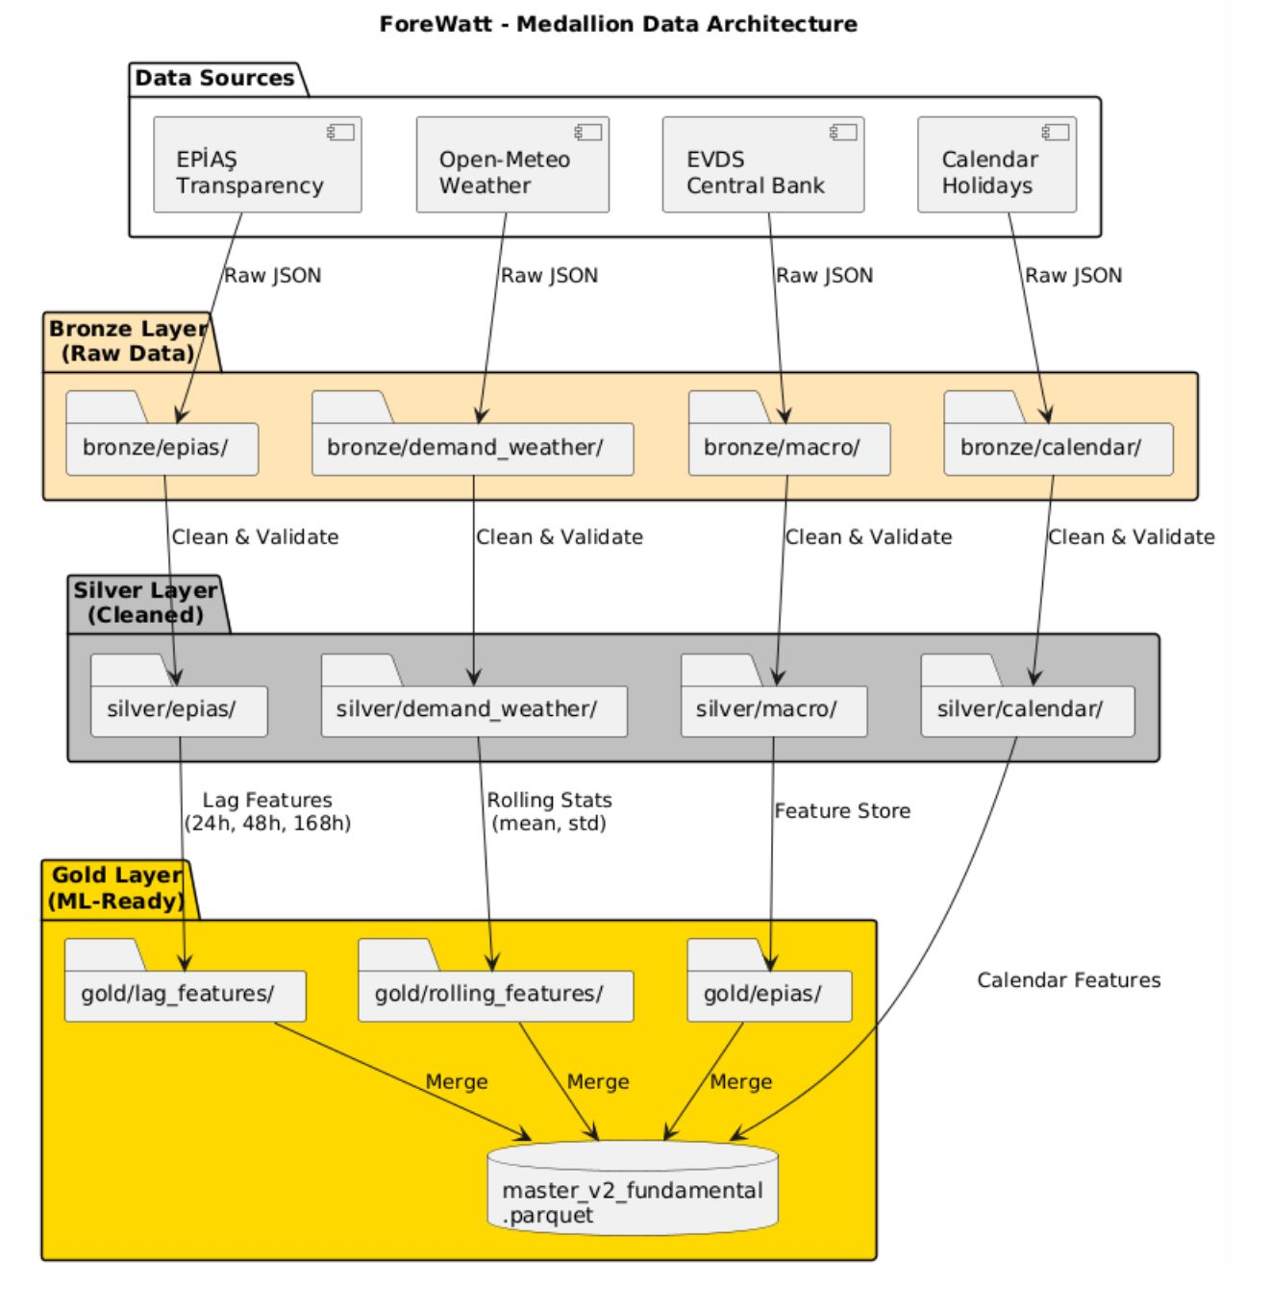
Figure 1. Medallion data architecture showing Bronze, Silver, and Gold layers with data flow from external sources through cleaning and feature engineering stages.
All data was persisted in Apache Parquet format with Snappy compression, selected for its efficient columnar storage, fast read performance, and native support for complex data types including timezone-aware timestamps. Files were organized with monthly partitioning for forecast archives and date-range naming conventions for training datasets. Dual-format export to CSV was maintained as a secondary format for human readability and compatibility with spreadsheet applications. The complete master dataset spanning from January 2020 to October 2025 contained approximately 51,000 hourly records with 80 features, stored in a 52.5 megabyte Parquet file. The data pipeline supported incremental updates through skip-existing logic that detected previously downloaded data and avoided redundant API calls, significantly reducing fetch times for routine updates while ensuring data completeness for model retraining.

