2.2 Feature Engineering and Master Data
The transformation of raw data into predictive features represents a critical stage in the ForeWatt pipeline. A comprehensive feature engineering framework was developed to extract meaningful signals from heterogeneous data sources, including historical consumption patterns, electricity market dynamics, meteorological observations, and calendar information. The feature engineering pipeline is implemented through a modular architecture consisting of specialized generators for lag features, rolling window statistics, calendar encodings, and weather-derived indicators. These components operate on data organized according to a medallion architecture, processing information from the Silver layer (cleaned and normalized) to produce Gold layer assets (machine learning-ready features).
Lag features constitute the foundation of the autoregressive modeling approach employed in ForeWatt. For the consumption forecasting model, lags are computed at multiple temporal horizons to capture patterns operating at different time scales. Short-term lags at 1, 2, 3, and 6 hours capture immediate consumption inertia and autoregressive dependencies that reflect the physical constraints of electricity demand. The 12-hour and 24-hour lags capture diurnal patterns and day-over-day changes, while the 48-hour and 168-hour (weekly) lags encode longer-term seasonal cycles. Temperature lag features are similarly constructed at 1, 2, 3, 24, and 168 hour intervals to account for the delayed response of electricity demand to weather conditions. Price lag features at 24-hour and 168-hour horizons provide economic context by reflecting historical market conditions.
Rolling window statistics extend the feature set by computing aggregate measures over sliding windows of 24 hours and 168 hours. For each window size, the mean, standard deviation, minimum, and maximum values are calculated for consumption, temperature, and price variables. These statistics capture both the central tendency and variability of the underlying processes. Derived features are computed from these rolling statistics, including the consumption range (maximum minus minimum) as a measure of daily volatility, the coefficient of variation (standard deviation divided by mean) as a normalized variability indicator, and the diurnal temperature range to characterize weather stability. The rolling standard deviation of price over 24 hours serves as a proxy for market volatility, which is particularly important for price prediction during periods of supply uncertainty.
Calendar features encode temporal structure and institutional patterns that influence electricity consumption and prices. Basic temporal features include day of week, day of month, month, and week of year. Binary indicators distinguish weekends from weekdays, reflecting the systematic reduction in commercial and industrial demand during non-working days. Holiday features are constructed from a comprehensive calendar of Turkish official holidays, religious observances, and half-day holidays. The holiday encoding includes both day-level and hour-level flags, with special handling for half-day holidays where morning hours may exhibit normal demand patterns. Cyclical encodings using sine and cosine transformations are applied to day of week and month features to preserve the periodic nature of these variables and avoid artificial discontinuities at period boundaries.
Weather features are derived from temperature, humidity, and wind speed observations collected from twelve major Turkish cities. A population-weighted national temperature index is computed to represent aggregate weather conditions across the country. Heating Degree Days (HDD) and Cooling Degree Days (CDD) are calculated using standard formulas with base temperatures calibrated for Turkish climate conditions. The heat index combines temperature and humidity to characterize perceived temperature during summer months when air conditioning loads are significant. Binary indicators flag extreme temperature conditions (hot and cold thresholds) that trigger non-linear demand responses. These weather features capture the thermosensitive component of electricity demand, which can account for substantial variation during extreme weather events.
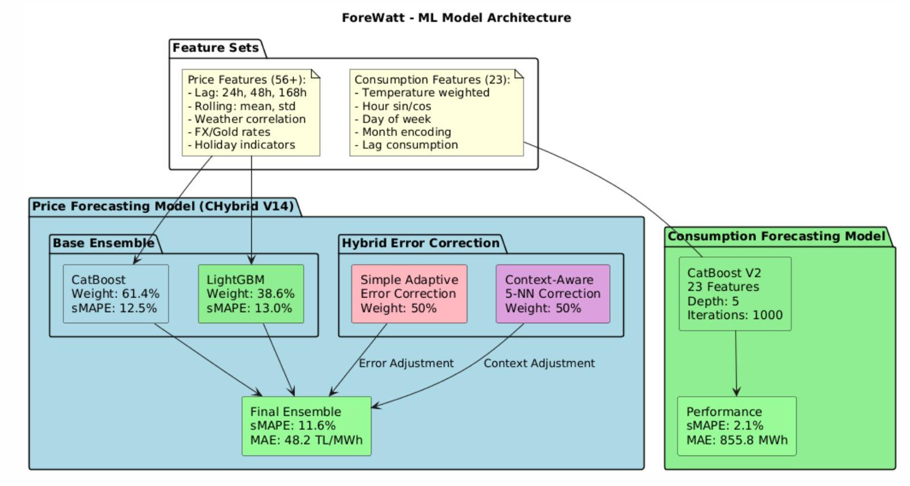
Figure 2. Machine learning model architecture showing feature flow and model ensemble
The price forecasting model employs a distinct feature set designed to capture market dynamics and supply-demand fundamentals. Market signal features include thermal gap, which measures the difference between thermal generation capacity and actual thermal output, indicating the availability of dispatchable generation. Renewable saturation captures the proportion of demand met by variable renewable sources, which influences price volatility through merit order effects. The spark spread proxy approximates the profitability of gas-fired generation using historical price relationships. System short signals indicate periods when scheduled generation may be insufficient to meet forecasted demand, typically associated with price spikes. Load factor and reserve margin ratio characterize system utilization and capacity adequacy, respectively.
Profile evolution features capture the time-varying nature of hourly price patterns. The daily average price and hourly ratio relative to the daily average encode the typical shape of the daily price curve. Profile features computed over 14-day and 28-day windows capture the recent evolution of these patterns, while profile momentum measures the rate of change in the profile shape. Solar-specific features account for the growing penetration of photovoltaic generation in Turkey, including solar ratio, solar profiles, and price-solar interaction terms. These features enable the model to adapt to structural changes in the price formation process as the generation mix evolves.
Table 1. Consumption Model Features (23 total)
Feature Name | Description
consumption_lag_24h | Consumption value from 24 hours prior
consumption_lag_48h | Consumption value from 48 hours prior
consumption_lag_168h | Consumption value from one week prior
consumption_rolling_mean_24h | 24-hour rolling mean of consumption
consumption_rolling_std_24h | 24-hour rolling standard deviation
temp_national | Population-weighted national temperature
humidity_national | Population-weighted national humidity
HDD | Heating Degree Days
CDD | Cooling Degree Days
heat_index | Combined temperature-humidity index
is_hot | Binary indicator for hot conditions
is_cold | Binary indicator for cold conditions
temp_lag_24h | Temperature from 24 hours prior
hour_sin, hour_cos | Cyclical encoding of hour of day
dow_sin, dow_cos | Cyclical encoding of day of week
month_sin, month_cos | Cyclical encoding of month
is_weekend | Binary weekend indicator
is_holiday_day | Binary day-level holiday indicator
is_holiday_hour | Binary hour-level holiday indicator
price_ptf_lag_24h | Day-ahead price from 24 hours prior

Table 2. Price Model Features (33 total)
Feature Name | Description
hour_sin, hour_cos | Cyclical encoding of hour of day
dow_sin, dow_cos | Cyclical encoding of day of week
is_weekend | Binary weekend indicator
price_ptf_rolling_std_24h | 24-hour rolling price volatility
price_ptf_rolling_mean_24h | 24-hour rolling price average
price_ptf_rolling_min_24h | 24-hour rolling price minimum
price_ptf_rolling_max_24h | 24-hour rolling price maximum
price_ptf_lag_24h | Day-ahead price from 24 hours prior
price_ptf_lag_168h | Day-ahead price from one week prior
thermal_gap | Thermal capacity minus thermal generation
thermal_gap_lag_24h | Thermal gap from 24 hours prior
renewable_saturation | Renewable generation as fraction of demand
spark_spread_proxy_lag_24h | Historical spark spread proxy
system_short_signal | Binary indicator for system shortage
load_factor | Actual demand divided by peak capacity
consumption_forecast | Forecasted consumption for target hour
reserve_margin_ratio | Available reserve as fraction of demand
price_volatility_lag24h | Lagged price volatility measure
realtime_premium_lag24h | Lagged real-time price premium
hour | Hour of day (integer)
daily_avg_price | Daily average price level
hourly_ratio | Current hour price to daily average ratio
profile_14d, profile_28d | Hourly price profiles over rolling windows
profile_momentum | Rate of change in price profile
daily_avg_momentum | Rate of change in daily average price
solar_ratio | Solar generation as fraction of capacity
solar_profile_14d, solar_profile_28d | Solar generation profiles
solar_momentum | Rate of change in solar profile
price_solar_interaction | Interaction between price and solar features

The master dataset is produced by merging all feature components through a systematic process implemented in the feature merger module. Features from different sources are aligned on timestamp and joined using inner merges to ensure temporal consistency. The resulting master dataset is stored in the Gold layer at data/gold/master/ in Apache Parquet format for efficient storage and retrieval. The current production version (v2) contains approximately 52.5 megabytes of data spanning from January 2020 to October 2025, comprising over 50,000 hourly observations with all engineered features. A versioning scheme based on creation date and feature hash ensures reproducibility and enables tracking of dataset evolution across model iterations. Accompanying metadata files in JSON format document the feature list, data date range, missing value statistics, and creation timestamp for each version of the master dataset.

