2.5 System Architecture
The ForeWatt platform was designed with a cloud-native architecture to ensure scalability, reliability, and cost-effectiveness for production deployment. The system architecture follows modern microservices principles while maintaining simplicity through a serverless deployment model. The backend API was built using FastAPI, a high-performance Python web framework, and is deployed on Google Cloud Run, which provides automatic scaling, pay-per-use pricing, and seamless integration with other Google Cloud services.
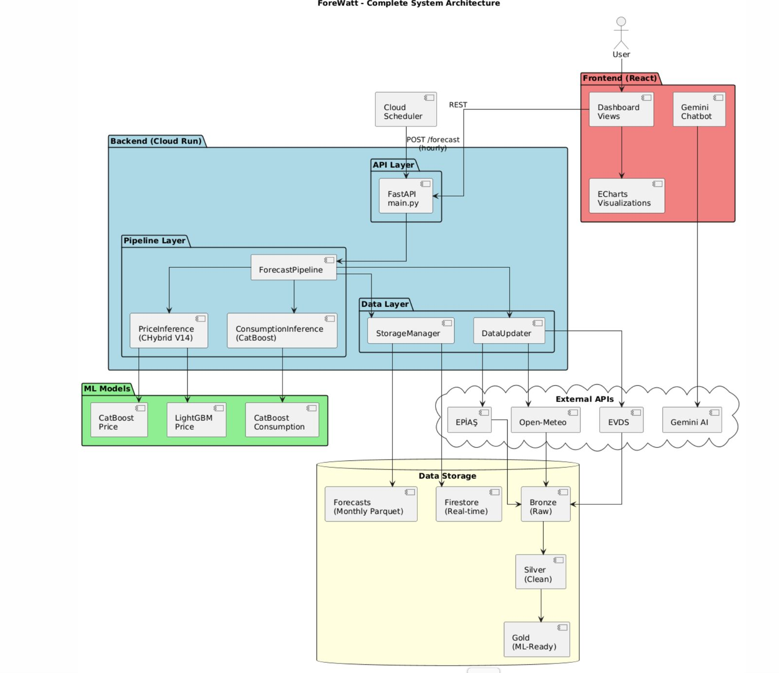
Figure 15. Complete system architecture showing data flow from external sources through the ML pipeline to the frontend dashboard.
The FastAPI application serves as the central API gateway, exposing multiple endpoints for forecast generation, data retrieval, and system monitoring. The primary endpoints include POST /forecast for triggering hourly forecast generation, GET /api/realtime/{model} for fetching real-time forecasts from Firestore, GET /history/{model} for retrieving historical data from Parquet archives, and GET /api/anomaly/{model} for accessing anomaly detection results. Additional endpoints such as GET /api/aggregates/day-type/{model} and GET /api/aggregates/hourly/{model} provide pre-computed statistics for efficient dashboard loading. The API was designed with RESTful principles, utilizing query parameters for date filtering and pagination while returning JSON responses with consistent data structures.
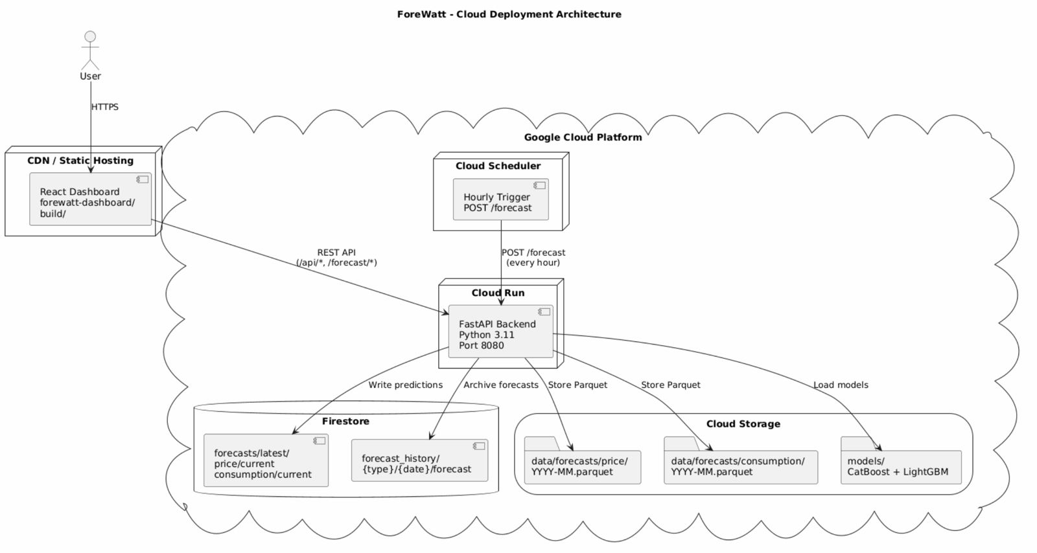
Figure 16. Cloud deployment architecture on Google Cloud Platform showing the interaction between Cloud Run, Cloud Scheduler, Firestore, and Cloud Storage.
To optimize cold start performance on Cloud Run, several strategies were implemented. The forecast pipeline and Firestore client were designed with lazy loading patterns, where expensive imports and model loading are deferred until the first request requires them. This approach reduces the initial container startup time from approximately 15 seconds to under 3 seconds. GZIP compression middleware was enabled with a minimum response size of 1000 bytes, achieving 80-90% reduction in response payload sizes for large forecast datasets. Cross-Origin Resource Sharing (CORS) middleware was configured to allow requests from the Firebase-hosted dashboard domain while maintaining security for production deployments.
The application was containerized using Docker with a Python 3.11-slim base image to minimize the container footprint while providing all necessary dependencies. The Dockerfile was structured to leverage layer caching by copying requirements.txt separately before the application code, ensuring that dependency installation is cached across builds. System dependencies including build-essential and libgomp1 were installed to support the CatBoost and LightGBM machine learning libraries. The trained model files were bundled directly into the container image to eliminate model loading latency during inference, with the models directory containing the CatBoost and LightGBM model artifacts for both price and consumption forecasting.
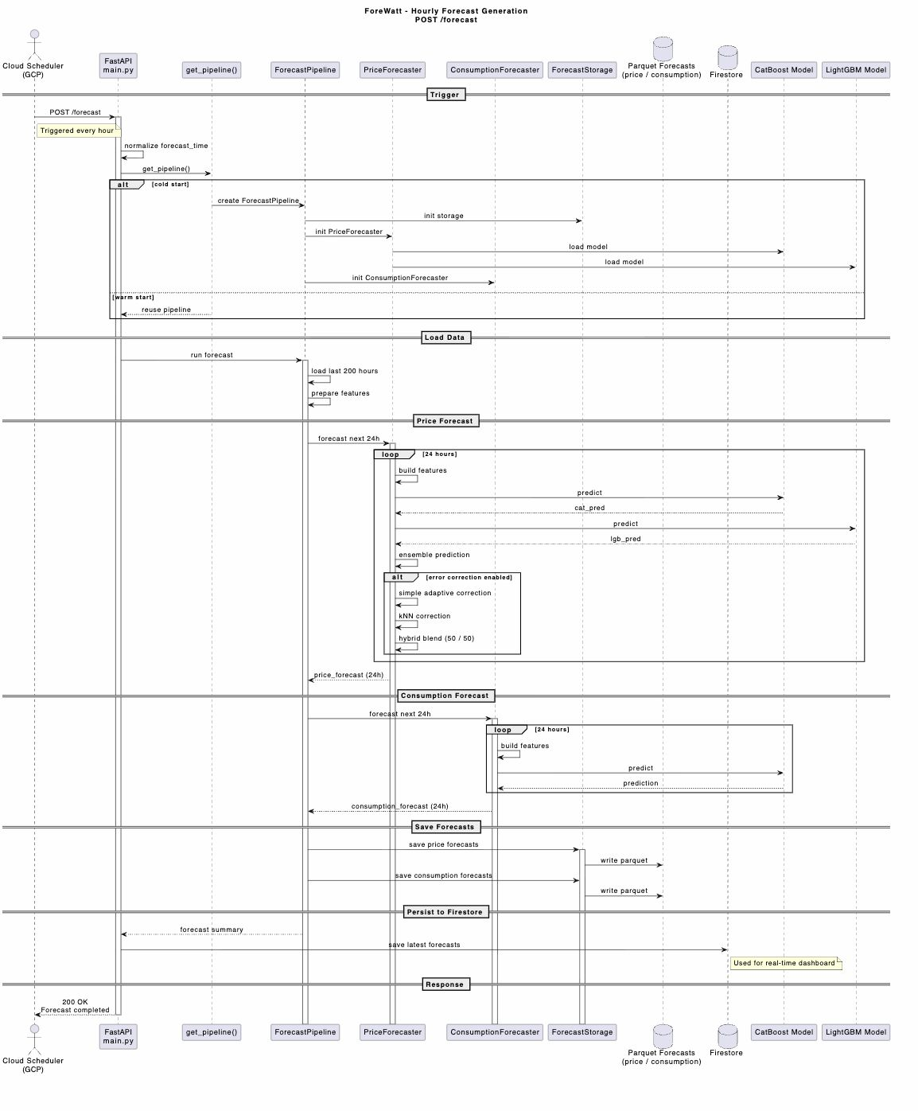
Figure 17. Sequence diagram illustrating the hourly forecast generation flow triggered by Cloud Scheduler.
Google Cloud Scheduler was configured to trigger the forecast pipeline every hour by sending a POST request to the /forecast endpoint. Upon receiving the trigger, the ForecastPipeline class orchestrates the complete forecasting workflow. The pipeline first loads the latest market data from the master Parquet file stored in Google Cloud Storage, then generates 24-hour ahead forecasts using both the price and consumption models. The forecast results were stored in multiple locations to optimize for different access patterns. Google Cloud Firestore was used for real-time data access, with forecasts stored under the forecasts/latest/{type}/current document path for immediate retrieval by the dashboard. Historical forecasts were archived in Parquet format organized by month (data/forecasts/{type}/{YYYY-MM}.parquet) for efficient batch processing and backtesting operations.
The storage architecture followed a medallion pattern with bronze, silver, and gold data layers. The bronze layer contained raw data fetched from EPIAS, Open-Meteo, and EVDS APIs. The silver layer stored cleaned and validated data with standardized schemas. The gold layer housed the feature-engineered master dataset used for model training and inference, stored as master_v2_fundamental.parquet with a total size of approximately 52.5 megabytes. The ForecastStorage class provided abstraction over the storage layer, implementing methods for saving forecasts with automatic monthly partitioning and retrieving historical forecasts with date range filtering. Query result caching with a 30-minute time-to-live was implemented to reduce redundant data fetching and improve API response times for frequently accessed endpoints.
For local development and testing, a Docker Compose configuration was provided that orchestrates multiple services including the scheduler, API, dashboard, MLflow for experiment tracking, and InfluxDB for optional time-series storage. The scheduler service was configured to run the forecast pipeline at configurable intervals, while the MLflow service provided a user interface for tracking model experiments and comparing performance across different model versions. This development environment enabled rapid iteration on the forecasting models and API endpoints before deployment to the production Cloud Run environment.

2.6 Frontend & Dashboard
The ForeWatt dashboard was developed as a modern single-page application using React 19 with TypeScript for type safety and improved developer experience. The build system was configured with Vite, a next-generation frontend tooling that provides fast hot module replacement during development and optimized production builds. Styling was implemented using Tailwind CSS, a utility-first CSS framework that enabled rapid UI development with consistent design patterns. The dashboard was deployed on Firebase Hosting, which provides global content delivery network distribution and automatic SSL certificate management.
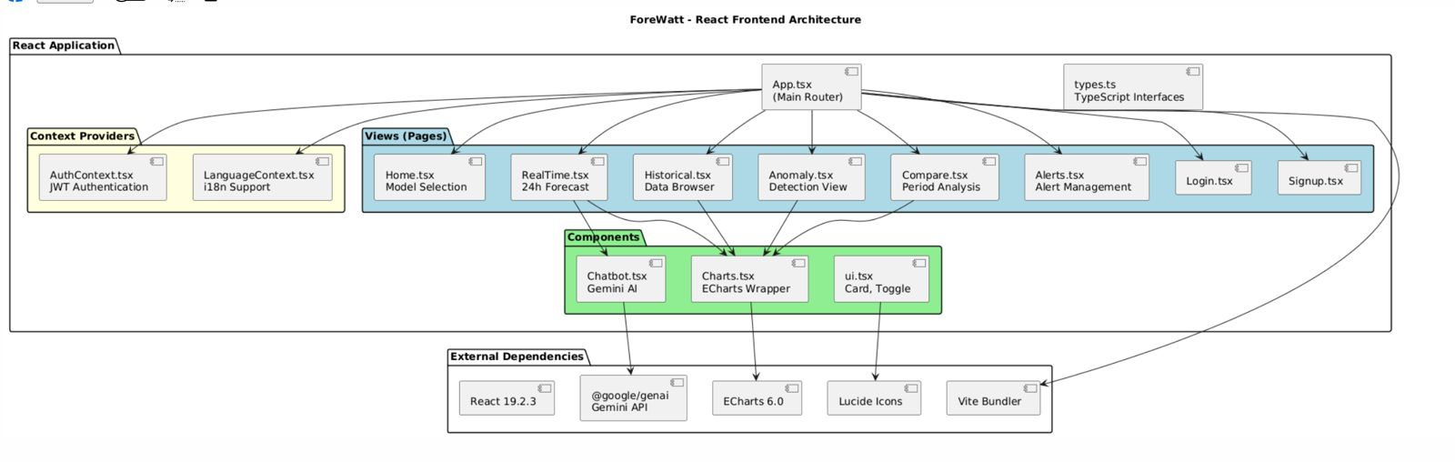
Figure 18. React frontend architecture showing the component hierarchy and data flow patterns.
The dashboard was organized into six primary views accessible through a sidebar navigation component. The RealTime view displays the current 24-hour forecast with 12 hours of historical actuals and 12 hours of predictions, visualized using interactive ECharts line charts with confidence interval bands. The Historical view enables exploration of past data with customizable date range selection and comparison between actual values and model forecasts. The Anomaly view presents detected anomalies using scatter plots that highlight data points with high anomaly scores based on statistical deviation from expected patterns. The Compare view facilitates period-over-period analysis through weekday versus weekend comparisons and hourly pattern visualizations. The Alerts view provides a management interface for system notifications and forecast threshold alerts, with role-based access control restricting certain features to administrator users.
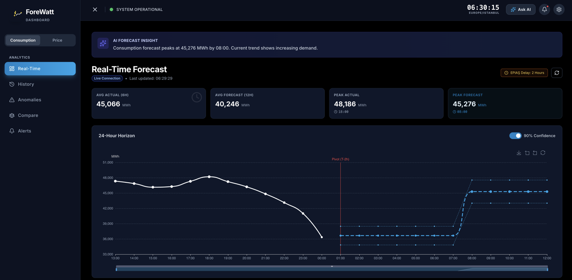
Figure 19. Real-time consumption forecast view showing the 24-hour horizon with actual data, predictions, and confidence intervals.
The user interface was designed with a glassmorphism aesthetic featuring semi-transparent panels with backdrop blur effects, providing a modern and professional appearance. A theme toggle was implemented to support both dark and light modes, with the dark mode set as the default for reduced eye strain during extended monitoring sessions. Bilingual support was provided through a LanguageContext provider that manages translations between English and Turkish, enabling seamless language switching without page reload. The interface was designed to be fully responsive, adapting layouts for desktop, tablet, and mobile screen sizes through Tailwind CSS responsive utility classes.
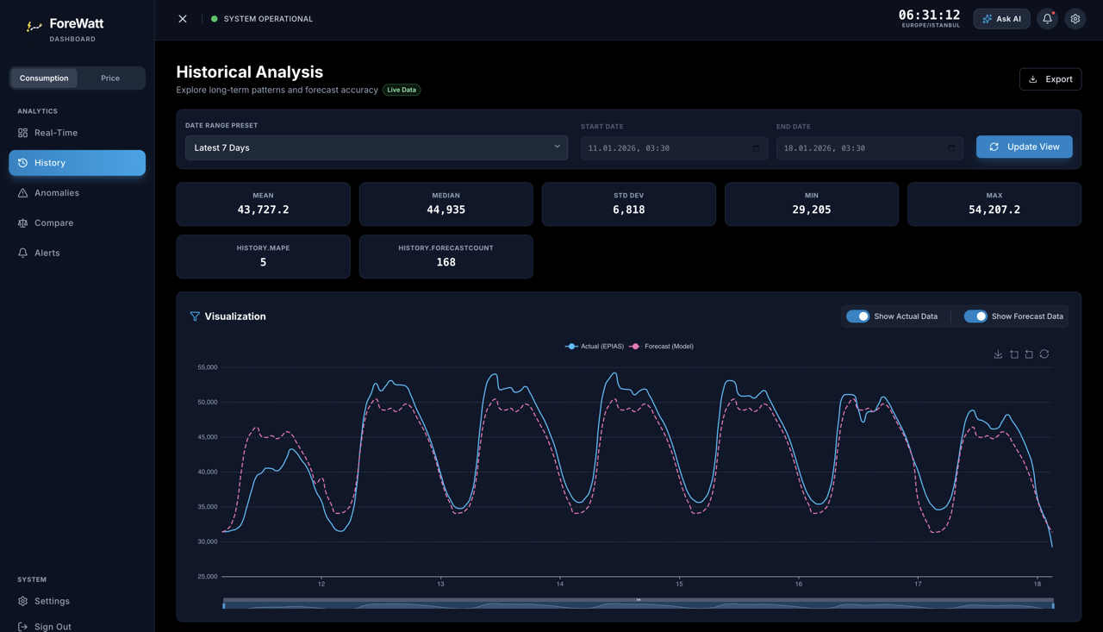
Figure 20. Historical analysis view displaying consumption data over a selected time period with actual versus forecast comparison.
An AI-powered chatbot was integrated into the dashboard using the Google Gemini 2.0 Flash model through the @google/genai SDK. The chatbot was configured with a domain-specific system prompt that establishes context about the ForeWatt platform, EPIAS data characteristics, and typical electricity consumption and price patterns in Turkey. When the chat session is initiated, current dashboard context including the active model type, latest actual values, forecast predictions, and summary statistics is injected into the conversation to enable contextual responses. The chatbot interface supports markdown rendering with syntax-highlighted code blocks through the react-markdown library with remark-gfm plugin for GitHub Flavored Markdown support. A fallback mock response system was implemented to provide basic functionality when the Gemini API key is not configured.
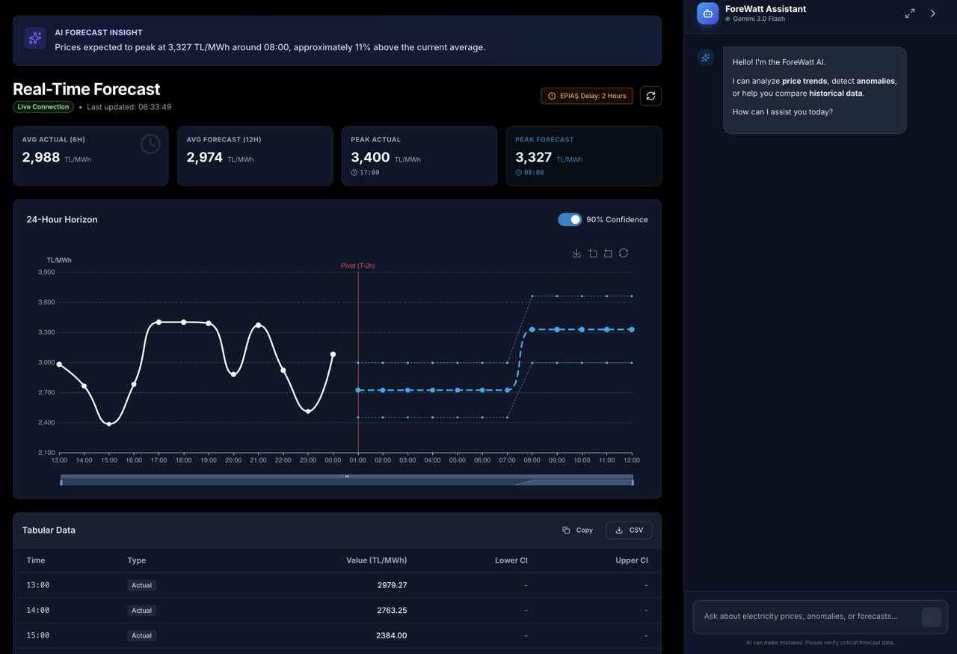
Figure 21. Real-time price forecast view with the AI chatbot panel open, demonstrating the contextual conversation capabilities.
Data visualization was implemented using ECharts, a powerful charting library that provides interactive features including zooming, panning, and data point tooltips. The RealTimeChart component renders actual data as solid lines and forecast data as dashed lines, with a pivot marker indicating the transition point between historical actuals and predictions. Confidence interval bands were rendered using stacked area series with semi-transparent fills and dashed border lines. The charts automatically adapt to theme changes through a MutationObserver that monitors the document's dark mode class and reinitializes charts with appropriate color schemes. State management was handled through React hooks with Context providers for global state including authentication status, language preferences, and current theme. API data fetching was implemented with automatic refresh intervals of 60 seconds to keep the real-time view updated with the latest forecast data.

