Національний технічний університет України

«Київський політехнічний інститут»

Факультет інформатики і обчислювальної техніки

Лабораторна робота №3

З ООП

*Виконав:*

Студент групи ІC-73

Глухов Никита

м. Київ 2020

16. Змiшаний алгоритм. FIFO + АП

Час чекання в черзi вiд iнтенсивностi:

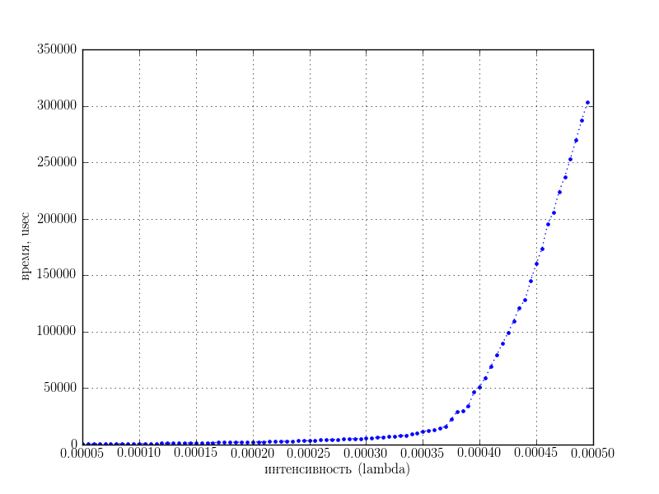

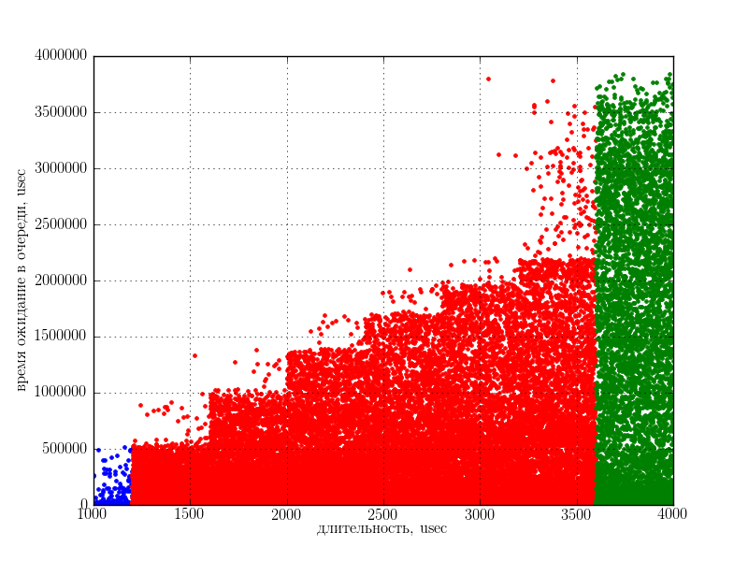

Час чекання в черзi вiд довжини задачi:

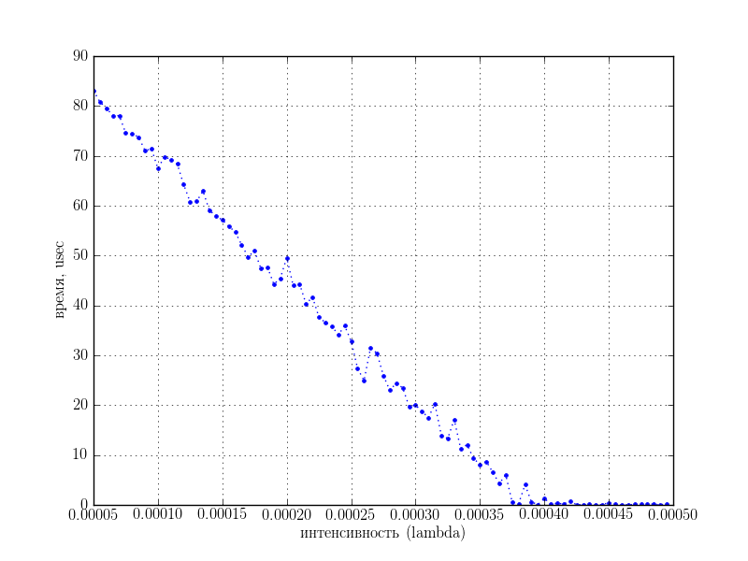Час простою вiд iнтенсивностi заявок:

Кiлькiсть опрацьованих задач вiд часу чека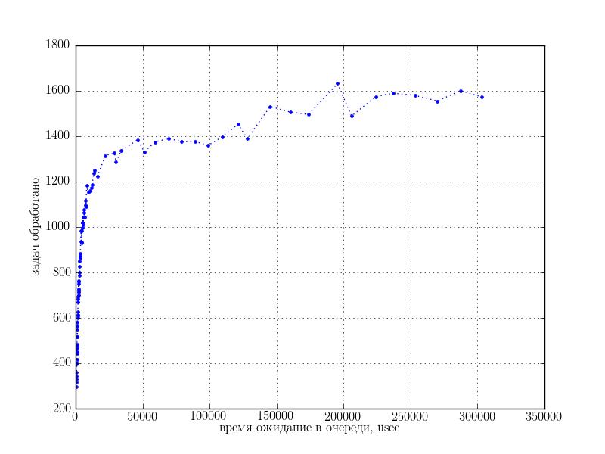ння:

Середнiй час очiкування задач абсолютного приорiтету в черзi вiд iнтенсивностi

заявок: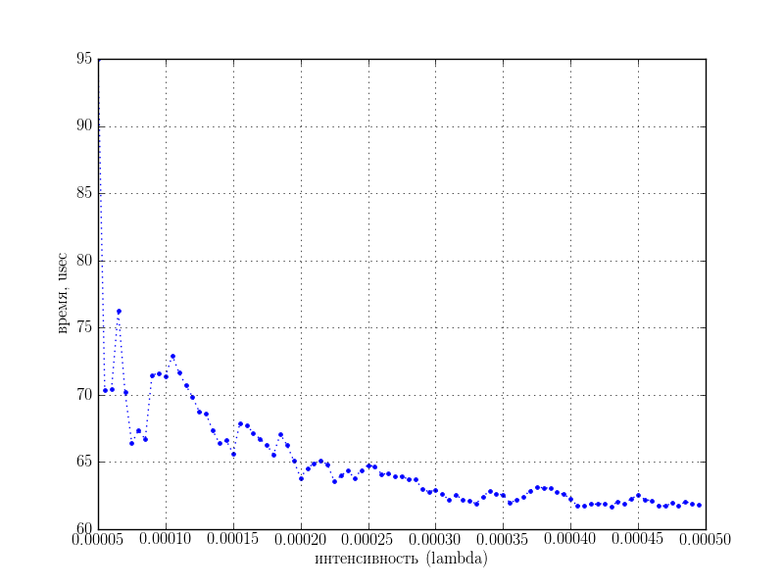

**Код програми**

import random

import logging

import math

from pylab import arange

logging.basicConfig(level=logging.INFO)

def log(name, text):

logging.getLogger(name).debug(text)

TASK_NEW, TASK_PROGRESS, TASK_SUSPENDED, TASK_FINISHED, TASK_KILLED = range(5)

class Task(object):

ALL_TASKS = []

ALL_TASKS_AP = []

def __init__(self, env, duration, ap):

self.env = env

self.duration = duration

self.creation_time = env.time

self.state = TASK_NEW

self.ap = ap

self.last_work_time = self.creation_time

self.waiting_time = 0

if ap:

log('tsk', "[%d] task produced %ds ABSOLUTE PRIORITY" % (env.time, self.duration))

else:

log('tsk', "[%d] task produced %ds" % (env.time, self.duration))

if ap:

Task.ALL_TASKS_AP.append(self)

else:

Task.ALL_TASKS.append(self)

def suspend(self):

if self.state != TASK_SUSPENDED:

self.last_work_time = self.env.time

self.state = TASK_SUSPENDED

log('tsk', "[%d] task #%d suspended" % (self.env.time, self.id))

def resume(self):

if self.state != TASK_PROGRESS:

self.waiting_time += self.env.time - self.last_work_time

self.state = TASK_PROGRESS

log('tsk', "[%d] task #%d resumed" % (self.env.time, self.id))

def finished(self):

self.state = TASK_FINISHED

self.finish_time = self.env.time

self.turnaround = self.finish_time - self.creation_time

log('tsk', "[%d] task #%d finished. turnaround time: %d" %

(self.env.time, self.id, self.turnaround))

def kill(self):

self.state = TASK_KILLED

log('tsk', "[%d] task #%d killed" % (self.env.time, self.id))

def task_generator(env, task_f, task_d, ap):

time = task_f() # once per period

prev_time = env.time

diff = env.time + time

while True:

diff = env.time - prev_time

while diff >= time:

diff -= time

task = Task(env, task_d(), ap)

yield task

prev_time = env.time

time = task_f()

yield None

def poisson(l):

return -(1/float(l)) * math.log(random.random())

def def_task_generator(env):

task_f = lambda: poisson(env.LAMBDA_DEF) # random.random()*3*1000+2000 # 2000..5000

task_d = lambda: random.random()*3*1000+1000 # 1000..4000

return task_generator(env, task_f, task_d, False)

def ap_task_generator(env):

task_f = lambda: poisson(env.LAMBDA_AP) # random.random()*1.5*1000+4000 # 4000..5500

task_d = lambda: random.random()*1*1000+500 # 500..1500

return task_generator(env, task_f, task_d, True)

class Queue(list):

pass

class BaseProcessor(object):

def __init__(self, environment):

self.new_tasks = []

self.tid_count = 1

self.environment = environment

def add_task(self, task):

task.id = self.tid_count

self.tid_count += 1

task.worktime = 0

self.new_tasks.append(task)

def tick(self):

pass

TIME_QUANT = 600

THRESHOLDS = [3, 6, 20]

QUEUE_NUM = 3

class Processor(BaseProcessor):

def __init__(self, env, quant=TIME_QUANT, q_num=QUEUE_NUM, thresholds=THRESHOLDS):

super(Processor, self).__init__(env)

self.qs = [Queue() for q in range(q_num)]

self.q_ap = []

self.current = None

self.thresholds = thresholds

self.quant = quant

self.prev_time = env.time

def get_new(self):

self.current = None

if len(self.q_ap):

self.current = self.q_ap[0]

self.current.queue = -1

self.current.resume()

self.q_ap.remove(self.current)

return

for q_id, queue in enumerate(self.qs):

if len(queue) > 0:

self.current = queue[0]

self.current.queue = q_id

self.current.resume()

self.qs[self.current.queue].remove(self.current)

break

def tick(self):

for task in self.new_tasks:

task.loops = 0

task.queue = 0

if task.ap:

self.q_ap.append(task)

else:

self.qs[0].append(task)

self.new_tasks = []

elapsed = self.environment.time - self.prev_time

# log('cpu', "elapsed %d" % elapsed)

self.prev_time = self.environment.time

if not self.current:

self.get_new()

if self.current:

self.current.session = 0

if self.current:

# elapsed = min(self.quant, self.current.duration -

# self.current.worktime)

self.current.worktime += elapsed

self.current.session += elapsed

# log('cpu', "[%d] task #%d worktime %d AFTER" %

# (env.time, self.current.id, self.current.worktime))

if self.current.worktime >= self.current.duration or \

self.current.session >= self.quant or \

(len(self.q_ap) and not self.current.ap):

self.current.session = 0

self.current.suspend()

self.current.loops += 1

if self.current.loops >= self.thresholds[self.current.queue] and \

not self.current.ap:

self.current.loops = 0

self.current.queue += 1

if self.current.queue >= len(self.qs):

self.current.kill()

else:

log('cpu', "task #%d moved to queue %d" %

(self.current.id, self.current.queue))

if self.current.worktime < self.current.duration and \

self.current.state != TASK_KILLED:

if self.current.queue == -1:

self.q_ap.append(self.current)

else:

self.qs[self.current.queue].append(self.current)

else:

self.current.finished()

self.get_new()

if self.current:

self.current.session = 0

# return elapsed # 0.6t period

def is_empty(self):

return all(len(q) == 0 for q in self.qs) and not self.current

class Environment(object):

def __init__(self):

self.time = 0

self.time = 0

self.tasks = def_task_generator(self)

self.ap_tasks = ap_task_generator(self)

self.processor = Processor(self)

self.producing = True

self.utilization_time = 0

self.QUANT = 10

self.LAMBDA_DEF = 0.0003

self.LAMBDA_AP = 0.00005

def is_empty(self):

return self.processor.is_empty()

def tick(self):

if self.producing:

task = next(self.tasks)

while task is not None:

self.processor.add_task(task)

log('env', "[%d] added task #%d" % (self.time, task.id))

task = next(self.tasks)

task = next(self.ap_tasks)

while task is not None:

self.processor.add_task(task)

log('env', "[%d] added task #%d" % (self.time, task.id))

task = next(self.tasks)

self.time += self.QUANT

if self.processor.current:

self.utilization_time += self.QUANT

self.processor.tick()

# log('env', "[%d] ticked" % (env.time))

def test(l_def, l_ap, time):

env = Environment()

env.LAMBDA_DEF = l_def

env.LAMBDA_AP = l_ap

while env.time < time:

env.tick()

prod = env.time

env.producing = False

while not env.is_empty():

env.tick()

print("SIMULATION FINISHED")

results = {}

results['overtime'] = env.time - prod

print("%d overtime" % results['overtime'])

results['utilization'] = (env.utilization_time / env.time)*100

results['tasks processed'] = env.processor.tid_count

results['AP tasks'] = len(Task.ALL_TASKS_AP)

results['tasks/s'] = (env.processor.tid_count / (env.time / 1000))

print("%4.2f%% utilization" % results['utilization'])

print("%d tasks processed" % results['tasks processed'])

print("%d AP tasks" % results['AP tasks'])

print("%4.4f tasks/s" % results['tasks/s'])

mean_turnaround_def = sum(t.turnaround for t in Task.ALL_TASKS) / len(Task.ALL_TASKS)

results['mean turnaround def'] = mean_turnaround_def

mean_turnaround_ap = sum(t.turnaround for t in Task.ALL_TASKS_AP) / len(Task.ALL_TASKS_AP)

results['mean turnaround ap'] = mean_turnaround_ap

print("%4.4f mean turnaround" % (mean_turnaround_def))

print("%4.4f mean turnaround AP" % (mean_turnaround_ap))

waiting_time = sum(t.waiting_time for t in Task.ALL_TASKS) / len(Task.ALL_TASKS)

results['waiting time'] = waiting_time

print("%4.4f waiting time" % waiting_time)

waiting_time_AP = sum(t.waiting_time for t in Task.ALL_TASKS_AP) / len(Task.ALL_TASKS_AP)

results['waiting time AP'] = waiting_time_AP

print("%4.4f waiting time AP" % waiting_time_AP)

sorted_tasks = sorted(Task.ALL_TASKS, key=lambda x: x.duration)

waiting_times = []

durations = []

last_dur = sorted_tasks[0].duration

vals = []

waiting_times_qs = [[] for x in range(QUEUE_NUM)]

durations_qs = [[] for x in range(QUEUE_NUM)]

start_q_id = 0

for i, dur in enumerate([t.duration for t in sorted_tasks]):

if last_dur != dur:

durations.append(last_dur)

waiting_times.append(sum(vals)/len(vals))

while last_dur > TIME_QUANT*(sum(THRESHOLDS[q_id] for q_id in range(0, start_q_id+1))):

start_q_id += 1

waiting_times_qs[start_q_id].append(sum(vals)/len(vals))

durations_qs[start_q_id].append(last_dur)

vals = []

vals.append(sorted_tasks[i].waiting_time)

last_dur = dur

else:

durations.append(last_dur)

waiting_times.append(sum(vals)/len(vals))

results['waiting times'] = waiting_times # [t.waiting_time for t in sorted_tasks]

results['durations'] = durations # [t.duration for t in sorted_tasks]

results['waiting times qs'] = waiting_times_qs

results['durations qs'] = durations_qs

return results

def make_plot(x, y, title_t, xlabel_t=u'intensity (lambda)', ylabel_t=u'time, usec', dot='b.:', clear=True):

from pylab import plot, axis, xlabel, ylabel, grid, show, savefig, cla, rc

rc('font', **{'family': 'serif'})

rc('text', usetex=True)

rc('text.latex', unicode=True)

rc('text.latex', unicode=True)

rc('text.latex', preamble='\\usepackage[utf8]{inputenc}')

rc('text.latex', preamble='\\usepackage[russian]{babel}')

plot(x, y, dot)

# axis([0, 0.01, 0, 10000])

ylabel(ylabel_t)

xlabel(xlabel_t)

grid()

savefig('%s.png' % title_t.replace(" ", "_"))

if clear:

cla()

if __name__ == '__main__':

time = 5000*600

l_def_r = arange(0.00005, 0.0005, 0.000005)

print

results = []

for l_def in l_def_r:

print ("Test: %f" % l_def)

res = test(l_def, 0.00005, time)

results.append(res)

make_plot(l_def_r, [x['waiting time'] for x in results], 'waiting time')

make_plot(l_def_r, [100-x['utilization'] for x in results], 'idle time')

make_plot(l_def_r, [x['waiting time AP'] for x in results], 'waiting time AP')

res = test(0.0002, 0.00005, time)

make_plot(res['durations'], res['waiting times'], 'waiting by duration',

'duration, usec', 'waiting time in queue, usec', dot='b.')

make_plot(res['durations qs'][0], res['waiting times qs'][0], 'waiting by duration with queues',

'duration, usec', 'waiting time in queue, usec', dot='b.', clear=False)

make_plot(res['durations qs'][1], res['waiting times qs'][1], 'waiting by duration with queues',

'duration, usec', 'waiting time in queue, usec', dot='r.', clear=False)

make_plot(res['durations qs'][2], res['waiting times qs'][2], 'waiting by duration with queues',

'duration, usec', 'waiting time in queue, usec', dot='g.', clear=True)

make_plot([x['waiting time'] for x in results],

[x['tasks processed'] for x in results], 'tasks count by waiting time',

'waiting time in queue, usec', ' handled tasks ', dot='b.:')