**Arrays/Lists explanation:**

**Definition/Description:**

An array, or a [List](https://www.w3schools.com/python/python_lists.asp)as Python calls it, is a block of memory.  It makes it easier to group similar data or information.

Remember my explanation of a "bowl" being a variable?  The bowl is a place to store something, just like a variable is a place to store (data)?

An Array or a List is instead like an egg carton.  It has 10 or more "bowls"  you can put eggs into.  So it is an Array with 10 spots.  Python calls these Lists, so I will use List instead from here forward.

The list positions are numbered starting at 0.  So the first position, is not 1, it is 0.  The tenth position is not 10, it is 9. **See the image below.**

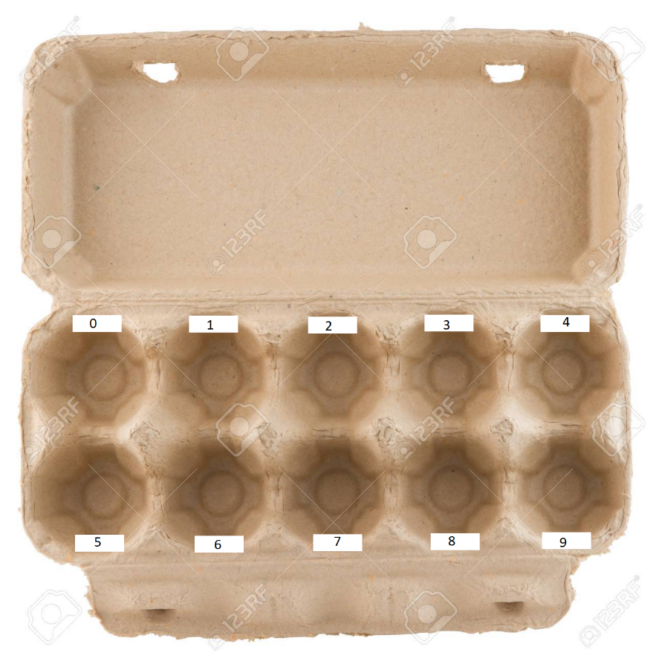

**Example Python code to create an empty list with zero spots:**

* egg_carton = []

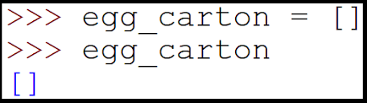

**Example Python code to create an empty list with 10 spots:**

* egg_carton = [none] * 10



**Example Python code to create a list with 10 spots, filled with 0's:**

* egg_carton = [0] * 10

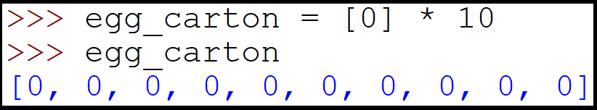

**Example Python code to create a list with 10 spots, filled with "X":**

* egg_carton = ["X"] * 10

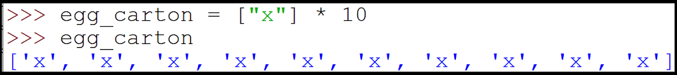

**Example Python code to put data into a list built above:**

* egg_carton**[**0**]** **=** "Broken Egg"  
  egg_carton**[**1**]** **=** "Good Egg"  
  egg_carton**[**2**]** **=** "Spoiled egg"

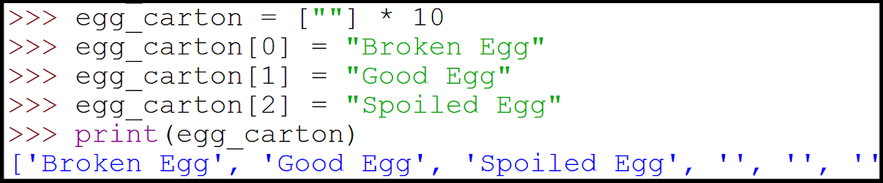

**Example Python code to see what data is in a specific spot in the list:**

**print(**egg_carton**[**1**])  
if** egg_carton**[**1**]** **==** "Good Egg"**:  
    print(**"Let's make French toast!"**)**

**How to get the length (Or number of slots) in a list:**

**print(**len**(**egg_carton**))**

**Array / List homework:**

Create a program that tracks the homework scores of a 10 anonymous students in class.  Ask the user to input 10 values, store them into the array.  Then average the scores together and print them out.

# Create a list with 10 slots, set the values to 0

# Ask the user to input 10 scores (0-100)

# Save each score in the list

# Create a temporary variable to store the total_score

# Loop over the values (Suggest using a [FOR](https://wiki.python.org/moin/ForLoop) loop)

**for** score **in** range**(**0**,** 10**):**

    # add them all up

# Divide the  total_score    by 10 to get the average score

# Print the average score