

UNIVERSITY OF GONDAR  
FACULTY OF INFORMATICS  
DEPARTMENT OF COMPUTER SCIENCE

WEB BASED CONSULTATION AND DISCUSSIONPLATFORM FOR ETHIOPIAN PSYCHOLOGICAL ISSUE

INDUSTRIAL PROJECT BY

NAME……………………………………………………………………..…..ID

1. YEABISRA FANTAHUN ………………………………………GUR/01359/10
2. AMANUEL DESALEGN …………………..…..........................GUR/01517/10
3. AMANUEL MULAT……..……………………….…………...GUR/01595/10
4. TIRUSEW ALEMU ………......................................................GUR/01861/10

PROJECT ADVISOER: MR FEDILU NURHUSSIEN

**Declaration**

This is to declare that the project work which is done under the advisor of MR. FEDLU NURHUSSIEN and having the title of Web Based Consultation and Discussion Platform for Ethiopian Psychological Issues. The system is developed under the contribution of:

NAME ID

1. YEABISRA FANTAHUN GUR/01359/10
2. AMANUEL DESALEGN GUR/01517/10
3. AMANUEL MULAT GUR/01595/10
4. TIRUSEW ALEMU GUR/01861/09

No part of the project work has been reproduced illegally (copy and paste) which can be considered as Plagiarism. All reference parts have been used to argue the idea and cited properly. We will be responsible and liable for any consequence if violation of this declaration is proven.

Date: 30/5/2021

GROUP MEMBERS

|  |  |
| --- | --- |
| **FULL NAME** | **SIGNATURE** |
| **YEABISRA FANTAHUN** | ___________________ |
| **AMANUEL DESALEGN** | ___________________ |
| **AMANUEL MULAT** | ___________________ |
| **TIRUSEW ALEMU** | ___________________ |

**Certificate**

I certify that this BSc industrial project entitled Web Based Consultation and Discussion Platform for Ethiopian Psychological Issues written by:

|  |
| --- |
| **YEABISRA FANTAHUN** |
| **AMANUEL DESALEGN** |
| **AMANUEL MULAT** |
| **TIRUSEW ALEMU** |

Is approved by me for submission. I certify further that, to the best of my knowledge, the project represents work carried out by the students.

________________________

Date Name and Signature of Supervisor

**ACKNOWLEDGEMETN**

We believe that any good accomplishment requires God’s support. So that we want to praise God with a great thankfulness. We would like to express our appreciation and thanks to our adviser MR.FEDLU NURHUSSIEN for his guidance and supervision. Finally we would like to thank for people who have willingly helped us to finish our project. We also have special thanks for DR.Mihert Teshome who specialized in psychologist for providing us necessary information for our project.

Contents

CHAPTER ONE 1

1. INTRODUCTION 1

1.1 Introduction 1

1.2 Background 2

1.3 Statement of the problem 2

1.4 Objective of the project 3

1.4.1 General objectives 3

1.4.2 Specific objectives 3

1.5 Scope of the project 3

1.6 Limitation of the project 3

1.7 System development methodology 3

1.7.1 System development approach 3

1.7.1.1 System development model 4

1.7.2 Tools to develop the system 5

1.8 Significance of the project 5

The main benefit of this system as it is computerized web based system : 5

1.9 The beneficiaries of the system 6

1.10 Feasibility study 7

1.9 Time schedule 8

CHAPTER TWO 9

2. REQUIREMENT ANALYSIS 9

2.1 Introduction 9

2.2 Current system 9

2.2.1 Major function of the current system 9

2.2.2 Problem of existing system 10

2.3 Requirement Gathering 10

2.3.1 Requirement gathering methodologies 10

2.3.2 Business rule 11

2.5 Proposed system 12

2.5.1 Overview 12

2.5.2 Functional requirement 12

2.5.3 Nonfunctional requirement 13

2.5.3.1 User interface and human factors 13

2.5.3.2 Documentation 13

2.5.3.3 Hardware and software consideration 13

2.5.3.4 Performance 13

2.5.3.5 Error handling and extreme conditions 14

2.5.3.6 Quality issues 14

2.5.3.7 System modifications 14

2.5.3.8 Physical environment 14

2.5.3.9 Security issues 14

2.5.3.10 Resource issue 15

CHAPTER 3 16

3 SYSTEM MODEL 16

3.1 Scenario 16

3.2 Use Case Model 17

3.3 Use case diagram 18

3.4 Description of use case model 19

3.5 Activity diagram 28

3.6 Object model 35

3.7 Data dictionary 35

3.8 Class diagram 39

3.9 Dynamic modeling 41

2.9.1 Sequence diagram 41

3.10 User Interface 46

CHAPTER FOUR 49

4. SYSTEM DESIGN 49

4.1 Introduction 49

4.2 Design goal 49

4.3 Current software architecture 49

4.4 Proposed software architecture 49

4.4.1 Overview 49

4.4.2 System decomposition 50

4.4.3 Hardware / software mapping 50

4.4.4 Persistent data management 52

4.4.5 Access control and security 53

4.4.6 Detailed class diagram 55

4.4.7 Package diagram 56

4.4.8 Deployment 57

CHAPTER FIVE 58

5. CONCLUSION AND RECOMENDATION 58

List for table

Table 1.1Time schedule 8

Table 3. 1Login use case description 19

Table 3. 2 Sign-up use case description 20

Table 3. 3 Generate report use case description 21

Table 3. 4 Report Inappropriate content use case description 22

Table 3. 5 Send/Receive message use case description 23

Table 3. 6 View notification usecase diagram 24

Table 3. 7 Upload resource use case description 26

Table 3. 8 Post meeting use case description 27

Table 3. 9 Create discussion use case description 28

Table 3. 10 Logout use case description 29

Table 3. 11 Attribute description of end users 37

Table 3. 12 Attribute description of psychologist 38

Table 3. 13 Attribute description of admin 38

Table 3. 14 Attribute description of resource 38

Table 3. 15 Attribute description of discussion 39

Table 3. 16 Attribute description of message 40

Table 4. 1 Access control and security 54

List for figure

Figure 3. 1 Use case diagram 18

Figure 3. 2 30

Figure 3. 3 Activity diagram for Sign-up 31

Figure 3. 4 32

Figure 3. 5 Activity diagram for post meeting 33

Figure 3. 6 Activity diagram for Manage categories 34

Figure 3. 7 Activity diagram for upload resources 35

Figure 3. 8 Class Diagram 41

Figure 3. 9 Sequence diagram for login 42

Figure 3. 10 Sequence diagram for sign-up 43

Figure 3. 11 Sequence diagram for generate report 44

Figure 3. 12 Fig Sequence diagram for create discussion 45

Figure 3. 13 Sequence diagram for send/receive message 46

Figure 3. 14 Register UI for psychologist 47

Figure 3. 15 Home page UI 48

Figure 3. 16 Register UI for users 48

Figure 3. 17 Log in UI 49

Figure 3. 18 Adobe XD screenshot 49

Figure 4. 1 Component diagram for ECPI 51

Figure 4. 2 Deployment diagram 52

Figure 4. 3 Persistent data management diagram 53

Figure 4. 4 Component diagram for subsystem 55

Figure 4. 5 Detail class diagram 56

Figure 4. 6 package diagram 57

Figure 4. 7 Deployment diagram 58

**ACRONYMS**

ECPI: Ethiopian consultation for psychological issues

BR: Business Rule

CPU: Central Processing Unit

CSS: Cascading Style Sheet

HTML: Hypertext Markup Language

PHP: Hypertext Preprocessor

RAM: Random Access Memory

REQ: Requirement

UI:User Interface

Abstract

This documentation is part of industrial project for the fulfillment of bachelor degree in computer science. The main objective of this project is to develop web based consultation and discussion platform for Ethiopian psychological issues. Since there is no specifically designed web based consultation and discussion for Ethiopian we proposed a new system from the scratch. Our proposed system will be developed to overcome the psychological problems of our society and build mentally and behaviorally healthy society. The system make comfortable environment for psychologically victim users to share their problems with professional psychologists or to discuss with another user. In addition to that our system has extra features such as generating report, upload resource like audio, video, books materials and also users can view meeting posted by psychologists. The methodology that we use to develop the system is object oriented approach specifically iterative technique.

Key words: Consultation, discussion, psychologist, psychologically victim.

# CHAPTER ONE

# 1. INTRODUCTION

## Introduction

Psychological disorders are conditions characterized by abnormal thoughts, feelings, and behaviors. Although challenging, it is essential for psychologists and mental health professionals to agree on what experiences and actions constitute the presence of a psychological disorder. Inner experiences and behaviors that are a typical or violate social norms could signify the presence of a disorder; however, each of these criteria alone is inadequate. It is generally accepted that a psychological disorder is defined by significant disturbances in thoughts, feelings, and behaviors; these disturbances must reflect some kind of dysfunction (biological, psychological, or developmental), must cause significant impairment in one’s life, and must not reflect culturally expected reactions to certain life events.

Perhaps the simplest approach to conceptualizing psychological disorders is to label behaviors, thoughts, and inner experiences that are a typical, distressful, dysfunctional, and sometimes even dangerous, as signs of a disorder. For example, if you ask a classmate for a date and you are rejected, you probably would feel a little dejected. Such feelings would be normal. If you felt extremely depressed—so much so that you lost interest in activities, had difficulty eating or sleeping, felt utterly worthless, and contemplated suicide—your feelings would be **atypical**, would deviate from the norm, and could signify the presence of a psychological disorder. Just because something is atypical, however, does not necessarily mean it is disordered.

In Ethiopia, it is estimated that 15% of people are affected by major mental illness or Psychological disorders but major or minor mental illness can be treated in many ways. For example, if we take previous example which is if you ask a classmate for a date and you are rejected and if you felt extremely depressed what you going to do?. The easiest way to feel better is to discuss with someone who has the same problem or Psychologist. But how we are going to find? Here is where our system become helpful it will help you to discuss with peoples and get some answers and comments if that doesn’t help you, the system can also help you to chat with psychologist, and you can also find some books, videos, and audio,books provided by a psychologist.

There are a lot of introvert people who have no ideas of the way to discuss and no friends to share their real problems. For example, there might be a problem between husband and wife, there might be a problem between children and family, a guy who is struggling to quit addiction, a girls who have raped. Those all things lead to mental illness, unless there is a place or something that enables those people to share their problems with their peer and experienced persons and solve their problems therefore we can say that the platform is the best way to develop a healthy society.

## 1.2 Background

In Ethiopia there is no specifically designed psychological consultation website. Due to that people try to express their psychological feelings in different ways. For example, through social media like Facebook and telegram, through different kinds of programs in television, radio, and seminars, and also through direct contact with someone they think who helps them like their friends, professional psychologists, family and so on. And also there is a radio program which is called “ERK MEAD” on FM 97.1 they receive a phone call from user and discuss about user problem through phone but it is not enough, here is where our system come to improve the current system by making more digitized.

## **1.3 Statement of the problem**

In the current system there is no online consultation and discussion platform for Ethiopian people who is suffering from different kinds of psychological issues due to that the society especially the youth express their psychological feelings and problems in different options. For example they express their feelings and problems through social media, though, television and radio programs and seminars and also through direct contact with someone like their friends, family, psychologists and so on. Those options mentioned earlier have their own drawbacks such as lack of specificity, not available for 24/7, some of them are expensive and lack privacy. The proposed system overcome those drawbacks mentioned earlier by making great comfortable environment for discussion and consultancy. The proposed system is available 24/7, less expensive, and the user’s privacy is protected and It is specifically designed for psychological discussion and consultancy issues for Ethiopian. Due to this reason peoples are wasting their time and money by finding a psychologist, book, videos, and audio. It is very difficult to find a psychologist, a book or videos related to their problem, perhaps they need someone to talk, someone who struggles the same way they struggle or someone who struggle other related problem but it is difficult to find as well.

In Ethiopia most society do not have enough knowledge about psychological problem for example, most family’s treat their children by locking them in one room they will not take them hospital like they have heart diseases or other common diseases so Psychologist, Psychiatrist or other psychologists will struggle to give information or awareness for the people who is suffering.

## 1.4 Objective of the project

### 1.4.1 General objectives

The general objective of this project is to develop online consultation and discussion platform for psychological issues in Ethiopia.

### 1.4.2 Specific objectives

The specific objective of this consultation and discussion platform are:

* Observing and identifying problem of the current system
* Analyzing the current system in order to propose the solution
* Design our proposed system considering the current situation
* Implement the proposed system
* Test and evaluate the developed system and make the required modification

## 1.5 Scope of the project

The scope of this project focus only on psychological problems in Ethiopia that is preventing a serious psychological problems before it happens by allowing users discuss with other users and professional psychologist and psychologist and by providing them a book, a video, and an audio that related to their problem.

## 1.6 Limitation of the project

Generally our proposed system is limited to do the following activities

* Our system is not available if there is no internet connection.

## 1.7 System development methodology

In this section we are going to discuss about the system development methodology that we follow to develop our system and the method we used to collect data.

### 1.7.1 System development approach

In this project team members decide to use object oriented system analysis and design to develop our system because of the following reason

* It can be easily maintained and modified
* It support the design and representation of the system using UML diagram like use case diagram, activity diagram, sequence diagram and others
* Faster to develop
* Reuse of code through inheritance
* Effective problem solving
* It will give a better security
* Easy troubleshooting
* Can be easily upgraded from small to large systems.
* It will make the system more productive
* It facilitate change in the system at low cost
* Message passing techniques is used for communication between objects which makes the interface descriptions with external systems much simpler.
* To break the program into the bit-sized problems that can be solved easily

The new technology promises greater programmer productivity, better quality of software and lesser maintenance cost. One of the approaches in object oriented technique that we used to develop our system is interactive. Because it used as fast development and delivery of high quality system at relatively low cost. We improve the sub system until the complete version is reached .

### 1.7.1.1 System development model

Software Development Life Cycle includes various development and testing methodologies, tools and techniques,. One of the software development life cycle is Iterative design model.

The iterative model is a particular implementation of a software development life cycle that focuses on an initial, simplified implementation, which then progressively gains more complexity and a broader feature set until the final system is complete.

We used Iterative data model because of it is: -

* Easy Adaptable**:** It has the ability to adopt to the ever-changing needs of the project as well as the client
* Reliable feedback**:** we can get feedback from users at any level of the project development
* Good improvement**:** the model improves the project from simple to complex feature and it is important to make things right
* Testing and debugging during smaller iteration are easy
* Risks are identified and resolved during iteration
* Building and improving the product step by step. Hence, we can track defects at early stage

### 1.7.2 Tools to develop the system

* **Hardware tools**
  + Personal computer: for every activity of the project
  + Flash discs: to move and store files
* **Software tools** 
  + Adobe XD and Photoshop: to edit picture
  + Microsoft office word and PowerPoint: to edit the document and to prepare the presentation
  + Edraw-max: to draw system model diagrams.
  + MYSQL: to view data’s for a website that store in the database server
  + Web browser: to search reference and to execute the implementation
  + Snipping tool: to cut and save some required parts of a web page and diagrams
  + Windows Ink workspace: to make a screenshot and crop the screenshot
  + HTML: for front end to structure the web page
  + CSS: for front end to style the layout
  + JavaScript: for front end to make a website dynamic
  + PHP: for server side scripting
  + Bootstrap: HTML and CSS library used to design the layout
  + Ajax and JQuery: JavaScript library to make a website more faster
  + VsCode: code editing application

## 1.8 Significance of the project

Currently there is no consultancy web based platform about psychological problem in Ethiopia . So, the web based system is playing an important role by allowing them to discuss with other people also with professional psychologist, it will help them to feel better.

The main benefit of this system as it is computerized web based system :

* It saves the user’s time to search about their problem by providing categorized discussion
* The system provide information from psychologists and discussion from all users based on the users age
* The system provide discussion about specific users issue or some other issues so users will help each other
* The system provide chatting system to discuss with either psychologists or other users privately
* The users can access books, videos, audio and other resources quickly
* psychologists will post educational information or some story so users can learn from that post, (it will also include discussion)
* psychologists will arrange a meeting or seminars so users can discuss in person
* The discussion and psychologists post will be visible separately so it can reduce users confusion
* Introduce online discussion to technology and facilitate technology throughout Ethiopia, as it is web based system
* Since it is interactive system many users can join in to the system
* Generate more secured information from professional psychologist
* It makes smooth relation between psychologist and users
* Faster decision making by searching information from database
* Increase security by providing authorized users can only access the system service

## 1.9 The beneficiaries of the system

In this section we have discussed about users or psychologists that uses our system to accomplish user’s problems and psychologist’s works.

1. End users

* For users it will help them to share their problem and get feedback from other users and psychologists
* Based on that feedback users will have enough knowledge to treat themselves
* The users will also have private chat with psychologist so they can feel secure

2. Psychologist

* Most importantly psychologists will get satisfaction
* Avoid obstacles that prevent their time and energy
* Psychologist will make huge change in the society by creating healthy society

3. Project team members

* Our potential will increase every time we solving a problem
* We will make change on the society by making their life easier and healthier

## 1.10 Feasibility study

In this section we discussed the feasibility of the new system that is essential on Economic, operational, technical, time and legal feasibility.

1. Economic feasibility

The system to be developed is economically feasible since it is online consultancy platform any users and psychologists will use it without wasting any cost because it does not use any manpower or any material to use the system. The system will also have very interactive and understandable user interface so users do not need any training to use the system

2. Operational feasibility

The system will have very interactive interface so users can interact easily and it will provide the best service for the user who has been struggle alone, it will give good satisfaction for every user, it will be highly secure and provide discussion based on the user age so they can only read or discuss only what is good for them also every discussion and posts are categorized so it is operational acceptable for every users.

3. Technical feasibility

The system can be easily maintained, repaired, modified and updated for the better future there is no need for programmers involved for the technical use of the system it will be easy for every beginners so they can use it without any skill.

4. Time feasibility

The system according to time feasibility will be good because of it is fast and since it is interactive it is not hard to find anything in the system, the users will know everything the minute they use the system so they will not waste their time by understanding contents in the system.

5. Legal feasibility

The system will not use any illegal content and it will respect every rule and regulation, the system will not use content that will affect someone’s life, also it is independent to any governmental related work.

## Time schedule

|  |  |  |  |  |  |
| --- | --- | --- | --- | --- | --- |
| Activity | Time | | Duration | April | May |
| start | End |
| Introduction | 14/4/2021 | 22/4/2021 | 7 days |  |  |
| Requirement Analysis | 23/4/2021 | 28/4/2021 | 6 days |  |  |
| System Model | 29/4/2021 | 14/5/2021 | 16 days |  |  |
| System Design | 16/5/2021 | 26/5/2021 | 11 days |  |  |
| Implementation |  |  |  |  |  |
| Conclusion and Recommendation | 27/5/2021 | 29/5/2021 | 2 days |  |  |

Table 1.1Time schedule

# CHAPTER TWO

# 2. REQUIREMENT ANALYSIS

## 2.1 Introduction

In this section of the documentation, we will look detail works that are connected to the function and description of methodologies, and proposed system. We will also express functional and non-functional requirements of the system, and finally the detail of UML models such as use case diagram, activity diagram, sequence diagram and class diagram.

## 2.2 Current system

In Ethiopia there is no specifically designed psychological consultancy website. Due to that people try to express their psychological feelings in different options. For example, through social media like Facebook and telegram, through different kinds of programs in television, radio, and seminars, and also through direct contact with someone they think who helps them like their friends, professional psychologists, family and so on.

### 2.2.1 Major function of the current system

In fact, there is no web based psychological consultancy in Ethiopia, but by taking those three options mentioned in 2.2 as current system we will see their functions.

Based on the data collected through interview and observation we understand that the activities of current system. For clear understanding let us divide those systems in three categories, those are:

1. Social media

In this categories we can mention different examples like Facebook, Telegram, Viber, IMO…and so on. In this system first the user creates account for in one of the social media then joins the channels or groups which are related to his or her psychological feelings then the user can ask questions, and share their feelings for peer user.

1. Broadcasting programs and seminars

In this system people attend television, or radio programs and they can participate and share their psychological feelings through phone calls or by physically participating in seminars.

1. Advising professionals

In this system people directly go to some professional psychologist to ask and have a solution for their psychological problems.

### 2.2.2 Problem of existing system

Since there are different options to conduct the current system so, we will see the problems based on those options.

1. Major problems on social media related to psychological problem sharing

* Lacks specificity since it covers are different like news, entertainment, and business and so on.
* Even if there are some channels/groups for psychological problems most of them do not connect the user with professional psychologists.
* It lacks collected resource in psychological aspects like audio, video, books found separately.
* The categories are separated, that means we can get only channels/groups which deals with only in specific categories like only about drug or marriage, so we need to search if we want other.

1. Major problems on broadcasting media related to psychological problem sharing

* Those systems are not 24/7 available
* Little bit expensive
* Do not protect privacy, so people do not express their feeling freely.
* Not comfortable for introvert people.

3. Major problems on advising professional related to psychological problem sharing

* It needs high motivation to go and ask advice.
* Expensive.
* This is also not comfortable for introverts.

## 2.3 Requirement Gathering

This section explains about the data collection method that we apply to analyses the current system and its problem. The study was conducted as follows:

### 2.3.1 Requirement gathering methodologies

We used two method for obtaining data requirement for the project. Those methodologies are interviews and observations.

1.Interview

We interviewed some psychologists who have experience in the area. This information helps us how the victim of psychological problems find psychologist, how much the victim also comfortable to their services, and the most important thing is what are the most psychological issues the victims mostly asks. And also we interviewed some individuals around Gondar that helps us also how much the current system is comfortable to express their psychological feelings, and how the use it.

2. Observation

In this method, the project team observes that how much the society use the social media, broadcasting media to express psychological issues. We also observes that how different social Medias and broadcasting medias are works for solving psychological problems.

Results found

We found the following results while gathering the requirements regarding the problem of the current system:

* The social media users said that because of there is no well-organized social media designed for psychological discussion in Ethiopia we use Facebook, Telegram and other options to express our feeling but the problem is we usually attracted by other contents in those media instead of concentrating in expressing our feeling. Even we may forget what we are going to ask after reading or watching other contents in those media.
* The broadcasting media and seminar users said that mostly we fear to express our feeling by phone call or participating in seminars in front of people.
* The professional psychologist user said that it is expensive to cover the payment, and we prefer to go their if we get in big troubles.

### 2.3.2 Business rule

A business rule is a principle or policy that must be fulfilled and obligated in order to the system works effectively.

BR1. Users must respect others opinions.

BR2. Users must discuss or share contents only related to psychological things.

BR3. User’s age must be at least above 14 years old.

BR4. psychologists mush have legal certificate from well-known college or university in psychology related field.

## 2.5 Proposed system

To overcome all problems existing in the current system, there must be specifically designed consultation and discussion website for psychological problems and should be 24/7 online to satisfy the users. The purpose of this project is to develop a system for Ethiopian that can avoid all problems existing in current system. This web based psychological consultation provides proper security and privacy for the user. Our proposed system is focuses on the user comfort and satisfaction and build psychologically healthy society.

## 2.5.1 Overview

In Ethiopia there is no purposely or specifically designed psychological consultation and discussion website. The society uses other options to express or share their psychological problems or even they will not share due to lack of comfort and privacy of the current system. So that, after analyzing the current system we proposed a system that is easy, secured, and specific for psychological problems of the society. By using our system users can share and discuss their psychological problems for their peer user or to the psychologists freely without any distraction of other contents. Users can also download and use selected books, audios, videos related to their problems, user can see schedule of selected meeting or seminars. By using this system end-users can chat one another or end-users to psychologists. In this system psychologists post things that are related to psychological things, and they can also notify their followers when there is a meeting or seminars and admin of this system can register and approve psychologists ,ban account, add, delete, or update categories etc.

### 2.5.2 Functional requirement

Functional requirements are functions or services the system should provide. It describes how the system respond to specific input and how the system react in particular conditions. Functional requirements capture the intended behavior of the system. The proposed system is designed to do the following functionalities:

RQ1 the system should allow guests to visit only discussions.

RQ2 the system should allow users to create account.

RQ3 the system should allow users to update and change their profile.

RQ4 the system should allow users to share and discuss their psychological problems.

RQ5 the system should allow users to report other user for admin if there is violation of business rule.

RQ6 the system should allow end-user to end- user or end-user to psychologist chatting.

RQ7 the system should allow psychologists to send request to be psychologist.

RQ8 the system should allow psychologists to post and notify meeting or seminars to their followers.

RQ9 the system should allow psychologists to upload video, audio, books based on available categories in the system.

RQ10 the system should allow admin of the system to approve psychologists request.

RQ11 the system should allow admin to view report from users and ban or delete the user

RQ12 the system should allow admin to edit/update. delete categories in the system.

### 2.5.3 Nonfunctional requirement

Nonfunctional requirements are requirements that are not directly concerned with the specific functions delivered by the system. Nonfunctional requirement deals with how well the system provides or gives services to the users. This section includes user interface (UI), documentation, hardware and software consideration, performance characteristics such as how responsible the system is? How long it takes to respond? And security issues.

### 2.5.3.1 User interface and human factors

The user interface for the proposed system is very easily understandable and very interactive. The user only need to know Basic English language and how to use a computer.

### 2.5.3.2 Documentation

Documentation shows the process of the system requires. In addition to that, it describes the difference between both current and proposed system, and documentation explains details about the proposed system so that everyone can understand it.

### 2.5.3.3 Hardware and software consideration

The hardware required to run the systems are laptop or desktop computer, smartphone with capability of connecting to the internet so user can access our system. The software may use different operating system like windows, mac.

### 2.5.3.4 Performance

* The proposed system should provide all services that is essential for the user.
* Response time: the system under normal condition should display results with in a maximum of 3 seconds.
* Concurrent processing: Many users can use the system concurrently.
* Processing time::the system under normal condition should process results with in a maximum of 3 seconds.

### 2.5.3.5 Error handling and extreme conditions

The proposed system should handle exceptions listed below:

Incorrect input: The system handles exceptions like inserting alphabetic value in integer text field and vice versa and inserting empty string in database also will be handle then appropriate message for each error will be display.

Login error: The system handles unauthorized login.

Register error: Attempting to insert already existed username into database, not well formatted email will be handled.

### 2.5.3.6 Quality issues

* Reliability: the proposed system should give services without any error under normal condition.
* Availability: The proposed system should be available 24/7 under normal condition where there is internet and power.
* Operate ability: Our system is independent of platform like OS and browser.

### 2.5.3.7 System modifications

Since the only permanent thing is change, there will be future enhancement of the system as a result of new technology inventions. Therefore our system can be upgrade to the new technology by developers.

### 2.5.3.8 Physical environment

The proposed system can be affected by physical environment when a natural disaster occurs that leads to the hardware and the software available for our system may crush.

### 2.5.3.9 Security issues

The external security should be provided by given the login authentication. The system shall provide high level of security based on ages by blocking other contents that is not related to the age of the end user.

### 2.5.3.10 Resource issue

Server: minimum hardware requirements for Apache server are

* CPU:32 bit or 64 bit
* RAM:1GB or higher is recommended

# CHAPTER 3

# 3 SYSTEM MODEL

## 3.1 Scenario

**Scenario name: Login**

Participating actors: Administrator, Psychologist, End-User

**Flow of even**t: User initiate the login form by clicking login link and system displays login form. User enters username and password then the system checks whether the inputs are valid or not. If the inputs are valid the system displays all permitted operation and information for the user else error notification is displayed.

**Scenario name: Sign-up**

**Participating actors:** psychologist, End-User

**Flow of event 1:** End-users initiate the sign-up form by clicking sign-up button and system displays sign-up form then users fill the required information, the system checks the filled information and if it is correct it displays successfully registered message else displays error message.

**Flow of event 2:** Psychologist initiate the sign-up form by clicking sign-up button and system displays sign-up form then users fill the required information, the system checks the filled information and if it is correct it displays wait for the approval through email message else displays error message.

**Scenario name: Send/Receive message**

**Participating actors:** Psychologist, End-user

**Flow of event 1:** participating actors login to the system by using username and password. The participating actors click on user account and select message link then system display message text field and actors write message and click on send button.

**Flow of event 2:**participating actors login to the system by using username and password. The participating actors click on message button system display user incoming messages if there else system displays no message yet notification.

**Scenario name: Approve**

**Participating actors:** administrator

**Flow of event:** admin login to the system and system displays admin page then admin receive approval request from the system if there is then admin checks the request is correct or not. If it is correct admin click on send email button then send request is approved message the add the request sender as psychologist.

**Scenario name: Create discussion**

**Participating actors:** Psychologist, End-user

**Flow of event:** Participating actors login to the system and click on create discussion link. System displays create discussion form then the actors fill the required information and click on create button then the system validate the form and displays discussion created successfully message if it is valid or displays fill form again message.

**Scenario name: Upload resource**

**Participating actors:** psychologist

**Flow of event:** psychologist login to the system and click on menu and select upload list then system displays upload form then the psychologist upload resource based on the required criteria on the form then system validate the uploaded content whether it is valid or not. If the content is valid system displays successfully uploaded message else display error message.

**Scenario name: Generate report**

**Participating actors:** administrators

**Flow of event:** admin login to the system and click on generate report link, then the system displays generate report form, admin fill the form and click on generate button then system generate and displays the required report.

**Scenario name: Logout**

**Participating actors:** administrator, psychologist, end users

**Flow of event:** Users click on logout link then system display login form.

## 3.2 Use Case Model

Use casesdescribe the behavior of the system as seen from an actor’s point of view.It describes a

function provided by the system as a set of events that yields a visible result for the actors.[oosw]

In this section we will cover use case diagram, description of use case diagram and activity diagram this helps to know the functional interaction between user and the system.

## 3.3 Use case diagram

Use case diagram is a representation of interaction between the system and actors diagrammatically. These system actors and their use cases are described below.

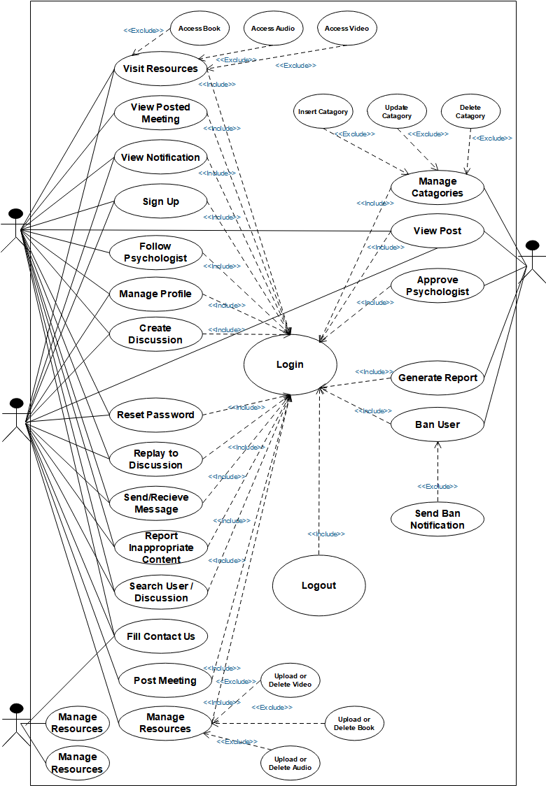

Figure 3. 1 Use case diagram

## 3.4 Description of use case model

The following tables show the use case description for each of use cases.Each table contains the use case name,the actors,description of use case and alternate action.

|  |  |  |
| --- | --- | --- |
| Use case id | UC-01 | |
| Use case name | Login | |
| Actor | Administrator,Psychologist,End-user | |
| Description | It is a confirmation method that allows users to login to the system | |
| Goal | System is accessed by authorized user | |
| Precondition | Users other than guest must have at least user name and password | |
| Post condition | Users access the system based on their privilege | |
| Basic flow of event | Actor action | System response |
| **Step 1**:users activate the system  **Step 3**:user enter username and and password then click login button | **Step 2** : system display login interface  **Step 4 :** system verify the validity username  And password  **Step 5:**system display page based on privilege. |
| Alternative action | 1. If user enters wrong username and/or password 2. System displays incorrect username and/or password 3. System display login interface | |

Table 3. 1Login use case description

|  |  |  |
| --- | --- | --- |
| Use case id | UC-02 | |
| Use case name | Sign-up | |
| Actor | Psychologist,End-user | |
| Description | To register new user and give privilege | |
| Goal | To enable users access full operations in the system based on their privilege | |
| Precondition | Users should initiate the system | |
| Post condition | Users information can be register and store in to database | |
| Basic flow of event | Actor action | System response |
| **Step 1**:users select sign up button  **Step 3**:user fill sign up form | **Step 2** : system display sign up form  **Step 4 :** system validate user sign up information  **Step 5:**system display sign up successfully message |
| Alternative action | A.If user enters wrong username and/or password  1.System displays incorrect username and/or password  2.System display login interface | |

Table 3. 2 Sign-up use case description

|  |  |  |
| --- | --- | --- |
| Use case id | UC-03 | |
| Use case name | Generate report | |
| Actor | Administrator | |
| Description | Generating report about psychologically victim users based on specific criteria | |
| Goal | To generate the required report information for the admin | |
| Precondition | User must have admin privilege | |
| Post condition | Display the report result | |
| Basic flow of event | Actor action | System response |
| **Step 1**:admin login to the system  **Step 4**:admin click on generate link  **Step 6:**admin fill the information on the report generate form and select generate report button | **Step 2** : system verify validity of username and password  **Step 3:** system display admin page  **Step 5:**system display report generate form  **Step 7:**system check the report information  **Step 8:**system display the result |
| Alternative action | A.If error occurs  1.System displays error message  2.System display report generation form | |

Table 3. 3 Generate report use case description

|  |  |  |
| --- | --- | --- |
| Use case id | UC-04 | |
| Use case name | Report Inappropriate content | |
| Actor | End-user | |
| Description | Users can send their complaint about some other user to the admin | |
| Goal | Helps the admin to ban misbehaved user and make comfortable condition for users | |
| Precondition | Reporter must be logged in | |
| Post condition | The report should be send to admin | |
| Basic flow of event | Actor action | System response |
| **Step 1**:users login to the system  **Step 4**:Psychologist or End-user click on user account and select send message button  **Step 6:**Psychologist or End-user write message and click send button | **Step 2** : system verify validity of username and  password  **Step 3:** system display home page  **Step 5:**system display message text field  **Step 7:**system accept the written message and send it to receiver |
| Alternative action | A.If error occurs  1.System displays error message | |

Table 3. 4 Report Inappropriate content use case description

|  |  |  |
| --- | --- | --- |
| Use case id | UC-05 | |
| Use case name | Send/Receive message | |
| Actor | Psychologist,End-user | |
| Description | Users other than guest and admin chat one another | |
| Goal | Providing live chat system for users | |
| Precondition | Psychologist or End-user must logged in to the system | |
| Post condition | Enabling communication in private | |
| Basic flow of event | Actor action | System response |
| **Step 1**:admin login to the system  **Step 4**:Psychologist or End-user click on user account and select send message button  **Step 6:**Psychologist or End-user write message and click send button | **Step 2** : system verify validity of username and  password  **Step 3:** system display home page  **Step 5:**system display message text field  **Step 7:**system accept the written message and send it to receiver |
| Alternative action | A.If error occurs  1.System displays error message | |

Table 3. 5 Send/Receive message use case description

|  |  |  |
| --- | --- | --- |
| Use case id | UC-06 | |
| Use case name | View notification | |
| Actor | End-user | |
| Description | End-user can receive and view notifications | |
| Goal | End-user will get latest discussion and receive ban notification from admin | |
| Precondition | End-user has to login to the system | |
| Post condition | End-user views notification | |
| Basic flow of event | Actor action | System response |
| **Step 1**:End-user login to the system  **Step 4**: End-user click on notification link  **Step 6:**User view notification | **Step 2** : system verify validity of username and  password  **Step 3:** system display the appropriate page  **Step 5:**system display notification |
| Alternative action | A.If error occurs  1.System displays error message  2.View process ends | |

Table 3. 6 View notification usecase diagram

|  |  |  |
| --- | --- | --- |
| Use case id | UC-07 | |
| Use case name | Upload resource | |
| Actor | Psychologist | |
| Description | Psychologist upload audio,video,and books | |
| Goal | Provide users a helper for their psychological problems | |
| Precondition | User has to psychologist privilege | |
| Post condition | Resource must be successfully uploaded based on given condition | |
| Basic flow of event | Actor action | System response |
| **Step 1**:Psychologist login to the system  **Step 4**:Psychologist click on menu link and select upload resource link  **Step 6:**Psychologist upload materials and click on upload button | **Step 2**:system verify validity of username and  password  **Step 3:** system display the appropriate page  **Step 5:** system display the upload form  **Step 7:**system validate materials and  display successfully uploaded message |
| Alternative action | A.If upload content is invalid  1.System displays error message  2.System display upload form | |

Table 3. 7 Upload resource use case description

|  |  |  |
| --- | --- | --- |
| Use case id | UC-08 | |
| Use case name | Post meeting | |
| Actor | Psychologist | |
| Description | This use case actor post meetings | |
| Goal | Psychologist notify the end-user about some specific meeting | |
| Precondition | Psychologist has to login to the system | |
| Post condition | Meeting notification will be created by Psychologist | |
| Basic flow of event | Actor action | System response |
| **Step 1**:Psychologist login to the system  **Step 4**:Psychologist click on post meeting link  **Step 6:**Psychologist upload materials and click on upload button | **Step 2**:system verify validity of username and  password  **Step 3:** system display the appropriate page  **Step 5:** system display the post meeting form  **Step 7:**system validate materials and  display successfully posted message |
| Alternative action | A.If post meeting form content is invalid  1.System displays error message  2.System display post meeting form | |

Table 3. 8 Post meeting use case description

|  |  |  |
| --- | --- | --- |
| Use case id | UC-09 | |
| Use case name | Create discussion | |
| Actor | Psychologist,End-user | |
| Description | Create discussion for sharing Psychologist and End-user problems | |
| Goal | Psychologist notify the end-user about some specific meeting | |
| Precondition | Psychologist or End-user need to login to the system | |
| Post condition | Discussion can be seen and be replayed by users | |
| Basic flow of event | Actor action | System response |
| **Step 1**:Psychologist or End-user login to the  system  **Step 4**:Psychologist or End-user click on create discussion link  **Step 6:**Psychologist or End-user and click on post button | **Step 2**:system verify validity of username and  password  **Step 3:** system display the appropriate page  **Step 5:** system display create discussion form  **Step 7:**system validate the form and  display successfully posted message |
| Alternative action | A.If create discussion form content is invalid  1.System displays error message  2.System displays create discussion form | |

Table 3. 9 Create discussion use case description

|  |  |  |
| --- | --- | --- |
| Use case id | UC-10 | |
| Use case name | Logout | |
| Actor | Psychologist,End-user,admin | |
| Description | This use case allows to logout from the privileged page | |
| Goal | Stop uses session in the system | |
| Precondition | User who are logged in to the system should want to logout | |
| Post condition | Users logged out from their privileges and go back to home page | |
| Basic flow of event | Actor action | System response |
| **Step 1**:User click logout link  **Step 3**:Use case end | **Step 2**:system returns to login page |

Table 3. 10 Logout use case description

## 

## 3.5 Activity diagram

An activity diagram describes the behavior of a system in terms of activities. Activities are modeling elements that represent the execution of a set of operations. The execution of an activity can be triggered by the completion of other activities, by the availability of objects, or by external events. Activity diagrams are similar to flowchart diagrams in that they can be used to represent control flow (i.e., the order in which operations occur) and data flow (i.e., the objects that are exchanged among operations). [6]

Figure 3.

Activity diagram for login

**Users start the system**

**System prompts**

**Enter username and password**

**User enter username and password and click login button**

**System validate username and password**

**valid**

**System display try again message**

**No**

**Yes**

**The system display the requested page**

Figure 3. Activity diagram for Sign-up

**User start the system**

**User click signup button**

**System display signup form**

**Users fill the form and click submit button**

**valid**

**System display please fill form with valid value**

**No**

**Yes**

**System display successfully Register**

**System validate form**

Figure 3.

Activity diagram for create discussion

**User login to the system**

**click on create discussion link**

**System display the form**

**Users fill the form and click post button**

**valid**

**System display invalid input please try again alert**

**No**

**Yes**

**System display posted successfully alert**

Figure 3. Activity diagram for post meeting

**Psychologist login to the system**

**click on create meeting link**

**System display the form**

**Psychologist fill the form and click create meeting button**

**valid**

**System display invalid input please try again alert**

**No**

**Yes**

**System display meeting created successfully alert**

Figure 3. Activity diagram for Manage categories

**Admin login to the admin site**

**Admin click on manage catagories button**

**System display manage catagories control form**

**Admin manage catagories and click save button**

Figure 3.  Activity diagram for upload resources

**Psychologist login to the system**

**Click on upload resource**

**System display the upload form**

**Psychologist fill upload form and click upload file**

**valid**

**System display invalid file please try again alert**

**No**

**Yes**

**System display upload successfully**

## 3.6 Object model

The object model, represented in UML with class diagrams, describes the structure of the system in terms of objects, attributes, associations, and operations. During requirements and analysis, the object model starts as the analysis object model and describes the application concepts relevant to the system. During system design, the object model is refined into the system design object model and includes descriptions of the subsystem interfaces. During object design, the object model is refined into the object design model and includes detailed descriptions of solution objects[7].Class are depicted as boxes with three sections:the top one indicates the name of the class,the middle one lists the attributes of the class,and the third one lists the methods.

## 3.7 Data dictionary

I t is also called meta data which is data about data.In this section we will describe the attributes of an object

|  |  |  |  |
| --- | --- | --- | --- |
| Object | Attribute | Description | Type |
| End-user | Id | This describes unique identification of end user | Int |
| First name | This describes first name of the end user | Varchar |
| Last name | This describes last name of end user | Varchar |
| Phone number | This describes the phone number of end user | Int |
| Email | This describes the email of end user | Varchar |
| Password | This describes the phone number of end user | Varchar |
| Date of birth | This describes the birth date of end user | Date |
| Gender | This describes the sex of end user | Varchar |
| Position | This describes the working status of the end user | Varchar |

Table 3. 11 Attribute description of end users

|  |  |  |  |
| --- | --- | --- | --- |
| Object | Attribute | Description | Type |
| Psychologist | Id | This describes unique identification of psychologist | Int |
| First name | This describes first name of the psychologist | Varchar |
| Last name | This describes last name of psychologist | Varchar |
| Phone number | This describes the phone number of psychologist | Int |
| Email | This describes the email of psychologist | Varchar |
| Password | This describes the phone number of psychologist | Varchar |
| Date of birth | This describes the birth date of psychologist | Date |
| Gender | This describes the sex of psychologist | Varchar |
| Position | This describes the working status of the psychologist | Varchar |
|  | University/college certificate | The education status of the psychologist | Varchar |
| Awards | This describes the awards of psychologist | Varchar |
| Publication | This describes the any published thing by psychologist | Varchar |

Table 3. 12 Attribute description of psychologist

|  |  |  |  |
| --- | --- | --- | --- |
| Object | Attribute | Description | Type |
| Admin | Id | This describes unique identification of admin | Int |
| User name | This describes the email of end user | Varchar |
| Password | This describes the phone number of admin | Varchar |
| Email | This describes the email of admin | Varchar |

Table 3. 13 Attribute description of admin

|  |  |  |  |
| --- | --- | --- | --- |
| Object | Attribute | Description | Type |
| Resource | Id | This describes unique identification of resource | Int |
| Categories | This describes the categories of resource | Varchar |
| Name | This describes the name of resource | Varchar |
| Type | This describes the file format of resource | Varchar |
| Uploader | This describes the one who upload resource | Varchar |

Table 3. 14 Attribute description of resource

|  |  |  |  |
| --- | --- | --- | --- |
| Object | Attribute | Description | Type |
| Discussion | Id | This describes unique identification discussion | Int |
| Title | This describes the title of discussion | Varchar |
| Content | This describes the content of discussion | String |
| Categories | This describes the categories of the discussion | Varchar |
| Author | This describes the one who create discussion | Varchar |

Table 3. 15 Attribute description of discussion

|  |  |  |  |
| --- | --- | --- | --- |
| Object | Attribute | Description | Type |
| Message | Id | This describes unique identification the message | Int |
| Sender name | This describes the name of sender | Varchar |
| Receiver name | This describes the name of receiver | Varchar |
| Content | This is content of the message | String |
| Date | This describes the date of created message | Date |
| Object | Attribute | Description | Type |
| Meeting | Id | This describes unique identification of meeting post | Int |
| Title | This describes the title of meeting post | Varchar |
| Content | This is content of meeting post | String |
| Place | This describes the place where meeting is takes place | Varchar |
| Date | This describes the when meeting is takes place | Varchar |
| Host | This describes the one who post the meeting |  |

Table 3. 16 Attribute description of message

## 3.8 Class diagram

Class diagrams are used to describe the structure of the system. Classes are abstractions thatspecify the common structure and behavior of a set of objects. Objects are instances of classesthat are created, modified, and destroyed during the execution of the system. An object has statethat includes the values of its attributes and its links with other objects.[8]Class diagrams describe the system in terms of objects, classes, attributes, operations, and their associations.

The following shows the class diagram for the following our proposed system

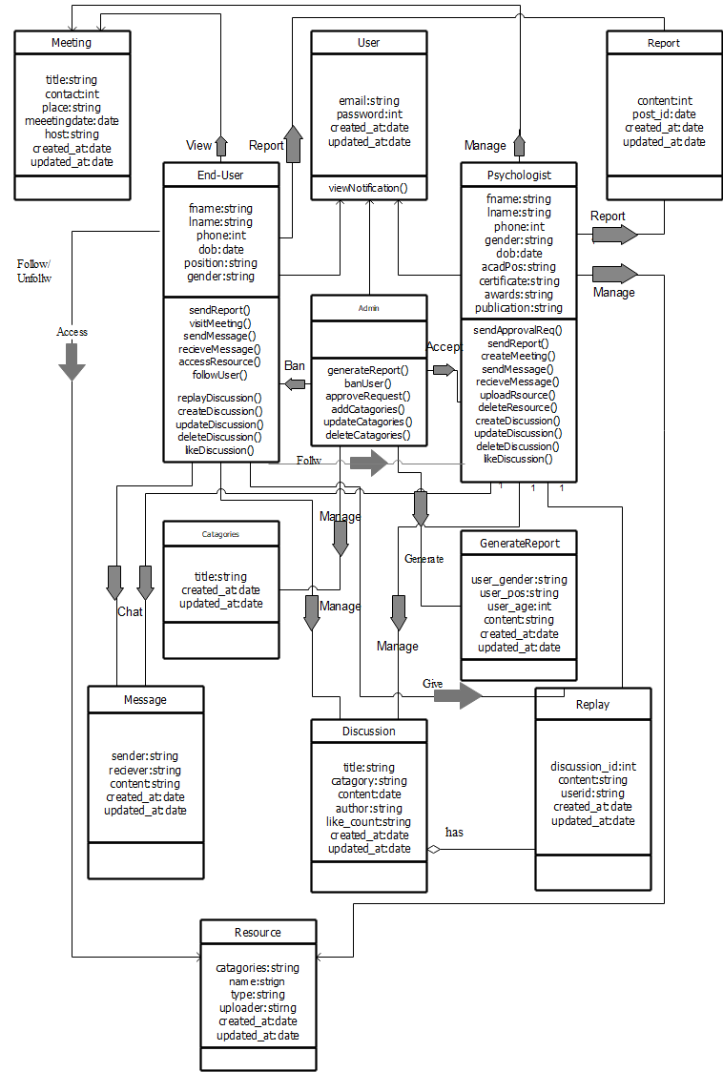

Figure 3. 8 Class Diagram

## 3.9 Dynamic modeling

Dynamic modeling describes the internal behavior of the system.It is a away of describing some type of interactions among the different elements in the model.In this section we will see about sequence diagram.

### 2.9.1 Sequence diagram

Sequence diagrams represent the objects participating in the interaction horizontally and

time vertically[].It is a good way to visualize and validate various runtime scenarios.

Figure 3. Sequence diagram for login

Login form

usernaemAndPassword()

click login()

Home page

Login controller

Database

submitForm()

validate form

errorMessage()

checkUsernamePassword()

invalidAccount()

validAccount()

openHomePage()

destroy()

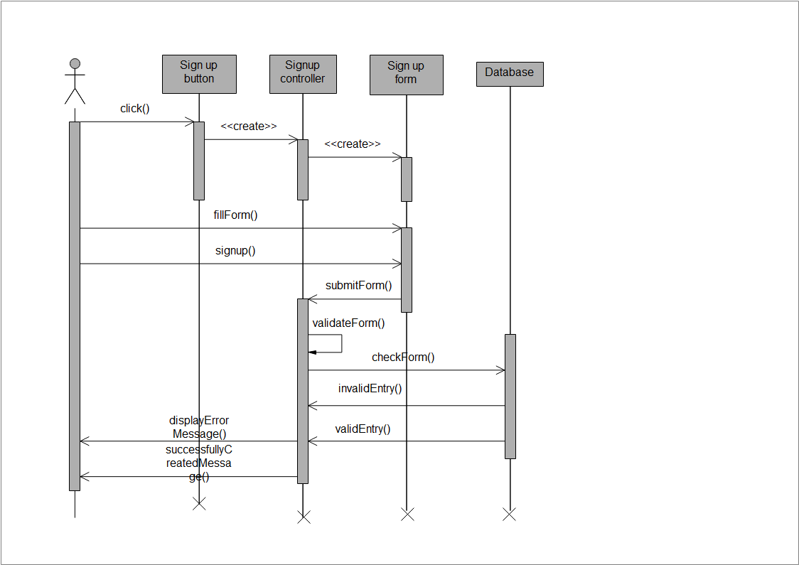

Figure 3. 10 Sequence diagram for sign-up

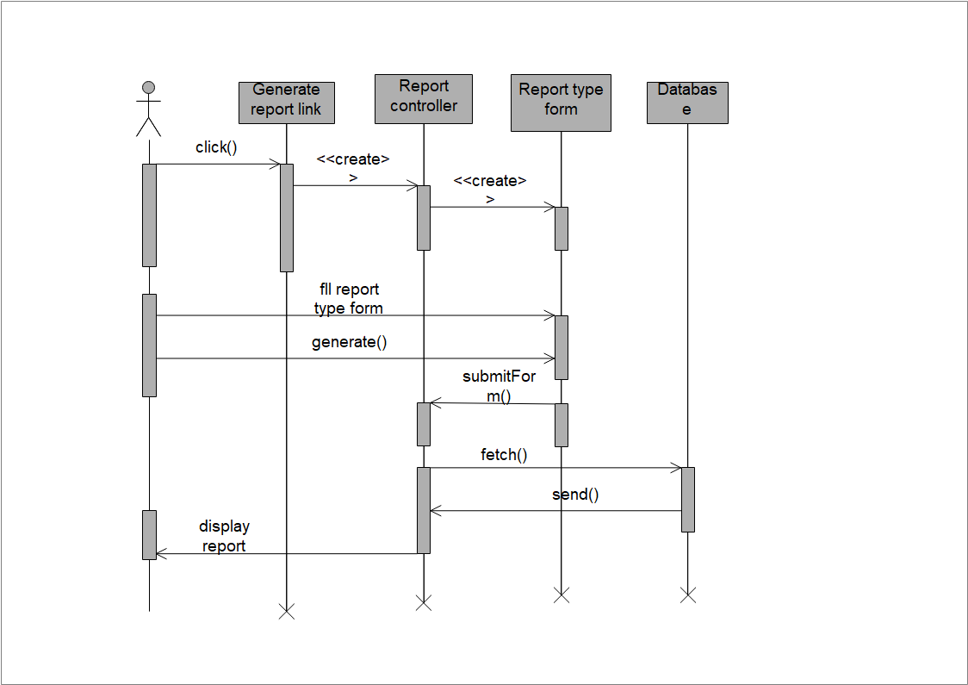

Figure 3. 11 Sequence diagram for generate report

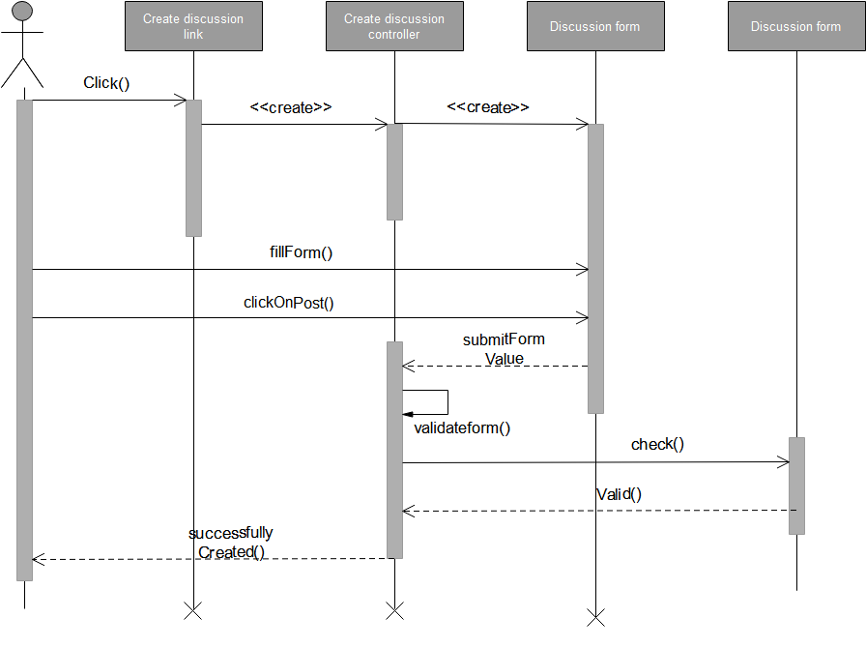

Figure 3. 12 Fig Sequence diagram for create discussion

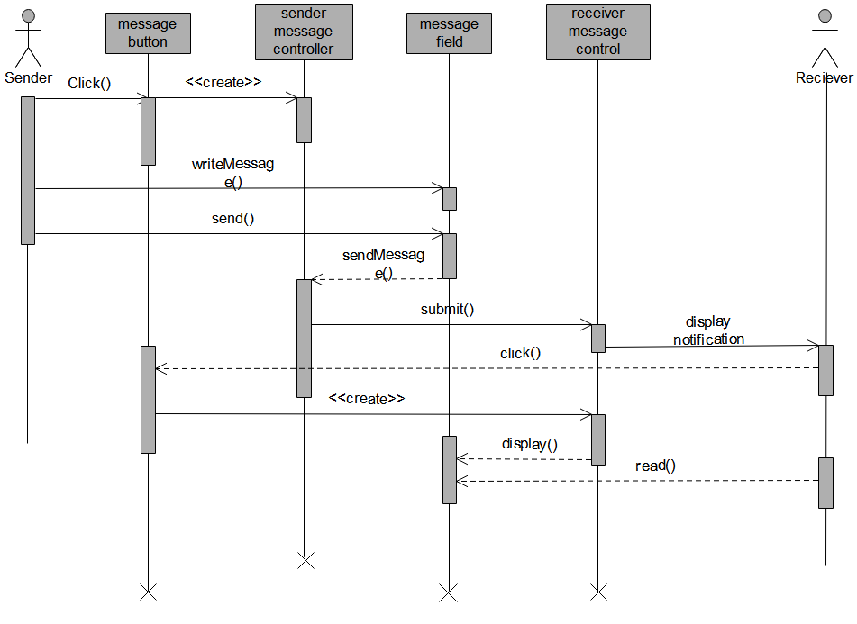

Figure 3. 13 Sequence diagram for send/receive message

## 3.10 User Interface

User interface is the front-end application view to which user interacts in order to use the system.We have a user interface as described below which is made by Adobe XD for sample view. 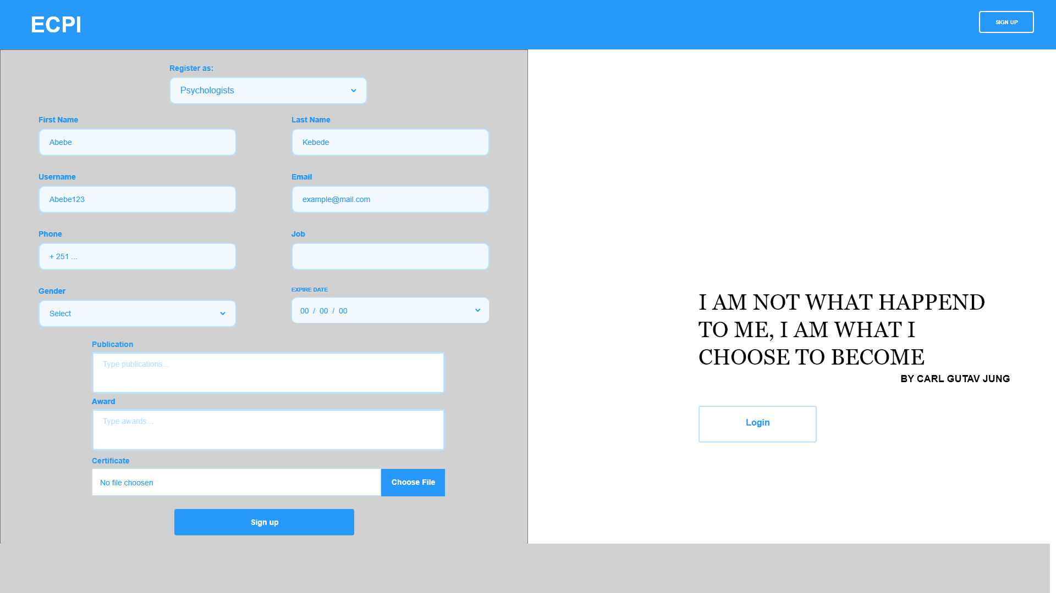

Figure 3. 14 Register UI for psychologist

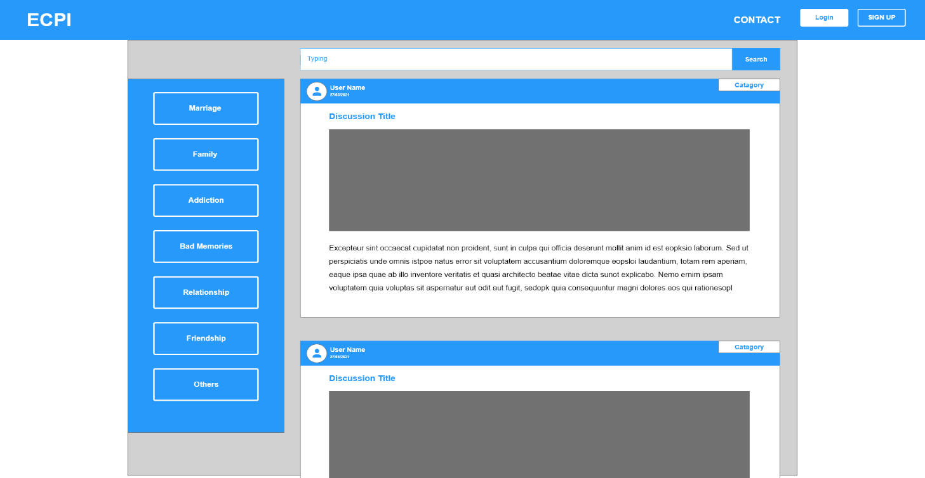

Figure 3. 15 Home page UI

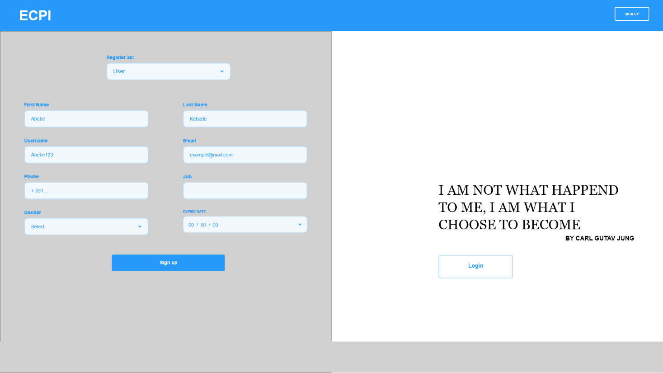

Figure 3. 16 Register UI for users

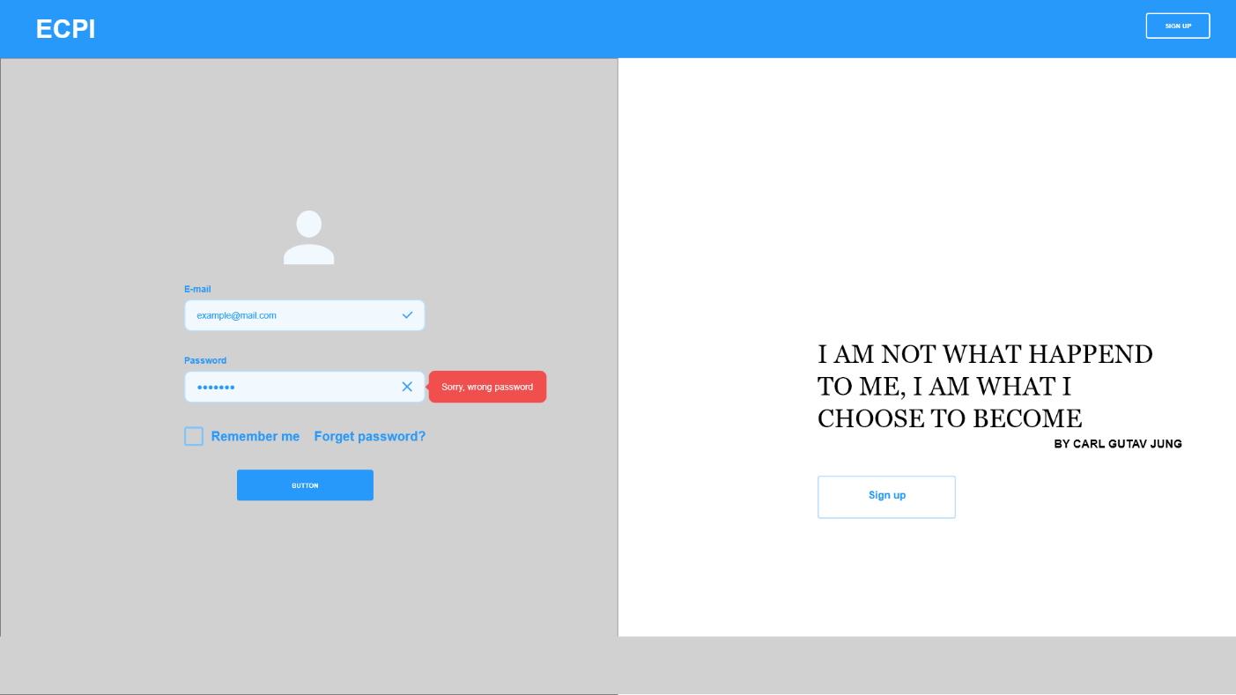

Figure 3. 17 Log in UI

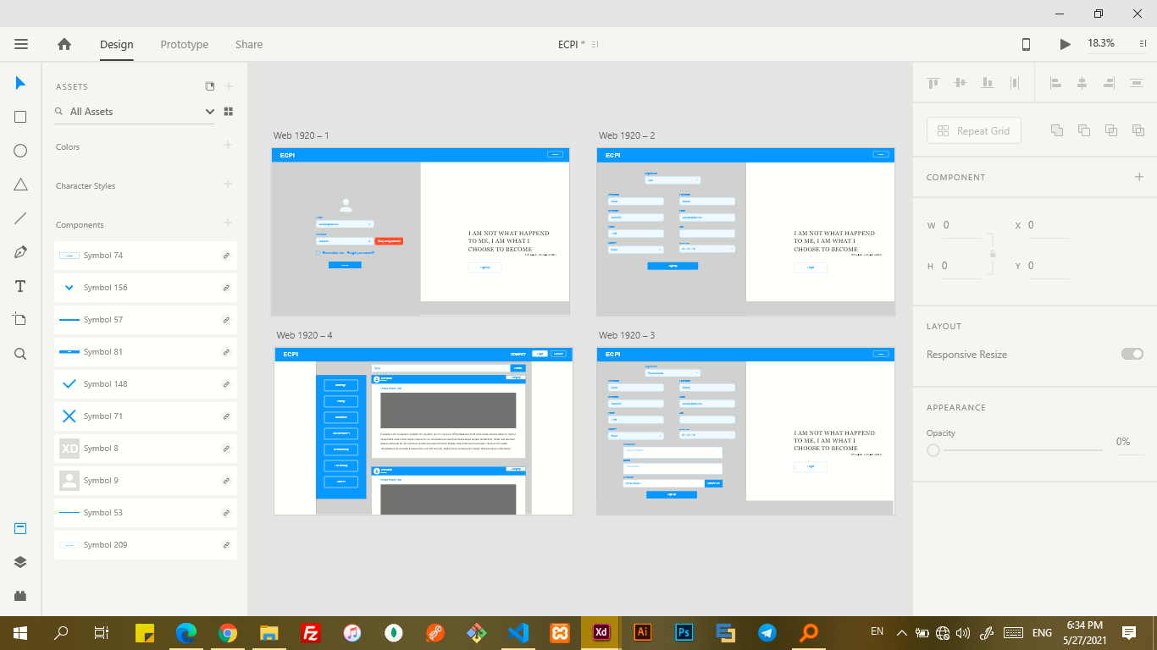

Figure 3. 18 Adobe XD screenshot

# CHAPTER FOUR

# 4. SYSTEM DESIGN

## 4.1 Introduction

System design is transformation of analysis model into system model.[OOS c-6 p-223] The purpose of designing is to describe how the system is built and to obtain clear information needed to drive the actual implementation of the system.In this chapter we will see about the current and proposed system software architecture and some design goals for better quality of the system.We will also describe the hardware and software mapping with deployment diagram,persistent data management,subsystem decomposition,access control and security.

## 4.2 Design goal

Design goals are important to model the system with good quality.It describe the qualities of the system that the developers should consider for instance non- functional requirements those are:

* Reliability:The proposed system should give services without any error under normal condition
* Usability:The proposed system should be easy to learn and operate.
* Response time:Taking less time for system to respond for the request
* Security:The proposed system must be protected from unauthorized access and threats to the system and user
* Cost:The proposed system should be developed with minimum cost
* Availability:The proposed system should be available 24/7 under normal condition where there is internet and power.

## 4.3 Current software architecture

Since there is no specifically designed web based psychological consultation and discussion platform for Ethiopian we do not have any type of software architecture for the current system.

## 4.4 Proposed software architecture

### 4.4.1 Overview

The architecture we used for the system is three tier architecture those are client tier,middle tier and data tier.

“The intermediate layer or middle tier is called the application server or the Web server, depending on the application. This server plays an intermediary role by running application programs and storing business rules (procedures or constraints) that are used to access data from the database server. It can also improve database security by checking a client’s credentials before forwarding a request to the database server. Clients contain GUI interfaces and some additional application-specific business rules. The intermediate server accepts requests from the client, processes the request and sends database queries and commands to the database server, and then acts as a conduit for passing (partially) processed data from the database server to the clients, where it may be processed further and filtered to be presented to users in GUI format. Thus, the user interface, application rules, and data access act as the three tiers”[FDS 77].

### 4.4.2 System decomposition

To reduce the complexity of our system,we decomposes a system into simpler parts called subsystem,which are made of a number of solution domain classes.We apply the principle when complex subsystems are occurs.Decomposition results large system into a set of loosely dependent parts which make up the system.The major subsystem identified includes:

Figure 4. Component diagram for ECPI

user interface

Web Server

Account creation sub-system

Notification sub-system

Discussion sub-system

Report

sub-system

Chat sub-system

Upload sub-system

ECPI database

User Interface layer

Application layer

Database layer

### 4.4.3 Hardware / software mapping

Hardware and software mapping is a process that allows a processor to identify and track the location of pieces of hardware and software by using UML deployment diagram which describes physical view of our system and it brings the software into real world by showing how the software gets physically mapped to hardware.

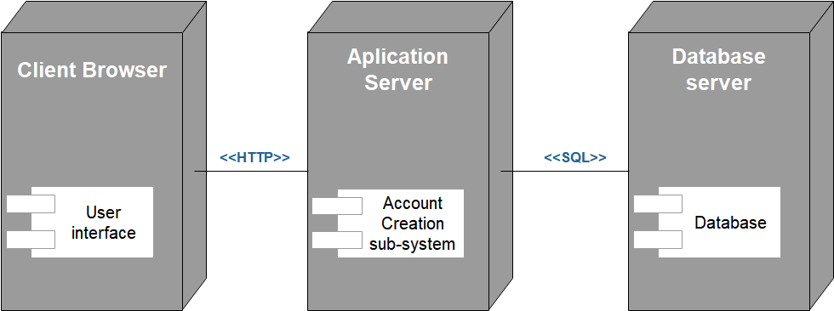

Figure 4. 2 Deployment diagram

### 4.4.4 Persistent data management

Persistent data management deals with how the persistent data are store and manage.It is a data that exists for long period of time.In order to store data persistently in a database the class objects identified in the class diagram is mapped into tables and the attributes into fields to respective table.The tables of the system with their respective fields and the relationships that exists between the table are expressed in this part.Since we use Mysql as database that means we are going to describe out persistent data in erms of relational database.

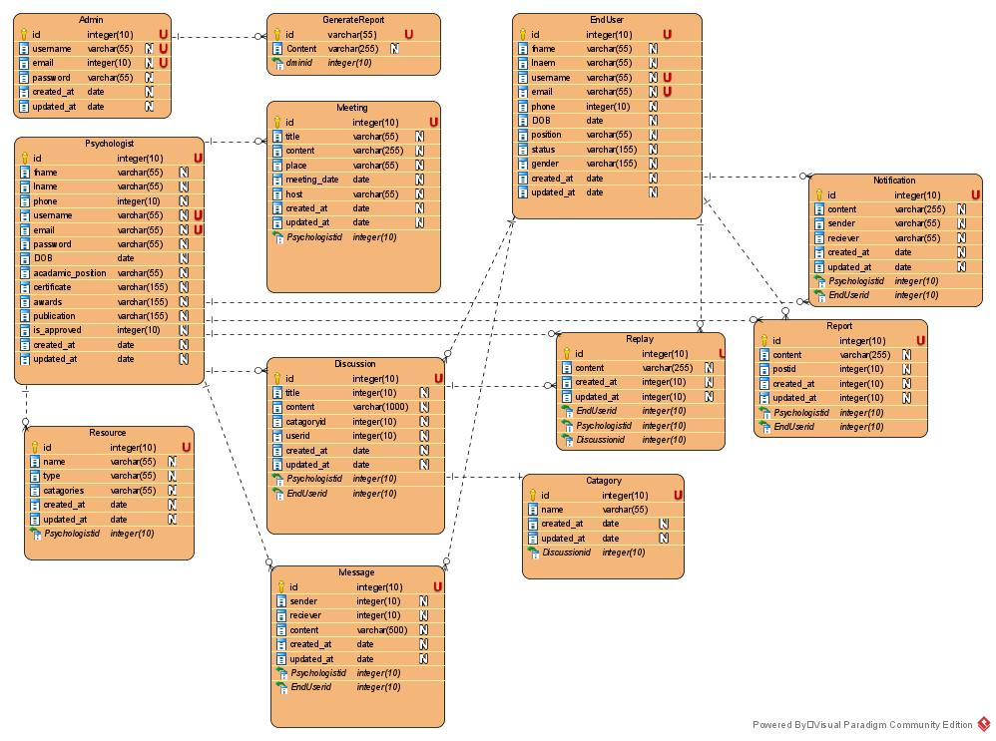

Figure 4. 3 Persistent data management diagram

### 4.4.5 Access control and security

This section describes user model of the system in terms of access.Therefore these privileges prevent unauthorized users form accessing data which they do not have granted to access.By letting users to insert their username and password in login form authentication is done.

|  |  |  |  |  |
| --- | --- | --- | --- | --- |
| Functions  Actors | Admin | Psychologist | End-user | Guest |
| Register |  | √ | √ |  |
| Generate report | √ |  |  |  |
| Approve psychologist request | √ |  |  |  |
| View notification |  | √ | √ |  |
| Send/Receive |  | √ | √ |  |
| Create discussion |  | √ | √ |  |
| Visit discussion | √ | √ | √ | √ |
| Reset password | √ | √ | √ |  |
| Post meeting |  | √ |  |  |
| Manage topic categories | √ |  |  |  |
| Upload resource |  | √ |  |  |
| Search discussion | √ | √ | √ | √ |
| View posted meeting |  | √ | √ |  |
| Manage profile |  | √ | √ |  |

Table 4. 1 Access control and security

**Subsystem services**

In this section each subsystem function is described below

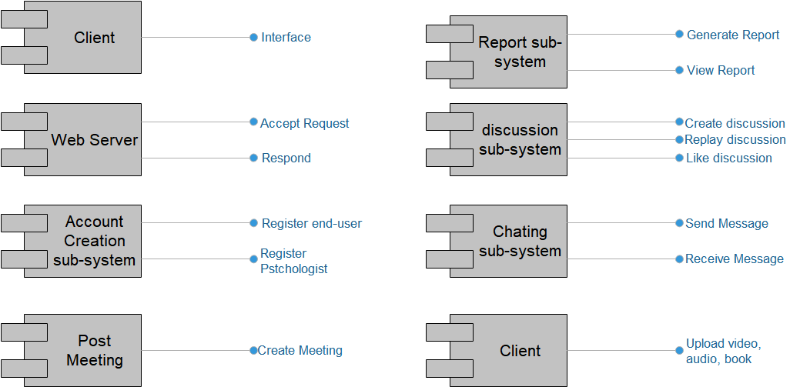

Figure 4. 4 Component diagram for subsystem

### 4.4.6 Detailed class diagram

Detailed class diagram is class diagram with visibility and signature specified for each attribute and operations

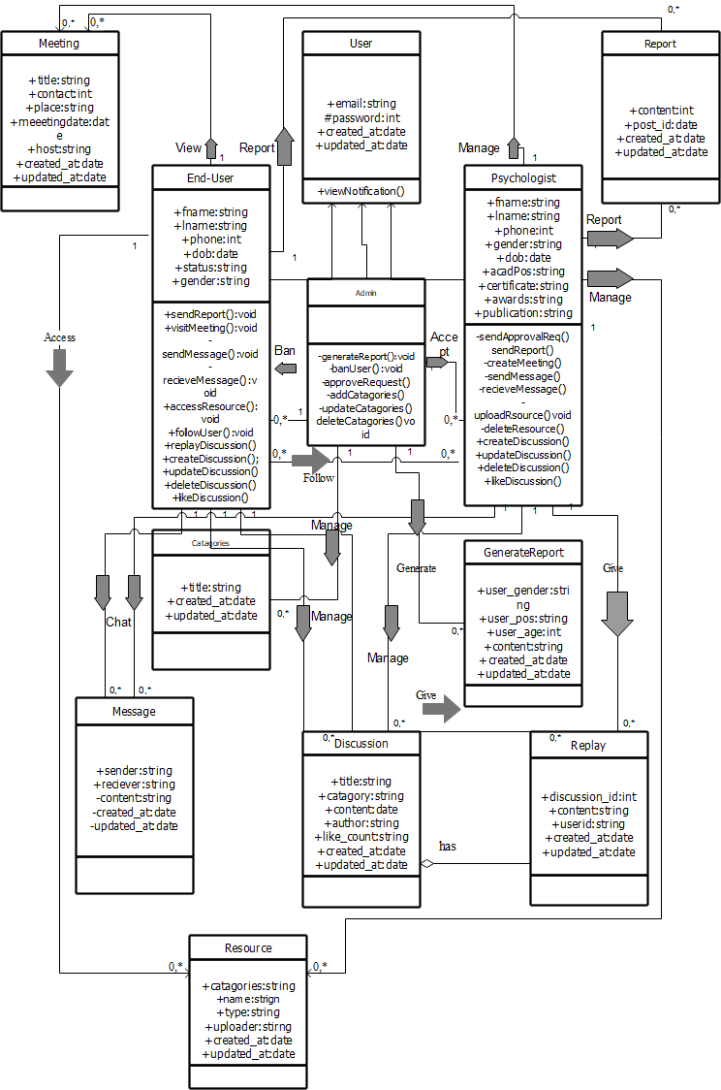

Figure 4. 5 Detail class diagram

### 4.4.7 Package diagram

A package diagram shows the arrangement,organization and dependencies between the packages that make up a model.It also used to show semantically related elements.The subsystems can be divided into three packages.

1. Interface package layer: It is client tier that is user interface.
2. Application package layer: It is a middle tier that contain subsystem.
3. Database package layer: It is a data tier that stores system information

**Client sub-system**

**Account creation sub-system**

**Discussion sub-system**

**notification sub-system**

**Reposrt sub-system**

**Chat sub-system**

**Upload sub-system**

**Database sub-system**

**Access**

**Access**

**Access**

**Access**

**Access**

**Access**

**Access**

**Access**

**Access**

**Access**

**Access**

**Access**

Figure 4. package diagram

### 4.4.8 Deployment

In this deployment system we describe how components will be accessed and type of infrastructure we used

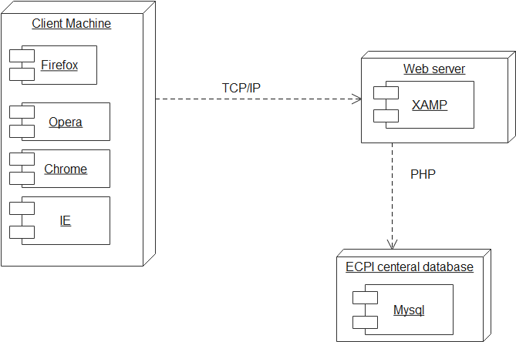

Figure 4. 7 Deployment diagram

# CHAPTER FIVE

# 5. CONCLUSION AND RECOMENDATION

The final output of this project is developing web based psychological issues consultation and discussion for Ethiopian. To do that we collect requirement needed for developing the project and also we identify the current psychological problems solver methods. During developing process we have learned a lot of things like how we develop a documentation for our project, what are the current issues that makes a person psychologically weak. We were also able to learn how the system analysis and design of the project is prepared and also how object oriented concept is useful and better approach for developing our project.

Finally we conclude that the development of web based consultation and discussion gives a great advantage for Ethiopian society by making comfortable environment for their psychological problems discussion. Our team also benefited from the process of the development.

Even if our proposed system has different additional features we only allow discussion by text and image posting. So we recommend improving our proposed system for more ways of discussions like online video discussion, audio discussion will make a great comfort and ease of usability for users.

REFERENCE

[1] Bruegge, B., and Dutoit, A. H. **Object-Oriented Software Engineering: Using UML, Patterns and Java**. 6th Edition. NJ: Prentice Hall, Upper Saddle River , 2003

[2] Elmasir, R., and Natathe, S. **Fundamentals of Database Systems**. 6th Edition. Pearson/Addison-Wesley, Boston, 2007