**How to select char in TextBox or textarea (need some modification). Example.**

**<https://ssrvsourcelib.cds.state.mo.us:8443/svn/sandbox/trunk/UserControlExperemental/>**

Major idea – **add TextBox** with transparent background and under TextBox **add DIV section** (need use absolute position).

<div id="divContainer" class="relative" clientidmode="AutoID" runat="server">

<div id="divCloneTxt" runat="server" clientidmode="AutoID" class="absolute whitebackground whitefont ">

</div>

<asp:TextBox ID="txtUC" runat="server" ClientIDMode="AutoID" class="absolute transporentbackground" TextMode="SingleLine" MaxLength="30"

Text="" AutoPostBack="True">

</asp:TextBox>

</div>

I built two different approaches you can use any for your purpose.

Set of selected char(s) are different. For mainframe probably best using first JS approach.

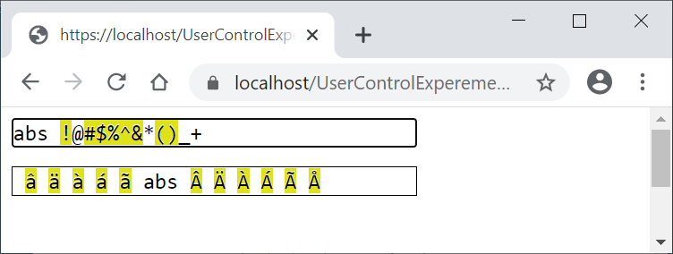

In **DIV** section add dynamically same char with white font and if char was encode with more than 1 byte

<script type="text/javascript">

//function name must be build dynamicaly

function txtUp_<%=divCloneTxt.ClientID%>(t) {

if ($('#<%=divCloneTxt.ClientID%>')[0].hasChildNodes()) {

$('#<%=divCloneTxt.ClientID%>')[0].innerHTML = ""

var strtxt = t.value;

//https://developer.mozilla.org/en-US/docs/Web/JavaScript/Reference/Global_Objects/escape

var origin = strtxt.split("");

var conv = "";

var strdiv = ""

for (i = 0; i < origin.length; i++) {

conv = escape(origin[i]);

if (conv.length > 1 && origin[i] != " ") {

strdiv += '<span class="yellowbackground">' + origin[i] + '</span>'

} else {

if (origin[i] != " ") {

strdiv += origin[i];

} else {

strdiv += "&nbsp;";

}

}

}

$('#<%=divCloneTxt.ClientID %>')[0].innerHTML = strdiv;

}

return false;

}

</script>

**And second approach using code behind, see VB code below**

Private Sub ValidateTextBox()

Dim strBefore As String = txtUC.Text

Dim strAfter As String = ""

If strBefore <> "" Then

Dim byteArray As Byte() = Encoding.UTF8.GetBytes(strBefore)

Dim asciiArray As Byte() = Encoding.Convert(Encoding.UTF8, Encoding.ASCII, byteArray)

strAfter = Encoding.ASCII.GetString(asciiArray) 'each not ASCII (wrong) char will be encode like “?”

End If

Dim charsBefore As Char() = strBefore.ToCharArray()

Dim charsAfter As Char() = strAfter.ToCharArray()

Dim strDiv As String = ""

Dim strError As String = "replace/update char(s): "

Dim blnError As Boolean = False

For i As Integer = 0 To charsBefore.Length - 1

If charsBefore(i) <> charsAfter(i) Then

strDiv += "<span class=""yellowbackground"">" + charsBefore(i) + "</span>"

blnError = True

strError += """" + charsBefore(i) + ""","

Else

If charsBefore(i) = " " Then

strDiv += "&nbsp;"

Else

strDiv += charsBefore(i)

End If

End If

Next

strError = strError.TrimEnd(",")

divCloneTxt.InnerHtml = strDiv

If blnError Then

txtUC.ToolTip = strError

Else

txtUC.ToolTip = ""

End If

_ErrorText = strError

End Sub