Software Requirements Specification
for
Workflow Automation System

Version #1
Prepared by Kuba Kałużniak
Lodz University of Technology
10.03.2026
Table of Contents
1. Introduction 3
1.1. Purpose 3
1.2. Document Conventions 3
1.3. Intended Audience and Reading Suggestions 3
1.4. Product Scope 3
1.5. References 3
2. Overall Description 4
2.1. Product Perspective 4
2.2. Product Features 4
2.3. User Classes and Characteristics 4
2.4. Operating Environment 4
2.5. Design and Implementation Constraints 5
2.6. User Documentation 5
2.7. Assumptions and Dependencies 5
3. System Features 5
3.1. Registration 5
3.2. Workflow management 5
3.3. Notification system 5
4. External Interface Requirements 5
4.1. User Interfaces Overview 5
4.2. Hardware Interfaces 6
4.3. Software Interfaces 6
5. System Features/Modules 6
5.1. Registration 6
5.1.1 Description and Priority 6
5.1.2 Stimulus/Response Sequences 6
5.1.3 Functional Requirements 6
5.2. Workflow Management 7
5.2.1 Description and Priority 7
5.2.2 Stimulus/Response Sequences 7
5.2.3 Functional Requirements 7
5.3. Notification system 7
5.3.1 Description and Priority 7
5.3.2 Stimulus/Response Sequences 7
5.3.3 Functional Requirements 7
6. Nonfunctional Requirements 7
6.1. Performance 7
6.2. Security 8
6.3. Reliability 8
6.4. Portability 8

Revision History
Name | Date | Reason for Changes | Version
Kuba Kałużniak | 10.03.2026 | Initial version | V1.0
Kuba Kałużniak | 17.03.2026 | Added references and use case diagrams | V2.0

1. Introduction

1.1. Purpose
The purpose of this document is to present a detailed description of the workflow automation platform. It will describe the usage and features of the system, operations the system is responsible for, and the constraints under which it must operate.
«Identify the product whose software requirements and design are specified in this document, including the revision or release number. Describe the scope of the product that is covered by this specification.»

1.2. Document Conventions
There is no significance in the fonts or highlighting used in this specification. Nevertheless, priorities corresponding to a system’s feature must be respected by each requirement listed within the feature.
«Describe any standards or typographical conventions that were followed when writing this specification, such as fonts or highlighting that have special significance. For example, state whether priorities for higher-level requirements are assumed to be inherited by detailed requirements, or whether every requirement statement is to have its own priority.»

1.3. Intended Audience and Reading Suggestions
The audience shall include company employees, as it is an internal tool intended to be used solely for professional purposes. The system shall be monitored by administrators and supervised by company managers.
The remaining sections of the document provide an overview of the system’s implementation, the requirements it shall follow, and characteristics of the users of the product. Section 2 includes general information about the system, including the overall description, its features, type of users and their roles, and operational constraints. Section 3 presents a detailed summary of the system’s features. The following sections serve as an extension of Section 3, including functional, non-functional, and interface requirements.
«Describe the different types of reader that the document is intended for, such as developers, project managers, marketing staff, users, testers, and documentation writers. Describe what the rest of this document contains and how it is organized. Suggest a sequence for reading the document, beginning with the overview sections and proceeding through the sections that are most pertinent to each reader type.»

1.4. Product Scope
The system consists of a web-based platform compatible with the company’s network and structure. The product’s purpose includes optimisation of the company’s workflow, leading to dynamic role changes. The system is expected to provide the answer for the challenge of workforce shortage and allow for contracting experts to establish the company’s position on the market.
«Provide a short description of the software being specified and its purpose, including relevant benefits, objectives, and goals. Relate the software to corporate goals or business strategies when applicable.»

1.5. References
Below is a list of documents which this specification refers to.
Kuba Kałużniak, “Use case diagram examples”, last modified 17.03.2026: https://lucid.app/lucidchart/e1a1ca7c-356a-47bd-9aae-347cbebf6e28/edit?invitationId=inv_89bc9674-1631-4e0c-acf5-7d5c8f722dcc
Kuba Kałużniak, “Car insurance system use case diagram”, last modified 17.03.2026: https://lucid.app/lucidchart/49a217c4-8f87-42f7-84f5-536ff3d93c80/edit?invitationId=inv_4add3aea-992d-4d5f-84b7-bedd9f406955
«List any other documents or Web addresses to which this document refers or was based on. These may include user interface style guides, contracts, standards, system requirements specifications, use case documents, or a vision and scope document. Provide enough information so that the reader could access a copy of each reference, including title, author, version number, date, and source or location. Include the assignment document in the references.»

2. Overall Description

2.1. Product Perspective
The product is a web-based platform which integrates with mailing systems, databases, and APIs. It runs on cloud infrastructure. It serves as a replacement for the formerly used automation system, which was deemed obsolete because of the lack of administrative support and limited applications. This product was designed based on the structure of systems from other areas, mentioned in 1.5. References. Then, a use case diagram was designed to outline the tasks each user is assigned to.
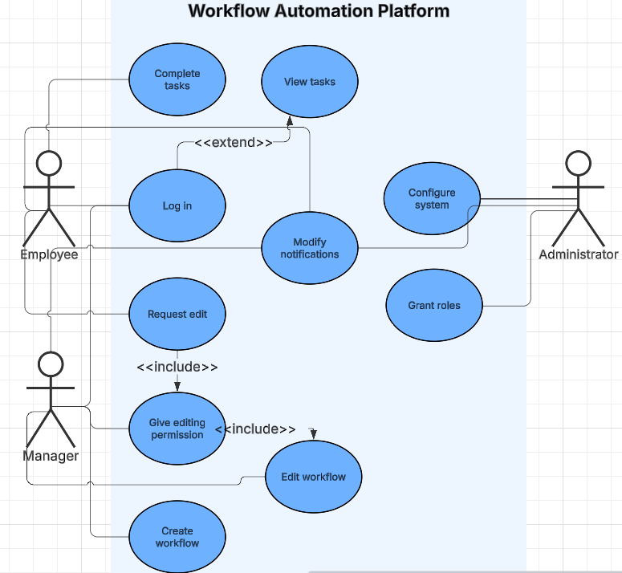
Figure 1. Simplified Use Case diagram of the system.
«Describe the context and origin of the product being specified in this specification. For example, state whether this product is a follow-on member of a product family, a replacement for certain existing systems, or a new, self-contained product.»

2.2. Product Features
«Summarize the major features the product must perform or must let the user perform. Details will be provided in Section 3, so only a bullet list is needed here. Organize the features to make them understandable to any reader of the specification. A picture of the major groups of related requirements and how they relate, such as a top level data flow diagram or object class diagram, is often effective.»
- Workflow creation and editing
- Task automation
- Notification system
- Dashboard for workflow monitoring
- Integration with external services

2.3. User Classes and Characteristics
User Type | Description
Administrator | Configures the system and integrations
Manager | Creates workflows and monitors performance
Employee | Executes assigned tasks

«Identify the various user classes (intended target for the product) that you anticipate will use this product. User classes may be differentiated based on frequency of use, subset of product functions used, technical expertise, security or privilege levels, educational level, or experience. Describe the pertinent characteristics of each user class. Certain requirements may pertain only to certain user classes. Distinguish the most important user classes for this product from those who are less important to satisfy.»

2.4. Operating Environment
Web browser: Firefox, Chrome, Edge
Operating System: Linux
Applications and technologies used: Angular, Fast API, PostgreSQL, Airflow, Docker, Kubernetes
«Describe the environment in which the software will operate, including the hardware platform, operating system and versions, and any other software components or applications with which it must peacefully coexist.»

2.5. Design and Implementation Constraints
«Describe any items or issues that will limit the options available to the developers. These might include: corporate or regulatory policies; hardware limitations (timing requirements, memory requirements); interfaces to other applications; specific technologies, tools, and databases to be used; parallel operations; language requirements; communications protocols; security considerations; design conventions or programming standards (for example, if the customer’s organization will be responsible for maintaining the delivered software).»

2.6. User Documentation
«List the user documentation components (such as user manuals, on-line help, and tutorials) that will be delivered along with the software. Identify any known user documentation delivery formats or standards.»

2.7. Assumptions and Dependencies
«List any assumed factors (as opposed to known facts) that could affect the requirements stated in the specification. These could include third-party or commercial components that you plan to use, issues around the development or operating environment, or constraints. The project could be affected if these assumptions are incorrect, are not shared, or change. Also identify any dependencies the project has on external factors, such as software components that you intend to reuse from another project, unless they are already documented elsewhere (for example, in the vision and scope document or the project plan).»

3. System Features
«The purpose here is to give a brief introduction to the system features, so that §4 has something to reference. Then, the full explanation of the system features is given in §5, likely referencing §4. The numbering in §3 and §5 should match.»

3.1. Registration
The system grants roles and responsibilities for concurrent users based on their role in the company. The users enter the platform by logging into the organisation’s portal, where redirection to the platform occurs.
«Brief description of the feature, generally 1-3 sentences»

3.2. Workflow management
The system provides tools which facilitate creating and editing workflows. Managers assess roles and responsibilities to employees, outline goals and set deadlines. Employees, under manager’s permission, may perform changes in the workflow.

3.3. Notification system
The product assures users are notified upon a change in the system. Users are able to modify their notification preferences. Notification messages follow a hierarchy, with the highest priority messages being unable to discard.

4. External Interface Requirements

4.1. User Interfaces Overview
«Describe the high level functionality of the system from the user’s perspective. Explain how the user should be able to use your system to complete all the expected features and the feedback information that will be displayed for the user (for each screen the user will see). For example, specify whether it is GUI or text based interface and how at high level it would work. Discuss at high level how user will interact with the game such as clicking buttons, typing in some selection character, etc.»
«Describe the minimum requirements for the interface. This may include some sample screen images whether for text or GUI approach, any GUI standards or product family style guides that are to be followed, screen layout constraints, for GUI standard buttons and functions (e.g., help) that must appear on every screen, keyboard shortcuts, error message display standards, and so on»

4.2. Hardware Interfaces
«Describe the logical and physical characteristics of each interface between the software product and the hardware components of the system. This may include the supported device types, the nature of the data and control interactions between the software and the hardware, and communication protocols to be used.»

4.3. Software Interfaces
«Describe the connections between this product and other specific software components (name and version), including databases, interpreters, operating systems, tools, libraries, and integrated commercial components. Identify the data items or messages coming into the system and going out and describe the purpose of each. Describe the services needed and the nature of communications. Identify data that will be shared across software components. If the data sharing mechanism must be implemented in a specific way (for example, use of a global data area in a multitasking operating system), specify this as an implementation constraint.»

5. System Features/Modules
«This template illustrates organizing the functional requirements for the product by system features, the major services provided by the product.»

5.1. Registration

5.1.1 Description and Priority
Users can register to the system using their company data. Highest priority.
«Provide a short description of the feature. Give its priority, too.»

5.1.2 Stimulus/Response Sequences
Stimulus: Opening the system’s web page while connected to the intranet.
«”Stimulus” or “Condition”»: «Describe the stimulus or condition»
Response: Registration or login form is displayed.
Stimulus: Filling in the form with company’s data.
Response: Redirecting to the dashboard
«Additional Stimulus/Response pairs as needed»

5.1.3 Functional Requirements
«Itemize the detailed functional requirements associated with this feature. These are the software capabilities that must be present in order for the user to carry out the services provided by the feature. Include how the product should respond to anticipated error conditions or invalid inputs. Requirements should be concise, complete, unambiguous, verifiable, and necessary. Each requirement should be uniquely identified with a sequence number or a meaningful tag of some kind.»
REQ-1.1: Upon entering the client-side page, the system shall provide the credential form for the employee.
«Some sentence goes here, in “shall” form, usually something like this: “Upon <some event or condition>, the <system, or the name of a module> shall <perform some action>.” Note that the entire requirement must be stated in the requirements area. Everything else is just a lead-up to this. There should be one such entry per S/R pair.»
REQ-1.2: Upon registering, the system shall display the employee’s profile with assigned roles and tasks.
REQ-1.3: The system shall grant appropriate privileges to the user based on their role.

5.2. Workflow Management

5.2.1 Description and Priority
Users can organise their work by creating and editing workflows. High priority.

5.2.2 Stimulus/Response Sequences
Stimulus: Manager enters the workflow panel.
Response: Checking if a user is permitted to create a new workflow.
Stimulus: Manager successfully creates a new workflow.
Response: Message is sent to organisational mail addresses of employees involved in the workflow.
Stimulus: Employee asks for editing permissions.
Response: Message is sent to the appropriate workflow manager.

5.2.3 Functional Requirements
REQ-2.1: The system shall allow only managers to create workflows.
REQ-2.2: Upon creating a workflow, the system shall notify the users concerned.
REQ-2.3: The system shall require manager’s permission for giving editing privileges to an employee.

5.3. Notification system

5.3.1 Description and Priority
Users can modify their notification settings. Notifications follow an importance hierarchy. Low priority.

5.3.2 Stimulus/Response Sequences
Stimulus: User opens the notification settings tab.
Response: A window with various types of notification preferences is displayed.
Stimulus: User confirms the updated notification settings.
Response: Server updates information about user’s notification preferences.

5.3.3 Functional Requirements
REQ-3.1: The system shall maintain information about each user’s notification settings.
REQ-3.2: The system shall provide a notification importance hierarchy.
REQ-3.3: The system shall disallow turning off notifications with highest importance.

6. Nonfunctional Requirements

6.1. Performance
NF-1.1: The system shall support 1000 concurrent workflows.
NF-1.2: The system shall provide response times < 1.5 s.

6.2. Security
NF-2.1: The system shall utilise role-based access control.
NF-2.2: The system shall encrypt all data.
NF-2.3: The system shall be accessed only by the devices connected to the company’s intranet.

6.3. Reliability
NF-3.1: The system shall maintain 99.5% uptime.

6.4. Portability
NF-4.1: The system shall support mobile device use.

