Software Requirements Specification
for
Workflow Automation System

Version #3
Prepared by Kuba Kałużniak
Lodz University of Technology
10.03.2026
Table of Contents
1. Introduction 3
1.1. Purpose 3
1.2. Document Conventions 3
1.3. Intended Audience and Reading Suggestions 3
1.4. Product Scope 3
1.5. References 3
2. Overall Description 3
2.1. Product Perspective 3
2.2. Product Features 4
2.3. User Classes and Characteristics 4
2.4. Operating Environment 4
2.5. Design and Implementation Constraints 5
2.6. User Documentation 5
2.7. Assumptions and Dependencies 5
3. System Features 5
3.1. Registration 5
3.2. Workflow management 5
3.3. Notification system 5
4. External Interface Requirements 5
4.1. User Interfaces Overview 5
4.2. Hardware Interfaces 5
4.3. Software Interfaces 5
5. System Features/Modules 5
5.1. Registration 5
5.1.1 Description and Priority 5
5.1.2 Stimulus/Response Sequences 5
5.1.3 Functional Requirements 5
5.2. Workflow Management 6
5.2.1 Description and Priority 6
5.2.2 Stimulus/Response Sequences 6
5.2.3 Functional Requirements 6
5.3. Notification system 6
5.3.1 Description and Priority 6
5.3.2 Stimulus/Response Sequences 6
5.3.3 Functional Requirements 6
6. Nonfunctional Requirements 6
6.1. Performance 6
6.2. Security 6
6.3. Reliability 7
6.4. Portability 7

Revision History
Name | Date | Reason for Changes | Version
Kuba Kałużniak | 10.03.2026 | Initial version | V1.0
Kuba Kałużniak | 17.03.2026 | Added references and use case diagrams | V2.0
Kuba Kałużniak | 24.03.2026 | Added UML class diagrams | V3.0

1. Introduction

1.1. Purpose
The purpose of this document is to present a detailed description of the workflow automation platform. It will describe the usage and features of the system, operations the system is responsible for, and the constraints under which it must operate.

1.2. Document Conventions
There is no significance in the fonts or highlighting used in this specification. Nevertheless, priorities corresponding to a system’s feature must be respected by each requirement listed within the feature.

1.3. Intended Audience and Reading Suggestions
The audience shall include company employees, as it is an internal tool intended to be used solely for professional purposes. The system shall be monitored by administrators and supervised by company managers.
The remaining sections of the document provide an overview of the system’s implementation, the requirements it shall follow, and characteristics of the users of the product. Section 2 includes general information about the system, including the overall description, its features, type of users and their roles, and operational constraints. Section 3 presents a detailed summary of the system’s features. The following sections serve as an extension of Section 3, including functional, non-functional, and interface requirements.

1.4. Product Scope
The system consists of a web-based platform compatible with the company’s network and structure. The product’s purpose includes optimisation of the company’s workflow, leading to dynamic role changes. The system is expected to provide the answer for the challenge of workforce shortage and allow for contracting experts to establish the company’s position on the market.

1.5. References
Below is a list of documents which this specification refers to.
Kuba Kałużniak, “Use case diagram examples”, last modified 17.03.2026: https://lucid.app/lucidchart/e1a1ca7c-356a-47bd-9aae-347cbebf6e28/edit?invitationId=inv_89bc9674-1631-4e0c-acf5-7d5c8f722dcc
Kuba Kałużniak, “Car insurance system use case diagram”, last modified 17.03.2026: https://lucid.app/lucidchart/49a217c4-8f87-42f7-84f5-536ff3d93c80/edit?invitationId=inv_4add3aea-992d-4d5f-84b7-bedd9f406955

2. Overall Description

2.1. Product Perspective
The product is a web-based platform which integrates with mailing systems, databases, and APIs. It runs on cloud infrastructure. It serves as a replacement for the formerly used automation system, which was deemed obsolete because of the lack of administrative support and limited applications. This product was designed based on the structure of systems from other areas, mentioned in 1.5. References. Then, a use case diagram was designed to outline the tasks each user is assigned to.
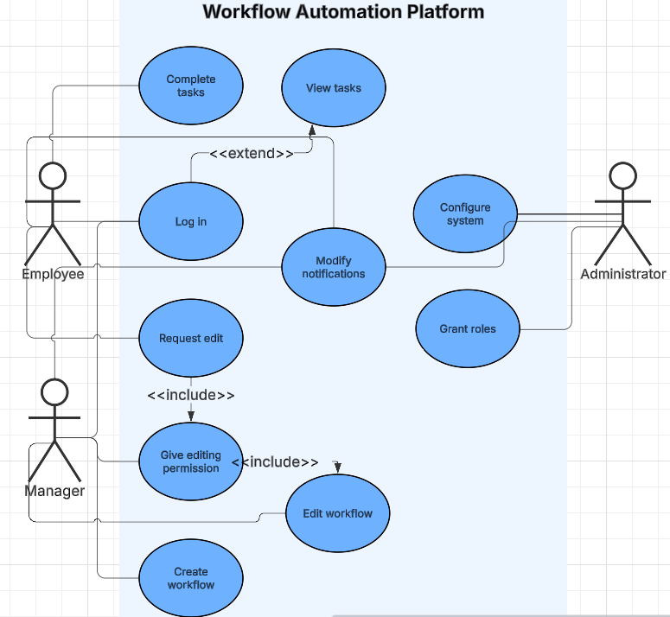
Figure 1. Simplified Use Case diagram of the system.

2.2. Product Features
- Workflow creation and editing
- Task automation
- Notification system
- Dashboard for workflow monitoring
- Integration with external services

2.3. User Classes and Characteristics
User Type | Description
Administrator | Configures the system and integrations
Manager | Creates workflows and monitors performance
Employee | Executes assigned tasks

2.4. Operating Environment
Web browser: Firefox, Chrome, Edge
Operating System: Linux
Applications and technologies used: Angular, Fast API, PostgreSQL, Airflow, Docker, Kubernetes

2.5. Design and Implementation Constraints

2.6. User Documentation

2.7. Assumptions and Dependencies

3. System Features

3.1. Registration
The system grants roles and responsibilities for concurrent users based on their role in the company. The users enter the platform by logging into the organisation’s portal, where redirection to the platform occurs.

3.2. Workflow management
The system provides tools which facilitate creating and editing workflows. Managers assess roles and responsibilities to employees, outline goals and set deadlines. Employees, under manager’s permission, may perform changes in the workflow.

3.3. Notification system
The product assures users are notified upon a change in the system. Users are able to modify their notification preferences. Notification messages follow a hierarchy, with the highest priority messages being unable to discard.

4. External Interface Requirements

4.1. User Interfaces Overview

4.2. Hardware Interfaces

4.3. Software Interfaces

5. System Features/Modules

5.1. Registration

5.1.1 Description and Priority
Users can register to the system using their company data. Highest priority.

5.1.2 Stimulus/Response Sequences
Stimulus: Opening the system’s web page while connected to the intranet.
Response: Registration or login form is displayed.
Stimulus: Filling in the form with company’s data.
Response: Redirecting to the dashboard

5.1.3 Functional Requirements
REQ-1.1: Upon entering the client-side page, the system shall provide the credential form for the employee.
REQ-1.2: Upon registering, the system shall display the employee’s profile with assigned roles and tasks.
REQ-1.3: The system shall grant appropriate privileges to the user based on their role.

5.2. Workflow Management

5.2.1 Description and Priority
Users can organise their work by creating and editing workflows. High priority.

5.2.2 Stimulus/Response Sequences
Stimulus: Manager enters the workflow panel.
Response: Checking if a user is permitted to create a new workflow.
Stimulus: Manager successfully creates a new workflow.
Response: Message is sent to organisational mail addresses of employees involved in the workflow.
Stimulus: Employee asks for editing permissions.
Response: Message is sent to the appropriate workflow manager.

5.2.3 Functional Requirements
REQ-2.1: The system shall allow only managers to create workflows.
REQ-2.2: Upon creating a workflow, the system shall notify the users concerned.
REQ-2.3: The system shall require manager’s permission for giving editing privileges to an employee.

5.2.4 Class Diagram
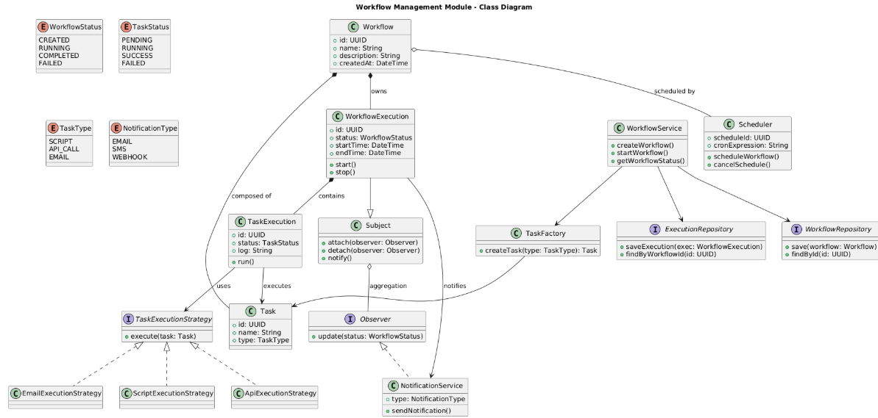
Figure 2. Workflow management module - class diagram.

5.3. Notification system

5.3.1 Description and Priority
Users can modify their notification settings. Notifications follow an importance hierarchy. Low priority.

5.3.2 Stimulus/Response Sequences
Stimulus: User opens the notification settings tab.
Response: A window with various types of notification preferences is displayed.
Stimulus: User confirms the updated notification settings.
Response: Server updates information about user’s notification preferences.

5.3.3 Functional Requirements
REQ-3.1: The system shall maintain information about each user’s notification settings.
REQ-3.2: The system shall provide a notification importance hierarchy.
REQ-3.3: The system shall disallow turning off notifications with highest importance.

6. Nonfunctional Requirements

6.1. Performance
NF-1.1: The system shall support 1000 concurrent workflows.
NF-1.2: The system shall provide response times < 1.5 s.

6.2. Security
NF-2.1: The system shall utilise role-based access control.
NF-2.2: The system shall encrypt all data.
NF-2.3: The system shall be accessed only by the devices connected to the company’s intranet.

6.3. Reliability
NF-3.1: The system shall maintain 99.5% uptime.

6.4. Portability
NF-4.1: The system shall support mobile device use.

