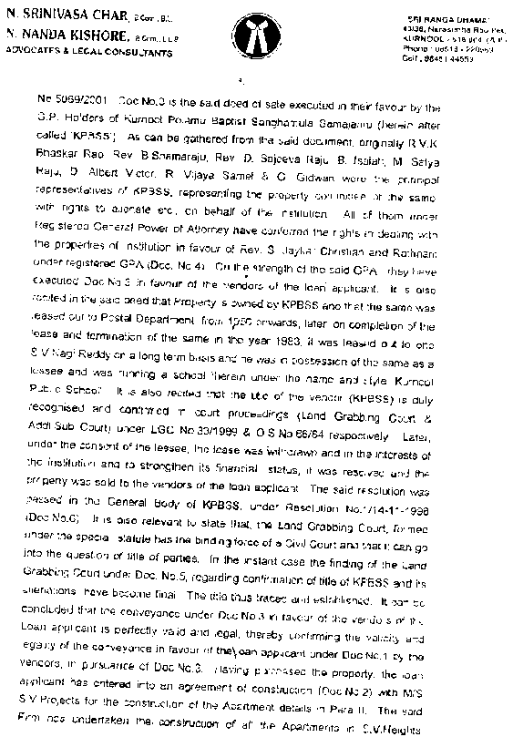
B. SIVA KRISHNA
ADVOCATE
Shop No. 220, 2ndFloor
C/o. Jagadeesh Mall
Birla Compound
KURNOOL-518 002
Cell No. 8008086291
Email I.D. sivakrishnallb@gmail.com
Date : {{DATE}}

TITLE VERIFICATION AND OPINION REPORT
To
The Branch Manager
Cholamandalam Investment & Finance Co. Ltd,
{{BRANCH_AREA}},
Andhra Pradesh

Sir
Name of the Applicant : {{APPLICANT_NAME}}
Property of Owner : {{APPLICANT_BOLD_OWNER}}
Application No. : {{APPLICATION_NO}}

DESCRIPTION OF THE PROPETY
SCHEDULE
(As per Doc.No. {{DEED_NO}} of {{SRO}} S.R.O. dated {{DEED_DATE}})
The part and parcel of house bearing Door No. {{DOOR_NO}}, Assessment No. {{Assessment_No}} measuring {{EXTENT_YARDS}} Square Yards in Survey Number {{SURVEY_NO}} located at {{ADDRESS}}, {{VILLAGE}}, {{GRAM_PANCHAYAT}} Gramapanchayat, and {{MANDAL}} Mandal within {{SRO}} Sub-Registration District and {{RO}} Registration District and {{DISTRICT}} District and bounded as follows :

East : {{EAST_BOUNDARY}}
West : {{WEST_BOUNDARY}}
North : {{NORTH_BOUNDARY}}
South : {{SOUTH_BOUNDARY}}
Within these boundaries site measuring
East – West : {{E_W}} Feet ; North – South : {{N_S}} Feet
Admeasuring {{EXTENT_YARDS}} Square Yards
Within these boundaries Construction measuring
East – West : {{E_W_FEET}} Feets; North – South : {{N_S_FEET}} Feets
Admeasuring {{EXTENT_FEET}} Square Feets
I)LIST OF DOCUMENTS VERIFIED
S.No | Date of  Documents | Doc. No. & S.R.O. | Nature of Document | Original/  C. C. /Xerox
1 | {{DEED_DATE}} | {{DEED_NO}} of {{SRO}}S.R.O. | Registered Sale Deed bearing no. {{DEED_NO}} dated {{DEED_DATE}} executed by {{EXECUTANT_FULL}} in favour of {{APPLICANT_OWNER_FULL}} | Photo Copy
2 | {{H_T_DATE}} | H.No. {{DOOR_NO}} | House Tax receipt dated {{H_T_DATE}} issued for the House bearing Door No. {{DOOR_NO}}, Assessment No. {{Assessment_No}}, Receipt No. {{H_T_RECIPT_NO}} paid for the financial year {{FINANCIAL_YEARS}} which stands in the name of {{HOUSE_TAX_NAME}} got issued by {{HOUSE_TAX_ISSUED_BY}}., {{MANDAL}} Mandal | Photo Copy
3 | {{EC_DATE}} | {{EC_NO}} | Online Statement of Encumbrance Certificate dated {{EC_DATE}} vide Statement No. {{EC_NO}} of {{SRO}} S.R.O. | Online copy
II) TRACING OF TITLE
As seen from the submitted documents it is reflected that
Originally, schedule site is the property of {{EXECUTANT_FULL}} who were in possession and enjoyment of the same.
Thereafter, {{EXECUTANT_FULL}} in turn to meet their family necessities got sold the schedule property to {{APPLICANT_OWNER_FULL}} by executing a Registered Sale Deed bearing No. {{DEED_NO}} dated {{DEED_DATE}} for sale consideration of Rs. {{WORTH}}/- by transferring absolute rights over the schedule property and delivered the possession and enjoyment of the same to {{APPLICANT_OWNER_FULL}} on the same day itself.
The House Tax receipt dated {{H_T_DATE}} issued for the House bearing Door No. {{DOOR_NO}}, Assessment No. {{Assessment_No}}, Receipt No. {{H_T_RECIPT_NO}} paid for the financial year {{FINANCIAL_YEARS}} which stands in the name of {{HOUSE_TAX_NAME}} got issued by {{HOUSE_TAX_ISSUED_BY}}., {{MANDAL}} Mandal reflects his present possession over the schedule property.
As per the document No. 3 submitted above i.e., the Online Statement of Encumbrance Certificate dated {{EC_DATE}} vide Statement No. {{EC_NO}} of {{SRO}} S.R.O., reflects the transactions over the schedule property and it is free from all encumbrances.

III LIST OF DOCUMENTS TO BE COLLECTED
S.No | Date of  Documents | Doc. No. & S.R.O. | Nature of Document | Original/  C.C. /Xerox
1 | {{DEED_DATE}} | {{DEED_NO}} of {{SRO}}S.R.O. | Registered Sale Deed bearing no. {{DEED_NO}} dated {{DEED_DATE}} executed by {{EXECUTANT_FULL}} in favour of {{APPLICANT_OWNER_FULL}} | Original
2 | {{H_T_DATE}} | H.No. {{DOOR_NO}} | House Tax receipt dated {{H_T_DATE}} issued for the House bearing Door No. {{DOOR_NO}}, Assessment No. {{Assessment_No}}, Receipt No. {{H_T_RECIPT_NO}} paid for the financial year {{FINANCIAL_YEARS}} which stands in the name of {{HOUSE_TAX_NAME}} got issued by {{HOUSE_TAX_ISSUED_BY}}., {{MANDAL}} Mandal | Original
3 | {{EC_DATE}} | {{EC_NO}} | Online Statement of Encumbrance Certificate dated {{EC_DATE}} vide Statement No. {{EC_NO}} of {{SRO}} S.R.O. | Online copy

REPORT/OPINION
Upon the verification of above documents submitted above, I am of the opinion that {{APPLICANT_BOLD_OWNER}} has got an absolute, clear, valid and Marketable title over the schedule property mentioned above. She has got every right to do any transactions or encumbrance over the schedule property in the capacity of absolute owner.
It is requested to have personal inspection of the property for ensure its physical existence and correct existing boundaries.
NOTE
I have issued this opinion as per the instructions of Cholamandalam Investment & Finance Co., Ltd. They informed me that there is policy of funding on single document and requested me to issue opinion basing on single document pertaining to the property.
(B. SIVA KRISHNA)


B. SIVA KRISHNA
ADVOCATE
Shop No. 220, 2ndFloor
C/o. Jagadeesh Mall
Birla Compound
KURNOOL-518 002
Cell No. 8008086291
Email I.D. sivakrishnallb@gmail.com
Date : {{DATE}}
VETTING FOR THE ORIGINAL PROPERTY DOCUMENTS

To
The Branch Manager
Cholamandalam Investment & Finance Co. Ltd,
{{BRANCH_AREA}}, Andhra Pradesh

Ref : Application No. {{APPLICATION_NO}}
Respected Sir,
Name of the Applicant : {{APPLICANT_NAME}}
Sub : Vetting report in respect of file of
{{APPLICANT_BOLD_OWNER}}
Ref : With reference to my legal opinion dated {{DATE}} wherein the following
documents have been asked as must for creation of security in favour of our
Cholamandalam Investment & Finance Co., Ltd, SBPL. The documents have been
vetted by me and are apparently found to be correct in order.

The documents vetted in Original

S.No | Date of  Documents | Doc. No. & S.R.O. | Nature of Document | Original/  C.C. /Xerox
1 | {{DEED_DATE}} | {{DEED_NO}} of {{SRO}}S.R.O. | Registered Sale Deed bearing no. {{DEED_NO}} dated {{DEED_DATE}} executed by {{EXECUTANT_FULL}} in favour of {{APPLICANT_OWNER_FULL}} | Original
2 | {{H_T_DATE}} | H.No. {{DOOR_NO}} | House Tax receipt dated {{H_T_DATE}} issued for the House bearing Door No. {{DOOR_NO}}, Assessment No. {{Assessment_No}}, Receipt No. {{H_T_RECIPT_NO}} paid for the financial year {{FINANCIAL_YEARS}} which stands in the name of {{HOUSE_TAX_NAME}} got issued by {{HOUSE_TAX_ISSUED_BY}}., {{MANDAL}} Mandal | Original
3 | {{EC_DATE}} | {{EC_NO}} | Online Statement of Encumbrance Certificate dated {{EC_DATE}} vide Statement No. {{EC_NO}} of {{SRO}} S.R.O. | Online copy

(B. SIVA KRISHNA)

