B. SIVA KRISHNA
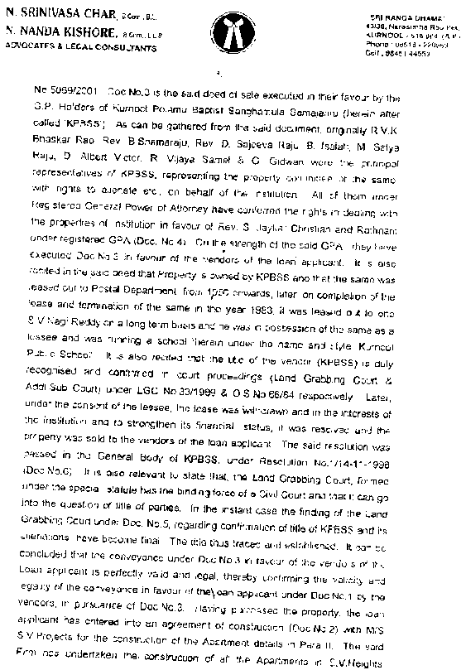
ADVOCATE
Shop N o. 220, 2nd Floor
C/o. Jagadeesh Mall
Birla Compound, Kurnool
Cell No. 8008086291
Email I.D. sivakrishnallb@gmail.com
Kurnool
Date :{{DATE}}
To
The Branch Manager
{{BRANCH_NAME}}
{{BRANCH_AREA}}

LEGAL SCRUTINY REPORT

Name of the Applicant  Application No | Sri. {{APPLICANT_BOLD}}  {{APPLICATION_NO}}
DESCRIPTION OF THE PROPERTY:
The part and parcel of the House, bearing door No.{{DOOR_NO}} and Plot no.{{PLOT_NO}}Having Assessment No.{{Assessment_No}} and measuring {{EXTENT_YARDS}} Square Yards in Survey number {{SURVEY_NO}}, Pyki located in {{ADDRESS}}, {{VILLAGE}}, {{GRAM_PANCHAYAT}} Gramapanchayat, and {{MANDAL}} Mandal within {{SRO}} Sub-Registration District and{{RO}} Registration District and {{DISTRICT}} District and bounded as follows :
East : {{EAST_BOUNDARY}}
West : {{WEST_BOUNDARY}}
North : {{NORTH_BOUNDARY}}
South : {{SOUTH_BOUNDARY}}

Within these boundaries site measuring
East – West : {{E_W}} Feets; North – South : {{N_S}} Feets
Admeasuring {{EXTENT_YARDS}} Square Yards
Within these boundaries Construction measuring
East – West : {{E_W_FEET}} Feets; North – South : {{N_S_FEET}} Feets
Admeasuring {{EXTENT_FEET}} Square Feets
DOCUMENTS VERIFIED:
- Xerox Copy of Registered {{DEED_TYPE}} Deed bearing No. {{DEED_NO}} dated {{DEED_DATE}} executed by {{EXECUTANT_FULL}} in favour of {{APPLICANT_FULL}}
- Xerox Copy of House Tax Dated {{HOUSE_TAX_DATE}} issued for the House bearing Door No. {{DOOR_NO}} and Receipt No {{HOUSE_TAX_RECIPT_NO}}, for the financial year {{FINANCIAL_YEARS}} which stands in the name of {{HOUSE_TAX_NAME}} got issued by {{GRAM_PANCHAYAT}}, {{MANDAL}} Mandal
- Electricity bill Dated {{ELECTRICITY_BILL_DATE}} Service No {{SERVICE_NO}} Issued In the name of {{ELECTRICITY_NAME}} By APSPDCL
- Online Statement of Encumbrance Certificate dated {{EC_DATE}} vide Statement No. {{EC_NO}} of {{SRO}} S.R.O.
FLOW OF TITLE:
As verified from the Submitted documents the flow of title is:
Originally, the schedule property is the ancestral property of {{EXECUTANT_FULL}} who got inherited the ancestress and was in possession and enjoyment of the same.
Subsequently, {{EXECUTANT_FULL}} voluntarily and out of love and affection on {{RELATION}} /applicant {{APPLICANT_FULL}} and in order to give some property for their livelihood gave schedule property as Gift without any consideration by executing a Registered {{DEED_TYPE}} Deed bearing No. {{DEED_NO}} dated {{DEED_DATE}} which is worth of Rs. {{WORTH}}/- by transferring absolute title over the said property and on acceptance of Gift Deed by {{APPLICANT_FULL}} the possession and enjoyment of the schedule property was delivered to him/her on the same day itself.
House Tax Dated {{HOUSE_TAX_DATE}} issued for the House bearing Door No. {{DOOR_NO}} and Having Assessment No.{{Assessment_No}}, Receipt No {{HOUSE_TAX_RECIPT_NO}}, for the financial year {{FINANCIAL_YEARS}} which stands in the name of {{HOUSE_TAX_NAME}} got issued by {{GRAM_PANCHAYAT}}, {{MANDAL}} Mandal, reflects possession of {{HOUSE_TAX_NAME}} over the schedule property
Electricity bill Dated {{ELECTRICITY_BILL_DATE}} Service No {{SERVICE_NO}} Issued In the name of {{ELECTRICITY_NAME}} By APSPDCL, reflects possession of {{ELECTRICITY_NAME}} over the schedule property
Thus, the flow of title for the Schedule Mentioned Property in the name of applicant {{APPLICANT_BOLD}} is clear.
ENCUMBERANCE:
The Online Statement of Online Statement of Encumbrance Certificate dated {{EC_DATE}} vide Statement No. {{EC_NO}} of {{SRO}} S.R.O., reflects the transactions of schedule mentioned property and free from encumbrance
OPINION :
Therefore, in view of the above discussion, I am of the opinion that the applicant {{APPLICANT_BOLD}} is having clear, valid and marketable title over the Schedule property free from encumbrance.
DOCUMENTS TO BE DEPOSITED FOR EXECUTING EQUITABLE MORTGAGE (In Originals)
- Registered {{DEED_TYPE}} Deed bearing No. {{DEED_NO}} dated {{DEED_DATE}} executed by {{EXECUTANT_FULL}} in favour of {{APPLICANT_FULL}}
- House Tax Dated {{HOUSE_TAX_DATE}} issued for the House bearing Door No. {{DOOR_NO}} and Having Assessment No.{{Assessment_No}}, Receipt No {{HOUSE_TAX_RECIPT_NO}}, for the financial year {{FINANCIAL_YEARS}} which stands in the name of {{HOUSE_TAX_NAME}} got issued by {{GRAM_PANCHAYAT}}, {{MANDAL}} Mandal
- Electricity bill Dated {{ELECTRICITY_BILL_DATE}} Service No {{SERVICE_NO}} Issued In the name of {{ELECTRICITY_NAME}} By APSPDCL [[/ELECTRICITY_BILL_DEPOSIT]]
- Online Statement of Encumbrance Certificate dated {{EC_DATE}} vide Statement No. {{EC_NO}} of {{SRO}} S.R.O.
The below points verified and noted here under:
1. Survey No. and Extent : As per the document the property is an
extent of {{EXTENT_YARDS}} Square Yards in Survey number {{SURVEY_NO}} Pyki, located at {{VILLAGE}} Village Lands
2. Existing Loan to be discharged : NO
3. Partition Deed – Certified Copy : NO
4. Encumbrance Certificate : YES
5. Possession from : Applicant is in possession from {{TIME}}
6. House Tax/Electricity Bill
Receipt in favour of applicant : NO
7. Court Seal if any : NO
8. For M.O.D. Registered Doc.
To be obtained (original) : Registered {{DEED_TYPE}} Deed
Doc. No: {{DEED_NO}} dated {{DEED_DATE}}

(B. SIVA KRISHNA)

