TITLE AND DATE
Document name: Project#4 PWM Motor Drive Lab Report
Document reference: Alvey,Kaylee.cmpe311.fall25.project#4
Date of publication: December 02, 2025

LEAD ENGINEER: Kaylee Alvey, UMBC

STAKEHOLDERS:
Prof Kidd, Instructor, University of Maryland Baltimore County, Baltimore, Maryland, USA
MD Safwan Zaman, TA, University of Maryland Baltimore County, Baltimore, Maryland, USA

HIGH-LEVEL DESCRIPTION: This document is the project document for Project#4 of the CMPE311 class. It contains customer, technical and testing requirements as well as the design and results of the validation testing.

DESCRIPTION: This design is to create a circuit on an Arduino Uno R3 development platform that allows the user of the program to control a motor Driving Circuit. The Speed of the motor must increase from 0 to maximum back down to 0 and repeat using a push-button to change the speed. The project must be implemented using Pulse Width Modulation signals and Interrupt Service Routines. Included in this document are the customer requirements obtained from the customer, the high-level technical requirements derived from those customer requirements, the design, the testing scenarios and requirements, and the results of testing. Appended to this document is the code executed and a video of those tests that required video documentation.

RESULT SUMMARY: The project was a success, the embedded system design meeting all testing and high-level requirements.

REFERENCES AND GLOSSARY

REFERENCES:
- projetAddDutyCycle.pdf– The definition of the project this document addresses
- Arduino UNO R3 Product Reference Manual SKU A000066, 12/03/2024
- Basics of PWM (Pulse Width Modulation), Timothy Hirzel, arduino.cc, 12/15/2022

DEFINITIONS:
“The User” – The person operating (not programming) the embedded system
“The System” – The embedded system being operated by The User
“The Customer” – The person(s) paying for the embedded system being designed and built
“The Developer” – The person(s) designing and building the System
“The Evaluator” – The person(s) that determine whether or not The System satisfies The Customer-requirements.
“The Customer-requirements” – The requirements defined by The Customer as satisfying The Contract.
“The Requirements” – The System’s high-level technical requirements derived from The Customer-requirements.
“The Educational-constraints” – Requirements imposed by the instructor unrelated to the embedded system that allow The System to be evaluated.
“The Company” – The organization The Customer has contracted with to build The System.
“The Contract” – The business document that legally binds The Company to provide some service or product to The Customer.
“serial-monitor” – The serial port used by the Arduino IDE to communicate with The User.
“The Reference-platform” – The configuration of The System used by The Developer to test and validate The System. For this class, The System is the Arduino compatible ELEGOO Uno R3 development board.

ACRONYMS AND ABBREVIATIONS:
Arduino – an Italian open-source hardware and software company; also refers to a development board created by the company
arduino.h – header for a library of convenience functions specific to the Arduino development platform
AVR – A family of microcontrollers, originally developed by Atmel, and currently owned by Microchip Technology
ELEGOO – A Chinese company that develops and markets 3D printers and accessories
IDE – Integrated Development Environment
gcc – front end for the GNU Compiler Collection
Github – A widely used distributed SVC (Software Version Control) system
LED – Light Emitting Diode
PWM- Pulse Width Modulation
ISR- Interrupt Service Routine

REQUIREMENTS

CONVENTIONS:
Must, shall or will – your design must satisfy the requirement
May – your design may satisfy the requirement but doesn’t have to
Informative – the intent of the following description is to make the requirement more understandable
All customer requirements are started with “C.#”.
All high-level requirements are started with “HL.#”.
All testing/validation requirements ar5e started with “T.#”

CUSTOMER REQUIREMENTS: <list the customer requirements which I gave you>

C1. The User must be able to push the button to change the speed of the motor
C2. The System must run upon an Arduino Uno R3 compatible development board.
C3. The duty cycle must be expressed as a fraction

HIGH-LEVEL TECHNICAL REQUIREMENTS: <list the derived high-level technical requirements>

HL.1. The User using the push button serial monitor must be able to cycle the speed of the motor from 0 to maximum back down to zero and repeat. (From requirement C1)
HL.2. The user through the IDE serial monitor must be able to see the duty cycle of the PWM signal in a fraction (From requirement C3)
HL.3. The System must run upon an Arduino Uno R3 compatible development board. (From requirement C2)

DESIGN:
<include schematics, flow diagrams, pseudo code, equipment needed, assumptions, software, data requirements, etc>

DESIGN PRE-REQUISITES:
- ELEGOO Arduino Uno R3 clone
- Arduino IDE 2.3.3 or better

DEVELOPMENT PLATFORM:
- See DESIGN PRE-REQUISITES above

ANY ADDITIONAL DESIGN CONSIDERATIONS:
- None

See Appendix A for the logical flow of the project program.
See Appendix B for the code executing on the Arduino Uno R3.

Part 1 Schematic and Picture:
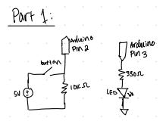
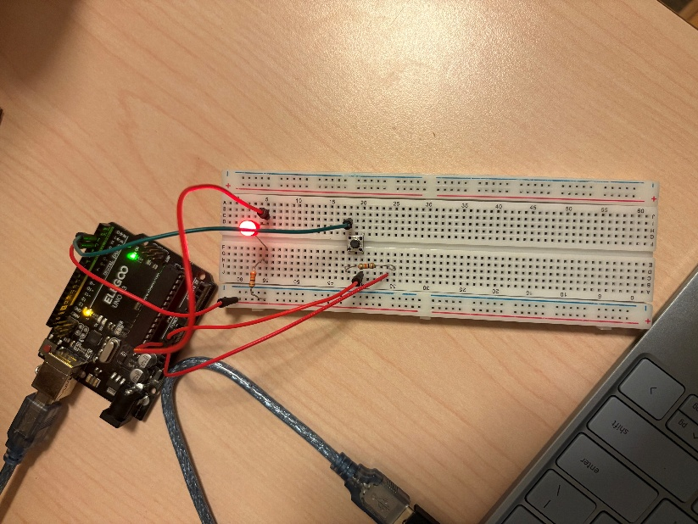

Part 2 Schematic, Picture, and Calculations:
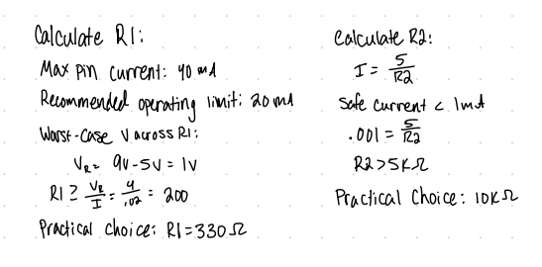
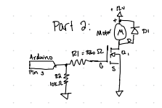

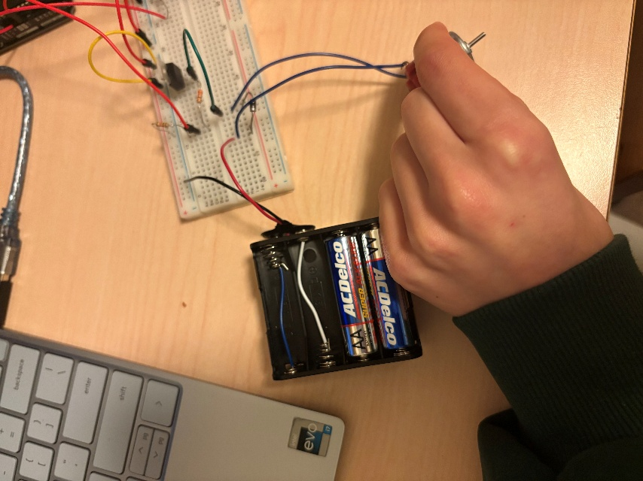

Part 3 Schematic and Picture:
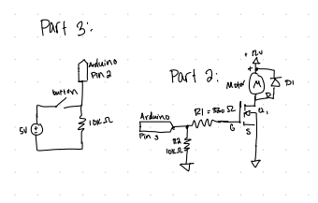
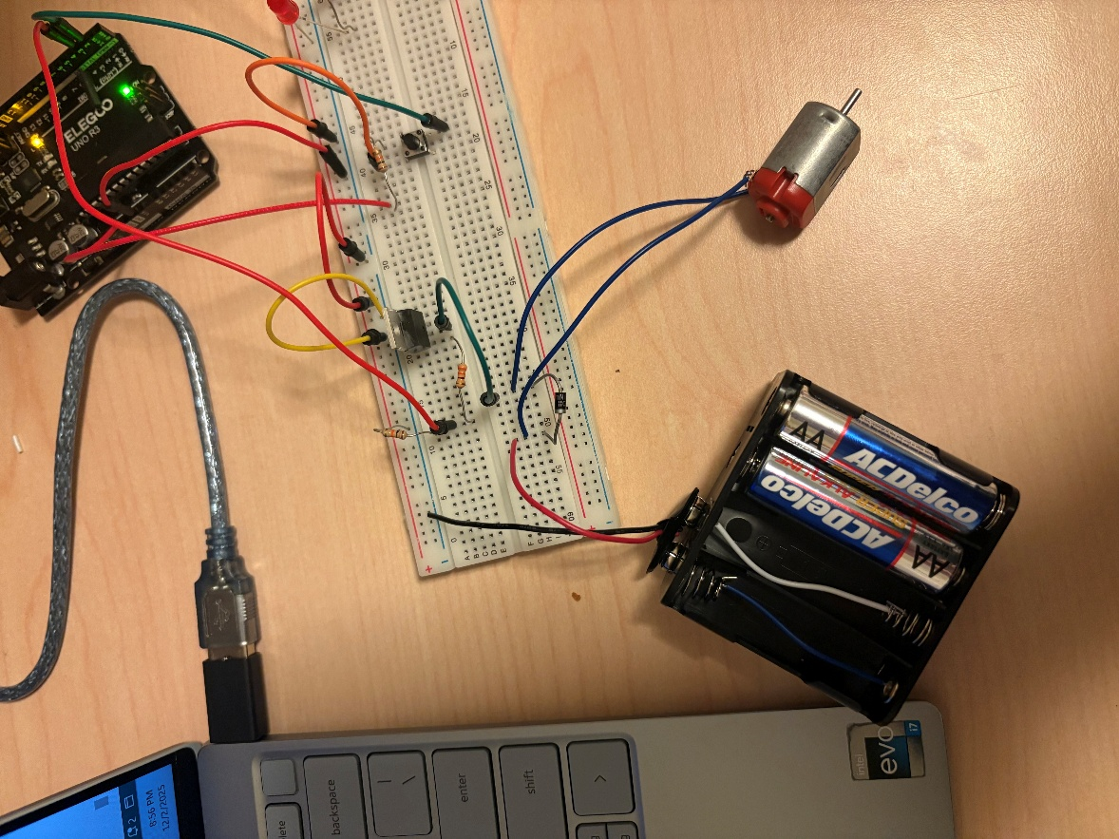

TESTING AND VALIDATION

DESCRIPTION: The tests that have to be performed and validated are shown in Table 1. These tests were performed on the testbed shown Figure 1. The results of testing are shown in Table 2. When necessary, a video of the test is provided along with this report.

Figure 1. Testbed Setup. LEDs connected to digital pins 2 & 3.
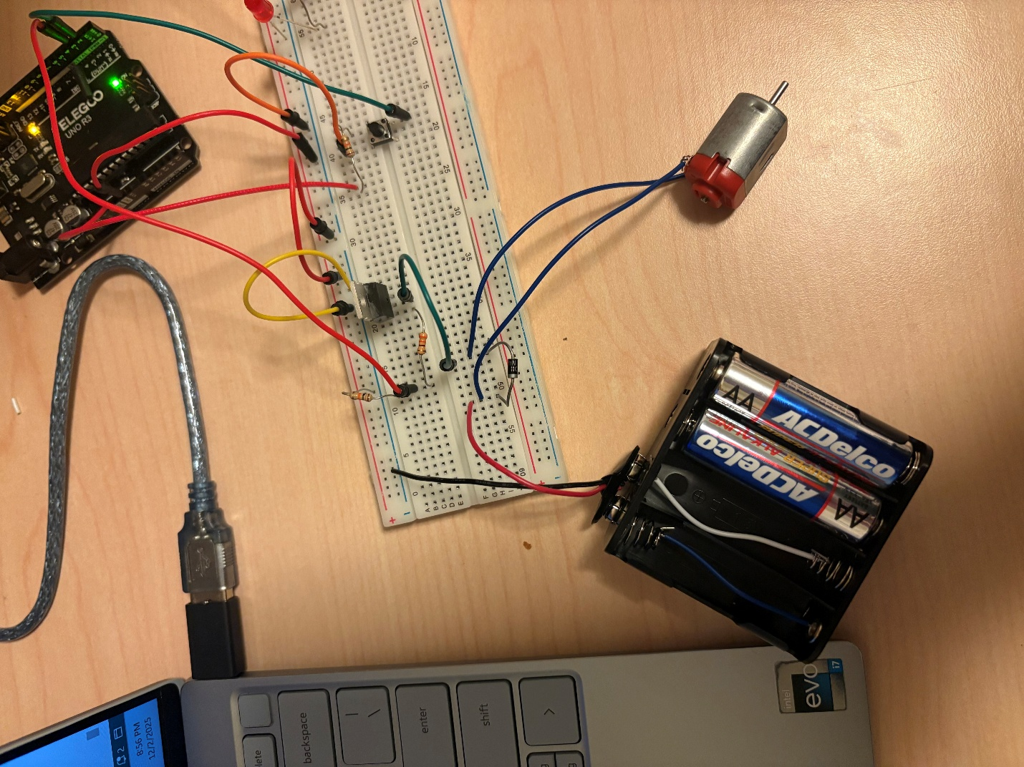

TESTING PLATFORM: <include any equipment, SW, etc necessary to reproduce your design environment>
- ELEGOO Arduino Uno R3 clone
- Arduino IDE 2.3.3 or better
- Power: Testing platform powered through USB cable and battery pack

TESTING AND VALIDATION REQUIREMENTS: <include all tests using appropriate language, e.g. must, so that there is no ambiguity>

Table 1. Testing and Validation Requirements
T.0 All testing and validation must be done on the testbed illustrated in Figure 1.
T.1 The button must be debounced and must not skip any speeds
T.2. The speed of the motor must change with push button
T.2.1. Must increase from 0 to max then back down to 0
T.2.2. Must be able to repeat

TESTING RESULTS: <include any relevant tests, data, videos, etc that are used to confirm the tests>

Table 2. Results of tests
Test performed | Results
T.1 | Satisfied. See video of test.
T.2 | Satisfied. See video of test.
T.2.1 | Satisfied. See video of test.
T.2.2 | Satisfied. See video of test.

Test video Links:
Part 1:
https://drive.google.com/file/d/1sHCau1C-dLjYpPUZWD6n0X8TOdhZOYW8/view?usp=drive_link

Part 2:
https://drive.google.com/file/d/1fMYud0W6sI6cJGHKRFOt-b-NJkojcJa9/view?usp=drive_link

Part 3:
https://drive.google.com/file/d/1Js6X_-Wk_3PyGWMfgdFS82iueswMoHt8/view?usp=drive_link

Appendix A. Logic Flow Chart

Figure 2. Logic flow for program.
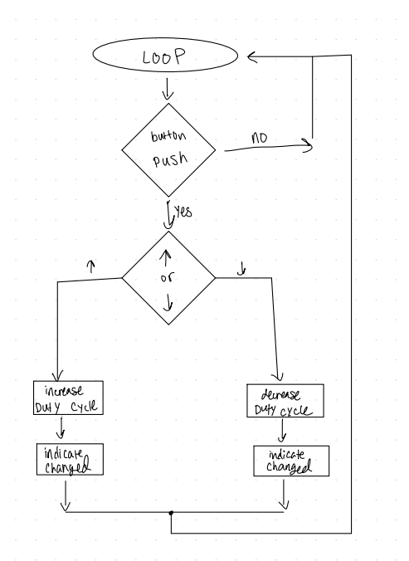

APPENDIX B. DESIGN CODE

#define buttonInput 2 // pin 2 button input
#define LED 3 // pin 3 = OC2B

// Duty cycle sequence
int dutyCycle[] = {0, 64, 128, 191, 255, 191, 128, 64};
int dutyCycleArrLen = 8;
int dutyCycleIndex = 0;

volatile uint8_t currentDuty = 0;
bool flagUpdate = false;

// Debounce variables
bool lastButtonState = HIGH; // pull-up, so HIGH when unpressed
bool stableButtonState = HIGH;
unsigned long lastDebounceTime = 0;
const unsigned long debounceDelay = 50; // ms

// PWM ISR
ISR(TIMER2_OVF_vect) {
if (currentDuty > 0) PORTD |= (1 << PD3); // LED ON at overflow
}

ISR(TIMER2_COMPB_vect) {
if (currentDuty < 255) PORTD &= ~(1 << PD3); // LED OFF at compare match
}

// Timer2 setup for ISR PWM
void setupTimer2PWM() {
cli();
DDRD |= (1 << PD3); // pin 3 output

// Fast PWM mode, TOP = 255
TCCR2A = (1 << WGM20) | (1 << WGM21);
TCCR2B = (1 << WGM22);

// Clock prescaler = 64 (~976 Hz PWM)
TCCR2B |= (1 << CS22);

// Enable interrupts
TIMSK2 |= (1 << TOIE2); // overflow interrupt
TIMSK2 |= (1 << OCIE2B); // compare match B

OCR2A = 255; // TOP
OCR2B = 0; // start at 0% duty

sei();
}

// Duty cycle update
void dutyCycleUpdate() {
if (flagUpdate) {
dutyCycleIndex++;
if (dutyCycleIndex == dutyCycleArrLen) dutyCycleIndex = 0;

currentDuty = dutyCycle[dutyCycleIndex];
OCR2B = currentDuty;

Serial.print("Duty Cycle set to ");
Serial.print(currentDuty);
Serial.println("/255");

flagUpdate = false;
}
}

// Non-blocking debounce
void buttonUpdates() {
bool reading = digitalRead(buttonInput);

// Reset debounce timer if state changes
if (reading != lastButtonState) {
lastDebounceTime = millis();
lastButtonState = reading;
}

// If stable longer than debounceDelay
if ((millis() - lastDebounceTime) > debounceDelay) {
if (reading != stableButtonState) {
stableButtonState = reading;

// Trigger on button press (LOW because using pull-up)
if (stableButtonState == LOW) {
flagUpdate = true;
}
}
}
}

// Task list
typedef void (*tasks)();
tasks taskList[] = { dutyCycleUpdate, buttonUpdates };

void setup() {
Serial.begin(9600);
pinMode(buttonInput, INPUT_PULLUP); // internal pull-up
pinMode(LED, OUTPUT);

// Ensure LED starts OFF at startup
PORTD &= ~(1 << PD3);

// Start at first duty cycle = 0
dutyCycleIndex = 0;
currentDuty = dutyCycle[dutyCycleIndex];
OCR2B = currentDuty;

// Initialize debounce state
stableButtonState = digitalRead(buttonInput);
lastButtonState = stableButtonState;
flagUpdate = false;

setupTimer2PWM(); // enable ISR PWM

Serial.print("Duty Cycle set to ");
Serial.print(currentDuty);
Serial.println("/255");
}

// Main loop
void loop() {
for (int i = 0; i < 2; i++) {
taskList[i]();
}
}

END OF DOCUMENT

