TITLE AND DATE
Document name: Project#2 Task Management CE Lab Report
Document reference: Alvey,Kaylee.cmpe311.fall25.project#2
Date of publication: November 11, 2025

LEAD ENGINEER: Kaylee Alvey, UMBC

STAKEHOLDERS:
Prof Kidd, Instructor, University of Maryland Baltimore County, Baltimore, Maryland, USA
MD Safwan Zaman, TA, University of Maryland Baltimore County, Baltimore, Maryland, USA

HIGH-LEVEL DESCRIPTION: This document is the project document for Project#2 of the CMPE311 class. It contains customer, technical and testing requirements as well as the design and results of the validation testing.

DESCRIPTION: This design is to create a circuit on an Arduino Uno R3 development platform that allows the user of the program to independently specify an LED number and its blink interval. The blinking of the LEDs must continue asynchronously with any input from the user. The project must be implemented using polled and round-robin Cyclic Executive task manager. Included in this document are the customer requirements obtained from the customer, the high-level technical requirements derived from those customer requirements, the design, the testing scenarios and requirements, and the results of testing. Appended to this document is the code executed and a video of those tests that required video documentation.

RESULT SUMMARY: The project was a success, the embedded system design meeting all testing and high-level requirements.

REFERENCES AND GLOSSARY
<to eliminate any ambiguity, include any specific terms or entities, any unique words, any clarification, and any abbreviations>

REFERENCES:
- projectTaskMgmtCE_draft – The definition of the project this document addresses
- ProjectAsynTasking_draft – The definition of project 1 from CMPE311
- CMPE310 Project #5 – A similar project assigned in CMPE310 in Spring 2025
- Arduino UNO R3 Product Reference Manual SKU A000066, 12/03/2024
- Async Programming in Arduino: Unleashing the Power of Non-Blocking Code, Mahdi Valizadeh, medium.com, 4/8/2024
- How To Do Multitasking With Arduino, The Robotics Back-End, roboticsbackend.com

DEFINITIONS:
“The User” – The person operating (not programming) the embedded system
“The System” – The embedded system being operated by The User
“The Customer” – The person(s) paying for the embedded system being designed and built
“The Developer” – The person(s) designing and building the System
“The Evaluator” – The person(s) that determine whether or not The System satisfies The Customer-requirements.
“The Customer-requirements” – The requirements defined by The Customer as satisfying The Contract.
“The Requirements” – The System’s high-level technical requirements derived from The Customer-requirements.
“The Educational-constraints” – Requirements imposed by the instructor unrelated to the embedded system that allow The System to be evaluated.
“The Company” – The organization The Customer has contracted with to build The System.
“The Contract” – The business document that legally binds The Company to provide some service or product to The Customer.
“serial-monitor” – The serial port used by the Arduino IDE to communicate with The User.
“The Reference-platform” – The configuration of The System used by The Developer to test and validate The System. For this class, The System is the Arduino compatible ELEGOO Uno R3 development board.

ACRONYMS AND ABBREVIATIONS:
Arduino – an Italian open-source hardware and software company; also refers to a development board created by the company
arduino.h – header for a library of convenience functions specific to the Arduino development platform
AVR – A family of microcontrollers, originally developed by Atmel, and currently owned by Microchip Technology
ELEGOO – A Chinese company that develops and markets 3D printers and accessories
IDE – Integrated Development Environment
gcc – front end for the GNU Compiler Collection
Github – A widely used distributed SVC (Software Version Control) system
LED – Light Emitting Diode

REQUIREMENTS
<customer, high-level and testing requirements>

CONVENTIONS:
Must, shall or will – your design must satisfy the requirement
May – your design may satisfy the requirement but doesn’t have to
Informative – the intent of the following description is to make the requirement more understandable
All customer requirements are started with “C.#”.
All high-level requirements are started with “HL.#”.
All testing/validation requirements ar5e started with “T.#”

CUSTOMER REQUIREMENTS: <list the customer requirements which I gave you>

C1. The User must be able to set the blink rate of two different LEDs.
C2. The User must be able to update the blink rate of each of the LEDs independently.
C3. The LED must blink at the set rate until The User tells the LED to blink at a different
rate.
C4. The System must run upon an Arduino Uno R3 compatible development board.
C5. The blink rate of an LED must be expressed in terms of milliseconds

The customer requirements, C1 through C5, are identical to that of PROJECT-ASYNC.
Ref: kiddKid.cmpe311.fall25.project#1, CUSTOMER REQUIREMENTS section.

HIGH-LEVEL TECHNICAL REQUIREMENTS: <list the derived high-level technical requirements>

HL.1. The User through the IDE serial monitor must be able to set the blink rate of two different LEDs. (From requirement C1)
HL.1.1. The blink rate of each LED must be able to be set independent of the other LED. (From requirement C2)
HL.1.2. The setting of an LED blink rate must not interfere with the blinking of the LEDs until the new LED and blink rate are specified. (From requirements C2 and C3)
HL.2. The user through the IDE serial monitor must set the blink rate in terms of once every N milliseconds (From requirement C5)
HL.3. The System must run upon an Arduino Uno R3 compatible development board. (From requirement C4)

The high-level technical requirements, HL.1, HL.1.1, HL.1.2, HL.2, and HL.3, are identical to that of PROJECT-ASYNC.
Ref: kiddKid.cmpe311.fall25.project#1, HIGH-LEVEL TECHNICAL REQUIREMENTS section.

DESIGN:
<include schematics, flow diagrams, pseudo code, equipment needed, assumptions, software, data requirements, etc>

DESIGN PRE-REQUISITES:
- ELEGOO Arduino Uno R3 clone
- Arduino IDE 2.3.3 or better

DEVELOPMENT PLATFORM:
- See DESIGN PRE-REQUISITES above

ANY ADDITIONAL DESIGN CONSIDERATIONS:
- None

See Appendix A for the logical flow of the project program.
See Appendix B for the code executing on the Arduino Uno R3.

Picture of Circuit:

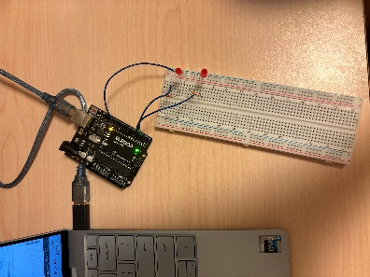

TESTING AND VALIDATION

DESCRIPTION: The tests that have to be performed and validated are shown in Table xxx. These tests were performed on the testbed shown Figure 1. Table 1 shows a dialog that must be successfully performed by the embedded system. The results of testing are shown in Table 3. When necessary, a video of the test is provided along with this report.

Figure 1. Testbed Setup. LEDs connected to digital pins 2 & 3.
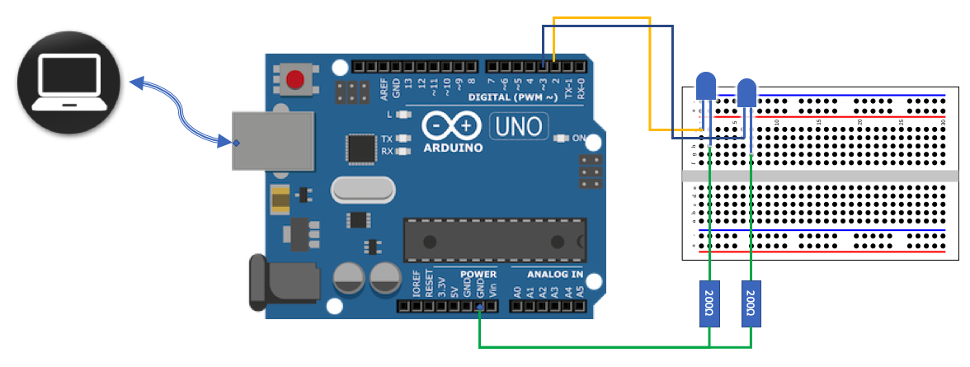

TESTING PLATFORM: <include any equipment, SW, etc necessary to reproduce your design environment>
- ELEGOO Arduino Uno R3 clone
- Arduino IDE 2.3.3 or better
- Power: Testing platform powered through USB cable, LEDs connected directly through Digital Outputs

Table 1. Required Test Dialog (blue are the user inputs).
Serial port I/O | Notes
What LED? (1 or 2) 2
What interval (in msec)? 600 | LED2 starts blinking at an interval of 300ms on and 300ms off. LED1 is unaffected.
What LED? (1 or 2) 1
What interval (in msec)? 1600 | LED1 starts blinking at an interval of 800ms on and 800ms off. LED2 is unaffected.
What LED? (1 or 2) | Waiting for next LED# interval pair

TESTING AND VALIDATION REQUIREMENTS: <include all tests using appropriate language, e.g. must, so that there is no ambiguity>

Table 2. Testing and Validation Requirements
T.0 All testing and validation must be done on the testbed illustrated in Figure 1.

T.1 The dialog above (or similar) must work as shown
T.1A The blink rate of an LED must be able to be set without interfering with the blinking of the other LED
T.1.1 Setting of the blink rate (and LED#) must be through the IDE serial monitor
T.2 The blink rate of the LED being set must not change until the input is complete
T.3 The user must specify the blink rate in milliseconds per blink
T.4 The blink rate specified by the user must be correctly reflected on the testbed LEDs.
T.4.1 The blink rate specified by the user must be reflected on the LED specified by the user
T.5. The setting of an LED’s blink rate must be able to be repeated at least 5 times
T.5.1. Successively for the same LED
T.5.2. Alternately between the different LEDs

TESTING RESULTS: <include any relevant tests, data, videos, etc that are used to confirm the tests>

Table 3. Results of tests
Test performed | Results
T.1.1 | Satisfied. See video of test.
T.1 | Satisfied
T.2 | Satisfied. See video of test.
T.3 | Satisfied
T.4 | Satisfied. See video of test.
T.4.1 | Satisfied. See video of test.
T.5.1 | Satisfied. See video of test.
T.5.2 | Satisfied. See video of test.

Test video Link:
https://drive.google.com/file/d/1kUIoCdlfBso679xWYnxyAaFpXdAoeUQh/view?usp=sharing

Appendix A. Logic Flow Chart

Figure 2. Logic flow for program.
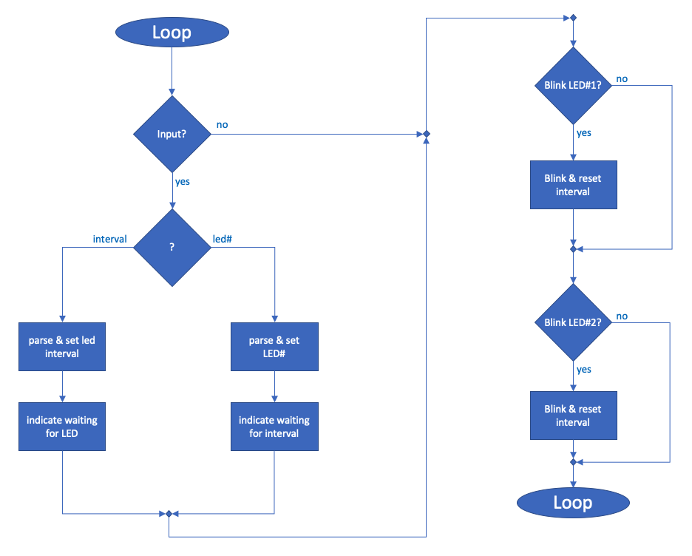

APPENDIX B. DESIGN CODE

// Pin Definitions
const int led1Pin = 2; //LED1 digital output 2
const int led2Pin = 3; //LED2 digital output 3

unsigned long interval1 = 0; // Default interval for LED1
unsigned long interval2 = 0; // Default interval for LED2

unsigned long previousMillis1 = 0; //stores the previous time
unsigned long previousMillis2 = 0; //stries the previous time

bool led1State = LOW; //initial state
bool led2State = LOW; //initial state

// Serial Input State
int step = 0; // 0 = Ask for LED, 1 = Ask for interval
int selectedLED = 0;
String input = ""; //empty string to store inputs later

// Function Prototypes
void Task_BlinkLED1(void);
void Task_BlinkLED2(void);
void Task_SerialHandler(void);

// Cyclic Executive Task Table
typedef void (*TaskPtr)(void);
TaskPtr taskTable[] = {
Task_BlinkLED1,
Task_BlinkLED2,
Task_SerialHandler
};
const int NUM_TASKS = sizeof(taskTable) / sizeof(taskTable[0]);

void setup() {
pinMode(led1Pin, OUTPUT);
pinMode(led2Pin, OUTPUT);
Serial.begin(9600);
Serial.println("What LED? (1 or 2)");
}

// Cyclic Executive Loop
void loop() {
for (int i = 0; i < NUM_TASKS; i++) {
(*taskTable[i])(); // Call each task in round-robin order
}
}

// Task Implementations

// LED1 Blink Task
void Task_BlinkLED1(void) {
unsigned long currentMillis = millis();
if (interval1 > 0 && (currentMillis - previousMillis1 >= interval1)) {
previousMillis1 = currentMillis;
led1State = !led1State; //toggle the LED state
digitalWrite(led1Pin, led1State); //output the toggled state
}
}

// LED2 Blink Task
void Task_BlinkLED2(void) {
unsigned long currentMillis = millis();
if (interval2 > 0 && (currentMillis - previousMillis2 >= interval2)) {
previousMillis2 = currentMillis;
led2State = !led2State; //toggle the LED
digitalWrite(led2Pin, led2State); //output the toggled state
}
}

// Serial Input Task
void Task_SerialHandler(void) {
while (Serial.available()) {
char read = Serial.read();

if (read == '\n') { //if the charcacter is newline, we have read the whole input
if (input.length() > 0) { //make sure input is not empty
if (step == 0) { //user is selecting which LED
selectedLED = input.toInt(); //storing as an int rather than a character
if (selectedLED == 1 || selectedLED == 2) { //makes sure they only input 1 or 2
Serial.println("What interval (in msec)?"); //asks for interval
step = 1; //changes step to 1 indicating that the user will be inputing an interval
} else {
Serial.println("Invalid LED. Enter 1 or 2.");
}
} else if (step == 1) { //user is inputting an interval
unsigned long newInterval = input.toInt(); //stores interval as an integer
if (newInterval > 0) { //makes sure it's greater than 0
if (selectedLED == 1) {
interval1 = newInterval; //stores interval in variable
} else if (selectedLED == 2) {
interval2 = newInterval; //stores interval in variable
}
Serial.println("What LED? (1 or 2)"); //re-asks for an LED and loop starts over
step = 0; //changes step back to 0
} else {
Serial.println("Invalid interval. Enter a positive number.");
}
}
input = ""; //resets inout string
}
} else {
input += read; //adds read string into input when we have not reached a newline
}
}
}

END OF DOCUMENT

