ggplot_hook

Vin

2024-02-17

##Setting up my environment Notes : setting up my environment by loading the ‘tidyverse’ and ‘palmer penguins’ packages

library(tidyverse)

## ── Attaching core tidyverse packages ──────────────────────── tidyverse 2.0.0 ──  
## ✔ dplyr 1.1.4 ✔ readr 2.1.5  
## ✔ forcats 1.0.0 ✔ stringr 1.5.1  
## ✔ ggplot2 3.4.4 ✔ tibble 3.2.1  
## ✔ lubridate 1.9.3 ✔ tidyr 1.3.1  
## ✔ purrr 1.0.2   
## ── Conflicts ────────────────────────────────────────── tidyverse_conflicts() ──  
## ✖ dplyr::filter() masks stats::filter()  
## ✖ dplyr::lag() masks stats::lag()  
## ℹ Use the conflicted package (<http://conflicted.r-lib.org/>) to force all conflicts to become errors

library(palmerpenguins)  
  
ggplot(data = penguins) +   
 geom_point(mapping = aes(x=flipper_length_mm, y = body_mass_g,color=species,shape=species)) +  
 labs(title = "Palmer Penguins : Body Mass vs Flipper Length", subtitle = "Sample of Three Penguins Species",   
 caption = "Data collected by Dr. Kristen Gorman")

## Warning: Removed 2 rows containing missing values (`geom_point()`).

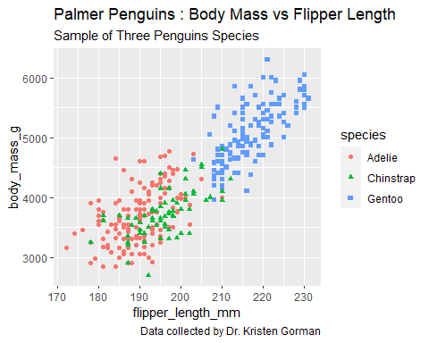

library(ggplot2)  
  
library(palmerpenguins)  
  
data(penguins)  
  
View(penguins)

ggplot(data = penguins) +  
  
geom_point(mapping = aes(x = flipper_length_mm, y = body_mass_g))

## Warning: Removed 2 rows containing missing values (`geom_point()`).

