**Structure the project via the CRISP-DM or Team DS methodologies and give a recommendation of how a git repository for the project could look like. Note that you do not have to structure your final code according to your git-repository proposal.**

**Proposed structure:**

**transaction-prediction**/

├── data/

│ └── dataset.csv

├── models/

│ └── tensor_flow_model.h5

├── notebooks/

│ └── preprocessing_model_training_Scripts.ipynb

├── src/

│ └── app.py

├── templates/

│ └── index.html

├── README.md

└── requirements.txt

**• Access the quality of the provided data set. Prepare and visualize your findings of the initial data analysis in order that business stakeholders can understand them in a clear and easy way.**

The dataset contains some Duplicated the rows ,Unneccessary columns and made some Data exploration such as digitizing the country column into 3 columns which names like Is_Germany,Is_Austia,Is_Switzerland. These are made in the preprocessing and model training scripts.ipynb file.

• **Provide a baseline model as well as an accurate predictive model, .ich fulfills business requirements, i.e. increase credit card success rate and keep fees low.**

The baseline model we trained is tensorflow model and it also kept in the model folder.

**In order that the business places confidence in your rnodel, discuss the importance of the individual features and make the results of the model interpretable.**

Feature Importance Analysis and Feature Interpretation are completed on the the preprocessing and model training scripts.ipynb file.

**In the last step of the project, give a proposal of how your model could be used by the business in everyday work, for instance, via a graphical user interface (GUI).**

I here we used to make this model as Flask API. We can access the model .the GUI look like this.  
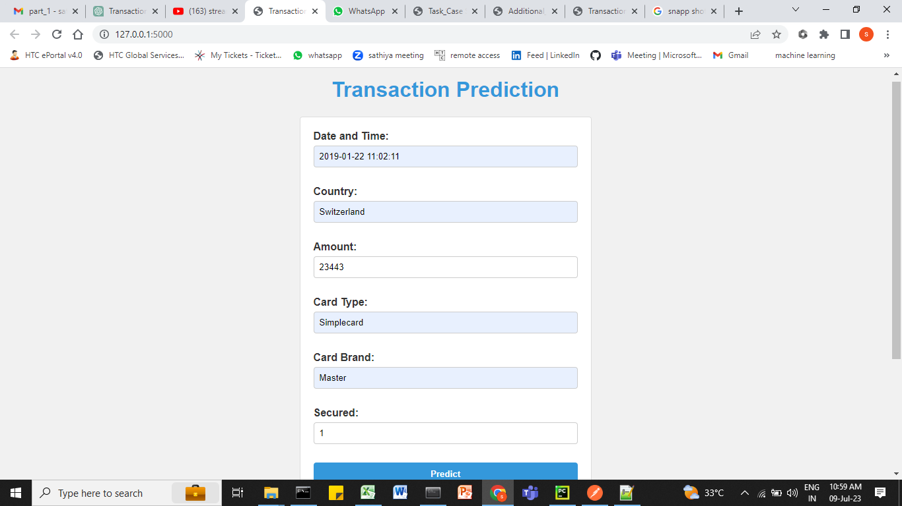

The sample result of the Model:

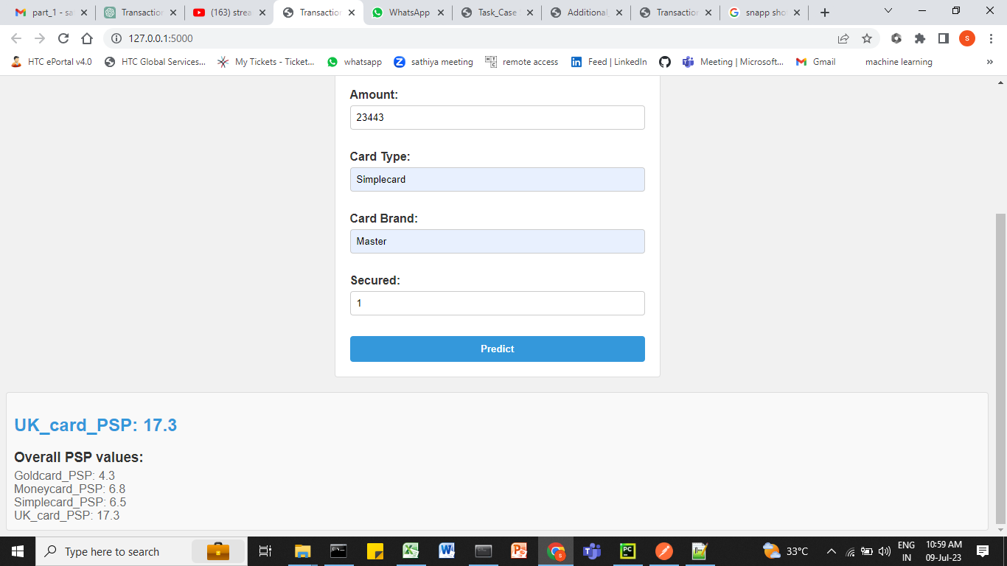

And I attached the result.html as below.  
I have attached the Transaction_Prediction_result.html file for GUI understandings.

**• Finally, do not forget to attach the code to the final subrnission docurnent.** It is also attached in the folder