Friendly Fedora – Project # 22-302

Preliminary Report

Comparison between Microsoft Windows, Fedora Linux, and Linux Mint Operating Systems.

When we compare Linux to other ecosystems like those from Microsoft and Apple, we find that Microsoft’s Windows and Apple’s macOS are closed source systems and Linux is an open source system. Windows and macOS do not have their source codes readily available for others to use and build upon, but Linux source codes are officially available for others to copy, modify and improve. We will be comparing the Graphical User Interfaces of Fedora Linux with that of Linux Mint, using Windows GUI as a frame of reference.

**Graphical User Interface**:

The Graphical User Interfaces of Microsoft Windows 10, Fedora Linux 36, and Linux Mint Operating Systems have some similarities and some differences. When we discuss about the similarities regarding some aspects of the Graphical User Interface, we understand that some features are similar in two out of the three Operating Systems, and are different in the third Operating System, whereas some features might be different in all the three Operating Systems.

Here are some of the aspects of the Graphical User Interface and the similarities and differences between the Operating Systems.

**1. Desktop / Home Page**:

The default Desktop or Home Page is usually the first landing page that gets displayed when a user boots up the computer and signs into the Operating System. After careful observation of the Desktops of the three Operating Systems, we realize that Microsoft Windows and Linux Mint have a similar Desktop Layout, with the Start Button at the bottom left, and the expanded menus getting displayed when the Start Button is clicked. Windows 11 brought the Start Button towards the center of the taskbar at the bottom of the display, but traditionally, from Windows 95 to Windows 10, the Start Button has been present at the bottom left of the display, with Windows 8 being the only exception. However, Fedora Linux seems to be different here as the ‘Activities’ Button at the top left of the display works like the equivalent of a Start Button. Clicking on the Activities button expands the menu, and we can search for more apps in the ‘Type to search’ field which is at the top of the display. In addition to this, while Windows and Linux Mint have the names of actively running programs displayed at the bottom on the taskbar as a minimized window, Fedora has the names of actively running programs next to the Activities Tab at the top. Even system related icons like volume, network, battery etc. are displayed at the bottom right in Windows and Linux Mint, and at the top right in Fedora. Some apps are also displayed at the bottom center of the display in Fedora, but the structure equivalent to a taskbar is at the top.

The screenshot shown above is a Fedora 36 Desktop.

The screenshot shown above is a Linux Mint Desktop.

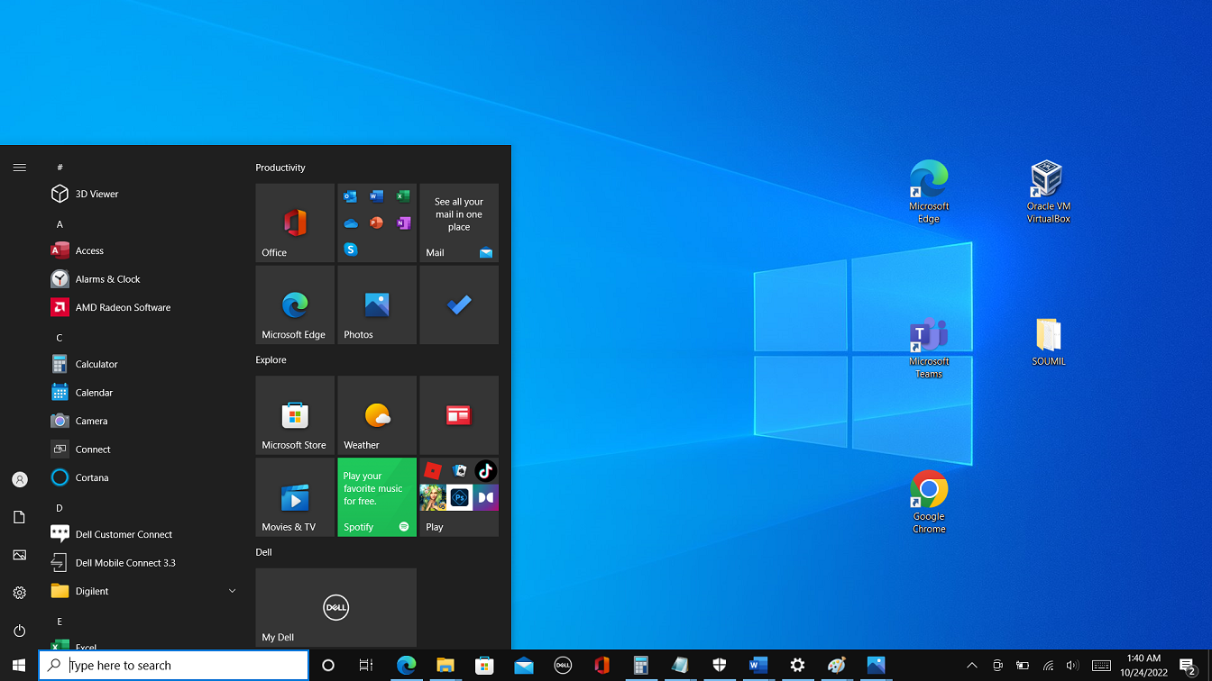

The screenshot shown above is a Windows 10 Desktop.

**2. Scrolling and Scroll Bars**:

Scroll bars are used in almost every Desktop Operating System to handle content that does not fit in the viewable area of the screen. After scrolling through content on Windows and Fedora Linux Operating Systems, it is observed that in Windows, if we click anywhere on the vertical scroll line below the scroll bar, the page scrolls down just enough to show the user the next subset of the content. But in Fedora Linux, if we click below the scroll bar, the amount by which the content on the page scrolls down depends on where we clicked. If we clicked just below the scroll bar, the page would scroll down just enough to display the next subset of the content. But if we clicked on the vertical scroll line towards the bottom of the page, the page scrolls all the way towards the bottom most subset of the content.

In this aspect of the Graphical User Interface, Fedora Linux is similar to Linux Mint, with scroll bars responding identically to user clicks.

**3. File / Folder System**:

The Graphical User Interface of the File / Folder System in Fedora is similar to the one used in Linux Mint and Windows. The outermost structure is a rectangular window with buttons on the top right to minimize, maximize and close the window. The depth of nested folders within folders is large enough for users’ needs. However, Windows uses single letters for partitions on Hard Drive or Solid State Drive, with C: representing the Operating System partition, and subsequent letters representing other partitions.

**4. Hovering the mouse pointer on files with long names**:

In Fedora, when we hover the mouse pointer over the icon of an app whose name is partially displayed because of space limitations, the full name of the app appears. Whereas in Windows, when we hover the mouse pointer over the icon of a file with a long name, a temporary rectangular bubble appears and displays the full name of the file, in addition to its file size and last modified date. In Linux Mint, the files with long names have their entire names displayed.

**5. Downloading Apps**:

To download apps and software in Windows, we traditionally have started through a web browser, we visit the website of the software, and then download the software. But in more modern versions of Windows like Windows 10 and Windows 11, Microsoft has also provided a Microsoft Store that serves as a one-stop place to install apps.

In case of Linux distros like Fedora and Mint, Mint has the Software Manager which is equivalent to the Microsoft Store, where users can download and install apps through GUI. In Fedora, when we click ‘Activities’ on the Home Screen / Desktop, a few icons appear at the bottom, one of which is named as ‘Software’ but usually referred to as Software Center. Users can install apps here using GUI.

**6. Installation Process**:

The installation process of Windows, Fedora and Mint are usually similar. Typically, Windows users purchase their computers with Windows pre-installed, but they can perform a clean installation of Windows if they want to. The installation media previously used to be a .iso file burned to a CD/DVD, but today it is a .iso file burned mostly to a USB flash drive. If the OS being installed inside a Virtual Machine, then a .iso file can be mounted to the virtual optical drive of the Virtual Machine. The installation processes are usually GUI based, however light Fedora versions for devices with lower end specifications can be text based, for example, text, VNC or kickstart installations are preferred for low memory systems.

**References**:

<https://activerains.com/list-of-windows-operating-system-versions-history/>

<https://en.wikipedia.org/wiki/List_of_Microsoft_Windows_versions>

<https://community.linuxmint.com/software/view/mintinstall>

<https://www.davenport.edu/sites/default/files/2022-09/Open-source_software_%E2%80%93_Security_concerns_in_a_corporate_environment-DewayneWasson.pdf>

<https://docs.fedoraproject.org/en-US/fedora/latest/install-guide/>

<https://www.virtualbox.org/manual/UserManual.html>

<https://docs.fedoraproject.org/en-US/fedora/latest/release-notes/welcome/Hardware_Overview/>