Supervised Learning
In supervised learning, we are given a data set and already know what our correct output should look like, having the idea that there is a relationship between the input and the output.
Supervised learning problems are categorized into "regression" and "classification" problems. In a regression problem, we are trying to predict results within a continuous output, meaning that we are trying to map input variables to some continuous function. In a classification problem, we are instead trying to predict results in a discrete output. In other words, we are trying to map input variables into discrete categories.

Unsupervised Learning
Unsupervised learning allows us to approach problems with little or no idea what our results should look like. We can derive structure from data where we don't necessarily know the effect of the variables.
We can derive this structure by clustering the data based on relationships among the variables in the data.
With unsupervised learning there is no feedback based on the prediction results.

To describe the supervised learning problem slightly more formally, our goal is, given a training set, to learn a function h : X → Y so that h(x) is a “good” predictor for the corresponding value of y. For historical reasons, this function h is called a hypothesis.

Cost Function
We can measure the accuracy of our hypothesis function by using a cost function. This takes an average difference (actually a fancier version of an average) of all the results of the hypothesis with inputs from x's and the actual output y's.
This function is otherwise called the "Squared error function", or "Mean squared error". The mean is halved ½ as a convenience for the computation of the gradient descent, as the derivative term of the square function will cancel out the ½ term. The normal equation formula is given below:

Notation

Cost Function Graph
Example of one parameter θ. Every point on the surface is a combination of θ (on X axis) and cost function (on y axis) values.

Gradient Descent
The gradient descent algorithm is:
repeat until convergence:

At each iteration j, one should simultaneously update the parameters θ.

Notation

m – number of training examples
n – number of features
x^{(i)} – i^{th} input training example
y^{(i)} – i^{th} output training example

The square error function plots quadratic line (convex function – with only 1 global minimum), regardless the hypothesis function. Partial derivative calculates function’s slope for particular variable (other variables are constant therefore ignored). When the slope is negative, the value ofincreases and when it is positive, the value of θ decreases.

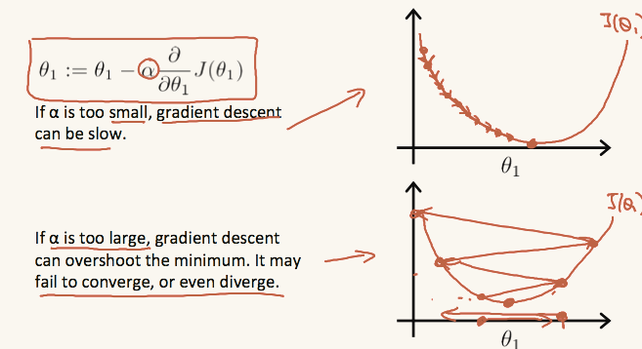

On a side note, we should adjust our parameterto ensure that the gradient descent algorithm converges in a reasonable time. Failure to converge or too much time to obtain the minimum value imply that our step size is wrong.
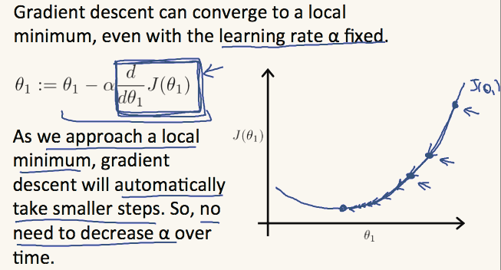

Gradient Descent For Linear Regression
New form of the gradient descent equation can be derived. We can substitute our actual cost function and our actual hypothesis function and modify the equation to:

Calculating derivative for function of 2 variables:

Multiple Features
The multivariable form of the hypothesis function accommodating these multiple features is as follows:

is an additional parameter.
is a bias varialbe with the value of ‘1’ that need to be added at the beginning of every training vector.

Feature Scaling
We can speed up gradient descent by having each of our input values in roughly the same range. This is because θ will descend quickly on small ranges and slowly on large ranges, and so will oscillate inefficiently down to the optimum when the variables are very uneven.
The way to prevent this is to modify the ranges of our input variables so that they are all roughly the same. For example:

Two techniques to help with this are feature scaling and mean normalization. Feature scaling involves dividing the input values by the range (i.e. the maximum value minus the minimum value) of the input variable, resulting in a new range of just 1. Mean normalization involves subtracting the average value for an input variable from the values for that input variable resulting in a new average value for the input variable of just zero.
Feature scaling: where range is
Mean normalization: where s_{i} is range(x_{i}) or standard deviation of x_{i}

Learning Rate
Debugging gradient descent:
Make a plot with number of iterations on the x-axis. Now plot the cost function, J(θ) over the number of iterations of gradient descent.
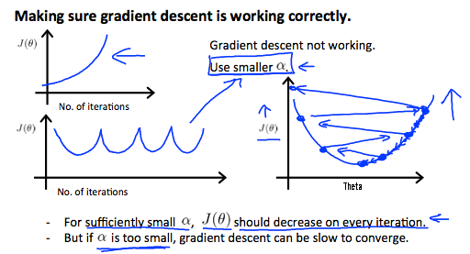

If α is too small: slow convergence.
If α is too large: may not decrease on every iteration and thus may not converge.

Polynomial Regression
We can improve our features and the form of our hypothesis function in a couple different ways.
We can combine multiple features into one. For example, we can combine x₁ and x₂ into a new feature x₃ by taking x₁⋅x₂.
Our hypothesis function need not be linear (a straight line) if that does not fit the data well.
We can change the behavior or curve of our hypothesis function by making it a quadratic, cubic or square root function (or any other form).
For example, if our hypothesis function is h_{θ}(x)=θ₀+θ₁x₁ then we can create additional features based on x₁, to get the quadratic function h_{θ}(x)=θ₀+θ₁x₁+θ₂x₁² or the cubic function h_{θ}(x)=θ₀+θ₁x₁+θ₂x₁²+θ₃x₁³
In the cubic version, we have created new features x₂ and x₃ where x₂=x₁² and x₃=x₁³.
To make it a square root function, we could do:
One important thing to keep in mind is, if you choose your features this way then feature scaling becomes very important.
eg. if x₁ has range 1 - 1000 then range of x₁² becomes 1 - 1000000 and that of x₁³ becomes 1 - 1000000000

Normal Equation
In the Normal Equation method, we will minimize J by explicitly taking its derivatives with respect to the θ_{j}’s, and setting them to zero. This allows us to find the optimum theta without iteration. The normal equation formula is given below:

There is no need to do feature scaling with the normal equation.
The following is a comparison of gradient descent and the normal equation:
Gradient Descent | Normal Equation
Need to choose alpha | No need to choose alpha
Needs many iterations | No need to iterate
O (kn²) | O (n³), need to calculate inverse of X^{T}X
Works well when n is large | Slow if n is very large

With the normal equation, computing the inversion has complexity O(n³). So if we have a very large number of features, the normal equation will be slow. In practice, when n exceeds 10,000 it might be a good time to go from a normal solution to an iterative process.

Classification
To attempt classification, one method is to use linear regression and map all predictions greater than 0.5 as a 1 and all less than 0.5 as a 0. However, this method doesn't work well because classification is not actually a linear function therefore polynomial function can’t be fitted well:
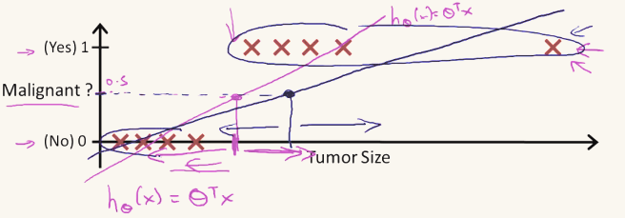
The classification problem is just like the regression problem, except that the values y we now want to predict take on only a small number of discrete values. For now, we will focus on the binary classification problem in which y can take on only two values, 0 and 1. (Most of what we say here will also generalize to the multiple-class case.) For instance, if we are trying to build a spam classifier for email, then x^{(i)} may be some features of a piece of email, and y may be 1 if it is a piece of spam mail, and 0 otherwise. Hence, y∈{0,1}. 0 is also called the negative class, and 1 the positive class, and they are sometimes also denoted by the symbols “-” and “+.” Given x^{(i)}, the corresponding y^{(i)} is also called the label for the training example.

Hypothesis Representation
We could approach the classification problem ignoring the fact that y is discrete-valued, and use our old linear regression algorithm to try to predict y given x. However, it is easy to construct examples where this method performs very poorly. Intuitively, it also doesn’t make sense for h_{θ}(x) to take values larger than 1 or smaller than 0 when we know that y ∈ {0, 1}. To fix this, let’s change the form for our hypotheses h_{θ}(x) to satisfy 0 ≤ h_{θ}(x) ≤ 1. This is accomplished by plugging θ^{T}x into the Logistic Function.
Our new form uses the "Sigmoid Function," also called the "Logistic Function":
Notation

The following image shows us what the sigmoid function looks like:
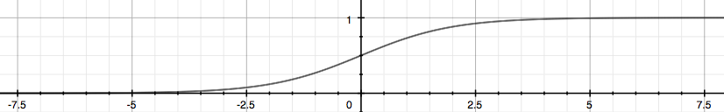
The function g(z), shown here, maps any real number to the (0, 1) interval, making it useful for transforming an arbitrary-valued function into a function better suited for classification.
h_{θ}(x) will give us the probability that our output is 1. For example, h_{θ}(x)=0.7 gives us a probability of 70% that our output is 1. Our probability that our prediction is 0 is just the complement of our probability that it is 1 (e.g. if probability that it is 1 is 70%, then the probability that it is 0 is 30%).

Decision Boundary
In order to get our discrete 0 or 1 classification, we can translate the output of the hypothesis function as follows:

The way our logistic function g behaves is that when its input is greater than or equal to zero, its output is greater than or equal to 0.5:

So if our input to g is θ^{T}X, then that means:

The decision boundary is the line that separates the area where y = 0 and where y = 1. It is created by our hypothesis function.

Example how it works:

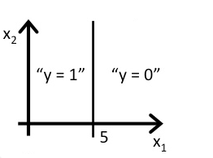

Cost Function
We cannot use the same cost function that we use for linear regression because the Logistic Function will cause the output to be wavy, causing many local optima. In other words, it will not be a convex function.
Instead, our cost function for logistic regression looks like:

Simplified Cost Function
We can compress our cost function's two conditional cases into one case:

Gradient Descent for Classification
The equation is identical to the one we used in linear regression.

Advanced Optimization
"Conjugate gradient", "BFGS", and "L-BFGS" are more sophisticated, faster ways to optimize θ that can be used instead of gradient descent. We suggest that you should not write these more sophisticated algorithms yourself (unless you are an expert in numerical computing) but use the libraries instead, as they're already tested and highly optimized. Octave provides them.
We first need to provide a function that evaluates the following two values for a given input value θ:
Cost function J(θ)
Gradient
We can write a single function that returns both of these:

Then we can use octave's "fminunc()" optimization algorithm along with the "optimset()" function that creates an object containing the options we want to send to "fminunc()".

Multiclass Classification: One-vs-all
Now we will approach the classification of data when we have more than two categories. Instead of y = {0,1} we will expand our definition so that y = {0,1...n}.
We are basically choosing one class and then lumping all the others into a single second class. We do this repeatedly, applying binary logistic regression to each case, and then use the hypothesis that returned the highest value as our prediction.

The following image shows how one could classify 3 classes:
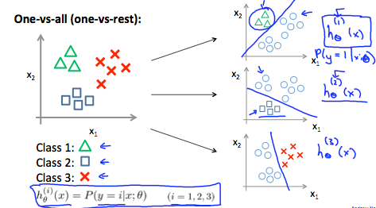

To summarize:
Train a logistic regression classifier h_{θ}(x) for each class to predict the probability that y = i.
To make a prediction on a new x, pick the class that maximizes h_{θ}(x).

The Problem of Overfitting
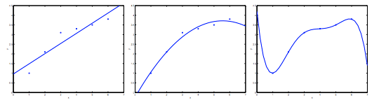
Consider the problem of predicting y from x ∈ R. The leftmost figure below shows the result of fitting a y = θ₀ + θ₁x to a dataset. We see that the data doesn’t really lie on straight line, and so the fit is not very good.

Instead, if we had added an extra feature x2, and fit y = θ₀ + θ₁x + θ₂x², then we obtain a slightly better fit to the data (See middle figure). Naively, it might seem that the more features we add, the better. However, there is also a danger in adding too many features: The rightmost figure is the result of fitting a 5th order polynomial . We see that even though the fitted curve passes through the data perfectly, we would not expect this to be a very good predictor of, say, housing prices (y) for different living areas (x). Without formally defining what these terms mean, we’ll say the figure on the left shows an instance of underfitting - in which the data clearly shows structure not captured by the model - and the figure on the right is an example of overfitting.
Underfitting, or high bias, is when the form of our hypothesis function h maps poorly to the trend of the data. It is usually caused by a function that is too simple or uses too few features. At the other extreme, overfitting, or high variance, is caused by a hypothesis function that fits the available data but does not generalize well to predict new data. It is usually caused by a complicated function that creates a lot of unnecessary curves and angles unrelated to the data.
This terminology is applied to both linear and logistic regression. There are two main options to address the issue of overfitting:
1) Reduce the number of features:
- Manually select which features to keep.
- Use a model selection algorithm (studied later in the course).
2) Regularization
- Keep all the features, but reduce the magnitude of parameters θ_{j}.
- Regularization works well when we have a lot of slightly useful features.

Cost Function + Regularization

If we have overfitting from our hypothesis function, we can reduce the weight that some of the terms in our function carry by increasing their cost.
Say we wanted to make the following function more quadratic:

We'll want to eliminate the influence of θ₃x³ and θ₄x⁴. Without actually getting rid of these features or changing the form of our hypothesis, we can instead modify our cost function:

We've added two extra terms at the end to inflate the cost of θ₃ and θ₄. Now, in order for the cost function to get close to zero, we will have to reduce the values of θ₃ and θ₄ to near zero. This will in turn greatly reduce the values of θ₃x³ and θ₄x⁴ in our hypothesis function. As a result, we see that the new hypothesis (depicted by the pink curve) looks like a quadratic function but fits the data better due to the extra small terms θ₃x³ and θ₄x⁴.

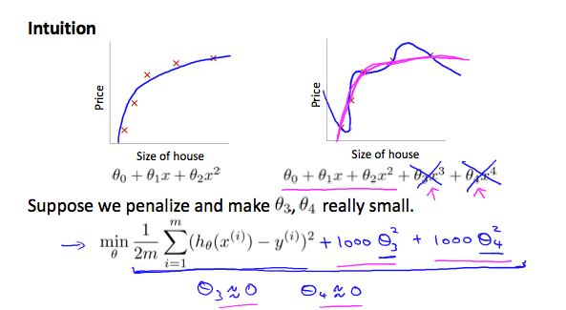

We could also regularize all of our theta parameters in a single summation as:

The λ, or lambda, is the regularization parameter. It determines how much the costs of our theta parameters are inflated.
Using the above cost function with the extra summation, we can smooth the output of our hypothesis function to reduce overfitting. If lambda is chosen to be too large, it may smooth out the function too much and cause underfitting.
Gradient Descent + Regularization
We will modify our gradient descent function to separate out θ₀ from the rest of the parameters because we do not want to penalize θ₀.

The second sum, ∑_{j=1}^{n}=θ_{j}² means to explicitly exclude the bias term, θ₀. I.e. the θ vector is indexed from 0 to n (holding n+1 values, θ₀ through θ_{n}), and this sum explicitly skips θ₀, by running from 1 to n, skipping 0. Thus, when computing the equation, we should continuously update the two following equations:

The term performs our regularization. With some manipulation our update rule can also be represented as:

Regularized Logistic Regression
We can regularize logistic regression in a similar way that we regularize linear regression. As a result, we can avoid overfitting.

Cost Function:

Gradient Descent:

Neural Network
Let's examine how we will represent a hypothesis function using neural networks. At a very simple level, neurons are basically computational units that take inputs (dendrites) as electrical inputs (called "spikes") that are channeled to outputs (axons). In our model, our dendrites are like the input features x_{1⋯}x_{n}, and the output is the result of our hypothesis function. In this model our x₀ input node is sometimes called the "bias unit." It is always equal to 1. In neural networks, we use the same logistic function as in classification, , yet we sometimes call it a sigmoid (logistic) activation function. In this situation, our "theta" parameters are sometimes called "weights".
Visually, a simplistic representation looks like:

Our input nodes (layer 1), also known as the "input layer", go into another node (layer 2), which finally outputs the hypothesis function, known as the "output layer".
We can have intermediate layers of nodes between the input and output layers called the "hidden layers."
In this example, we label these intermediate or "hidden" layer nodes a₀²⋯a_{n}² and call them "activation units."

Notation

Model Representation I:
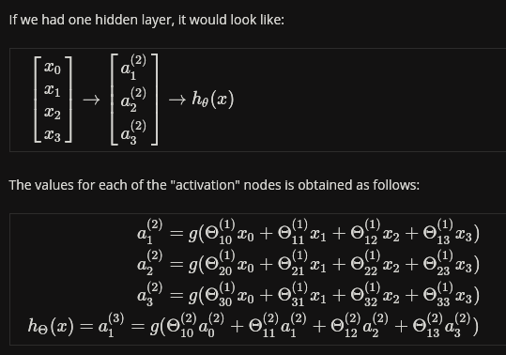

This is saying that we compute our activation nodes by using a 3×4 matrix of parameters. We apply each row of the parameters to our inputs to obtain the value for one activation node. Our hypothesis output is the logistic function applied to the sum of the values of our activation nodes, which have been multiplied by yet another parameter matrix Θ⁽²⁾ containing the weights for our second layer of nodes.
Each layer gets its own matrix of weights, Θ(j).
The dimensions of these matrices of weights is determined as follows:
If network has s_{j} units in layer j and s_{j+1} units in layer j+1, then Θ^{(j)} will be of dimension s_{j+1}×(s_{j}+1).
The +1 comes from the addition in Θ^{(j)} of the "bias nodes," x₀ and Θ₀^{(j)}. In other words the output nodes will not include the bias nodes while the inputs will.

Model Representation II:
To re-iterate, the following is an example of a neural network:
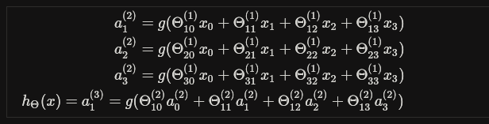
In this section we'll do a vectorized implementation of the above functions. We're going to define a new variable z_{k}^{(j)}that encompasses the parameters inside our g function. In our previous example if we replaced by the variable z for all the parameters we would get:

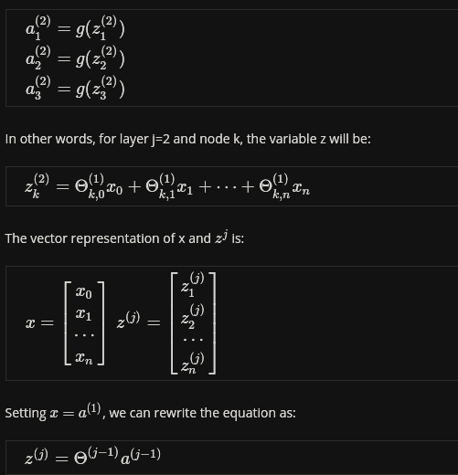

We are multiplying our matrix Θ^{(j−1)} with dimensions s_{j}×(n+1) (where s_{j} is the number of our activation nodes) by our vector a^{(j−1)} with height (n+1). This gives us our vector z^{(j)} with height s_{j}. Now we can get a vector of our activation nodes for layer j as follows:
a^{(j)}=g(z^{(j)})
Where our function g can be applied element-wise to our vector z^{(j)}.
We can then add a bias unit (equal to 1) to layer j after we have computed a^{(j)}. This will be element a₀^{(j)} and will be equal to 1. To compute our final hypothesis, let's first compute another z vector:
z^{(j+1)}=Θ^{(j)}a^{(j)}
We get this final z vector by multiplying the next theta matrix after Θ^{(j−1)} with the values of all the activation nodes we just got. This last theta matrix Θ^{(j)} will have only one row which is multiplied by one column a^{(j)} so that our result is a single number. We then get our final result with:
h_{Θ}(x)=a^{(j+1)}=g(z^{(j+1)})
Notice that in this last step, between layer j and layer j+1, we are doing exactly the same thing as we did in logistic regression. Adding all these intermediate layers in neural networks allows us to more elegantly produce interesting and more complex non-linear hypotheses.

Multiclass Classification
To classify data into multiple classes, we let our hypothesis function return a vector of values. Say we wanted to classify our data into one of N categories.
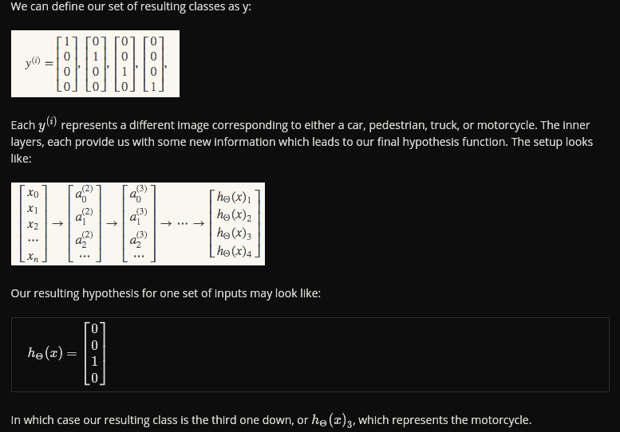
Example:
House represented by 2 features: area and number of doors:
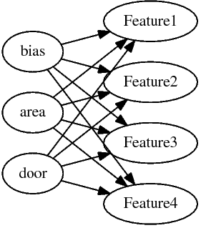

Let’s say we have data about 50 houses that are described by 2 features. It gives us:
a 50x2 matrix - each row represents one house
a 50x3 matrix if we add a bias unit for every training example
If the hidden layer contains 4 units then the transition matrix from input to first layer:
is 4x3 size – each row contains θ parameters for every single training example
If we do multiplication we get 50x4 matrix where:
each row contains an activation value of specific feature from the hidden layer for each training example.

Cost Function
Recall that in neural networks, we may have many output nodes. We denote h_{Θ}(x)_{k} as being a hypothesis that results in the k^{th} output. Our cost function for neural networks is going to be a generalization of the one we used for logistic regression. For neural networks, it is going to be slightly more complicated:

We have added a few nested summations to account for our multiple output nodes. In the first part of the equation, before the square brackets, we have an additional nested summation that loops through the number of output nodes.
In the regularization part, after the square brackets, we must account for multiple theta matrices. The number of columns in our current theta matrix is equal to the number of nodes in our current layer (including the bias unit). The number of rows in our current theta matrix is equal to the number of nodes in the next layer (excluding the bias unit). As before with logistic regression, we square every term.
Note:
- the double sum simply adds up the logistic regression costs calculated for each cell in the output layer
- the triple sum simply adds up the squares of all the individual Θs in the entire network.
- the i in the triple sum does not refer to training example i

