
raster data manager

raswct Web Client Toolkit
Developer Guide

rasdaman version 9.0

rasdaman Version 9.0 raswct Web Client Toolkit Developer Guide
Rasdaman Community is free software: you can redistribute it and/or modify it under the terms of the GNU General Public License as published by the Free Software Foundation, either version 3 of the License, or (at your option) any later version.
Rasdaman Community is distributed in the hope that it will be useful, but WITHOUT ANY WARRANTY; without even the implied warranty of MERCHANTABILITY or FITNESS FOR A PARTICULAR PURPOSE. See the GNU General Public License for more details.
You should have received a copy of the GNU General Public License along with rasdaman Community. If not, see www.gnu.org/licenses. For more information please see www.rasdaman.org or contact Peter Baumann via baumann@rasdaman.com.
Copyright 2003-2013 rasdaman GmbH.
All trade names referenced are service mark, trademark, or registered trademark of the respective manufacturer.

Preface

Overview
Purpose of the raswct (“rasdaman Web Client Toolkit”) toolkit is to allow developers creating Web user interfaces for displaying data from a raster database.

Implementation
The toolkit is developed in Javascript and uses popular libraries like jQuery. Its structure follows the principle of separating data transmission and processing from the presentation, the two main namespaces reflecting this philosophy:
- Query namespace - containing all the classes that can be used to retrieve data from a server, be it a simple HTTP server or a rasdaman server.
- Widget namespace - containing all the classes that can be used to display the data in meaningful ways

This document describes how to create widgets and modify them to suit particular purposes. At the end of each widget description an example of use is given. More examples can be found in the docs/examples folder in the toolkit package.
Throughout the document, the code fragments will be represented using italic.

Audience
Information in this manual is intended primarily for Web application developers.

Rasdaman Documentation Set
This manual should be read in conjunction with the complete rasdaman documentation set which this guide is part of. The documentation set in its completeness covers all important information needed to work with the rasdaman system, such as programming and query access to databases, guidance to utilities such as the graphical-interactive query tool rView, and release notes.
In particular, current restrictions, known bugs, and workarounds are listed in the Release Notes. All documents, therefore, always have to be considered in conjunction with the Release Notes.
The rasdaman Documentation Set consists of the following documents:
- C++ Developer's Guide
- Java Developer's Guide
- Query Language Guide
- Web Client Toolkit Guide
- Installation and Administration Guide
- Error Messages
- rView Guide
- Release Notes

Table of Contents
1 Introduction 7
1.1 Purpose and Use 7
1.2 Implementation 8
1.3 References 8
2 Query Namespace 9
2.1 Base Query 9
2.2 Select Query 10
2.3 URL Query 11
2.4 Query Executor 12
3 Widget Namespace 14
3.1 Base Widget 14
3.2 Input Widget 15
3.3 Text Widget 16
3.4 Slider Widget 17
3.5 Knob Widget 17
3.6 Output Widget 18
3.7 Map Widget 18
3.8 Diagram Widget 20
3.9 Linear Diagram 21
3.10 Area Diagram 22
3.11 Scatter Diagram 24
3.12 Gauge Widget 25
3.13 JGauge Widget 26
3.14 Led Widget 27

Introduction

Purpose and Use
This toolkit allows developers to easily create individualized Web interfaces for displaying multi-dimensional raster data. For example, diagrams serve to present 1-D query results, images and a geo Web Map interface serve to display 2-D query results. 3-D displays are under development. All such data can stem from multi-dimensional database contents, such as 1-D extracts from a 4-D climate data set.
Database queries can be hidden behind interactive parameter setting through sliders, gauges, etc., thereby hiding the complexity of the query language to casual users.
Crafting such Web interfaces often is as easy as writing HTML, without resorting to JavaScript, which is the raswct implementation language. That said, all JavaScript is available to advanced developers for designing high-end interactive data interfaces.

Implementation
The raswct toolkit is developed in Javascript and uses popular libraries, like jQuery. Its structure follows the principle of separating data transmission and processing from the presentation:
- The Query namespace, Rj.query, contains all the classes for data retrieval from a server, be it a simple HTTP server or a rasdaman server.
- The Widget namespace, Rj.widget, contains all the classes for displaying data in various ways.
- Utility functions, gathered in the Rj.util namespace, compensate for Javascript's lack of features in interaction widget basics.

References
Raswct tutorial material is provided at http://raswct.flanche.net/apps/doc and http://raswct.flanche.net/apps/trainer.
The raswct toolkit is heavily used in the EarthLook geo service standards showcase.

Query Namespace

Base Query
Description
Base class for the query classes. It does nothing on its own, but is a good starting point for any class that wants to have data transport capabilities.
Attributes
Name | Type | Description
- id | Int | Unique identifier of the BaseQuery object
- query | String | The string query that will be executed.
Methods
Name | Parameters | Return Type | Description
+ getId() |  | Int | Standard getter for the id attribute.
+ getQuery() |  | String | Standard getter for the query attribute.
+ setQuery( query ) | query: string | BaseQuery | Sets a new value to the query and returns the BaseQuery object on which the operation has been performed.
Notes
This class should not be used on its own, it is provided only as a means for exposing new ways of querying the data from the server. Please note that although there is no mechanism in JavaScript to enforce this any child class should implement a transport method (see class QueryExecutor for more details)

Select Query
Description
The SelectQuery class provides an abstraction over the select query sent to the server. It allows widget developers to easy modify queries by adding new variables to the query that can be replaced with meaningful values at the transmission time.
Attributes
Name | Type | Description
- url | String | The url to the service that can execute the raster query
- query | String | The initial query attached to this object.
- variables | Object | The variables that are attached to the query, each of them can be modified using setVariable.
Methods
Name | Parameters | Return Type | Description
+ getVariable( variable ) | String | String | Returns the value attached to the given variable.
+ setVariable( variable, value ) | variable: string,  value: mixed | [[SelectQuery]] | Assigns a value to a variable and returns the query object the action is being performed on.
+ replaceVariablesInQuery() |  | String | Replaces the variables from the query and returns its new value.
+ transport() |  | Object | Return the query in a transport format, as requested by the QueryExecutor specs.
Examples
The following code snippet creates a raster query:
var rasQuery = new Rj.Query.SelectQuery(
“http://example.org/raster_service”,
“SELECT (x.red > $red, x.green > $green)
FROM collection as x”, {});
rasQuery.setVariable( “$red”, 25);
rasQuery.setVariable( “$green”, 50);
rasQuery.setVariable( “$red”,
rasQuery.getVariable(“$red”) + 10);
console.log( rasQuery.replaceVariablesInQuery() );
This will output SELECT jpeg(x.red > 35, x.green > 50) FROM collection as x.
Note
In most cases you will not need to use the replaceVariablesInQuery() method as all transport methods call it automatically.

URL Query
Description
The UrlQuery class provides an abstraction over queries sent to a server.
It allows seamless request-response transactions to a http server.
Attributes
Name | Type | Description
- baseUrl | String | The URL to start from.
- type | String | The request type (e.g. GET || POST)
- parameters | Array | An array of parameters to be used.
Methods
Name | Parameters | Return Type |  | Description
+ addParameter( parameter ) | parameter: object | Void | Adds a parameter to the request.
+ removeParameter( parameter ) | parameter: object | Void | Removes a parameter from the request.
+ transportGet() |  | String | Returns a formatted get string URL.
+ transport() |  | Object | Implements the transport method required for all objects that are handled by an executor.
Examples
The following code snippet creates an UrlQuery and modifies its parameters. Please see QueryExecutor for the data retrieval procedure
var exQuery = new Rj.Query.UrlQuery(
“http://example.org/data_service/”,
Rj.Constants.UrlQuery.POST, {
param1 : “some value”,
param2 : “some value 2”
});
exQuery.addParameter( “param3”, “value 3” );
exQuery.removeParameter( “param2” );
We now have a query object that retrieves data from example.org/data_service via a POST request sending several parameters (param1 and param3).

Query Executor
Description
The QueryExecutor is a singleton class that is responsible for the communication with the server. It can receive queries from any BaseQuery descendants and then send them to the server through an HTTP request responding to the requester with the result object received from the server. The requests are done asynchronous in a non-blocking way so that multiple widgets can request queries from the server without waiting one for the other.
Attributes
Name | Type | Description
- query | Object | An object of type descendant of BaseQuery Class.
Methods
Name | Parameters | Return Type | Description
+ sendRequest( data, handler ) | Object data, Function handler | none | send the request to the server containing the query and calls the handler function provided with an array of results. Please note that the function doesn’t return a result, but calls the handler once the server has responded
Examples
var rasQuery = new Rj.Query.SelectQuery(
“http://example.org/raster_service”,
“SELECT jpeg(x.red > $red, x.green > $green)
FROM collection as x”, {} );
rasQuery.setVariable( “$red”, 25 );
rasQuery.setVariable( “$green”, 50 );
var executor = Rj.Query.QueryExecutor( rasQuery );
executor.callback( function(response){ // here response
console.log( response ); // from server
});
Note that the executor is a deferrable object, similar to Future objects in Java, so that means you will get the result asynchronously, e.g. you can register a handle that will be executed when the data is retrieved from the server.

Widget Namespace

Base Widget
Description
The base widget is a wrapper class that has to be extended by any widget that want to interact with the system. It wraps an existing widget from a library like jQuery UI or any other a developer might need, providing it with a simple event-communication system and with a BaseQuery that can modify the database results.
Atrributes
Name | Type | Description
- widget | Object | The library widget that is being used, e.g., jQuery.ui.slider or google.Charts.VisualizationChart
- query | BaseQuery | The query that the widget wants to manipulate, any descendant of BaseQuery can be used
- listeners | Array | An array of events that the widget wants to listen to. Each element has to be defined as an object of form {eventName : handlerFunction}
- selector | CSS3 / XPath | A CSS3/XPath selector used as indentifier for the position of the widget.
Methods
Name | Parameters | Return Type | Description
+ renderTo( node ) | DOMObject node | None | Renders the widget in the node provided. Can be anything ranging from body to a specific div
+ show() | none | None | Make the widget visible. By default widgets are rendered invisible
+ hide() | none | None | Make the widget invisible
+ fireEvent( eventName, bubble, args ) | String eventName, boolean bubble, Array args | None | Fires a defined event, with the arguments specified in the third parameter. If bubble is a set to true, the event will be propagated upwards and any widgets that registered for the event will be notified
+ addListener( eventName, handler) | String eventName, function handler | None | Registers a new handler for a specific event
+ removeListener( eventName ) | String eventName | None | Removes the handler of this widget for the event, the widget will not be notified of these event anymore
Examples
This is a base class for widgets so it shouldn’t be initialized or used except for extending the current widget system.

Input Widget
Description
InputWidget is a simple grouper class that helps better define the relationships between widgets.
Attributes
Name | Type | Description
- value | string | The value displayed in widget.
Methods
Name | Parameters | Return Type | Description
+ getValue() |  | string | Standard getter for the value attribute.
+ setValue( value ) | value : string | Void | Standard setter for the value attribute.

Examples
This is a base class for widgets so it shouldn’t be initialized or used except for extending the current widget system.

Text Widget
Description
Defines a widget which allows the user to input text queries.
Attributes
Name | Type | Description
- rows | Int | The number of rows the widget has.
- cols | Int | The number of columns the widget has.
- submitValue | String | The value of the submit button.
- value | String | The value displayed in the widget.
Examples
Js code:
var txtWidget = new Rj.Widget.TextWidget();
txtWidget.renderTo(“#text-widget-example”);
txtWidget.setValue(“Hello World”);
Html code:
<div id=”#text-widget-example”>
The widget will be rendered here
</div>

Slider Widget
Description
Defines an abstraction of a widget which allows the user to use a multiple level slider.
Attributes
Name | Type | Description
- slideLevel | Int | The current level to which the slider is.
Methods
Name | Parameters | Return Type | Description
+ getSlideLevel() |  | int | Standard getter for the slideLevel attribute.
+ setSlideLevel( slideLevel ) | SlideLevel: int | Void | Standard setter for the slideLevel attribute.
Examples
The following example will display a slider with values from 1000 to 11000 with a step size of 500. When the slider is moved a message will be printed to the console.
var thresholdSlider = new Rj.Widget.SliderWidget(
1000, 11000, Rj.Constants.WidgetSlider.VERTICAL,
500, 8000); //min, max, orientation, step size, default
thresholdSlider.renderTo( “#thr” );
// Using changevalue event to detect slider modification
thresholdSlider.addListener( “myAppName”, “changevalue”,
function(value){
console.log( “This is the new value: “
+ value.toString();
});

Knob Widget
Description
Defines a knob widget.
Attributes
Name | Type | Description
- min | Int | The lower bound of the knob.
- max | Int | The higher bound of the knob.
- value | Int | The initial value of the knob.
-reverse | Bool | If true, the values are distributed backwards (from 360 degrees to 0 degrees).
- snap | Int | The number of degrees from which the knob is snapped to 0.
Methods
Name | Parameters | Return Type | Description
+ getValue() | None | Int | Standard getter for the value attribute.
Examples
The following code creates a Knob object within a <div id = ”knob”></div> element:
var knob = new Rj.Widget.Knob(0, 10, 5, false, 20);
knob.renderTo(“knob”);

Output Widget
Description
OutputWidget is a simple grouper class that helps better define the relationships between widgets.
Attributes
Name | Type | Description
- query | Object | The query object used for getting the results displayed by the widget.
- widget |  | Identifier of the widget.
Methods
Name | Parameters | Return Type | Description
+ refresh() |  |  | Stub method for the extending classes.

Map Widget
Description
Defines an a widget used for displaying maps composed of several layers.
Implementation is based on the OpenLayers library, see http://openlayers.org/.
Attributes
Name | Type | Description
- map | Object | The raw OpenLayers map.
Methods
Name | Parameters | Return Type | Description
+ getRawMap() |  | Object | Returns the raw OpenLayers Map.
+ addLayers() |  | Void | Adds layers to the map.

Examples
The following code will display a map with one layer:
//Define the map widget and the coordinate system
var map = new Rj.Widget.MapWidget({
projection : "EPSG:32633",
maxExtent : new OpenLayers.Bounds( 489750, 7988500,
492750, 7990000 ),
tileSize : new OpenLayers.Size(500, 500),
numZoomLevel : 4
});
//Define a new base layer for the map.
// Any WMS service url will do:
var HakoonBathymetryLayer = new Rj.Widget.LayerWidget(
"Hakon_Bathymetry",
”http://212.201.49.173:8080/rasogc/rasogc”, {
layers: 'Hakon_Bathymetry',
styles: 'colored',
format : "image/png",
version : "1.1.0",
exceptions : 'application/vnd.ogc.se_xml',
customdem : 'minLevel,maxLevel,T'
},{
transitionEffect : 'resize'
});
//Add this layer to the map
map.addLayers([HakoonBathymetryLayer]);
//... and render it to the #maps div
map.renderTo("#maps");
Visual appearance:
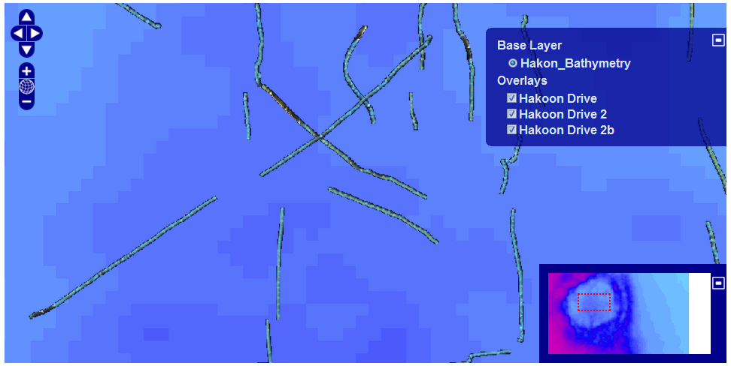

Diagram Widget
Description
Defines a widget used as a base for all charts.
Attributes
Name | Type | Description
- title | String | The title of this diagram.
- xAxisTitle | String | The title of the X axis.
-yAxisTitle | String | The title of the Y axis.
Methods
Name | Parameters | Return Type | Description
+ setData | data: Array | Boolean | Sets the data attribute and fires two events: datapreload - before the data is loaded  datapostload - fired once the data is loaded
+ getData |  | Array | Returns the data assigned to the widget
+ addDataSeries | series: Array  name: String | Int | Adds a data series to the diagram as an array of form [ [x,y] , [x1, y1] ] and returns an index of the new data serie
+ removeDataSeries | index: Int | Int | Removes a series from the diagram. The index is the same as the one returned by addDataSeries
+ configure | cfg: Object | Object | Configures the chart object before rendering. All subclasses should override this method in order to add their specific configurations.
+ renderTo | selector: String, cfg: Object |  | Renders the widget to a given DOM element.
Note
This is a base class for graphs so it shouldn’t be initialized or used except for extending the current graph system.

Linear Diagram
Description
Defines a widget used for displaying linear graphs.
Methods
Name | Parameters | Return Type | Description
+ configure | cfg: Object | Object | Configures the chart object before rendering..

Examples
JS Code:
//Initialize query - we are using an URL Query object
var source = “NN3_10”;
var query = new Rj.Query.UrlQuery( "wcpsParser.php",
'GET', {
'coverageId': source
});
//Create widget
var diagram = new Rj.Widget.LinearDiagram( query,
"#chartPlace", source );
// Get diagram axis and labels before data is rendered
// by listening to the datapreload event
diagram.addListener( 'wcps','datapreload',
function(response){
// Check if any errors occurred,
// and if so display a nice error message
if(response.error){
$("body").append( "<div id='dialog'>"
+ response.error + '</div>');
$( "#dialog" ).dialog({
modal : true,
title : 'Parse Error'
}).show();
throw "Error while processing the data";
}
var values = [];
for(var i = 0; i < response.data.length; i++){
values.push( [i, parseInt(response.data[i],
10)]);
}
//Configure the widget axes
this.configure({
axes : {
xaxis:{ title : response.domainInfo.axisLabel },
yaxis: { title : "Values" }
}
});
return {
data : [values]
};
});
// load data and render widget
diagram.loadData(true);
HTML Code:
<div id=’chartPlace’ style=’width:600px; height:500px;’>
<!-- The chart will go here -->
</div>’
Visual appearance:
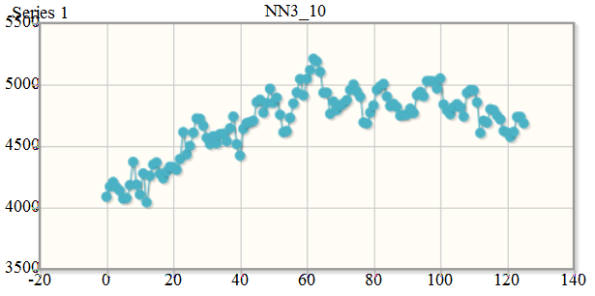

Area Diagram
Description
Defines a widget used for displaying area graphs.
Methods
Name | Parameters | Return Type | Description
+ configure | cfg: Object | Object | Configures the chart object before rendering..

Examples
JS Code:
var source = “NN3_10”
//Initialize query - we are using an URL Query object
var query = new Rj.Query.UrlQuery("wcpsParser.php", 'GET', {
'coverageId': source
});
//Create widget
var diagram = new Rj.Widget.AreaDiagram( query,
"#chartPlace", source);
// Get diagram axis and labels before data is rendered
diagram.addListener( 'wcps','datapreload',
function(response){
var values = [];
for(var i = 0; i < response.data.length; i++){
values.push( [i, parseInt(response.data[i],
10)]);
}
//Configure the widget labels
this.configure({
axes: {
xaxis: {
title: response.domainInfo.axisLabel },
yaxis: { title : "Values" }
}
});
return { data : values };
});
//Load the data and render the widget
diagram.loadData(true);
HTML Code:
<div id=’chartPlace’ style=’width:600px; height:500px;’>
<!-- The chart will go here -->
</div>’
Visual appearance:
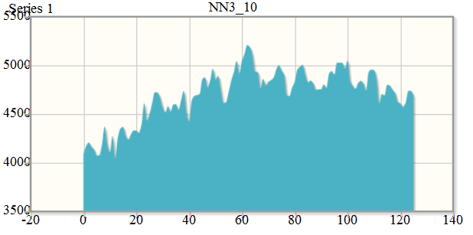

Scatter Diagram
Description
Defines a widget used for displaying scattered graphs.
Methods
Name | Parameters | Return Type | Description
+ configure | cfg: Object | Object | Configures the chart object before rendering..

Examples
JS Code:
// Initialize query - we are using an URL Query object
var source = “NN3_10”
var query = new Rj.Query.UrlQuery("wcpsParser.php", 'GET', {
'coverageId': source
});
// Create widget
var diagram = new Rj.Widget.ScatterDiagram( query,
"#chartPlace", source);
// Get diagram axis and labels after data is loaded
// by listening to datapreload event
diagram.addListener( 'wcps','datapreload',
function(response){
var values = [];
for(var i = 0; i < response.data.length; i++){
values.push( [i, parseInt(response.data[i],
10)]);
}
// Configure widget labels
this.configure({
axes : {
xaxis: {
title : response.domainInfo.axisLabel
},
yaxis : { title : "Values" }
}
});
return { data : values };
});
diagram.loadData(true);
HTML Code:
<div id=’chartPlace’ style=’width:600px; height:500px;’>
<!-- The chart will go here -->
</div>’
Visual appearance:
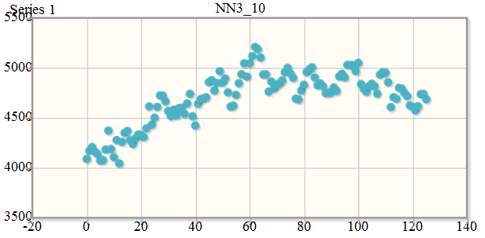

Gauge Widget
Description
Defines a circular gauge widget.
Attributes
Name | Type | Description
- value | Int | The initial value displayed.
- labelSuffix | String | The string displayed after the label value.
- taco | Bool | Sets a custom display.
Methods
Name | Parameters | Return Type | Description
+ getValue() |  | Int | Standard getter for the value attribute.
+ setValue( value ) | value: Int | Void | Standard setter for the value attribute.

Examples
The following example will display a gauge within a <div id = ”gauge”></div> element.
var gauge = new Rj.Widget.Gauge(null,24);
gauge.renderTo("gauge");
Gauge overview
Below the gauges are listed which are available currently; they are described in the subsequence subsections.
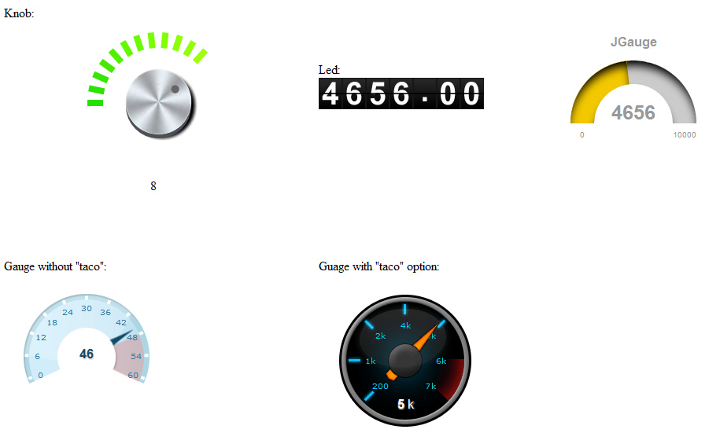

JGauge Widget
Description
Defines a semi-circular gauge widget.
Attributes
Name | Type | Description
- title | String | The title of the widget.
- label | String | The label of the widget.
- min | Int | The lower bound of the displayed values.
- max | Int | The upper bound of the displayed value
- showMinMax | Bool | Shows or hides the bounding values.
- value | String | The initial value displayed.
- width | Float | The scale at which the widget is displayed. 1 is the reference point.
- shadow | Bool | Shows or hides the shadow of the upper part of the widget.
- color | String | The background color of the widget.
- titleColor | String | The color of the title.
- valueColor | String | The color of the value.
- labelColor | String | The color of the label.
Methods
Name | Parameters | Return Type | Description
+ getValue() |  | int | Standard getter for the value attribute.
+ setValue(value) | value: int | Void | Standard setter for the value attribute.

Examples
The following example will display a JGauge object within a <div id = ”jgauge”></div> element.
var jGauge = new Rj.Widget.JGauge( “JGauge”, “Degrees”, 0,
180, 90, 1, true, #fff, #000, #000);
jGauge.renderTo("jgauge");

Led Widget
Description
Defines a led counter widget.
Attributes
Name | Type | Description
- value | Float | The initial value displayed.
- numIntegralDigits | int | The number of digits of the display.
- numFractionalDigits | Bool | The number of fractional digits to display.
Methods
Name | Parameters | Return Type | Description
+ getValue() |  | Float | Standard getter for the value attribute.
+ setValue( value ) | value: Float | Void | Standard setter for the value attribute.

Examples
The following example will display a LED within a <div id = ”led”></div> element.
var led = new Rj.Widget.Led(100.54, 3, 2);
led.renderTo(“led”);

