**MCA372 – Unix Programming**

**Task for Lab 2 – 27.05.2020**

**Command Line Task**

1. **What does cd ..do? And what does cd ../.. do?**

Both commands will move to one directory previous of the current working directory.

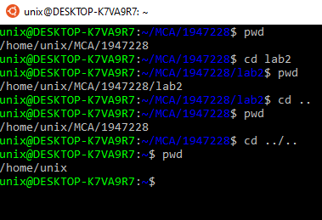

1. **If you do cd / followed by pwd, what will happen?**

It displays the Present working directory(pwd).

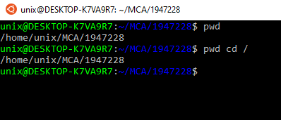

1. **What information about a file is shown by ls -laF?**

It will display a list of directories and denote other directories with a trailing /.

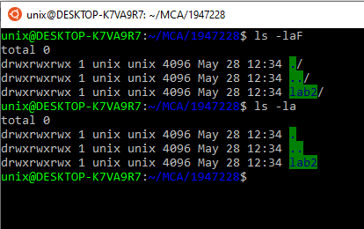

1. **If you have two files, a and b, and you issue the command mv a b, what happens? Is there an option to mv that will issue a warning in this situation?**

It moves the contents of a.txt to b.txt but it deletes the original file(a.txt).

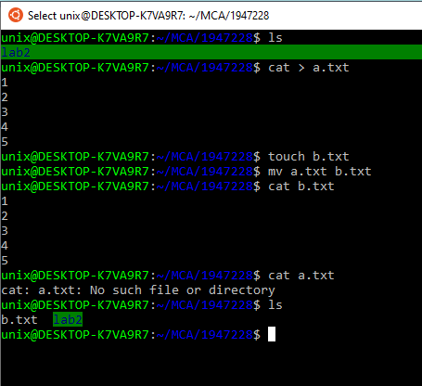

1. **What is the command to duplicate the contents of /dir1 to /dir2, preserving modification times, ownership and permissions of all files?**

The command to duplicate the contents of /dir1 to /dir 2 is copy(cp). “-p“ with cp command is used to preserve modification times, ownership and permissions of all files.

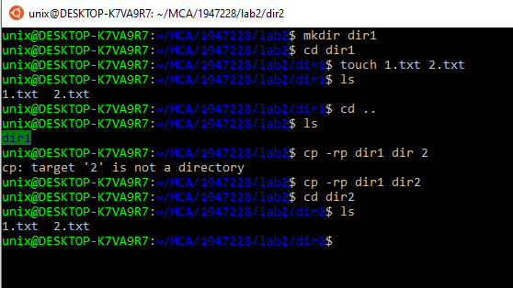

1. **How do you make the file "secret" readable and writable by root, readable by the group "wheel" and inaccessible to everybody else?**

By placing a dot (.) infront of the filename, we can make a hidden file. For eg - .1.txt would create a hidden file, we will use this command chmod u+rw, g+r-w-x, o-wxr filename.extension to make it inaccessible to everyone else.

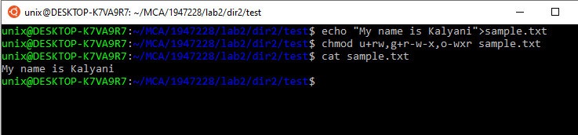

1. **How can you remove a directory, including its contents, with a single command?**

“rm –r directoryname” can be used to delete a directory along with all of its contents.

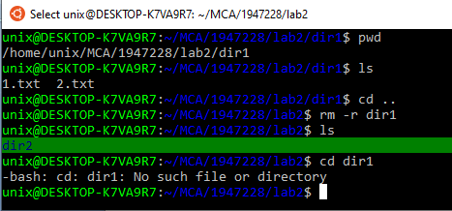

1. **How to remove files with extension of .jpg and .txt in a directory?**

*.txt can be used to remove all files with .txt files and similarly *.jpg will remove .jpg files.

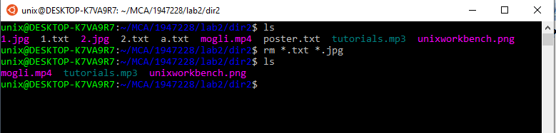

1. **How to add users? How to create two users called msc, mca and set password as ADMIN for both the users?**

We can add users by using sudo command.

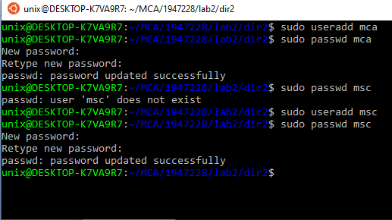

**10. How to create a group called CHRIST and group members are msc and mca to access a directory?**

By using groupadd command.

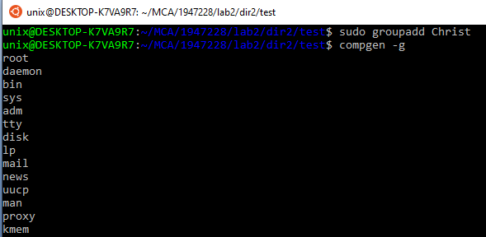

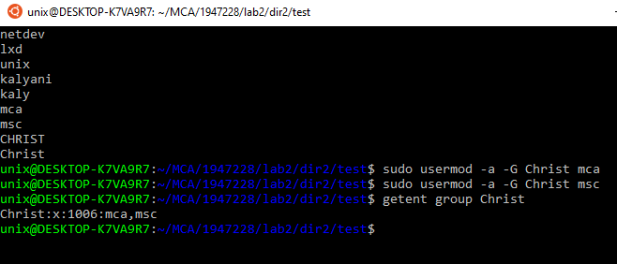

**Write Shell Script to demonstrate the following using command line arguments -**

1. **Delete the duplicate files present in two directories and store the deleted filenames in a file called ‘duplicate.txt’**

**OUTPUT -**

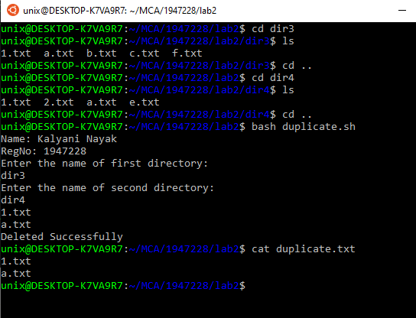

**CODE -**

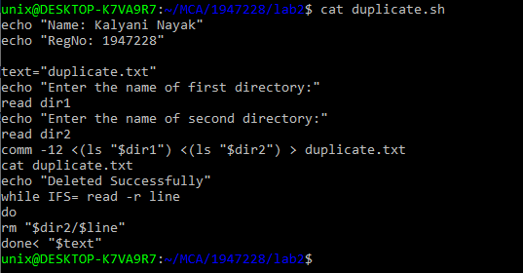

1. **Create two files with the name of Test_File_One.txt and Test_File_two.txt which should contain some common words and distinct words. Display the common words and store it in a new file.**

**OUTPUT & CODE -**

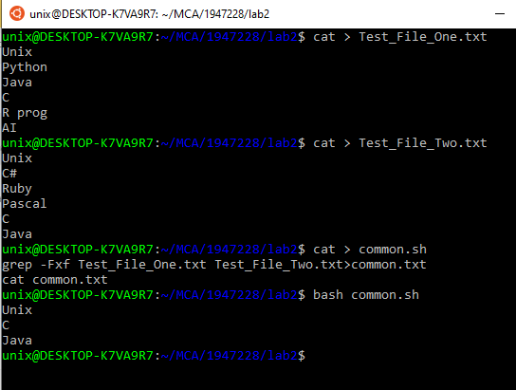

1. **Write a shell script that prompts the user for a name of a file or directory and reports if it is a regular file, a directory, or other type of file. Also perform an ls command against the file or directory with the long listing option.**

**OUTPUT -**

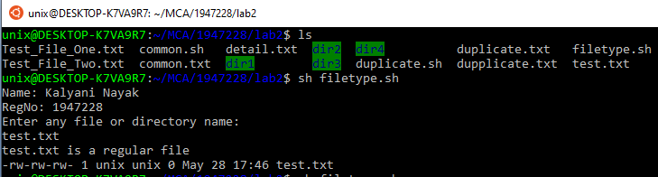

**CODE -**

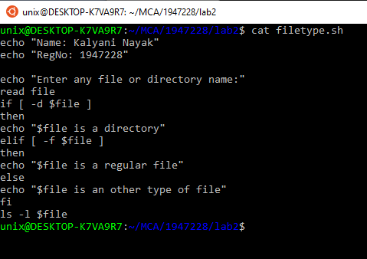

1. **Factorial of a given number**

**OUTPUT -**

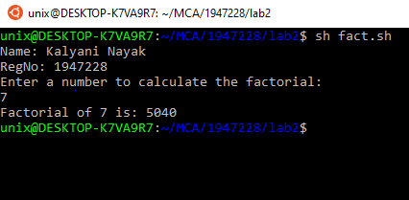

**CODE -**

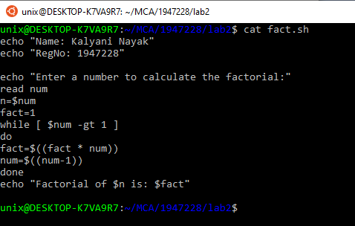

1. **To check whether a given number is prime or not. Also try to print prime numbers between a user defined range.**

**OUTPUT -**

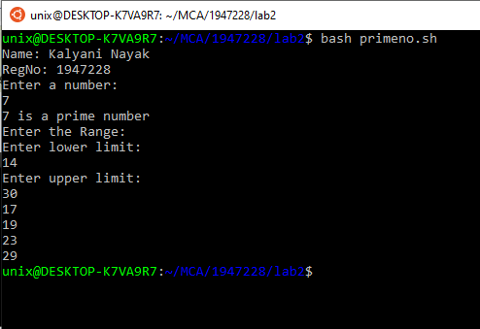

**CODE -**

