**MCA372 – Unix Programming**

**Task for Lab 3 – 02.06.2020**

* **Command Line Practice**
  + Five files are attached – Find out the program and execute then write a brief note about that program.
  + File names are 1 to 5
  + Programs may have error (your responsibility to rectify)

**File 1.txt**

**Code –**

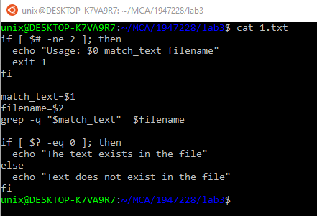

**Input & Output –**

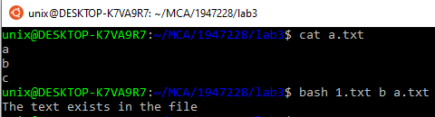

**Purpose of 1.txt file –**

This file checks whether a word given as an input is present in the given filename or not. It takes input of a filename and a word to be matched with that filename. If that word exists in that file then it displays the message that the text exists in the file. For e.g. – in the above screenshot, ‘b’ is present in ‘a.txt’. If we don’t specify any arguments it prints message "**Usage:1.txt match_text filename**". No errors were found in this file.

**File 2.txt**

**Code –**

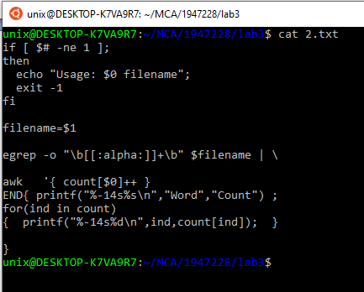

**Input & Output –**

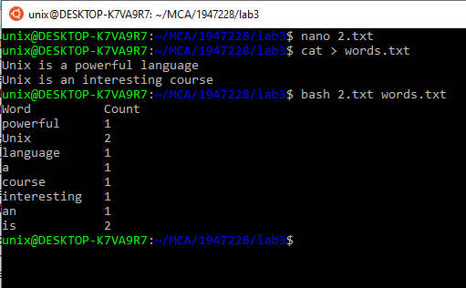

**Purpose of 2.txt file –**

This program displays the total words present in the file and the number of occurrences of a word in the given filename. For e.g. – in the above screenshot it shows that the word ‘Unix’ has occurred 2 times in the file ‘words.txt’. If we don’t specify any arguments it prints message " **Usage: 2.txt filename**". No errors were found in this file.

**File 3.txt**

**Code –**

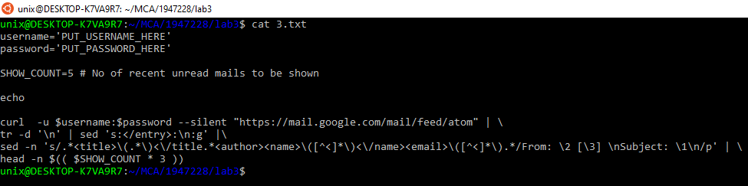

**Input & Output –**

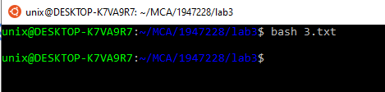

**Purpose of 3.txt file –**

The program displays all the unread messages from email and then prints the first five unread messages from our mail inbox. We have to give username and password as an input for this. No error found in this file.

**File 4.txt**

**Code –**

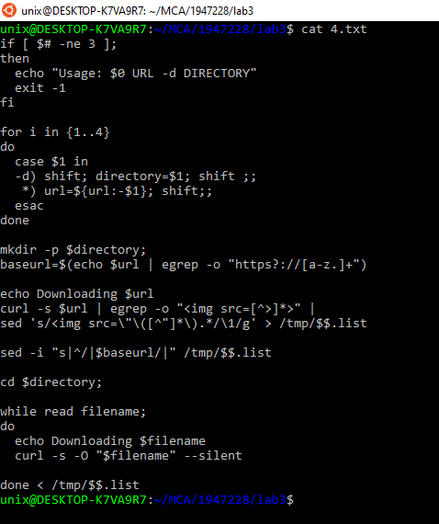

**Input & Output –**

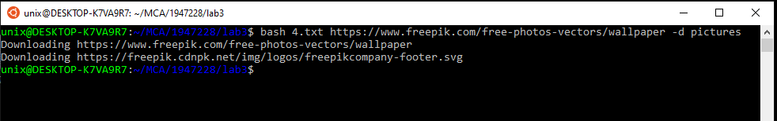

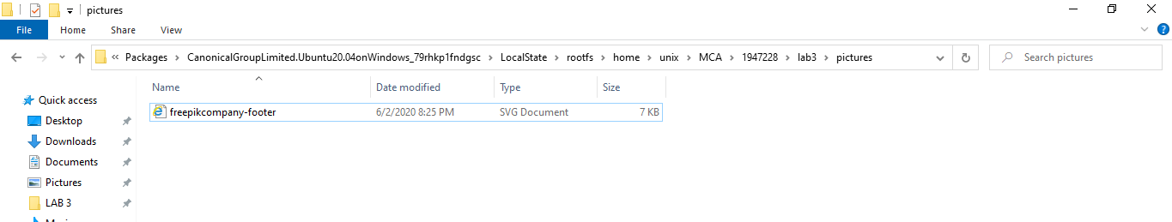

**Purpose of 4.txt file –**

This program downloads all the images from the URL given through the command line and it downloads all the images in the directory given at the time of input. For e.g. - I have given URL as “[**https://www.freepik.com/free-photos-vectors/wallpaper**](https://www.freepik.com/free-photos-vectors/wallpaper)” which saves all the images in the directory called “**pictures**”. No error was found in this file.

**File 5.txt**

**Code –**

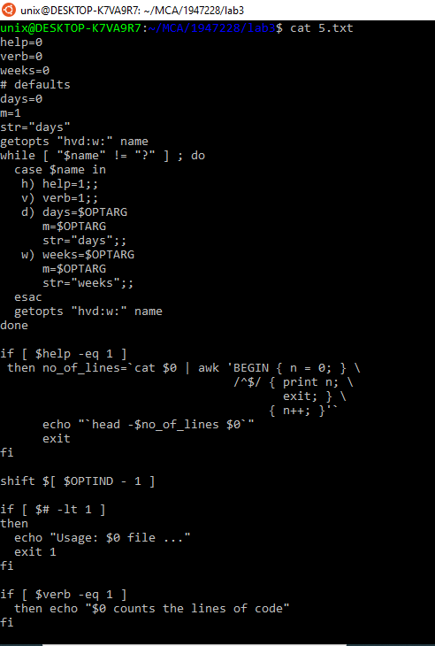

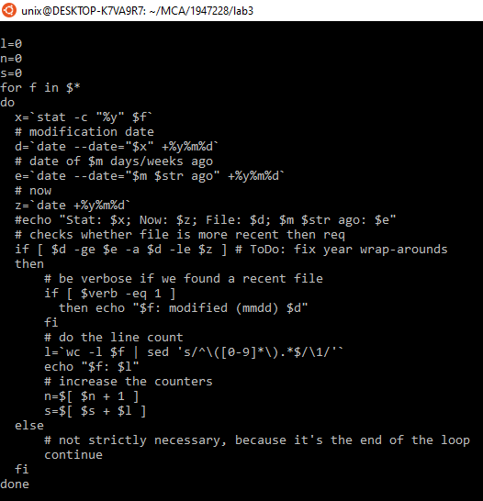

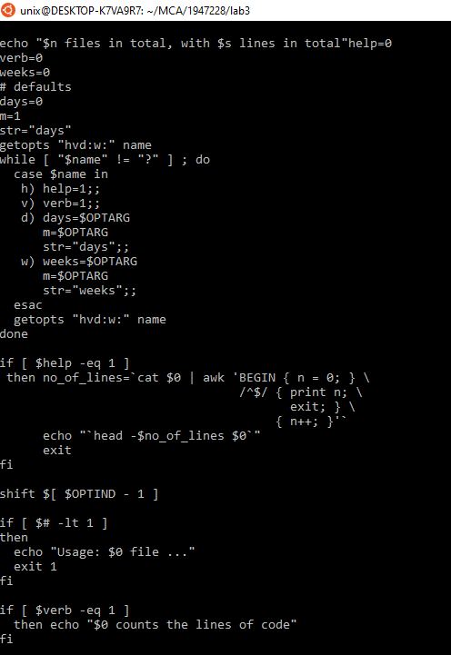

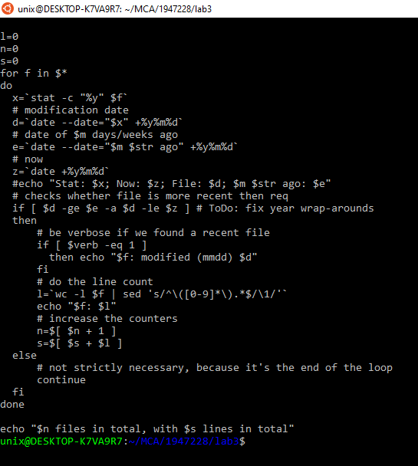

**Input & Output –**

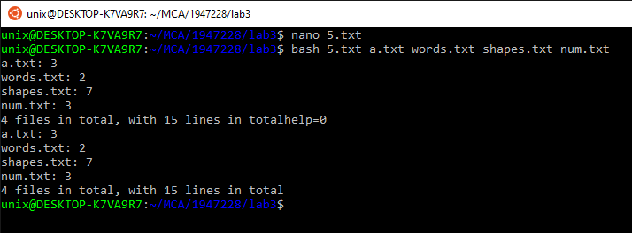

**Purpose of 5.txt file –**

This program takes multiple files through the command line and then gives output of the files that are passed to it and prints the total number of lines present in all the passed files. For e.g. – I have passed four files through the command line and it displays the total number of files, the total number of lines present in each file and the count of lines in total. No errors were found in this file.