**MCA372 – Unix Programming**

**Task for Lab 4 – 04.06.2020**

1) Write a shell script to demonstrate the following array related commands and operations

1. DISPLAY ALL ARRAY ELEMENTS

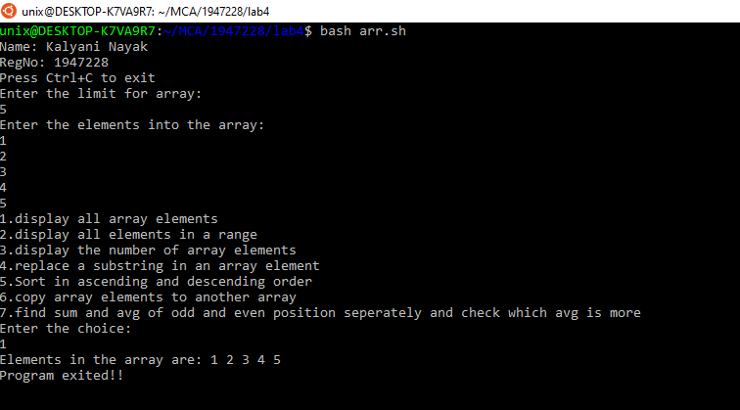

2. DISPLAY ALL ELEMENTS IN A RANGE

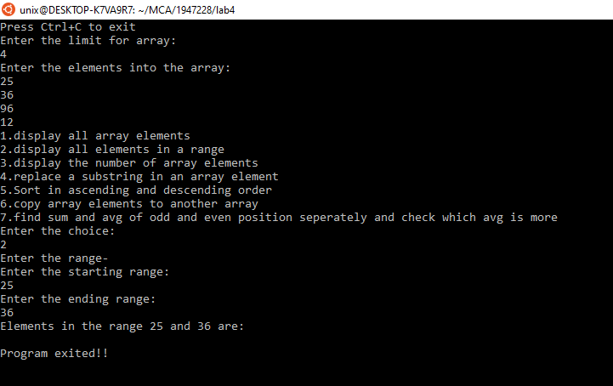

3. DISPLAY THE NUMBER OF ARRAY ELEMENTS

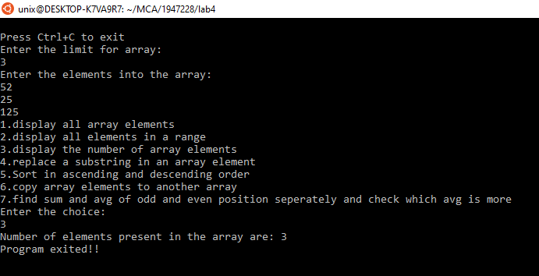

4. REPLACE A SUBSTRING IN AN ARRAY ELEMENT

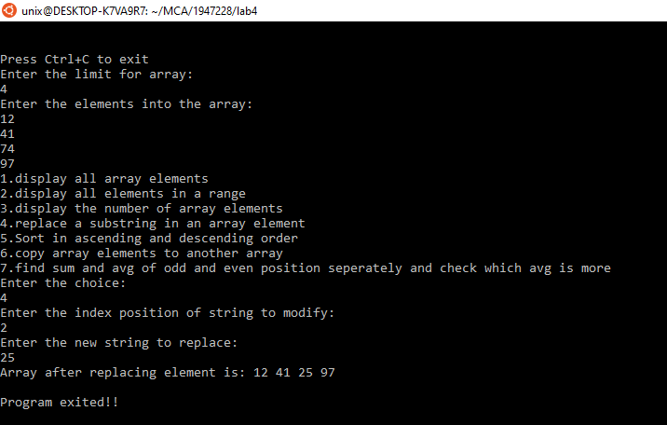

5. SORT AND DISPLAY THE ARRAY ELEMENT IN ASCENDING ORDER AND DESCENDING ORDER

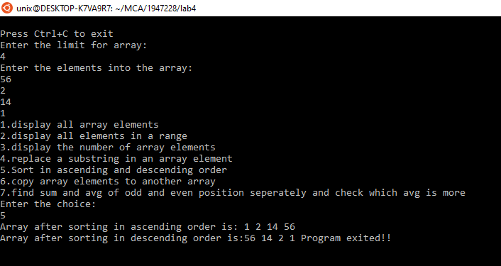

6. COPY AN ARRAY ELEMENTS TO ANOTHER ARRAY

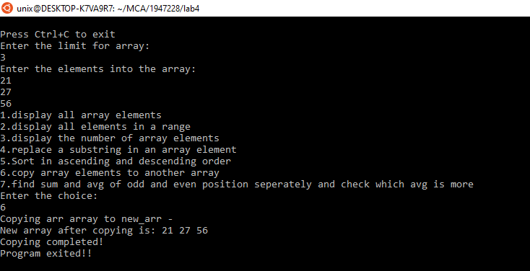

7. DISPLAY THE SUM AND AVERAGE OF ODD POSITION ELEMENTS AND EVEN POSITION ELEMENTS OF AN ARRAY AND FIND WHICH POSITION NUMBERS ARE HAVING GREATER AVERAGE

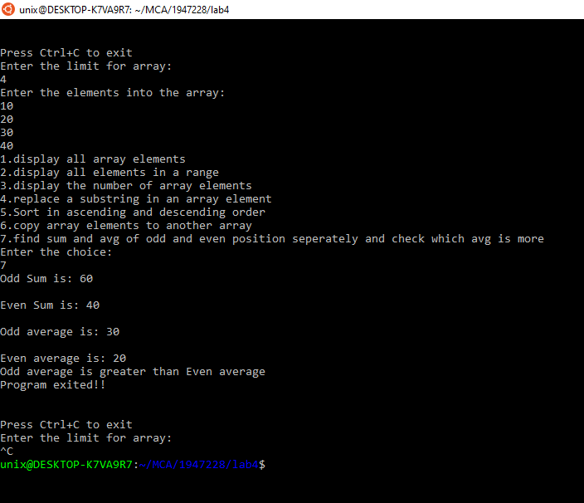

Code:

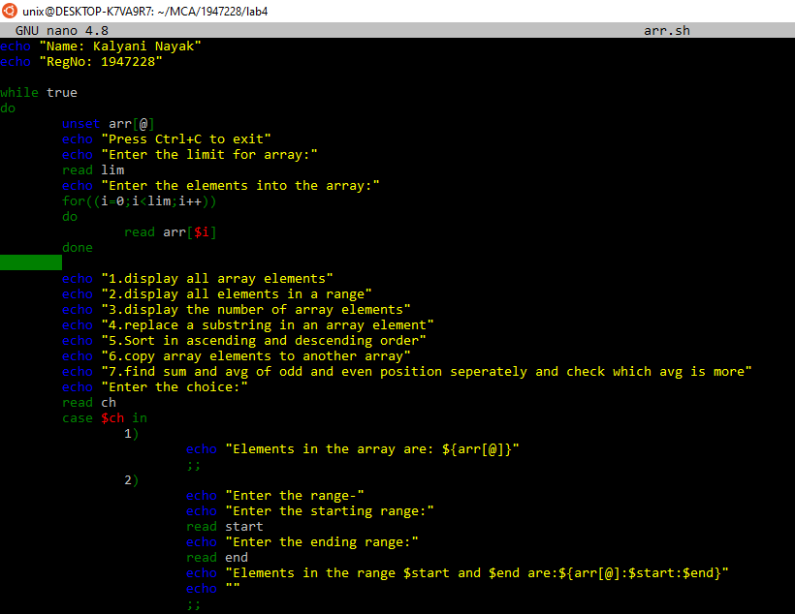

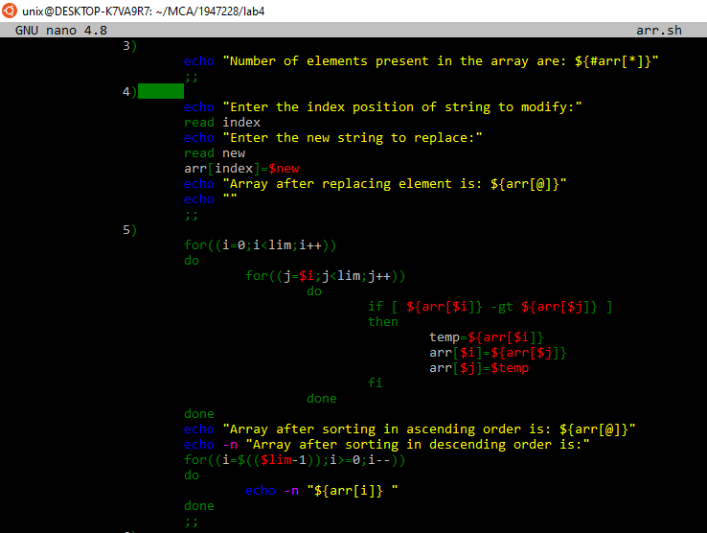

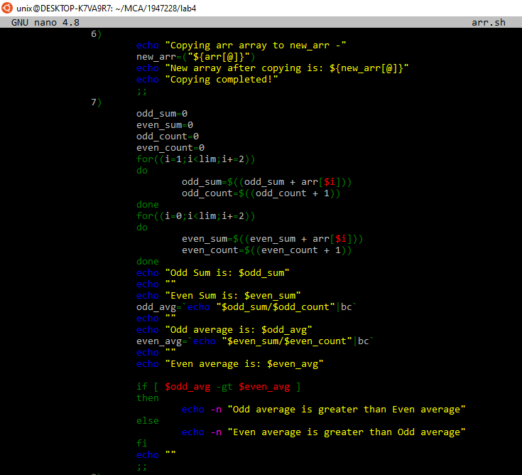

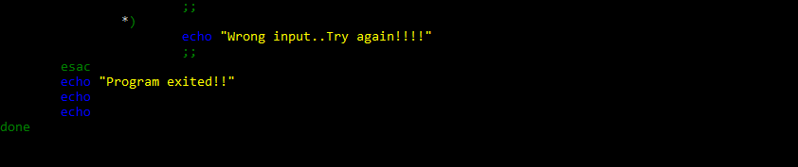

2) Write a shell script with three array structures to hold the values as given below,

Arrray_empl = (Naman Karthik Vishal………)

Array_basic = ( 9000 15000 18000………)

Array_gross = (0 0 0……..)

Update the corresponding (based on the array index) gross salary of the employees in the Array_gross according to rule given below,

* If basic salary is &lt; Rs15000 then Gross Salary = basic Salary + 90% of basic salary.
* If basic salary is &gt;=Rs15000 then Gross Salary = basic Salary + 98% of basic salary.

Code:

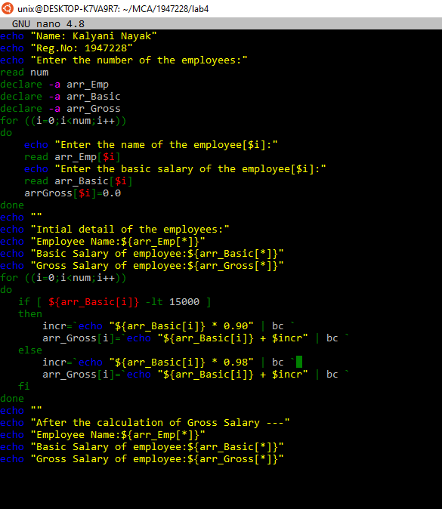

Output:

