**MCA372 – Unix Programming**

**Task for Lab 5 – 09.06.2020**

1. Write a shell script to count the number of duplicate lines for the given file using function.

Code:

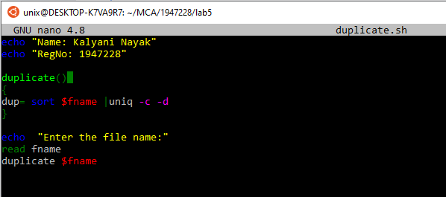

Output:

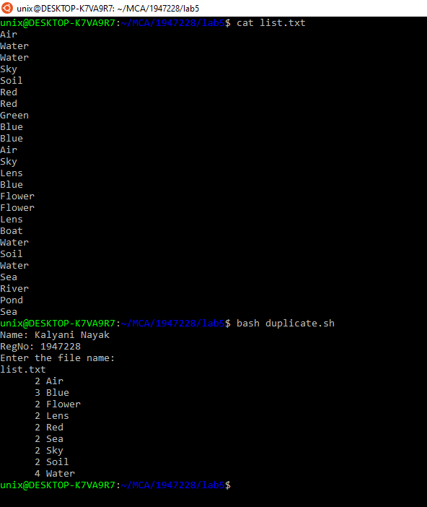

1. Write a shell script to count the number of duplicate files for the given two directories using a recursive function.

Code:

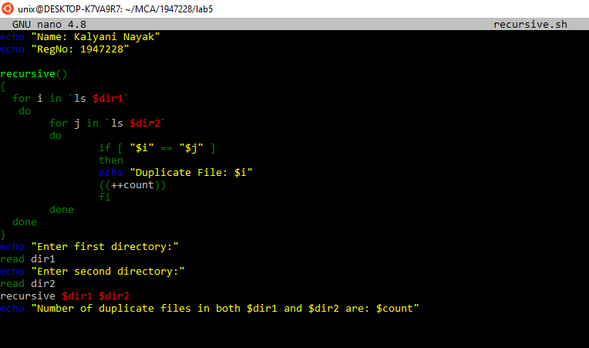

Output:

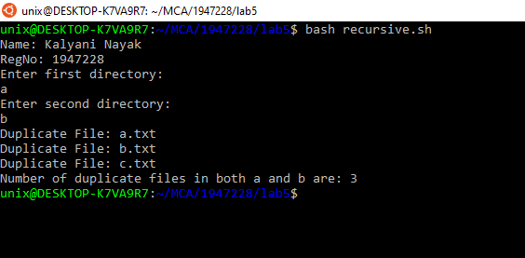

1. Write a Shell Script to create a function that accepts name and displays the name entered by the user followed by greeting based on time (Good morning, Good afternoon, Good evening and Good night)

Code:

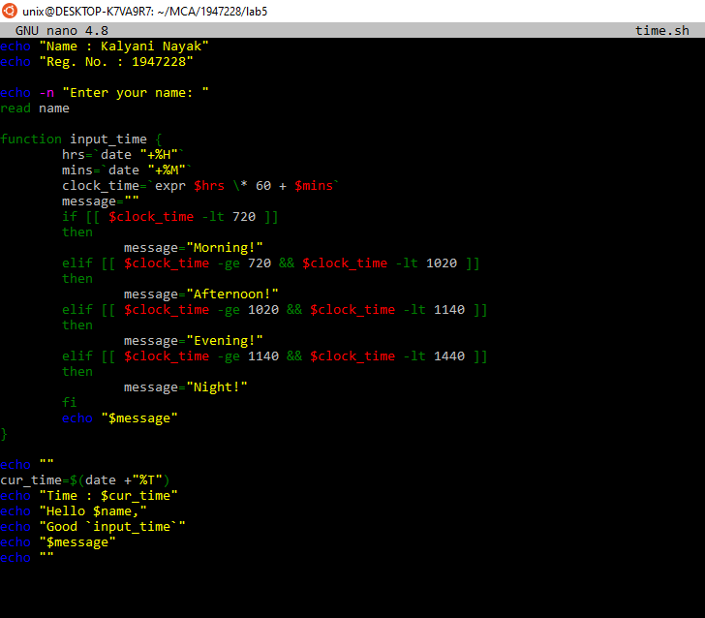

Output:

