**MCA372 – Unix Programming**

**Task for Lab 7 – 18.06.2020**

**File Permission and Compression**

**Write a MENU DRIVEN Shell Script to demonstrate the following:**

1. Demonstrate the commands to change the ownership of a file.

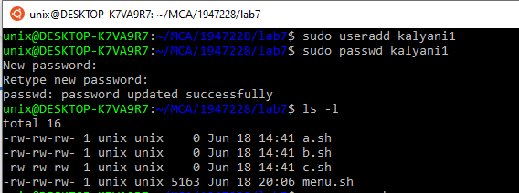

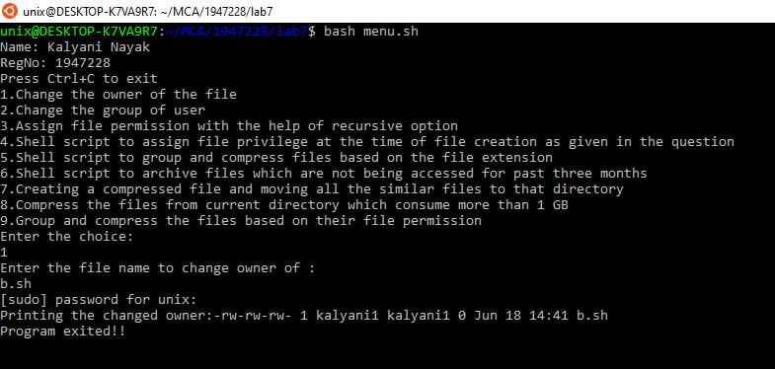

1. Demonstrate the commands to change the group of user.

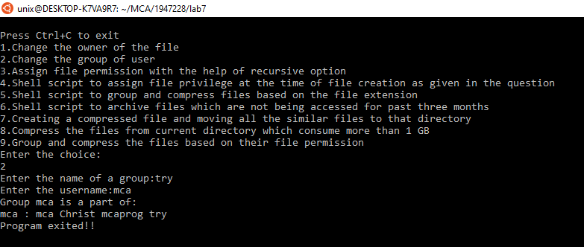

1. Demonstrate the recursive option to assign file permission.

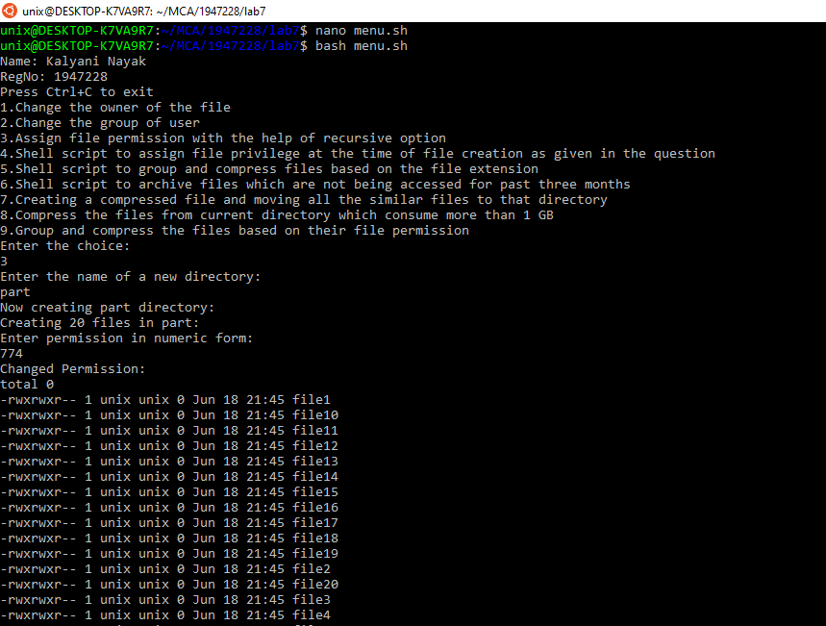

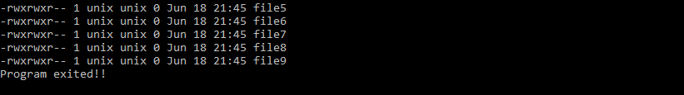

1. Create a shell script (Permission.sh) to assign the file privileges at the time of creating a file based on the Roles as mentioned below. (Use switch case)

ROLE FILE PERMISSION

Administrator R W X

Student R – –

Faculty R W –

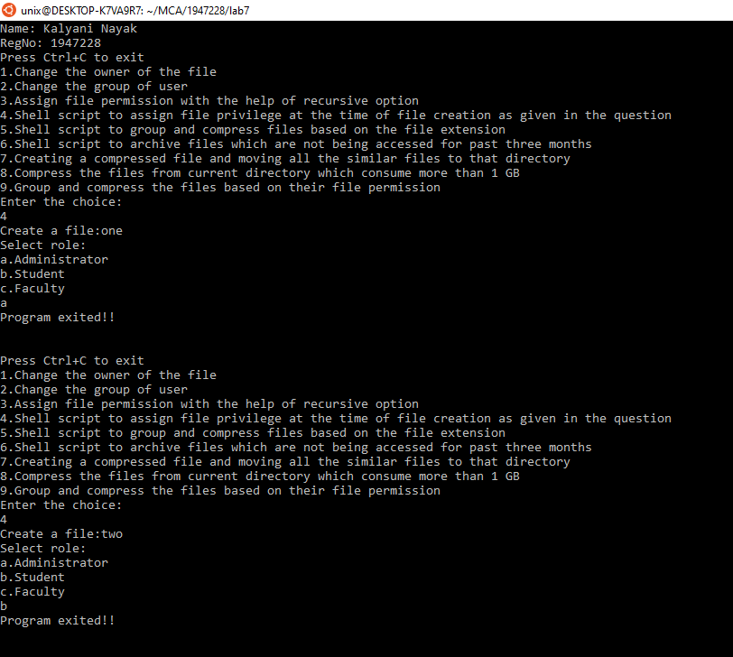

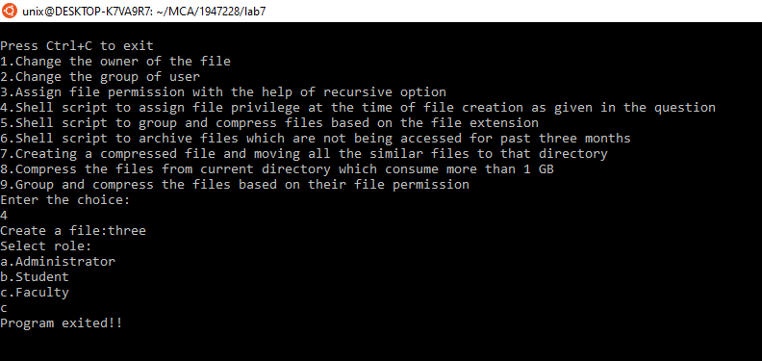

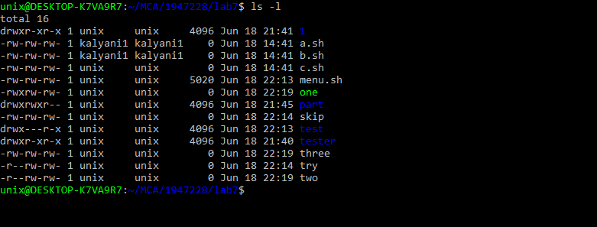

1. Write a shell script to group and compress the file based on their file extension.

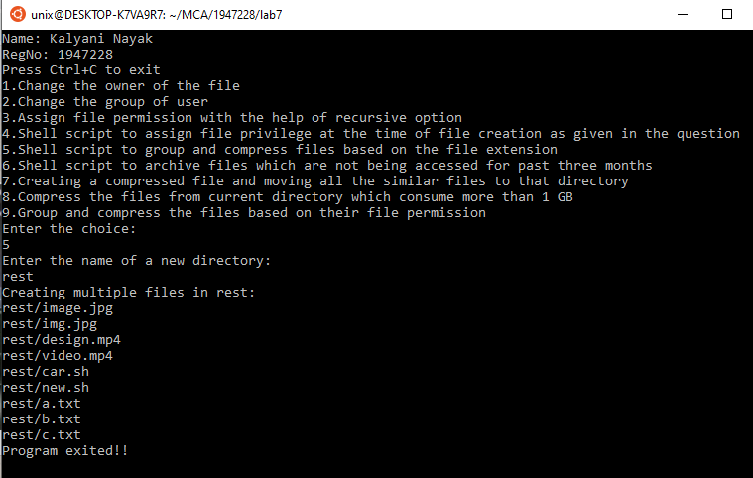

1. Write a shell script to archive the files which are not accessed for past three months.

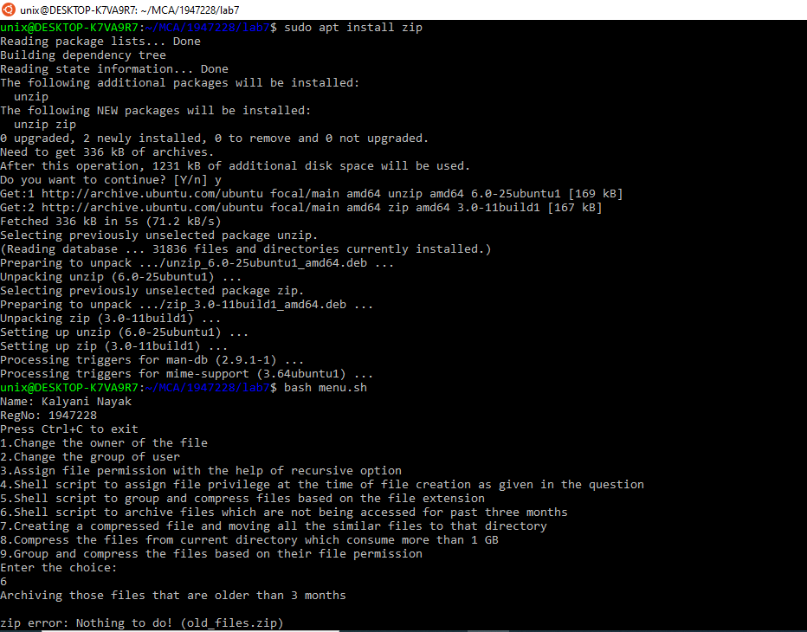

1. Create a compressed file called Collection.tar and move all the files starting with a specific character to the directory Collection.tar

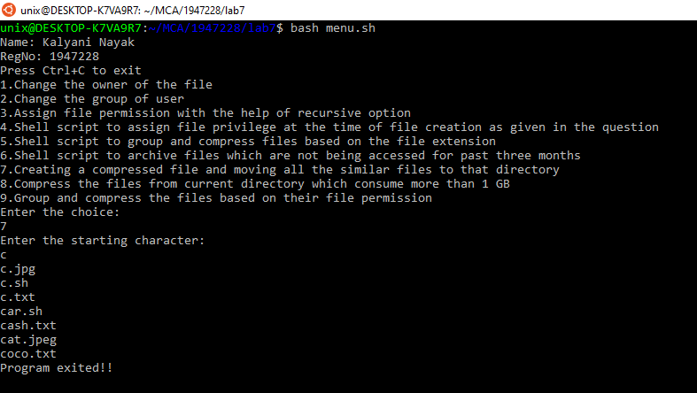

1. Compress the files from the current directory which consume more than 1GB

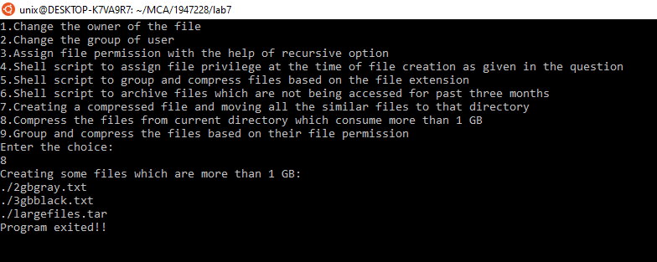

9. Group and compress the files based on their file permission.(For example compress the file with ‘read’ only/’read&write’/’read,write&execute’)

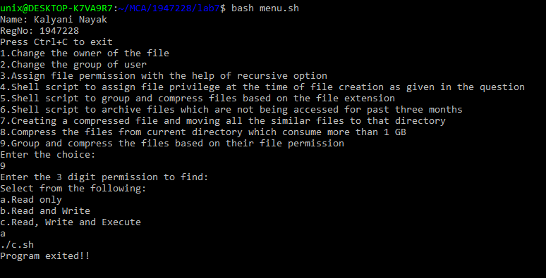

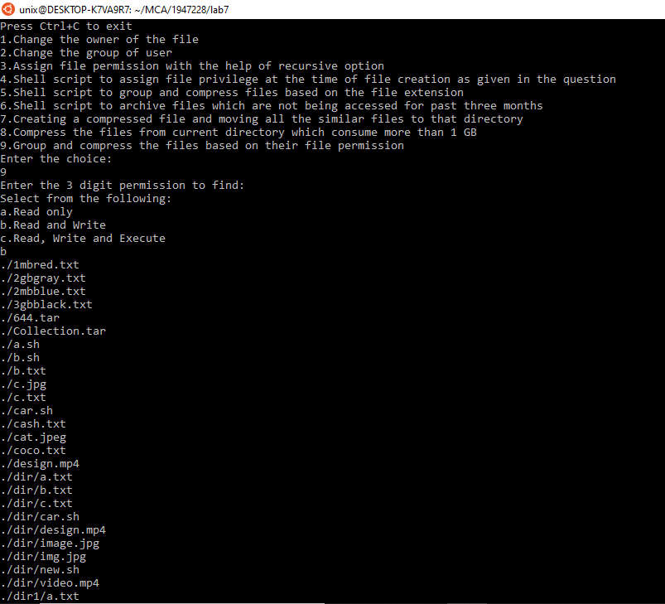

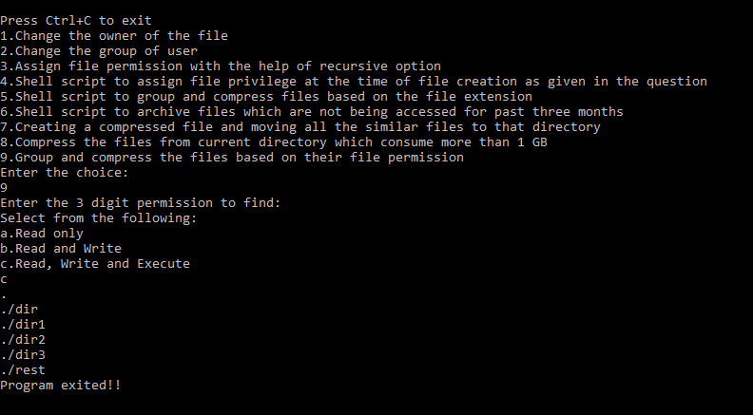

CODE:

echo "Name: Kalyani Nayak"

echo "RegNo: 1947228"

while true

do

echo "Press Ctrl+C to exit"

echo "1.Change the owner of the file"

echo "2.Change the group of user"

echo "3.Assign file permission with the help of recursive option"

echo "4.Shell script to assign file privilege at the time of file creation as given in the question"

echo "5.Shell script to group and compress files based on the file extension"

echo "6.Shell script to archive files which are not being accessed for past three months"

echo "7.Creating a compressed file and moving all the similar files to that directory"

echo "8.Compress the files from current directory which consume more than 1 GB"

echo "9.Group and compress the files based on their file permission"

echo "Enter the choice:"

read ch

case $ch in

1)

echo "Enter the file name to change owner of :"

read file

sudo chown kalyani1:kalyani1 $file

echo -n "Printing the changed owner:"

ls -l $file

;;

2)

echo -n "Enter the name of a group:"

read g_name

sudo groupadd $g_name

echo -n "Enter the username:"

read user

sudo usermod -a -G $g_name $user

echo "Group $user is a part of:"

groups $user

;;

3)

echo "Enter the name of a new directory:"

read dname echo "Now creating $dname directory:" mkdir $dname

echo "Creating 20 files in $dname:"

touch $dname/file{1..20}

echo "Enter permission in numeric form:"

read per

chmod -R $per $dname

echo -n "Changed Permission:"

ls -l $dname

;;

4)

echo -n "Create a file:"

read file

touch $file

echo "Select role:"

echo "a.Administrator"

echo "b.Student"

echo "c.Faculty"

read role

case $role in

"a")

chmod u=rwx $file

;;

"b")

chmod u=r $file

;;

"c")

chmod u=rw $file

;;

esac

;;

5)

echo "Enter the name of a new directory:"

read dname

mkdir $dname

echo "Creating multiple files in $dname:"

cd $dname

touch a.txt b.txt c.txt video.mp4 image.jpg img.jpg design.mp4 car.sh new.sh

cd ..

ext=( $(ls -X $dname | egrep -o "[.]\w+" | uniq) )

for i in ${ext[@]}

do

tar -cvf $dname/${i:1}.tar $dname/*$i

done

;;

6)

echo "Archiving those files that are older than 3 months:"

find . -mtime +30 | xargs zip old_files.zip

;;

7)

echo "Enter the starting character:"

read beg

tar -cvf Collection.tar $beg*

;;

8)

echo "Creating some files which are more than 1 GB:"

truncate -s 1M 1mbred.txt

truncate -s 2M 2mbblue.txt

truncate -s 2G 2gbgray.txt

truncate -s 3G 3gbblack.txt

find -size +1G | tar -cvf largefiles.tar -T -

;;

9)

echo "Enter the 3 digit permission to find:"

echo "Select from the following:"

echo "a.Read only"

echo "b.Read and Write"

echo "c.Read, Write and Execute"

read type

case $type in

"a")

find -perm 444

;;

"b")

find -perm 666

;;

"c")

find -perm 777

;;

esac

;;

*)

echo "Wrong input..Try again!!!!"

;;

esac

echo "Program exited!!"

echo

echo

done