**MCA372 – Unix Programming**

**Task for Lab 11 – 04.08.2020**

**AWK**

1. Create a text file of your choice and execute the following:
   1. awk -f program-file input-file
   2. awk '{ print $3 }' input file
   3. awk '/0.5/ { print $1 }' input file
   4. awk '/^[0-9][0-9]/ { print $1 }' input file
   5. awk '$2 ~ /ia/ { print $1 }' input file
   6. awk '$2 !~ /ia/ { print $1 }' input file
   7. awk '$3 > 50 { print $1 }' input file
   8. awk '$4 == 31, $4 == 33 { print $0 }' input file
   9. awk 'BEGIN { print "Start Processing." }; { print $3 }; END { print "End Processing." }' input file
   10. awk 'BEGIN { FS = "." } { print $1 }' input file

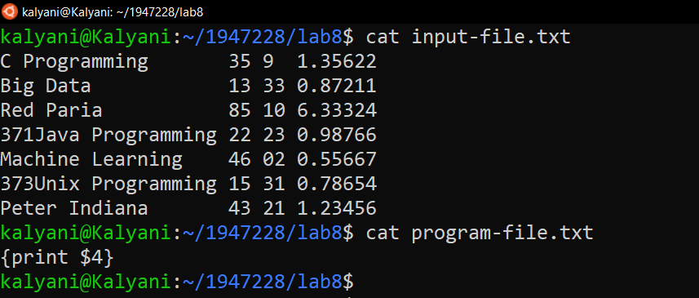

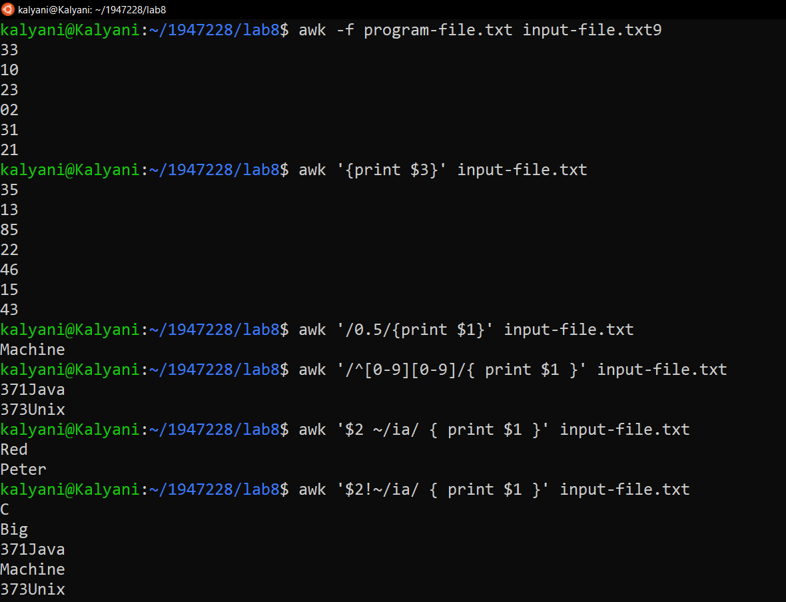

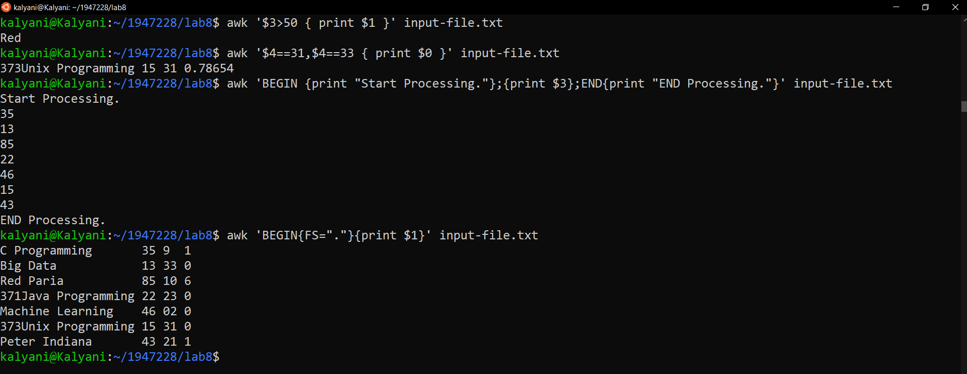

1. Prepare a single Awk command, to make a copy of this CSV file, nameemailavg.csv (which is attached with the program), the input is a comma separated file, with three fields. The output should be the same, but tab-separated.

{Hint: Learn Field, Line Separators with variables}

