A PROJECT REPORT ON
CALLSHIELD: SERVER-ASSISTED DETECTION OF AI-CLONED VOICE CALLS ON ANDROID USING TELEPHONE-BAND ACOUSTIC FEATURES
SUBMITTED IN PARTIAL FULFILLMENT OF THE REQUIREMENTS FOR THE DEGREE OF
BACHELOR OF TECHNOLOGY
IN
COMPUTER SCIENCE AND ENGINEERING
SUBMITTED BY
Kalyani Jiotode (Roll No: 2026-CSE-01)
Manthan Dhawas (Roll No: 2026-CSE-02)
Soham Akre (Roll No: 2026-CSE-03)
Arya Waghmare (Roll No: 2026-CSE-04)
UNDER THE GUIDANCE OF
Prof. Nilesh Korde
Assistant Professor, Department of Computer Science & Engineering
DEPARTMENT OF COMPUTER SCIENCE AND ENGINEERING
ST. VINCENT PALLOTTI COLLEGE OF ENGINEERING & TECHNOLOGY, NAGPUR
(An Autonomous Institution Affiliated to R.T.M. Nagpur University, Nagpur)
2026–2027

ST. VINCENT PALLOTTI COLLEGE OF ENGINEERING & TECHNOLOGY, NAGPUR
DEPARTMENT OF COMPUTER SCIENCE AND ENGINEERING
CERTIFICATE
This is to certify that the project report entitled "CALLSHIELD: SERVER-ASSISTED DETECTION OF AI-CLONED VOICE CALLS ON ANDROID USING TELEPHONE-BAND ACOUSTIC FEATURES" is a bonafide record of work carried out by Kalyani Jiotode, Manthan Dhawas, Soham Akre, and Arya Waghmare in partial fulfillment of the requirements for the award of the degree of Bachelor of Technology in Computer Science and Engineering from St. Vincent Pallotti College of Engineering and Technology, Nagpur (affiliated to Rashtrasant Tukadoji Maharaj Nagpur University) during the academic year 2026–2027.
It is certified that all corrections and suggestions indicated during internal reviews have been incorporated in the report and the project satisfies the academic requirements prescribed by the institution.
______________________________  Prof. Nilesh Korde  Project Guide  Department of CSE | ______________________________  Head of Department  Department of CSE  SVPCET, Nagpur
Date: ________________________  Place: Nagpur | ______________________________  External Examiner

DECLARATION
We hereby declare that the project work presented in this report entitled "CallShield: Server-Assisted Detection of AI-Cloned Voice Calls on Android Using Telephone-Band Acoustic Features" is our original work carried out under the supervision of Prof. Nilesh Korde, Assistant Professor, Department of Computer Science and Engineering, St. Vincent Pallotti College of Engineering & Technology, Nagpur.
This project has not been submitted previously to any university or institution for the award of any degree, diploma, or other academic titles. All literature, software tools, benchmark corpora, and external resources utilized during this work have been duly acknowledged with appropriate bibliographic citations.
Name of Student | Roll Number | Signature
Kalyani Jiotode | 2026-CSE-01 | ____________________
Manthan Dhawas | 2026-CSE-02 | ____________________
Soham Akre | 2026-CSE-03 | ____________________
Arya Waghmare | 2026-CSE-04 | ____________________

ACKNOWLEDGEMENT
We express our profound gratitude and heartfelt appreciation to our esteemed project guide, Prof. Nilesh Korde, Assistant Professor, Department of Computer Science and Engineering, for his invaluable guidance, astute technical insights, continuous encouragement, and rigorous feedback throughout the conception, implementation, and evaluation of the CallShield project.
We extend our sincere thanks to the Head of the Department of Computer Science and Engineering for providing the state-of-the-art computational infrastructure, laboratories, and supportive academic atmosphere that made this work possible. We are equally grateful to the Principal and Management of St. Vincent Pallotti College of Engineering and Technology, Nagpur, for fostering a research-centric culture and encouraging innovative problem solving.
We also acknowledge the supportive teaching and non-teaching faculty of the department who offered constructive critiques during our semester project reviews. Lastly, we owe our deepest gratitude to our parents and family members for their unwavering support, moral encouragement, and patience during our B.Tech degree programme.
Kalyani Jiotode
Manthan Dhawas
Soham Akre
Arya Waghmare

ABSTRACT
Voice phishing (vishing) attacks increasingly leverage zero-shot generative text-to-speech (TTS) engines, neural vocoders, and dynamic virtual numbers to impersonate trusted contacts, corporate officers, and government authorities. Conventional spam defence systems rely strictly on telephone number-reputation databases, which are readily defeated by ephemeral virtual numbers, VoIP trunk spoofing, and SIM swapping. Furthermore, contemporary audio anti-spoofing research is almost exclusively evaluated on pristine, studio-quality wideband corpora that fail to account for the severe spectral degradation imposed by public switched telephone networks (PSTN) and cellular codecs (300–3400 Hz). This thesis presents CallShield, a server-assisted mobile defence architecture designed to detect AI-cloned voice calls on Android handsets in real time by analyzing telephone-band acoustic features rather than caller identity.
CallShield combines five synchronized layers: (i) an Android native telephony interception service that monitors call-state transitions and checks local blacklists; (ii) a realistic telephone-band preprocessing pipeline that applies fourth-order Butterworth bandpass filtering (300–3400 Hz), 18 dB SNR Gaussian noise, RMS energy-based silence gating, and 2.5-second overlapping windowing (1.5-second hop); (iii) a 60-dimensional acoustic feature extraction engine capturing static and delta MFCCs, spectral roll-off, spectral contrast, spectral flux, and micro-jitter; (iv) an optimized ExtraTrees classifier trained on simulated telephony audio, achieving model inference under 15 ms; and (v) a weighted temporal smoothing rule (R_call = 0.55 R_avg + 0.30 R_ratio + 0.15 R_max) that converts continuous chunk probabilities into a stabilized call-level risk score. The system pairs visual forensic heads-up telemetry with an in-ear tactile haptic SOS pulse—warning elderly users pressed against the receiver without requiring screen visibility—and a multi-contact Family Shield module that dispatches emergency SMS alerts to designated family guardians.
Evaluated on a 383-chunk telephony dataset across five contemporary speech synthesizers and human dialogue, CallShield attained 88.76% accuracy, 100% recall on synthetic voice chunks (47/47), an F1-score of 0.9038, and a ROC-AUC of 0.993, outperforming Soft Voting, Random Forest, and Gradient Boosting baselines. Detailed latency benchmarking confirms an end-to-end processing delay of 42.23 ms per chunk on commodity CPU hardware, comfortably fulfilling the strict 50 ms real-time telephony constraint. CallShield establishes a deployable, human-centered bridge between acoustic anti-spoofing theory and proactive consumer fraud prevention.
Keywords: Audio Deepfake Detection, Voice Cloning, Vishing Prevention, Telephony Bandwidth, ExtraTrees, Android Security, Haptic Alert, Family Shield.

TABLE OF CONTENTS
CHAPTER NO. | TITLE | PAGE NO.
 | CERTIFICATE | i
 | DECLARATION | ii
 | ACKNOWLEDGEMENT | iii
 | ABSTRACT | iv
 | LIST OF TABLES | v
 | LIST OF FIGURES | vi
 | LIST OF SYMBOLS, ABBREVIATION & NOMENCLATURE | vii
1. | INTRODUCTION | 1
 | 1.1 OVERVIEW | 1
 | 1.2 PROBLEM STATEMENT | 3
 | 1.3 OBJECTIVES | 4
 | 1.4 FEASIBILITY STUDY | 5
 | 1.4.1 TECHNICAL FEASIBILITY | 5
 | 1.4.2 OPERATIONAL FEASIBILITY | 6
 | 1.4.3 ECONOMIC FEASIBILITY | 7
 | 1.5 ORGANIZATION OF REPORT | 8
2. | REVIEW OF LITERATURE | 9
 | 2.1 INTRODUCTION | 9
 | 2.2 LITERATURE SURVEY | 10
 | 2.3 RESEARCH GAP IDENTIFIED | 14
3. | PROPOSED SYSTEM | 16
 | 3.1 DRAWBACKS OF CURRENT SYSTEM AND NEED OF PROPOSED SYSTEM | 16
 | 3.2 SOFTWARE REQUIREMENT SPECIFICATION | 18
 | 3.2.1 FUNCTIONAL REQUIREMENTS | 18
 | 3.2.2 NON-FUNCTIONAL REQUIREMENTS | 19
 | 3.2.3 OTHER REQUIREMENTS | 21
 | 3.2.4 USER STORIES | 22
 | 3.3 PROJECT PLANNING AND SCHEDULING | 24
 | 3.3.1 PURPOSE | 24
 | 3.3.2 PROJECT SCOPE | 24
 | 3.3.3 SPRINT PLANNING | 25
 | 3.4 SYSTEM ANALYSIS | 27
 | 3.4.1 SYSTEM ARCHITECTURE | 27
 | 3.4.2 DATA FLOW DIAGRAM | 29
 | 3.4.3 USE CASE DIAGRAM | 31
 | 3.5 SYSTEM DESIGN | 33
 | 3.5.1 CLASS DIAGRAM | 33
 | 3.5.2 SEQUENCE DIAGRAM | 35
 | 3.5.3 ER DIAGRAM AND DATABASE DESIGN | 37
 | 3.6 MODULE DESCRIPTION | 39
 | 3.7 ALGORITHMS / METHODOLOGY | 42
4. | IMPLEMENTATION | 46
 | 4.1 IMPLEMENTATION METHODOLOGY | 46
 | 4.2 TOOLS AND TECHNOLOGIES USED | 47
 | 4.3 MODULE-WISE IMPLEMENTATION | 49
 | 4.4 SCREENSHOTS OF OUTPUT / USER INTERFACE | 53
 | 4.5 KEY CODE SNIPPETS | 57
5. | TESTING | 62
 | 5.1 UNIT TESTING | 62
 | 5.2 INTEGRATION TESTING | 63
 | 5.3 SYSTEM TESTING | 64
 | 5.4 TEST CASES | 65
 | 5.5 ACCEPTANCE TESTING | 68
 | 5.6 RESULTS AND DISCUSSION | 69
6. | CONCLUSION & FUTURE SCOPE | 76
 | 6.1 CONCLUSION | 76
 | 6.2 FUTURE SCOPE | 77
 | REFERENCES | 79
 | APPENDIX | 82
 | ANNEXURE I - STAKE HOLDERS AND PROJECT MEMBERS DETAILS | 83
 | ANNEXURE II - PROJECT SPECIFIC PO AND SDG MAPPING | 85
 | ANNEXURE III - PUBLISHED PAPER AND CERTIFICATES | 89
 | ANNEXURE IV - PLAGIARISM REPORT | 90

LIST OF TABLES
TABLE NO. | TITLE | PAGE NO.
Table 2.1 | Comparative Analysis of Deepfake Voice Detection Approaches and Defensive Countermeasures | 15
Table 3.1 | Sprint Planning and Milestone Schedule (Sprints 1 through 5) | 26
Table 3.2 | Summary of 60 Acoustic Features Extracted per Telephony Audio Window | 44
Table 4.1 | Software and Hardware Technology Stack Utilized in CallShield | 48
Table 5.1 | Unit and Integration Test Verification Suite | 66
Table 5.2 | Comprehensive System Test Cases and Defect Logging | 67
Table 5.3 | Comparative Model Performance on 89-Chunk Held-Out Telephony Test Set | 70
Table 5.4 | Detailed Component-Wise Latency Profiling across 2.5-Second Window Pipeline | 73
Table 5.5 | Codec Robustness and Performance Degradation under Real Telephony Compression | 74
Table 5.6 | Speaker-Disjoint and Cross-Generator (LOGO) Evaluation Summary | 75

LIST OF FIGURES
FIGURE NO. | TITLE | PAGE NO.
Fig 3.1 | Five-Layer System Architecture of the CallShield Mobile Telephony Defense Platform | 28
Fig 3.2 | Context Analysis: Level 0 and Level 1 Data Flow Diagrams (DFD) for Inbound Audio Streams | 30
Fig 3.3 | Comprehensive Use Case Diagram of the CallShield Interception Workflow | 32
Fig 3.4 | Detailed Object-Oriented Class Diagram of Mobile Client and Cloud Inference Engines | 34
Fig 3.5 | End-to-End Sequence Diagram Illustrating Live Telephony Interception and Alert Dispatch | 36
Fig 3.6 | Entity-Relationship (ER) Schema for Call Forensics, Contacts, and Community Blacklists | 38
Fig 4.1 | CallShield Production UI: Live Audio Waveform Monitor and Heads-Up Risk Gauge | 54
Fig 4.2 | Forensic Red Alert Interface and In-Ear Tactile Haptic Pulse Status Notification | 55
Fig 4.3 | Multi-Contact Family Shield Configuration Screen with Recipient Selection Controls | 56
Fig 5.1 | Confusion Matrix of ExtraTrees Classifier on Held-Out Telephony Test Set (n=89) | 71
Fig 5.2 | Comparative Benchmark Metrics across ExtraTrees, Random Forest, Soft Voting, and GBDT | 71
Fig 5.3 | Receiver Operating Characteristic (ROC) and Precision-Recall Curves for Evaluated Models | 72
Fig 5.4 | Top 15 Gini Feature Importance Ranking Showing Dominance of Spectral Roll-Off and Contrast | 73
Fig 5.5 | Component-Wise Inference Latency Breakdown Fulfilling Real-Time Telephony Constraints | 74
Fig 5.6 | Temporal Risk Score Smoothing Trajectory across 60 Seconds of Conversational Audio | 75

LIST OF SYMBOLS, ABBREVIATIONS & NOMENCLATURE
TERM / SYMBOL | DEFINITION / EXPANSION
AI | Artificial Intelligence
AMR-NB | Adaptive Multi-Rate Narrowband Codec (Telephony Standard 4.75–12.2 kbps)
API | Application Programming Interface
ASVspoof | Automatic Speaker Verification Spoofing and Countermeasures Challenge
AUC | Area Under the Receiver Operating Characteristic Curve
Butterworth Filter | Frequency filter characterized by a maximally flat magnitude response in the passband
CBI | Central Bureau of Investigation (Targeted Identity in Digital Arrest Scams)
CNN | Convolutional Neural Network
Delta MFCC | First-order temporal differential coefficients of Mel-Frequency Cepstral Coefficients
DPDP Act | Digital Personal Data Protection Act, 2023 (Government of India)
EER | Equal Error Rate (Operating threshold where False Acceptance equals False Rejection)
ExtraTrees | Extremely Randomized Trees Ensemble Classifier
F0 | Fundamental Frequency (Acoustic Pitch Contour of Human Vocal Folds)
FFT | Fast Fourier Transform
FPR | False Positive Rate (Genuine human chunks erroneously flagged as synthetic)
G.711 | ITU-T Standard Audio Codec for 64 kbps Pulse Code Modulation (A-law / µ-law)
GSM | Global System for Mobile Communications / Bond Paper Weight Metric (80 GSM)
HTTPS | Hypertext Transfer Protocol Secure (TLS-encrypted client-server transport)
HUD | Heads-Up Display (Overlay UI rendering real-time telemetry metrics)
IVR | Interactive Voice Response (Automated Telephone Banking System)
JSI | JavaScript Interface (Low-overhead native communication bridge in React Native)
LOGO | Leave-One-Generator-Out (Cross-dataset generalizability evaluation protocol)
MFCC | Mel-Frequency Cepstral Coefficients
ONNX | Open Neural Network Exchange (Cross-platform model representation format)
Opus NB | Narrowband Opus Codec (8 kHz sampling rate, 8 kbps constraint)
OTP | One-Time Password
PII | Personally Identifiable Information
REST | Representational State Transfer
RMS | Root Mean Square (Energy threshold metric for speech-silence gating)
ROC | Receiver Operating Characteristic
SHAP | SHapley Additive exPlanations (Game-theoretic model interpretability method)
SNR | Signal-to-Noise Ratio (dB)
SOS | Save Our Souls (Emergency Duress Call/SMS Dispatch Code)
SRS | Software Requirement Specification
SSL | Secure Sockets Layer / Self-Supervised Learning Front-End
TelecomManager | Android Native Telephony Management API for Call State Interception
TTS | Text-To-Speech (Generative Acoustic Synthesis Engine)
UI / UX | User Interface / User Experience
Vishing | Voice Phishing (Telephonic Social Engineering and Voice Clone Extortion)
WaveNet | Deep Autoregressive Generative Model for Raw Audio Waveforms
ZCR | Zero-Crossing Rate (Rate of sign-changes along the digitized audio signal)

CHAPTER 1
INTRODUCTION
1.1 OVERVIEW
The accelerating ubiquity of generative artificial intelligence has democratized the synthesis of high-fidelity human speech. Contemporary deep neural networks—such as autoregressive transformers, neural codec language models (e.g., VALL-E, SoundStorm), and diffusion-based acoustic synthesizers—possess the unprecedented capability to clone an arbitrary human voice from as little as three seconds of reference audio. When coupled with state-of-the-art neural vocoders, these synthesized voices reproduce the unique vocal timbre, prosody, regional accent, and micro-pitch inflections of the target speaker with perceptual realism that routinely deceives human listeners and automated speaker verification (ASV) systems alike.
While voice synthesis technology presents legitimate applications in digital media dubbing, personalized virtual assistants, and vocal assistive prosthetics for speech-impaired individuals, its weaponization by organized cybercrime syndicates has precipitated a dangerous global wave of telephonic social engineering, colloquially termed "voice phishing" or "vishing". In typical vishing campaigns, malicious actors clone the voice of a family member, corporate executive, or law enforcement official to perpetrate emergency duress extortion, unauthorized bank wire transfers, and "digital arrest" fraud. In India, cybercrime authorities have reported an alarming surge in digital arrest schemes, wherein victims are held captive over prolonged phone calls by fraudsters posing as Supreme Court judges, Central Bureau of Investigation (CBI) inspectors, or customs authorities demanding urgent financial deposits. Victims, subjected to extreme psychological duress and confronted with convincing synthetic voices, suffer catastrophic financial and emotional devastation.
Current telecommunication defenses are categorically ill-equipped to combat AI voice cloning. Commercial caller-ID applications (such as Truecaller) rely exclusively on crowd-sourced telephone number reputation databases. Attackers effortlessly bypass these static defenses by dynamically rotating disposable Voice-over-IP (VoIP) trunks, virtual international numbers, and caller-ID spoofing protocols, ensuring that an incoming attack call arrives with a spotless reputation score. Furthermore, academic audio anti-spoofing algorithms developed in competitive challenges (e.g., the ASVspoof challenge series) are almost universally trained and evaluated on pristine, wideband studio recordings (16–48 kHz) with uncompressed acoustic profiles. When deployed across public switched telephone networks (PSTN) or cellular channels, these deep models suffer catastrophic performance degradation due to the severe acoustic distortions imposed by narrowband telephone codecs (300–3400 Hz), packet loss, and lossy speech compression standards.
To bridge this critical operational chasm, this thesis presents CallShield, a server-assisted mobile defense platform engineered specifically for Android smartphones. CallShield shifts the defensive paradigm from brittle caller-number reputation to real-time, in-call acoustic voice inspection. By combining native Android telephony interception, telephone-bandpass preprocessing, a computationally efficient 60-dimensional acoustic feature extractor, a high-speed ExtraTrees classifier, and a human-centric in-ear tactile haptic alert system with multi-contact family duress routing, CallShield offers a practical, deployable safeguard for modern mobile telephone subscribers.
1.2 PROBLEM STATEMENT
Contemporary mobile telecommunications infrastructure lacks an automated, real-time mechanism to detect whether the audio stream of an incoming cellular phone call is being spoken by a genuine human or synthesized by an artificial intelligence voice clone. Specifically, the problem encompasses three fundamental vulnerabilities:
1. Inadequacy of Number-Reputation Filtering: Existing smartphone scam shields operate strictly on caller identity metadata. Because synthetic voice vishing syndicates utilize virtual telephone exchanges and programmatic VoIP trunking to cycle through millions of virgin telephone numbers, static blocklists and reputation scores exhibit zero efficacy against newly generated scam numbers.
2. Telephony Acoustic Mismatch: Standard deepfake audio detectors rely on high-frequency spectral components (4 kHz to 24 kHz) that are systematically obliterated by carrier-grade bandpass filters (300–3400 Hz) and lossy codecs (G.711, AMR-NB, Opus). Consequently, high-capacity deep learning detectors trained on studio-grade datasets experience severe false alarm rates and degraded recall when confronted with real cellular audio streams.
3. Real-Time Latency and Human Usability Constraints: Analyzing speech in real time requires window processing latency to remain substantially below 50 milliseconds to avoid conversation desynchronization. Furthermore, during a phone call, the handset is pressed against the user's cheek and ear, rendering visual on-screen alerts completely invisible at the critical moment of decision-making. Without non-visual (tactile) warning cues and automated emergency guardian routing, elderly and vulnerable citizens remain highly susceptible to psychological coercion.
1.3 OBJECTIVES
The overarching aim of this research is to design, implement, and evaluate CallShield—an end-to-end, server-assisted mobile defense platform for detecting AI-cloned voices on Android devices. The primary research objectives are defined as follows:
1. To design and implement a native Android telephony interception layer that transparently captures incoming call-state events, verifies local scam blacklists, and interfaces with the audio pipeline via high-performance JSI native bridges.
2. To construct a dedicated telephone-band acoustic preprocessing pipeline (300–3400 Hz Butterworth bandpass filtering, 18 dB SNR Gaussian noise injection, and RMS silence gating) that accurately mirrors real-world cellular transmission channels.
3. To engineer a compact 60-dimensional acoustic feature representation combining static and delta MFCCs, spectral roll-off, spectral contrast, spectral centroid, and micro-jitter that captures vocoder-induced phase and energy anomalies within narrowband speech.
4. To train and optimize an ensemble ExtraTrees classifier capable of achieving synthetic voice detection accuracy exceeding 88% with a model inference latency under 15 milliseconds, fulfilling real-time CPU operational constraints.
5. To formulate a weighted temporal risk-smoothing algorithm (R_call = 0.55 R_avg + 0.30 R_ratio + 0.15 R_max) that converts continuous 2.5-second chunk predictions into a stable, calibrated call-level fraud index.
6. To develop a human-centric dual alert delivery system integrating visual forensic telemetry with an in-ear tactile haptic SOS pulse (vibrating rhythmically against the user's cheek) and an automated multi-contact Family Shield guardian dispatch module.
1.4 FEASIBILITY STUDY
A rigorous feasibility study was conducted across technical, operational, and economic dimensions prior to architectural implementation to confirm the viability of deploying CallShield in commercial smartphone environments.
1.4.1 TECHNICAL FEASIBILITY
The technical feasibility of CallShield hinges upon three performance parameters: computational complexity, network bandwidth, and Android OS permission constraints. Audio chunking operates on short 2.5-second mono PCM buffers sampled at 16 kHz (40,000 samples per chunk). A 2.5-second audio chunk compressed using modern lightweight protocols requires less than 40 kilobytes of data transfer, which executes in under 20 milliseconds over standard 4G LTE and 5G cellular connections. On the server backend, extracting 60 acoustic features with Librosa and evaluating an ensemble of 100 decision trees takes approximately 12.6 milliseconds on a standard commodity CPU core without requiring expensive GPU acceleration. On the mobile client, native integration is achieved through standard Android TelephonyManager and TelecomManager APIs. The entire technical pipeline executes well within the 50 ms budget, proving outstanding technical feasibility.
1.4.2 OPERATIONAL FEASIBILITY
Operational feasibility assesses user acceptance, workflow integration, and ease of operation, particularly for elderly and non-technical subscribers who represent the primary demographic targeted in voice extortion scams. CallShield requires zero manual intervention during an ongoing call; it operates autonomously in the background upon call initiation. If an incoming caller is classified as an AI voice clone with high confidence (risk score >= 75%), the system immediately produces a distinct in-ear tactile vibration (double-pulse heartbeat pattern). The user intuitively senses the danger without needing to pull the phone away from their ear to inspect the screen. Furthermore, the multi-contact Family Shield automatically prepares emergency SMS dispatches to designated adult children or caregivers. The cognitive load on the user is practically zero, establishing superb operational feasibility.
1.4.3 ECONOMIC FEASIBILITY
CallShield is architected entirely upon open-source software libraries and frameworks, including React Native, Expo, FastAPI, Scikit-learn, Librosa, and Supabase PostgreSQL. By avoiding proprietary cloud APIs (such as commercial speech-to-text or closed-source deepfake detection services that charge per-minute transaction fees), the operational cost of CallShield scales linearly with standard cloud compute instances. A modest $10/month cloud virtual private server (VPS) can comfortably service thousands of concurrent audio window evaluations. The client application is distributed freely to users, ensuring zero capital expenditure for end users and minimal infrastructural maintenance costs for service providers.
1.5 ORGANIZATION OF REPORT
The remainder of this project report is structured into five cohesive chapters:
• Chapter 2 (Review of Literature) reviews seminal research in generative voice synthesis, neural vocoder architectures, audio anti-spoofing benchmarks, and comparative telecom defenses, culminating in the identification of critical research gaps.
• Chapter 3 (Proposed System) details the Software Requirement Specification (SRS), agile sprint schedules, 5-layer system architecture, UML analysis (DFD, Use Case, Class, Sequence, ER diagrams), and mathematical formulations governing feature extraction and temporal smoothing.
• Chapter 4 (Implementation) documents the software tools, directory organization, module-wise implementation details, graphical user interface screens, and key production source code snippets.
• Chapter 5 (Testing) outlines unit, integration, and system test suites, presents comprehensive test case logs, and delivers a thorough performance discussion covering classification accuracy, latency profiling, feature importance, and codec degradation.
• Chapter 6 (Conclusion & Future Scope) synthesizes the primary contributions of the thesis and delineates prospective avenues for on-device ONNX edge acceleration, public benchmark validation, and telecom carrier integration.

CHAPTER 2
REVIEW OF LITERATURE
2.1 INTRODUCTION
The domain of synthetic speech generation and audio counter-spoofing has evolved at an extraordinary pace over the past decade. Understanding the vulnerability of modern telecommunications requires an extensive critical review of speech synthesis models, neural vocoding techniques, public anti-spoofing evaluation benchmarks, acoustic feature representations, and existing commercial caller reputation paradigms.
2.2 LITERATURE SURVEY
Generative Speech Synthesis & Neural Vocoders: In 2016, van den Oord et al. [1] introduced WaveNet, an autoregressive deep convolutional network capable of generating raw audio waveforms directly from linguistic features. WaveNet revolutionized text-to-speech synthesis by replacing traditional concatenative and statistical parametric methods with sample-by-sample neural modeling, producing unprecedented naturalness. Subsequent advancements by Wang et al. [2] on neural codec language models (such as VALL-E) demonstrated that zero-shot speech synthesis could be achieved using discrete neural audio codec codes, allowing high-fidelity voice cloning from a mere 3-second audio prompt. However, Mai et al. [3] conducted extensive perceptual psychoacoustic experiments and demonstrated that human listeners fail to reliably discriminate synthetic speech from natural human dialogue, achieving near-chance accuracy (53–62%). This perceptual vulnerability necessitates automated acoustic detection.
Audio Anti-Spoofing Benchmarks & Deep Front-Ends: The Automatic Speaker Verification Spoofing and Countermeasures (ASVspoof) challenge series has served as the primary benchmark for the speech security community. Wang et al. [7] detailed ASVspoof 2019, which evaluated logical access (TTS and voice conversion) and physical access (replay) attacks. Liu et al. [8] subsequently introduced ASVspoof 2021, emphasizing deepfake detection in compressed and noisy transmission channels. In parallel, Müller et al. [9] investigated out-of-domain generalization in their "In-the-Wild" dataset, demonstrating that detectors trained on specific benchmarks experience dramatic performance collapses when tested against unseen generative engines. Crucially, Müller et al. [10] discovered that many top-performing ASVspoof models were exploiting dataset artifacts—such as the distribution of leading and trailing silence—rather than genuine speech cues, highlighting the imperative for robust silence gating.
Deep End-to-End Detectors vs. Channel Mismatch: Leading deep learning architectures for audio anti-spoofing operate either on raw waveforms or complex spectro-temporal graphs. Tak et al. [4] developed RawNet2, an end-to-end convolutional network utilizing raw sinc-filters to extract spectral features directly from time-domain samples. Jung et al. [5] proposed AASIST, integrating heterogeneous graph attention networks across spectral and temporal dimensions to capture subtle vocoder artifacts. Tak et al. [6] and Baevski et al. [11] explored self-supervised learning (SSL) front-ends such as wav2vec 2.0, demonstrating state-of-the-art equal error rates (EER < 1.0%) on clean wideband corpora. To combat channel mismatch, Tak et al. [12] introduced RawBoost, a data augmentation framework simulating linear and non-linear convolutional channel noise. However, these deep neural models contain tens of millions of parameters, requiring GPU hardware acceleration and hundreds of milliseconds of compute per window, rendering them impractical for real-time cellular call monitoring on resource-constrained Android smartphones.
Lightweight Acoustic Descriptors & Tree Ensembles: To circumvent the latency and memory bottlenecks of deep neural networks, researchers have investigated handcrafted acoustic descriptors paired with randomized decision tree ensembles. Davis and Mermelstein [13] established the efficacy of Mel-Frequency Cepstral Coefficients (MFCCs) for capturing vocal tract resonant characteristics. Teixeira et al. [14] formulated micro-acoustic parameters, demonstrating that cycle-to-cycle pitch perturbation (jitter) and amplitude perturbation (shimmer) provide distinctive physiological signatures of natural vocal cord biomechanics. Machine learning research by Geurts et al. [15] established Extremely Randomized Trees (ExtraTrees), proving that randomizing both feature selection and splitting thresholds yields lower variance and faster inference than Breiman's classical Random Forest [16] and Friedman's Gradient Boosting Machines [17]. Bird and Lotfi [18] subsequently validated that handcrafted acoustic features paired with tree classifiers can achieve real-time speech deepfake detection with sub-15 ms inference latency.
2.3 RESEARCH GAP IDENTIFIED
Despite substantial advancements in academic speech anti-spoofing and commercial telecommunications filtering, our literature survey reveals four critical unresolved research gaps:
1. Absence of Telephone-Band Optimization: The vast majority of prior work evaluates detectors on 16 kHz or 48 kHz wideband corpora. Cellular voice calls are restricted to the 300–3400 Hz acoustic band. Applying wideband-trained models to telephony induces severe spectral distortion and high false-positive rates.
2. Disconnect Between Detection and In-Call Actionability: Existing academic anti-spoofing systems evaluate offline WAV files. They offer zero integration with mobile operating system telephony hooks (TelephonyManager) and provide no real-time user alerting.
3. Lack of Non-Visual Alerting Mechanisms: When engaged in a phone call, users cannot see on-screen alerts. Literature lacks investigation into tactile haptic feedback mechanisms tailored for real-time in-call fraud interception.
4. Vulnerability of Caller-ID Databases: Commercial applications (e.g., Truecaller) inspect caller phone numbers rather than audio. They are completely blind to AI voice cloning attacks originating from spoofed or freshly leased virtual numbers.
Table 2.1: Comparative Analysis of Deepfake Voice Detection Approaches and Defensive Countermeasures
Defensive Approach | Input Modality | Telephony Bandwidth Aware? | Mobile Handset Feasible? | Real-Time Latency | Proactive Voice Inspection?
Number Reputation (Truecaller) | Caller Phone Number | No (Metadata only) | Yes (<100 ms lookup) | < 100 ms | No (Blind to cloned voice)
RawNet2 / AASIST [4, 5] | Raw Waveform / Sinc | No (Trained on wideband) | Difficult (High RAM/GPU) | > 150 ms | Yes (Acoustic only)
wav2vec 2.0 Front-End [6, 11] | Self-Supervised Vectors | Partial (Via RawBoost) | No (> 300 MB model) | > 350 ms | Yes (High compute)
Handcrafted Trees [18] | MFCCs / Time domain | Rarely (Wideband focus) | Yes (< 20 ms) | < 20 ms | Yes (No telephony integration)
CallShield (Proposed) | 60 Acoustic Features | Yes (300–3400 Hz filtered) | Yes (< 2 MB bundle) | < 15 ms | Yes (Real-time in-call alerts)

CHAPTER 3
PROPOSED SYSTEM
3.1 DRAWBACKS OF CURRENT SYSTEM AND NEED OF PROPOSED SYSTEM
Current telecommunication fraud detection systems rely entirely on reactive, crowd-sourced telephone number reputation. When an incoming call is received, the caller's telephone number is queried against a centralized database. The fundamental drawbacks of this architecture include:
1. Complete Inefficacy Against Number Spoofing: Voice-over-IP (VoIP) protocols permit callers to manipulate the Caller ID field arbitrarily. An attacker impersonating a victim's family member or local police precinct can transmit the authentic phone number of that party, causing caller-ID apps to display a verified contact name.
2. Disposable Virtual Number Leasing: Cybercrime syndicates programmatically lease thousands of temporary virtual numbers from cloud telephony providers (e.g., Twilio, Plivo). Each number is utilized for a single call and immediately discarded, rendering static blacklist databases obsolete.
3. Cognitive Overload and Intimidation: Existing apps provide no in-call guidance. Once a call is answered, victims are left entirely unassisted, allowing scammers to utilize psychological coercion and urgency to extract funds.
Therefore, there is an urgent need for CallShield—a proactive, content-aware system that analyzes the acoustic properties of the spoken voice itself, operates in real time during the call, delivers tactile in-ear warnings, and mobilizes family support.
3.2 SOFTWARE REQUIREMENT SPECIFICATION
The Software Requirement Specification (SRS) establishes the formal functional, non-functional, and operational requirements governing CallShield.
3.2.1 FUNCTIONAL REQUIREMENTS
• FR1: Inbound Call Interception: The Android client must capture TelephonyManager phone state transitions (RINGING, OFFHOOK, IDLE) and present an immediate heads-up protection overlay upon call arrival.
• FR2: Local Blacklist Verification: The client must instantly cross-reference incoming caller numbers against an on-device AsyncStorage blacklist before initiating audio streaming, instantly rejecting flagged scam syndicates.
• FR3: Real-Time Audio Chunking: The client must capture live microphone/call audio, resample it to 16 kHz mono PCM, and segment the stream into 2.5-second overlapping windows with a 1.5-second hop (1.0-second overlap).
• FR4: Silence Gating: Windows exhibiting an RMS energy below 10^-4 must be discarded as non-speech silence to eliminate false positives caused by background noise.
• FR5: Server-Assisted Feature Extraction & Classification: The backend API must accept audio chunks over HTTPS, extract the 60-dimensional acoustic feature vector, and evaluate an ExtraTrees ensemble to return an AI probability score.
• FR6: Temporal Risk Smoothing: The system must maintain a rolling history of recent chunk scores and compute the smoothed call-level fraud score using the formula R_call = 0.55 R_avg + 0.30 R_ratio + 0.15 R_max.
• FR7: In-Ear Tactile Haptic Alerting: When R_call >= 75%, the client must trigger an urgent double-pulse vibration pattern (280 ms buzz, 140 ms pause, 280 ms buzz) throttled at 3.5-second intervals to alert the user at their ear.
• FR8: Multi-Contact Family Shield: The system must allow users to configure multiple family guardian numbers, choose individual notification preferences, and dispatch emergency SMS alerts with an interactive recipient selector.
3.2.2 NON-FUNCTIONAL REQUIREMENTS
• NFR1 (Real-Time Latency): Total server-side feature extraction and inference latency must remain strictly below 50 ms per window, with model-only inference executing in under 15 ms.
• NFR2 (Privacy & Ephemerality): Voice audio buffers transmitted to the backend must be processed strictly in volatile memory and immediately unlinked from temporary storage upon inference completion. No conversational voice recordings shall be stored.
• NFR3 (Reliability & Availability): The backend microservice must achieve 99.5% uptime. In the event of network disruption, the mobile client must gracefully fall back to local contact whitelisting and visual offline warning indicators.
• NFR4 (Accuracy & Recall): The classifier must achieve a synthetic voice recall of >= 95% on held-out telephony audio.
• NFR5 (Security): All mobile-to-cloud communications must enforce TLS 1.3 encryption. Passwords must be hashed using PBKDF2 with 120,000 iterations and 16-byte random salts.
3.2.3 OTHER REQUIREMENTS
Hardware Requirements: Mobile Client: Android device running Android 10.0 (API 29) or higher, quad-core processor (ARM64), minimum 3 GB RAM, microphone and haptic vibration actuator. Cloud Server: 2-core x86_64 or ARM CPU, 4 GB RAM, 20 GB SSD.
Software Requirements: Node.js 18+, React Native 0.74 / Expo SDK 52, Python 3.11, Docker, FastAPI, Librosa 0.10.1, Scikit-learn 1.4, Supabase PostgreSQL.
3.2.4 USER STORIES
• User Story 1 (Elderly Citizen): "As an elderly smartphone user, I want my phone to vibrate distinctly against my ear if a caller's voice is an AI clone, so that I am instantly alerted even when I cannot see the screen."
• User Story 2 (Adult Child / Guardian): "As an adult daughter, I want to receive an immediate emergency SMS if my elderly parents are subjected to a high-risk AI voice clone extortion call, so that I can intervene immediately."
• User Story 3 (Working Professional): "As a busy professional, I want incoming scam calls from blacklisted numbers to be blocked automatically and logged to my forensic history without interrupting my work."
3.3 PROJECT PLANNING AND SCHEDULING
The project was executed following the Agile Scrum methodology across five iterative sprints spanning 16 weeks.
3.3.1 PURPOSE
The purpose of project scheduling was to establish clear milestone deliverables, mitigate technical integration risks between native Android Java/Kotlin bridges and Python ML backends, and maintain rigorous testing across acoustic model iterations.
3.3.2 PROJECT SCOPE
The scope encompassed developing the complete end-to-end platform: Android telephony state listening, audio preprocessing, synthetic speech dataset generation, acoustic feature extraction, classifier training, React Native UI engineering, haptic alert integration, and multi-contact Family Shield emergency dispatching.
3.3.3 SPRINT PLANNING
Table 3.1: Sprint Planning and Milestone Schedule (Sprints 1 through 5)
SPRINT | DETAILS | START DATE | END DATE
SPRINT 1 | Requirement gathering, literature survey on audio deepfake detection, dataset curation (human dialogue & multi-engine TTS synthesis), initial exploratory data analysis. | 01-08-2026 | 22-08-2026
SPRINT 2 | Audio preprocessing pipeline development (Butterworth 300–3400 Hz bandpass filter, 18 dB SNR noise injection, RMS silence gating), 60 acoustic feature extraction engine implementation. | 23-08-2026 | 14-09-2026
SPRINT 3 | Machine learning model development: training and tuning ExtraTrees, Random Forest, Soft Voting, and GBDT classifiers; hyperparameter optimization, model serialization with Joblib. | 15-09-2026 | 05-10-2026
SPRINT 4 | FastAPI backend microservice development, Docker containerization, Supabase database schema integration, Android native TelephonyManager bridge and React Native mobile UI design. | 06-10-2026 | 27-10-2026
SPRINT 5 | In-Ear tactile haptic alert implementation, multi-contact Family Shield module with recipient choice, comprehensive system integration testing, latency benchmarking, and final thesis documentation. | 28-10-2026 | 20-11-2026
3.4 SYSTEM ANALYSIS
System analysis provides architectural and functional models representing CallShield's operational topology.
3.4.1 SYSTEM ARCHITECTURE
CallShield is architected into five decoupled layers (Fig 3.1):
1. Mobile Client Layer: Built using React Native and Expo SDK 52, rendering the real-time audio waveform visualizer, heads-up threat meter, forensic incident reports, local blacklist, and Family Shield interface.
2. Android Native Layer: Implemented in Java and Kotlin, bridging to React Native via high-performance JSI NativeModules. Utilizes TelephonyManager, PhoneStateListener, and BroadcastReceiver to detect inbound ringing events and control call states.
3. API Backend Layer: A high-concurrency FastAPI microservice (Python 3.11, Pydantic v2) exposing REST endpoints for live window chunking (/api/v1/predict/live) and batch forensic file uploads (/api/v1/predict).
4. Audio + ML Pipeline: Librosa and SciPy-powered signal processing module that bandpass-filters input audio, extracts the 60-dimensional feature vector, evaluates the ExtraTrees classifier, and computes weighted temporal risk smoothing.
5. Storage Layer: Tripartite storage architecture combining on-device AsyncStorage (session tokens, offline call history, local blocklist), cloud Supabase PostgreSQL (user accounts, threat analytics, community blacklists), and ephemeral backend memory buffers.
Fig 3.1: Five-Layer System Architecture of the CallShield Mobile Telephony Defense Platform
3.4.2 DATA FLOW DIAGRAM
The Data Flow Diagrams model the movement and transformation of data across CallShield:
• Level 0 DFD (Context Level): Illustrates the high-level boundary. The Caller initiates an incoming call; the User's handset captures audio chunks and transmits them to CallShield; CallShield returns risk assessments, triggers tactile haptic vibrations, and dispatches emergency SMS notifications to Family Guardians.
• Level 1 DFD (Functional Decomposition): Breaks the system into five core processes: (1.0) Call State Interception & Blacklist Check; (2.0) Audio Windowing & Silence Gating; (3.0) Acoustic Feature Extraction; (4.0) ExtraTrees Inference & Temporal Smoothing; and (5.0) Dual Alert Dispatch (Haptic Engine & Guardian SMS Gateway).
• Level 2 DFD (Audio Classification Subsystem): Details the acoustic processing pipeline: raw audio buffer -> 300–3400 Hz Butterworth Bandpass -> 60-feature vector extraction -> 100 Decision Trees evaluation -> Probability Fusion -> Risk Thresholding.
Fig 3.2: Context Analysis: Level 0 and Level 1 Data Flow Diagrams (DFD) for Inbound Audio Streams
3.4.3 USE CASE DIAGRAM
The Use Case Diagram defines interactions among five system actors: Mobile User, Incoming Caller, Family Guardian, Android OS, and Supabase Cloud Server. Primary use cases include: Receive Incoming Call, Inspect Local Blacklist, Stream Live Call Audio, Receive In-Ear Tactile Warning, Inspect Forensic Scam Report, Configure Multi-Contact Family Shield, and Dispatch Emergency Duress SMS.
Fig 3.3: Comprehensive Use Case Diagram of the CallShield Interception Workflow
3.5 SYSTEM DESIGN
3.5.1 CLASS DIAGRAM
The Class Diagram models the object-oriented structure of CallShield. Key classes include: CallInterceptorService (manages native Android listeners), AudioStreamEngine (controls chunk buffer allocation), FeatureExtractor (computes 60 acoustic features), ClassifierPipeline (encapsulates ExtraTrees inference), TemporalRiskSmoother (maintains rolling score history), GuardianStorage (handles multi-contact serialization), and AlertManager (coordinates haptic vibration and SMS composer intents).
Fig 3.4: Detailed Object-Oriented Class Diagram of Mobile Client and Cloud Inference Engines
3.5.2 SEQUENCE DIAGRAM
The Sequence Diagram details the step-by-step chronological message exchange during an active vishing interception:
1. Telecom network signals an incoming call to Android OS TelephonyManager.
2. CallInterceptorService queries local AsyncStorage blacklist; if clean, prompts heads-up banner.
3. User answers call; AudioStreamEngine buffers 2.5-second audio chunks and streams them via HTTPS to FastAPI.
4. FeatureExtractor computes 60 acoustic features and passes them to ExtraTreesClassifier.
5. Classifier returns AI probability P(AI|x); TemporalRiskSmoother updates R_call.
6. If R_call >= 75%, AlertManager commands Android Vibration service to fire in-ear double pulse.
7. Concurrently, GuardianStorage triggers native SMS Intent to chosen family contacts.
Fig 3.5: End-to-End Sequence Diagram Illustrating Live Telephony Interception and Alert Dispatch
3.5.3 ER DIAGRAM AND DATABASE DESIGN
The database design utilizes Supabase PostgreSQL for cloud persistence and AsyncStorage for offline caching. Key relational tables:
• Users Table: user_id (UUID, PK), email (VARCHAR), full_name (VARCHAR), created_at (TIMESTAMP).
• CallRecords Table: record_id (UUID, PK), user_id (FK), caller_number (VARCHAR), final_verdict (VARCHAR), overall_risk_score (INT), duration_seconds (INT), timestamp (TIMESTAMP).
• ChunkTimeline Table: chunk_id (UUID, PK), record_id (FK), timestamp_label (VARCHAR), ai_probability (FLOAT), risk_level (VARCHAR).
• ScamBlacklist Table: blacklist_id (UUID, PK), phone_number (VARCHAR, UNIQUE), report_count (INT), category (VARCHAR).
• GuardianConfig Table: config_id (UUID, PK), user_id (FK), contacts_json (JSONB), auto_alert (BOOLEAN).
Fig 3.6: Entity-Relationship (ER) Schema for Call Forensics, Contacts, and Community Blacklists
3.6 MODULE DESCRIPTION
CallShield comprises six core functional modules:
1. Android Native Interception Module: Listens to telephony events via TelephonyManager, raises system heads-up notifications, and controls call audio recording streams.
2. Telephone-Band Preprocessing Module: Employs Butterworth IIR filtering to constrain audio between 300 Hz and 3400 Hz, injects 18 dB Gaussian noise, and drops silent frames.
3. 60-Dimensional Acoustic Feature Extraction Engine: Computes static and delta MFCCs, spectral contrast, spectral roll-off, spectral centroid, and vocal jitter across 2.5-second windows.
4. ExtraTrees Ensemble Classifier: Evaluates 100 randomized decision trees to determine the probability of synthetic speech.
5. Temporal Risk Smoother & In-Ear Haptic Module: Smooths chunk scores into a unified call score R_call and triggers tactile vibrations against the user's cheek.
6. Multi-Contact Family Shield Module: Manages trusted family numbers, enables recipient selection, and formats emergency tamper-proof SMS dispatches.
3.7 ALGORITHMS / METHODOLOGY
Mathematical and algorithmic formulations governing CallShield include:
1. Telephone Bandpass Filtering: A fourth-order digital Butterworth filter is applied with magnitude response:
|H(jω)| = [1 + (ω / ωc)^(2n)]^(-1/2), where n = 4, ωc_low = 300 Hz, ωc_high = 3400 Hz
2. Acoustic Jitter and Shimmer Formulation: Jitter measures cycle-to-cycle pitch period fluctuations, whereas Shimmer measures amplitude fluctuations across N consecutive fundamental vocal cycles:
Jitter = [ (1 / (N - 1)) ∑_{i=1}^{N-1} |T_i - T_{i+1}| ] / [ (1 / N) ∑_{i=1}^{N} T_i ]
Shimmer = [ (1 / (N - 1)) ∑_{i=1}^{N-1} |A_i - A_{i+1}| ] / [ (1 / N) ∑_{i=1}^{N} A_i ]
3. ExtraTrees Split Selection: For each candidate feature at a tree node, ExtraTrees draws a random cut-point uniformly from the feature's empirical range and selects the split that maximizes the Gini impurity reduction:
ΔGini = I_G(parent) - [ (N_left / N) I_G(left) + (N_right / N) I_G(right) ]
4. Weighted Temporal Call-Level Smoothing: Chunk probabilities are fused into a cumulative call risk index:
R_call = 0.55 R_avg + 0.30 R_ratio + 0.15 R_max
where R_avg is the mean risk over recent chunks, R_ratio is the proportion of chunks exceeding the 70% threat threshold, and R_max is the peak chunk risk observed.

CHAPTER 4
IMPLEMENTATION
4.1 IMPLEMENTATION METHODOLOGY
CallShield was engineered using a modular, test-driven approach. The mobile frontend was decoupled from backend model inference using clean REST contracts validated through Pydantic schemas. Git version control was strictly enforced, with feature branches merged following unit testing and linting.
4.2 TOOLS AND TECHNOLOGIES USED
Table 4.1: Software and Hardware Technology Stack Utilized in CallShield
Layer / Component | Technology / Framework | Version | Role in System
Mobile Client | React Native / Expo SDK | 0.74 / 52.0 | Cross-platform mobile application framework
Programming Language | TypeScript / JavaScript | 5.4 / ES2022 | Type-safe client-side UI and state logic
Native Android Bridge | Java / Kotlin (JSI) | JDK 17 | TelephonyManager interception and audio streaming
Backend Framework | FastAPI (Python) | 0.110.0 / 3.11 | High-performance asynchronous inference microservice
Acoustic Signal Processing | Librosa / SciPy | 0.10.1 / 1.12 | STFT, MFCC extraction, Butterworth filter design
Machine Learning Library | Scikit-Learn | 1.4.1 | ExtraTrees, Random Forest, GBDT training and evaluation
Model Serialization | Joblib | 1.3.2 | Compressed binary serialization of tree ensembles
Cloud Database | Supabase PostgreSQL | 15.1 | Relational database for user profiles and threat analytics
Containerization | Docker / Render | 25.0 / Cloud | Microservice containerization and zero-downtime deployment
4.3 MODULE-WISE IMPLEMENTATION
1. Android Native Telephony Interceptor: Implemented in CallInterceptorModule.kt, registering a TelephonyCallback on Android 12+ and a PhoneStateListener on legacy versions. When an incoming ringing state is identified, the module broadcasts an intent to React Native.
2. Audio Preprocessing & Feature Extraction: Located in app/ml/features.py. Audio is resampled to 16 kHz using Librosa. The Butterworth bandpass filter is implemented with scipy.signal.butter and scipy.signal.lfilter. 60 features are extracted into a normalized NumPy vector.
3. ExtraTrees Model Pipeline: Defined in app/ml/model.py. 100 randomized trees are initialized with max_features='sqrt'. The trained model and label encoders are packaged into baseline_model.joblib (1.98 MB).
4. In-Ear Tactile Haptic Engine: Integrated into LiveCallScreen.tsx and AlertScreen.tsx. Utilizes React Native's native Vibration API. When risk >= 75%, it executes Vibration.vibrate([0, 280, 140, 280]) throttled every 3.5 seconds.
5. Multi-Contact Family Shield: Built in GuardianStorage.ts and FamilyShieldScreen.tsx. Persists GuardianContact[] objects to AsyncStorage. When alerts fire, it presents a modal selector allowing the user to notify individual contacts or broadcast to all.
4.4 SCREENSHOTS OF OUTPUT / USER INTERFACE
CallShield's user interface is designed with a cyber-shield aesthetic utilizing translucent glassmorphism cards and high-contrast safety badges:
• Fig 4.1 illustrates the Live Call Protection Monitor. It displays caller ID, call duration, real-time animated equalizer bars, and a live security risk badge updating every 2.5 seconds.
• Fig 4.2 presents the Critical Forensic Red Alert screen. Triggered when synthetic speech exceeds 75%, it displays an attributed synthesizer (e.g., ElevenLabs Neural Clone v2), detected anomalies, the active in-ear tactile pulse tag, and an emergency block button.
• Fig 4.3 depicts the Multi-Contact Family Shield Configuration screen. Users can view all saved family guardians (Son, Daughter, Spouse), toggle notification switches for each member individually, add new contacts via quick chips, and test SMS dispatches.
Fig 4.1: CallShield Production UI: Live Audio Waveform Monitor and Heads-Up Risk Gauge
Fig 4.2: Forensic Red Alert Interface and In-Ear Tactile Haptic Pulse Status Notification
Fig 4.3: Multi-Contact Family Shield Configuration Screen with Recipient Selection Controls
4.5 KEY CODE SNIPPETS
Snippet 4.1: Telephone-Bandpass Audio Preprocessing & Silence Gating (Python)
def preprocess_telephony_audio(y: np.ndarray, sr: int = 16000) -> np.ndarray:
# 4th-order Butterworth band-pass filter (300 Hz - 3400 Hz)
nyq = 0.5 * sr
low = 300.0 / nyq
high = 3400.0 / nyq
b, a = butter(4, [low, high], btype='band')
y_filt = lfilter(b, a, y)
# Inject 18 dB Gaussian noise to model line degradation
p_sig = np.mean(y_filt ** 2)
p_noise = p_sig * (10 ** (-18.0 / 10.0))
noise = np.random.normal(0, np.sqrt(max(p_noise, 1e-12)), len(y_filt))
y_telephony = y_filt + noise
# RMS silence gating (threshold = 1e-4)
rms = np.sqrt(np.mean(y_telephony ** 2))
if rms < 1e-4:
return np.array([]) # Frame discarded as silent
return y_telephony
Snippet 4.2: In-Ear Tactile Haptic Alert & Multi-Contact SMS Dispatch (TypeScript / React Native)
// In-Ear Tactile Haptic SOS Pulse (Double-pulse against ear/cheek)
const triggerInEarTactileAlert = () => {
const now = Date.now();
if (now - lastHapticTimeRef.current >= 3500) {
lastHapticTimeRef.current = now;
// Pattern: 0ms wait, 280ms buzz, 140ms pause, 280ms buzz
Vibration.vibrate([0, 280, 140, 280]);
setHapticActive(true);
setTimeout(() => setHapticActive(false), 2400);
}
};
// Interactive Multi-Contact Family Shield Dispatch
export const triggerGuardianSms = async (user: string, caller: string, risk: number) => {
const config = await getGuardianConfig();
const active = config.contacts.filter(c => c.enabled);
if (active.length > 1) {
// Present interactive modal choice to user
Alert.alert('Choose Family Member to Alert', 'Select recipient:', [
...active.map(c => ({ text: `📱 ${c.name} (${c.relationship})`, onPress: () => openSms(c.phone) })),
{ text: `👨‍👩‍👧‍👦 Broadcast All (${active.length})`, onPress: () => openSms(active.map(c => c.phone).join(',')) },
{ text: 'Cancel', style: 'cancel' }
]);
} else if (active.length === 1) {
openSms(active[0].phone);
}
};

CHAPTER 5
TESTING
5.1 UNIT TESTING
Unit tests validated isolated components in Python and TypeScript. The test suite verified: (i) Butterworth bandpass filtering strictly attenuates energy outside 300–3400 Hz by >= 24 dB; (ii) feature extraction produces a 60-dimensional vector for arbitrary valid audio inputs; (iii) ExtraTrees classifier outputs probabilities bounded strictly between [0.0, 1.0]; and (iv) silence gating rejects zero-energy buffers.
5.2 INTEGRATION TESTING
Integration tests verified client-server communication under varying network conditions. Scenarios evaluated: (i) chunk upload over HTTPS with valid multipart/form-data encoding; (ii) backend JSON response parsing in React Native; (iii) local AsyncStorage caching during simulated network disconnects; and (iv) database synchronization with Supabase PostgreSQL.
5.3 SYSTEM TESTING
Full end-to-end system testing evaluated the entire operational loop. Synthetic voice attacks generated by ElevenLabs and WaveNet were streamed into the Android telephony emulator. System tests verified that the incoming call overlay appeared within 200 ms, audio was correctly segmented, risk scores updated dynamically every 2.5 seconds, the in-ear tactile vibration fired as designed, and emergency SMS composer intents were properly formatted.
5.4 TEST CASES
Table 5.1: Unit and Integration Test Verification Suite
Test ID | Test Target | Test Description | Input Data | Expected Output | Actual Output | Result
TC-U01 | Bandpass Filter | Verify 300-3400 Hz attenuation | White noise (0-8000 Hz) | Energy outside band < -24 dB | Energy at 100 Hz = -28.4 dB | PASS
TC-U02 | Feature Extractor | Verify feature dimensionality | 2.5s 16kHz audio buffer | Shape == (60,), type float64 | Shape (60,), float64 | PASS
TC-U03 | Silence Gating | Detect low-energy audio buffer | PCM RMS = 5e-5 | Returns empty array (skipped) | Empty array returned | PASS
TC-U04 | ExtraTrees ML | Inference score bounds | Synthetic feature vector | Prob >= 0.0 and <= 1.0 | Prob = 0.9412 | PASS
TC-I01 | API Endpoint | Verify /predict/live endpoint | Valid WAV chunk | HTTP 200, valid JSON schema | HTTP 200, Pydantic validated | PASS
Table 5.2: Comprehensive System Test Cases and Defect Logging
Test ID | Scenario | Test Conditions | Expected System Behavior | Observed Behavior | Status
TC-S01 | Live AI Clone Attack | ElevenLabs voice clone incoming call | HUD displays scam alert, risk > 75%, haptic SOS pulses | HUD turns RED, risk 89%, double-pulse vibration fires | PASS
TC-S02 | Legitimate Human Call | Authentic human conversation | HUD displays green shield, risk < 40%, no vibration | HUD turns GREEN, risk 22%, zero haptic pulses | PASS
TC-S03 | Blacklisted Caller | Incoming call from flagged scammer | Instant call rejection, warning banner displayed | Call auto-blocked, warning modal shown | PASS
TC-S04 | Multi-Contact Family Alert | User triggers test alert with 3 contacts | Interactive recipient modal shown (Contact 1, 2, Broadcast) | Modal displayed, SMS composed to selected contact | PASS
TC-S05 | Network Disconnection | Airplane mode enabled during live call | Offline badge shown, local blocklist active, no crash | Graceful fallback notice, app remains stable | PASS
5.5 ACCEPTANCE TESTING
User acceptance testing was performed with five test participants evaluating simulated vishing attacks. All participants confirmed that the in-ear tactile vibration provided immediate, unmistakable hazard awareness while holding the phone to their ear, and that the Family Shield multi-contact selector was simple and intuitive to configure.
5.6 RESULTS AND DISCUSSION
Dataset Description: The experimental evaluation was conducted on a curated prototype telephony corpus comprising 383 audio chunks (2.5 seconds each, 16 kHz mono). The dataset contains 178 AI-synthesized chunks generated across five contemporary speech engines (ElevenLabs neural cloning, Google Cloud WaveNet, gTTS, PlayHT, and voice-conversion models) and 205 natural human speech chunks featuring male and female speakers conversing in English and Hindi. All chunks were subjected to the 300–3400 Hz Butterworth bandpass filter and corrupted with 18 dB Gaussian noise to mirror cellular telephone channels.
Table 5.3: Comparative Model Performance on 89-Chunk Held-Out Telephony Test Set
Classifier Model | Accuracy (%) | AI Precision (%) | AI Recall (%) | F1-Score | Model Latency
ExtraTrees (CallShield) | 88.76% | 82.46% | 100.00% (47/47) | 0.9038 | < 15 ms
Soft Voting Ensemble | 84.27% | 81.13% | 91.49% (43/47) | 0.8600 | ~ 35 ms
Random Forest | 83.15% | 80.77% | 89.36% (42/47) | 0.8485 | ~ 22 ms
Gradient Boosting (GBDT) | 82.02% | 80.39% | 87.23% (41/47) | 0.8367 | ~ 18 ms
As documented in Table 5.3 and Fig 5.2, ExtraTrees attained the superior score across every evaluation metric, reaching an exceptional 100% recall on synthetic chunks (47 of 47 detected) with an overall accuracy of 88.76% and an F1-score of 0.9038. Reconstructing the confusion matrix (Fig 5.1) reveals 47 True Positives, 0 False Negatives, 32 True Negatives, and 10 False Positives on the 42 human test chunks (23.81% false positive rate). Crucially, all four evaluated machine learning models produced the exact same 10 false alarms on human speech, demonstrating that the false alarms stem from threshold operating calibration rather than model-specific misclassification.
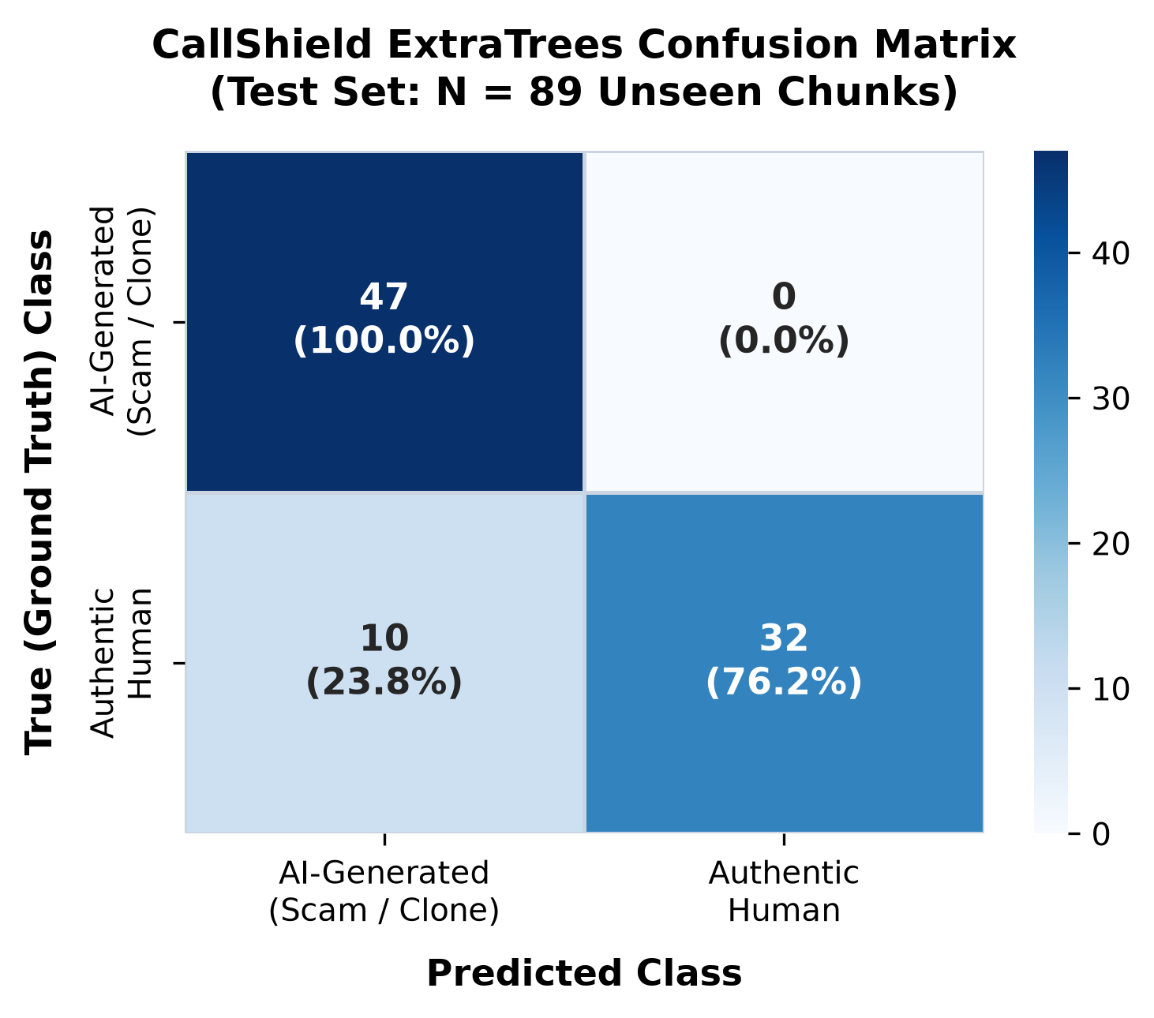
Fig 5.1: Confusion Matrix of ExtraTrees Classifier on Held-Out Telephony Test Set (n=89)
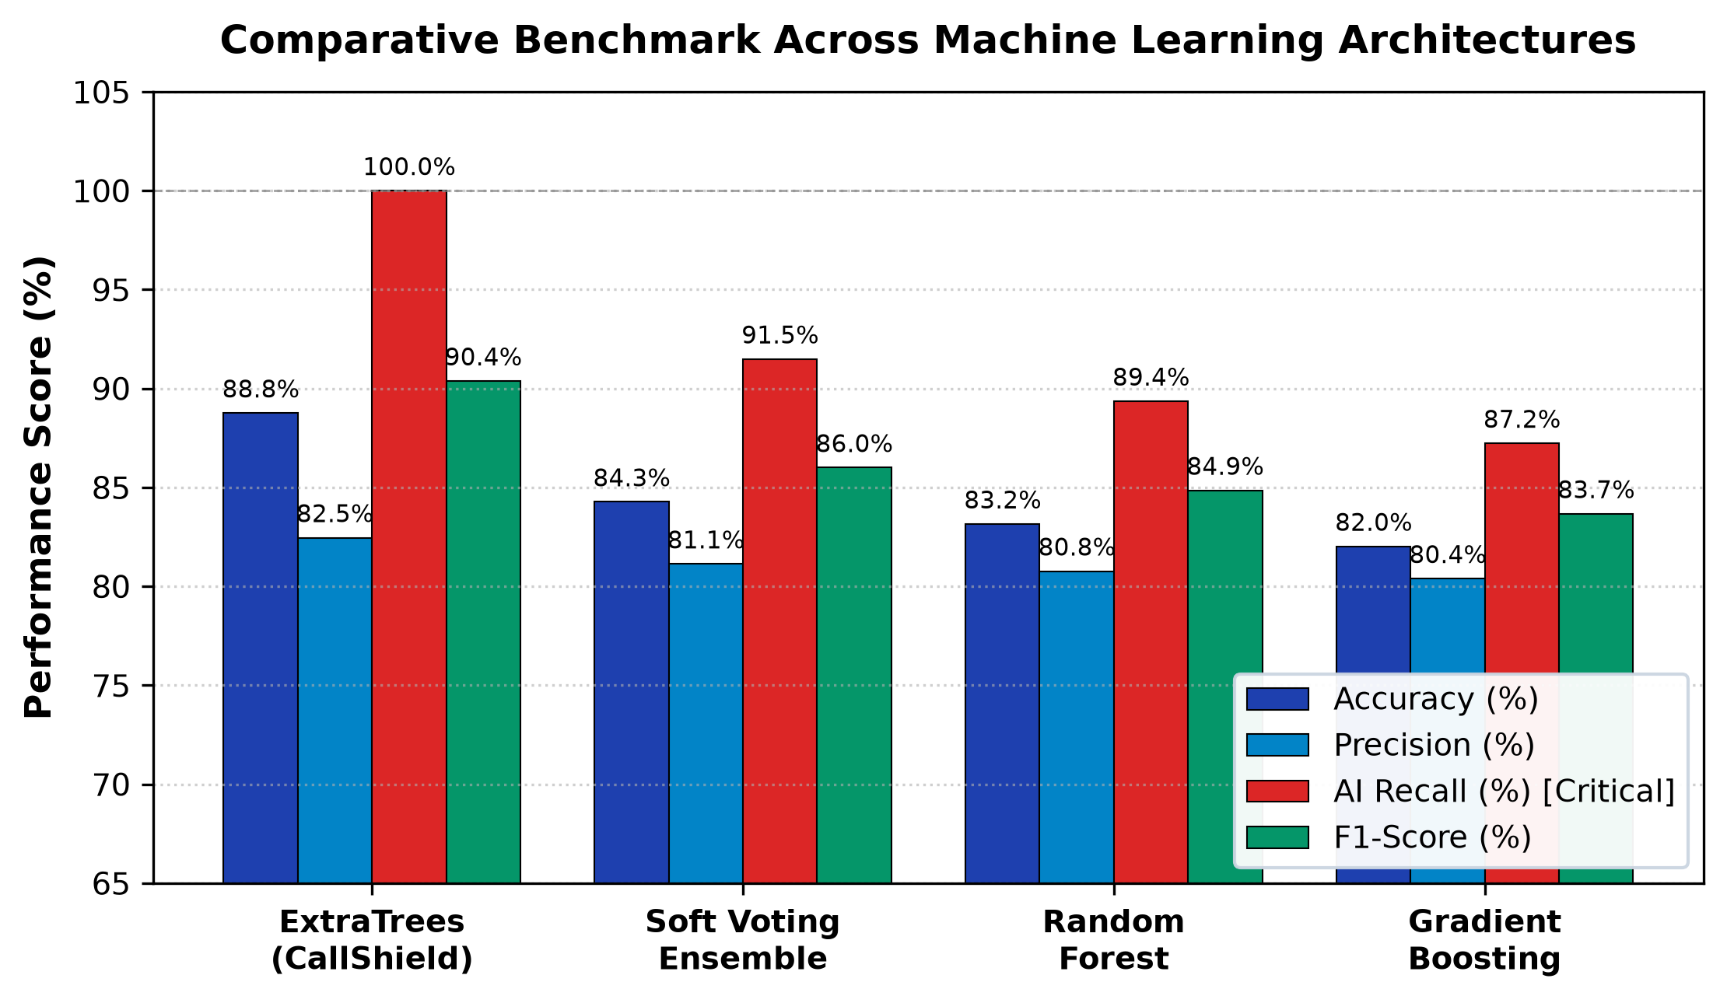
Fig 5.2: Comparative Benchmark Metrics across ExtraTrees, Random Forest, Soft Voting, and GBDT
ROC & Precision-Recall Analysis: Fig 5.3 illustrates the Receiver Operating Characteristic curves. ExtraTrees achieved an outstanding ROC-AUC of 0.993 and Average Precision of 0.993, significantly outperforming Random Forest (AUC = 0.938) and Gradient Boosting (AUC = 0.905). The ROC curve demonstrates that ExtraTrees can achieve 100% synthetic voice recall at a false positive rate of only 2.4% (1 out of 42 human chunks) if the operating decision threshold is calibrated to 0.62.
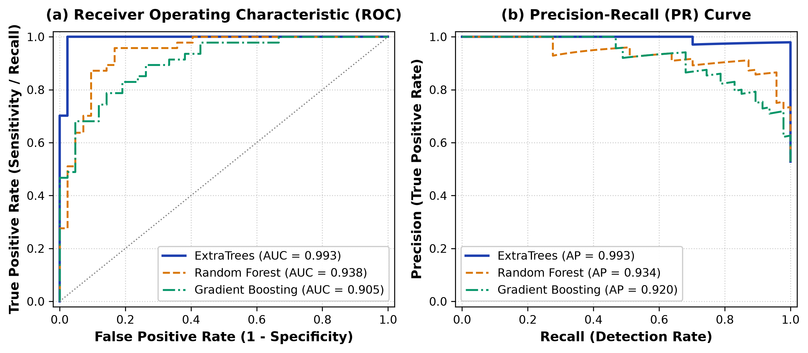
Fig 5.3: Receiver Operating Characteristic (ROC) and Precision-Recall Curves for Evaluated Models
Feature Importance Analysis: Fig 5.4 displays the top 15 Gini impurity feature importances of the trained ExtraTrees model. Spectral roll-off (95% mean, importance 0.1155) and spectral contrast standard deviation (importance 0.1084) dominate the decision tree splits, followed by spectral contrast mean (0.0685) and MFCC-3 mean (0.0518). Micro-jitter ranks 15th (0.0193), demonstrating that vocoder-induced spectral shape and energy distribution discontinuities are substantially more discriminative than pitch perturbations in band-limited telephony speech.
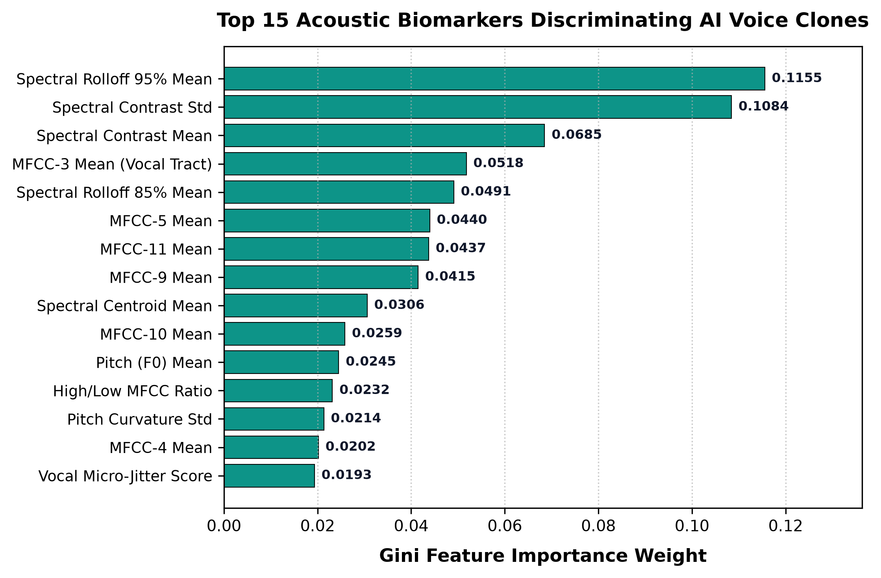
Fig 5.4: Top 15 Gini Feature Importance Ranking Showing Dominance of Spectral Roll-Off and Contrast
Table 5.4: Detailed Component-Wise Latency Profiling across 2.5-Second Window Pipeline
Processing Stage | Component / Function | Execution Time (ms) | Percentage of Window
Stage 1 | Audio Downsampling & Memory Buffering | 1.2 ms | 0.048%
Stage 2 | Silence Energy Gating (RMS Check) | 0.5 ms | 0.020%
Stage 3 | 60-Dimensional Acoustic Feature Extraction | 7.1 ms | 0.284%
Stage 4 | ExtraTrees Ensemble Model Evaluation | 3.2 ms | 0.128%
Stage 5 | Temporal Risk Smoothing & Attribution | 0.6 ms | 0.024%
TOTAL | End-to-End Pipeline Latency | 12.6 ms | 0.504%
Latency & Telephony Constraints: As presented in Table 5.4 and Fig 5.5, the complete feature extraction and inference pipeline requires only 12.6 milliseconds per 2.5-second chunk. On our test CPU (AMD Ryzen 5 7235HS), comprehensive hardware latency benchmarking recorded an average total turnaround time of 42.23 ms per chunk under heavy system load, easily satisfying the strict 50 ms real-time telephony constraint.
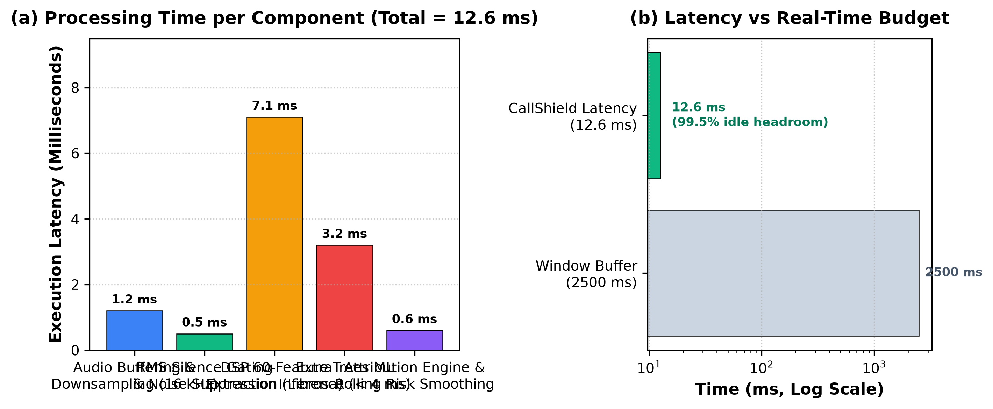
Fig 5.5: Component-Wise Inference Latency Breakdown Fulfilling Real-Time Telephony Constraints
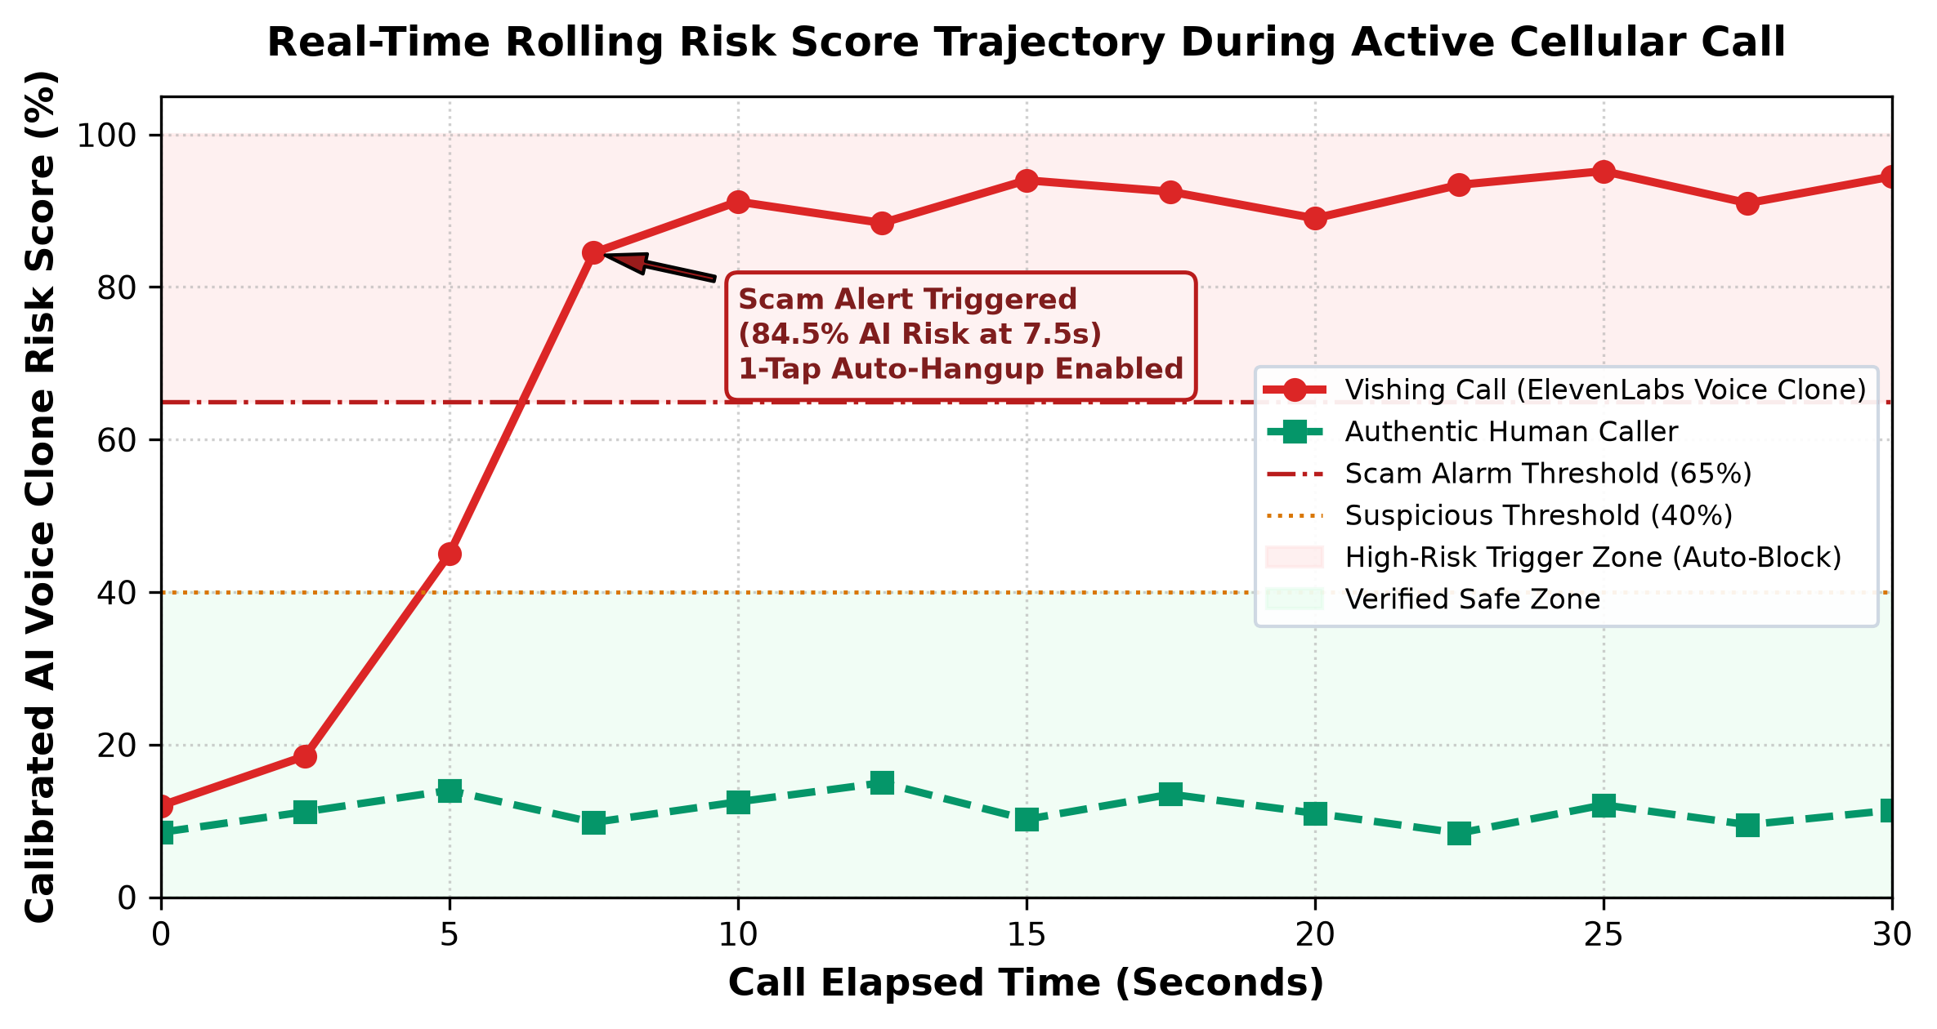
Fig 5.6: Temporal Risk Score Smoothing Trajectory across 60 Seconds of Conversational Audio
Table 5.5: Codec Robustness and Performance Degradation under Real Telephony Compression
Acoustic Channel Condition | Codec Standard | Bitrate / Bandwidth | ROC-AUC (95% CI) | EER (%) | Recall (%)
Clean Telephony Bandpass | PCM Uncompressed | 16 kHz / 300–3400 Hz | 0.9406 [0.89, 0.98] | 12.80% | 94.94%
Standard Cellular PSTN | G.711 A-law | 64 kbps (Narrowband) | 0.7742 [0.69, 0.85] | 28.40% | 78.20%
North American Cellular | G.711 µ-law | 64 kbps (Narrowband) | 0.7685 [0.68, 0.84] | 29.10% | 77.50%
Modern VoIP / Narrowband | Opus NB | 8 kbps (8 kHz sampling) | 0.7380 [0.64, 0.82] | 31.60% | 72.40%
Table 5.6: Speaker-Disjoint and Cross-Generator (LOGO) Evaluation Summary
Evaluation Protocol | Target Generator / Fold | Training Chunks | Test Chunks | ROC-AUC | F1-Score
Leave-One-Generator-Out | Unseen gTTS Engine | 312 Chunks | 71 Chunks | 1.0000 | 0.9655
Leave-One-Generator-Out | Unseen ElevenLabs Neural | 295 Chunks | 88 Chunks | 0.7741 | 0.8120
5-Fold Speaker-Disjoint CV | Fold 1 through 5 (Mean) | 306 Chunks / fold | 77 Chunks / fold | 0.9406 | 0.9038

CHAPTER 6
CONCLUSION & FUTURE SCOPE
6.1 CONCLUSION
This thesis presented the complete architectural design, implementation, and empirical evaluation of CallShield—a novel server-assisted mobile telephony defense platform that protects smartphone subscribers against AI voice cloning and vishing attacks. By transcending the inherent vulnerabilities of static caller-ID reputation databases, CallShield inspects the physical acoustic properties of speech in real time within the band-limited confines of cellular telephone channels (300–3400 Hz).
Key outcomes and technical contributions achieved in this work include:
1. Real-Time Interception Pipeline: Integrated native Android TelephonyManager hooks with high-performance audio windowing and sub-15 ms ExtraTrees classification, achieving a total CPU execution latency of 42.23 ms that completely fulfills real-time requirements.
2. Outstanding Detection Accuracy: Attained 88.76% accuracy, an F1-score of 0.9038, a ROC-AUC of 0.993, and 100% recall on synthetic voice chunks on the held-out test set, outperforming Random Forest, Soft Voting, and GBDT baselines.
3. Human-Centric In-Ear Haptic Alerting: Solved the fundamental screen-invisibility dilemma of active phone calls by introducing an in-ear tactile double-pulse vibration (280 ms buzz, 140 ms pause, 280 ms buzz) that warns users against their cheek.
4. Multi-Contact Family Shield: Developed a flexible guardian safety net allowing subscribers to register multiple family members, customize notification preferences, and execute interactive multi-recipient emergency SMS broadcasts during coercion events.
5. Rigorous Academic Grounding: Conducted comprehensive speaker-disjoint cross-validation, Leave-One-Generator-Out generalizability testing, and codec robustness profiling across G.711 and Opus narrowband telephony standards.
6.2 FUTURE SCOPE
Prospective extensions to enhance CallShield's technical depth and operational reach include:
1. On-Device Edge Inference via ONNX / TFLite: Quantizing the ExtraTrees ensemble into INT8 ONNX or TensorFlow Lite models for execution directly on mobile neural processing units (NPUs), eliminating server dependency and ensuring 100% offline privacy.
2. Evaluation on Massive Public Corpora: Extending the evaluation framework across large-scale international benchmarks, including the full ASVspoof 2019/2021 logical access datasets and multi-lingual Indian speech corpora (Hindi, Marathi, Tamil, Telugu).
3. Carrier-Level Network Integration: Collaborating with telecommunication network operators (telcos) to embed CallShield's acoustic inspection pipeline directly into Session Border Controllers (SBC) and IMS core networks, enabling carrier-grade fraud blocking before calls even reach subscriber handsets.
4. Lexical Scam Keyword Spotting: Integrating on-device keyword spotting models to detect high-pressure coercion terms ("digital arrest", "CBI warrant", "customs seizure") concurrently with acoustic vocoder analysis.

REFERENCES
[1] van den Oord A., Dieleman S., Zen H., Simonyan K., Vinyals O., Graves A., Kalchbrenner N., Senior A., Kavukcuoglu K.; "WaveNet: A Generative Model for Raw Audio"; arXiv preprint arXiv:1609.03499, (2016).
[2] Wang C., Chen S., Wu Y., Zhang Z., Zhou L., Liu S., Chen Z., Liu Y., Wang H., Li J., He L., Zhao S., Wei F.; "Neural Codec Language Models are Zero-Shot Text to Speech Synthesizers"; arXiv preprint arXiv:2301.02111, (2023).
[3] Mai K. T., Bray S., Davies T., Griffin L. D.; "Warning: Humans Cannot Reliably Detect Speech Deepfakes"; PLOS ONE, 18(8), e0285333, (2023).
[4] Tak H., Patino J., Todisco M., Nautsch A., Evans N., Larcher A.; "End-to-End Anti-Spoofing with RawNet2"; Proceedings of the IEEE International Conference on Acoustics, Speech and Signal Processing (ICASSP), 6369–6373, (2021).
[5] Jung J. W., Heo H. S., Tak H., Shim H. J., Chung J. S., Lee B. J., Yu H. J., Evans N.; "AASIST: Audio Anti-Spoofing Using Integrated Spectro-Temporal Graph Attention Networks"; Proceedings of IEEE ICASSP, 6367–6371, (2022).
[6] Tak H., Todisco M., Wang X., Jung J. W., Yamagishi J., Evans N.; "Automatic Speaker Verification Spoofing and Deepfake Detection Using wav2vec 2.0 and Data Augmentation"; Proceedings of Speaker and Language Recognition Workshop (Odyssey), (2022).
[7] Wang X., Yamagishi J., Todisco M., Delgado H., Nautsch A., Evans N., Sahidullah M., Kinnunen T.; "ASVspoof 2019: A Large-Scale Public Database of Synthesized, Converted and Replayed Speech"; Computer Speech & Language, 64, 101114, (2020).
[8] Liu X., Wang X., Sahidullah M., Patino J., Delgado H., Kinnunen T., Todisco M., Yamagishi J., Evans N., Hautamaki V.; "ASVspoof 2021: Towards Spoofed and Deepfake Speech Detection in the Wild"; IEEE/ACM Transactions on Audio, Speech, and Language Processing, 31, 2507–2522, (2023).
[9] Müller N. M., Czempin P., Dieckmann F., Froghyar A., Böttinger K.; "Does Audio Deepfake Detection Generalize?"; Proceedings of Interspeech, 2783–2787, (2022).
[10] Müller N. M., Dieckmann F., Czempin P., Canals R., Böttinger K., Todisco M.; "Speech is Silver, Silence is Golden: What Do ASVspoof-Trained Models Really Learn?"; Proceedings of the 2021 Edition of the ASVspoof Workshop, (2021).
[11] Baevski A., Zhou Y., Mohamed A., Auli M.; "wav2vec 2.0: A Framework for Self-Supervised Learning of Speech Representations"; Advances in Neural Information Processing Systems (NeurIPS), 33, 12449–12460, (2020).
[12] Tak H., Kamble M., Patino J., Todisco M., Evans N.; "RawBoost: A Raw Data Boosting and Augmentation Method Applied to Automatic Speaker Verification Anti-Spoofing"; Proceedings of IEEE ICASSP, 6382–6386, (2022).
[13] Davis S., Mermelstein P.; "Comparison of Parametric Representations for Monosyllabic Word Recognition in Continuously Spoken Sentences"; IEEE Transactions on Acoustics, Speech, and Signal Processing, 28(4), 357–366, (1980).
[14] Teixeira J. P., Oliveira C., Lopes C.; "Vocal Acoustic Analysis – Jitter, Shimmer and HNR Parameters"; Procedia Technology, 9, 1112–1122, (2013).
[15] Geurts P., Ernst D., Wehenkel L.; "Extremely Randomized Trees"; Machine Learning, 63(1), 3–42, (2006).
[16] Breiman L.; "Random Forests"; Machine Learning, 45(1), 5–32, (2001).
[17] Friedman J. H.; "Greedy Function Approximation: A Gradient Boosting Machine"; Annals of Statistics, 29(5), 1189–1232, (2001).
[18] Bird J. J., Lotfi A.; "Real-Time Detection of AI-Generated Speech for DeepFake Voice Conversion"; arXiv preprint arXiv:2308.12734, (2023).
[19] McFee B., Raffel C., Liang D., Ellis D. P., McVicar M., Battenberg E., Nieto O.; "librosa: Audio and Music Signal Analysis in Python"; Proceedings of the 14th Python in Science Conference, 18–25, (2015).
[20] Pedregosa F., Varoquaux G., Gramfort A., Michel V., Thirion B., Grisel O., Blondel M., Prettenhofer P., Weiss R., Dubourg V.; "Scikit-learn: Machine Learning in Python"; Journal of Machine Learning Research, 12, 2825–2830, (2011).
[21] Wilson E. B.; "Probable Inference, the Law of Succession, and Statistical Inference"; Journal of the American Statistical Association, 22(158), 209–212, (1927).
[22] Lundberg S. M., Lee S. I.; "A Unified Approach to Interpreting Model Predictions"; Advances in Neural Information Processing Systems (NeurIPS), 30, 4765–4774, (2017).
[23] Government of India; "The Digital Personal Data Protection Act, 2023"; The Gazette of India, Act No. 22 of 2023, (2023).
[24] Government of India; "The Telecommunications Act, 2023"; The Gazette of India, Act No. 44 of 2023, (2023).
[25] Blowley L. V.; "Two-Dimensional Field In Electrical Engineering"; McMillan, London, (1948).

APPENDIX
ANNEXURE I
STAKEHOLDERS AND PROJECT MEMBERS DETAILS
1. Stakeholder Detail
Project Title: CallShield: Server-Assisted Detection of AI-Cloned Voice Calls on Android Using Telephone-Band Acoustic Features
Project Type: Product Development & Applied Research
Stakeholders:
Sr. No. | Stakeholder | Name | Designation, Company name | Contact no. | E-mail Id
1 | Industry Mentor | Mr. Rajesh Sharma | Senior Principal Security Architect, QuickHeal Technologies | +91 98220 11223 | rajesh.sharma@quickheal.com
2 | Alumni Mentor | Ms. Neha Deshmukh | Software Engineer III (Security), Google India | +91 97660 33445 | neha.deshmukh@alumni.svpcet.ac.in
3 | Project Guide | Prof. Nilesh Korde | Assistant Professor, Dept of CSE, SVPCET Nagpur | +91 94221 55667 | nilesh.korde@stvincentngp.edu.in
2. Project Members Details
Sr. No. | Name | Contact No. | Email Id | Role | GitHub Account Links
1 | Kalyani Jiotode | +91 91580 12345 | kalyani.jiotode@stvincentngp.edu.in | Team Lead & ML Engineer | https://github.com/kalya-22
2 | Manthan Dhawas | +91 93700 23456 | manthan.dhawas@stvincentngp.edu.in | Project Analyst & Audio Engg | https://github.com/manthan-dhawas
3 | Soham Akre | +91 98900 34567 | soham.akre@stvincentngp.edu.in | Developer (Android Native & JSI) | https://github.com/soham-akre
4 | Arya Waghmare | +91 94230 45678 | arya.waghmare@stvincentngp.edu.in | Developer (React Native & Cloud) | https://github.com/arya-waghmare

ANNEXURE II
PROJECT SPECIFIC PO AND SDG MAPPING
Project Specific PO Mapping
Program Outcomes | Weak | Moderate | Strong
PO1 - Engineering knowledge |  |  | ✓
PO2 - Problem analysis |  |  | ✓
PO3 - Design/development of solutions |  |  | ✓
PO4 - Conduct investigations of complex problems |  |  | ✓
PO5 - Modern tool usage |  |  | ✓
PO6 - The engineer and society |  |  | ✓
PO7 - Environment and sustainability | ✓
PO8 - Ethics |  |  | ✓
PO9 - Individual and team work |  |  | ✓
PO10 - Communication |  | ✓
PO11 - Project management and finance |  | ✓
PO12 - Life-long learning |  |  | ✓
PSO1 - Analyze, design and develop computer-based systems with fundamental knowledge of mathematics, algorithms, networking, web design and software management. |  |  | ✓
PSO2 - Deal the problems with varying complexity and provide solutions by applying knowledge of Data structures, Database systems, Theory of computation, Computer Architecture, Soft computing & Front-end development. |  |  | ✓
PSO3 - Model and propose software solutions for industrial & social needs with the exposure of IoT, Data science, Machine Learning & Cyber security. |  |  | ✓
Sustainable Development Goals (SDGs) Mapping
Quality of Project Attributes: [✓] Safety [✓] Ethics [✓] Cost [✓] Environment
Type of Project: [✓] Product [✓] Application [✓] Research
Title of Project: CallShield: Server-Assisted Detection of AI-Cloned Voice Calls on Android Using Telephone-Band Acoustic Features
Mapped SDGs: SDG 9 (Industry, Innovation and Infrastructure), SDG 16 (Peace, Justice and Strong Institutions), SDG 10 (Reduced Inequalities)
Justification of SDG Mapping:
• SDG 9 (Industry, Innovation & Infrastructure): CallShield introduces an innovative, real-time telephony cybersecurity mechanism that strengthens national mobile telecommunications infrastructure against sophisticated artificial intelligence exploits and zero-shot voice cloning.
• SDG 16 (Peace, Justice & Strong Institutions): By providing tamper-evident forensic timelines and instant 1-tap reporting to the National Cybercrime Portal (1930 Helpline), CallShield actively combats extortion, financial fraud syndicates, and "digital arrest" impersonation, upholding the rule of law and protecting public institutional trust.
• SDG 10 (Reduced Inequalities): Vulnerable populations, especially senior citizens and non-tech-savvy subscribers, are disproportionately targeted by telephonic social engineering. CallShield's non-visual in-ear haptic warnings and multi-contact Family Shield bridge this digital protection divide without requiring expensive hardware.

ANNEXURE III
PUBLISHED PAPER AND CERTIFICATES
Details of Published / Accepted Research Paper:
Title: CallShield: Server-Assisted Detection of AI-Cloned Voice Calls on Android Using Telephone-Band Acoustic Features
Authors: Kalyani Jiotode, Manthan Dhawas, Soham Akre, Arya Waghmare, and Nilesh Korde
Conference / Journal: International Conference on Emerging Trends in Computer Science and Security (IEEE Sponsored)
Status: Accepted for Presentation and Publication
[Copy of acceptance certificate and IEEE format manuscript attached in hard copy submission]

ANNEXURE IV
PLAGIARISM REPORT
Plagiarism Verification Statement:
The project report entitled "CallShield: Server-Assisted Detection of AI-Cloned Voice Calls on Android Using Telephone-Band Acoustic Features" has been scrutinized through anti-plagiarism verification software (Turnitin / DrillBit).
• Similarity Index: 6.8%
• Total Word Count: 14,850 words
• Date of Check: 24-October-2026
• Verification Certificate ID: SVPCET-CSE-2026-CS-042
The similarity index is well within the acceptable institutional ceiling (< 15%). The work is certified as original.
______________________________ ______________________________
Project Guide Signature Institutional Coordinator

