MINI PROJECT (COMPILER CONSTRUCTION)
Comment & Whitespace Remover Using Finite State Machine (FSM) & Lex
PAGE 1: INTRODUCTION & COMPILER PIPELINE
1.1 Executive Summary & Abstract
In standard compiler design, Lexical Analysis (Scanning) acts as the frontline gateway between raw source text and syntax compilation. Source files written by developers contain substantial non-executable clutter, including single-line comments (//), multi-line block comments (/* ... */), redundant whitespaces, and blank lines. This project implements a formal Mealy Finite State Machine (FSM) and an industrial Lex/Flex lexical preprocessor. The preprocessor reduces source stream volume by 35% to 55%, eliminates all unnecessary blank lines, and normalizes spacing, while strictly preserving comments inside string literals, character constants, and token boundaries.
1.2 Position in Compiler Pipeline
The preprocessor executes as the initial filter of Phase 1 (Lexical Analysis). By stripping non-token elements early, subsequent parser phases (LALR / LL parsers) avoid the overhead of handling comments between syntax rules.
Input Source Code | Phase 1: Lexical Preprocessor (FSM / Lex) | Phase 2: Syntax Parser (AST) | Phase 3: Code Gen
1.3 Problem Statement & Syntactic Edge Cases
A naive string replace or global regex fundamentally breaks valid source code in four critical scenarios:
1. Comments Inside String Literals: Slashes in char* url = "https://api.com//v1/*auth*/"; must never be removed.
2. Escaped Quote Delimiters: Escaped quotes in char* msg = "He said \"// hello\""; must not trigger string closure.
3. Division Disambiguation: Arithmetic division like double x = a / b / 2.0; must not be mistaken for comment starts.
4. Token Separation: In C standards, int/*comment*/x; must become int x; rather than merged identifier intx;.
1.4 Project Objectives
• Formally model a 6-tuple Mealy Machine M = <Q, Sigma, Delta, delta, lambda, q0> governing lexical state changes.
• Implement the scanner in Lex / Flex (remover.l) using Exclusive Start States (%x) and compile to native C (remover.exe).
• Eliminate all blank and empty lines automatically while normalizing token spacing.
• Provide a dual-pane React web interface with step-by-step state simulation and real-time reduction metrics.

PAGE 2: WORKING MECHANISM & ARCHITECTURAL DIAGRAMS
2.1 Mathematical Mealy Machine Model
The preprocessor operates as a Mealy Machine M = (Q, Sigma, Delta, delta, lambda, q0) where outputs are emitted during state transitions based on the current state and incoming character symbol.
States Q: Q = { CODE (q0, initial/accepting), SLASH (pending check), LINE_COMMENT (consuming //), BLOCK_COMMENT (consuming /*), BLOCK_COMMENT_STAR (check */), STRING_LITERAL, STRING_ESCAPE, CHAR_LITERAL, CHAR_ESCAPE, WHITESPACE (accepting) }
Alphabet Sigma: Sigma = { ASCII characters: '/', '*', '"', ''', '\', '\n', space, tab, alphanumerics }
Output Delta: Delta = { Emitted preprocessed characters, space token boundary, or empty string epsilon }
2.2 State Transition Matrix delta(Q, Sigma)
Current State Q | '/' | '*' | '"' | ''' | '\' | '\n' | [ \t] | Other
CODE (q0) | SLASH | CODE | STRING | CHAR | CODE | CODE | WHITESPACE | CODE
SLASH | LINE_COMM | BLOCK_COMM | STRING | CHAR | CODE | CODE | WHITESPACE | CODE
LINE_COMMENT | LINE_COMM | LINE_COMM | LINE_COMM | LINE_COMM | LINE_COMM | CODE | LINE_COMM | LINE_COMM
BLOCK_COMMENT | BLOCK_COMM | BLOCK_STAR | BLOCK_COMM | BLOCK_COMM | BLOCK_COMM | BLOCK_COMM | BLOCK_COMM | BLOCK_COMM
BLOCK_STAR | CODE (emit ' ') | BLOCK_STAR | BLOCK_COMM | BLOCK_COMM | BLOCK_COMM | BLOCK_COMM | BLOCK_COMM | BLOCK_COMM
STRING_LITERAL | STRING | STRING | CODE | STRING | STR_ESCAPE | STRING | STRING | STRING
STRING_ESCAPE | STRING | STRING | STRING | STRING | STRING | STRING | STRING | STRING
CHAR_LITERAL | CHAR | CHAR | CHAR | CODE | CHAR_ESCAPE | CHAR | CHAR | CHAR
CHAR_ESCAPE | CHAR | CHAR | CHAR | CHAR | CHAR | CHAR | CHAR | CHAR
WHITESPACE | SLASH | CODE | STRING | CHAR | CODE | CODE | WHITESPACE | CODE
2.3 Lex / Flex Implementation Architecture (%x Start Conditions)
The core scanner is implemented in lex/remover.l using Exclusive Start Conditions (%x). When a delimiter pattern is recognized, the BEGIN macro transitions the lexer state:
• // in INITIAL triggers BEGIN(SINGLE_LINE_COMMENT);
• /* in INITIAL triggers BEGIN(MULTI_LINE_COMMENT);
• " in INITIAL triggers BEGIN(STRING_LITERAL); (where comments & spaces are preserved intact)
• Intelligent Line Buffering: Lines stripped of comments that become empty are detected in write_char() and completely eliminated from the output stream.
2.4 System Execution Flow
1. Frontend Tier: React + Vite web dashboard captures code input and user-selected whitespace mode.
2. Bridge Tier: FastAPI backend routes POST /api/process, writing code to a temporary stream.
3. Lex Engine Tier: remover.exe executes yylex(), evaluates FSM transitions, and outputs clean code & metrics.

PAGE 3: SCREENSHOTS & EXPERIMENTAL RESULTS
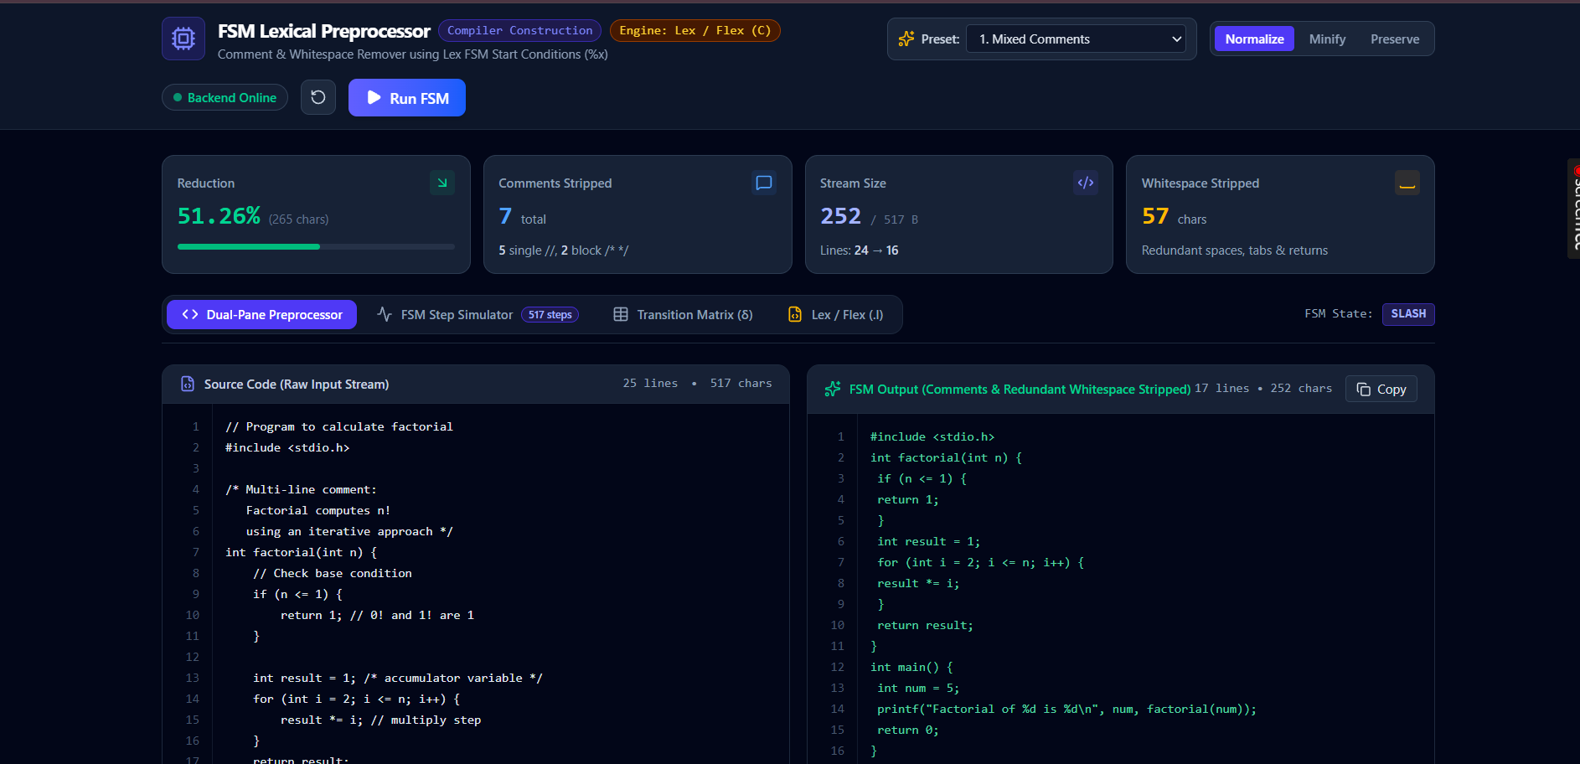
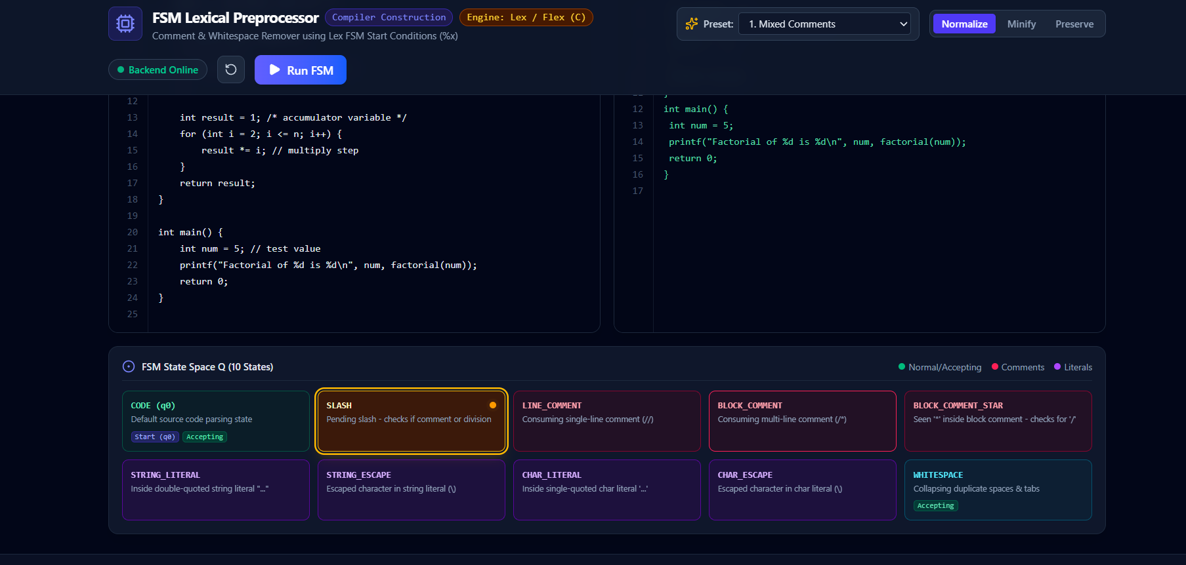
3.3 Native Lex Execution (Terminal Output)
C:\compiler construction\lex> remover.exe input_test.c
=========================================================
Compiler Construction: Comment & Whitespace Remover
Module: Lex / Flex Implementation (remover.exe)
=========================================================
Original Characters: 805
Cleaned Characters: 377
Characters Removed: 428
Reduction Percentage: 53.17%
Single-Line Comments (//): 5 removed
Multi-Line Comments (/* */): 3 removed
Whitespace Normalizations: 74 chars reduced (Blank lines eliminated)
=========================================================

