

**AWS EC2 LAB**

**Introduction**

**Overview**

This guide introduces you to Creation of Amazon Elastic Cloud Compute Instance (Amazon EC2) using the AWS Management Console.

Amazon API Gateway



Updated region code

For more Information about regions, see

http://docs.aws.amazon.com/general/latest/gr/rande.html

**Topics covered**

By the end of this lab, you will be able to:

1. Log into the Amazon Management Console.
2. Create an Amazon Linux Instance from an Amazon Machine Image (AMI).
3. Find your instance in the Amazon Management Console.
4. Log into your instance.

**Pre-requisite**

Download Putty or Xshell

If you do not already have the PuTTY client installed on your machine, you can download and then launch it from here:

http://the.earth.li/~sgtatham/putty/latest/x86/putty.exe

Xshell link – License Type – “Home and School Use”

https://www.netsarang.com/download/down_form.html?code=522&downloadType=0&licenseType=1,

A link would be sent to your email ID to download the file.

**Log into the Amazon Management Console**.

1. Click on **“Sign in to the Console”**

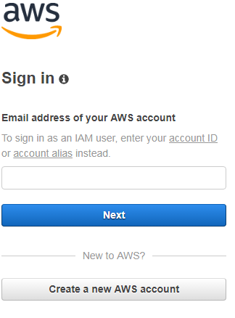

2. Click on **“Create a new AWS**

**Account”**

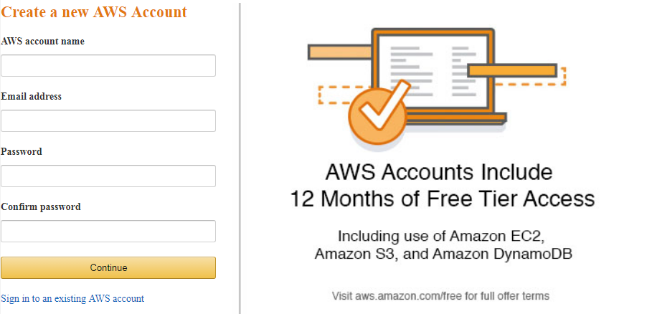

3. Please provide the correct Phone number as there will be an verification call to activate the account.

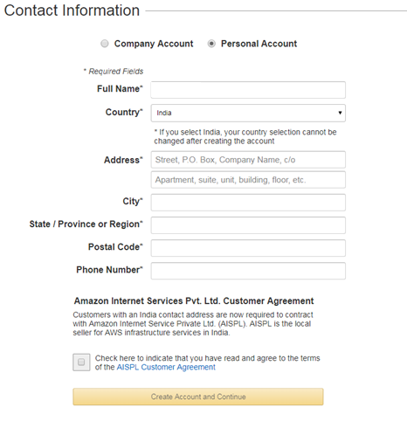

4. This is an free account, but for verification you will need to give Credit or Debit card details. They would charge INR 2.

**Note:- Please change EXPIRE date of the card later on the aws portal**

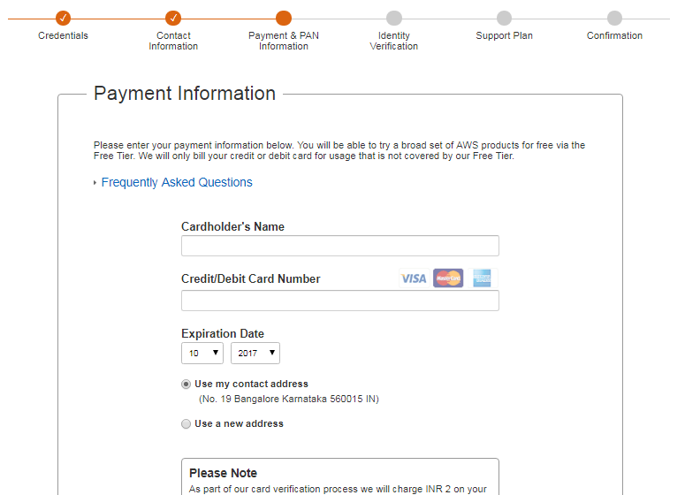

5. You would get an call as verification from AWS.

6. Enter the “Code” shown on the screen on the phone to verify the same.

CONGRATS your AWS account is READY to use

**Create an Amazon Linux Instance from an Amazon Machine Image (AMI).**

1. In the **AWS Management Console**, on the **Services** menu, click **EC2.**

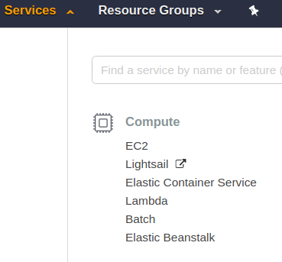

2. Click **Launch Instance.**

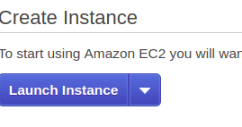

3. Find the **Amazon Linux AMI** instance (usually the first choice in the list). Click **Select** for this **AMI.**

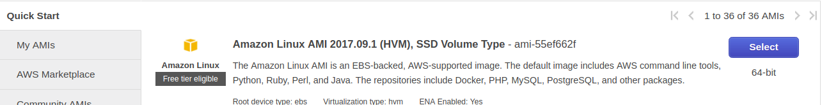

4. Select instance type General purpose – t2.micro.

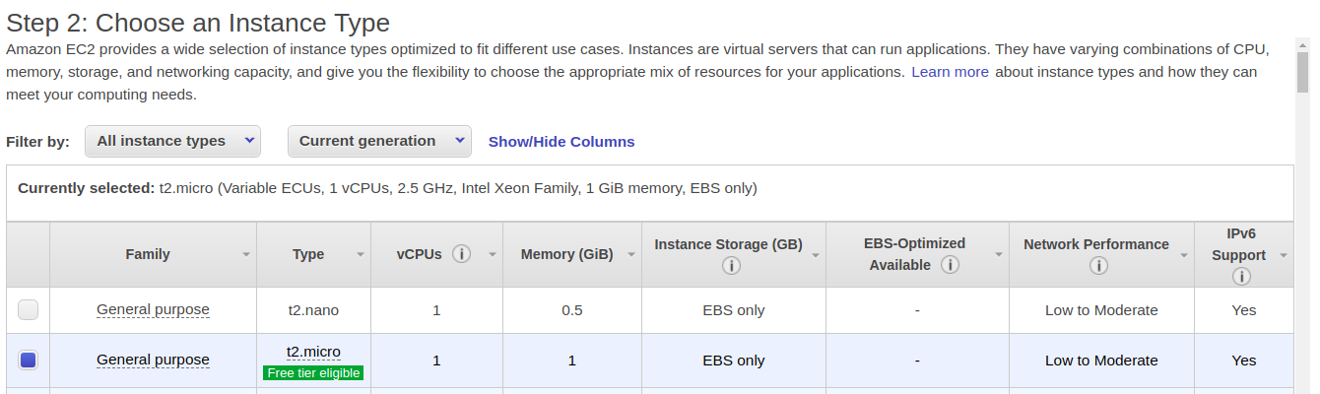

5. **Click Next: Configure Instance Details.**

Tip: It is worth to note the various options on this page.

This is the location where you would set access, network settings, monitoring and other options.

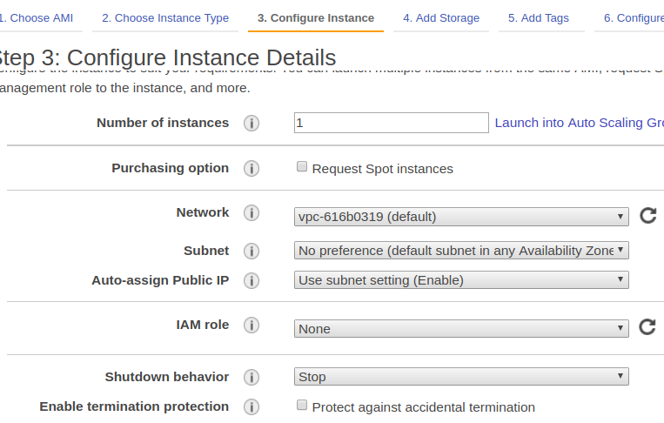

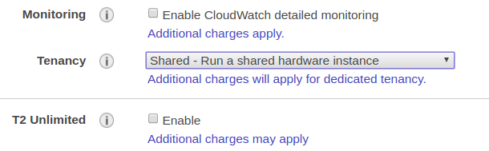Tenancy is an option to select from

a. Shared Instance

b. Dedicated Instance

c. Dedicated Host Instance

T2 Ulimited --> Enable’s the Instance to scale up on the CPU RAM, as when required, out of the Specified Instance type.

Example. If Instance type is t2.micro(1 CPU, 1 GB), Enabling “T2 Unlimited”, instance can scale up to 8 core, 16 GB (the max of t2 ). Charges would be on prodata basis.