**PROJECT 1: (**[**WWW.TEATIMEGOSSIPS.COM**](http://WWW.TEATIMEGOSSIPS.COM)**)**

**Part-1:**

**Website Created using Wordpress:**

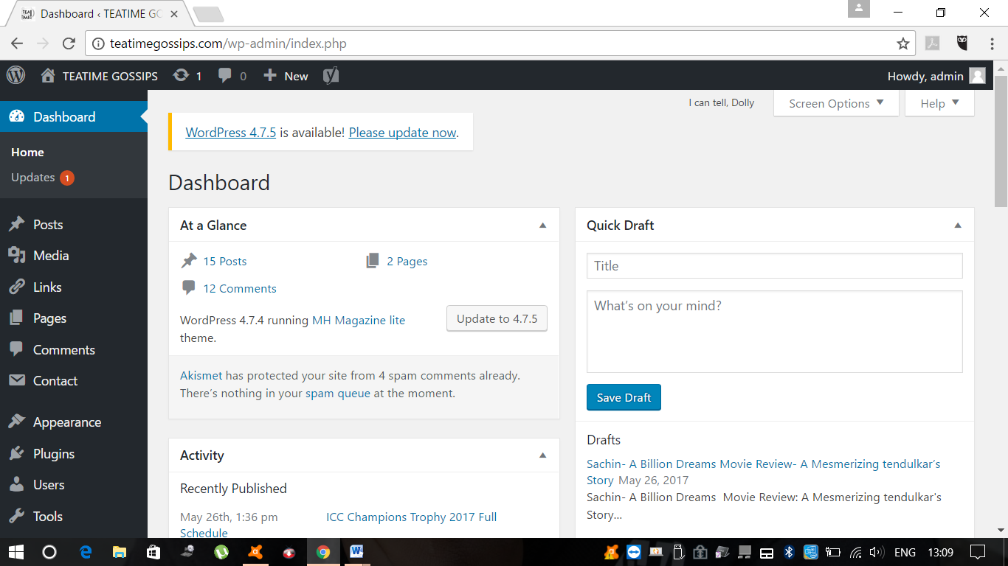

**Posts in Teatime Gossips website: www.teatimegossips.com**

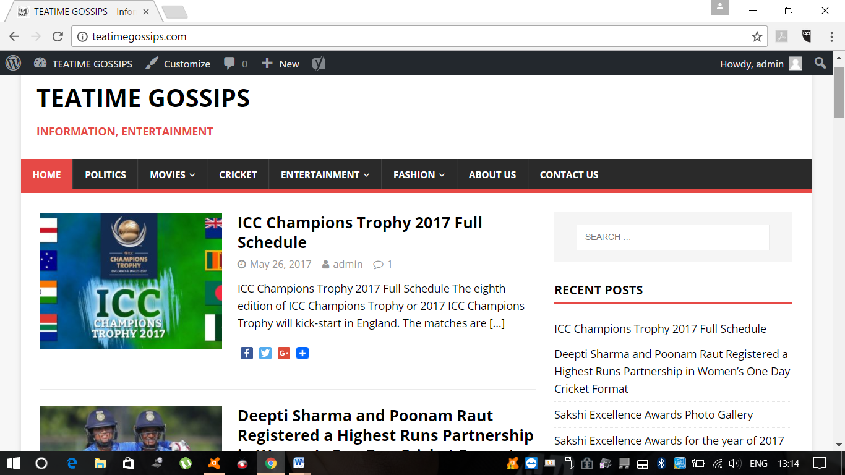

**URL for Project-1 in Part -2:**

* Do On-Page SEO of the website
* Keyword Research and analysis using the tool as discussed in the class.
* Appropriate Page Titles for every page
* Ensure the SEO tags are appropriately defined (Title, Meta Description, H1 tag, Image alt tags)

[**http://teatimegossips.com/wp-admin/post.php?post=170&action=edit**](http://teatimegossips.com/wp-admin/post.php?post=170&action=edit)

**Part-3:**

**Add the website to Google Webmasters and verify the ownership:**

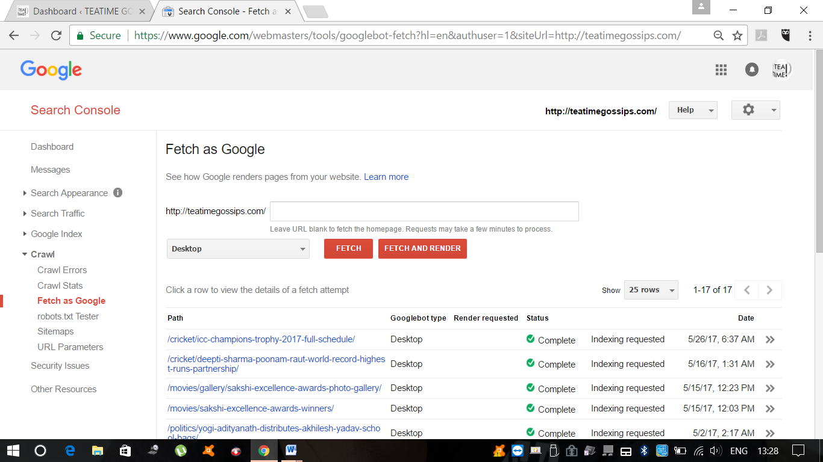

**Set up Google Analytics (GA) and add GA tracking code to your site:**

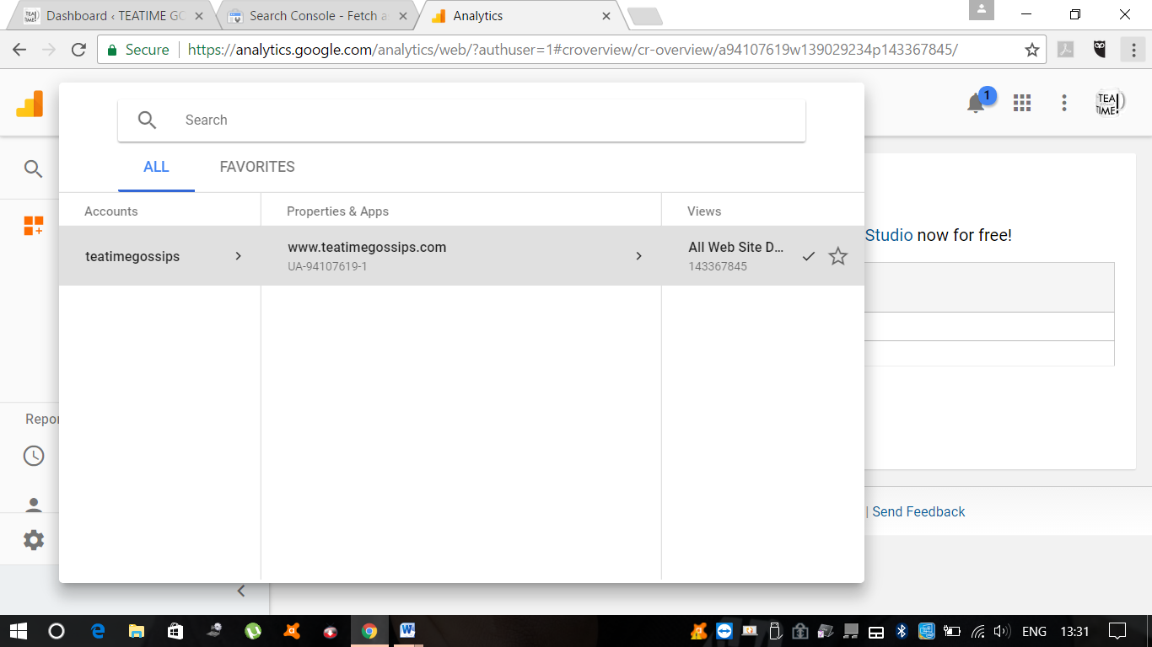

**Weekly Goal Report:**

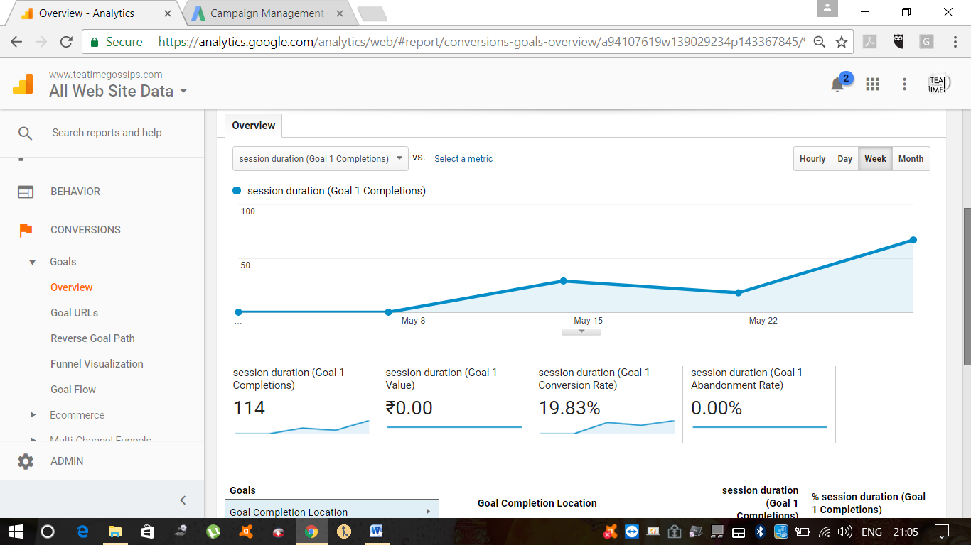

**Monthly Goal Report:**

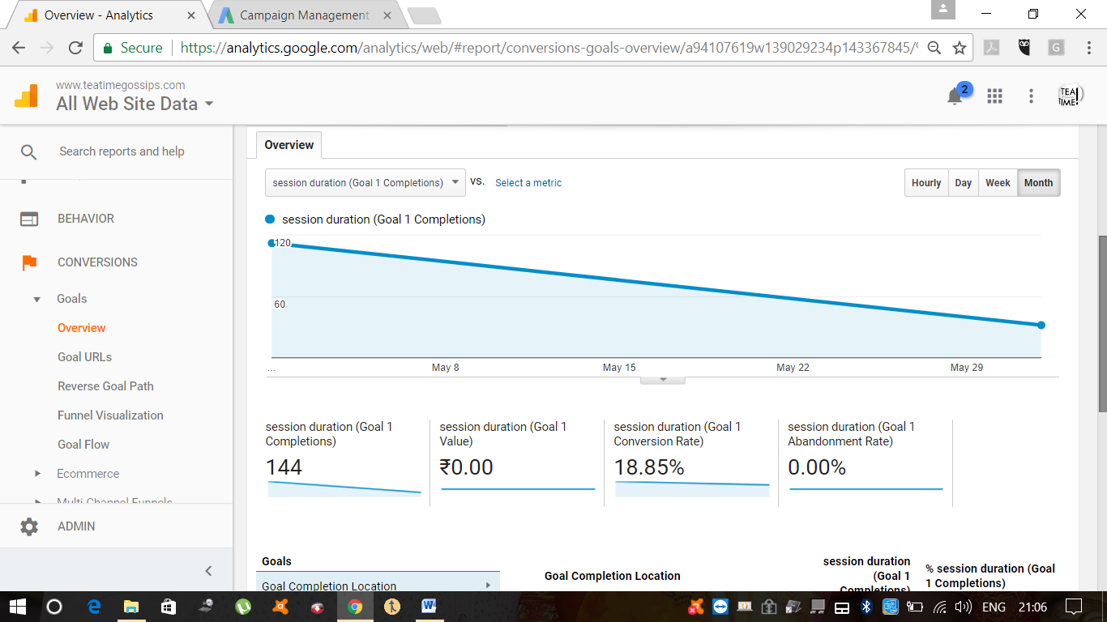

**Set up Google Ad words Account:**

