**PART-1:**

**FACE BOOK PAGE:**

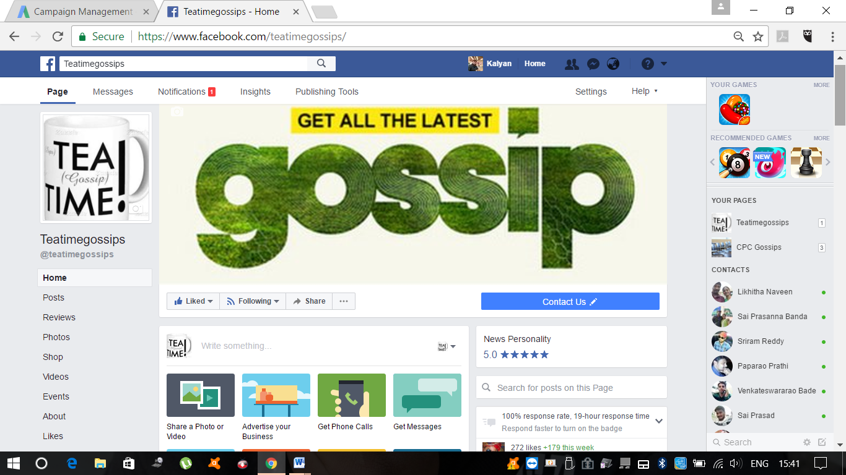

**FACEBOOK POSTS URL LINK:**

[**https://www.facebook.com/pg/teatimegossips/posts/?ref=page_internal**](https://www.facebook.com/pg/teatimegossips/posts/?ref=page_internal)

**SCHEDULED FB POST URL LINK:**

[**https://www.facebook.com/teatimegossips/publishing_tools/?section=SCHEDULED_POSTS&sort[0]=scheduled_publish_time_ascending**](https://www.facebook.com/teatimegossips/publishing_tools/?section=SCHEDULED_POSTS&sort%5b0%5d=scheduled_publish_time_ascending)

**CANVA PAGE URL LINK:**

[**https://www.canva.com/account#profile**](https://www.canva.com/account#profile)

**HOOTSUITE PAGE:**

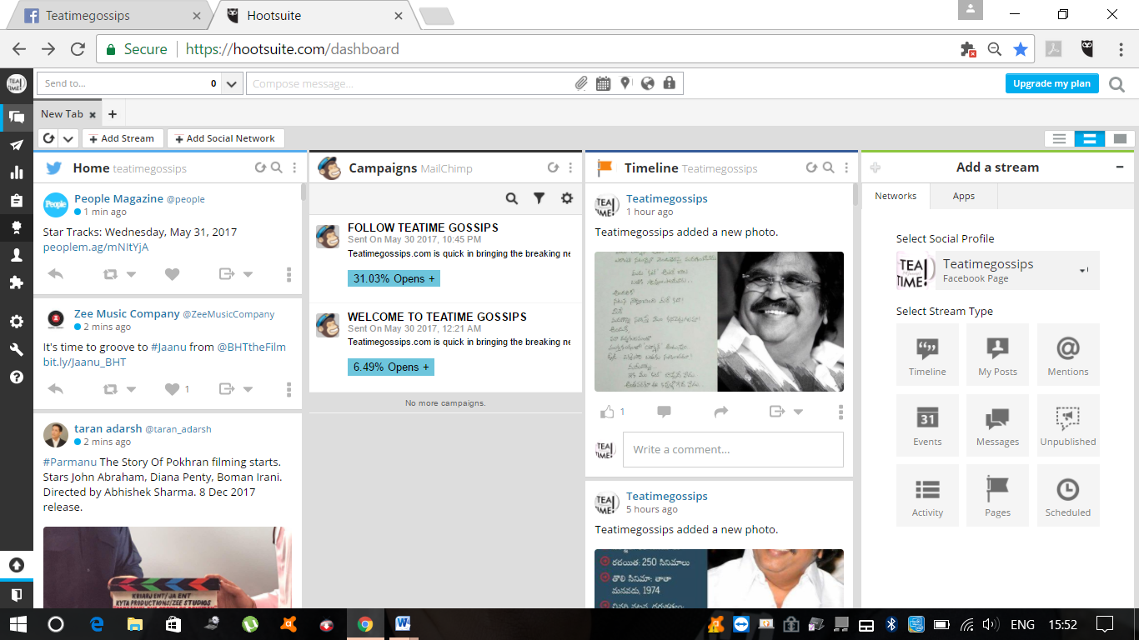

**HOOTSUITE PAGE URL LINK:**

[**https://hootsuite.com/dashboard**](https://hootsuite.com/dashboard)

**FACEBOOK PAGE MANAGER APPLICATION:**

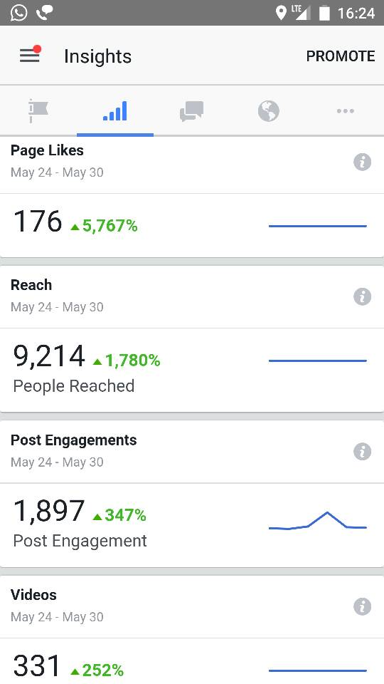

**YOUTUBE CHANNEL:**

[**https://www.youtube.com/channel/UCQGydCuSvvOcN5ipLwJj7Dg**](https://www.youtube.com/channel/UCQGydCuSvvOcN5ipLwJj7Dg)

**YOUTUBE INSIGHTS:**

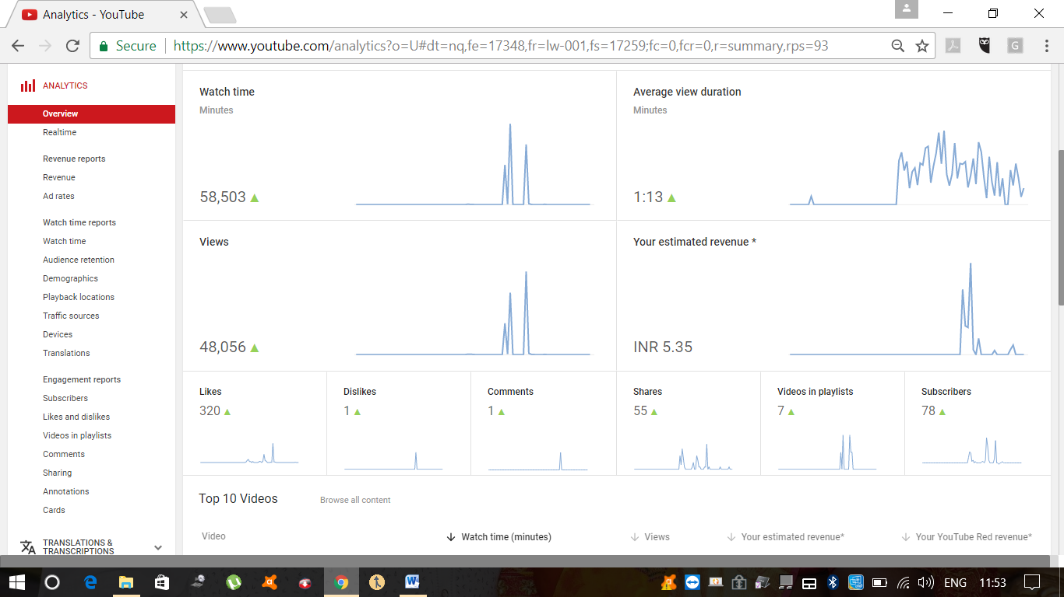

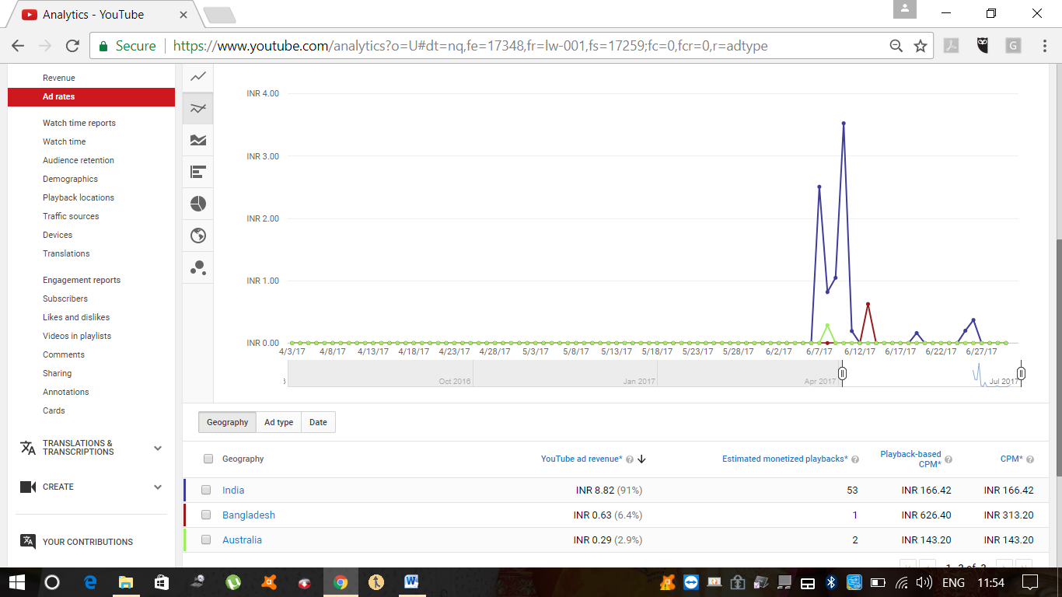

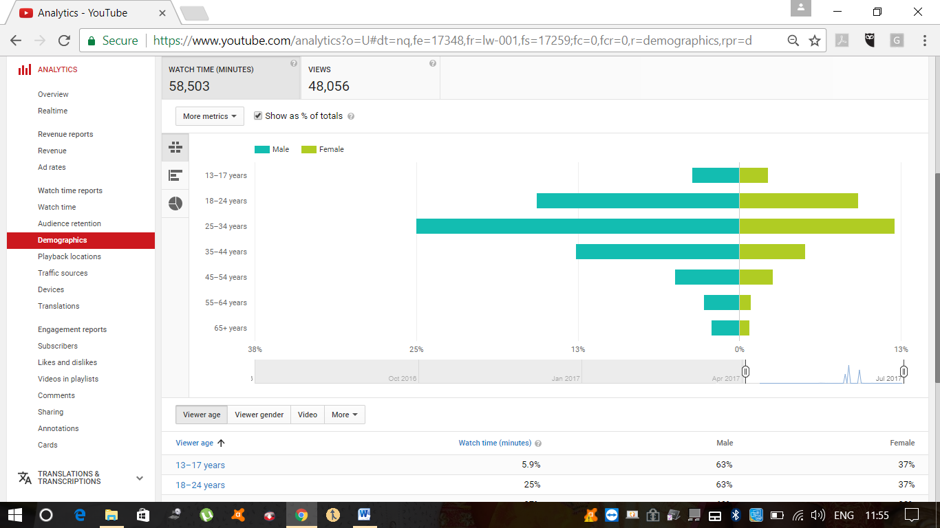

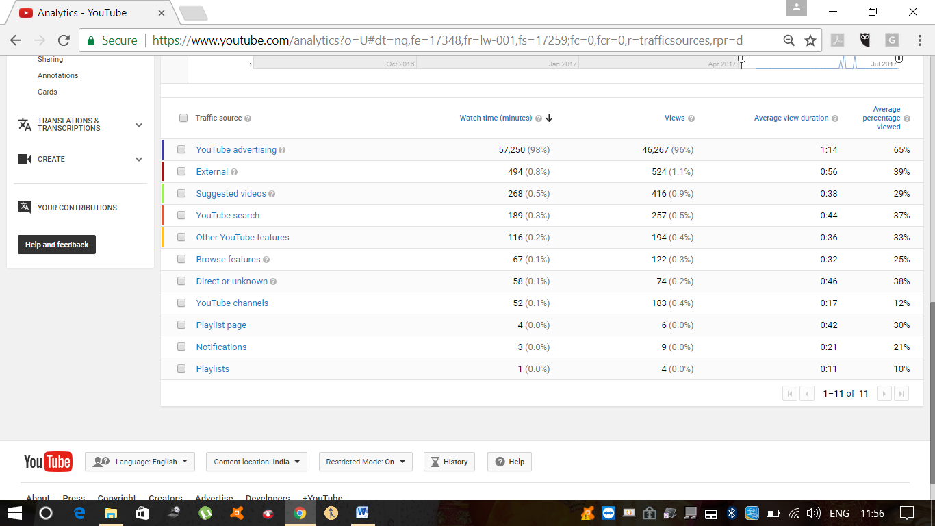

**MAILCHIMP ACCOUNT:**

[**https://us15.admin.mailchimp.com/account/profile/**](https://us15.admin.mailchimp.com/account/profile/)

**E MAIL CAMPAIGNS USING MAIL CHIMP:**

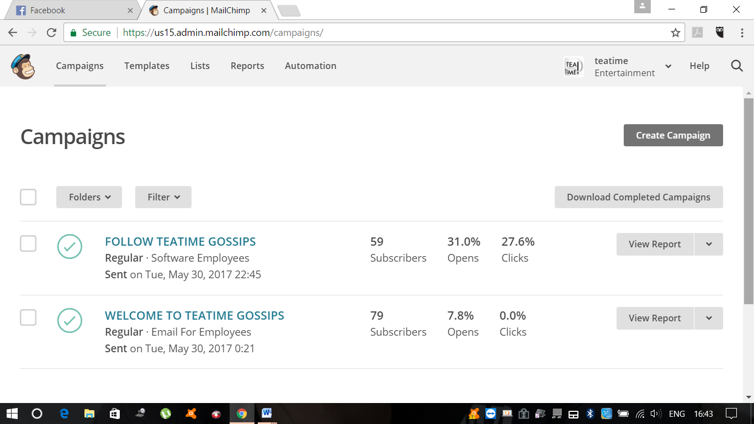

[**https://us15.admin.mailchimp.com/lists/dashboard/overview?id=120323**](https://us15.admin.mailchimp.com/lists/dashboard/overview?id=120323)