Deliverable-2
Project Title: eMed-a complete pharmacy cart at your doorstep.
Group Name: Team Delta
Group Members:
S. No | Full Name | Student ID | Email
1. | Shabana Syed | 11723237 | ShabanSyed2@my.unt.edu
2. | Ganesh Gundekarla | 11700551 | ganeshgundekarla@my.unt.edu
3. | Rishika Kandrigal | 11699010 | rishikakandrigal@my.unt.edu
4. | Md Ariful Hasan | 11428575 | MdArifulHasan@my.unt.edu
5. | Vishnu Priya Vulichi | 11727751 | vishnupriyavulichi@my.unt.edu
6. | Vivek Nelluri | 11691249 | Viveknelluri@my.unt.edu
7. | Pranav Chalasani | 11712496 | PranavChalasani@my.unt.edu
8. | Ajay Kumar Reddy Sammeta | 11646754 | Ajaykumarreddysammeta@my.unt.edu

SYSTEM STRUCTURE
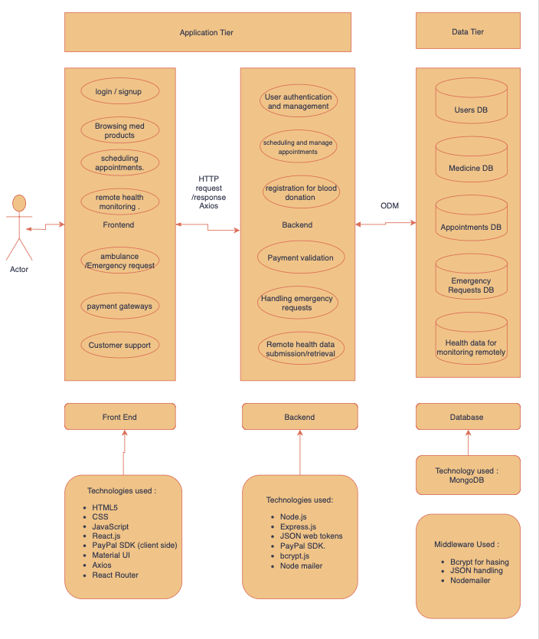

Data flow:
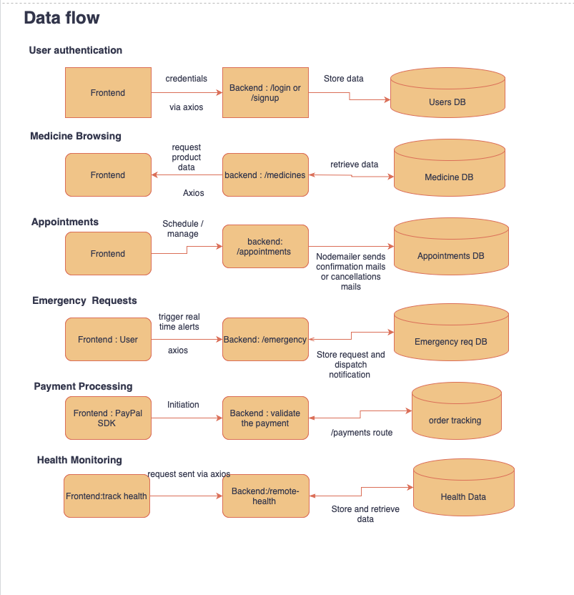

REQUIREMENT SPECIFICATION
FUNCTIONAL REQUIREMENTS:
- User Authentication & Registration: The user should be able to create an account with personal details. Users should have data privacy and be able to change their credentials through an email ID verification.

- Searching for Medication: The user should be able to access the medicines list and choose the desired medication and should be able to purchase the medication.

- Doctor Profiles and Appointment Scheduling: The interface should have a detailed page that displays doctor profile and appointment scheduling information.

- Blood Donation and Emergency needs: The user should be able to access the blood donor's details. In case of an emergency, the user should be able to make an emergency blood request.

- Admin Control Center: The admin should be able to manage the user information and appointments and have overall control over the application.

- User-Admin Communication: The user should be able to access the live chat to resolve the queries, updates regarding scheduling the appointments medicine purchased.

- Ambulance Services and Emergency Assistance: The user should be able to make a request for an ambulance service in an emergency.

- Payment Gateway and Checkout Options: The payment gateway should be provided to pay the bill for a medicine purchase and provide the shipping details.

- Category Pages with SEO Optimization: The platform should be integrated with the SEO to enhance the user experience where patients can easily fetch the medication history, patient details.

- Remote Wellness Monitoring: The application should have feature to give the summary of the patient details, medication and health conditions.

NON- FUNCTIONAL REQUIREMENTS:
- Performance:
- The e-health system shall serve each page to the user within 3 seconds of initiation under normal load conditions.
- The platform will support up to 10,000 concurrent users without performance degradation.
- Scalability:
- The system can scale horizontally to accommodate growing user numbers, especially during peak times like health emergencies.
- Security:
- Sensitive data, such as patient information and payment details, will be encrypted both in transit and at rest.
- The system will use multi-factor authentication (MFA) for user login, especially for administrative users.
- Reliability:
- The website will ensure continuous availability for users to book appointments and request emergency services.
- Usability:
- The website will provide a user-friendly interface accessible to users with minimal technical skills.
- Maintainability:
- The website will have a modular architecture, making it easy to update individual components without affecting the entire system.
- Backup and Recovery:
- In case of a system failure, a backup system will restore data within an hour to prevent data loss and minimize downtime.

USER INTERFACES:
Interfaces:
Readability should be good with all the devices.
Breaking main components of UI for our website:
- Logo page with the title of our project.
- Sign up and sign in options. Redirecting to forgot password if clicked on.
- Medicine information page with a bar where we have options like:
Medicine
Doctor
Blood
Contact Us
Sign in
- In that page of medicine, pictures of medicines along with some information to understand.
- When clicked on a specific medicine we get a add to cart option with a reviews section
- Shopping cart to check price and then shipping info, payment method
- When selected doctor, doctors' information will get displayed
- Booking an appointment page
- Blood donors page with requesting blood
- Admin pages for orders, appointments and blood requests.
Phase 1 of the Implementation Plan Development Process:
Fundamental Features Priority of Implementation: High
Time frame: 1 weeks
- User Authentication & Registration:
  - This feature enables users to register
  - Users can login once registered.
  - User can see his/her orders, appointments and other information by logging in.
- Medicine Browsing & Purchase:
  - Users can search and browse medicines that are available to purchase.
  - This feature enables customers to check their required medicines, add medications to a cart and proceed further for checkout.
- Doctor Profiles and Appointment Scheduling:
  - This feature shows detailed doctor profiles with information about the specialties, qualifications, and availability of each doctor.
  - Allows customers to book doctor appointments according to their preferences and availability.
- Fundamental UI/UX: Simple and appealing visuals are being used to make the website look good.

Phase 2 - Improved Functionality and Medium Polish

Time Frame: 1 week

Key Enhancements:
- Product Management Improvements:
- Allow admin users to edit or remove products.
- Display additional product details like descriptions, available colors, sizes, and usage instructions.
- Implement search functionality for users to find products by name or category.
- Checkout Process:
- Enable users to proceed through checkout using their shopping cart.
- Prompt users to provide payment and shipping information.
- Upon successful checkout, send confirmation emails with order details.
- User Experience Improvements:
- Implement mobile responsiveness to ensure smooth use on all devices.
- Add accessibility features like alt text for images and keyboard navigation, ensuring WCAG compliance.
- Performance optimization to reduce load times, targeting a sub-3 second response time for page loads.
Phase Three of Development:
Conditions:
- User Profile Enhancement:
- Improve the user profile system to deliver customized services and a better overall user experience.
- Enable users to check their order history and appointment history easily.
- Set up user preferences for notifications like e-mail, messages.
- Enhanced Search and Smart Filter System:
- Implement advanced search and filtering for finding medicines, doctors, and blood donors.
- Create text search in MongoDB to find drugs by name, category, and symptoms.
- Add options for doctors based on specialization and availability.
- Real Time Features:
- Add real-time notifications for order updates, reminders, blood requests.
- Make sure that real-time communication channels are secure and handle high traffic smoothly.
- User Feedback and Review System:
- Improve the feedback mechanism to provide better service and quality control.
- Allow users to leave detailed reviews and feedback on their experience.
- Add a rating system for doctors, medicines, and services provided by the platform.
Roles Assignment:
Task | Top preference
Project Management Lead | Rishika Kandrigal
Requirements Lead | Ganesh Gundekarla
Design Lead | Vivek Nelluri
Implementation Lead for front-end | Ganesh Gundekarla
Implementation Lead for back-end | Vishnu Priya Vulichi
Configuration Management Lead | Vivek Nelluri
Testing Lead | Shabana Syed
Documentation Lead | Ajay Kumar Reddy Sammeta
Demo and Presentation Lead | Pranav Chalasani
System Administrator Lead | Md Ariful Hasan

SKILLS ASSIGNMENT:
Language/Technology | Assigned to:
Node.js with Express.js | Ganesh Gundekarla, Pranav Chalasani
MongoDB (via Mongoose) | Vishnu Priya Vulichi, Shabana Syed
React.js | Ganesh Gundekarla, Rishika Kandrigal, Pranav Chalasani
Axios for API requests | Vishnu Priya Vulichi, Ajay Kumar Reddy Sammeta
PayPal SDK (client-side) | Ajay Kumar Reddy Sammeta, Ganesh Gundekarla
JavaScript Object Notation | Md Ariful Hasan, Vivek Nelluri
JavaScript | Vivek Nelluri, Md Ariful Hasan
HTML5, CSS | Shabana Syed, Rishika Kandrigal

Team members Description:
Member name | Contribution description | Overall Contribution (%) | Note  (if applicable)
Shabana Syed | Worked on functional requirements, and specified key features like medicine browsing, order processing workflows, and user authentication. | 12.5%
Ganesh Gundekarla | Worked on designing and developing the system structure and data flow of the system. | 12.5% | This is a planning and development phase, and it could be changed in the future.
Rishika Kandrigal | Worked on User Interfaces by researching and collecting data for improving user experience and functionality. | 12.5%
Md Ariful Hasan | Worked on Nonfunctional requirements. | 12.5%
Vishnu Priya Vulichi | Worked on phase one of development in developing the fundamental features of the project | 12.5%
Vivek Nelluri | Worked on Phase three of development to design features | 12.5%
Pranav Chalasani | Worked on Phase 2, the focus is on the project management improvements and enhancing the overall user experience | 12.5%
Ajay Kumar Reddy Sammeta | Helped in developing and designing system structure and gathering information related to system requirements. | 12.5%

