A Model for prediction of consumer conduct using machine learning algorithm

In this project author has used traditional machine learning algorithms such as SVM, Random Forest, logistic regression to predict consumer conduct such as consumer CLICKED on business linked or not while browsing.

In extension we have added advance machine learning algorithm called BaggingClassifier and compare its accuracy with traditional algorithms

A Bagging classifier is an ensemble meta-estimator that fits base classifiers each on random subsets of the original dataset and then aggregate their individual predictions (either by voting or by averaging) to form a final prediction. Such a meta-estimator can typically be used as a way to reduce the variance of a black-box estimator (e.g., a decision tree), by introducing randomization into its construction procedure and then making an ensemble out of it.

SCREEN SHOTS

To run project double click on ‘run.bat’ file to get below screen

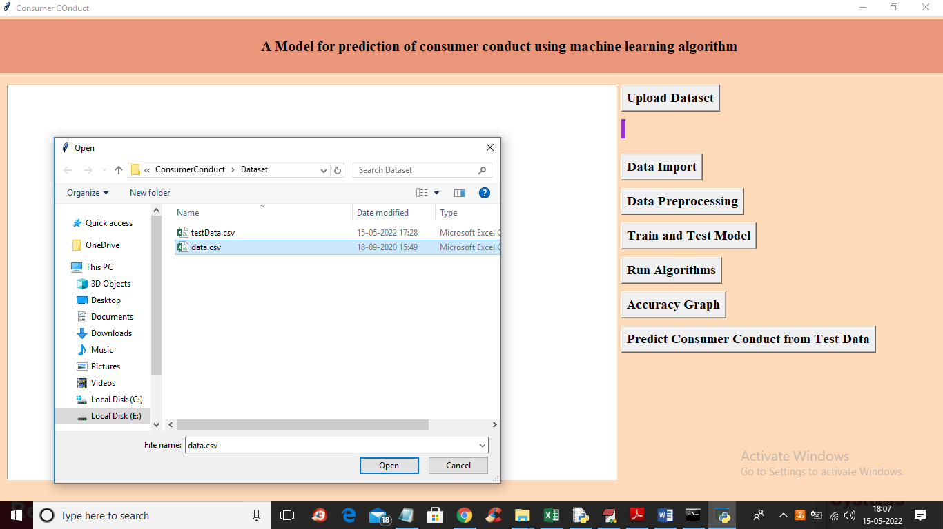

In above screen click on first button to upload dataset and then click remaining buttons and while training ML algorithms we can see output of extension BaggingClassifier like below screen

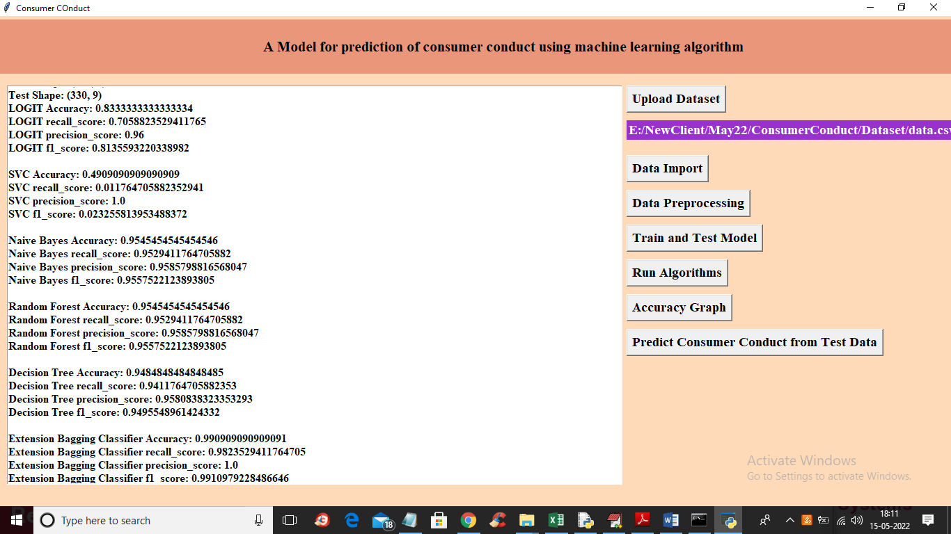

In above screen you can see accuracy of all traditional algorithms such as logistic regression, SVM, Naïve Bayes, Random Forest and Decision Tree but extension Bagging Classifier is giving high accuracy as 99% and now click on ‘Accuracy Graph button to get below graph

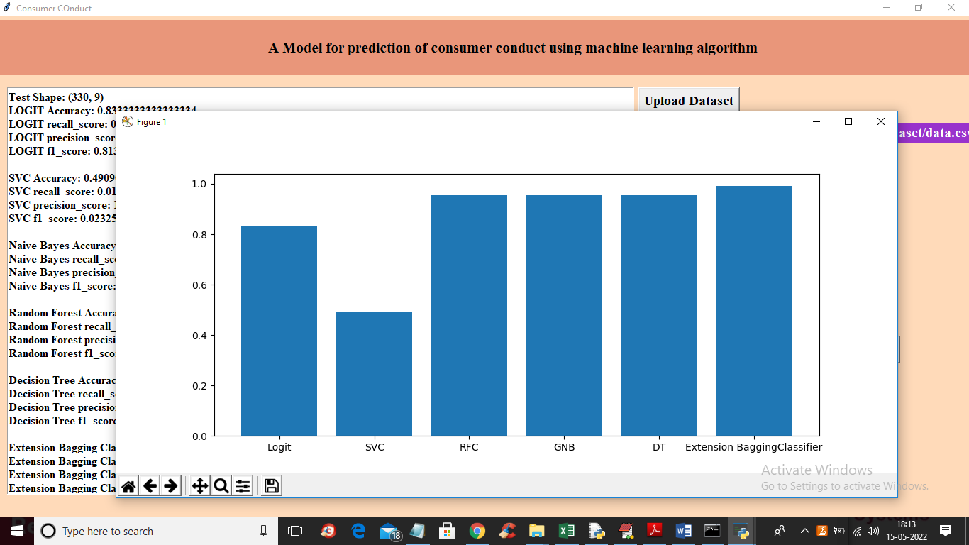

In above graph x-axis represents algorithm names and y-axis represents accuracy of all algorithms and in all algorithms extension got high accuracy and now close above graph and then click on ‘Predict Consumer Conduct from Test Data’ button to upload test data and then extension algorithm will predict consumer conduct like below screen

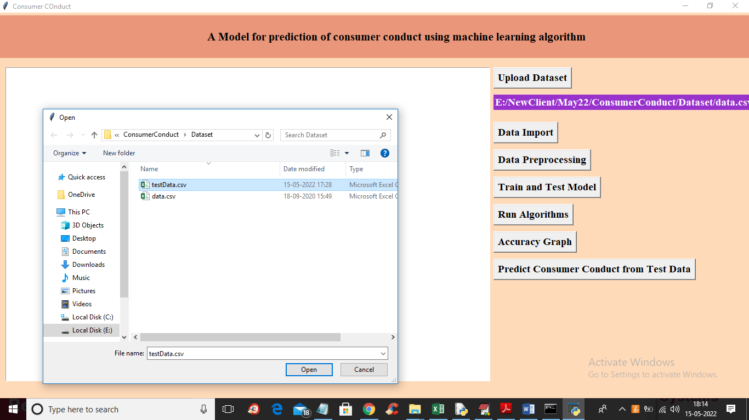

In above screen selecting and uploading ‘testData.csv’ file and then click on ‘Open’ button to load dataset and get below output

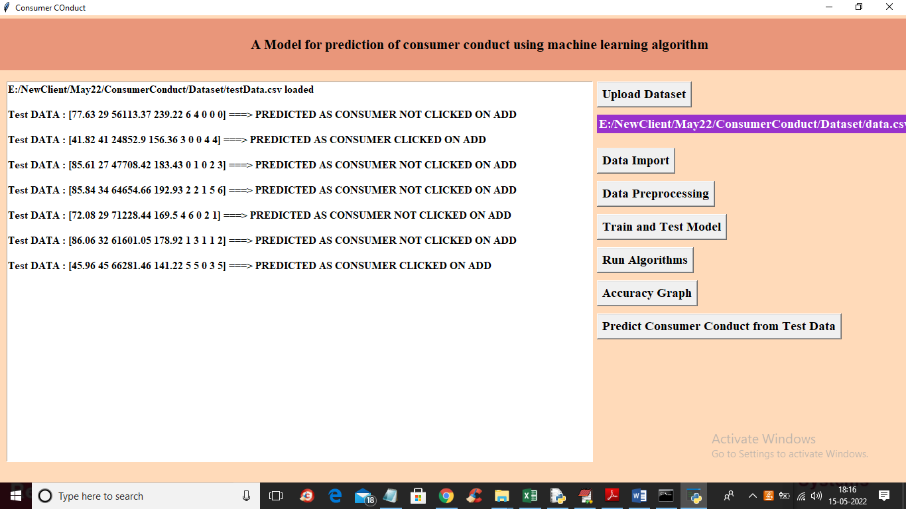

In above screen in square bracket we can see test data values and after square bracket we can see predicted values as ‘consumer clicked on ADD or NOT’