**A Model for prediction of consumer conduct using machine learning algorithm**

**Introduction:**

Machine learning is a part of artificial intelligence, in which we train a machine to predict the desired value. During this training, we define certain rules or patterns and our machine find out the defined pattern. So, in Machine Learning, input information is generated on the basis of knowledge stored in database. Since we are making our system to predict or extract relevant information from input data set, So, we need to develop an algorithm and pattern to retrieve the required information. After these two steps i.e. developments of algorithm and pattern have been completed, the machine can accomplish the following tasks:

Obtain, extract and summarize relevant information Make predictions based on analytical data Calculate the probability of certain effects To adapt to specific development independently

**About abstract:**

The machine learning algorithm has become important because of their accuracy in forecasting. It is very difficult to predict a customer’s satisfaction due to an unexpected customer situation. Many algorithms are designed for the same purpose. In this paper, we have studied and analysed three Bays algorithms such as AODE, Naive Bayes and AODEsr.

**Existing Methods:**In Existing methods , we are using Bays algorithms such as AODE, Naive Bayes and AODEs with all the features.So As we selected all the features and our model not performing well. As some some are surpassing the output due to under fitting.

**Proposed Method:**

In this paper, we proposing feature selection with machine learning algorithms which will increase the model performance and over and undefitting

**Dataset:Location:**<https://www.kaggle.com/c/santander-customer-satisfaction/data?select=train.csv>

Data consists of 370 columns

Train data consists of 76020 rows

Test data consists of 75818 rows

**Project Development Modules:**

1. **Data collecction:** Collect the data from Kaggle
2. **Data Preparation:** Cleaning and Create new columns and delete columns, handling missing/outliers
3. **Feature Selection:** select features using Chi2 and RFEEV methods and create new dataset
4. **Data Split:**Split the data in train and test in the ration 8:2
5. **Model:** Machine Learning algorithms Navie bayes Random Forest , Decision Tree. Train the model with training data
6. **Evaluation:**Test the model with testing data.
7. Predict the cosumer Satisfaction

**Input:** how many weeks to forecast

**Output of project:**Forecasting values for the given week

**Extension or improvements in project:**random forest model to increase better performance

**Conclusion of project:**We will build the machine learning algorithm for consumer satisfaction

Importing required packages:

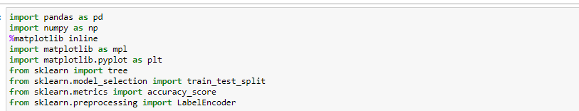

Read the data by using pandas and data is stored to df variable.

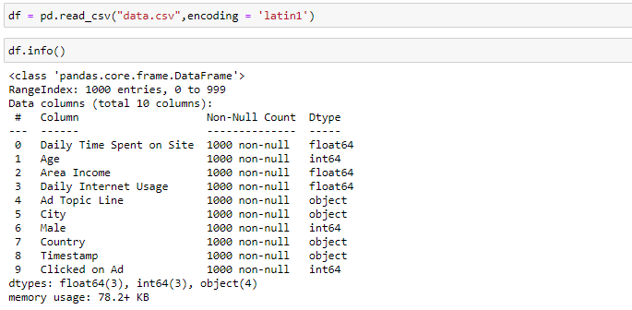

Preprocessing:

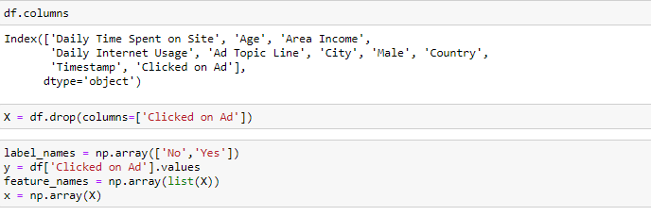

Splitting the data for training and testing



Encoding the train and test data by using labelEncoder()

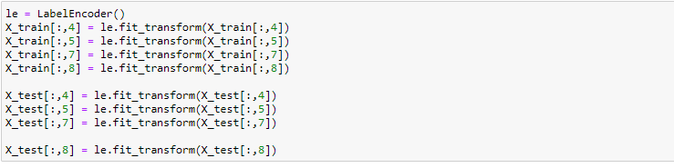

Applying maching learning algorithms to data for prediction

Logistic regression:

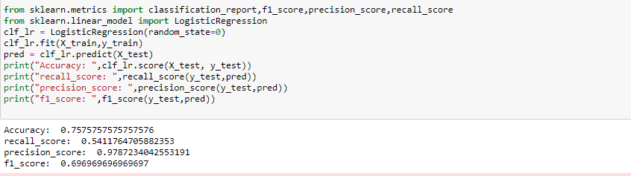

GaussianNB

