**Write a pig script to find the count of each Hashtag in the dataset. You can download the twitter data from the below link.**

**1st data**

**Code:**

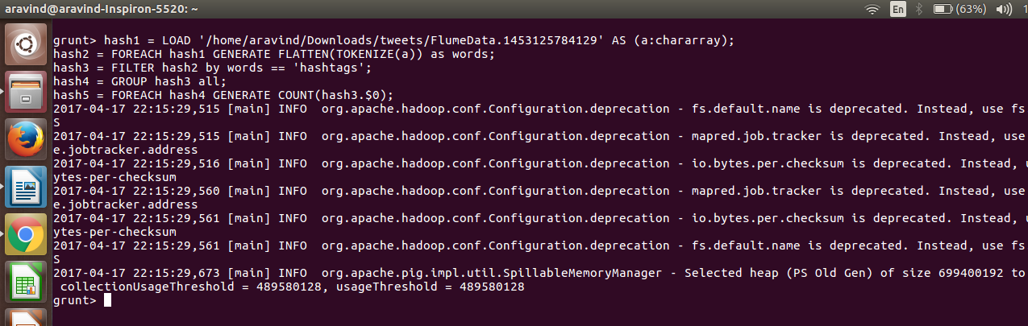

**Output:**

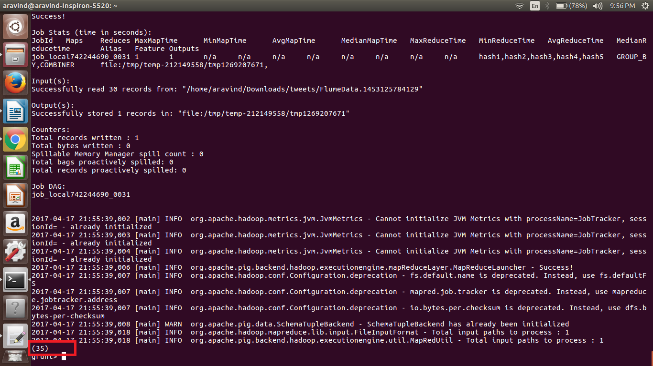

**2ND DATA:**

**Code:**

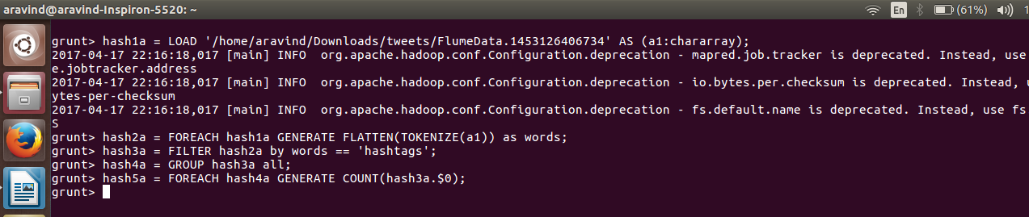

**Output:**

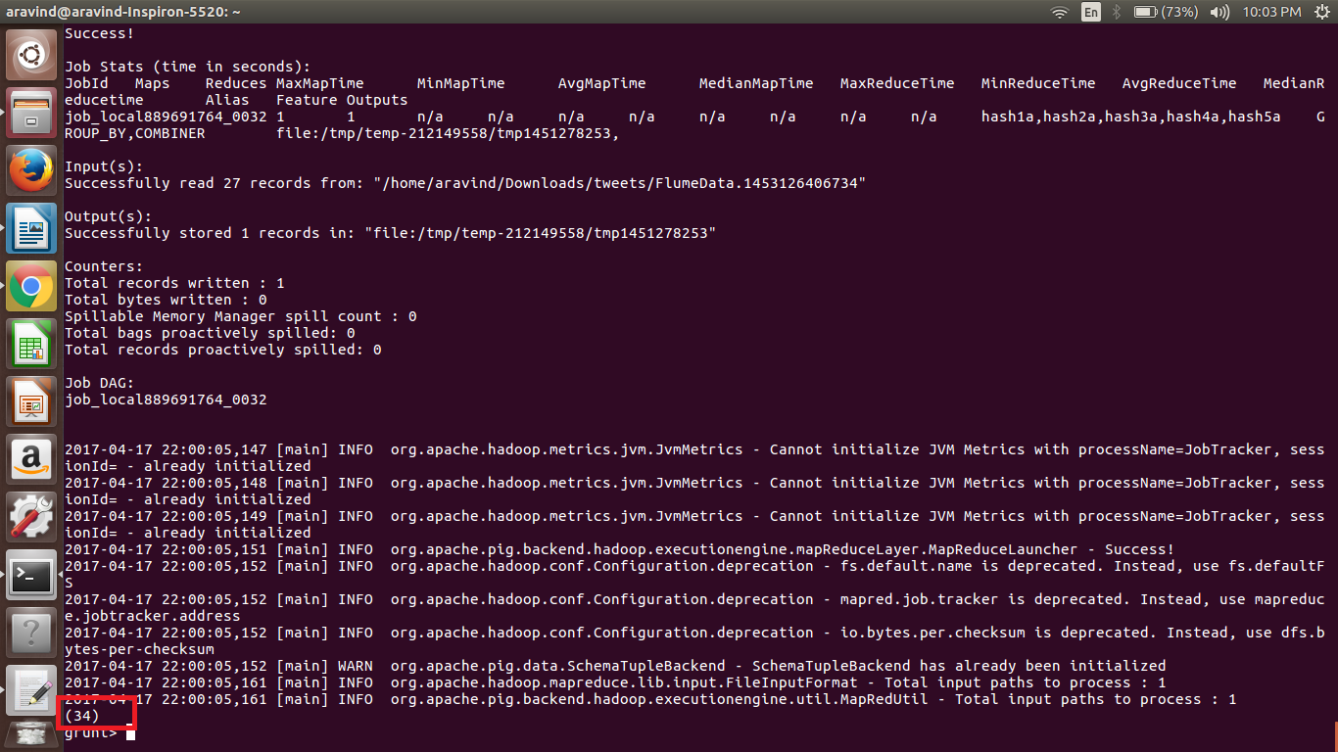

**3RD DATA:**

**Code:**

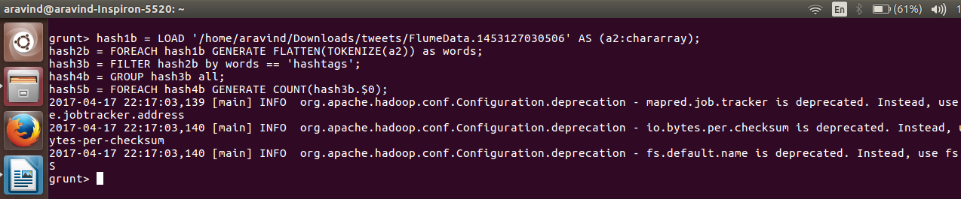

**Output:**

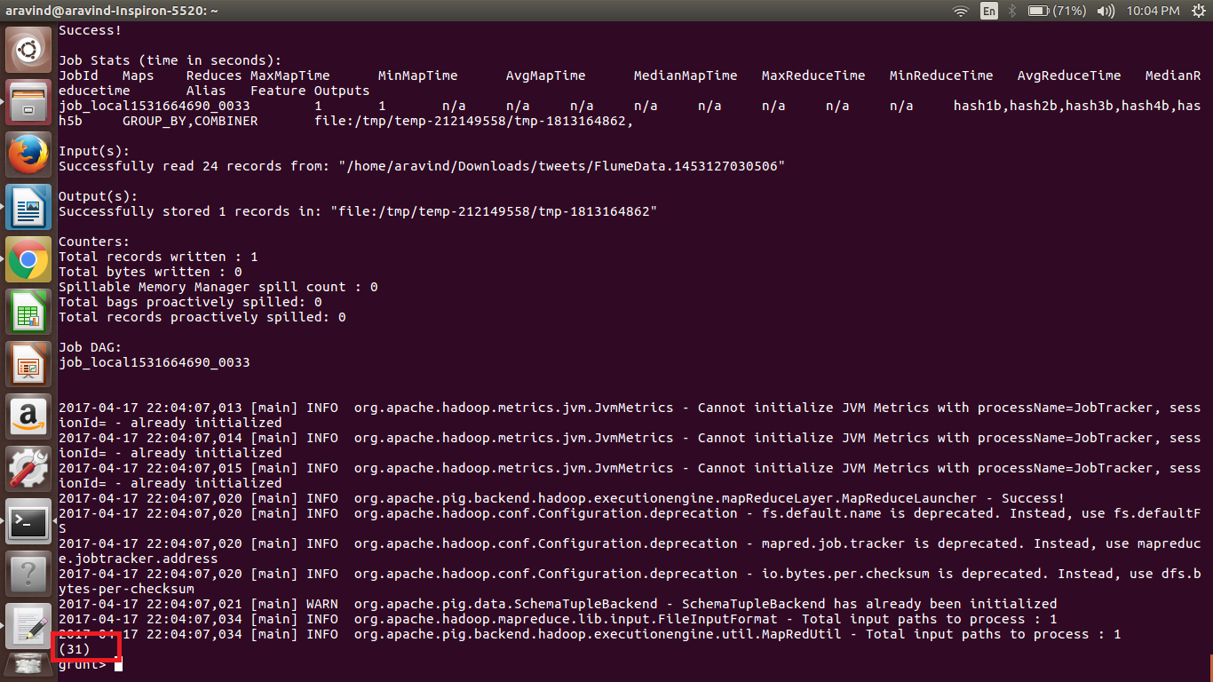

**4TH DATA:**

**Code:**

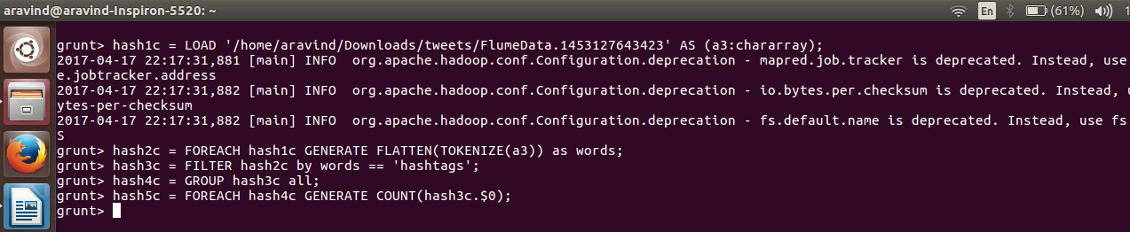

**Output:**

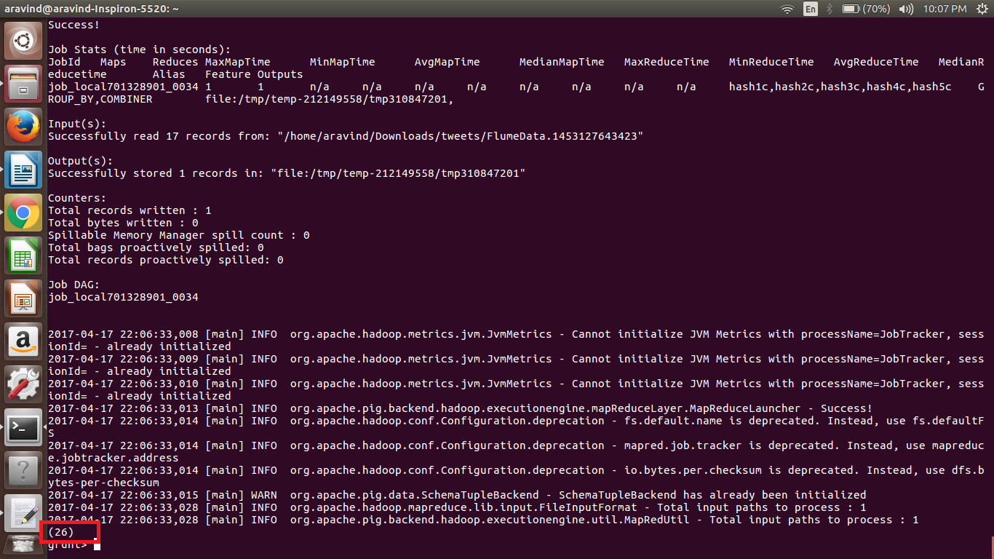

**5TH DATA:**

**Code:**

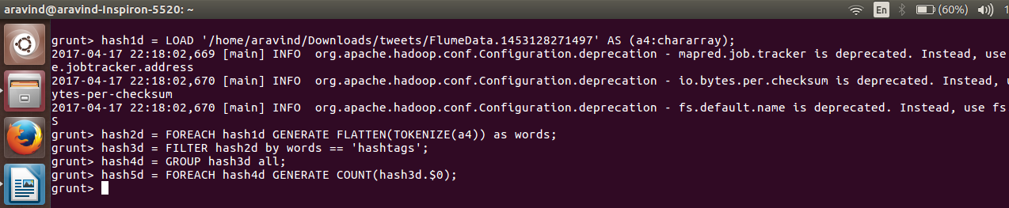

**Output:**

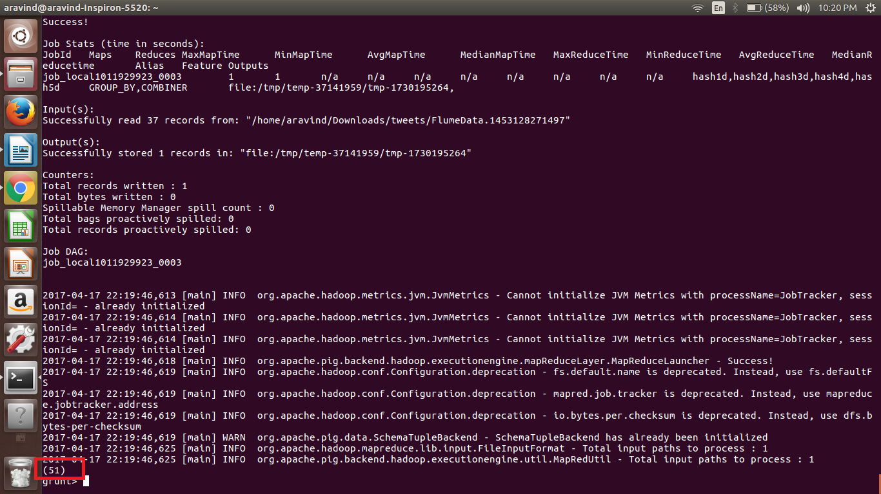

**6TH DATA:**

**Code:**

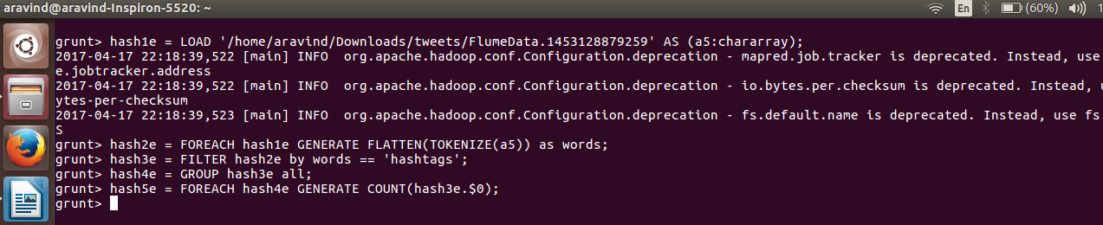

**Output:**

